

Securing New Zealand’s Future

Budget
at a Glance

Hon Nicola Willis
Minister of Finance
28 May 2026


Embargo: Contents not for communication in any form
before 2:00 pm on Thursday 28 May 2026

Budget 2026
1 | Secures New Zealand’s future by getting back to surplus and reducing debt as a share of GDP.
2 | Invests to drive better results in health, education, and law and order.
3 | Delivers jobs-rich infrastructure projects including hospitals, schools, courthouses, police stations, rail upgrades and a new Road of National Significance.
4 | Provides temporary, timely and targeted support for households and public services facing fuel price pressures.
5 | Drives forward reforms to increase energy security, boost housing growth and replace the RMA.
6 | Continues to rebuild the capacity of the Defence Force so it can protect New Zealand’s interests.
7 | Improves the fairness of housing support and supports the delivery of up to 2,250 more social houses.
8 | Ends final-year Fees Free while doubling the number of Trades Academy places for years 11 to 13 students and funding 1,000 more Youth Guarantee places for school leavers.
Unless otherwise stated, funding in this document refers to total operating expenditure over the forecast period (the four years to 2029/30).
Capital funding is a one-off sum.

Budget 2026 package
Budget 2026 is a package of new spending, savings, and reprioritisation to frontline services, all within a net operating package of only $2.1 billion per annum, on average. The single biggest allocation of funding is for frontline health services.
Budget package  ($ million) | Operating total over 4 years | Operating average per annum | Capital
Health | 5,839 | 1,460 | 682
Education  (including tertiary) | 2,017 | 503 | 501
Defence and intelligence | 1,156 | 388 | 2,348
Law and order | 1,076 | 269 | 215
Social housing and welfare | 824 | 255 | 2
Transport | 477 | 119 | 2,878
Housing | 430 | 107 | -
Energy security | 198 | 50 | 198
Other expenditure | 2,649 | 662 | 135
Total new expenditure | 14,666 | 3,813 | 6,959
Savings and revenue | (6,394) | (1,667) | (1,257)
Net package | 8,272 | 2,146 | 5,702
The Budget package adds to existing planned expenditure. In total, the Government is expected to spend $155 billion in the next financial year, mostly on health, education, welfare and NZ Superannuation (see chart on “How taxpayers’ money is spent” page).

Health
Budget 2026 provides new funding to ensure Kiwis can access timely, quality healthcare.
- A $5.5 billion increase in funding for frontline health services.
- Funding for three-day postnatal stays ($34 million) and specialist paediatric palliative care ($16 million).
- An additional $54 million for Pharmac to purchase medicines.
- Capital investment of $682 million, including a new tower block for Whangārei Hospital.
- $33 million to further extend eligibility for the National Bowel Screening Programme to age 56.
- $35 million to boost support for road ambulance services.

Fuel response
Budget 2026 includes temporary, timely and targeted funding for households and public services facing fuel pressures.
- Additional funding for Fire and Emergency, Corrections, Police, Customs and Education to maintain frontline operational activities in the face of sustained fuel price increases.
- A $50 per week increase to the In-Work Tax Credit for up to a year to help working families with increased fuel costs ($373 million).
- Funding of $150 million for additional strategic fuel reserves to firm up New Zealand’s fuel resilience.
- A temporary increase in mileage rates for support workers and people traveling for specialist treatment ($24 million).
- Funding set aside for additional temporary fuel-related measures, if required ($450 million).

Infrastructure
Budget 2026 provides new funding to build or enable infrastructure that will lift productivity, resilience and living standards.
- Capital investment of $1.8 billion to build the Cambridge to Piarere Expressway, a Road of National Significance.
- $705 million capital and $477 million operating funding to renew and upgrade New Zealand’s rail network.
- $294 million to drive forward reforms to New Zealand’s resource management system.
- Capital investment of $400 million for a package of state highway resilience upgrades.
- $400 million to introduce a new financial incentive for councils to encourage housing growth.
- Investment in hospitals, schools, courthouses, police stations, and defence assets.
New investment is on top of an existing pipeline of infrastructure spending, funded in previous Budgets or from government agencies’ balance sheets. Around $60 billion is expected to be spent over the next four years.

Law and order
Budget 2026 provides new funding to help reduce crime and keep Kiwis safe.
- $503 million for frontline Corrections services, including more resources to manage prison growth.
- Capital investment of $215 million, including new courthouses in Rotorua and new police stations in Whanganui and Greymouth.
- Support for frontline policing, with $50 million of additional funding.
- Funding to reform the firearms safety system.
- $21 million for Customs to combat drug smuggling and transnational crime.

Education
Budget 2026 supports the Government’s commitment to lifting student achievement at school. In addition, it reinvests some of the savings from ending final-year Fees Free into preparing young people for trades and other vocational education.
- A $131 million package of measures to strengthen teaching and learning to help students meet standards in reading, writing and maths.
- A $74 million package to support the implementation of a refreshed curriculum and new national qualifications.
- Ending final-year Fees Free at the end of 2026 (a saving of just over $1 billion).
- Funding of $87 million for 1,000 more Youth Guarantee places, providing free learning for young people with no or low qualifications.
- Capital investment of $470 million to redevelop up to 10 schools, deliver up to 232 additional classrooms and buy land for new schools.
- $212 million to continue the Healthy School Lunches and Early Childhood Education Food programmes in 2027.
- Increasing funding rates to support providers of foundation education ($25 million).
- Funding of $69 million to double the number of Trades Academy places to 20,000, providing free trades training to year
11 to 13 students.

Energy security
Budget 2026 makes investments to support New Zealand’s energy security.
- Capital investment in Genesis Energy to accelerate investment in new generation and firming capacity.
- A new loan guarantee scheme to support businesses to transition away from gas.

Defence and foreign affairs
Budget 2026 invests a total of $2.3 billion capital and $1.2 billion operating funding in New Zealand’s defence and intelligence capabilities. It also increases funding to promote New Zealand’s interests overseas.
- Funding to retain existing Defence Force staff and increase numbers in key areas.
- Investment to improve facilities at military bases across New Zealand.
- $110 million for international development cooperation, focused on the Pacific.
- Investment to ensure the Anzac-class frigates and HMNZS Canterbury remain operational.
- Funding to enable continued operation of aircraft, ships and land forces.
- $145 million to ensure a resilient, safe and secure offshore diplomatic and trade network.

Revenue
Budget 2026 contains tax measures to reduce compliance costs, maintain integrity, and help retain capital and talent in New Zealand. It also introduces a new prudential levy on banks and other financial institutions.
- Simplifying fringe benefit tax rules for private motor vehicle use to reduce compliance costs.
- Changes to tax rules to help retain talent and support increased foreign investment.
- Changes to tax rules for charities and not-for-profits that support the sector and maintain integrity.
- A new prudential levy on banks and other financial institutions to help cover the cost of regulation and supervision by the Reserve Bank.

Social housing and welfare
Budget 2026 improves the fairness and sustainability of the social housing and welfare systems.
- A fiscally neutral package to improve the fairness of government financial support to lower-income renters by:
  - Increasing the Accommodation Supplement for people in private rentals, and
  - Increasing income-related rents for people in social housing.
- $69 million to fund up to 2,250 additional social houses.
- More case management and assistance to support sole parents into work.
- Lower maximum payments of Temporary Additional Support (saving $196 million).
- $45 million to extend support for community food support and kids’ breakfasts programmes.

Public service transformation
Budget 2026 includes savings from government agencies that will be delivered through increases in productivity and greater efficiency.
- $424 million of savings to reprioritise to frontline services.
- $2 billion of savings from future baseline reductions.

Other Budget initiatives
Budget 2026 contains many other initiatives to improve public services, reprioritise funding and meet commitments.
- $109 million package for better control of wilding pines.
- An additional $184 million for Oranga Tamariki to protect and support children.
- $36 million to make the SuperGold Card an official form of ID.
- Funding for new technology to improve NZ’s emergency management system.

Economic outlook
Conflict in the Middle East has delayed but not derailed New Zealand’s economic recovery. Treasury forecasts show the economy continuing to grow and inflation coming down after an initial spike from higher fuel prices.

Economic growth (real GDP)
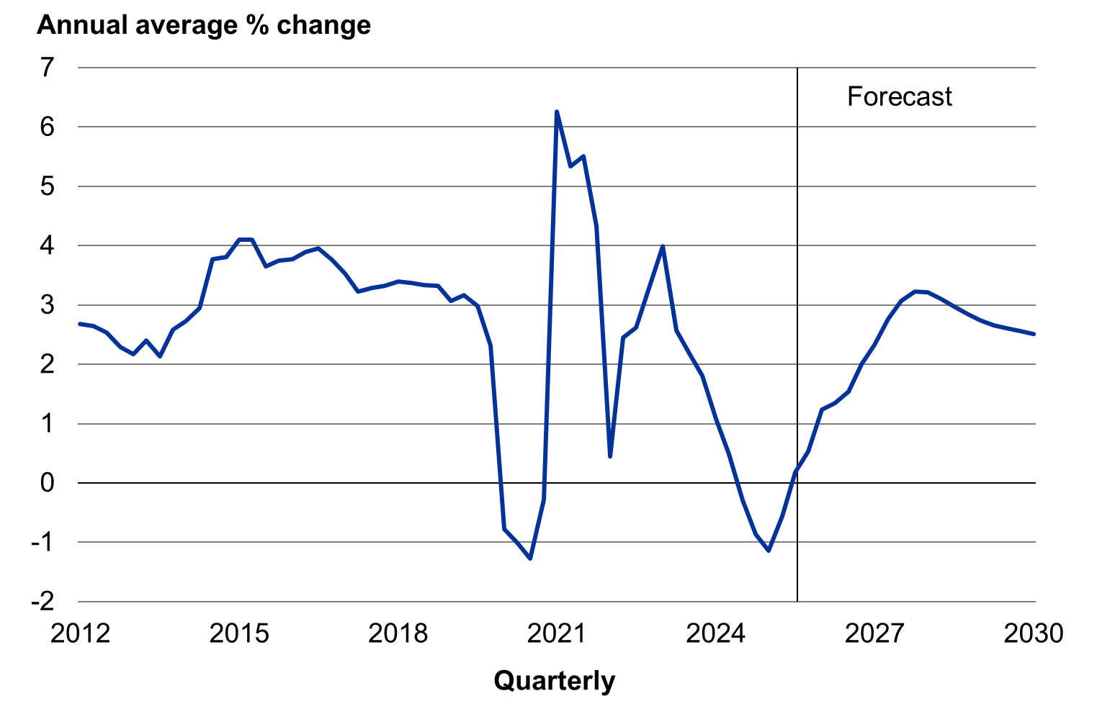

Consumers Price Index inflation
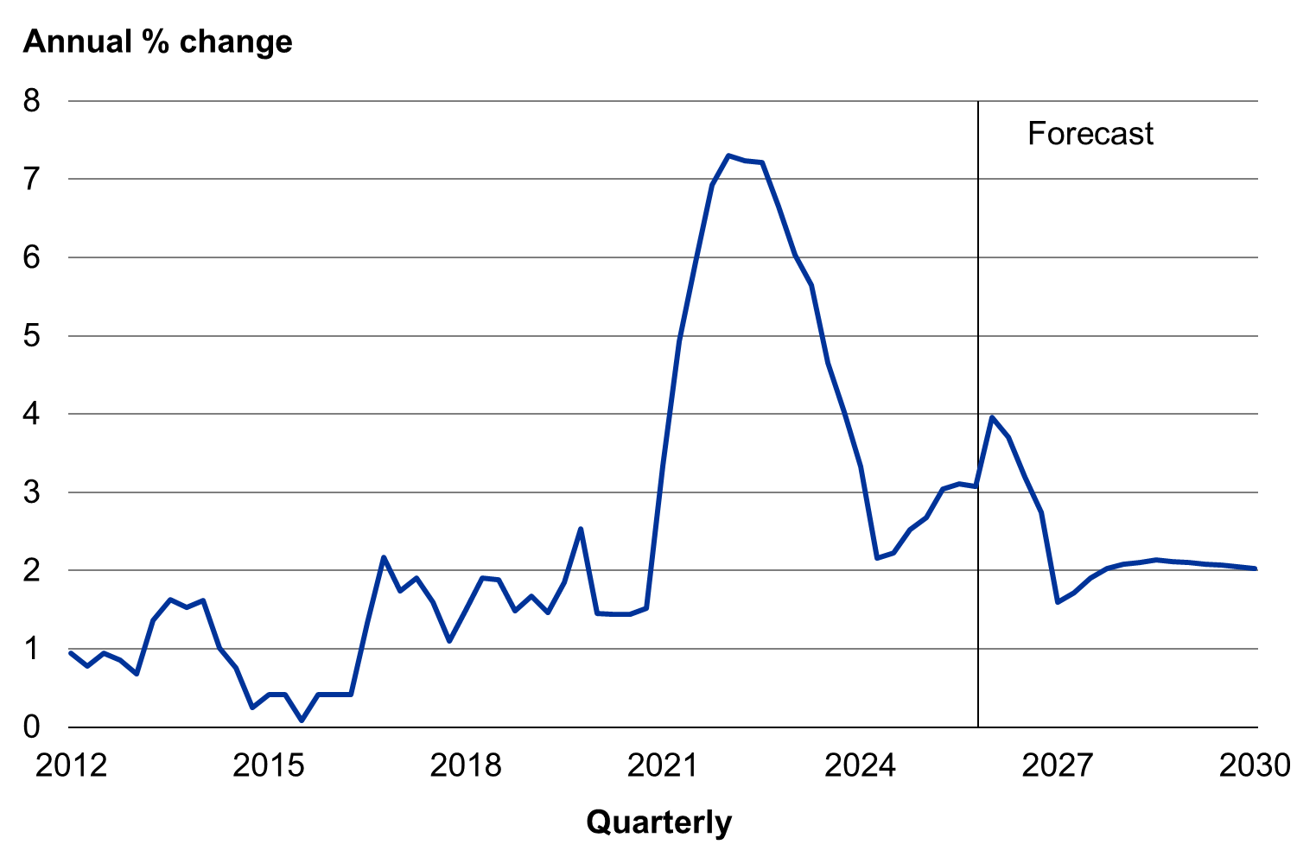

Fiscal outlook
The Government inherited a poor set of books and is getting these back in order, bringing discipline to government spending and keeping a lid on debt. Treasury forecasts show the operating balance returning to surplus in 2028/29 and the government debt curve stopping its rise and heading downwards.

Operating balance (before gains and losses, excluding ACC)
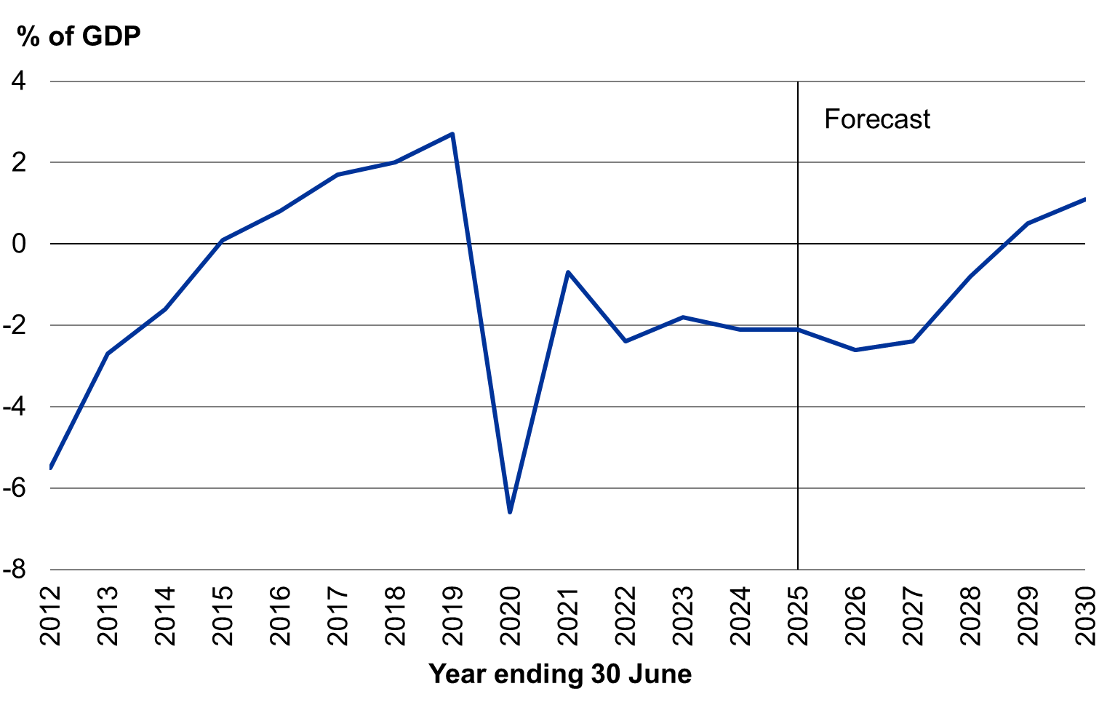

Net core Crown debt
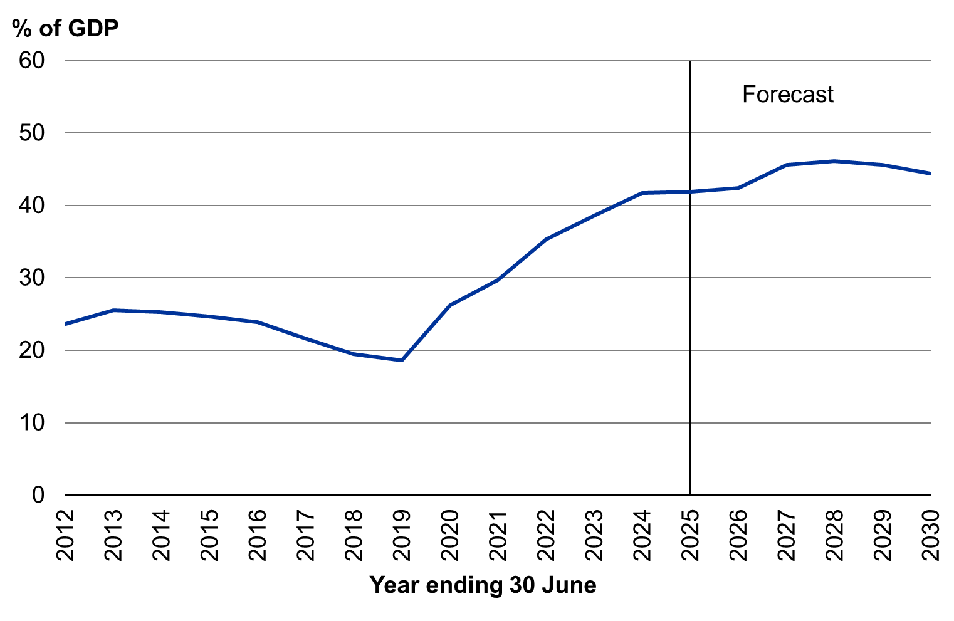

How taxpayers’ money is spent
Health, education, welfare and NZ Superannuation are the biggest areas of government spending.

Forecast core Crown expenses 2026/27

Revenue to pay for this spending is raised largely from income tax, GST and corporate tax.

Forecast core Crown revenue 2026/27

Permanent URL:
treasury.govt.nz/publications/glance/budget-glance-2026
Budget 2026 website URL: budget.govt.nz/budget/2026/at-a-glance/

© Crown copyright
This work is licensed under the Creative Commons Attribution 4.0 International licence.

