

Child Poverty
Report

Hon Nicola Willis
Minister of Finance
28 May 2026

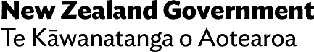
Embargo: Contents not for communication in any form
before 2:00 pm on Thursday 28 May 2026


This work is licensed under the Creative Commons Attribution 4.0 International licence. In essence, you are free to copy, distribute and adapt the work, as long as you attribute the work to the Crown and abide by the other licence terms.
To view a copy of this licence, visit https://creativecommons.org/licenses/by/4.0. Please note that no departmental or governmental emblem, logo or Coat of Arms may be used in any way which infringes any provision of the Flags, Emblems, and Names Protection Act 1981. Attribution to the Crown should be in written form and not by reproduction of any such emblem, logo or Coat of Arms.
Permanent URL:
www.treasury.govt.nz/publications/child-poverty-report/child-poverty-report-2026
Budget 2026 website URL:
budget.govt.nz/budget/2026/child-poverty-report/

Introduction
Under section 15EA of the Public Finance Act 1989, the Minister of Finance is required to present to the House on Budget Day a report on child poverty that:
- discusses any progress made, in the most recent completed financial year, in reducing child poverty consistent with the targets under the Child Poverty Reduction Act 2018, and
- indicates whether and, if so, to what extent, measures in or related to the Budget will affect child poverty.

How child poverty is measured
The Child Poverty Reduction Act 2018 specifies four primary measures of child poverty for which governments must set long-term (ten-year) and intermediate (three-year) targets. These four primary measures are material hardship, the after-housing-costs (fixed-line) measure, the before-housing-costs (moving-line) measure and persistent poverty. Targets for the first three measures, as set by successive governments, are as follows. The fourth measure, persistent poverty, will be reported from 2027.

Primary measure | This measures child poverty by looking at… | Second inter-mediate targets (2023/24) | Third inter-mediate targets (2026/27) | Ten-year targets (2027/28)
Material hardship | …the proportion of children living in households lacking seven or more items on the MH-18 material hardship index | 9.0% | 11.0% | 6.0%
The after-housing-costs fixed-line measure (AHC50) | …the proportion of children living in households with incomes that are less than half the median income in 2017/18, after paying for housing costs (e.g. rent) and adjusting for inflation | 15.0% | 14.0% | 10.0%
The before-housing-costs moving-line measure (BHC50) | …the proportion of children living in households with incomes before housing costs that are less than half the median income for the financial year | 10.0% | 12.0% | 5.0%

Progress in the last financial year
Child poverty statistics for the most recently completed financial year, 2024/25, were released by the Government Statistician in February 2026. The statistics are calculated from survey data and are therefore subject to uncertainty. This uncertainty is important when looking at year-on-year changes. None of the reported increases or decreases in child poverty rates between 2023/24 and 2024/25, as set out below, are statistically significant.
Primary measure | 2017/18 | 2023/24 | 2024/25 | Change between  2023/24 and 2024/25
Material hardship | 13.3% | 13.5% | 14.3% | 0.8 percentage point increase*
AHC50 | 22.8% | 18.2% | 17.8% | 0.4 percentage point decrease*
BHC50 | 16.5% | 12.7% | 12.6% | 0.1 percentage point decrease*
*not statistically significant

The Government’s approach
to child poverty
The Government’s focus is on changing the circumstances that trap people in poverty, by providing them with opportunities to make changes and choices. It therefore aims to address the long-term drivers of child poverty to achieve reductions in poverty rates. Reducing child material hardship is a priority in the Government’s Child and Youth Strategy.
A key driver of child poverty is living in a benefit-dependent home. The Government is committed to supporting parents who are receiving a benefit into work, including as part of the target to reduce the number of Jobseeker Support recipients by 50,000. An important element of this is making work pay. The Government will also continue to focus on factors in childhood that increase the risk of long-term disadvantage, including school attendance and achievement, avoidable hospitalisations, and housing affordability.
The principles of social investment – intervening earlier and more effectively – will guide decisions on where to invest and what to do differently to improve outcomes for New Zealand’s children and young people.
A stronger economy will also help facilitate an improvement in child poverty measures – both directly, by providing more opportunities and higher incomes, and indirectly, through the Government’s ability to fund high-quality public services and programmes.

Budget 2026 initiatives
Budget 2026 initiatives that will have an impact on the incomes of eligible households and can be modelled for their effect on child poverty measures are outlined below.
- A fiscally neutral package that makes housing support fairer by reducing the gap between financial assistance for people in social housing and financial support for lower-income households renting in the private market. This package:
- Increases the amount that people in social housing pay toward their rent from 25 per cent to 30 per cent of their income, from 1 April 2027, bringing this closer to, but still lower than, the levels paid by low-income private renters.
- Increases the maximum rates of the Accommodation Supplement, from 1 April 2027, by between $10 and $30 per week.
- A temporary, $50 per week increase to the in-work tax credit to support up to 157,000 low-to-middle-income working families as conflict in the Middle East drives up fuel prices and adds pressure to household budgets.
- A reduction in the maximum rate for Temporary Additional Support (TAS) from 30 per cent to 25 per cent of the relevant main benefit rate (net of tax). This change to the TAS formula partially offsets the impact that large above-inflation increases in main benefit rates over the last two terms of Parliament had on the size of weekly hardship payments.

Other Budget 2026 initiatives that could impact on child poverty, but are not able to be modelled, are:
- funding 1,800 to 2,250 new social houses, delivered by community housing providers or Kāinga Ora
- greater employment support for sole parents, including increased case management
- continuing the Healthy School Lunches and Early Childhood Education Food programmes for the 2027 calendar year, and
- ongoing funding for community providers to source and distribute food through food hubs and foodbanks, and funding for the KickStart Breakfast programme.

Child poverty forecasts
The Treasury forecasts future levels of child poverty on the AHC50 and BHC50 measures, based on economic forecasts and changes in key income-support measures. This modelling involves considerable uncertainty, so future child poverty rates are expressed as a range. The Treasury’s model is unable to forecast material hardship.
The latest forecasts and historical figures are shown below. Shaded areas around the lines show the 95 per cent confidence intervals. Tax and transfer measures in the Budget 2026 package are estimated to decrease child poverty in 2026/27, on both the AHC50 and BHC50 measures. These decreases are statistically significant and are driven by the temporary, $50 a week increase in the in-work tax credit. Impacts in subsequent years are small and not statistically significant.

Material hardship
How many households do not have access to the essential items for living?
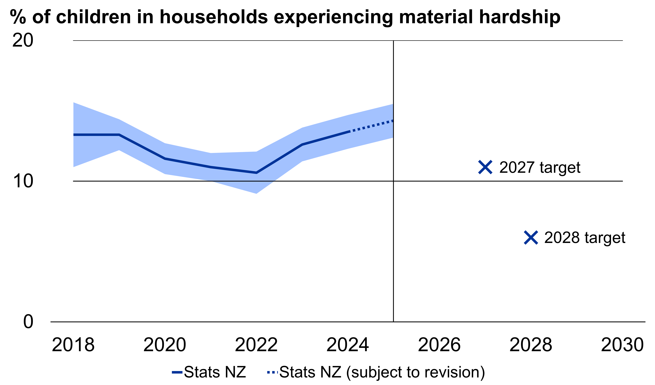
The Treasury’s model cannot estimate material hardship.

After-housing-costs, fixed-line measure (AHC50)
How many households have very low incomes relative to previous years, after considering housing costs and increases to the cost of living?
 | 2030
Projection | 17.8 per cent
Margin of error | ± 1.4 (percentage points)
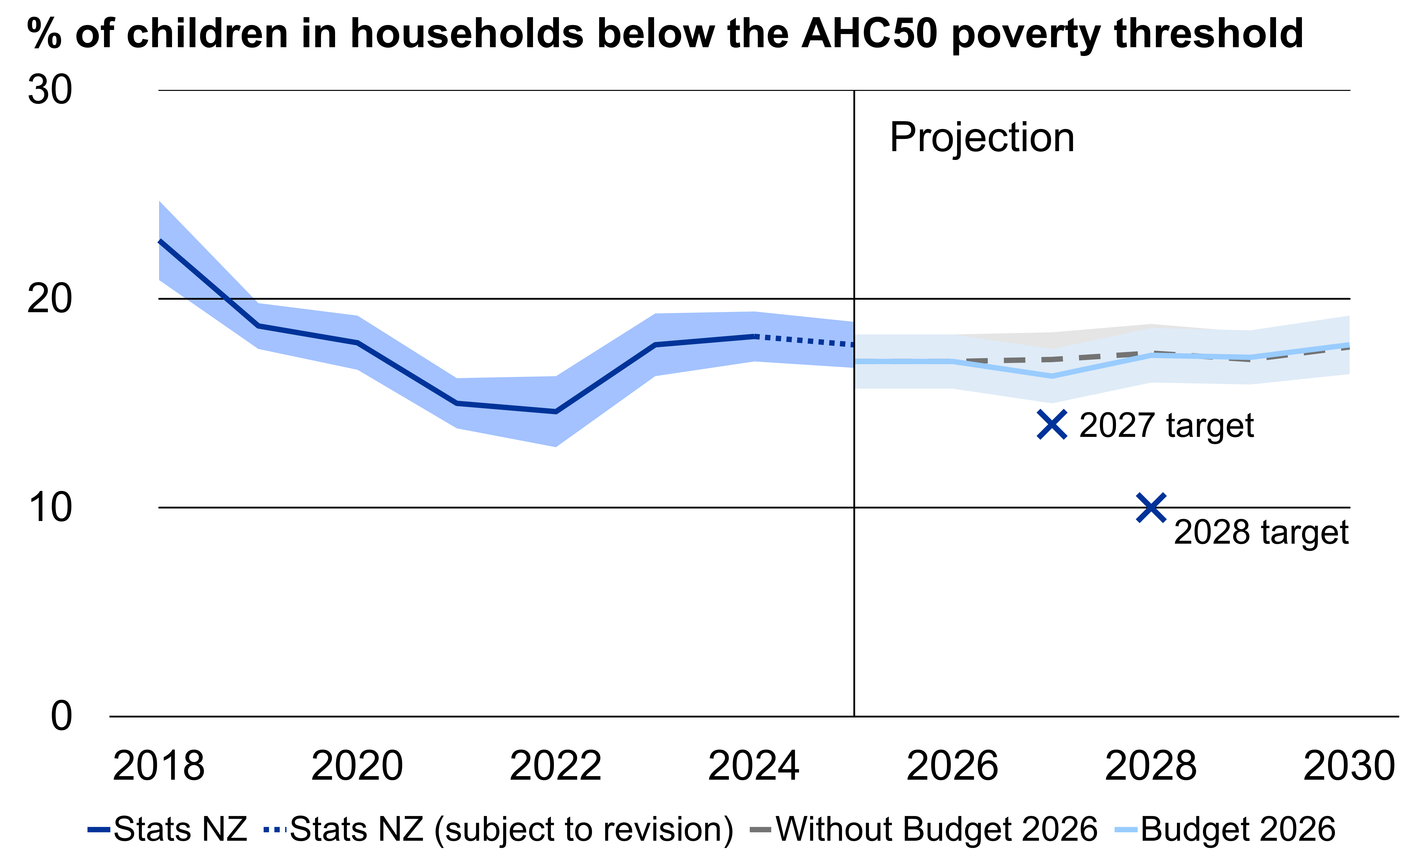

Before-housing-costs, moving-line measure (BHC50)
How many households have much lower incomes than middle-income households?
 | 2030
Projection | 12.6 per cent
Margin of error | ± 1.2 (percentage points)
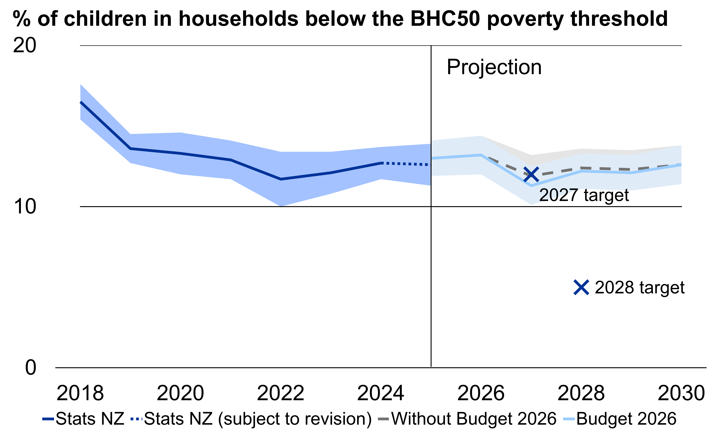

More information on each of the measures and targets can be found at https://www.msd.govt.nz/about-msd-and-our-work/child-wellbeing-and-poverty-reduction/child-poverty-reduction-measures-targets.html
More information can be found at https://www.stats.govt.nz/information-releases/child-poverty-statistics-year-ended-june-2025/
For modelling purposes, this increase is assumed to be in place until 31 March 2027.
There is a discontinuity between Treasury modelling and Stats NZ’s most recently reported child poverty statistics for 2025, because the 2025 statistics are subject to revision as updated Working for Families data become available over the next year, in line with standard practice.

