Game-informed MCDA decision-support report v0.9.0
Project: Primary care funding architecture in Australia and New Zealand
Focus: New Zealand upstream access, primary care, ambulance and hospital-pressure games
Version: v0.9.0
Status: Demonstrative decision-support layer; not empirically calibrated

Executive summary
This report adds a game-informed MCDA layer to the final hybrid model. The purpose is to help decision-makers evaluate whether the mapped games matter, how strongly each game contributes to the policy problem, and which policy options are most likely to move the system toward better equilibria.
The MCDA does not replace empirical modelling. It makes judgement explicit. It is designed for RACMA discussion, stakeholder workshops, policy option screening and validation planning.
The central thesis remains:
New Zealand may be managing primary care and ambulance activity so tightly that unmet need is channelled into hospitals by default.
The MCDA translates that thesis into two decision-support tools:
- Diagnostic game-position mapping: where does each game currently sit, and how important is it?
- Policy-option MCDA: which reform option best balances access, equity, hospital deflection, fiscal control, governance, market entry and feasibility?
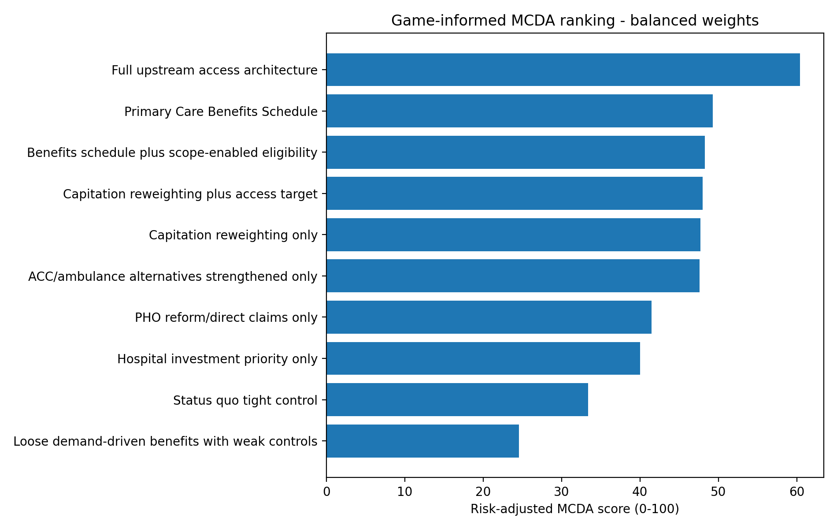
Default MCDA ranking

Why MCDA is useful here
This policy problem is not just a technical funding-design problem. It also involves values, risk tolerance, professional boundaries, equity, Te Tiriti legitimacy, rural resilience, fiscal exposure, data observability and political feasibility.
A pure model can show what follows from assumptions. MCDA shows which assumptions and values decision-makers are using.

Diagnostic game map
The highest-priority diagnostic games in the example scoring are:
game_id | game_name | current_equilibrium | better_equilibrium | priority_score_0_to_100
G11 | KPI salience game | hospital-target dominance | upstream target salience | 85.6
G14 | Data observability game | hidden-unmet-need equilibrium | observable upstream-flow equilibrium | 85.6
G1 | Hospital-salience budget game | hospital-rescue equilibrium | upstream-salience equilibrium | 80.2
G3 | Capitation marginal-supply game | marginal-rationing equilibrium | marginal-expansion equilibrium | 78.4
G7 | Ambulance conveyance game | ED-conveyance default | safe alternative-disposition equilibrium | 76.3
G8 | Scope-of-practice supply game | professional-bottleneck equilibrium | scope-enabled supply equilibrium | 73.4
G4 | Consumer access pathway game | delay/pay/ED substitution | early-access equilibrium | 71.2
G12 | Equity and trust game | transactional-access without trust | benefits plus equity-function equilibrium | 69.6
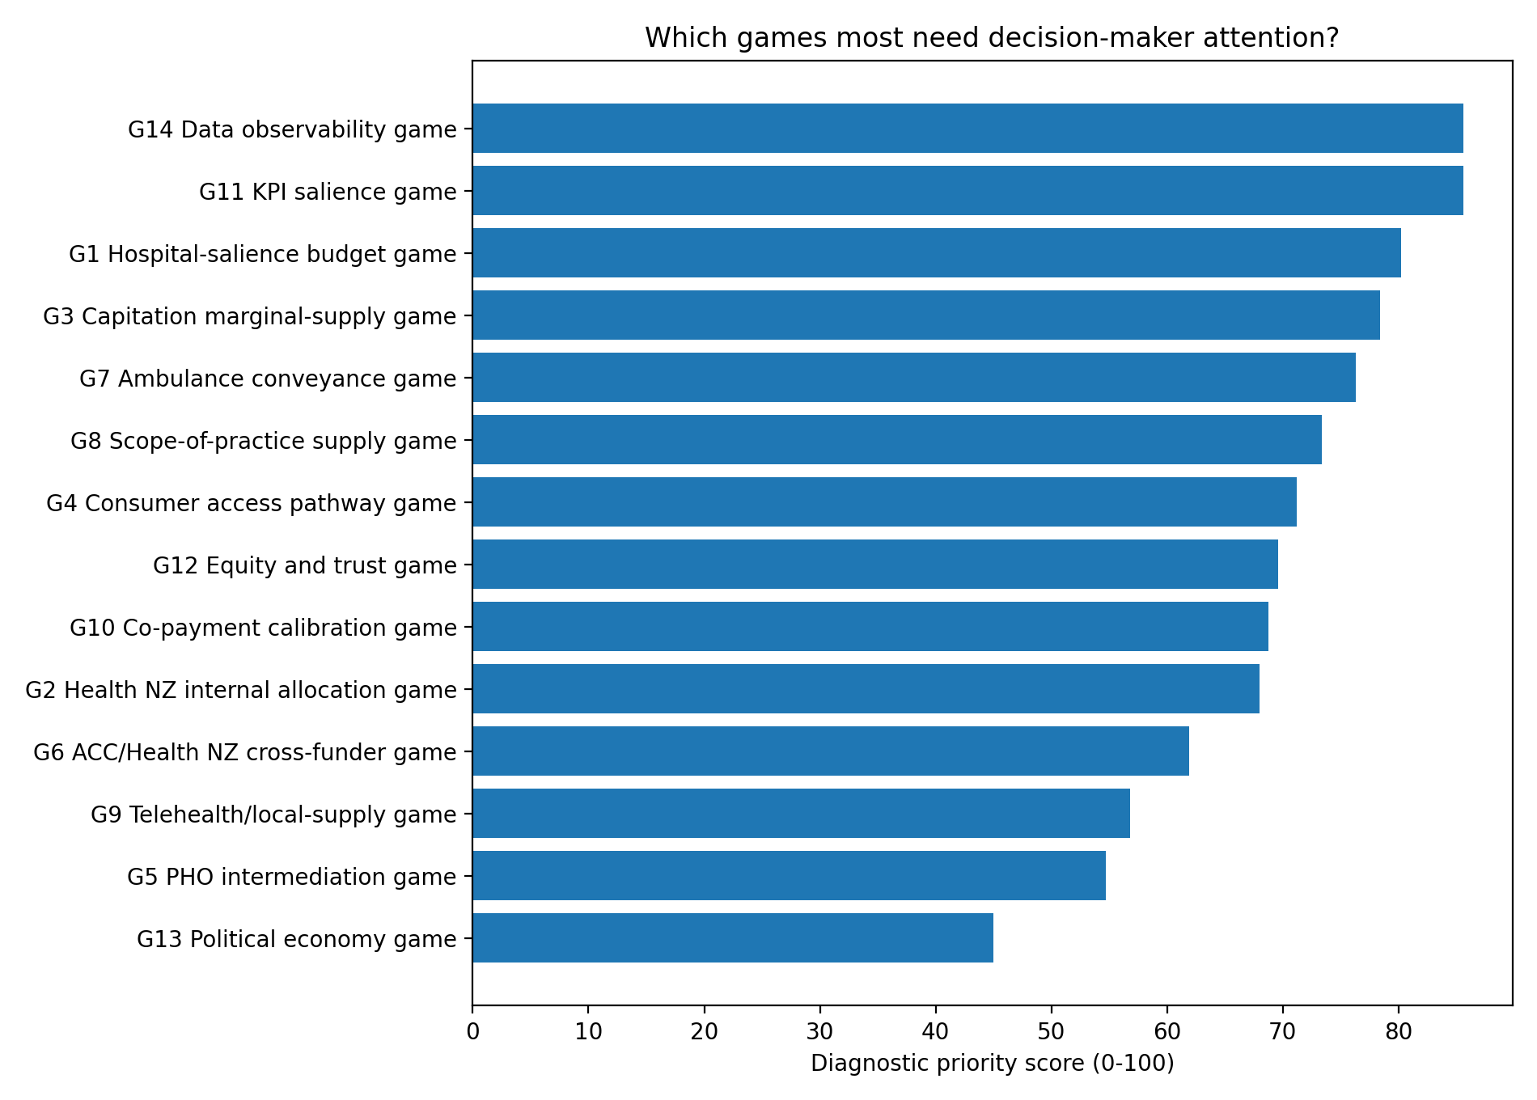
Diagnostic game priority
The diagnostic map suggests that KPI salience, data observability, hospital salience, capitation marginal supply, ambulance conveyance and scope-of-practice supply are especially important games to test and discuss.

Policy-option MCDA
The default MCDA criteria are:
criterion_id | criterion | default_weight | related_games
C1 | Access and supply generation | 14 | G3, G4, G8
C2 | Hospital deflection | 14 | G1, G2, G7
C3 | Equity and Te Tiriti legitimacy | 14 | G10, G12
C4 | Rural and in-person resilience | 9 | G7, G8, G9
C5 | Fiscal sustainability | 12 | G1, G2, G6, G10
C6 | Gaming and low-value activity risk | 10 | G3, G5, G10, G13
C7 | Administrative simplicity and market entry | 9 | G5, G8, G14
C8 | Governance and clinical safety | 10 | G8, G11, G14
C9 | Political feasibility | 5 | G5, G12, G13
C10 | Data and accountability readiness | 8 | G11, G14
The default policy options are:
option_id | option | mapped_scenario
O0 | Status quo tight control | S0
O1 | Capitation reweighting only | S1
O2 | Capitation reweighting plus access target | S1+target
O3 | Primary Care Benefits Schedule | S2
O4 | Benefits schedule plus scope-enabled eligibility | S2+scope
O5 | Full upstream access architecture | S3
O6 | Loose demand-driven benefits with weak controls | S4
O7 | ACC/ambulance alternatives strengthened only | partial
O8 | PHO reform/direct claims only | partial
O9 | Hospital investment priority only | hospital

Balanced-weight result
rank | option_id | option | weighted_total_before_penalty | risk_penalty | risk_adjusted_score
1 | O5 | Full upstream access architecture | 70.77 | 10.35 | 60.42
2 | O3 | Primary Care Benefits Schedule | 59.37 | 10.1 | 49.27
3 | O4 | Benefits schedule plus scope-enabled eligibility | 60.58 | 12.3 | 48.28
4 | O2 | Capitation reweighting plus access target | 54.5 | 6.5 | 48
5 | O1 | Capitation reweighting only | 52.89 | 5.2 | 47.69
6 | O7 | ACC/ambulance alternatives strengthened only | 55.78 | 8.2 | 47.58
7 | O8 | PHO reform/direct claims only | 53.72 | 12.25 | 41.47
8 | O9 | Hospital investment priority only | 48.04 | 8 | 40.04
9 | O0 | Status quo tight control | 40.9 | 7.5 | 33.4
10 | O6 | Loose demand-driven benefits with weak controls | 47.33 | 22.75 | 24.58
The full upstream access architecture ranks first in the demonstrative MCDA. The Primary Care Benefits Schedule ranks second. Benefits plus scope-enabled eligibility ranks third but is more heavily penalised for implementation and governance risk. Capitation reweighting and capitation reweighting plus an access target perform moderately: they improve allocation and visibility, but do not fully solve marginal supply.
Loose demand-driven benefits with weak controls rank last, despite scoring well on access. This is because the risk-adjustment layer penalises weak equity protections, weak data, weak governance, and high gaming/fiscal exposure.

Sensitivity across stakeholder weight sets
option | Balanced policy | Equity and Te Tiriti focused | Fiscal-control focused | Hospital-pressure focused | Market-entry focused | Rural access focused
ACC/ambulance alternatives strengthened only | 6 | 6 | 4 | 4 | 4 | 4
Benefits schedule plus scope-enabled eligibility | 3 | 5 | 6 | 3 | 3 | 2
Capitation reweighting only | 5 | 3 | 2 | 6 | 6 | 6
Capitation reweighting plus access target | 4 | 4 | 3 | 5 | 4 | 5
Full upstream access architecture | 1 | 1 | 1 | 1 | 1 | 1
Hospital investment priority only | 8 | 8 | 8 | 8 | 8 | 8
Loose demand-driven benefits with weak controls | 10 | 10 | 10 | 10 | 10 | 10
PHO reform/direct claims only | 7 | 7 | 7 | 7 | 7 | 7
Primary Care Benefits Schedule | 2 | 2 | 5 | 2 | 2 | 3
Status quo tight control | 9 | 9 | 9 | 9 | 9 | 9
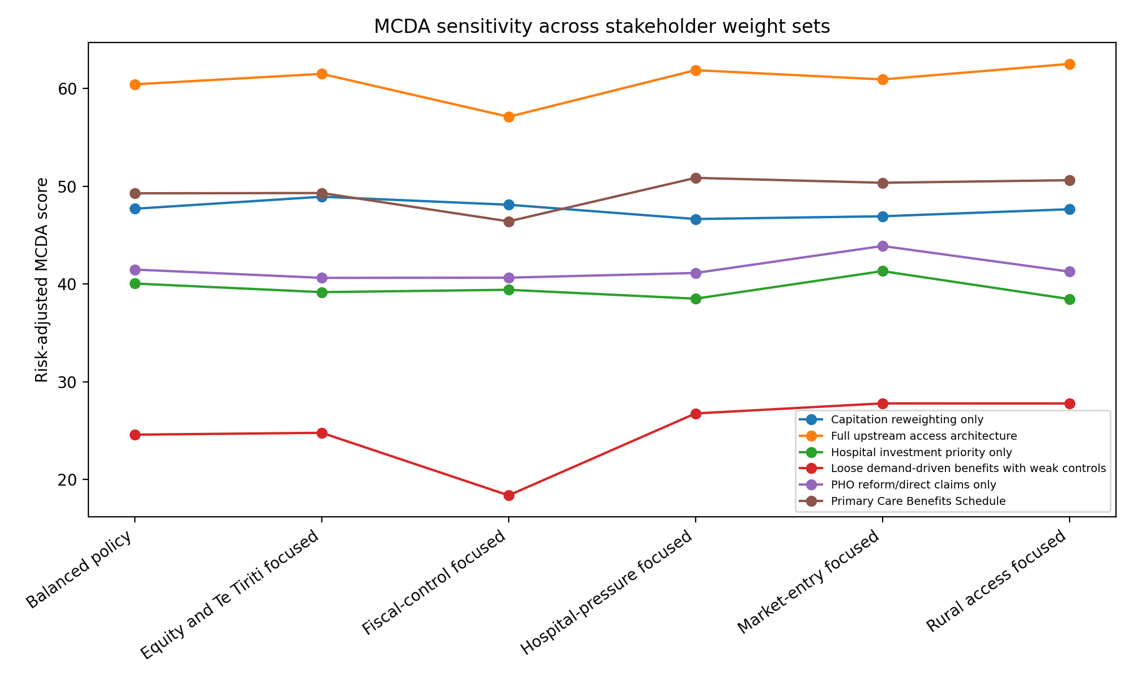
MCDA sensitivity across stakeholder weight sets
The ranking is not intended to force consensus. It is intended to show where the result is robust and where it depends on stakeholder values.

Interpretation
The MCDA supports a refined version of the policy thesis:
A demand-driven Primary Care Benefits Schedule may improve marginal supply and hospital-deflection logic, but it becomes a viable policy architecture only when paired with scope governance, equity protections, co-payment calibration, ambulance alternatives, direct/optional claiming, data observability and top-tier KPIs.
This can be expressed as:
Demand-driven within rules; not demand-driven without rules.

How to use this package
Use the MCDA in three ways:
- Internal RACMA discussion: test whether colleagues accept the game map and priority scores.
- Stakeholder workshop: compare group-specific scores and weight sets.
- Empirical validation planning: turn low-confidence, high-impact criteria into research tasks.

Audit status
This is a structured decision-support artefact. It is not proof of policy effectiveness. It should be updated after OIA responses, stakeholder validation, review findings, fiscal modelling and calibrated simulation.

Included artefacts
- MCDA framework.
- Game-position scoring rubric.
- Policy-option scoring rubric.
- Stakeholder workshop guide.
- Weighting methods note.
- Results interpretation guide.
- Criteria, option, scorecard and weight-set CSVs.
- Blank scoring templates.
- Executable MCDA model.
- Example figures and workbook.

