Primary care funding architecture: pragmatic validation package
v1.1.0 - 8 May 2026
Purpose: proceed with stakeholder validation, rapid review, OIA/data requests, targeted empirical checks and pilot design, without attempting a fully calibrated predictive model at this stage.

1. Executive summary
The project should now proceed as a validation and translation programme rather than a full national predictive modelling programme. The current model is source-informed and parameterised, but it remains demonstrative. That is sufficient for policy scoping, RACMA discussion, stakeholder engagement, Substack publication and an NZMJ Viewpoint or methods/protocol article.
A fully calibrated predictive model becomes necessary only if decision-makers require quantified forecasts of ED presentations, hospital admissions, costs, savings, supply effects or implementation business-case outcomes.
The immediate work should therefore focus on validating the games, exposing disagreements, making funding flows observable and testing the five most load-bearing assumptions.

2. Evidence threshold by output
output | minimum_evidence_needed | current_status | do_not_claim
Substack series | Public evidence + transparent theory + caveats | Ready | Quantified forecast, fiscal savings, proven causation
RACMA discussion paper | Game map + audit trail + source-informed demonstrative model + validation plan | Ready | Policy is proven or implementation-ready
Policy brief for sector/political audience | Public evidence + options analysis + model caveats + stakeholder validation plan | Ready with caveats | Guaranteed hospital demand reduction
NZMJ Viewpoint | Conceptual/theoretical argument + policy context + transparent limitations | Ready | Empirical predictive results
NZMJ methods/protocol article | Model structure + audit + standards crosswalk + validation pathway | Ready | Empirically calibrated impact estimates
Government business case | Stakeholder validation + targeted empirical checks + fiscal modelling/pilot results | Not ready | Budget-neutrality or savings
Implementation advice | Pilot/evaluation evidence + operational design + data governance + equity review | Not ready | System can implement without unintended effects
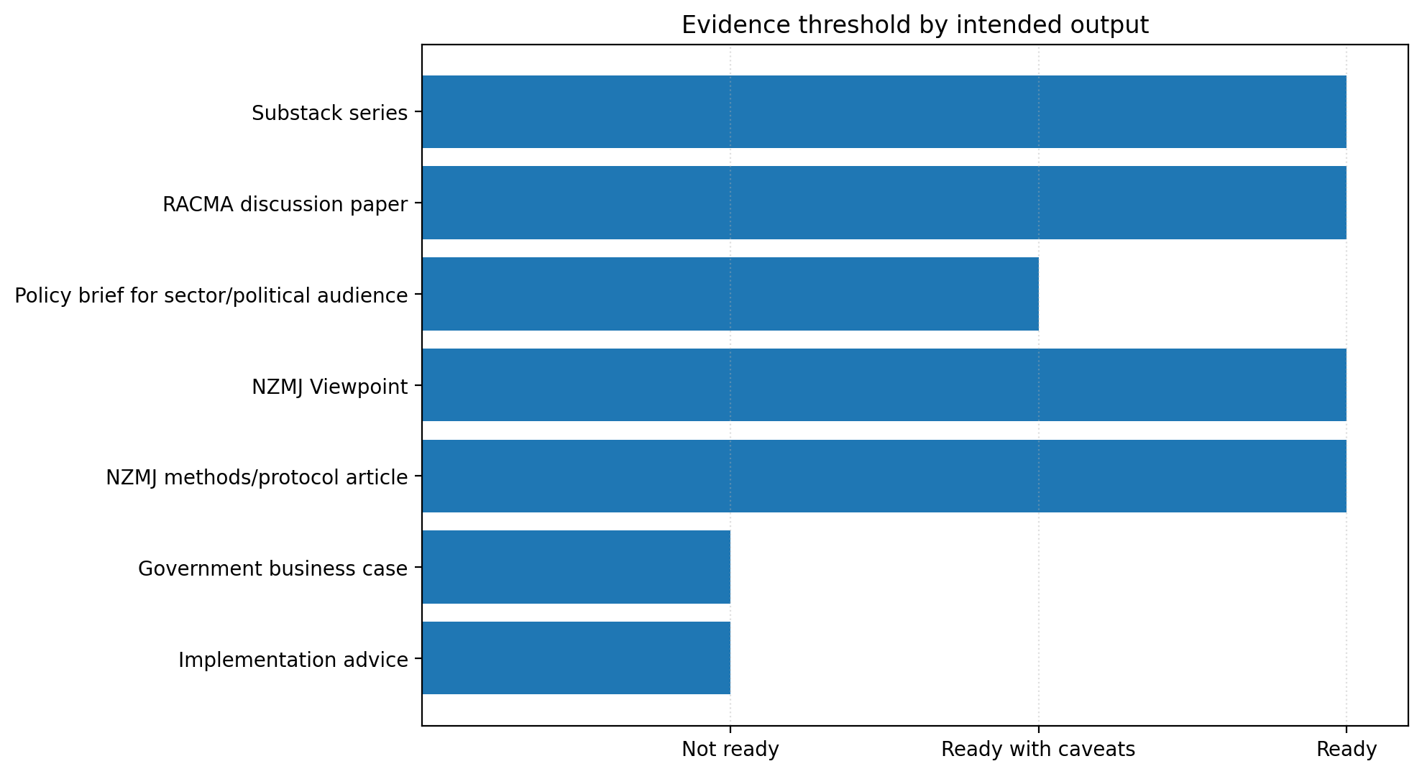

3. Priority empirical checks
These five assumptions carry the greatest decision weight. They should be tested before a national implementation business case, but they do not need to be fully resolved before public or professional policy discussion begins.
priority_rank | parameter | why_it_matters | proposed_method | decision_use
1 | Marginal supply response to contact-based payment | Determines whether a Primary Care Benefits Schedule expands safe upstream activity rather than simply redistributing existing demand. | Practice-level panel analysis; before-after comparison where payment/activity settings vary; stakeholder validation of capacity response. | Whether to proceed with benefits schedule design and which contact types to include first.
2 | Unmet primary care to ED/ambulance/hospital conversion | Tests the core wood-from-trees hypothesis that constrained upstream access channels demand into higher-cost hospital pathways. | Linked longitudinal cohort; time-to-event or hazard models linking access delay/unmet need to ED, ambulance, admissions and re-presentations. | Whether upstream funding expansion plausibly deflects hospital demand.
3 | ACC activity funding stabilisation effect | Tests whether ACC fee-for-service and treatment payments are mitigating wider primary care supply failure. | Practice-level revenue-mix analysis; compare practices/regions with different ACC revenue shares; sensitivity to ACC payment changes. | Whether ACC treatment-payment policy should be assessed whole-of-system, not in isolation.
4 | PHO intermediation transaction-cost / entry-barrier effect | Determines whether PHO reform should focus on function redesign, direct claims, transparency, or abolition/optionalisation. | Mixed-methods analysis: PHO financial-flow audit, onboarding timelines, provider interviews, comparison of PHO pass-through and support functions. | Whether to separate PHO value-adding functions from payment-gateway functions.
5 | Scope-enabled provider supply and safety | Tests whether pharmacists, NPs, nurses, allied health and paramedics can safely generate additional contact activity under scope-based benefits. | Pilot evaluation by contact type and provider type; safety audit; re-presentation and escalation analysis; patient experience. | Which contact types can be provider-neutral, which require GP/NP governance, and where patient choice is safe.
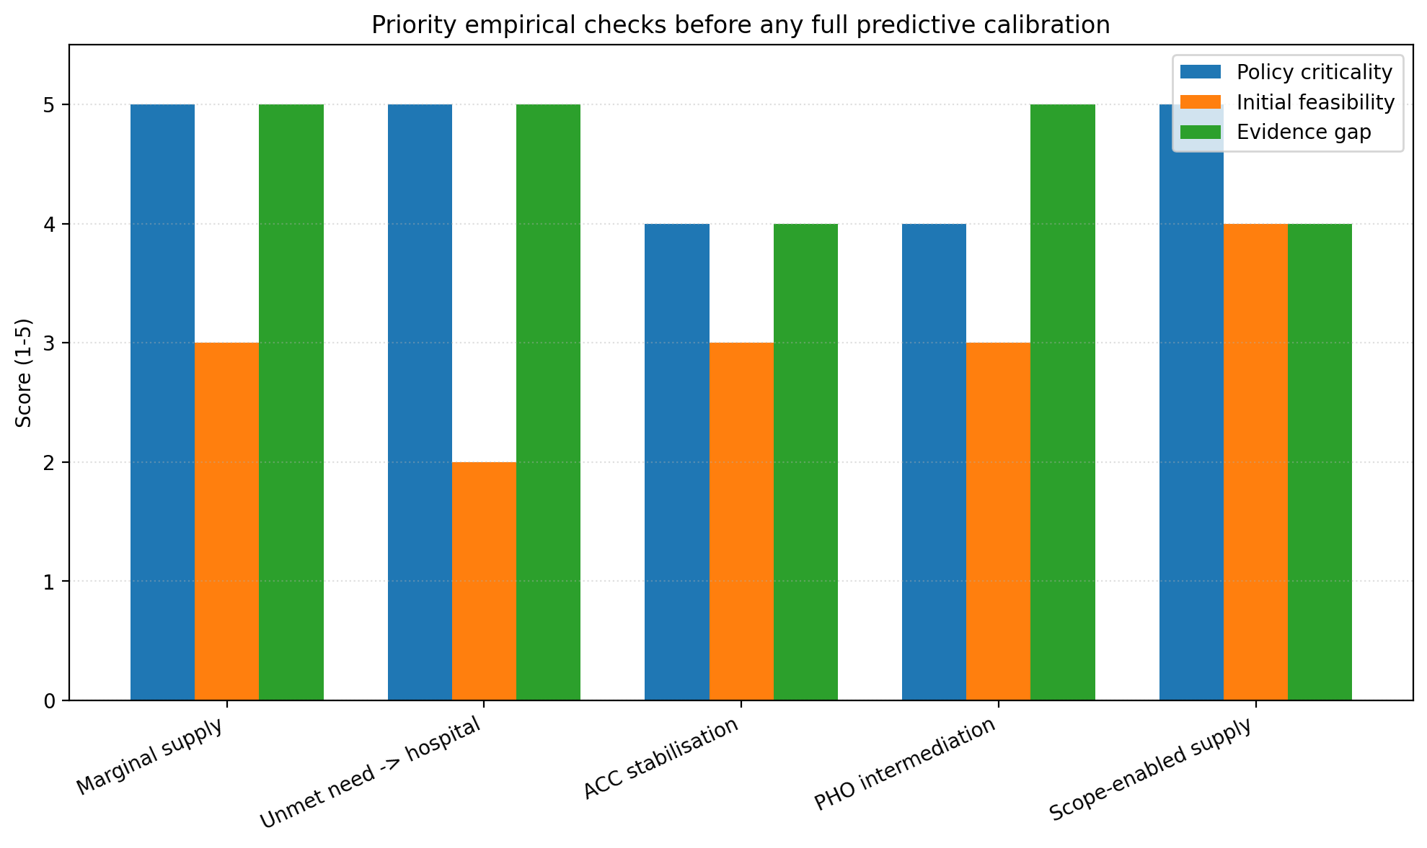

4. Pragmatic validation pathway
phase | timeframe | workstream | activities | outputs
1 | Weeks 1-2 | Policy synthesis | Finalize narrative, limitations, stakeholder-ready artefacts, evidence threshold matrix. | Validation and translation report; one-page brief; Substack synthesis.
2 | Weeks 2-4 | Stakeholder MCDA preparation | Recruit groups; circulate game map; prepare workshop pack; test scoring instrument. | Workshop pack; scoring workbook; participant briefing.
3 | Weeks 3-6 | OIA/data requests | Submit OIA requests for capitation formula, PHO advice, NPCD data elements, ambulance and ACC data. | OIA tracker; source update log; request copies.
4 | Weeks 4-8 | Rapid scoping review | Register protocol internally; run searches; screen studies; extract mechanisms; evidence map. | PRISMA-ScR evidence map; review memo; source matrix.
5 | Weeks 6-10 | Stakeholder validation | Run workshops/interviews; analyse agreement/disagreement; update game map and MCDA weights. | Stakeholder validation report; revised MCDA.
6 | Weeks 8-12 | Targeted empirical checks | Assess feasibility of five priority parameters; negotiate data access; prepare pilot protocols. | Data readiness report; empirical check protocols.
7 | Months 3-6 | Prospective pilot design | Choose pilot contact types and sites; define KPIs; governance; evaluation protocol. | Pilot evaluation plan and implementation-ready measurement framework.
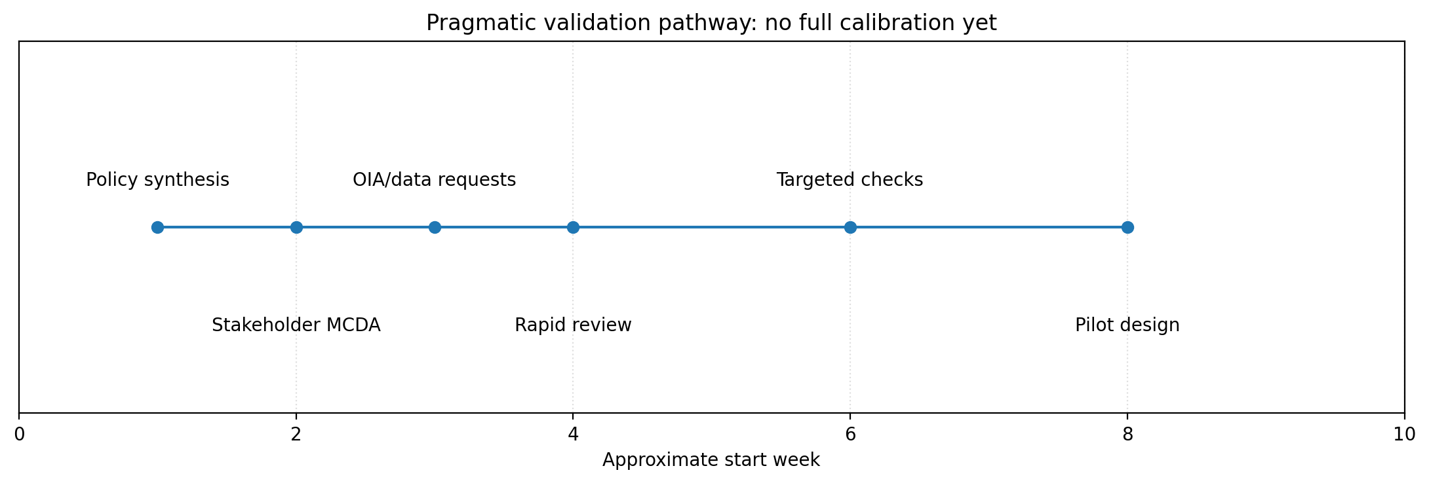

5. Stakeholder validation and MCDA
The highest-value next step is stakeholder validation. The game-informed MCDA should not be treated as proof. It is a deliberative decision-support method that makes assumptions, values, disagreement and risk tolerance explicit.
Suggested stakeholder groups include general practice, nurse practitioners, nurses, pharmacists, physiotherapists, mental health providers, paramedics, rural providers, kaupapa Maori and Pacific providers, PHOs/localities, Health NZ, ACC, ambulance leaders, Treasury/fiscal observers and consumer advocates.
Each game should be scored for reality, harm, hospital-growth contribution, equity relevance, tractability, reform risk and confidence. Policy options should then be scored against access/supply, hospital deflection, equity, rural resilience, fiscal control, gaming risk, market entry, clinical governance, political feasibility and data readiness.

6. OIA and data requests
request_id | agency | request_title | purpose | status
OIA01 | Ministry of Health | Current capitation formula, rate tables and implementation model | Make the funding architecture reproducible and auditable. | Draft
OIA02 | Ministry of Health | PHO roles, functions and options for change advice H2025067082 | Understand unreleased advice on PHO remit/function and options for change. | Draft
OIA03 | Health New Zealand | Primary care payment flows, PHO pass-through and provider onboarding | Test PHO intermediation and transaction-cost hypotheses. | Draft
OIA04 | Health New Zealand | National Primary Care Dataset metadata and aggregate access data | Prepare stakeholder validation and future empirical checks using NPCD fields. | Draft
OIA05 | Health New Zealand / Ambulance Team | Ambulance conveyance, alternative disposition and handover indicators | Test ambulance as upstream access infrastructure and hospital-deflection lever. | Draft
OIA06 | ACC | ACC primary care treatment payments by provider type and region | Test whether ACC activity payments stabilise primary care supply. | Draft
The OIA pack in this release contains draft request text for each item. The priority is not to obtain every dataset immediately, but to establish which funding and data flows are observable, which are withheld, and which would require formal research agreements.

7. Rapid scoping review
The rapid review should be PRISMA-ScR aligned and should map mechanisms rather than only outcomes. The key question is: what evidence exists that funding architecture affects access, marginal supply, market entry, equity, ambulance/urgent-care pathways and hospital demand?
The review should produce an evidence map linked to the 14 games and the five priority assumptions.

8. Prospective pilot/evaluation design
pilot_domain | pilot_question | primary_outcomes | design
Benefits schedule contact types | Can defined contact benefits expand safe upstream care? | Encounter volume, 7-day access, same-day urgent access, re-presentation, patient fee burden | Stepped-wedge or matched comparison; prospective process evaluation
Scope-enabled providers | Which provider types safely generate additional activity within scope? | Completed contacts, GP substitution, escalation, safety events, patient experience | Contact-type pilot with clinical governance and safety audit
Ambulance alternatives | Do funded alternatives reduce ED conveyance without unsafe re-presentation? | Non-conveyance, ED presentation within 72h/7d, response times, patient satisfaction | Interrupted time series or controlled before-after
Direct claims / PHO optionality | Do direct claims reduce transaction cost and entry barriers? | Onboarding time, payment lag, administrative cost, claim rejection, patient access | Process evaluation plus comparative implementation study
The pilot pathway should test contact types, provider scope, ambulance alternatives, direct claiming and equity protections before any national-scale implementation. A stepped-wedge or matched comparison design is preferable where feasible.

9. Recommended language
Preferred formulation: The current work is a structured, source-informed and falsifiable policy hypothesis. It is sufficient to open the policy conversation and design validation. It is not yet a calibrated estimate of effect size.
Avoid claiming: quantified ED reduction, fiscal savings, proven PHO causation, or definitive market failure without targeted empirical evidence.

10. Source anchors
SRC01 - Ministry of Health capitation reweighting: https://www.health.govt.nz/strategies-initiatives/programmes-and-initiatives/primary-and-community-health-care/capitation-reweighting
SRC02 - Cabinet paper: Primary Health Care Funding Improvements: https://www.health.govt.nz/system/files/2025-07/Cabinet%20paper%20-%20Primary%20Health%20Care%20Funding%20Improvements%20Redacted.pdf
SRC03 - Health NZ National Primary Care Dataset and health target: https://www.healthnz.govt.nz/about-us/what-we-do/planning-and-performance/primary-care-tactical-action-plan/national-primary-care-dataset-and-new-primary-care-health-target
SRC04 - Ministry of Health PHO finances briefing H2025069314: https://www.health.govt.nz/system/files/2025-11/H2025069314-Briefing-PHO-finances-a-summary-of-available-information.pdf
SRC05 - NZ Health Survey 2024/25 annual update: https://www.health.govt.nz/publications/annual-update-of-key-results-202425-new-zealand-health-survey
SRC06 - Closed books study - PubMed abstract: https://pubmed.ncbi.nlm.nih.gov/38452229/
SRC07 - ACC provider payment page: https://www.acc.co.nz/for-providers/invoicing-us/paying-patient-treatment
SRC08 - Health NZ Ambulance Team: https://www.healthnz.govt.nz/about-us/what-we-do/programmes-and-initiatives/the-ambulance-team
SRC09 - Health NZ emergency ambulance national performance reports: https://www.healthnz.govt.nz/publications/emergency-ambulance-service-national-performance-reports-2025
SRC10 - Ministry of Health OIA requests page: https://www.health.govt.nz/about-us/contact-us/oia-requests
SRC11 - PRISMA-ScR: https://www.prisma-statement.org/scoping
SRC12 - ISPOR MCDA introduction: https://www.ispor.org/heor-resources/good-practices/article/multiple-criteria-decision-analysis-for-health-care-decision-making---an-introduction
SRC13 - STRESS guidelines: https://www.equator-network.org/reporting-guidelines/strengthening-the-reporting-of-empirical-simulation-studies-introducing-the-stress-guidelines/

