1. The useful question is who should invest—and why
The exact five-configuration model now distinguishes health-system resources from CHHHS resource exposure, conditional government allocations and family expenditure/time. The extension is an early cost–consequence and investment-threshold analysis, not a validated cost-utility analysis. All strategy effects remain conditional on transported evidence and stated assumptions. [M7]
Portfolio | Panda mean net/year | 95% prior interval | P(saving)
Pilot (3) | $4,252 | −$38,979 to $66,225 | 50.5%
CHHHS (10) | $5,721 | −$117,413 to $181,668 | 46.3%
CHHHS + TCHHS (14) | −$6,773 | −$142,826 to $187,193 | 39.2%
Illustrative state (33) | $304,308 | −$828,871 to $1,913,200 | 65.6%
The extra regional locations incur readiness costs even where few or no consultations are credited. That is a conservative scenario, not evidence that clinical need is absent. Reference values do not establish a universal preference for a camera. Prototype equivalence is unproven; current established-option results exclude the kit. [R7; M7]
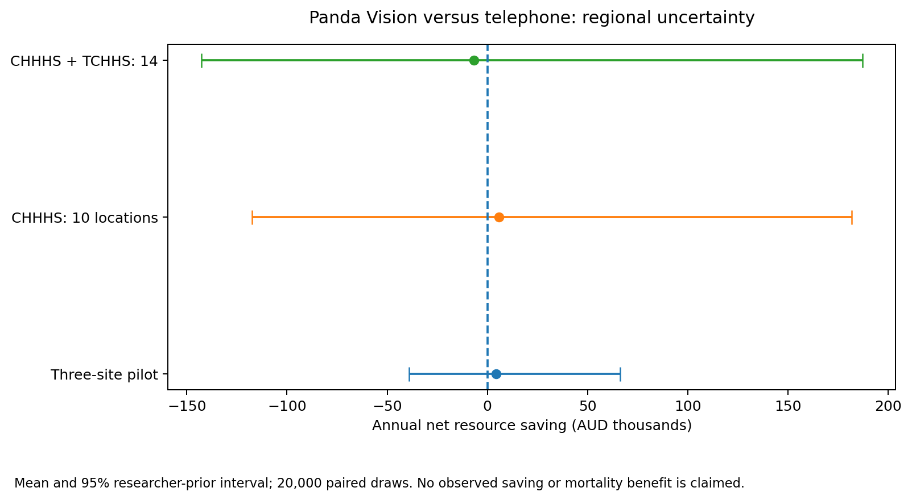

2. Regional coverage: hospitals are not all clinical outposts
The CHHHS scenario includes ten named hospital/emergency locations; adding the four TCHHS hospitals creates fourteen. Community and primary-health centres are outside this inventory. Local eligibility, capability and referral routes are not certified. Historical birth counts are retained without silently treating missing counts as observed zeros. [CHHHS_DIR; TCHHS_DIR; QH2022]
Location | HHS | 2022 births | Model role
Cairns | CHHHS | 2223 | birth/referral
Atherton | CHHHS | 157 | birthing
Mareeba | CHHHS | 134 | birthing
Innisfail | CHHHS | 195 | birthing
Tully | CHHHS | Not in table | readiness scenario
Mossman | CHHHS | 6 | readiness scenario
Babinda | CHHHS | Not in table | readiness scenario
Gordonvale | CHHHS | Not in table | readiness scenario
Herberton | CHHHS | Not in table | readiness scenario
Yarrabah Emergency Service | CHHHS | 8 | readiness scenario
Cooktown | TCHHS | 6 | reopened birthing
Weipa | TCHHS | Not in table | reopened birthing
Thursday Island | TCHHS | 89 | birthing
Bamaga | TCHHS | 1 | readiness scenario
Cooktown resumed birthing on 14 September 2026 after its February 2022 suspension. Weipa resumed in May 2024 and reported 32 births in 2025. The reopened scenario uses Weipa 32 plus an explicitly assumed Cooktown 50/year; neither is silently merged into the common-year 2022 denominator. A separate Cairns-referral-only scenario removes its originating consultation cohort while retaining readiness. [COOKTOWN26; WEIPA2026]
Readiness-only locations are modelling candidates, not approved deployment sites. Adding one hypothetical consultation per readiness location tests incident exposure without manufacturing an observed birth rate.

3. Six views, one reconciled resource ledger
View | Included / interpretation
Health system | Incremental programme, local/receiving care and retrieval resources across providers.
Bounded societal | Health resources plus the existing family travel/time aggregate. Not complete lifetime education, disability, informal-care or environmental accounting.
CHHHS provider | Local hospital/workflow/capital resources; assumed retrieval payer and receiving share for the regional catchment. Before unverified grants, revenue and inter-HHS settlements.
Patient / family | Incremental nonmedical out-of-pocket travel after hypothetical subsidy, plus opportunity time. No treatment benefit or individual preferences have been estimated.
Commonwealth | Incremental funding response, zero in fixed-funding reference. This does not mean total Commonwealth funding is zero.
Queensland state | Residual allocated resource/funding burden plus subsidy; not a literal cash-budget forecast.
Signed incremental costs reconcile as state + Commonwealth + patient/family = bounded societal. CHHHS is nested inside the system and is not added again. Subsidies and intergovernmental transfers cancel on aggregation. Family travel excludes resources already counted in the retrieval bill; its time component must not be added again as a productivity loss. [M7]
NHRA 2026–31 clause A36 gives minimum input-rate floors, beginning at 40.5% in 2026–27. Prior-rate rules, eligible streams, caps and block funding also matter. Applying 40.5% mechanically to a marginal episode is not justified; the model uses that coefficient only in an explicitly uncapped sensitivity. QWAU/QEP inputs remain missing, not invented. [NHRA26; QHFUND26]
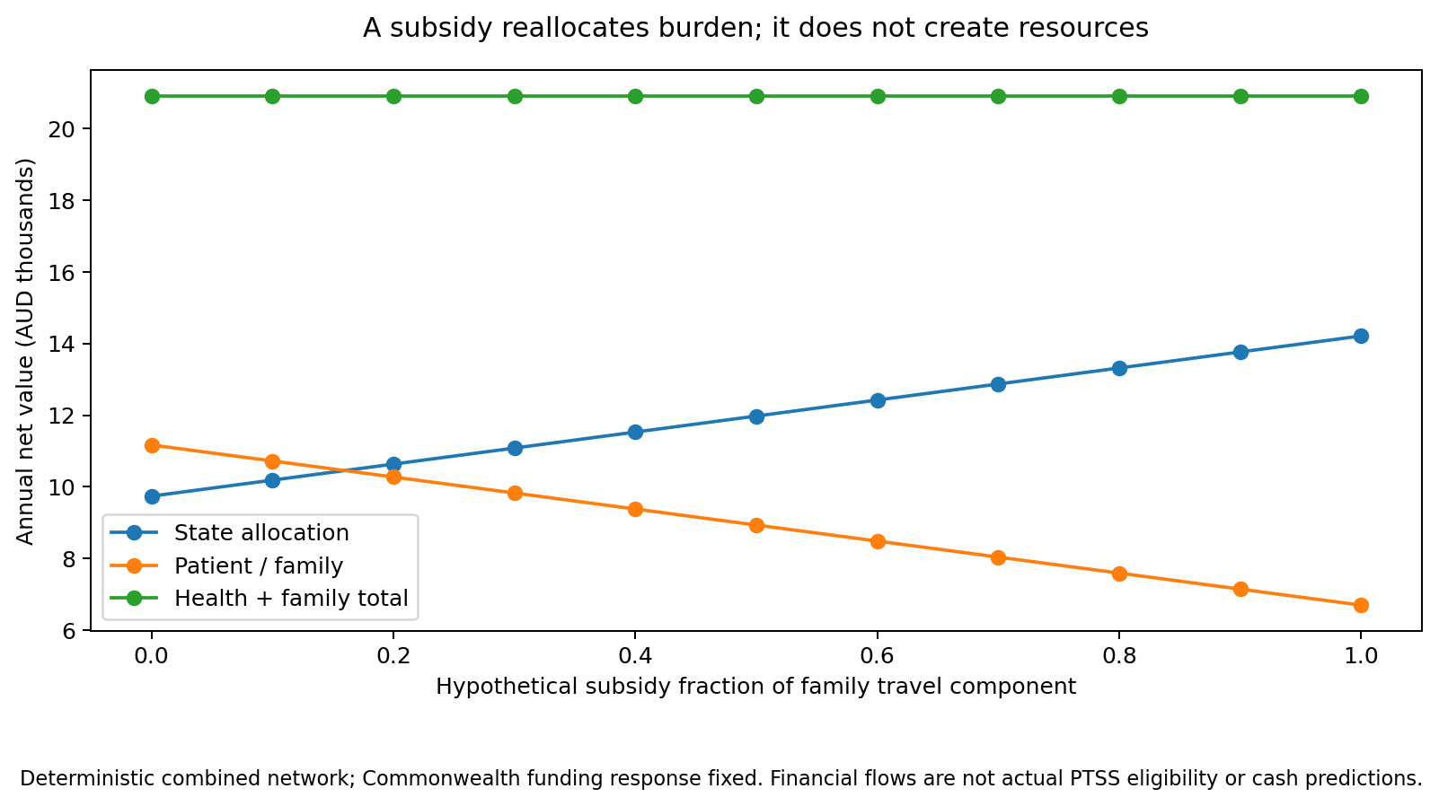

4. Value of perspective is decision regret, not a bonus
The inspected vop_poc_nz contract defines current-information directional regret: select one expected-value-optimal strategy under perspective p, then evaluate that fixed decision under q. The comparison is max E[value under q] minus E[value under q for the p-selected decision]. It is not the mean of per-draw optimal choices, and network-year values must not be multiplied by population again. [VOP]
Expected-value ties are split transparently, with tie-specific bounds retained. A Commonwealth zero-response ledger is indifferent among all strategies; the lottery is an explicit tie rule, not a clinical recommendation. Patient-cost ties likewise do not demonstrate device equivalence.
Pilot (3): when CHHHS is allocated local costs but no receiving/retrieval benefit, its expected-cost choice is telephone rather than the societal-choice kit. Directional societal regret is $12,737 per network-year. This is an allocation stress test, not an observed contract effect.
CHHHS (10): when CHHHS is allocated local costs but no receiving/retrieval benefit, its expected-cost choice is telephone rather than the societal-choice kit. Directional societal regret is $31,995 per network-year. This is an allocation stress test, not an observed contract effect.
CHHHS + TCHHS (14): when CHHHS is allocated local costs but no receiving/retrieval benefit, its expected-cost choice is telephone rather than the societal-choice kit. Directional societal regret is $26,049 per network-year. This is an allocation stress test, not an observed contract effect.
Reference provider and societal expected choices coincide, giving zero directional regret for that comparison. The main heatmap excludes patient and Commonwealth tie lotteries; all six-view results and tie bounds remain in the tables. The model does not tune assumptions to force a positive value of perspective.
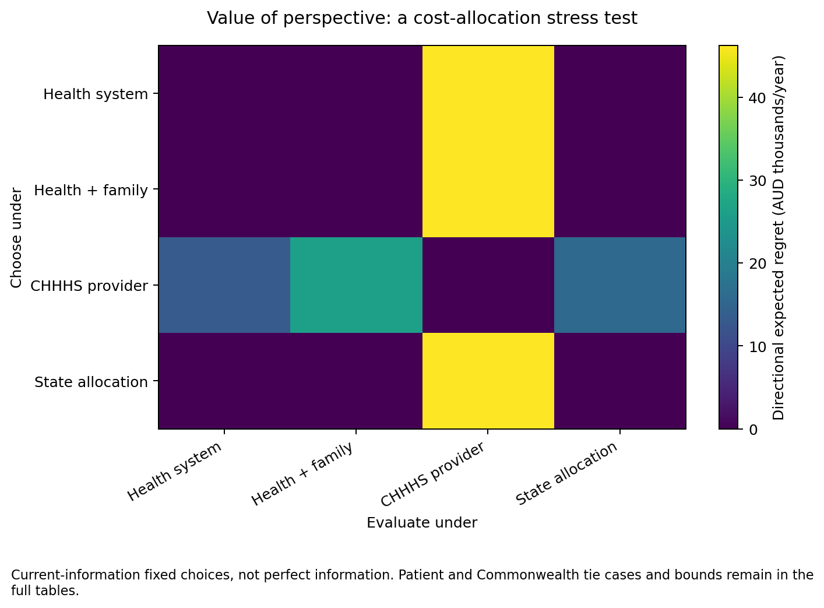

5. Parameter choices, distributions and fitting were audited
The field register covers 49 retained/new fields, including six historical parameters retired from active costing. A companion method register exposes additional hard-coded priors, activity factors, transport ratios and health-bridge assumptions. Source verification is not synonymous with empirical identification: the 4–5 Atherton cases do not supply a complete denominator or treatment-effect likelihood. No local hierarchical model, survival model or posterior was fitted. Forecast consultations are treated as distinct clinical episodes; repeated calls per infant remain an unresolved workload/denominator issue. [A7]
Input class | Choice and limitation
Transfer effect | Observational OR 0.48; log-effect halved in reference, with extra transportability SD 0.35. The unattenuated alternative still retains transportability uncertainty.
Baseline transfer / casemix | Beta and Dirichlet precision 20 are judgement, not sample sizes. Critical transfer probability 0.98 is assumed and receives no avoidance credit.
Probability scenarios | Non-reference beta means now use mean × concentration parameters. Scaling/clipping was repaired to avoid artificial mass at one. Reference v6 draws remain unchanged.
Triangular cost inputs | Central values are modes, not means. For example equipment $8k/$10k/$15k has mean $11k. These bounds are not confidence intervals.
Air resource anchor | Indexed historical point is a lognormal median. Mode multipliers and avoidable fractions remain assumptions, not neonatal tariffs.
Hospital prototypes | NEP26 Appendix H selected inlier weights; no actual patient grouping, outlier calculation or full NWAU is claimed.
Family / fiscal allocations | Travel/time shares, subsidy, receiving share and funding-response coefficients are scenario quantities, not observed payment rules.
Systematic effect and cost draws remain common across sites and alternatives. The 44 paired PSA structures, exact allocation grids and bounded health bridges are different designs; grid frequencies are not probabilities. No new machine-learning classifier is required to evaluate this inexpensive exact model.
The full audit includes fixed inputs and retired parameters, with source IDs, distribution parameters, assumptions and remaining verification needs. Four core economic/effect papers remain full-text access gaps.

6. HRQoL inputs can inform thresholds—not prove benefit
EPICure2 compared extremely preterm children (≤26 weeks, England 2006 cohort) with term-born classmates at age 11. The article body and selected Table 4 rows were reviewed. Parent-proxy reports and adult tariffs, attrition and control selection limit transportability. A Victorian cohort provides relevant Australian corroboration, but its abstract reports different instruments/median contrasts and was not pooled numerically. [EPICURE2; VICS2021]
Measure | EP mean / control mean | Adjusted decrement
HUI2 UK statistical inference | 0.789 / 0.930 | 0.13 (95% CI 0.09–0.18)
HUI3 Canadian tariff | 0.685 / 0.947 | 0.28 (95% CI 0.18–0.37)
These are alternative age-11 cohort contrasts, not video-treatment effects or interchangeable utilities. Video does not prevent prematurity. The 54 bridge scenarios start at age 11, discount back to birth and apply assumed durations and improved fractions only to show the possible order of magnitude; they do not estimate clinical effectiveness. A source row with inconsistent parsed confidence bounds was excluded.
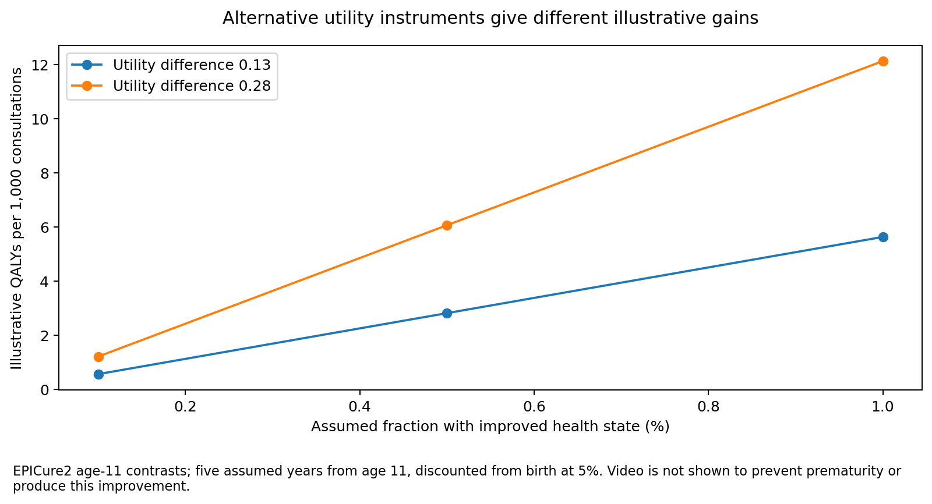
QALYs require preference-weighted survival over time. DALYs require condition/sequela-specific YLL and YLD inputs. Disability weights are not one minus utility; QALYs and DALYs must not be added. AIHW burden definitions are registered, but no local neonatal DALY result is calibrated. [AIHW_ABDS]

7. The health gain required can be made explicit
When transfer rates do not improve, the programme may still be worthwhile through better care. A threshold analysis asks how much additional health would be needed at a stated hypothetical valuation. It does not fill the evidence gap by assuming that benefit occurred. [M7]
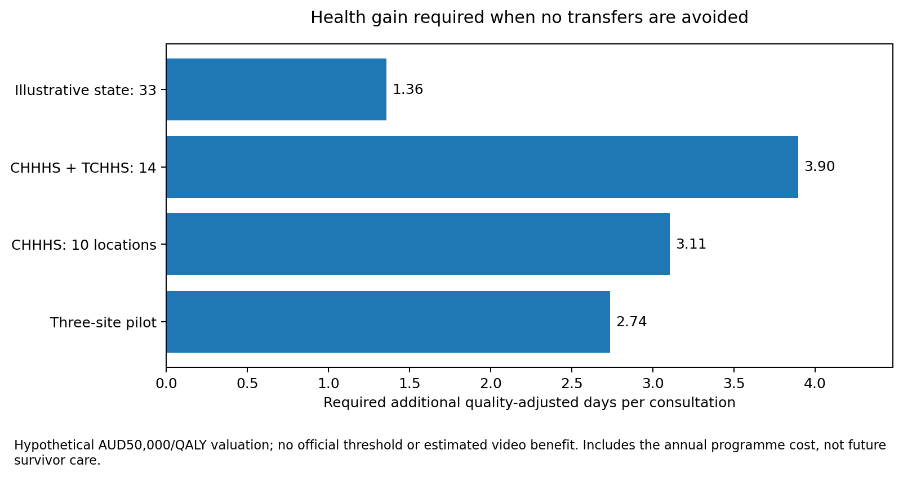
Portfolio | Annual cost, null transfer effect | Required QALYs | QALY-days / call
Pilot (3) | $14,052 | 0.281 | 2.74
CHHHS (10) | $45,487 | 0.910 | 3.11
CHHHS + TCHHS (14) | $61,029 | 1.221 | 3.90
Illustrative state (33) | $207,222 | 4.144 | 1.36
AUD 30,000, AUD 50,000 and AUD 100,000 per QALY are scenario valuations, not official Australian thresholds. These figures exclude any additional future care cost among extra survivors. The earlier survival-with-morbidity frontier remains exploratory and archived, not part of the primary estimated benefit.
The next useful health-outcome evidence would link earlier treatment/stabilisation to morbidity or survival in a comparable clinical subgroup. Without that link, precise utilities do not make a causal QALY model valid.

8. Simulated reviews found and resolved concrete issues
Simulated reviewer | Finding and disposition
Clinical / regional | Preserved missing birth counts; added reopened/readiness/Cairns-role alternatives; did not label all primary clinics covered or certify device suitability.
Economics / perspectives | Separated funding transfers and nested provider costs. Repaired catchment allocation and retained capital only at the three known pilot installations, not all regional locations.
Statistics / evidence | Repaired non-reference clipped beta distributions; distinguished means/modes and likelihood-free priors; retained null/harm structures and explicit utility transportability.
Software / security | Current receipts no longer overwrite v6. Source redirects are checked before requests. Ordinary tests disable shared-host plugin autoload; full unavailable checks remain blocked.
These are sequential role-based reviews by the same assistant. No independent agents, professional reviewer sign-offs or simulated run identifiers are fabricated. The panel is a structured self-review, useful for exposing gaps but insufficient to claim independent validation. [V7]
New behavioural repairs were reproduced in failing tests, then rerun after implementation. Exact cohort and perspective-ledger residuals are below numerical tolerance. Historical inputs and v6 default results are preserved; source abstractions and new assumptions are separately versioned.
AdViSHE/TECH-VER/ISPOR domains remain a status map, not certification. Open items are current capability/routing, local invoices and marginal costs, critical full texts, independent clinical/economic review and a reproducible connected release environment. The reviewer record contains detailed scope, findings and adjudication.

9. Privacy, security and source archiving have limits
The private repository saves supplied original corporate templates, a selected two-page ELC pricing excerpt, IHACPA and NHRA numeric transcriptions, HRQoL table abstractions, regional reading notes and a source registry. SHA256 hashes and sizes describe actual stored files. A transcription is not the original XLSX or PDF. [S7]
The original public NEP PDF/XLSX, NHRA PDF and perinatal PDF downloads failed on DNS. Their URLs and failed retrieval receipts are retained. The opt-in fetcher is allowlisted, HTTPS-only, bounded in size, validates file signatures and checks redirects before following them. No successful original download is implied by an installed script.
No patient-level data were added. The full 541-page ELC pack is not copied into this version’s source archive. Corporate materials and the restricted excerpt are not authorised for public redistribution. A public research release must exclude them and check each source licence.
Actual Gitleaks, strict lint/type/property/mutation/profiler/prose tools and hosted CI remain unverified when unavailable. A bounded redacted text scan found no matching secret patterns in its scope; that is not a Gitleaks pass, full-history scan or assurance that every binary is safe. Full dependency-lock and transitive-policy checks remain blocked without a genuine resolved environment.
The core remains NumPy plus standard-library CSV; Polars is the only permitted DataFrame engine. No pandas/xarray project import was introduced. Numerical analysis does not need another orchestration framework. The prior optional machine-learning stack remains historical rather than part of the new perspective kernel.
All automation is explicit and local unless authorised otherwise. No GitHub push, journal submission, cloud code upload or deployment was performed. The final assurance receipt records actual command outcomes and supersedes earlier execution claims.

10. Source and reproducibility map
M7 / R7 / A7 / V7 — outputs/v7/*.csv; src/pathways_v6.py; src/perspectives_v7.py; src/portfolios_v7.py; evidence/v7/parameter_audit.csv; docs/validation/v7/simulated_panel.md.
VOP — edithatogo/vop_poc_nz, perspective.py, commit ad84d3090a2d97f2805a86e94a7b9614a3d1ab14. Fixed expected-choice contract 1.1.0; inspected through GitHub, package not imported.
EPICURE2 — Achana et al. Paediatr Perinat Epidemiol.2022;36:696–705. DOI10.1111/ppe.12906; PMID35830294; PMC9543967. Article body reviewed; supplementary files not acquired.
VICS2021 — Peart et al. ADC Fetal Neonatal.2021;106:425–429. DOI10.1136/archdischild-2020-320582; PMID33597226. Abstract only.
NEP26 — IHACPA. National Efficient Price Determination2026–27.11March2026. Appendix H, physical PDF pp.82–83; NEP$7,418. Source-file retrieval incomplete.
NHRA26 — Australian governments. NHRA2026–31 consolidated addendum, clauses A35–A40; minimum input-rate table p.27. Floors do not define a marginal episode-payment model.
QH2022 — Queensland Perinatal Statistics2022, Chapter 8, table 8.09. Common-year denominator, not current service capability.
CHHHS_DIR / TCHHS_DIR — Official hospital and health-centre directories. Fourteen hospital/emergency scenarios do not enumerate every community or primary-care site.
COOKTOWN26 / WEIPA2026 — Queensland Health Cooktown birthing-return report,9October2026; TCHHS Weipa fifty-birth milestone,11February2026. Reopening years remain separate.
AIHW_ABDS — AIHW. Australian Burden of Disease Study2024, definitions/summary. National burden does not establish intervention-attributable health gain.
S7 — sources/source_register.csv; sources/manifest.json; sources/retrieval_receipts.json. Read the representation and rights fields before reuse.
Critical retained evidence — Haynes2020, Armfield2012, Yoo2022 and Thao2022 remain subject to full-text verification. Lietz2026, Maddox2021 and Fox2024 full-body review status is retained fromv6.
Regeneration: scripts/analyse_v7.py; scripts/plot_v7.py; scripts/build_workbook_v7.py; scripts/build_documents_v7.py. The workbook is a results export; its formulas reconcile totals but do not rerun PSA. Conductor identifies active files, assumptions, executed checks and unresolved gates.

