1. The question is configuration and investment timing
Compare five complete services: telephone advice, mobile teleconference, Panda Vision, fixed ceiling/wall pan–tilt–zoom (PTZ), and a proposed tablet/OBSBOT kit. Consultation occurs in all arms. This extends, rather than replaces, the original pilot and Queensland model. The existing Panda deterministic and paired probabilistic results are numerically unchanged. [M5]
Configuration | Installed capital/site | Evidence boundary
Telephone | $0 incremental | Existing telephone consultation remains; not zero healthcare cost
Mobile teleconference | $45,000 | ELC indicative comparator; actual purchase/share unverified
Panda Vision | $10,000 | ELC and user estimate; invoices/components not checked
Ceiling/wall PTZ | $47,000 | ELC comparator; room coverage and suitability site-dependent
Tablet + OBSBOT kit | $4,500 reference | $2,500–$10,000 range; $7,500 scenario; no supplier quote
OBSBOT is a camera brand/component, not a separate clinical intervention by itself. The fifth arm includes the tablet, mount, power, integration, support and approved workflow. It is not priced at the ELC’s camera-only $349. Reference video effects and usable-connection probabilities are identical as an explicit hypothesis—not established equivalence. [ELC2026; M5]
Three distinct decisions are analysed: acquire new equipment; retain an installed system; and attribute shared equipment costs to neonatal activity. Existing equipment removes sunk purchase expenditure only for that arm. Cross-use attribution does not reduce the full cash procurement bill. Hypothetical fixed-unit sharing may be infeasible and must be checked locally.
All five arms are retained in conceptual comparisons, with separate eligibility-restricted results excluding the proposed kit. No ranking supplies biomedical, privacy, cyber, cleaning or clinical-governance approval.

2. Exact model, inputs and evidentiary limits
The annual cohort has low-, moderate- and critical-acuity pathways. Critical cases receive no transfer-avoidance credit. Connection failure returns to telephone; retained patients may later need rescue. Shared effect/cost draws preserve systematic uncertainty across arms and sites. Incremental resource consequences, family costs and cash expenditure remain separate. [M2; M5]
Local activity remains 10–15 video consultations per site/year (37.5 across three sites at midpoint); 4–5 episodes occurred at Atherton. Historical 2022 births are 157, 134 and 195 at Atherton, Mareeba and Innisfail. The 65-site public roster and illustrative 33-spoke portfolio are not a verified 2026 capability census. No new patient-level dataset was collected.
The primary clinical effect is an attenuated observational transfer odds ratio, with published, sceptical and null alternatives. No device-specific clinical effect is estimated from the four-to-five pilot episodes. Published economic evaluations provide model precedents, not independent clinical replications. A new full-text systematic review has not been completed. [HAY2020; ARM2012; THAO2022; YOO2022; LIETZ2026]
The indexed public air-retrieval anchor is not a neonatal marginal tariff. Transport mix, avoidable fractions and net downstream costs retain their uncertainty. NEP26 = $7,418; current QEP/local QWAU adjustments remain unverified. Resource saving is not automatically cash released, reduced funding or additional health. Original source/parameter registers are retained in the repository.
Assumption group | Deterministic range / treatment
Clinical transfer OR | 0.35–1.30; no-effect/increased-transfer possibilities
Activity | 5–25 calls/pilot site/year for sensitivity, not measured incidence
Marginal resources / hospital delta | 10–100%; hospital delta −$4,000 to +$10,000
Life / critical share | 3–7 years; critical 5–40%
Usable video / workflow | 80–100% established; 70–100% prototype; $0–$175/call
Prototype kit / shared capital | Kit $2,500–$10,000; 5–100% attribution, not procurement discount
The sensitivity space is a bounded researcher-defined design. It is neither an empirical distribution of Queensland hospitals nor a posterior distribution of clinical outcomes.

3. Five-arm probabilistic comparison
Pilot: new equipment | Mean saving/year | 95% uncertainty interval | P(cost-optimal)
telephone | $0 | $0 to $0 | 46.1%
mobile | −$24,909 | −$71,035 to $39,796 | 0.0%
panda | $2,428 | −$41,148 to $65,642 | 0.0%
fixed | −$26,471 | −$72,830 to $38,287 | 0.0%
obsbot | $6,724 | −$36,715 to $69,770 | 53.9%
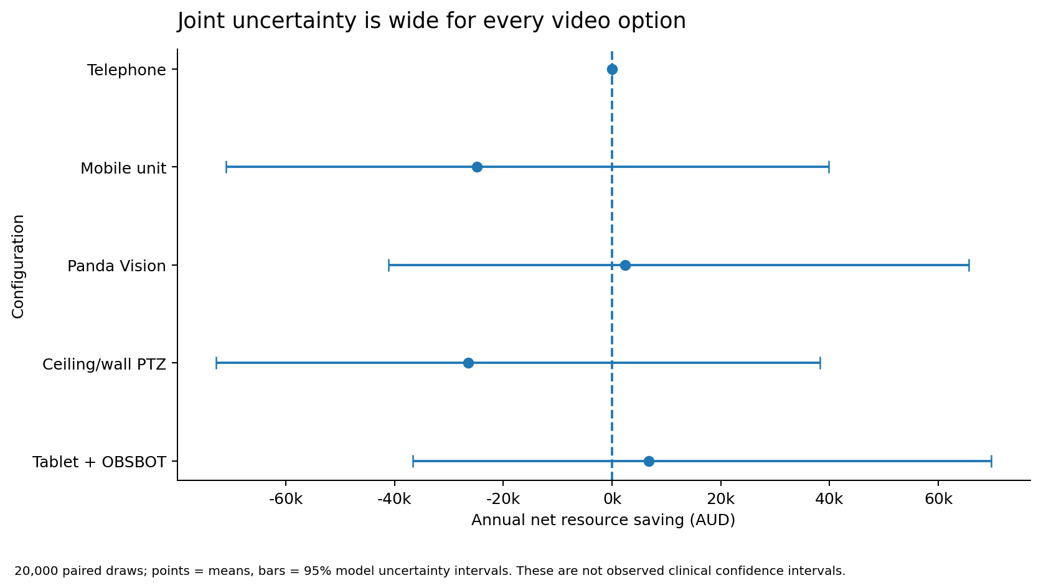
Under equal video effects, delivery and support, the cheaper proposed kit is mechanically preferred to the more expensive video options. That finding is conditional on a complete clinically acceptable configuration costing the assumed amount. Panda’s 46.0% probability of saving versus telephone is different from its zero probability of being the cheapest among these five in this particular structure. [M5]

4. Incumbency and prototype uncertainty reverse choices
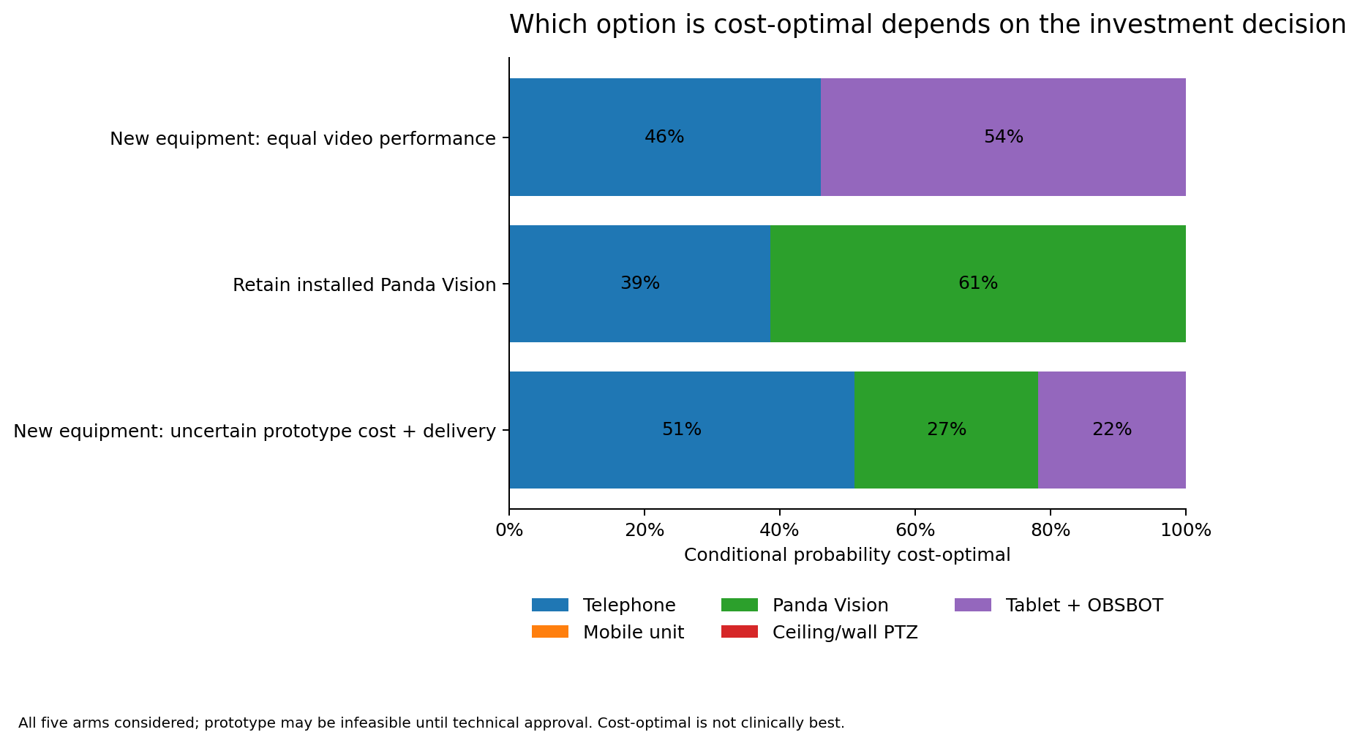
Retaining installed Panda yields mean annual resource saving $10,238 and 61.4% probability of being cost-optimal. Buying a new kit instead retains its purchase cost; switching does not make the new hardware free. The same reasoning applies to an already-owned mobile or fixed system.
A separate structural PSA assigns the kit uncertain installed cost (triangular $2,500/$4,500/$10,000, with common cost inflation) and uncertain delivery relative to the established system (triangular 0.65/0.95/1.0). These are explicit analyst priors. Pilot probabilities are telephone 51.0%, Panda 27.2%, kit 21.8%; kit has the slightly greater expected saving ($3,295 versus $2,428). Most likely optimal and greatest expected value are not the same statistic.
In the illustrative 33-site network under that prototype uncertainty, Panda has the greatest expected resource saving ($135,429 versus $107,582 for the kit). These are not probabilities of superior clinical care.
Cost-only annual EVPI is $6,179 for the pilot in the reference new-purchase structure. This is the expected loss from uncertainty under that objective and decision set, not a recommended research budget or a lifetime health-value estimate. Expected regret and all pairwise distributions are supplied.

5. One-way sensitivity and exact decision surfaces
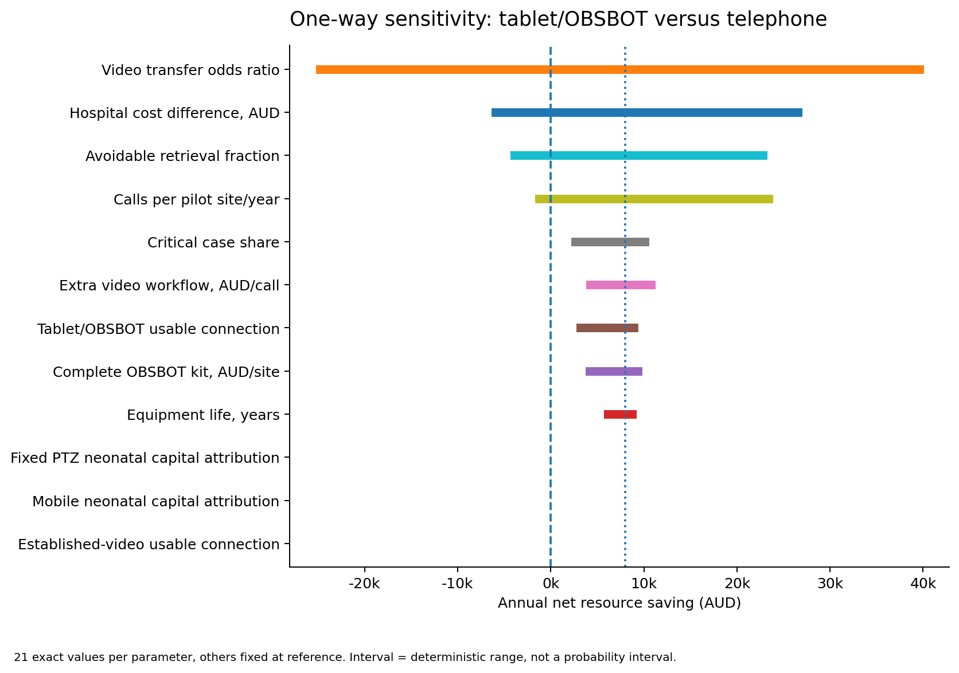
Twelve dimensions are varied over 21 points for both pilot and state portfolios: 2,520 arm-level rows. The strongest single-arm drivers include clinical effect, hospital-resource difference and the avoidable retrieval fraction. Other inputs are held at reference. These endpoints are not a 95% interval.
Four complete two-way pairs are evaluated at 31 × 31 points in both portfolios (7,688 design points): activity × effect; prototype cost × reliability; mobile capital attribution × prototype reliability; and equipment life × avoidable resources. Every plotted winner is obtained from the exact five-arm model.

6. Prototype price and delivery are not interchangeable
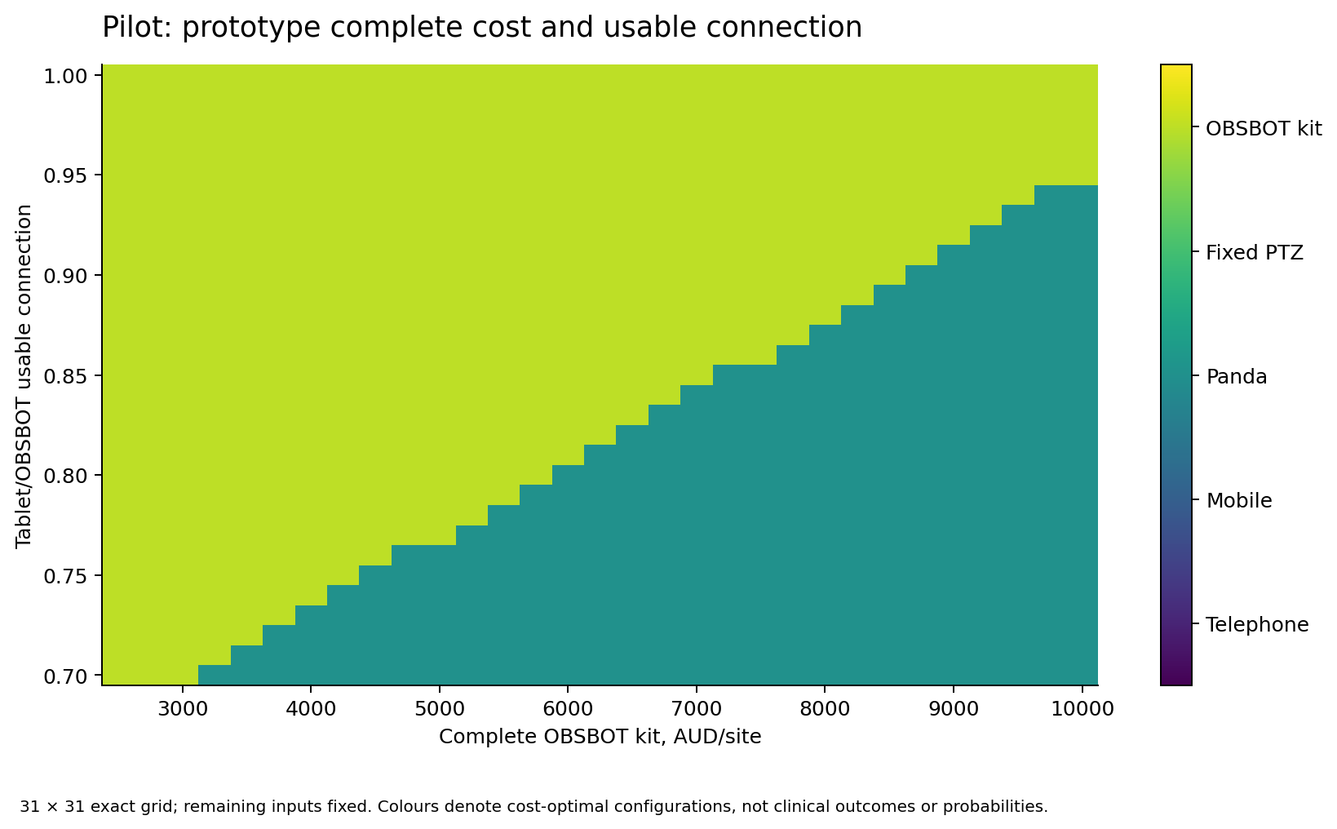
A low purchase cost is not enough if effective delivery falls. Conversely, a technically equivalent lower-cost complete kit can be preferred for new investment. These thresholds make validation questions explicit without pretending that a prototype has demonstrated equivalence.
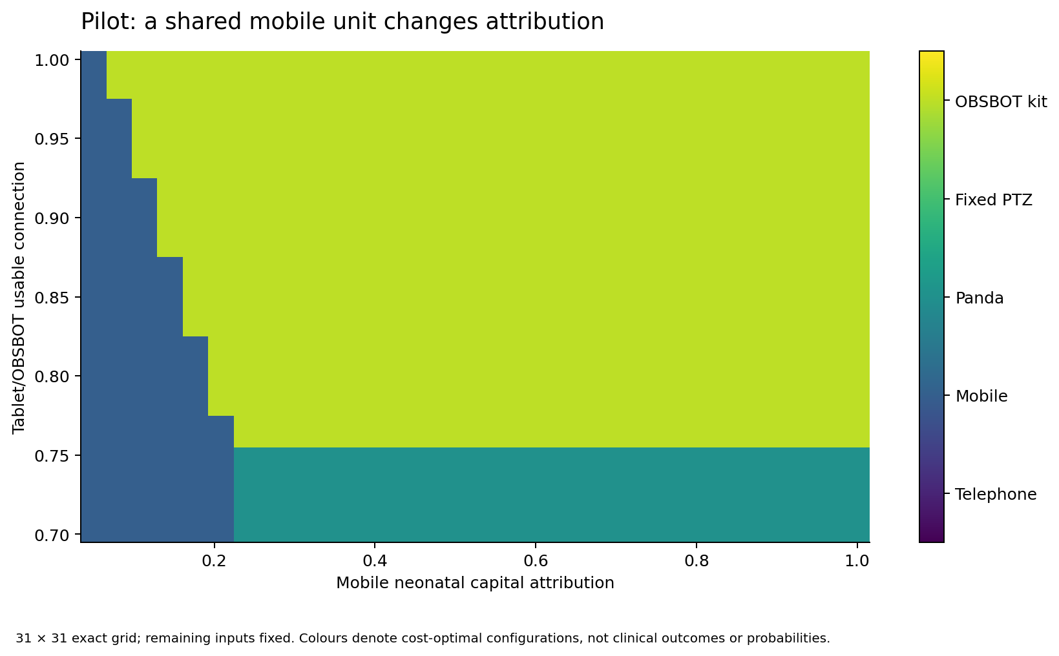
Shared-unit attribution can make a mobile configuration economically attractive. This applies only where use by other services and the attribution method are defensible; it does not reduce the total purchase payment.

7. Joint deterministic and variance-based sensitivity
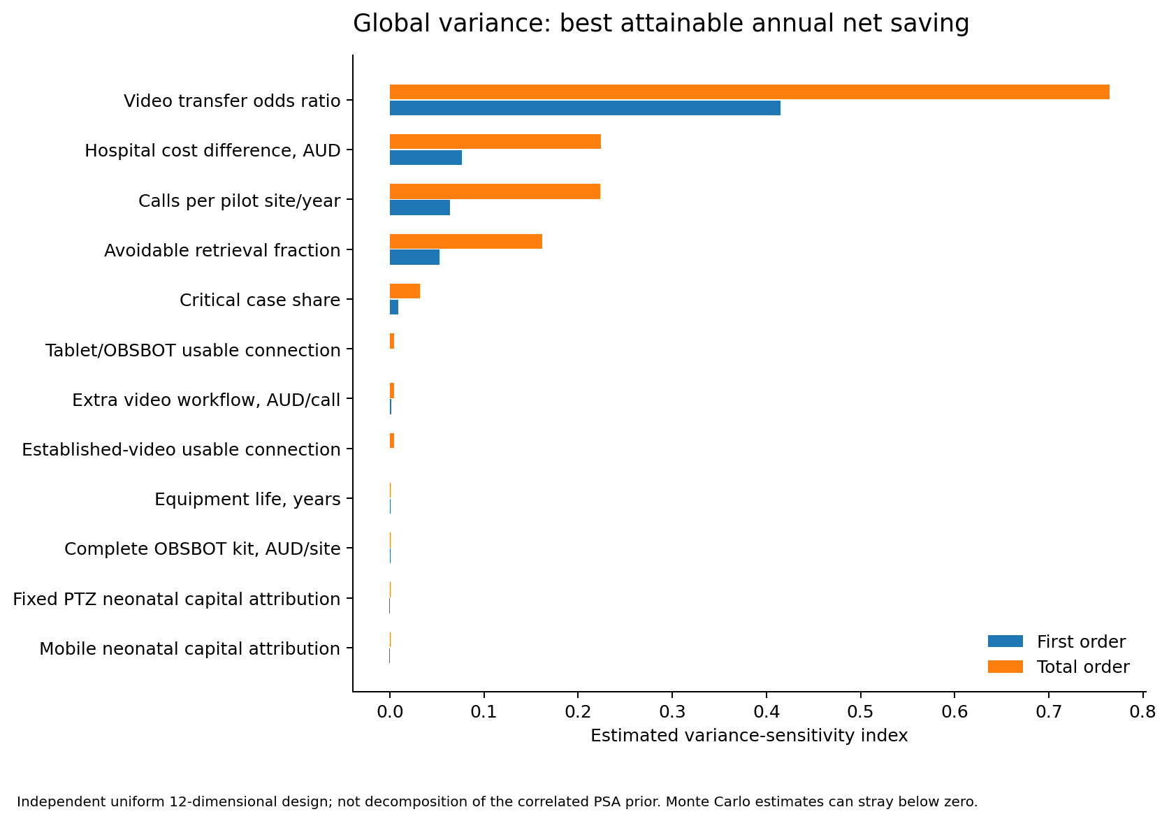
The independent 12-dimensional design uses 8,192 training, 2,048 selection and 4,096 fresh holdout points. Separate Sobol decompositions use base sizes 2,048 and 4,096: 86,016 model design evaluations across six outcomes. First-order and total-order estimates distinguish direct variation and interactions within the assumed independent uniform ranges. This is not a decomposition of the correlated clinical PSA prior. [SOBOL]
The five most influential decision coordinates on the selection sample drive a complete 5⁵ = 3,125-point grid: effect, hospital difference, avoidable fraction and fixed/mobile capital attribution. A separately prespecified 7⁴ = 2,401-point equipment grid varies kit cost, kit delivery, utilisation and effect. All grid outcomes are exact; their frequencies are design coverage, not probabilities.

8. Unsupervised then supervised analysis: useful limits
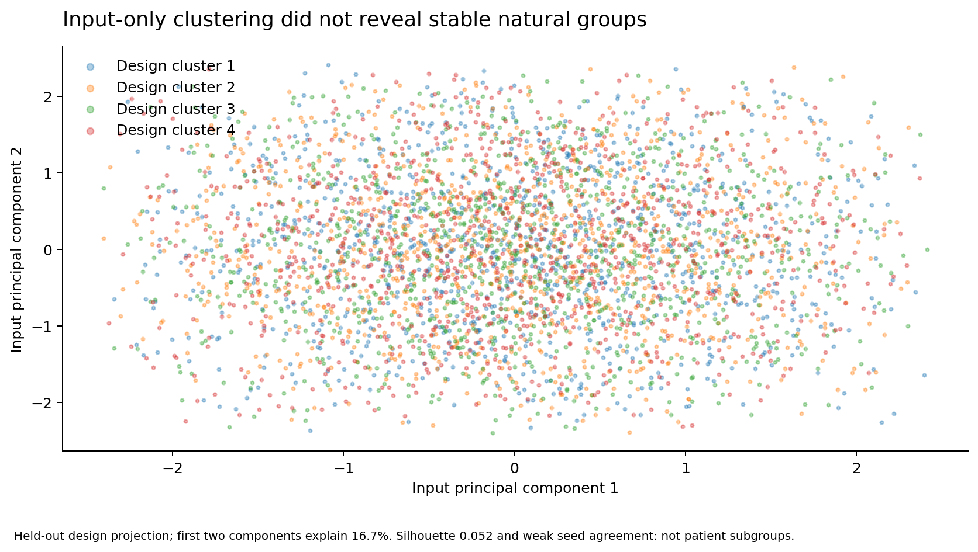
Input-only clustering was fitted without outcomes and without looking at the holdout. The silhouette was 0.052; repeated initialisations had adjusted Rand agreement 0.001 and 0.109. Thus the partitions are unstable and not convincing natural regimes. All clusters were retained. No patient, hospital or clinical subgroup was discovered.
The initial cost-regression forest had high R² but poor decision agreement. Two classifiers were compared on a separate selection sample. That diagnostic holdout was retired; final reporting uses a new independent holdout (seed 504) without additional tuning. The chosen histogram-gradient classifier explains exact decision labels. It is not used to replace the model.
Independent holdout metric | Decision classifier
Accuracy / balanced accuracy | 95.0% / 93.3%
Mean / worst annual pilot regret | $60 / $8,970
Within $100 / $1,000 of exact best | 95.3% / 98.0%
Role | Explanatory only; not clinical or procurement validation

9. Which assumptions are worth clarifying?
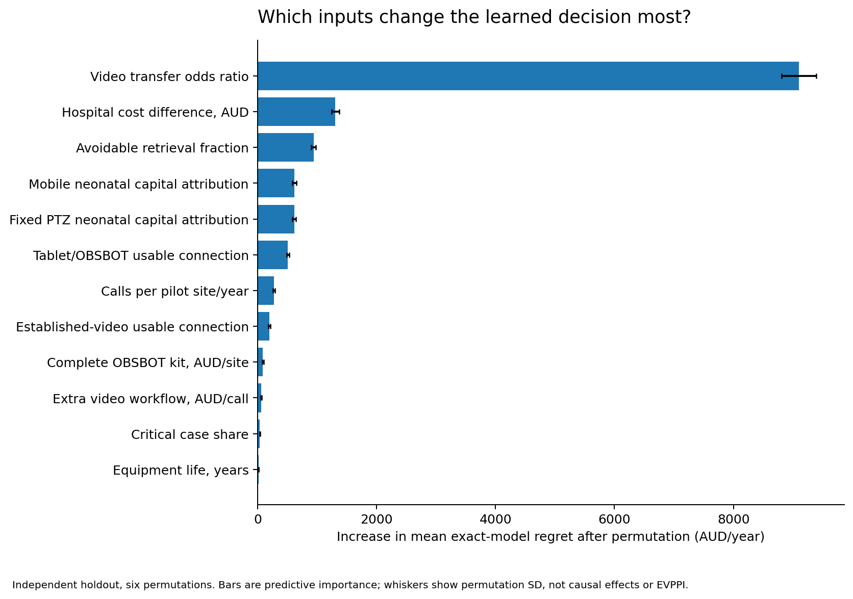
Held-out permutation diagnostics identify clinical effect as the leading decision driver, followed by net hospital costs, avoidable retrieval resources, shared-capital attribution and prototype delivery. Importance is measured as the increase in exact-model annual regret after permuting a coordinate, not as a causal effect or EVPPI. Correlated clinical priors are not inferred from this independent design. [PERM]
The selected classifier has a nontrivial worst-case error despite high average agreement. The shallow explanatory tree has much greater regret and is not suitable as a decision rule. Every headline result, grid and ranking in this report is evaluated by the exact model, not by a learned approximation.
The analysis is broad but not exhaustive. Route-specific retrieval times, repeated consultations per infant, antenatal transfers, correlated outages/hub delays and a calibrated lifetime cost-utility model remain limitations. The original 58 scenarios, 108 survival/morbidity combinations and budget tables remain available; they are not reclassified as five-device clinical evidence.

10. Publication recommendation and manuscript design
Priority / journal | Fit and suggested presentation
1. Journal of Telemedicine and Telecare | Best first choice; comparative/economic analyses encouraged. Generally 3,000 body words; 250-word structured abstract.
2. Telemedicine and e-Health | Close topical alternative; prior teleneonatology model. Emphasise costs, access and diffusion; verify current detailed limits.
3. Cost Effectiveness and Resource Allocation | Strong methods-forward alternative: modelling, uncertainty and resource allocation explicitly in scope.
4. Australian Health Review | Best Australian commissioning audience; 2,500-word article. Funding/resource distinction and implications for HHSs.
5. Journal of Medical Internet Research | Stretch target; strengthen international generalisability and independent validation.
Suggested title: “Choosing neonatal teleconsultation technology for regional hospitals: a five-strategy economic model and uncertainty analysis in Queensland”. The contribution is not “telemedicine saves money”: prior studies exist. It is configuration choice, sunk versus new capital, transparent contemporary costs, paired uncertainty and a reusable decision framework. [JTT; TEH; CERA; AHR; JMIR]
JTT lists no fee for its subscription route; optional open access is separate. CERA currently lists an APC of £2,190 / US$2,890 / €2,490 before applicable taxes, determined at acceptance. Institutional agreements or waivers need verification. Other journal-specific fees have not been verified.
Keep machine learning in the supplement. The main paper should show options/assumptions, evidence mapping, five-arm outcomes, incumbent decisions, one-way drivers and one or two exact decision surfaces. Use CHEERS 2022 with a separate budget-impact section; it is a reporting framework, not proof of validity. No journal submission has been made. [CHEERS]

11. Publication readiness, reproducibility and sources
Before submission: verify the critical studies in full text; obtain independent clinical/economic model review; retain unverified quotes and costs as assumptions; resolve governance, authorship, conflicts, funding, data rights and AI-use disclosure; complete a connected locked-environment verification run. Neither new trial recruitment nor structured expert elicitation is a prerequisite. Do not invent an ethics exemption or external endorsement.
The exact model adds no pandas/xarray dependency. Offline sensitivity/explanation uses NumPy/SciPy/scikit-learn arrays; the new target versions are SciPy 1.18.1 and scikit-learn 1.9.1, but this run used installed 1.17.0 and 1.8.0. Latest-toolchain compatibility and hosted CI are not certified. Conductor records implementation separately from blocked acceptance. Numerical results are not a substitute for clinical evidence.
Source ZIP and Git bundle are working handoffs. Do not publicly redistribute the full ELC pack, corporate artwork or restricted records without permission. Prepare a clean research release from authorised code and derived data.
[ELC2026] CHHHS ELC Operational 21 October 2026, item 2.1.7, printed pp197–215. Private source available to user; not for public redistribution
[JTT] Journal of Telemedicine and Telecare instructions. https://journals.sagepub.com/author-instructions/jtt
[TEH] Telemedicine and e-Health scope. https://journals.sagepub.com/home/tehb
[CERA] Cost Effectiveness and Resource Allocation guidelines. https://link.springer.com/journal/12962/submission-guidelines
[AHR] Australian Health Review author guidelines. https://connectsci.au/ah/pages/ah-authors
[JMIR] Journal of Medical Internet Research scope. https://www.jmir.org/about-journal/focus-and-scope
[CHEERS] Husereau et al. CHEERS 2022. https://www.bmj.com/content/376/bmj-2021-067975
[SOBOL] SciPy sobol_indices documentation. https://docs.scipy.org/doc/scipy/reference/generated/scipy.stats.sobol_indices.html
[PERM] scikit-learn permutation importance documentation. https://scikit-learn.org/stable/modules/permutation_importance.html
[ARM2012] Armfield et al. 2012 acute neonatal telemedicine economics. https://pubmed.ncbi.nlm.nih.gov/23148301/
[HAY2020] Haynes et al. neonatal transfer comparison. https://pubmed.ncbi.nlm.nih.gov/32081766/
[THAO2022] Thao et al. cost of teleneonatology. https://pubmed.ncbi.nlm.nih.gov/35235430/
[YOO2022] Yoo et al. economic evaluation of neonatal consultations. https://pubmed.ncbi.nlm.nih.gov/35074308/
[LIETZ2026] Lietz et al. neonatal consultation simulation. https://pubmed.ncbi.nlm.nih.gov/42647428/
Full original source/parameter registers, current journal register, all numerical outputs, code and actual verification receipts are included in the repository. This supplement reports v5 model outputs [M5]; retained v2/v4 material is denoted [M2].

