1. What the completed model can support
The decision is whether to continue, replace or extend video support in neonatal specialist consultations that would occur anyway by telephone. This is an existing-evidence evaluation, not a prospective study proposal. V4 preserves all 27 economic parameters and the default model outputs; it strengthens workflow, diagnostic analyses and deliverable consistency.
Annual result | Pilot: 3 sites | Illustrative network: 33 sites
Consultations | 37.5 | 1,114.5
Economic programme cost | $14,052 | $327,222
Deterministic net resource saving | $4,167 | $137,912
PSA mean | $2,428 | $135,429
PSA median | −$2,194 | $9,692
PSA 2.5th percentile | −$41,148 | −$1,011,529
PSA 97.5th percentile | $65,642 | $1,808,652
Probability resource cost saving | 46.00% | 50.67%
Results are conditional on analyst priors, not measured CHHHS savings or posterior estimates. Resource cost saving is not cash released. Absence of financial saving does not imply absence of clinical value. The primary analysis credits no proven mortality benefit. [M1]
Analysis actually run | Extent
Deterministic scenarios | 58 primary comparisons; five portfolios; separate Weipa reopening
Probabilistic analysis | 8 structures × 20,000 draws; separate annual realisation uncertainty
Precision / robustness | Nested prefixes and 6 independent-seed runs × 20,000 draws
Further checks | 6 equipment-life cases; 18 two-way break-even thresholds
Clinical consequences | 108 exploratory survival/morbidity/value combinations
Funding / budget | 9 hypothetical QWAU/QEP comparisons; 2 five-year cash budgets
Population / artifacts | 65 historical site projections; 14 individual charts; full CSV tables

2. Population, scope and traceable inputs
The 21 October ELC paper describes implementation at Atherton, Mareeba and Innisfail. Local clarification establishes 4–5 episodes at Atherton and a forecast 10–15 video consultations per site annually. The period and eligible population for the observed episodes are not known, so no local incidence/effect is inferred. Installation cost $10,000 is local information requiring invoice/component verification. [ELC2026; USER2026]
Site | 2022 babies | Forecast consultations | Implied calls / birth
Atherton | 157 | 10–15 | 6.4–9.6%
Mareeba | 134 | 10–15 | 7.5–11.2%
Innisfail | 195 | 10–15 | 5.1–7.7%
Total | 486 | 30–45 | 6.2–9.3%
The official perinatal table contains 72 public rows; co-located birth centres are combined into 65 sites without changing the 46,711-birth total. The 33-site primary spoke scenario contains 28,276 births. Its threshold of at least 20 births is an analytical rule, not a capability standard. Private births are aggregate only. This is not a complete contemporary 2026 operating-site roster. [QH2022]
ANZNN describes a selected high-risk population and participating units; it is not an all-birth or outborn-consultation denominator. Group/geography assignments are labelled proxies. Reopened services are separate hybrid-year scenarios. Newer registration data were located but not imported; registration and perinatal definitions are not interchangeable. [ANZNN2023; BDM2025]
The parameter register records sources, ranges and analyst assumptions. Current schema, arithmetic, reference and protected-file checks pass; they cannot establish the empirical truth of uncertain cost/effect inputs. Full study extraction and contemporary operational validation remain incomplete. No additional structured elicitation is imposed.

3. Evidence mapped to model roles
Study | Evidence used | Interpretation
Armfield 2012; PMID23148301 | 5/19 avoided transports; 4 helicopters; historical net saving AUD54,400 | Queensland economic precedent, not a current local causal rate.
Haynes 2020; PMID32081766 | 317 newborns; adjusted transfer OR0.48 (0.26–0.90) | Observational effect, attenuated for transportability.
Haynes 2021; PMID33691080 | Stabilisation −1.8min (−16.0 to12.4) | No proven stabilisation-time saving monetised.
Yoo 2022; PMID35074308 | Decision model, 1,000 simulations; ROI2.23 | Economic/state-scale precedent; US2017 prices not transplanted.
Thao 2022; PMID35235430 | Decision tree, transport and hospital costs | Structural precedent; not independent effect replication.
Lietz 2026; PMID42647428 | Simulation93participants; no difference between phone/video/AR | Supports null incremental-video possibility; not clinical equivalence proof.
Sandhu 2026; PMID42313572 | 20participants; improved procedural confidence | Implementation/training, not survival-effect estimation.
The search is targeted and largely abstract-verified, not a completed systematic full-text review. Economic studies sharing clinical evidence are not counted as independent effect replications. Original prices and dollar findings remain in their stated historical contexts unless source year/resource quantities permit a defensible update. [ARM2012; HAY2020; HAY2021; YOO2022; THAO2022; LIETZ2026; SANDHU2026]
The reference prior uses half the Haynes log-OR (central OR≈0.693) with added transportability uncertainty. This attenuation is an analyst judgement. Published-effect, sceptical and no-effect structures are separately evaluated. No procedural-confidence-to-mortality conversion is made.

4. Pilot and statewide probabilistic distributions
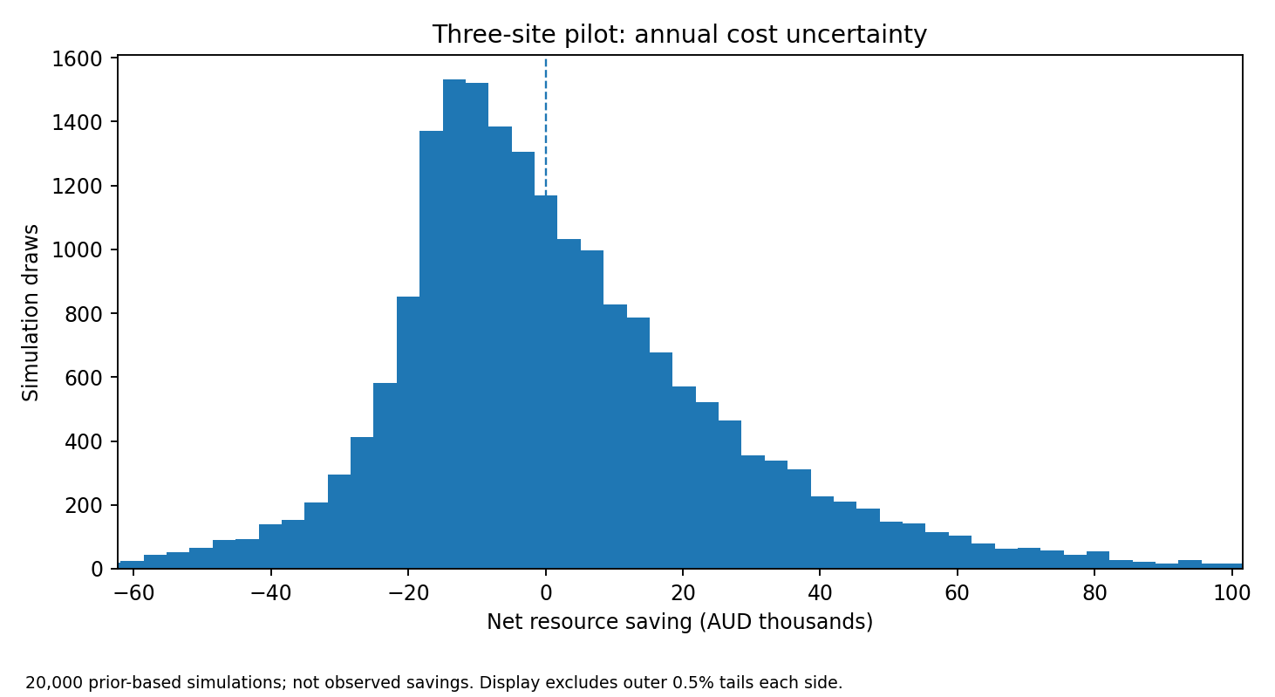
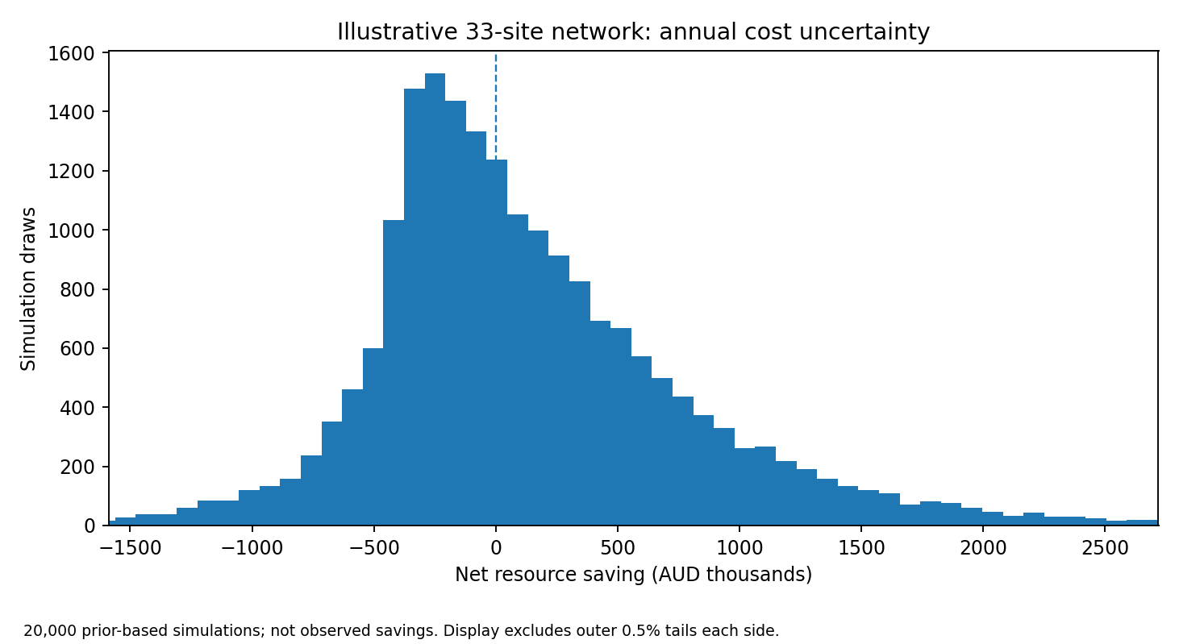
The same uncertain clinical-effect draw is shared across sites. Increasing scale improves representation of activity and casemix but does not average away a systematic error in effectiveness. Annual event-count variability is calculated separately from parameter uncertainty. [M1]

5. Structural scenarios and the financial conclusion
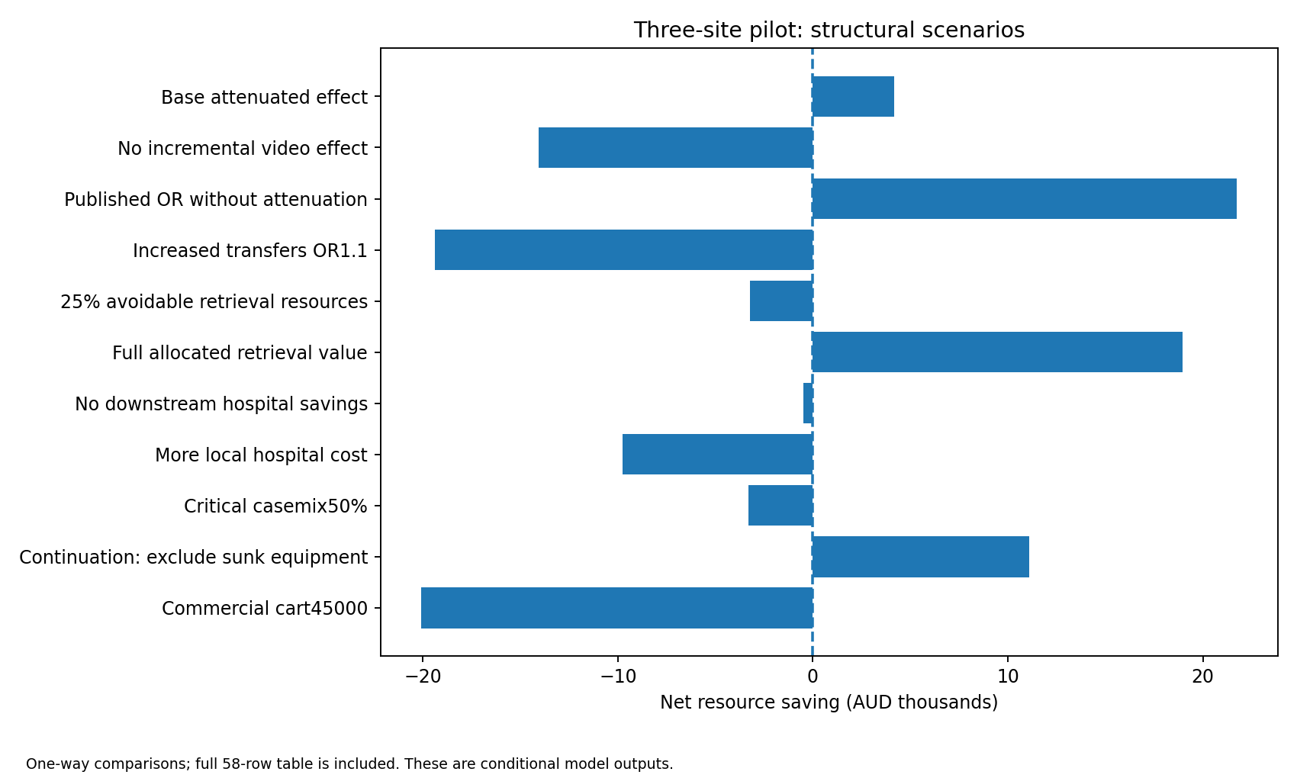
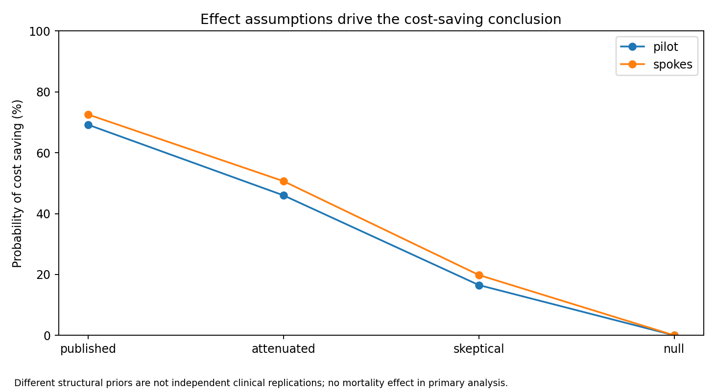
Null effects, greater transfer rates, later rescue, critical-heavy casemix, additional local care and different avoidable-cost fractions remain represented. A new transfer may be clinically appropriate, not a harm. The full 58-row CSV includes state results and other variations. [M1]

6. Simulation precision is not clinical certainty
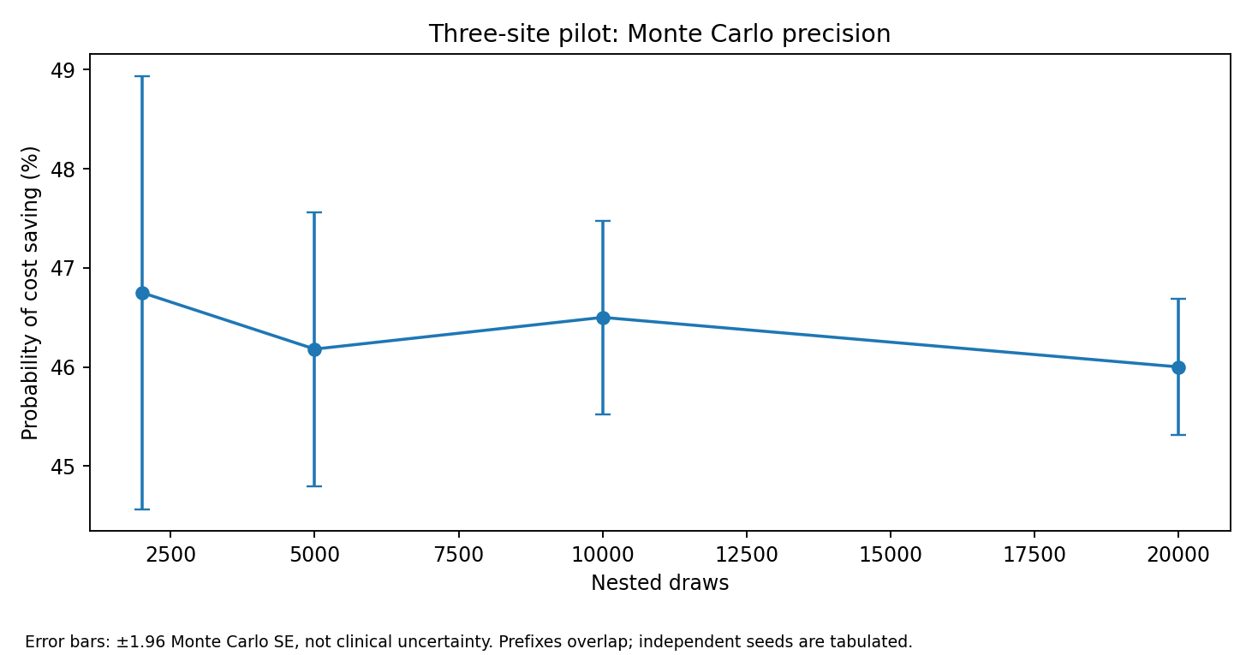
Portfolio | Seed | Draws | Cost-saving probability
pilot | 20261028 | 20000 | 45.930%
pilot | 20261029 | 20000 | 45.945%
pilot | 20261030 | 20000 | 45.985%
spokes | 20261028 | 20000 | 51.100%
spokes | 20261029 | 20000 | 50.750%
spokes | 20261030 | 20000 | 50.625%
Pilot repeats span 45.93–45.985%; state repeats 50.625–51.10%. The reference probability Monte Carlo SE is about 0.35 percentage points at 20,000 draws. These checks indicate adequate simulation precision for the present decision uncertainty; they do not validate assumed priors or clinical effectiveness. Nested prefixes overlap and are not independent studies. [M1]

7. Retrieval costing and funding must stay separate
A Queensland aeromedical resource anchor of $18,670 is reported in a Torres Strait skin/soft-tissue infection study of 2018–19 care. It is all-age, non-neonatal, mixed-air and not an RSQ marginal tariff. Assuming a 2019 price year, the CPI bridge gives $23,824.91 at June 2026: 18,670 ×102.03 / [115.125 ×(99.73/143.6)]. The source-price year is uncertain; 2018 and additional30% air-cost pressure are tested. [AIR2019; CPIBASE; CPI2026]
Rotary1.2× / fixed-wing0.9× multipliers, geographic mode mix and50% avoidable fraction are assumptions. Road$4,000 is a bottom-up illustration: staff$3,000, distance$360, coordination$400 and equipment$240. NeoSTRESS was 45 outbound, non-patient sound-measurement legs, not a representative neonatal transport census. [NEOSTRESS2020]
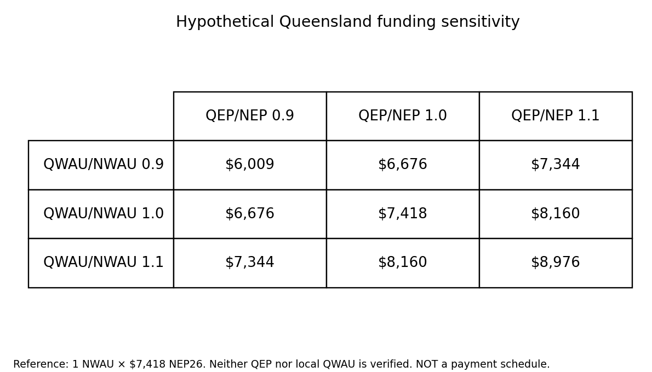
Maintain four ledgers: resource cost; NWAU×NEP; QWAU×QEP; actual organisational budget. The numerical QEP/local weights remain missing. Your mchs 2026 parity is not validated; use a verified official/GEN_WAU export for episode valuation. Do not add funding benchmarks together. [NEP26; QHFUND26; MCHS]

8. Equipment life and conditional break-even
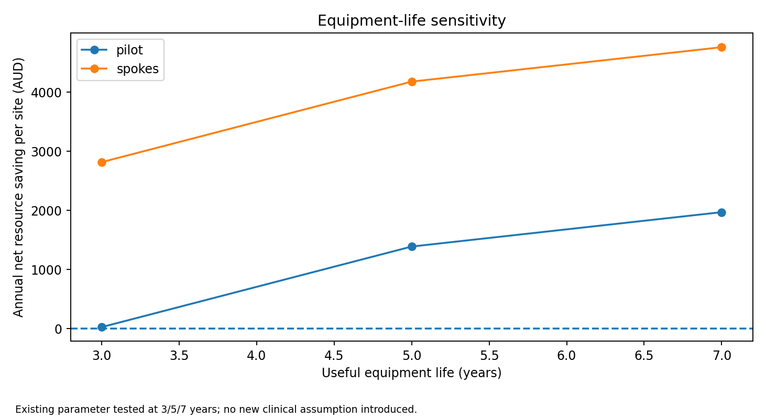
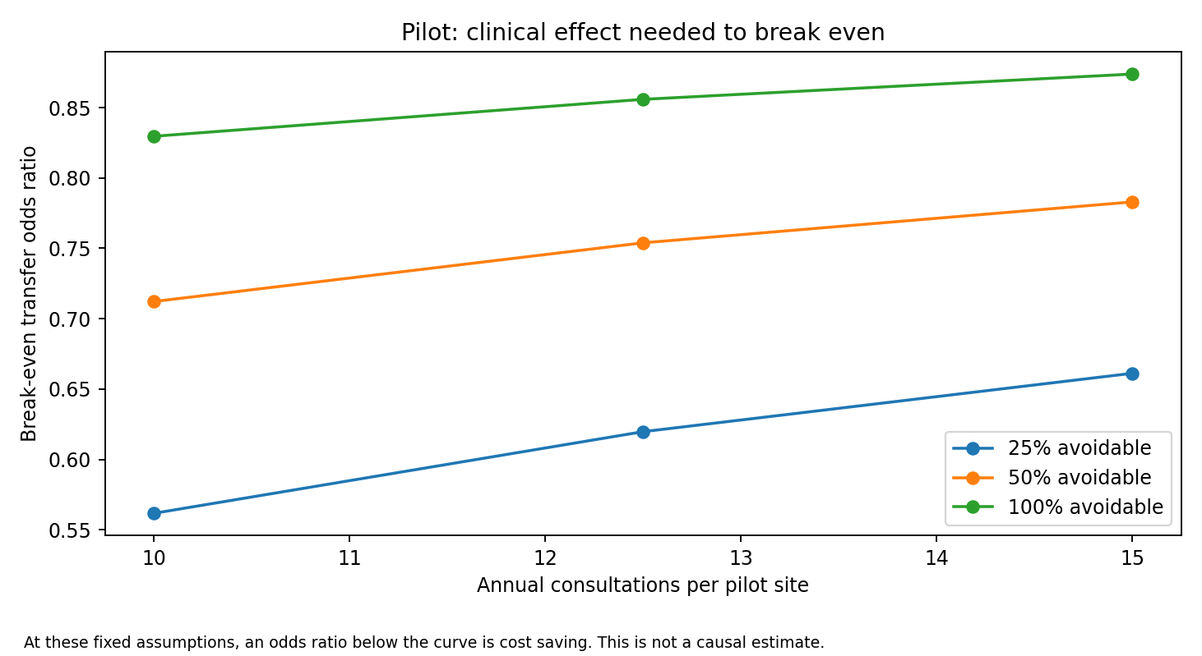
The three-year equipment-life case leaves only about $80/year deterministic pilot saving, compared with $4,167 over five years and $5,912 over seven. The 18 break-even thresholds vary utilisation and avoidable resource fraction using existing parameters. They are conditions under the model, not observed treatment effects or procurement thresholds. [M1]

9. Budget impact and societal interpretation
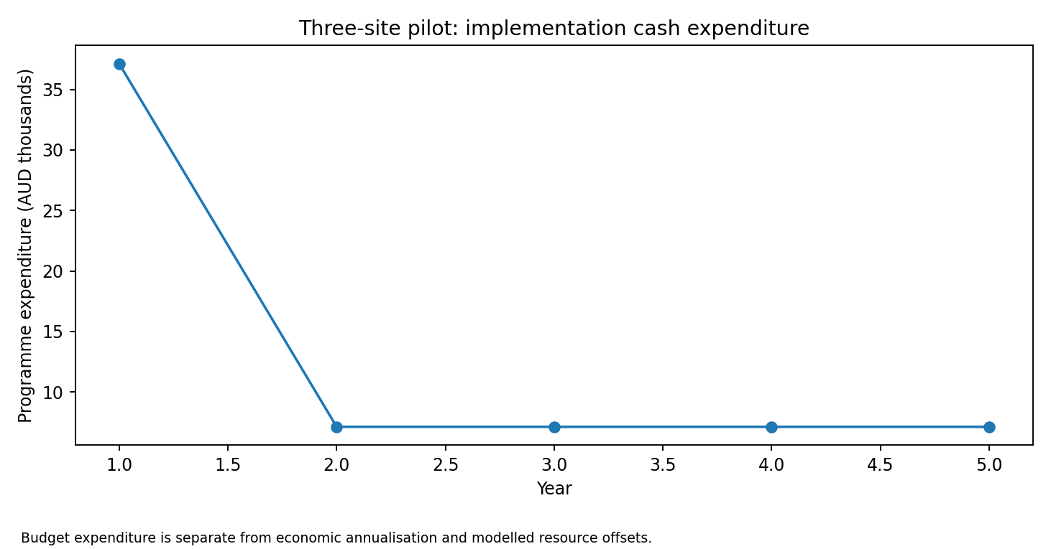
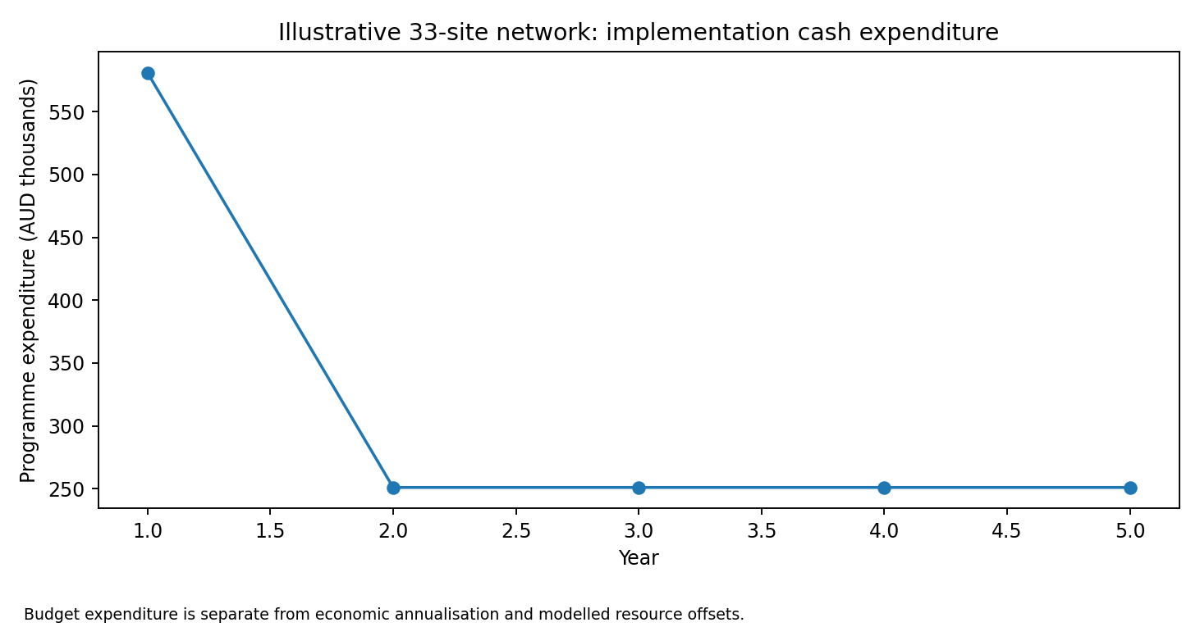
Year-one capital and later cash costs are separate from annualised resource values. Family travel/time offsets are estimated; they do not equal cash savings to CHHHS. The workbook retains separate health-system and societal deterministic columns. Actual organisational funding consequences cannot be inferred without verified contracts, allocations and activity adjustments. [M1]

10. Survival with morbidity and remaining structural limits
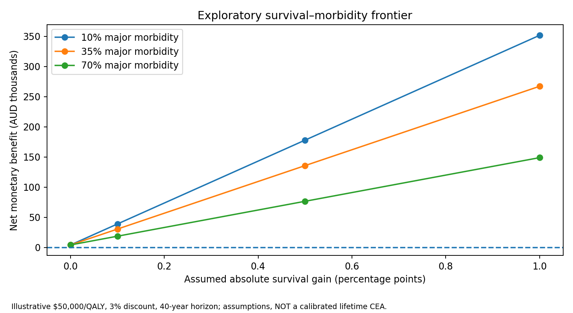
The108-point frontier includes survivors with major morbidity and higher future costs. Absolute survival gain0/0.1/0.5/1%, major-morbidity share10/35/70%, discount0/3/5% and illustrative value$0/$50k/$100k per QALY are varied. Forty-year survival, utilities0.9/0.5 and annual costs$1k/$20k are assumptions. No survival benefit or calibrated lifetime ICER is claimed. These utility inputs do not define the worth of disabled people. [M1]
Not implemented as empirically supported models: antenatal maternal transfer, repeated consultations per infant, origin–destination flight/crew routes, shared network outages, specialist response delays, differential effects by condition, age-varying survival/morbidity and caregiver/equity spillovers. These remain explicit limitations, not hidden additional features. They can be explored later where decision value warrants it; current work does not depend on obtaining a formal elicitation.
Decision use: assess benefit requirements, equipment/implementation choices and robustness across priors, rather than report only a probability of financial saving. Cost-only EVPI in the model is not an automatically justified research budget and does not capture unquantified health benefits.

11. Lean engineering and reusable safeguards
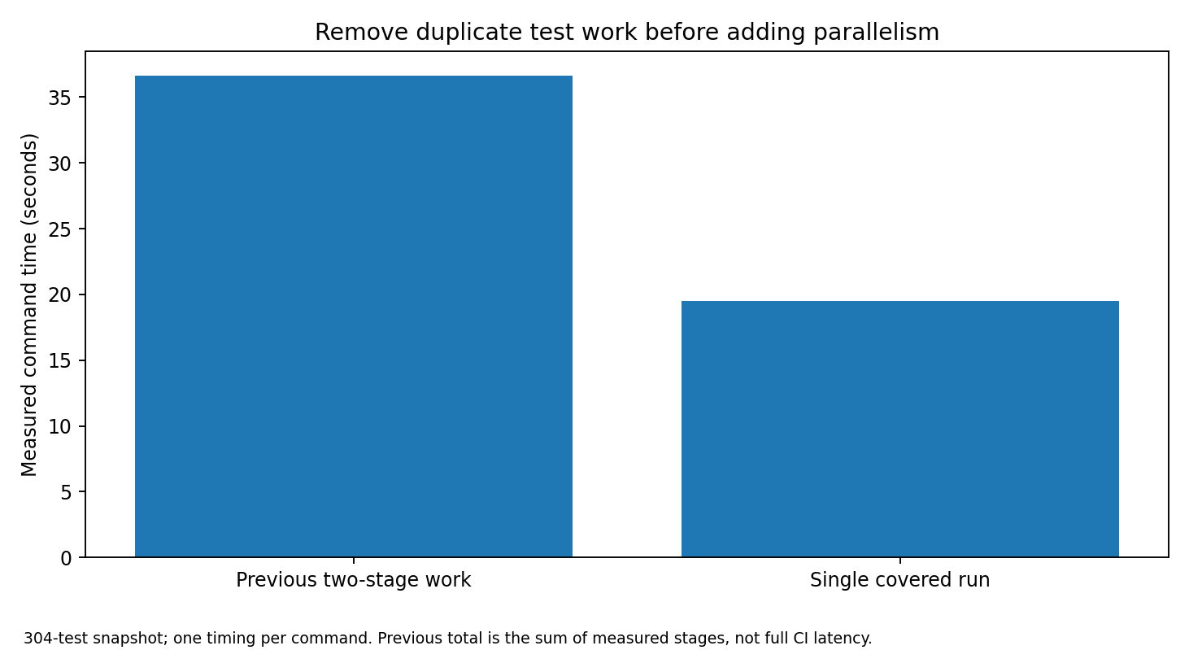
The full harness executes the ordinary suite once under coverage, then reuses its output for coverage checks. Local prek hooks are thin; optional testmon/mutation caches invalidate on static inputs, dependency/interpreter/configuration changes and source deletions. PR, full-local and hosted assurance remain different claims. One Renovate configuration replaces duplicate updater policy; no bot activation or hosted CI is claimed.
The v4 local suite currently passes 317 tests. The full harness records 6 passed, 22 blocked and 1 failed gate: the missing real uv.lock is a failed consistency check. Ruff, ty, basedpyright, Hypothesis, Gremlins, Scalene, Gitleaks, Vale, Polars, prek, actionlint and zizmor could not execute because dependencies/binaries could not be installed in this network-restricted runtime. New tool configurations may expose additional diagnostics on their first real run. The Conductor gitlink is pinned, not populated.
The reusable maintaining-lean-ci skill is included under .agents/skills with a portable receipt checker and adversarial contract tests. Validation is executable checker tests plus author review, not independent fresh-agent pressure testing. It is repo-local/portable; no permanent installation in ChatGPT or all future projects is claimed. Artifact tooling is separate from the numerical model environment.

12. Sources and reproducibility
Source and parameter registries, seven-study mapping, full scenario tables, fixed-seed draws, diagnostic code, plot inputs and engineering receipts are included in the repository. Source labels below identify public references; local ELC/USER statements are explicitly local information. M1 is a model result, not published evidence.
[QH2022] Queensland Health. Queensland Perinatal Statistics 2022, Chapter 8. Data/reference period: 2022. https://www.health.qld.gov.au/__data/assets/pdf_file/0020/1378010/8-fac2022x.pdf
[BDM2025] Queensland Registrar. Births by hospital 2025. Data/reference period: 2025. https://www.data.qld.gov.au/dataset/births-by-hospital/resource/51505dd2-c23d-4369-8ad8-c1d501c24e88
[ANZNN2023] UNSW/ANZNN. ANZNN report 2023. Data/reference period: 2023. https://www.unsw.edu.au/content/dam/images/medicine-health/npesu/research/annual-reports/2026-03-report-of-the-australian-and-new-zealand-neonatal-network-2023-excl-follow-up.pdf
[AIR2019] RRH primary research. SSTI healthcare resource use, Torres Strait. Data/reference period: 2018-2019. https://www.rrh.org.au/journal/article/8572/
[CPI2019] ABS. CPI June-quarter 2025 historical series. Data/reference period: 2019. https://www.abs.gov.au/statistics/economy/price-indexes-and-inflation/consumer-price-index-australia/jun-quarter-2025
[CPIBASE] ABS. Re-referencing the quarterly CPI. Data/reference period: 2026. https://www.abs.gov.au/statistics/detailed-methodology-information/information-papers/re-referencing-quarterly-consumer-price-index
[CPI2026] ABS. CPI June 2026. Data/reference period: 2026. https://www.abs.gov.au/statistics/economy/price-indexes-and-inflation/consumer-price-index-australia/jun-2026
[QHFUND26] Queensland Health. HHS Funding and Purchasing Guidelines. Data/reference period: 2026. https://www.publications.qld.gov.au/dataset/e1c2648f-eb8e-4e7f-a0d7-42604cd9212f/resource/c8b19f98-6a34-4db7-a660-1e60391e4325/download/hhs-funding-and-purchasing-guidelines.pdf
[NEP26] IHACPA. National Efficient Price Determination 2026-27. Data/reference period: 2026-27. https://www.ihacpa.gov.au/resources/national-efficient-price-determination-2026-27
[MCHS] Dylan Mordaunt GitHub. mchs README and NWAU interface. Data/reference period: 2026. https://github.com/edithatogo/mchs
[ELC2026] CHHHS. ELC item2.1.7 Panda Vision. Data/reference period: 2026-10-21. internal://CHHHS/ELC/2026-10-21/item2.1.7
[USER2026] Dylan Mordaunt. User clarification. Data/reference period: 2026-10-27. conversation://panda-vision/2026-10-27
[NEOSTRESS2020] Gilmour et al.. NeoSTRESS neonatal retrieval sound study. Data/reference period: 2020. https://pubmed.ncbi.nlm.nih.gov/32949204/
[QAO2025] Queensland Audit Office. Health 2025, tabled 20 January 2026. Data/reference period: 2024-25. https://www.qao.qld.gov.au/reports-resources/reports-parliament/health-2025
[WEIPA2026] Torres and Cape HHS. Weipa maternity service celebrates 50th baby birth. Data/reference period: 2025. https://www.torres-cape.health.qld.gov.au/about-us/news/weipa-maternity-service-celebrates-50th-baby-birth
Reproduce: python scripts/run_v2.py --out outputs/v4 --iterations 20000; python scripts/complete_analysis_v4.py. Use the reviewed locked environment for full acceptance. The delivered host versions and incomplete gates are recorded separately from target dependency pins.

