1. What changed—and what did not
The v6 kernel repairs the site-count hub charge and exposes complete, mutually exclusive care pathways. Historical v2–v5 code/results remain for replication; the current entry point is scripts/analyse_v6.py. No new local patients, trial outcomes, invoice verification or clinician-derived probability estimates have been added. The unchanged original data files do not make the new structural assumptions empirical. [M6; E6]
Configuration | Indicative capital/site | Evidence
Telephone | $0 incremental | Existing consultation remains
Mobile unit | $45,000 | ELC system benchmark
Panda Vision | $10,000 | ELC/user installation estimate; unverified invoice
Fixed PTZ | $47,000 | ELC system benchmark
Tablet/OBSBOT | $4,500 assumed | Complete unquoted prototype; clinical eligibility unproven
The reference comparison assumes common clinical video performance. Cost-optimal therefore means best under a restricted resource objective—not safest, clinically superior or approved for purchase. Retained-equipment and uncertain-prototype cases are separate. [ELC2026; M6]
Panda vs telephone | Pilot | Illustrative state
Reference annual programme resource cost | $14,052 | $207,222
Deterministic net resource saving | $8,516 | $387,427
PSA mean net resource saving | $4,252 | $304,308
95% model interval | −$38,979 to $66,225 | −$828,871 to $1,913,200
P(resource saving) | 50.5% | 65.6%
PSA uses researcher-specified distributions and shared systematic draws. The 33-site portfolio is historical/illustrative, not a certified October 2026 service census. Unverified QEP and QWAU adjustments remain absent. [M6; QH2022]

2. Care pathways and the transfer endpoint
Each consultation enters a severity stratum. An unsuccessful video connection returns to telephone. Each arm then has three disjoint final paths: immediate transfer; initial local care followed by delayed rescue; or final local care. Counts—not only net avoided transfers—are exported. [M6]
Primary interpretation: if T is eventual transfer probability and d is the share of transfers occurring after delay, immediate = (1−d)T; rescue = dT; final local = 1−T. Initial local = 1−(1−d)T. The conditional rescue risk among initially retained babies is dT / [1−(1−d)T]. Critical strata have no video transfer-avoidance effect. Video success/failure branches are probability-weighted.
An odds ratio for eventual transfer must not be reduced again for the same delayed rescues. An alternative initial-decision interpretation is separately evaluated: rescue = (1−T)d. Extra video-associated rescue shifts probability from final local care into delayed transfer and is an explicit harm scenario. Neither timing interpretation is confirmed from the inaccessible core study full text.
Pilot, expected episodes/year | Telephone | Panda
Consultations | 37.500 | 37.500
Immediate transfer | 20.556 | 18.236
Initially local | 16.944 | 19.264
Delayed rescue | 1.082 | 0.960
Final local | 15.863 | 18.304
Any transfer | 21.637 | 19.196
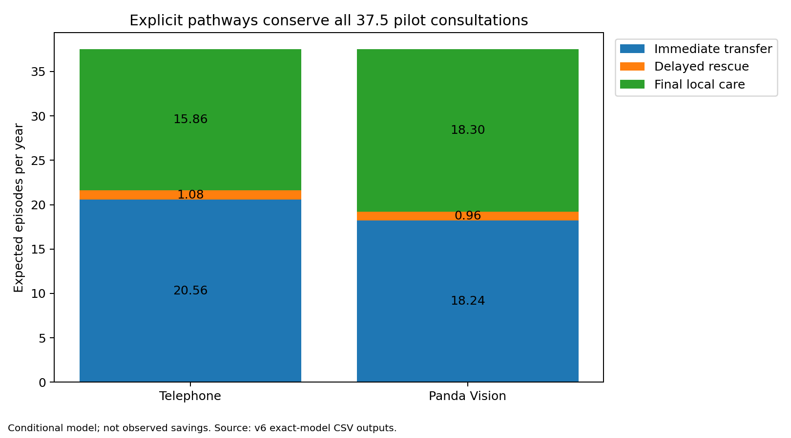

3. Hospital resources are now component-based
Immediate transfer incurs originating stabilisation plus receiving care. Delayed transfer incurs those components once, plus additional pre-rescue care. Final local care incurs one local episode. A separate rescue receiving-cost premium is zero in the reference and scenario-tested. It is not a mortality or morbidity effect. [M6]
Hospital benchmark = (immediate + rescue) × (origin + receiver) + final local × local episode + rescue × extra pre-rescue care. A provisional hospital avoidable-resource fraction is applied separately from the transport fraction. Receiving care is not also charged as a complete local episode.
Prototype | Weight | NEP26 × weight | Use boundary
P68D | 0.6454 | $4,788 | Unadjusted episode, not a bed-day
P68B | 1.4581 | $10,816 | Unadjusted episode, not a bed-day
P60B | 0.8224 | $6,101 | Unadjusted episode, not a bed-day
P60A | 1.653 | $12,262 | Unadjusted episode, not a bed-day
P06B | 7.1826 | $53,281 | Unadjusted episode, not a bed-day
Origin prototypes: P60B/P60B/P60A. Local and receiving prototypes: P68D/P68B/P06B. These map low/moderate/critical model strata to illustrative price scenarios; they are NOT observed clinical coding, full NWAU calculation or calibrated casemix. Correct code assignment would require clinical episode data, length of stay, ventilation and applicable adjustments. [NEP26]
Reference hospital fraction 0.5; local resource multiplier 1.0; additional pre-rescue care $2,000. All are analyst assumptions. PSA and scenarios allow substantially more expensive local care, zero hospital offsets and increased rescue. Raw benchmark totals and economic resource estimates are separate columns. Actual QEP/QWAU and cash released are not inferred.
Separate arithmetic check | Value
Probabilities | Immediate .4; rescue .1; local .5
Component costs | Origin100; receiver1,000; local200; extra delay50
Expected cost | .5×1,100 + .5×200 + .1×50 = 655

4. Hub costs, spare capacity and replacement
There is no site-count trigger. Economic hub cost = consultations × incremental video minutes / 60 × loaded hourly rate. The reference splits the inherited $75/call staff allowance into $25 local coordination plus 15 hub minutes at $200/hour. This is a transparent assumption, not a measured time study. Total video duration must not be substituted for incremental time over telephone. [M6; ARMPOSTER2009]
Cash capacity is a separate budget ledger: ceiling[max(0, hours − spare hours) / block hours] × block cost. Reference: 100 spare hours, 200-hour blocks, $40,000/block. These explicit assumptions are not funded posts. Hourly resource cost is not added again to paid-capacity cash. Staff readiness and local workflow cash also remain estimated, not confirmed budget release.
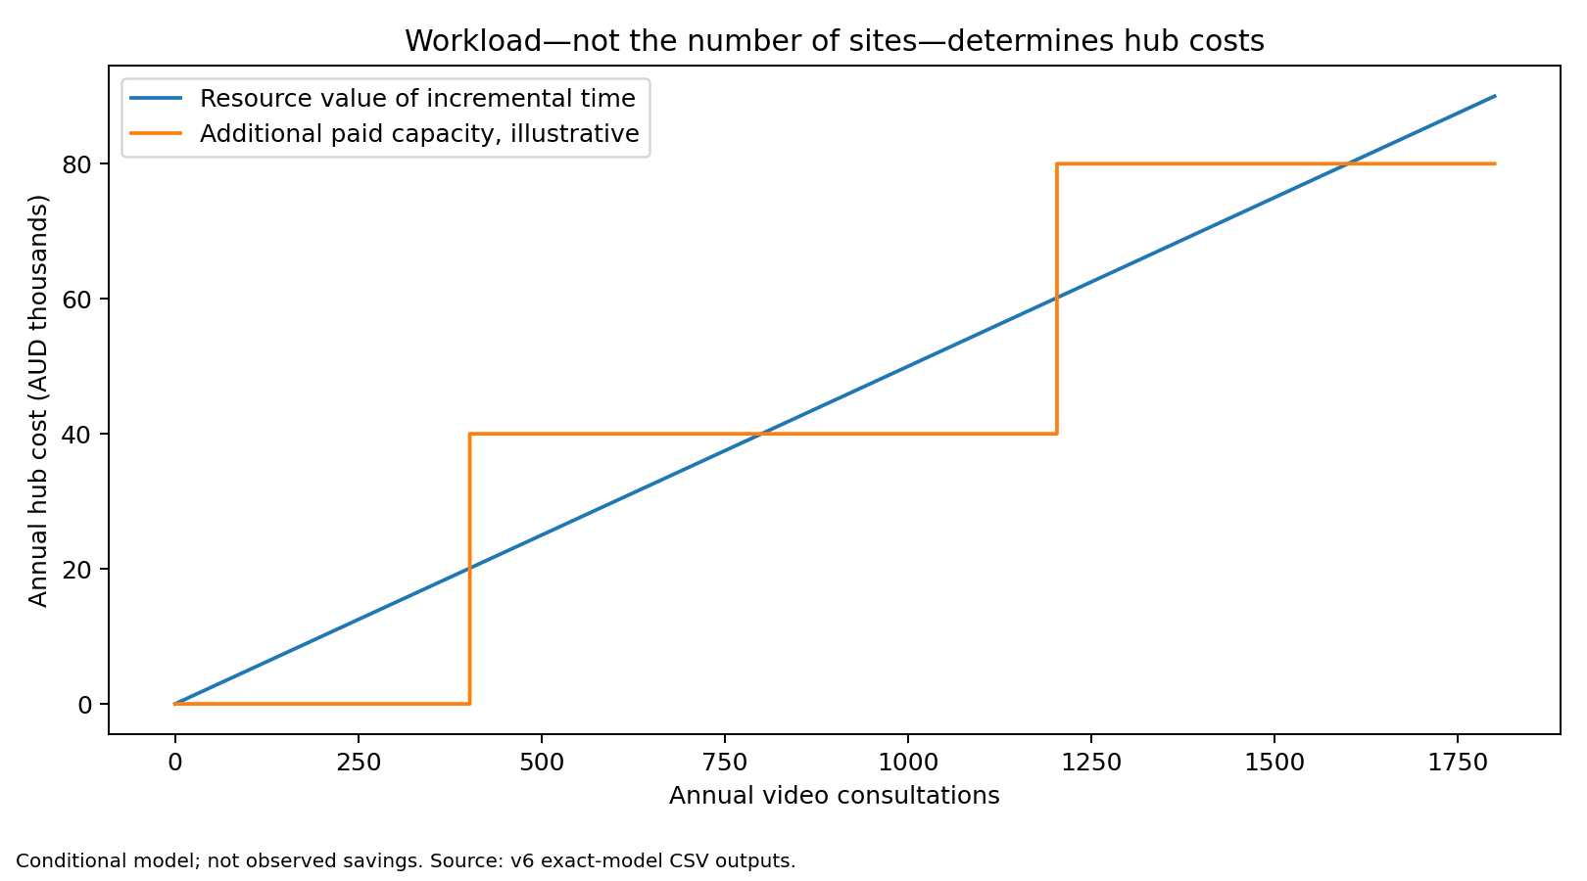
At the deterministic pilot volume, hub workload is 9.375 extra hours/year, valued at $1,875; no extra paid block is assumed. The state portfolio uses 278.64 hours/year and one additional $40,000 cash block. Unlike the old rule, a fourth zero-activity site changes equipment/readiness cost but not hub cost.
Seven-year undiscounted constant-price budgets include replacement. Existing Panda with two years of remaining life first requires replacement in year 3; sunk initial expenditure is not a permanent waiver of future costs. Residual asset value is not treated as a cash receipt. Economic annuities and cash purchases are reported separately.

5. Uncertainty and changes from v5
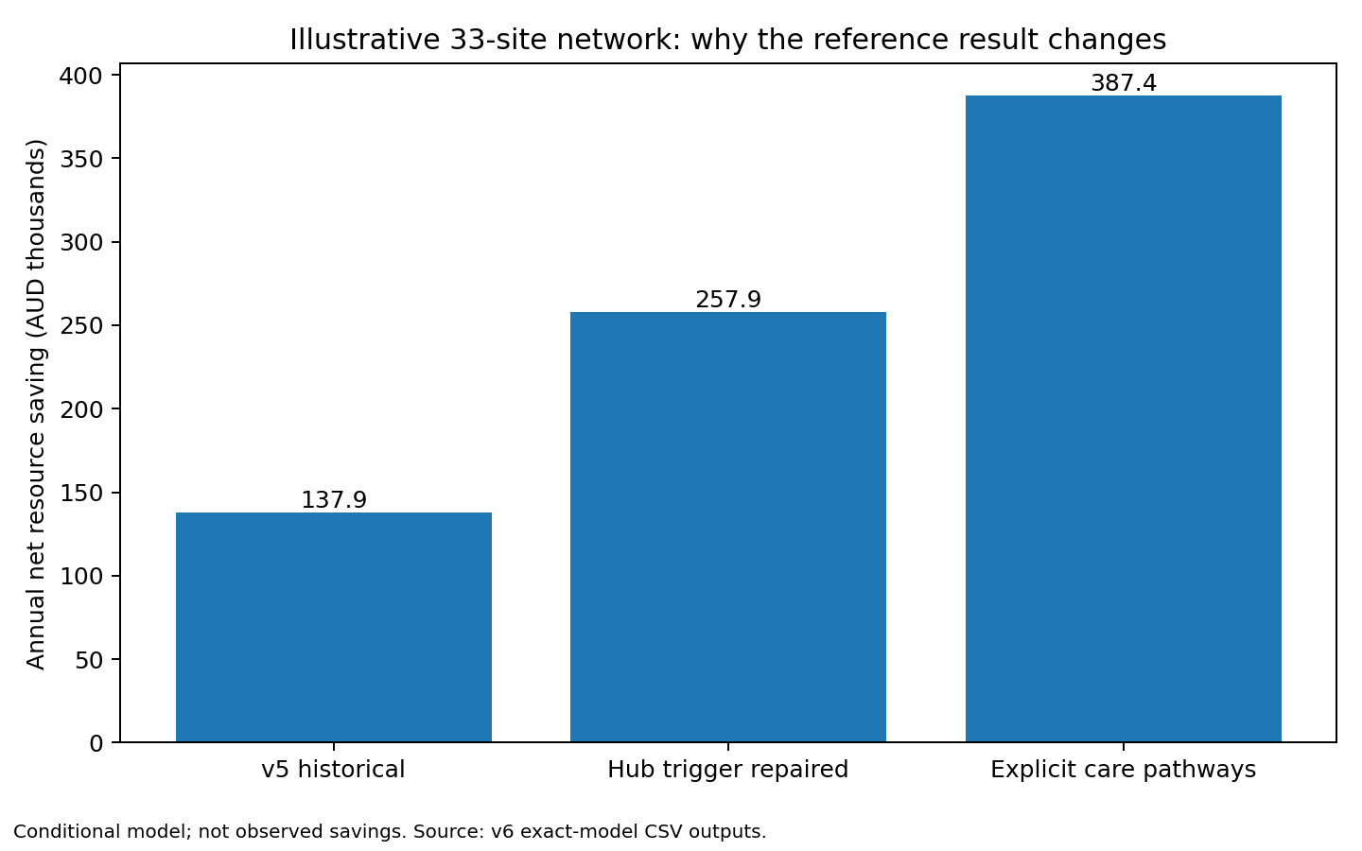
For the state portfolio, removing the old site-count/call-threshold charge improves the deterministic resource result by $120,000 before any pathway change. The remaining change is jointly attributable to explicit transfer timing and hospital component pricing. This bridge is not evidence that clinical performance improved. Pilot hub charging was already within the per-call allowance, so its reference programme cost is unchanged. [M6]
Analysis | Current v6 scope
Paired PSA | 22 structures × 20,000 draws × 5 options
One-way | 12 dimensions × 21 values × 2 portfolios
Two-way | Three 21×21 grids × 2 portfolios
Four-way | 625 exact joint pilot configurations
Accounting checks | Arm/stratum conservation; component reconciliation
Budget | Seven years; new/retained equipment and replacement
Do not carry forward v5 economic probabilities as current v6 findings. Machine learning, clustering and uncalibrated lifetime analyses are retained historically but removed from the primary v6 argument. The additional simulations test assumptions; they do not validate clinical effects or populate missing source data.

6. Paired results and clinically important alternatives
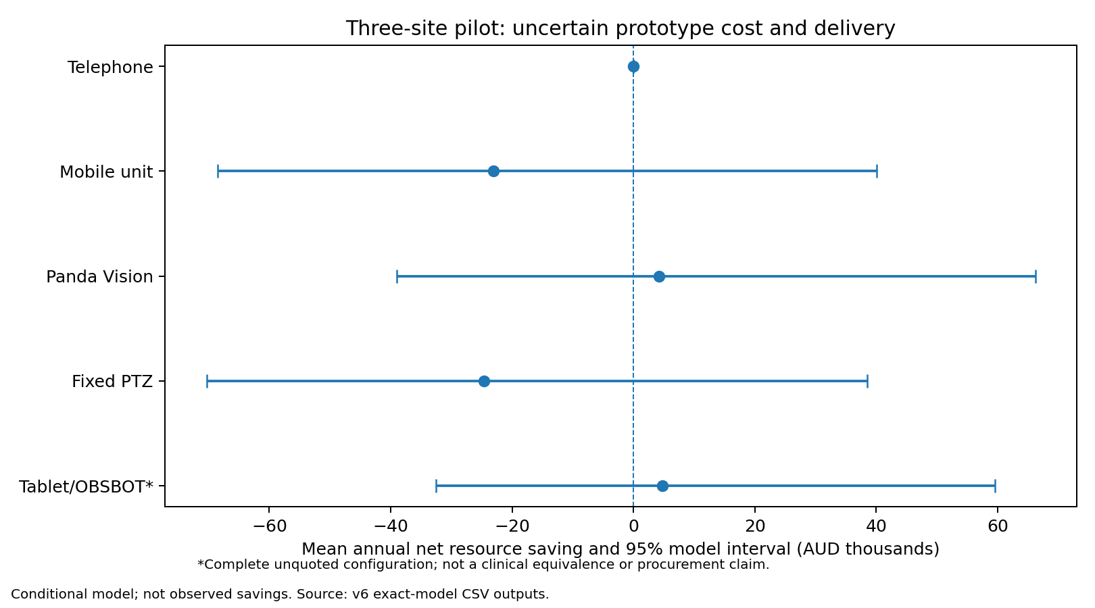
Panda pilot scenario | Mean annual resource saving | P(saving)
reference | $4,252 | 50.5%
null | −$16,556 | 0.0%
skeptical | −$16,526 | 17.9%
initial_decision_endpoint | $2,913 | 48.1%
video_delays_more | $614 | 44.5%
excess_rescue_2pct_retained | $614 | 44.4%
no_hospital_offset | −$1,249 | 38.1%
higher_local_burden | −$1,578 | 37.7%
All video strategies share evidence draws; the prototype scenario additionally varies its cost and relative usable delivery. Probability-best, mean net value and downside are distinct outputs. The null scenario has no care benefit and leaves only programme cost. Increased delay can raise cost even when eventual transfer counts do not change. [M6]

7. Full-text verification: completed and blocked
Source | Actual review | Implication
Lietz 2026 | Full article body | Simulation does not establish device equivalence or clinical outcomes
Maddox 2021 | Full article body | Selected cohort excludes deaths/mandatory transfers; no mortality inference
Fox 2024 | Full article text | Transport resource anchor is not neonatal or a marginal tariff
NEMO poster | Complete extracted poster text | Not the 2012 economic article; historical comparison only
IHACPA NEP26 | Relevant official price text | Prototype weights; not full calculator parity
Haynes 2020 | Abstract only; full text blocked | Core effect and timing require full-text check
Armfield 2012 | Abstract only; full text blocked | Original economic tables not verified
Yoo 2022 | Abstract only; full text blocked | Economic tables/cohort overlap not fully verified
Thao 2022 | Abstract only; full text blocked | Model assumptions/tables not fully verified
Haynes 2021 | Abstract only | Stabilisation-time evidence remains provisional
The source register records PMID/DOI, retrieval route, access failure and model use. Publisher pages, repository/title searches, the user Library and a second page-fetch tool did not yield the four core full texts. No abstract was reclassified as a full paper, and the poster is not substituted for Armfield 2012. Full-text verification is therefore PARTIAL, not complete. [E6]
Fox reports the $18,670 Queensland Health air-retrieval cost in a 2018–2019 skin-infection cohort. The exact tariff date is not explicit; 2019 indexing is still an assumption. Lietz and Maddox are used for interpretation and applicability, not as independent estimates pooled with the historical OR. No new local efficacy evidence is claimed.

8. Validation, acceptance and publication
Completed: separate scalar arithmetic for 20 seeded cases, a hand-worked hospital example, coherent arm conservation, failure fallback, null/critical/harm cases, component sums, replacement schedules and aggregation checks. The scalar code was written separately from the production functions but by the same author. This is technical cross-checking—not independent clinical or economic validation. [V6]
Requested independent subagent panel: NOT EXECUTED. No subagent runner or agent CLI was available. Clinical, economic, evidence and software review briefs and a structured pending-status register are supplied. No role-play, fictitious reviewer identities, invented endorsements or majority-vote acceptance is reported.
Validation domain | Current status
Conceptual/face validity | Documented and author-reviewed; independent review pending
Input validity | Provenance and assumptions separated; critical full texts incomplete
Technical validity | Regression, scalar-oracle and accounting checks executed
Cross validation | Historical bridge; not full independent replication
External/predictive validity | Not established; no new outcome dataset
Latest toolchain / hosted CI | Not certified; required missing tools/lock remain blockers
CHEERS / standards | Domain mapping, not a quality score or certification
Before journal submission: resolve full-text gaps, run the independent reviews, reconcile important findings, and complete a clean reproducible acceptance run. Confirm governance, authorship, conflicts, funding, data rights and AI disclosure. Do not publicly redistribute corporate templates or the full ELC pack. No new RCT or formal elicitation is required to conduct this early model. [V6]
Main-paper focus: the decision, complete configurations, pathways, cost components, uncertainty, incumbent decisions and limits. Describe a health-system evaluation with a limited family-cost extension—not a comprehensive societal or calibrated lifetime cost-utility study.

9. Sources and reproducibility
M6 — Versioned exact model, scripts/analyse_v6.py; outputs/v6 results, CSV and draw files.
E6 / V6 — evidence/v6/full_text_verification.csv; docs/validation/v6/standards_assessment.csv; panel_status.json.
ELC2026 — CHHHS ELC Operational, 21 October 2026, item2.1.7. Internal source; no public redistribution.
HAY2020 — Haynes et al. 2020. doi:10.1016/j.acap.2020.02.013. https://pubmed.ncbi.nlm.nih.gov/32081766/
ARM2012 — Armfield et al. 2012. doi:10.1258/jtt.2012.gth101. https://pubmed.ncbi.nlm.nih.gov/23148301/
YOO2022 — Yoo et al. 2022. doi:10.1016/j.jpeds.2021.11.076. https://pubmed.ncbi.nlm.nih.gov/35074308/
THAO2022 — Thao et al. 2022. doi:10.1089/tmj.2021.0527. https://pubmed.ncbi.nlm.nih.gov/35235430/
LIETZ2026 — Lietz et al. doi:10.1159/neo/adsag002. https://pmc.ncbi.nlm.nih.gov/articles/PMC13688369/
MADDOX2021 — Maddox et al. doi:10.3389/fped.2021.648536. https://pmc.ncbi.nlm.nih.gov/articles/PMC8102672/
FOX2024 — Fox et al. doi:10.22605/RRH8572. https://www.rrh.org.au/journal/article/8572/
ARMPOSTER2009 — NEMO case-series poster, 2009 prices. https://chsr.centre.uq.edu.au/files/1037/390_Armfield_poster_4.pdf
NEP26 — IHACPA NEP Determination 2026–27, Appendix A. https://www.ihacpa.gov.au/resources/national-efficient-price-determination-2026-27
QH2022 — Queensland perinatal public facility table2022. Historical roster preserved in data/births_queensland_2022.csv.
Standards — ISPOR–SMDM report7: https://www.ispor.org/heor-resources/good-practices/article/model-transparency-and-validation ; AdViSHE doi:10.1007/s40273-015-0327-2 ; TECH-VER doi:10.1007/s40273-019-00844-y ; CHEERS2022 https://www.ispor.org/heor-resources/good-practices/cheers
Primary health outcomes and clinical equivalence remain unverified. Missing QEP and local weights are not filled with invented numbers. The public price prototypes are scenario inputs; original-source verification is distinct from empirical validity. Fixed-seed simulation reduces numerical noise, not structural uncertainty.

