NZ legislation corpus workflow pack
Operating model for five election-facing health policy studies
Focus  Workflow and delivery design | Target  NZMJ-suitable 2026 studies | Assets  Markdown, docx, code, images, import pack

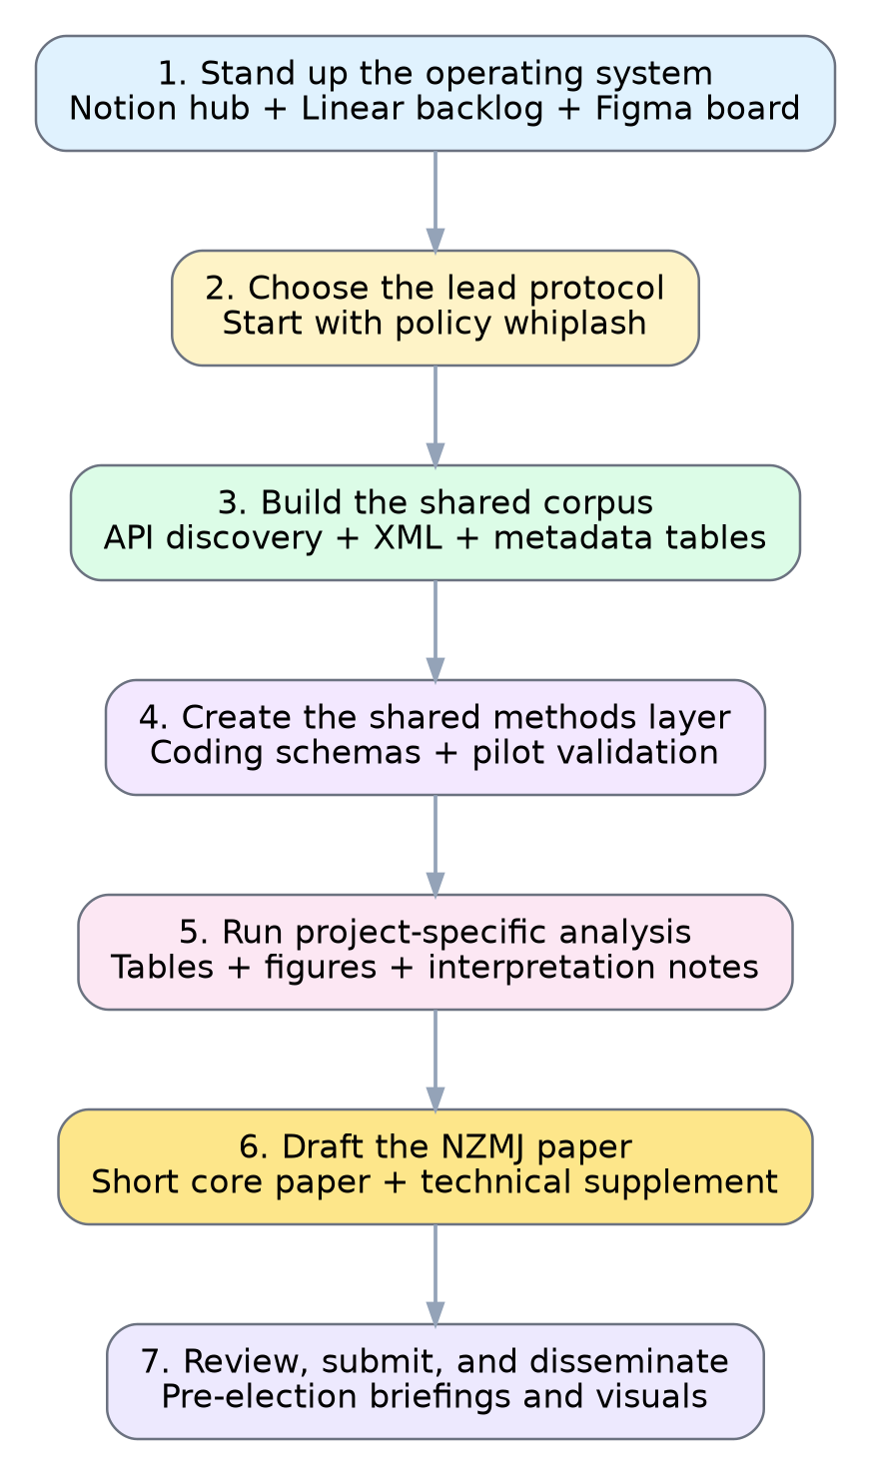
Figure 1. Recommended operating sequence for the NZ legislation corpus programme.

How the workflow should operate
The programme works best as one coordinated operating system. Figma holds the visual map, Notion holds the knowledge base, Linear holds execution, and the code repository holds the reproducible corpus and analysis pipeline.

Role of each workspace
Workspace | Primary role | What belongs there
Figma | Visual coordination | Workflow map, sequencing, publication pathway, figure concepts
Notion | Knowledge system | Protocols, definitions, decisions, corpus notes, manuscript plans
Linear | Delivery system | Initiative, epics, issues, dependencies, milestones, weekly work
Code repo | Reproducibility | API queries, corpus scripts, codebooks, tables, figures, supplements

Practical sequence
- Stand up the operating system: Create the programme hub, issue backlog, workflow board, and shared corpus specification.
- Do the lead paper first: Lead with policy whiplash and instability because it is the most election-relevant and the easiest to frame for NZMJ.
- Reuse the backbone: Move next to accountability drift, governance load, rights versus coercion, and then Māori governance and equity.

Weekly operating rhythm
Point in week | Focus | Deliverable
Monday | Choose the single analysis question | Confirmed issue chain in Linear
Mid-week | Update corpus and test coding | One table or figure draft
Friday | Write and record decisions | One manuscript section plus updated notes

Protocol sequence
- Policy whiplash and legislative instability
- Responsibility and accountability drift
- Governance load and administrative burden
- Rights language versus coercive powers
- Māori governance and equity language

Figma and package notes
Open the live FigJam workflow board: NZ legislation corpus workflow
This environment did not expose a writable Notion connector. The package therefore includes a Notion-import-ready markdown folder rather than a direct write into your workspace.
Included in the zip
• Markdown docs
• Word document
• Workflow code (Mermaid, DOT, YAML, JSON)
• Images (PNG and SVG)
• Notion-import-ready pages
• Linear issue seeds

