A framework for hybrid machine and human computation for the Research Proposal accurate and scalable analysis of human clinical EEG recordings

Scientific Protocol

April 2015
TABLE OF CONTENTS

A. Research Objectives 1
B. Impact 1
C. Background and Rationale 2
D. Progress to Date 3
E. Research Plan 3
E1. Sources of Data 3
E2. Aim 1 Methodology 4
E3. Aim 2 Methodology 5
E4. Aim 3 Methodology 5
E5. Logistics, Data Flow, Privacy, and Data Security 6
E6. Personnel 6
F. Appendices 8
F1. Appendix 1: Figures 8
F2. Appendix 2: Bibliography 11

A. RESEARCH OBJECTIVES
Electroencephalography (EEG) is a key tool in the diagnosis of epilepsy and sleep disorders. In current practice, EEG recordings are visually analyzed by specialist technicians and physicians. However, this is a slow process and dependent on the availability of these expert annotators. This limits EEG as a diagnostic medical tool in smaller communities. Even in larger centers, the time consuming nature of human EEG analysis can lead to backlogs and signiﬁcant delays in diagnosis and treatment. Thus, there is a need for rapid, scalable, cost-efﬁcient, accurate EEG interpretation that is not heavily dependent on the time of highly trained specialists.
These limitations have motivated efforts to develop fully automated algorithms for the interpretation of human EEG signals. Unfortunately, to date, these approaches have had limited success, in part because many aspects of EEG interpretation are fundamentally image classiﬁcation problems that while straightforward for trained humans, are difﬁcult to fully automate. The ﬁeld of human computation developed to address such problems where humans may have some advantages over pure automation. In this paradigm, problems are decomposed into a massive number of very simple, carefully designed, human micro-tasks to be carried out by an array of “human processors,” whose answers can be combined with automated algorithms to solve the original problem. This maximizes the advantages of both humans and computers in one algorithm, overcoming the limitations of either.
The overall goal of this project is to design a framework for hybrid machine and human computation to achieve accurate and scalable analysis of human clinical EEG recordings. In a multi-site collaboration between the University of Waterloo, McGill University, the Clinical Neurophysiology Laboratory at Sunnybrook Health Sciences Centre, and the Epilepsy Program at the University Health Network to achieve the following aims:
Aim 1. Develop a general set of algorithms to decompose EEG analysis into micro-tasks, and integrate the responses of non-expert and expert human processors with automated algorithms to solve EEG-related clinical problems.
Aim 2. Develop a general framework to compare these algorithms against fully automated approaches and specialist analyses, and an iterative approach to improve these algorithms.
Aim 3. Apply the algorithms to the interpretation of clinical EEGs from Canadian hospitals.
B. IMPACT
Approximately 250,000 Canadians, suffer from epilepsy [1]. Meanwhile, the prevalence of sleep apnea, the most common sleep disorder, has been estimated at ∼2-4% in adults [2]. EEG is key to the diagnosis of epilepsy, sleep disorders, and other neurological diseases. A large center such as the Toronto Western Hospital can perform over 12,500 EEGs annually. EEG and other tests for epilepsy are estimated to account for > 21% of the direct costs of caring for epilepsy patients [1]. Visual interpretation of EEG by trained specialists has the drawbacks of being slow, costly, and inefﬁcient. Furthermore, these drawbacks make it difﬁcult to provide EEG-based diagnostics in smaller communities in Canada and internationally.
Our project will address these needs by producing a prototype system freely available for general use by health care organizations for analyzing conventional EEG and polysomogram (PSG) data from Canadian hospitals. There will be several beneﬁts: 1) Timeliness. The use of automated algorithms to prune EEG records will reduce the human input needed to review each record. Meanwhile, careful task decomposition may allow much of the required human input to be provided by available non-EEG trained health care workers. Specialists may be called upon to provide input only on ambiguous cases, thus allowing a large proportion of records to be screened in near real-time without specialist input. 2) Accuracy. By decreasing the hours of recording requiring human review, and allowing for parallel review of ambiguous features by multiple experts, the proposed system will minimize errors due to lapses in vigilance, and improve accuracy especially in ambiguous cases. 3) Cost Efﬁciency. Specialist labour is the main cost associated with EEGs. By decreasing the need for this, our system should decrease EEG costs. 4) Capacity. By decreasing the amount of specialist labour needed to interpret each EEG, a single specialist will be able to review a much larger number of EEGs.

C. BACKGROUND AND RATIONALE
C1. EEG Analysis
Electroencephalography is a key neurological test used in many clinical contexts[1, 2]. Routine 20min EEGs (rEEG) are used in both inpatient and outpatient settings to diagnose epilepsy and other neurological conditions. Longer continuous EEGs (cEEG) recorded 24hr a day are used in inpatient epilepsy monitoring units (EMUs) to characterize seizures in patients with epilepsy, and in intensive care units (ICUs) for real-time detection of seizures and neurological deterioration. In the context of polysomnograms (PSGs), 8hr sleep EEGs (sEEG) are used to quantify sleep architecture and diagnose sleep disorders.
There are four main tasks in EEG interpretation (see Figure 2–7): 1) characterizing dominant frequencies, 2) identifying normal features such as K-complexes, sleep spindles etc, 3) using these features to classify segments of the EEG into normal (W, N1, N2, N3, R) or abnormal (e.g. encephalopathy) states, and 4) identifying discrete pathological features, notably interictal epileptiform discharges (IEDs; brief, often <200ms discharges of characteristic morphology) and seizures (runs of abnormal rhythmic brain activity lasting seconds to minutes which can cause loss of consciousness and other neurological symptoms).
Challenges in EEG interpretation include the need to identify relatively brief and rare features (e.g. a single <200ms IED in a 24-hour recording), the presence of signal noise and artifact that can mask or imitate pathological features, the similarity between normal (e.g. vertex waves) and pathological (e.g. IEDs) features, and the desirability in some contexts (e.g. cEEG in the ICU) for near-real-time identiﬁcation of abnormalities that may indicate neurological deterioration warranting prompt clinical action.
In current practice, specialized technicians and neurologists visually examine EEGs and report their ﬁndings. This has several drawbacks. The dependence on large amounts of specialist time (e.g. interpreting 24 hours of cEEG can take 3 hours of technician and 1 hour of neurologist time) limits EEG analysis to centers with these specialists, limits the number of EEGs performed, drives up costs, can delay diagnosis, and takes specialists away from other clinically vital tasks. Meanwhile, the subjective nature of visual analysis leads to inter-rater variability, making it difﬁcult to compare records interpreted by different physicians. Finally, the “needle in a haystack” nature of EEG analysis makes it prone to lapses in attention.
These limitations have led to a desire for automated approaches to EEG analysis. Seizure detection has attracted particular interest, and many automated algorithms [3-6] have been developed for this purpose. The complexity in creating automated algorithms comes from multiple factors. First, the mechanisms underlying seizure generation are not well understood, resulting in feature engineering challenges. Second, EEG recordings are made from small electrodes that capture a noisy state of the brain activity at a particular location. The electrode placement may not be optimal, yielding weak signals, and the origin of the seizure may be difﬁcult to determine from the ambiguous data. Third, the relatively low rate of occurrence of seizures and their short duration, compared to the amount of between seizures data, makes the EEG recordings highly unbalanced, posing challenges to most standard machine learning algorithms. An automated seizure detection system must address all these challenges in order to be effective.
Another EEG analysis task that has attracted interest is that of identifying normal features such as sleep spindles, and integrating this information into a segment-by-segment classiﬁcation of behavioral state. Unfortunately, automated algorithms for the detection of speciﬁc normal features (e.g. spindles) perform quite poorly compared to human experts, even when relatively artifact-free recordings are used [7]. Meanwhile, automated approaches to segment-by-segment EEG state classiﬁcation based on frequency analysis have shown some success when applied to relatively artifact-free datasets from healthy individuals or laboratory animals [8, 9], but have not been tested or proven in populations with a high prevalence of neurological diseases or sleep disorders – the individuals most likely to require EEGs.
C2. Human Computation
EEG interpretation is an example of a larger class of problems that are trivial for human experts but hard for pure artiﬁcial-intelligence (AI) systems. A new ﬁeld of computer science, human computation [10], emerged around the idea of harnessing human intelligence to improve upon automated algorithms. In this paradigm, complex tasks (e.g. image classiﬁcation) are decomposed into many micro-tasks (e.g. identifying shape, color), each of which may take seconds. Micro-tasks amenable to AI are performed by machines, while those that are not are performed by humans. The output of various micro-tasks is then aggregated to solve the original problem. Two key insights underlie human computation. First, by combining AI algorithms with human input, hybrid systems capture the strengths of both while avoiding the weaknesses of either. Second, by efﬁciently integrating the input of many non-experts and augmenting this with AI algorithms, the accuracy of groups of non-experts can approach or exceed that of experts.
Human computation has been used to solve a host of scientiﬁc problems that had proven intractable to pure AI methods, including protein folding [11], object recognition [12], and machine translation [13]. Examples of human computation systems include crowdsourcing marketplaces (e.g., Amazon Mechanical Turk [14]) where workers perform micro-tasks for payment, games with a purpose [15-17] that generate useful data through gameplay, identity veriﬁcation systems, e.g., reCAPTCHA [18], which digitize books through billions of users performing computation (e.g. transcribing words) for access to online content. Human computation approaches have been successfully applied to the analysis of some forms of clinical time series data. Zhu et al, in collaboration with China Mobile, have implemented a human computing platform for electrocardiogram (ECG) interpretation for a leading cardiac hospital in Beijing [19, 20]. By efﬁciently decomposing the task of ECG interpretation and integrating the input of multiple experts using a Bayesian framework, substantial improvement in accuracy is achieved.
Most recently, in a paper in Nature Medicine, Warby et al [7] applied human computation to the detection of sleep spindles in human EEGs. In their system, the aggregate performance of groups of non-experts exceeded that of even the best automated algorithms, and approached that of trained experts. Moreover, they showed that aggregating the input of groups of experts resulted in performance superior to any single expert. While this work concerns only sleep spindles, it demonstrates the potential superiority of human computation approaches compared to fully automated approaches for EEG feature detection. It also suggests that a carefully designed system combining human computation and automated algorithms for the detection of EEG features may achieve the accuracy of a trained expert, with minimal expert input.
D. PROGRESS TO DATE
A core component of any hybrid human-machine computing system is a platform to decompose complex tasks into micro-tasks, dynamically delegate these tasks to non-experts, experts, and automated algorithms, and reintegrate their results. PI Edith Law has developed such a platform. The Curio project (Figure 1) is general platform designed to allow scientists to apply human computation approaches to data processing tasks not easily amenable to pure AI approaches. It includes mechanisms for task decomposition, task delegation and result visualization. In collaboration with co-I Andrew Lim, Dr. Law has begun to adapt the interfaces and algorithms on the Curio platform to handle clinical EEG data.
Co-I Joelle Pineau has previously developed a machine learning toolkit for automating the various phases of building a personalized epileptic seizure detection algorithm. It provides a pool of features and parameterizations, a feature selection module that tailors algorithms to speciﬁc patients, high-level machine learning classiﬁers for detecting seizure events, and a new dataset containing EEG recordings from rats with epilepsy. Our research will further develop ideas on how these algorithms can be combined with human annotations to achieve better performance.
E. RESEARCH PLAN
E1. Sources of Data
Our goal is to design a framework for hybrid machine and human computation for the analysis of human clinical EEGs. Toward this end, we will leverage clinical EEG data from two large Canadian hospitals:
1) The Toronto Western Hospital / University Health Network (UHN) epilepsy program is one of the largest in Ontario, with over 1000 patient-visits per year. A key component is the clinical neurophysiology laboratory and associated inpatient epilepsy monitoring unit. The laboratory performs over 12,500 rEEGs and obtains over 84,000 hours of cEEG recording per year, and has an archived database of over 30,500 rEEGs, and over 680,000 hours of cEEG, all with expert annotation. This will provide fully annotated normal and abnormal rEEG and cEEG recordings from across the clinical spectrum.
2) The Sunnybrook Clinical Neurophysiology Laboratory is a major clinical neurophysiology site located at Sunnybrook Health Sciences Centre, a leading Canadian teaching hospital. The laboratory performs over 1300 rEEGs and nearly 1500 sEEGs per year, and has a database of over 6500 sEEGs and 4300 rEEGs. This will give us access to normal and abnormal sEEGs from across the clinical spectrum, as well as an independent set of rEEGs.
The logistics of data transfer, data security, and privacy are described below in section E5 below.

E2. Aim 1 Methodology
Our ﬁrst aim is to develop a general set of algorithms to decompose clinical EEG analysis into micro-tasks, and coordinate input from experts, non-experts and automated algorithms. We will develop a ﬁrst-pass ﬁlter approach whereby each record is analyzed ﬁrst by automated algorithms. Selected epochs will be passed to non-experts for additional semantic feature annotation. We will then combine the automatically extracted features and features identiﬁed by non-experts to generate a classiﬁer. Uncertainty scores from this classiﬁer will determine speciﬁc epochs or features to send to experts for further processing.
We aim to develop machine learning algorithms for combining expert labels, features detected by non-experts and automated algorithms, with a particular interest towards algorithms that can provide conﬁdence estimates. Ensemble methods [21], for example, compute conﬁdence based on agreement between multiple classiﬁers trained on the same data. Co-training [22], on the other hand, derives conﬁdence from the same classiﬁer trained on two different sets of features which are assumed to be conditionally independent given the class label, such as automatically extracted EEG features versus semantic EEG features (e.g. presence and absence of sleep spindles) scored by human annotators. This semi-supervised technique has the added advantage of requiring only a small number of labeled examples from experts to begin with; the algorithm will iteratively add more labeled examples if the two classiﬁers agree.
We describe here our proposed methodology for integrating automated algorithms, non-expert input, and expert input to solve each of the key tasks in EEG interpretation described in section 2.1.
Frequency Analysis. A key ﬁrst step in EEG interpretation is the characterization of segment-by-segment dominant frequencies, which can inﬂuence how the discrete features identiﬁed in the other tasks are interpreted. We propose to fully automate this using standard signal analysis techniques e.g. Fourier analysis.
Identiﬁcation of Normal Features. The normal EEG is characterized not only by background rhythmic activity, but also by discrete morphological features that deﬁne the normal ﬁve behavioral states (W, N1, N2, N3, and R) and whose absence may be indicative of an abnormal state (e.g. encephalopathy). We will apply a ﬁrst pass ﬁlter approach here. Initially, machine algorithms will be used to identify the presence of various normal features in 30s epochs. Because these features are common, these algorithms will be biased toward speciﬁcity, rather than sensitivity. Where features are detected with high conﬁdence, no further human input will be needed. Epochs with features detected at lower conﬁdence, or epochs with no features detected, will be sent to non-experts for additional feature detection, based on characteristics that will be selected in consultation with investigators Andrew Lim and Brian Murray (both neurologists with board certiﬁcation in sleep EEG interpretation). Others [7] have shown that, in principle, many such features can be conﬁdently identiﬁed by non-experts.
Epoch-By-Epoch Classiﬁcation of Behavioral State. Automated algorithms will combine information from the background frequency analyses, automated feature detection, and non-expert feature detection, to arrive at a classiﬁcation of the behavioral state for each non-overlapping 30s epoch of the EEG. For most epochs, these features will be concordant and a classiﬁcation will be made without expert intervention. For ambiguous epochs, experts will be provided with a visualization of a combination of automatic and non-expert annotations along with the uncertainty of their labels, to arrive at a ﬁnal classiﬁcation.
Identiﬁcation of Abnormal Features. The next task is identiﬁcation of abnormal discrete features, especially IEDs and seizures, as described in 2.1. As above, we will use a ﬁrst-pass ﬁlter approach. Automated algorithms developed by investigator Joelle Pineau, as described in section 3 above, will ﬁrst be deployed to prune the record. These will be biased toward high sensitivity to ensure that no features are missed. Then, the remaining portions of the record will be sent to available non-experts (e.g. nursing staff) to evaluate for speciﬁc characteristics, which will be selected in consultation with investigators Andrew Lim and Richard Wennberg (both neurologists with board certiﬁcation in EEG interpretation). These characteristics may include, as an example, the “sharpness” of a discharge or the extent of “evolution” of a run of rhythmic activity identiﬁed by an automated algorithm. The input from non-experts and the automated algorithms will then be integrated to create a conﬁdence score for each feature. Features identiﬁed with high conﬁdence and concordance may be classiﬁed at this stage. Features that are identiﬁed with lower conﬁdence or some discordance will then be sent to experts for disambiguation. The beneﬁt of inserting a layer of non-experts between the algorithms and the experts is that many algorithm misclassiﬁcations may be easily corrected by available non-expert readers without expert intervention. This is particularly important because in many situations (e.g. overnight care, or in smaller communities) non-experts such as nurses may be available, but EEG trained neurologists may not.
Generation of Final Narrative Report. The ﬁnal output of our framework will be an automatically generated table, based on automated algorithms and non-expert input, with or without additional expert input, indicating the presence/duration of abnormalities or behavioral state, and the presence/timing of discrete abnormalities such as seizures and interictal discharges. This narrative report, along with a fully annotated record, will be provided to the expert (if available) for further analysis and reporting.
E3. Aim 2 Methodology
The ﬁrst-pass ﬁlter approach developed in Aim 1 will generate an initial set of algorithms and interfaces that will enable a combination of automated algorithms and non-experts to handle a large proportion of most records, routing only ambiguous pages and features to experts. Aim 2 is to develop and validate an iterative reﬁnement process to improve these algorithms over time, and increase the proportion of the overall workload that can be handled by the combination of automated algorithms and non-experts.
First, this approach will include algorithms and interfaces to iteratively evaluate and improve the performance of non-experts, experts and automated algorithms. For example, when a non-expert differs from the group consensus or from an expert, the system will present corrective feedback to facilitate improvement. Using the same ground truth data, the accuracy of each non-expert can be re-assessed and recorded, allowing the system to personalize their training. Likewise, experts can improve over time as they are provided with more robust visual aids displaying the crowdsourced features, and the automated algorithms can improve over time due to the addition of training data from experts or the non-expert crowd. Second, a similar iterative reﬁnement approach will be applied to the framework as a whole. As the reliability of non-experts and automated algorithms improves, other algorithms will monitor and re-weigh these different sources of contributions, slowly moving toward a decreasing reliance on human expert input.
To validate the iterative reﬁnement approach, we will engage a group of non-experts and experts in a month-long experiment to evaluate the accuracy and efﬁciency of each of the components over time, and how the adaptive combination of these components impacts the accuracy of the overall classiﬁcation and the distribution of the workload.
E4. Aim 3 Methodology
Aim 3 is to apply our framework to the interpretation of a wide variety of clinical EEGs (rEEG, cEEG, sEEGs) from Canadian hospitals. We will develop an interface between the EEG recording software and our system to allow recordings from consecutive consenting patients (completely de-identified) to be uploaded to a central server. There, the interpretation of the record will be parsed into micro tasks as described in Aims 1 and 2 above, and distributed to automated algorithms, as well as to non-experts and experts via a web application which can be accessed on participants’ own time and from their own locations. For experts, we will use the physicians and technicians at the Toronto Western Hospital Epilepsy Program and the Sunnybrook Health Sciences Centre Clinical Neurophysiology lab, investigator Andrew Lim, and a technician from his laboratory, who will provide an independent source of expert annotations. For non-experts, we will use two sources: 1) paid crowdworkers through Amazon Mechanical Turk (as used by [7] in their study of sleep spindle detection) or paid CS undergraduates at the University of Waterloo. All records will also be annotated by experts at the recording site as per the usual clinical workﬂow to generate gold standard annotations. To ensure that we capture an unbiased representation of EEGs at our knowledge user sites, we will study consecutive recordings, without pre-selecting based on neurological diagnosis, patient features, or recording equipment.
As described in section 5.2, this process will begin with an in-depth needs assessment during which the computer science (CS) team from Dr. Law’s lab will embed themselves within the clinical teams at TWH and Sunnybrook to observe the current process of EEG interpretation, identify gaps, and identify key attributes of successful solutions. We will also conduct formal focus groups to allow technicians and neurologists to share perceived problems and solutions with the CS team. Then, as the framework and interfaces are being developed, there will be monthly site visits, during which the technicians and neurologists will use and provide feedback on the latest iterations of the prototype, to ensure a seamless interface between the end users, the clinical workﬂows, and our system.
To evaluate our approach, we will compare it to standard expert visual analysis. Efﬁciency criteria will include person-hours of human input needed per recording and at each level of training (non-expert vs. technician vs. neurologist). We will also assess total time to interpretation. For accuracy, we will assess concordance with the expert read on a number of levels -e.g. on the whole record level (e.g. seizure or not anywhere in the recording), on the page-by-page level (e.g. proportion of pages correctly classiﬁed as epileptiform or not) or on a feature-by-feature level (e.g. detection of individual IEDs or seizures).
E5. Logistics, Data Flow, Privacy, and Data Security

All three aims will retrospectively utilize clinical neurophysiological data (including EEG and PSG recordings) from two hospitals – Sunnybrook Health Sciences Centre and the University Health Network. Co-PI Dr. Andrew Lim or his delegate will identify appropriate neurophysiological (including EEG and PSG) data at Sunnybrook based on a retrospective review of data generated by the laboratory. Co-I Dr. Richard Wennberg or his delegate will identify appropriate neurophysiological (including EEG) data at the UHN based on a retrospective review of neurophysiological data generated by the laboratory. Records will be converted to de-identified .edf files containing the digital signal data only, and having as their filename an 8-digit unique identifier with no other identifying information. In addition, technician annotations (e.g. annotated sleep stages, annotated seizures) will be converted to de-identified .txt files containing only the annotations and having the same 8-digit unique identifier. Only the de-identified .edf and .txt files will be sent outside of Sunnybrook and the UHN. No personal health information will leave the originating hospitals. The keys linking these .edf and .txt files to patient records will be maintained at the originating hospital and will be accessible only to Dr. Lim (at Sunnybrook) or his delegate or Dr. Wennberg (at UHN) or his delegate. These keys will be encrypted and kept on secure central servers at the originating hospitals.
The de-identified neurophysiological data will be encrypted and sent by secure internet connection to secure encrypted servers at the University of Waterloo (overseen by PI Dr. Edith Law) and McGill University (overseen by Co-I Dr. Joelle Pineau). These de-identified digital signals will be accessible only to Dr. Law, Dr. Pineau, and students, technicians, or fellows working with them, all of whom will have received appropriate human subjects training. In addition, expert and non-expert individuals who may be recruited by public advertisements and who may or may not necessarily be directly affiliated with the investigators' laboratories, will view and annotate visual representations of portions of these records online via a web portal that will be hosted at the University of Waterloo and/or McGill University. Individuals logging into these servers will see only visual representations of portions of the fully anonymized data (i.e. they will not even have access to the 8-digit unique identifiers) and will not have access to the actual digital signals – only down-sampled visual representations of the digital signals.
Record annotations generated at the University of Waterloo and McGill will be sent back to investigators at the originating hospital (Dr. Lim at Sunnybrook, and Dr. Wennberg at UHN), along with the corresponding unique identifiers, to allow comparison to the original physician reports for these records.
The de-identified .edf and.txt files will be stored on the servers at the University of Waterloo and McGill for the duration of the project and for no longer than 10 years, after which they will be destroyed, unless a new research protocol is submitted.
E6. Personnel
As a world expert in human computation, co-PI Edith Law (University of Waterloo) will have the overall responsibility of the project and will lead a team of 2 PhD students and 1 MSc student to adapt the time series component of the Curio platform for clinical purposes. She will develop the human computation techniques, including algorithms for routing tasks and aggregating responses, as well as interfaces for nonn-expert annotations and training. As a board certiﬁed neurologist with specialty certiﬁcation in interpreting EEGs and PSGs, co-PI Andrew Lim (Sunnybrook Health Sciences Centre) will provide detailed input into the design of the task decomposition and integration frameworks. He and his technician and/or graduate student (50% time) will coordinate data transfer between the various study sites, and provide an independent source of expert annotations. As an expert in machine learning, Co-I Joelle Pineau (McGill University) will be responsible for the development and adaptation of algorithms for seizure detection. She will supervise 1 Ph.D. student (50% time) to extend her existing seizure detection toolbox for this project, and provide support for integration with Curio. As a senior researcher, she will also provide guidance on managing the project. As a board certified neurologist and epileptologist with specialty certification in interpreting EEGs, co-I Richard Wennberg (University Health Network) will provide input into the design of the task decomposition and integration frameworks, and also oversee record selection, data security, and data transfer from the University Health Network site. As a board certified neurologist and sleep specialist with specialty certification in interpreting PSGs, co-I Brian Murray (Sunnybrook Health Sciences Centre) will provide detailed input into the design of the task decomposition and integration frameworks.

F. Appendices
F1. Appendix 1: Figures

Figure 1: The Curio Project: A Platform for Mixed-Expertise Crowdsourcing
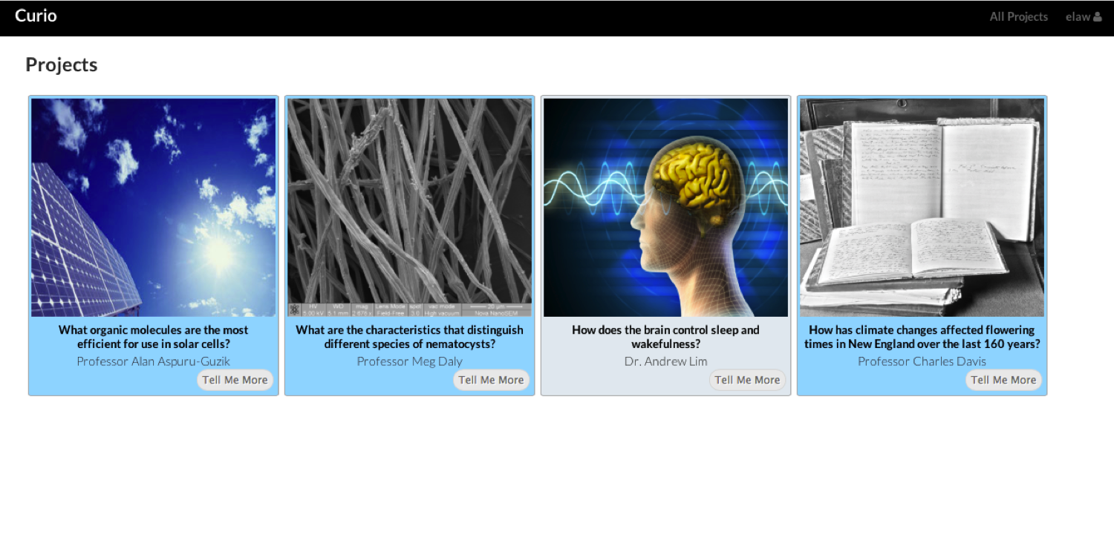

Figure 2: Normal Wake EEG. Note the 8Hz dominant background frequency
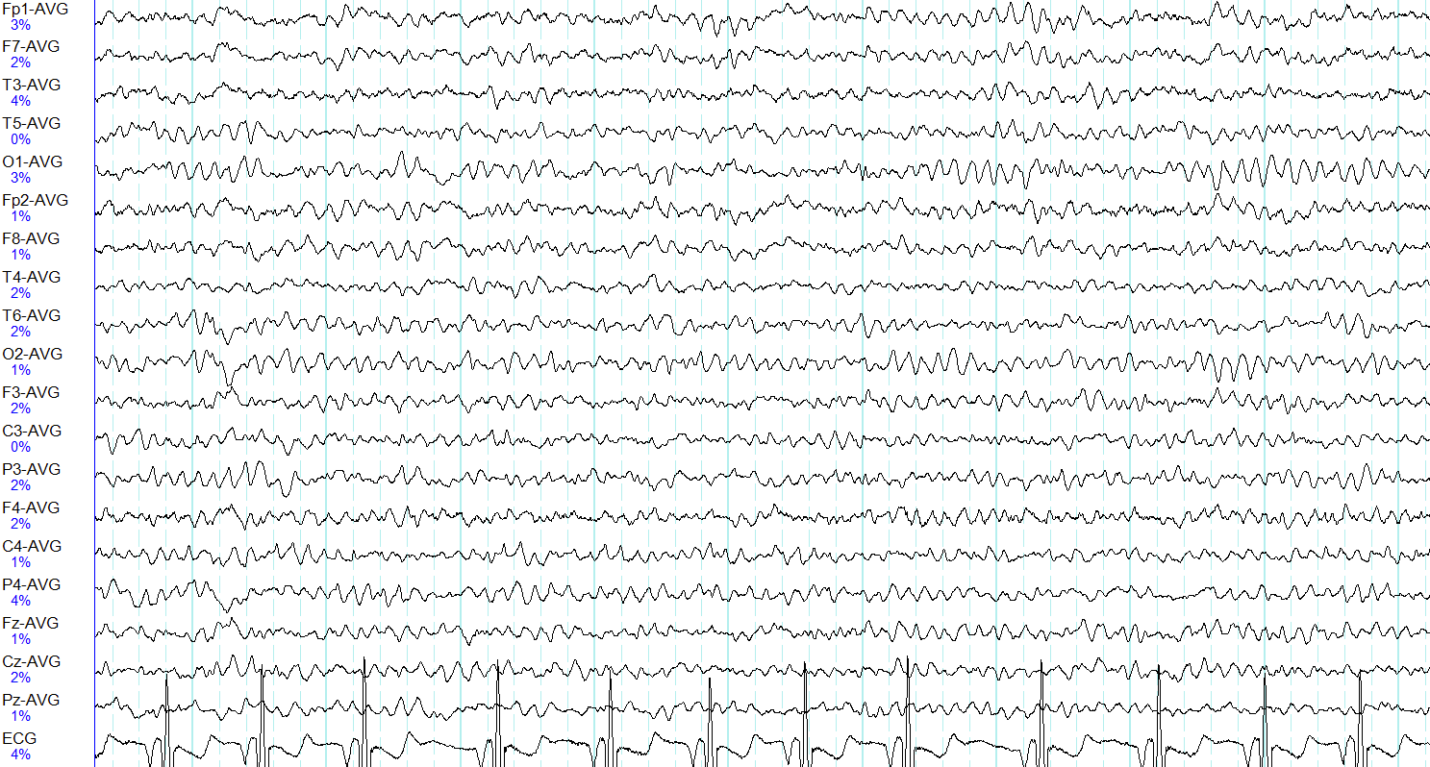

Figure 3: EEG in stage N2 sleep. Note the prominent sleep spindles (black box) and the dominant frequency <8Hz.
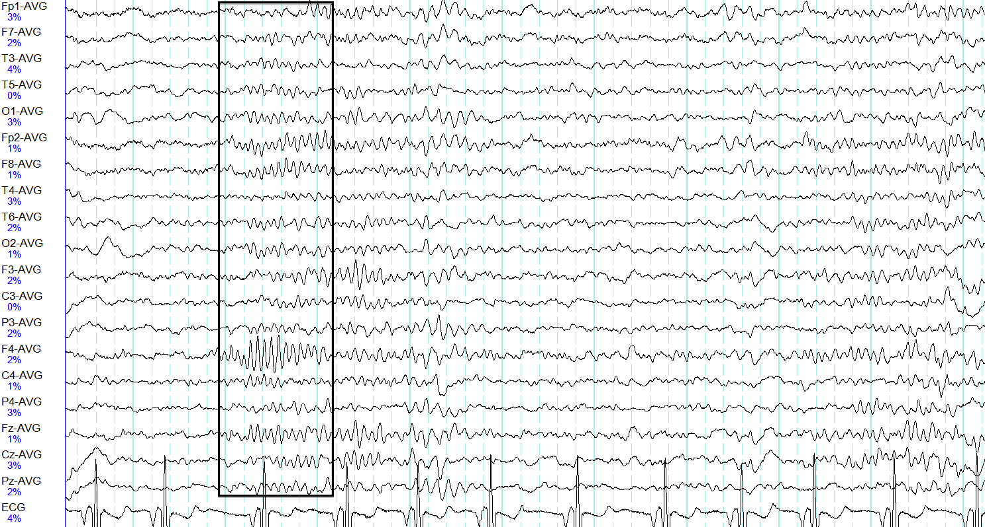

Figure 4: Abnormal burst-suppression background with brief bursts (box) punctuated by long periods of suppression. Note the interictal epileptiform discharges contained within the bursts
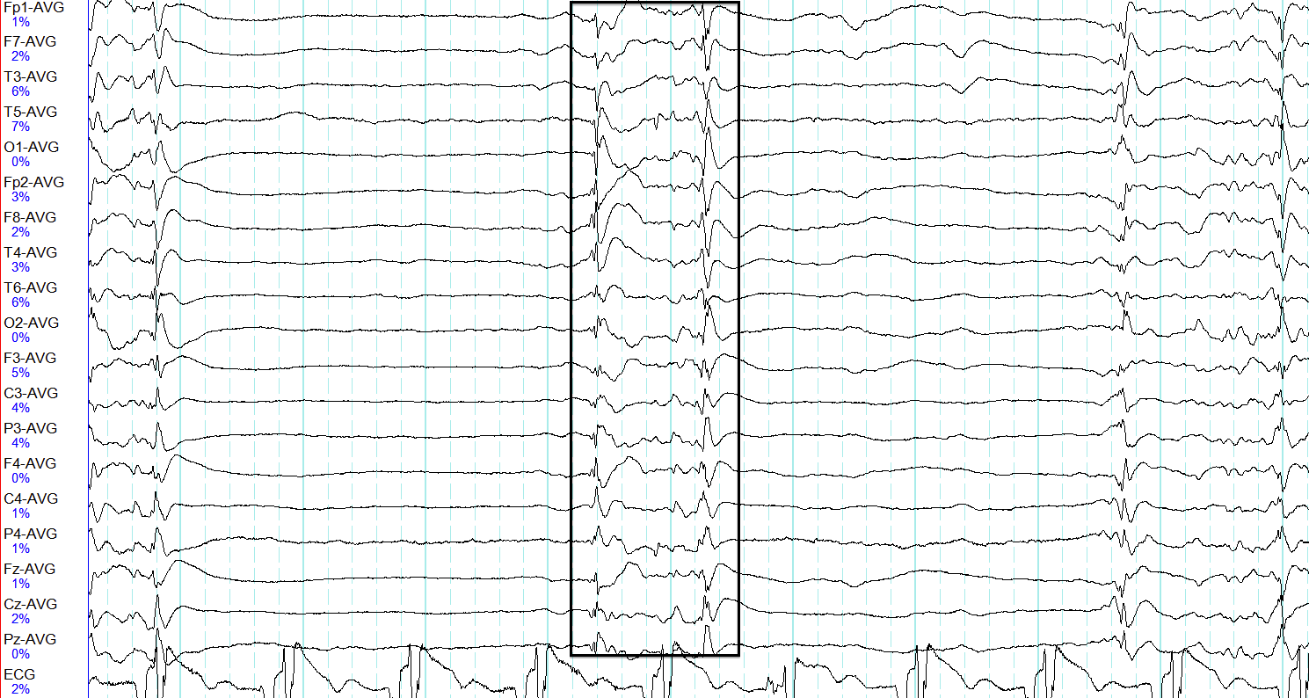

Figure 5: Interictal discharges (black boxes) on a slow (<8Hz) background.
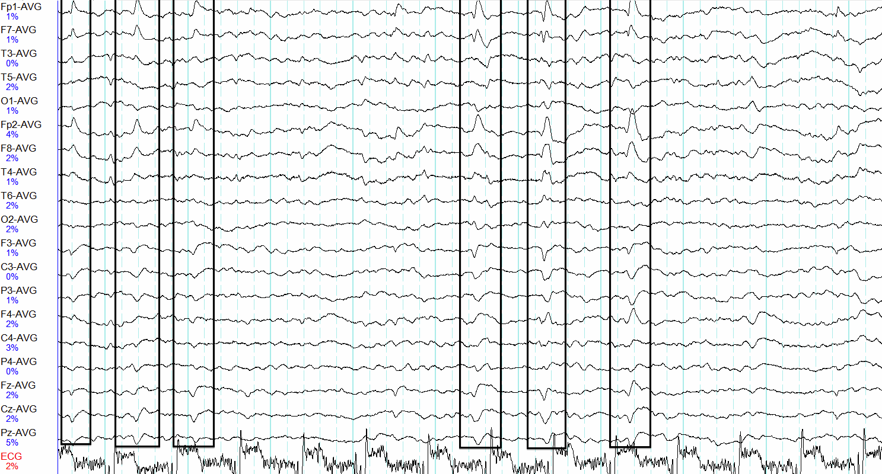

Figure 6: Single focal interictal discharge preceded by a normal spindle (black boxes) occurring in the context of otherwise normal stage N2 sleep.
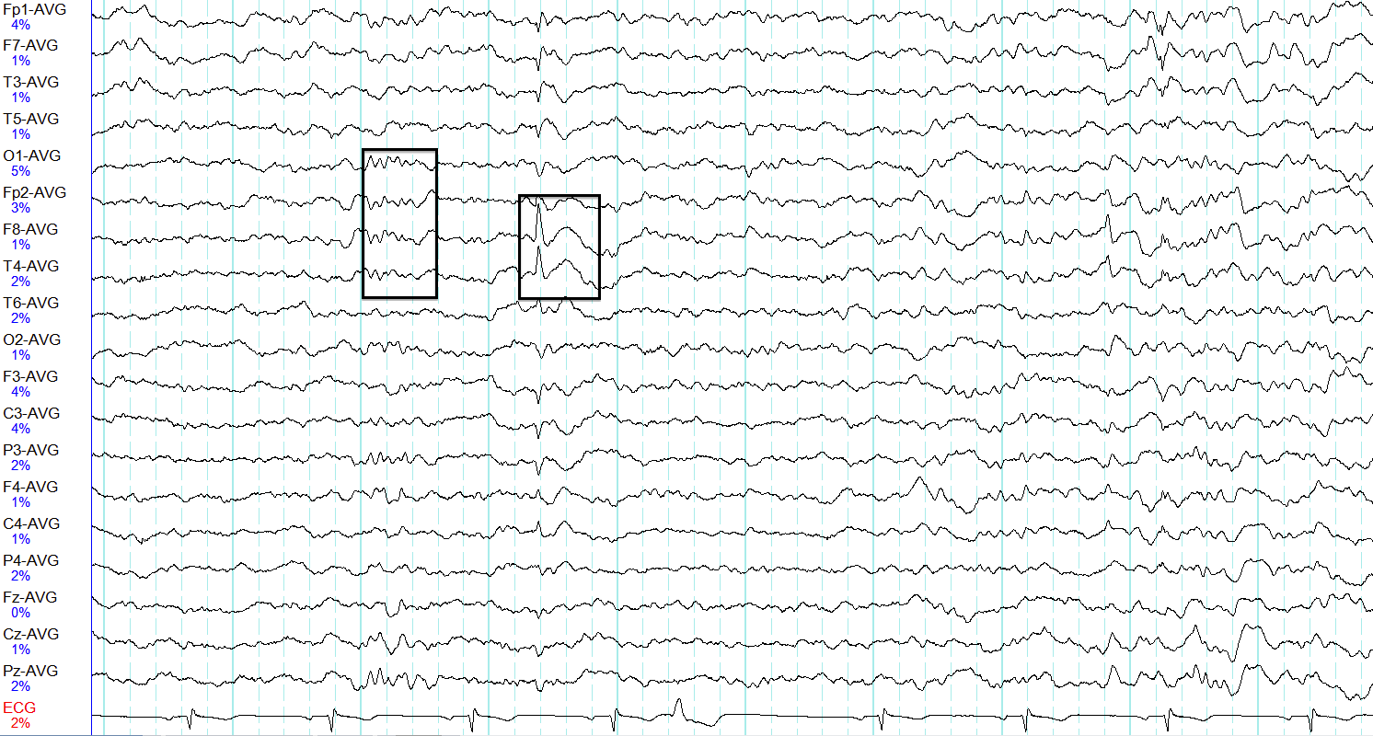
Figure 7: Middle of a generalized seizure (the beginning and end are not seen on this page).
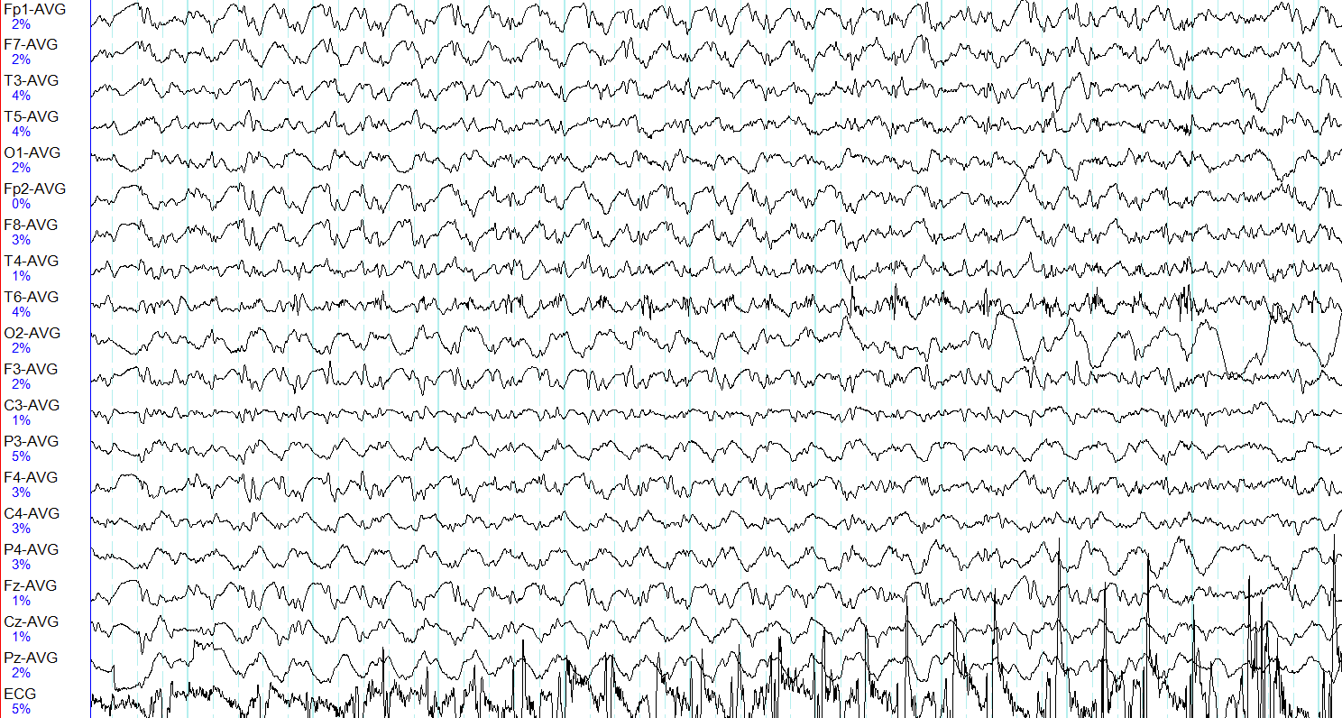

F2. Appendix 2: Bibliography
1. Wiebe, S., et al., Epidemiology of epilepsy: prevalence, impact, comorbidity and disparities. Can J Neurol Sci, 2009. 36 Suppl 2: p. S7-16.
2. Young, T., et al., The occurrence of sleep-disordered breathing among middle-aged adults. N Engl J Med, 1993. 328(17): p. 1230-5.
3. Schoeb, A. and J. Guttag, Application of machine learning to epileptic seizure detection., in International Converence on Machine Learning. 2010.
4. Chan, A.M., et al., Automated seizure onset detection for accurate onset time determination in intracranial EEG. Clin Neurophysiol, 2008. 119(12): p. 2687-96.
5. Saab, M.E. and J. Gotman, A system to detect the onset of epileptic seizures in scalp EEG. Clin Neurophysiol, 2005. 116(2): p. 427-42.
6. Zandi, A.S., et al., Automated real-time epileptic seizure detection in scalp EEG recordings using an algorithm based on wavelet packet transform. IEEE Trans Biomed Eng, 2010. 57(7): p. 1639-51.
7. Warby, S.C., et al., Sleep-spindle detection: crowdsourcing and evaluating performance of experts, non-experts and automated methods. Nat Methods, 2014. 11(4): p. 385-92.
8. Malhotra, A., et al., Performance of an automated polysomnography scoring system versus computer-assisted manual scoring. Sleep, 2013. 36(4): p. 573-82.
9. Bastianini, S., et al., SCOPRISM: a new algorithm for automatic sleep scoring in mice. J Neurosci Methods, 2014. 235: p. 277-84.
10. Law, E. and L. von Ahn, Human Computation. Synthesis Lectures on Artificial Intelligence and Machine Learning. 2011: Morgan and Claypool. 121.
11. Eiben, C.B., et al., Increased Diels-Alderase activity through backbone remodeling guided by Foldit players. Nat Biotechnol, 2012. 30(2): p. 190-2.
12. Vijayanarasimhan, S. and K. Grauman, What's it going to cost you?: Predicting effort vs. informativeness for multi-label image annotations, in Computer Vision and Pattern Recognition, 2009. 2009, IEEE: Miami, FL. p. 2262-2269.
13. von Ahn, L., Duolingo: learn a language for free while helping to translate the web, in Intelligent User Interfaces. 2013. p. 1-2.
14. Mason, W. and S. Suri, Conducting behavioral research on Amazon's Mechanical Turk. Behav Res Methods, 2012. 44(1): p. 1-23.
15. Law, E. and L. von Ahn, Input-Agreement: A New Mechanisms for Collecting Data Using Human Computation Games, in Computer Human Interaction. 2009: Boston. p. 361-374.
16. von Ahn, L. and L. Dabbish, Labeling images with a computer game, in Computer Human Interfaces. 2004. p. 319-326.
17. von Ahn, L. and L. Dabbish, General techniques for designing games with a purpose, in Communications of the ACM. 2008. p. 58-67.
18. von Ahn, L., et al., reCAPTCHA: human-based character recognition via Web security measures. Science, 2008. 321(5895): p. 1465-8.
19. Zhu, T., et al., Crowd-sourced annotation of ecg signals using contextual information. Ann Biomed Eng, 2014. 42(4): p. 871-84.
20. Zhu, T., et al., An intelligent cardiac health monitoring and review system, in Appropriate Healthcare Technologies for Low Resource Settings (AHT), The 8th International Converence. 2014.
21. Dietterich, T., Ensemble methods in machine learning, in First Internatioanl Workshop on Multiple Classifier Systems, Lecture Notes in Computer Sciene. 2000.
22. Blum, A. and T. Mitchell. Combining labeled and unlabeled data with co-training. in 11th Annual Conference on Computational Learning Theory. 1998.

