CloudOps Team
ARCHITECTURE OVERVIEW
SAS Viya · EKS · DAMS · RDS Aurora · EFS
AWS Production Environment — Component & Network Reference
Version | v1.0 — draft
Date | 11/09/2026
Owner | CloudOps Team
Environment | AWS Production — SAS Viya / DAMS
Classification | INTERNAL / CONFIDENTIAL

1. Executive Summary
This document provides a reference architecture overview of the AWS production environment hosting SAS Viya and the DAMS (Data Asset Management System) platform. It is intended for CloudOps engineers responsible for day-to-day operations, onboarding, and knowledge transfer.

The environment is built on three primary compute layers:
• Amazon EKS — orchestrates all SAS Viya microservices (compute, CAS, Studio, Logon, Data Agent) using managed node groups scaled by Karpenter.
• Amazon EC2 — hosts the DAMS application (PHP + Apache/Nginx), accessed exclusively through AWS Systems Manager — no bastion host required.
• Amazon RDS Aurora — provides PostgreSQL (for DAMS) and optionally MySQL (for SAS Viya internal services), deployed as Serverless v2 in Multi-AZ configuration.

Deployment automation follows a GitOps model: Argo CD continuously reconciles the cluster state against manifests stored in Azure DevOps Git repositories. Container images are served from a self-hosted Harbor registry accessible within the VPC.

⚠ WARNING
All values in <angle-brackets> are placeholders to be filled in during reverse-engineering of the environment. See Section 8 (Inventory Checklist) for the full list.

2. Architecture Diagram
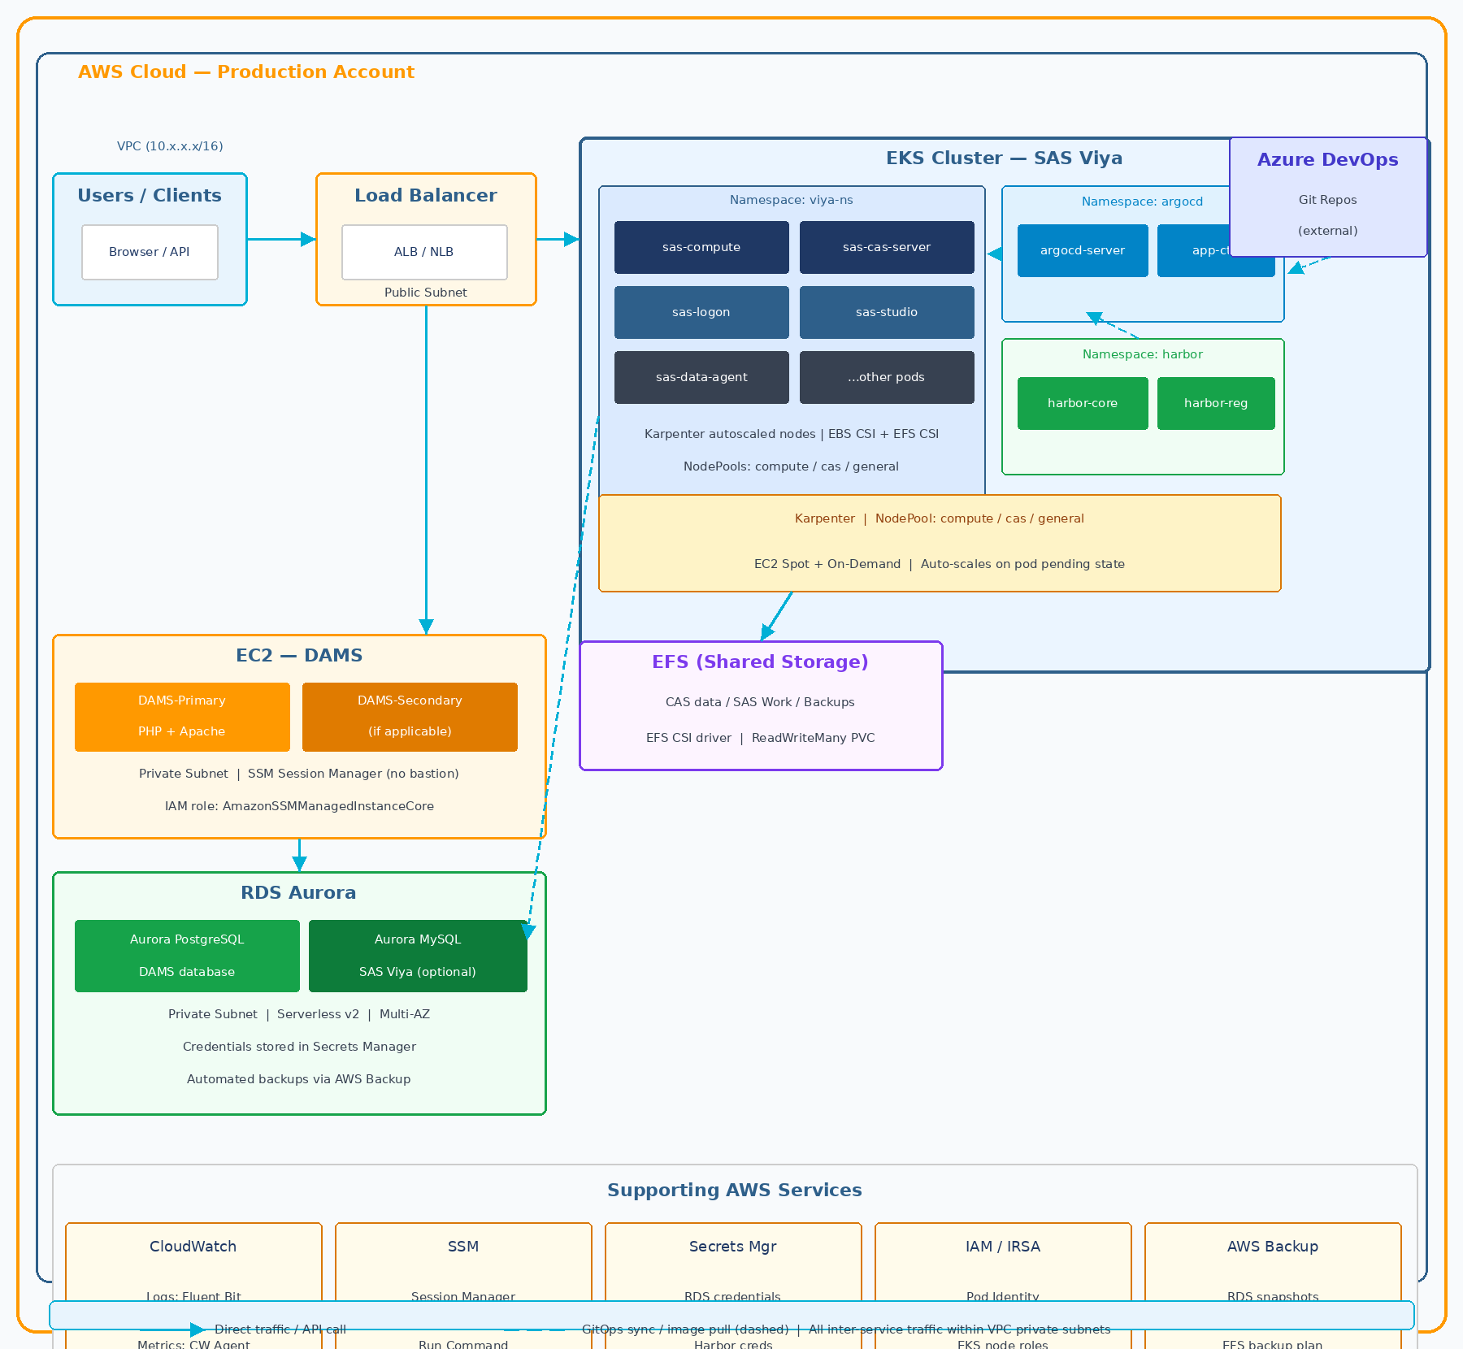
Figure 1 — High-level AWS architecture for the SAS Viya / DAMS production environment.

Key architectural principles:
• All compute (EKS nodes, EC2 DAMS) runs in private subnets — no direct internet exposure.
• Internet traffic is terminated at the ALB/NLB in the public subnet; all downstream communication is internal.
• EC2 DAMS instances are managed exclusively via SSM Session Manager — no SSH ingress, no bastion host.
• RDS Aurora clusters reside in isolated DB subnets with Security Group access restricted to EKS nodes and EC2 DAMS only.
• EFS is mounted read-write-many by EKS pods via the EFS CSI driver and dedicated PersistentVolumeClaims.
• GitOps: Argo CD pulls manifests from Azure DevOps; the cluster never receives direct kubectl apply from CI pipelines.

3. EKS Cluster — SAS Viya

3.1 Cluster Configuration
Parameter | Value
Cluster Name | <CLUSTER_NAME>
AWS Region | <REGION>
Kubernetes Version | <K8S_VERSION> (check: kubectl version)
EKS API Endpoint | Private (no public endpoint)
CNI Plugin | Amazon VPC CNI (aws-node daemonset)
DNS | CoreDNS (namespace: kube-system)
Ingress | AWS Load Balancer Controller + Ingress resources
Storage CSI | EBS CSI Driver + EFS CSI Driver
Node Autoscaler | Karpenter (replaces Cluster Autoscaler)
IRSA / Pod Identity | OIDC provider enabled — pods use IAM roles via IRSA

3.2 Node Groups / Karpenter NodePools
NodePool / Group | Instance Types | Purpose
<NODEPOOL_COMPUTE> | r6i.2xlarge, r6i.4xlarge (Spot) | SAS Compute pods
<NODEPOOL_CAS> | r6i.8xlarge, r6i.16xlarge (On-Demand) | CAS Server (memory-intensive)
<NODEPOOL_GENERAL> | m5.xlarge, m5.2xlarge (Spot) | General workloads, Argo CD, Harbor
System Node Group | t3.medium / m5.large (On-Demand) | kube-system, karpenter daemonsets
ℹ INFO
Actual instance types may differ. Run: kubectl get nodepools -o yaml to discover real configuration.

3.3 Key Namespaces
Namespace | Contents | Notes
<viya-ns> | All SAS Viya microservices | Primary application namespace
argocd | Argo CD server + controllers | GitOps engine
harbor | Harbor registry pods | Private container registry
karpenter | Karpenter controller | Node provisioning
kube-system | CoreDNS, VPC CNI, CSI drivers | Kubernetes system components
monitoring | CloudWatch Agent, Fluent Bit | Observability stack

3.4 SAS Viya Key Services
Service / Pod Prefix | Type | Notes
sas-cas-server | StatefulSet | CAS in-memory analytics engine — restart interrupts active sessions
sas-compute | Deployment | SAS Compute server for job execution
sas-studio | Deployment | SAS Studio web IDE
sas-logon | Deployment | Authentication / OAuth2 / LDAP
sas-data-agent | Deployment | Data connectivity agent
sas-cacheserver | StatefulSet | Redis-based cache — stateful
sas-postgres | StatefulSet | Internal SAS metadata DB (if not using RDS)
sas-consul-server | StatefulSet | Service discovery / config store
ℹ INFO
Run: kubectl get deployments,statefulsets -n <viya-ns> to get the actual list with real names.

4. DAMS — EC2 Application Layer

4.1 Instance Configuration
Parameter | Value
Instance Name Tag | DAMS-* (discover: aws ec2 describe-instances --filters "Name=tag:Name,Values=DAMS-*")
Instance Type | <INSTANCE_TYPE> (e.g. m5.xlarge)
OS | Ubuntu / Amazon Linux 2 (TBD — check via SSM)
Application Stack | PHP + Apache2 OR Nginx + PHP-FPM
Subnet | Private subnet — no public IP assigned
Access Method | SSM Session Manager — no SSH, no bastion
IAM Role | <DAMS_INSTANCE_ROLE> with SSM + Secrets Manager permissions
Storage | EBS root volume + optional data volume

4.2 Key File Paths (to verify via SSM)
Item | Path / Command
Application root | /var/www/html/ or /opt/dams/ (check ls /var/www/)
Apache config | /etc/apache2/sites-enabled/*.conf
Nginx config | /etc/nginx/sites-enabled/*.conf
Apache error log | /var/log/apache2/error.log
PHP-FPM error log | /var/log/php-fpm/error.log or /var/log/php*.log
PHP version check | php --version (via SSM Run Command)
Systemd service | systemctl status apache2 or nginx

4.3 Key Security Group Rules
Direction | Port | Source / Dest | Purpose
Inbound | 80 / 443 | ALB Security Group | Web traffic from load balancer
Outbound | 5432 | RDS Security Group | PostgreSQL — DAMS DB connection
Outbound | 443 | 0.0.0.0/0 (via NAT GW) | SSM, Secrets Manager, AWS APIs
Outbound | 2049 | EFS Security Group | EFS NFS mount (if applicable)
ℹ INFO
Verify actual Security Group rules via: aws ec2 describe-security-groups --group-ids <SG_ID>

5. RDS Aurora — Database Layer

5.1 PostgreSQL Cluster (DAMS)
Parameter | Value
Cluster Identifier | <POSTGRES_CLUSTER_ID>
Engine | Aurora PostgreSQL (compatible PostgreSQL 14/15)
Mode | Aurora Serverless v2 (ACU min/max — TBD)
Multi-AZ | Yes — writer + at least 1 reader replica
Writer Endpoint | <CLUSTER_ID>.cluster-<SUFFIX>.rds.amazonaws.com
Reader Endpoint | <CLUSTER_ID>.cluster-ro-<SUFFIX>.rds.amazonaws.com
Credentials | AWS Secrets Manager — secret name: <SECRET_NAME>
Subnet Group | Private DB subnets (isolated from app subnets)
Backup | AWS Backup plan — automated snapshots, retention: TBD days

5.2 MySQL Cluster (SAS Viya — if applicable)
Parameter | Value
Cluster Identifier | <MYSQL_CLUSTER_ID> (confirm: aws rds describe-db-clusters)
Engine | Aurora MySQL (compatible MySQL 8.0)
Mode | Serverless v2 or Provisioned (TBD)
Used by | SAS Viya internal services (if not using in-cluster sas-postgres)
Credentials | Stored in AWS Secrets Manager

5.3 Connection Architecture
• DAMS EC2 → Aurora PostgreSQL: Security Group rule, port 5432, credentials from Secrets Manager at runtime.
• EKS pods (SAS Viya) → Aurora MySQL: IRSA-authenticated Secrets Manager lookup, injected as env vars or mounted secrets.
• No direct public access to RDS — all connections originate from within the VPC.
• Aurora Serverless v2 scales ACU automatically; monitor with CloudWatch metric: ServerlessDatabaseCapacity.

6. Supporting AWS Services
Service | Role in Architecture | Key Details
Amazon EFS | Shared persistent storage for SAS Viya | PVC via EFS CSI driver | CAS data, SAS Work, backups | Access Mode: ReadWriteMany
AWS Secrets Manager | Credential store | RDS passwords, Harbor credentials, API keys — accessed via IRSA by pods and EC2 instance roles
AWS Systems Manager | EC2 management plane | Session Manager (shell), Run Command, State Manager (patching, Inspector2)
Amazon CloudWatch | Observability platform | Container Insights | Fluent Bit log shipping | Metric alarms | Log Insights queries
Fluent Bit | Log aggregation | DaemonSet on all EKS nodes | Forwards container stdout/stderr to CloudWatch Log Groups
CloudWatch Agent | Metrics collection | DaemonSet — node-level CPU/MEM/disk + Container Insights
AWS Backup | Backup orchestration | RDS automated snapshots + EFS backup plans | Retention TBD | Cross-region copy TBD
AWS IAM / IRSA | Identity & access control | OIDC provider on EKS | ServiceAccount → IAM Role mapping | Scoped permissions per workload
Amazon VPC | Network isolation | Public subnets (ALB), Private subnets (EC2/EKS), Isolated subnets (RDS) | NAT GW for egress
AWS LB Controller | Ingress / NLB provisioning | Watches Ingress/Service objects | Provisions ALB/NLB in public subnets automatically

6.1 GitOps Pipeline — Argo CD + Azure DevOps
• Manifests (Helm charts / Kustomize overlays) are stored in Azure DevOps Git repositories.
• Argo CD polls the repo every 3 minutes (default) or receives webhook triggers from Azure DevOps.
• On change: Argo CD applies the diff to the EKS cluster — no direct CI/CD kubectl apply.
• Harbor registry hosts all SAS Viya and DAMS container images; imagePullSecrets are configured per namespace.
• Azure DevOps pipelines build and push images to Harbor; Argo CD picks up the new tag via manifest update.

6.2 Network Flow Summary
From | To | Protocol / Port
Internet / Users | ALB (public subnet) | HTTPS 443
ALB | EKS Ingress (private) | HTTP 80 / HTTPS 443
ALB | DAMS EC2 (private) | HTTP 80 / HTTPS 443
DAMS EC2 | RDS Aurora PostgreSQL | TCP 5432
EKS pods (SAS) | RDS Aurora MySQL | TCP 3306 (optional)
EKS pods (SAS) | EFS mount target | NFS TCP 2049
EKS / EC2 | AWS APIs (SSM, SM, CW) | HTTPS 443 via NAT GW or VPC Endpoints
Argo CD | Azure DevOps Git (external) | HTTPS 443 via NAT GW
EKS nodes | Harbor Registry (internal) | HTTPS 443 via PrivateLink or internal DNS

7. IAM & Security Reference

7.1 Key IAM Roles
Role Name | Attached To | Key Permissions
<EKS_NODE_ROLE> | EKS managed node groups | AmazonEKSWorkerNodePolicy, AmazonEC2ContainerRegistryReadOnly, AmazonEKS_CNI_Policy
<KARPENTER_NODE_ROLE> | Karpenter-provisioned nodes | Same as node role + PassRole for Karpenter
<KARPENTER_CTRL_ROLE> | Karpenter controller (IRSA) | EC2 describe/create/terminate, pricing, SQS for interruption handling
<DAMS_INSTANCE_ROLE> | DAMS EC2 instances | AmazonSSMManagedInstanceCore, SecretsManagerReadWrite (scoped)
<ARGOCD_IRSA_ROLE> | Argo CD pods (IRSA) | Minimal read permissions on source repositories
<SAS_IRSA_ROLE> | SAS Viya pods (IRSA) | SecretsManager:GetSecretValue (RDS creds), S3 access (if applicable)

7.2 Secrets Manager Reference
Secret Name Pattern | Contains | Accessed By
<PREFIX>/dams/db | PostgreSQL host, port, user, password | DAMS EC2 instance role
<PREFIX>/viya/db | MySQL / SAS internal DB credentials | EKS pods via IRSA
<PREFIX>/harbor/admin | Harbor registry admin password | Argo CD / CI pipelines
<PREFIX>/saml/cert | SAML signing certificate (if applicable) | SAS Logon pods

ℹ INFO
Run: aws secretsmanager list-secrets --query "SecretList[*].Name" to enumerate all secrets and map them to the table above.

8. Environment Inventory — Fill-In Checklist
Complete this table by running the discovery commands listed in Section 8.1 against the AWS account:

Item | Status | Actual Value
AWS Account ID | ⬜ TODO
AWS Region | ⬜ TODO
VPC ID | ⬜ TODO
EKS Cluster Name | ⬜ TODO
Kubernetes Version | ⬜ TODO
SAS Viya Namespace | ⬜ TODO
Karpenter NodePool names | ⬜ TODO
DAMS EC2 Instance ID(s) | ⬜ TODO
DAMS EC2 Security Group ID | ⬜ TODO
RDS Aurora PostgreSQL Cluster ID | ⬜ TODO
RDS Aurora MySQL Cluster ID | ⬜ TODO
RDS Security Group ID | ⬜ TODO
EFS File System ID | ⬜ TODO
Argo CD Server URL | ⬜ TODO
Harbor Registry URL | ⬜ TODO
CloudWatch Log Group (EKS) | ⬜ TODO
EKS Node IAM Role ARN | ⬜ TODO
DAMS EC2 IAM Role ARN | ⬜ TODO
Secrets Manager prefix / naming pattern | ⬜ TODO
NAT Gateway ID(s) | ⬜ TODO
ALB / NLB ARN | ⬜ TODO
AWS Backup Plan Name | ⬜ TODO
Azure DevOps Organisation URL | ⬜ TODO
Harbor imagePullSecret name (in EKS) | ⬜ TODO

8.1 Quick Discovery Commands
What to discover | Command
AWS Account ID + Region | aws sts get-caller-identity
EKS clusters | aws eks list-clusters --region <REGION>
EKS node groups | aws eks list-nodegroups --cluster-name <CLUSTER>
All RDS clusters | aws rds describe-db-clusters --query "DBClusters[*].DBClusterIdentifier"
DAMS EC2 instances | aws ec2 describe-instances --filters "Name=tag:Name,Values=DAMS-*"
EFS file systems | aws efs describe-file-systems
All Secrets Manager secrets | aws secretsmanager list-secrets --query "SecretList[*].Name"
Karpenter NodePools | kubectl get nodepools OR kubectl get provisioners
All namespaces | kubectl get namespaces
All deployments + statefulsets | kubectl get deploy,sts -n <viya-ns>
VPCs and subnets | aws ec2 describe-vpcs / aws ec2 describe-subnets
Security Groups | aws ec2 describe-security-groups --filters "Name=tag:Name,Values=*"

9. Document Change Log
Version | Date | Author | Description
v1.0 | 11/09/2026 | CloudOps Team | Initial draft — reverse-engineered from environment inspection
v1.1
v1.2

⚠ WARNING
This document must be reviewed and updated after every major infrastructure change, DR test, or EKS version upgrade.

