

**SEN2022**

**SOFTWARE ENGINEERING ANALYSIS AND DESIGN**

**PROJECT REPORT**

Project Topic: Online Medical Scheduling System

Group Number: 2

Project Name: Need Medic!

Group Members:

Tolga Recep Mermer -1901820

Karcan Kublay -1901843

Ediz Özdil -1906811

Mehmed Arslan Aras -1902935

Responsibility Matrix

|  |  |
| --- | --- |
| Karcan Kublay | Chapter#1 |
| Ediz Özdil | Chapter#2 |
| Tolga Recep Mermer | Chapter#3 |
| Mehmed Arslan Aras | Chapter#4 |

Definition of the Project

Medical scheduling software is a type of software that helps medical offices atomale the patient scheduling process by allowing them to synchronize provider calendars and patient requests for appointments, as well as confirm available time slots.

Purpose of the Project

Patient management is made easier and more efficient with the use of online solutions. It not only offers your clinic a competitive edge, but it also relieves the administrative strain on your already overworked front-desk employees.

Scope of the Project

To create an environment where patients can choose an appointment more easily. To be able to reduce the queue at Health Centers even a little bit and not to waste the time of people with urgent work.

Project Constraints

🡪 Schedule: The new system must be operational by June 12.

🡪 Cost: The new system cannot cost upper than $10,000.

🡪 Policy: The new system must ensure the people needs.

🡪 Scope: The new system must save time for staff and patients.

Project Actors

🡪 Patient: Who create a appointment on the system.

🡪 System Administrator: Who controls the system.

🡪 Health Employee: Who monitor the appointments.

Functional Requirements of the Project

🡪The patient shall display the schedule of the meeting.

🡪The health employee can edit the information of patients and reschedule patients appointments.

🡪The health employee shall display the list of patients who will come on that day.

🡪 The system must send a confirmation mail when patient create the meeting successfully.

🡪The system must allow users to verify their accounts using their social security number.

Nonfunctional Requirements of the Project

🡪 The website’s load time should not be more than two second for users. (Performance)

🡪 A website should be capable enough to handle 10,000 users with affecting its performance. (Design)

🡪 The software should be portable so moving from one OS to other OS does not create any problem. (Portability)

🡪 If the Online Medical Scheduling System become unavailable, system should be under the maintenance for approximately four hours. (Maintainability)

🡪 Only the users with the role “Admin” can view the patient’s social security number. (Security)

🡪 The website’s interface should be easy to use. (Usability)

User Stories for the Project

Story 1:

As a patient, I'd like to see all of my upcoming appointments with any healthcare provider so that I can plan my time accordingly

Story 2:

The health employee edit the appointment description and/or comment on behalf of the patient with new information or rectify errors without having to cancel and rebook the appointment and risk losing the slot in the process as a health employee.

Story 3:

As a healthcare professional working for a health care organization, I'd like to have access to all open appointments so that a patient can be routed to the right care.

Story 4:

As a patient, I'd want to protect my account with a secure system, and when I make an appointment, I'd like to receive a confirmation code via email or phone.

Story 5:

I'd like to schedule an appointment for a registered patient as a healthcare professional at a healthcare organization so that I can properly manage their treatment.

SCENARIO 1

|  |  |
| --- | --- |
| Use case Name: | Check upcoming appointments |
| Use case Description: | The patient enters the system to learn the closest appointment date. The system displays the date and then the patient prepares his/her program according to this date. |

|  |  |
| --- | --- |
| Primary Actor: | Patient checks the upcoming appointments. |
| Support Actor(s): | Health employee who scheculed  the appoinments.  Authentication system authorizing patients. |

|  |  |
| --- | --- |
| Triggers: | The patients wants to check appointment schedule so clicks the button for learn. |
| Preconditions: | The patients must be registered with identification number.  The patients must have the appointment. |
| Postconditions: | The appointment should be placed in the schedule.  The appointment day will be placed in the system. |

|  |  |
| --- | --- |
| Normal Flow | 1.The patient wants to check his/her appointment.  2. The authentication system requests that the patient enters his/her identification number.  3- The patient enters his/her identification number.  4.The authentication system validates the patients.  5.The patients clicks the related button for the appointment information.  6-The system shows the information about the appointment to the patient. |
| Alternate Flows | If the identification number is invalid, an error message is displayed and patient re-enter the number.(Alt-Step 3)  If the health employee cancel the appointment, an informative message sent from the system.  (Alt-Step 6) |

|  |  |
| --- | --- |
| Bussiness Rules | The patient must be a registered to system. |

SCENARIO 2

|  |  |
| --- | --- |
| Use case Name: | Health employee wants to edit appointments. |
| Use case Description: | The health employee wants to edit appointments for their patients. |

|  |  |
| --- | --- |
| Primary Actor: | Health employee edits the appointments. |
| Support Actor(s): | Patient whose appointment is changed.  Authentication system authorizing health employee.  System administrator give a access to health employee for editting appointments. |

|  |  |
| --- | --- |
| Triggers: | The health employee wants to edit appointment so clicks the button for edit. |
| Preconditions: | The health employee must be registered with identification number.  The patients must have the appointment.  The health employee must have a permission for the edit. |
| Postconditions: | The appointment should be placed in the schedule.  The appointment day will be placed in the system. |

|  |  |
| --- | --- |
| Normal Flow | 1.The health employee wants to edit patient’s appointments.  2. The authentication system requests that the health employee enters his/her identification number.  3- The health employee enters his/her identification number.  4.The authentication system validates the health employee.  5.The health employee clicks the related button for the editing appointment.  6-The system shows the information about the appointment to the health employee. |
| Alternate Flows | If the identification number is invalid, an error message is displayed and health employee re-enter the number.(Alt-Step 3)  If the health employee cancel the appointment, an informative message sent from the system.  (Alt-Step 6) |

|  |  |
| --- | --- |
| Bussiness Rules | The health employee must be a registered to system.  The health employee must have a permission to edit. |

SCENARIO 3

|  |  |
| --- | --- |
| Use case Name: | Health employee wants to see his/her daily schedule |
| Use case Description: | The health employee enters the system to learn the daily appointments. The system displays appointments and then the health employee prepares his/her program according to this schedule. |

|  |  |
| --- | --- |
| Primary Actor: | The administrator shows the daily schedule. |
| Support Actor(s): | Patient whose appointment is that day.  Authentication system authorizing health employee.  System administrator give a access to health employee for shows appointments. |

|  |  |
| --- | --- |
| Triggers: | The health employee wants to display appointment so clicks the button. |
| Preconditions: | The health employee must be registered with identification number.  The patients must have the appointment in that day.  The health employee must have a permission for the display schedule. |
| Postconditions: | The appointment should be placed in the schedule.  The appointment day will be placed in the system. |

|  |  |
| --- | --- |
| Normal Flow | 1.The health employee wants to display patient’s appointments.  2. The authentication system requests that the health employee enters his/her identification number.  3- The health employee enters his/her identification number.  4.The authentication system validates the health employee.  5.The health employee clicks the related button for the display appointments.  6-The system shows the information about the appointment to the health employee. |
| Alternate Flows | If the identification number is invalid, an error message is displayed and patient re-enter the number.(Alt-Step 3)  If the health employee cancel the appointment, an informative message sent from the system.  (Alt-Step 6)  If the health employee’s schedule is empty, an informative message sent from the system to a health employee.(Alt- Step 5) |

|  |  |
| --- | --- |
| Bussiness Rules | The health employee must be a registered to system.  The health employee must have a permission to show. |

Scenario 4

|  |  |
| --- | --- |
| Use case Name: | Patients wants to secure their personal information |
| Use case Description: | Patients wants to protect with a secure system via confirmation code |

|  |  |
| --- | --- |
| Primary Actor: | The administrator sends a confirmation code to a patient. |
| Support Actor(s): | Patient who wants to receive confirmation code.  Authentication system authorizing patient. |

|  |  |
| --- | --- |
| Triggers: | The patients wants to security. |
| Preconditions: | The patients must be registered with identification number.  The patients must have the e-mail and phone number.    The administrator must have a permission for the send code. |
| Postconditions: | The e-mail and phone number will be placed in the system. |

|  |  |
| --- | --- |
| Normal Flow | 1.The patient wants to security.  2. The authentication system requests that the patient enters his/her identification number.  3- The patients enters his/her identification number.  4.The authentication system validates the patitents.  5.The patient clicks the confirmation button.  6-The administrator sends a code via e-mail or phone number.  7-The patient gets the code and write it to related place.  8-The system shows the information about the appointment with code to the patient. |
| Alternate Flows | If the identification number is invalid, an error message is displayed and patient re-enter the number.(Alt-Step 3)  If the confirmation code is nonfunctional, an error message is displayed into the screen and patient re-enter the confirmation code(Alt-Step 7)  If the health employee cancel the appointment, an informative message sent from the system.  (Alt-Step 8) |

|  |  |
| --- | --- |
| Bussiness Rules | The patient must be a registered to system.  The administrator must have a permission to edit.  The patient must be a registered with e-mail and phone number. |

SCENARIO 5

|  |  |
| --- | --- |
| Use case Name: | Health employee wants to schedule known patient’s appointments. |
| Use case Description: | The health employee wants to reschedule appointments for their known patients. |

|  |  |
| --- | --- |
| Primary Actor: | Health employee reschedule the appointments. |
| Support Actor(s): | Patient who known from the health employee.  Authentication system authorizing health employee.  System administrator give a access to health employee for schedule appointments. |

|  |  |
| --- | --- |
| Triggers: | The health employee wants to reschedule appointment so clicks the button for schedulize. |
| Preconditions: | The health employee must be registered with identification number.  The patient must be registered with identification number.  The patients must have the appointment.  The patient must have arrived in the past weeks.  The health employee must have a permission for the schedulize. |
| Postconditions: | The patient should be placed in the patient list.  The previous appointment day will be placed in the system. |

|  |  |
| --- | --- |
| Normal Flow | 1.The health employee wants to reschedule known patient’s appointments.  2. The authentication system requests that the health employee enters his/her identification number.  3- The health employee enters his/her identification number.  4.The authentication system validates the health employee.  5.The health employee clicks the related button for the schedulize appointment.  6-The system shows the information about the previous patient’s schedule. |
| Alternate Flows | If the identification number is invalid, an error message is displayed and patient re-enter the number.(Alt-Step 3)  If the previous patient dies the appointment cannot schedulize(Alt-Step 6) |

|  |  |
| --- | --- |
| Bussiness Rules | The health employee must be a registered to system.  The patient must be a registered to system.  The health employee must have a permission to schedule. |

Use-Case Diagram 1

Use-Case Diagram 2

Use-Case Diagram 3

Use-Case Diagram 4

Use-Case Diagram 5

Sequence Diagram 1

Sequence Diagram 2

Sequence Diagram 3

Sequence Diagram 4

Sequence Diagram 5

Activity Diagram 1

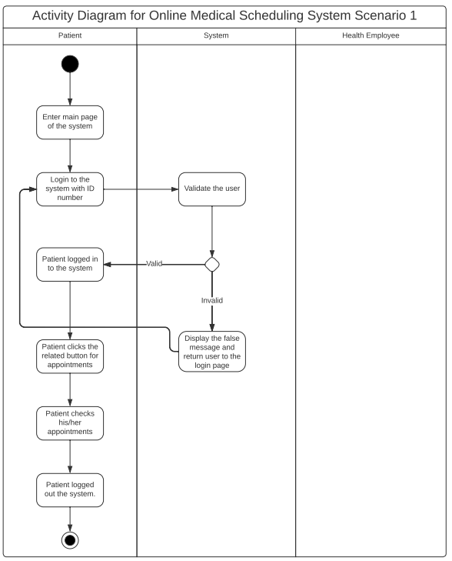

Activity Diagram 2

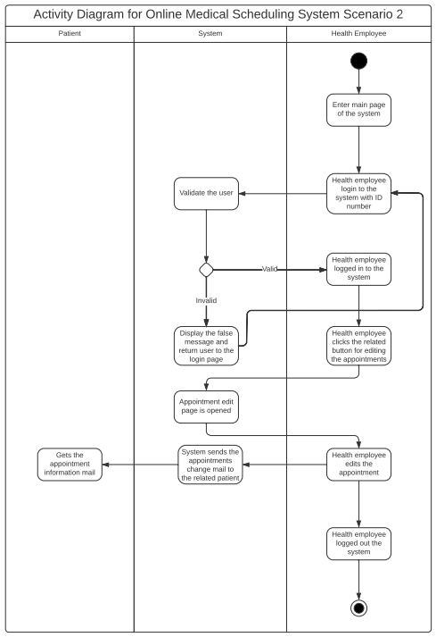

Activity Diagram 3

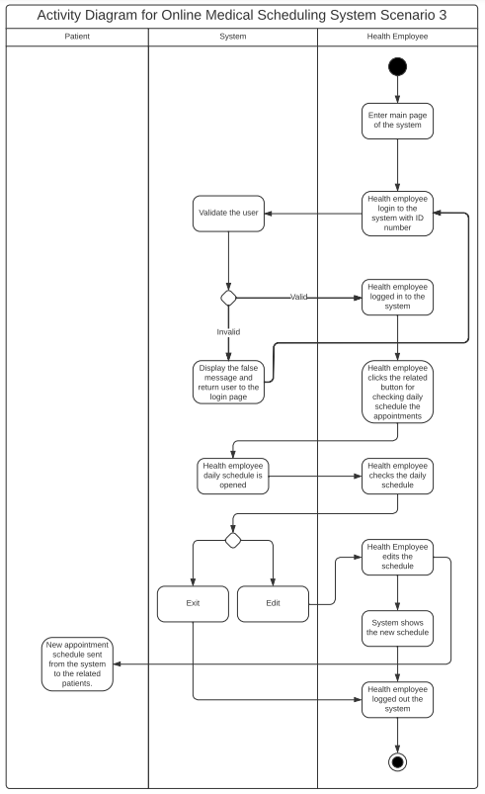

Activity Diagram 4

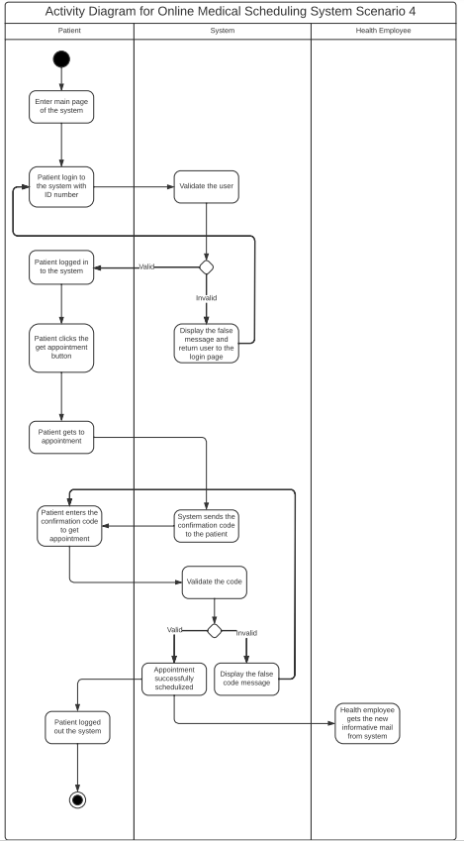

Activity Diagram 5

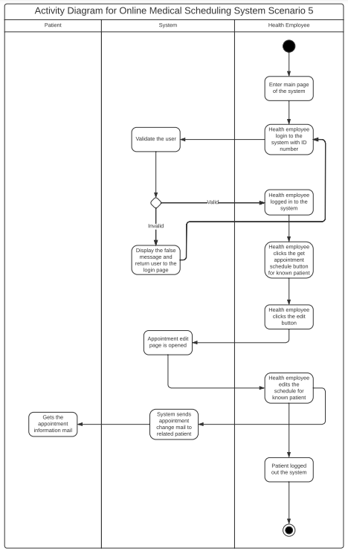

Context Level DFD

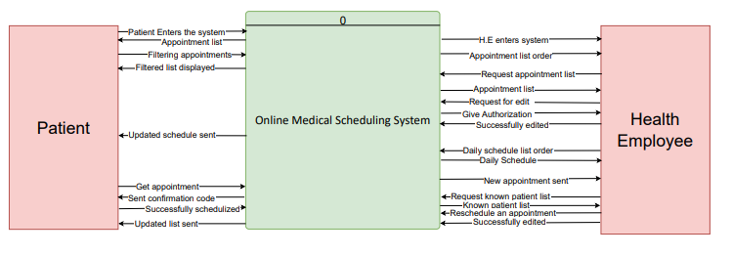

Level-0 DFD

