

SEN3003

Software Project Management Project

**Team GOAT**

|  |  |  |
| --- | --- | --- |
| **Submitted by:** | **Sarper Sarp (Project Manager)** | **1904479** |
|  | **Çağatay Tuğcu** | **1903204** |
|  | **Güngör Parlak** | **1904463** |
|  | **Aslıhan Gök** | **1904390** |
|  | **Doğa Yıldız** | **1903558** |
|  | **Ediz Özdil** | **1906811** |

**Mehmed Arslan Aras 1902935**

**Doruk Üngör 1902978**

**Subject to: Assoc. Prof. Yücel Batu Salman**

# Scope and Objectives

|  |  |
| --- | --- |
| **Name of the Project** | Transportation Portal Mobile Application |
| **Objective / Vision** | Transportation Portal Mobile Application mainly focused on that enables city residents and guests to learn more about a city’s transportation-related features. Aspects include details about available public transportation, schedules, costs, money-handling procedures, and other things (tutorial). The application may also offer current bus and other public transportation locations in real-time. |
| **Functional Requirements** | The users will also be able to see how much it costs by taxi.  The users can see the departure and arrival times of a transportation vehicle of their choice.  The users can find out how many different ways they can get to their destination.  The users can find out how to get to a location as quickly as possible.  The users can view transportation card refills at nearby points.  The users will be able to find out how much the whole road will cost.  The users scan change her current location while creating her route.  The users can name and save frequently used destinations, such as work, school and home. |
| **Non-Functional Requirements** | The system has to show all the steps of the route to go.  The system should have the working hours of all transportation vehicles.  The system should have approximate prices of all means of transport.  The system can send notification to users for out-of-service transportation lines if they wish.  The system will keep user’s information safe.  Public transport routes should always be up to date.  The system should show at least one option on the desired route. |

|  |  |
| --- | --- |
| **Stakeholders** | |
| Internal Stakeholders | External Stakeholders |
| Project Manager  Manages the project. Leads the project members and developers. | Users  The users who downloaded the application. |
| Project Team Members  Executes the project under the project manager's leadership. | Workers  People who controls the public transport vehicles that ensure the transmission of the necessary data. |
| Developers  Develops the applications of the platform. | Government  Stakeholder to be reached to obtain necessary permits. |

|  |  |
| --- | --- |
| **Objectives** | **Measure of effectiveness** |
| This application is a popular application among people who use public transport daily. | This application daily used by 60% of public transport users. |
| This application includes alternative transportation routes for people to arrive as soon as possible. | This application contains an average of 3 alternative routes per each result achieved. |
| This application is a public transit application that is the most preferred and contains the most data. | Thanks to this application, 90% of users can easily find the route they are looking for. |

The monthly agendas for the project meetings will be prepared by project manager Sarper

Sarp. The conferences will take place on Discord. The project manager will be mindful of the requirements of other team members. If required, he will plan meetings at irregular times.

**Relationship between Project and Strategic plan**

Transportation can always be complicated. This is exactly when you need a companion app at your fingertips. Who doesn't want a helper who can measure roads, timetables, and distances that can help everywhere in or out of the country, in or out of the city? Simply put, we've all wondered how much a taxi will cost for the distance we're going. This app will calculate and present you with how much to drive for an all-inclusive location. It will offer short or long options and will tell you to the minute. This project will be the kind of application that every person will need many times in their life.

**Installation standards and procedures**

Software installation standards refer to the guidelines and best practices that organizations follow when installing software on their systems. These standards help ensure that software is installed correctly and securely, and that any issues or errors are identified and resolved quickly. Some of the standards that organizations might follow include:

Version control: Keeping track of software versions and ensuring that the correct version is installed on each system.

Testing: Thoroughly testing software before installing it in a production environment.

Documenting changes: Keeping records of what software has been installed, when it was installed, and by whom.

Security: Ensuring that software is installed in a secure manner and that any security vulnerabilities are addressed before installation.

Compliance: Making sure that software installation adheres to any relevant regulations or industry standards, such as those set by HIPAA, SOC 2, ISO 27001.

Rollback: Having a plan for rolling back to a previous version of the software if the new version causes problems.

User acceptance testing: Getting users to test and approve the software before deployment to production.

Automation: Use of tools and frameworks to automate the installation and maintenance process.

Software installation procedures, on the other hand, refer to the specific steps and tasks that are performed during the software installation process. These procedures may include tasks such as:

Preparing the system for installation.

Downloading and verifying the software package.

Configuring the software and setting any necessary options.

Installing the software on the system.

Testing the software to ensure that it is working correctly.

Documenting the installation and any issues that were encountered.

Backing up the system before the installation.

Providing training to end-users on how to use the new software.

Maintaining and troubleshoot the software after installation.

These procedures may vary depending on the specific software being installed, the system it's being installed on, and the organization's policies and requirements.

**Project team Organization**

**Project as either objective or product driven**

Instead of focusing on a product, this project has a purpose. With the application that is being designed and developed, there are some objectives that are sought to be fulfilled. Based on these goals, the planning and design process will move forward.

**Other project characteristics**

Our application in our project can be easily used by all age groups. It will enable people to save time as an example that will help their daily lives in many areas. The project we are aiming for has a specific interface within measurable limits. The project is in specific, measurable, achievable, relevant and time bound for us.

**High-Level project risks**

Finalization of the project outside the specified time frame.

Poor performance within the system.

Exceeding the limits of the project budget.

The security of the data kept in the system is in danger.

Not being able to provide information from the necessary institutions about the change and cancellation of road works and transportation vehicles.

Lack of communication channels between staff and insufficient resources.

**User requirements concerning implementation**

Through the application, users will have easy access to many information such as directions, address information, ferry services, train times, and subway schedules. Users will be able to see many options for a destination. It will be able to view the costs of many options such as taxis, yellow minibuses, and minibuses. He will be able to get information about how long his journey will take. With the road options, he will be able to choose how many vehicles he can change at what time and how many minutes he will go to his destination.

**General life-cycle approach**

After researching among the methodologies in the Software Development Lifecycle, we ultimately decided to use the Agile Development Model. Among the reasons we made this decision, it was aimed to better control the project, to minimize increased flexibility, reduced risks, Continuous improvement, and documentation, and to ensure that the project concentrates more on implementing them, thus providing a faster and higher quality result.

**Overall resource estimates**

The development team is developing an application that is unique from the previous projects that have been developed. The project has a nominal degree of reliability about the security of the application. Development flexibility is high, but requirements change is formal and so the risk resolution exponent is rated low. Developers are familiar with the platform; therefore, the likelihood of any complications is low. The development team can work together in an office or in their home as a virtual Office, and the team cohesion is rated as high. In addition, the environment is informal according to its procedures. While the pressure rate of deadline is average, toolsets can be reached by the developers.

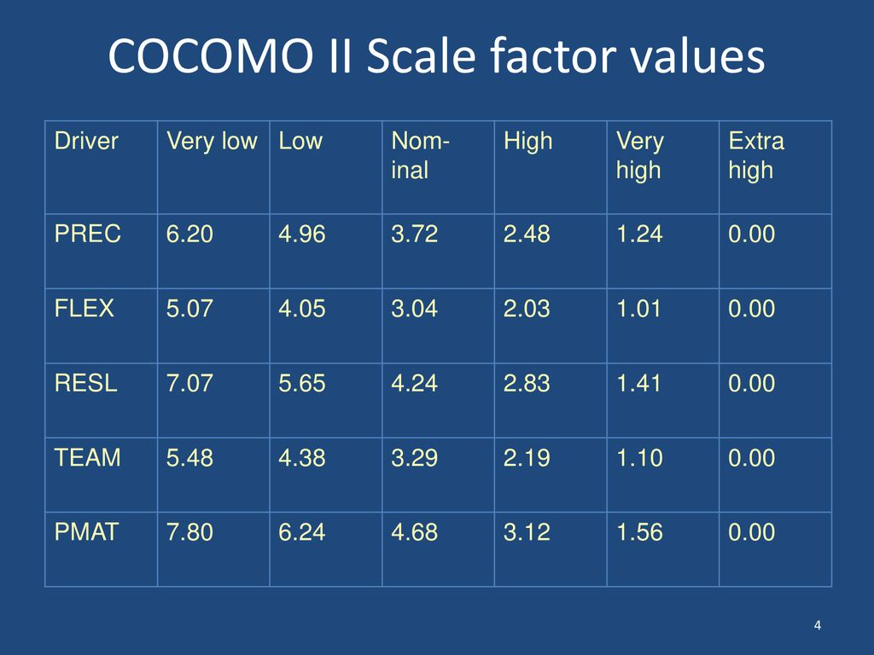

1. Scale factor

sf = B + 0.01 × Σ scale factor values

0.91 (B) + 0.01 × 4.96 (PREC low) + 2.03 (FLEX high) + 5.65 (RESL low) + 2.19

(TEAM high) + 4.68 (PMAT nominal)) = 1,1051

1. Effort multipliers

1.33 (RCPX high) × 0.95 (RUSE low) × 0.87 (PDIF low) × 0.83 (PERS high) × 0.87

(PREX high) × 1.00 (FCIL nominal) × 1.00 (SCED nominal) = 0.7937648145

1. Person months

The application contains 60.000 lines of code.

pm = A(size)(sf) × (em1) × (em2) × (em3) ….

= 2.94 × 60 ^1.1051 × 0.7937648145

= 215.314918154

≌ 215

**Project Products**

In the application, the cost of each transportation vehicle, how long it will reach, and the frequency of the trip will be available. In addition, it will offer many options for different transportation routes, and map extensions for all transportation routes will be included in our application. We will also announce new flights from within the application. You will be able to star your favorite places from the app. You will be able to examine all vehicle options one by one.

Quality criteria’s:

• The application should be accessible to users at all hours of the day. (Reliability)

• The application should protect users account information via related device.

(Security)

• The application's interface should be simple and understandable. (Usability)

• The application should record any interaction between the user and the system.

(Analyzability)

* The application will get updates frequently. (Maintainability)
* The application will work on all the mobile devices. (Portability)

**Generic Product Flows**

**Product Instances**

**Ideal Activity Network**

**Stages and Checkpoints**

**Effort Estimation of Activities**

**tablo içeren bir resim

Açıklama otomatik olarak oluşturuldu**

The given data from identify project products and activities is used for calculating effort instead of elapsed time.

Since some of the activities can be implemented simultaneously, we can observe some contradiction from elapsed time.

**Activity based Risks**

|  |  |  |  |
| --- | --- | --- | --- |
| Ref | Hazard Of Activity | Probability Level | Impact |
| R1 | General system changes | High | High |
| R2 | Target route is shown taking longer than expected | Moderate | Significant |
| R3 | Taxi fare is shown taking longer than expected | Low | High |
| R4 | Misunderstand test cases for system | Low | Moderate |
| R5 | Calculation system testing indicates errors | Significant | High |
| R6 | Route system testing indicates errors | Significant | High |
| R7 | Critical system bugs due to missing test cases | Low | Significant |
| R8 | System coding takes longer than expected | Moderate | Significant |
| R9 | Real-time performance deficiency in routing system | Low | Significant |
| R10 | Real-time performance deficiency in transportation filtering system | Low | Moderate |
| R11 | Security vulnerabilities in the system | High | High |

Probability Impacts

Low:R3,R4,R7,R9,R10

Moderate:R2,R4,R8,R10

Significant:R2,R5,R6,R7,R8,R9

High:R1,R3,R5,R6,R11

|  |  |
| --- | --- |
|  | Risk reduction / contingency measures |
| R1 | Use incremental development that having strict change control procedures. |
| R2 | Detailed route calculation report and all routes be extracted |
| R3 | Detailed fare calculation report and all routes be extracted |
| R4 | Test cases are checked by experienced testers (If necessary, a different tester is employed) |
| R5 | Prototyping method implemented successfully |
| R6 | Prototyping method implemented successfully |
| R7 | Use preferable analysis tools that have strict system testing procedures , hire preferable test engineers |
| R8 | Use multiple estimation and calculation methods |
| R9 | Benchmarking, prototyping, stress testing , tuning, use better analysis tools ,hire system analysts. |
| R10 | Benchmarking, prototyping, stress testing , tuning, use better analysis tools ,hire system analysts. |
| R11 | Better test engineer, better security softwares |

**Risk Reduction, Contingency Measures**

Risk = consequences × likelihood.

If we exceed the project budget, we should review the fees that we spent and get them again according to the determined budget.

This may be the reason why the project failed.

If we experience insufficient communication between staff and resources, the project manager should hold a meeting and convey the importance of communication to their staff.

This may be the reason why there are big differences in meaning within the project.

If the security of the data kept in the system is in danger, the necessary personnel and necessary software should be appointed by the project manager.

This may be the reason why theft of user data in the project

**Resource Allocation**

Aslıhan & Doğa & Ediz

Mehmed & Doruk

Sarper & Çağatay & Güngör

All

ADJUSTMENT TO PROJECT SCHEDULE

During the planning process, the project team found that there could be unplanned delays in the development of the software due to the problem of subtracting the shortest time due to the instant traffic flow of the application.

The team decided to make the following adjustments to the project plan to address this issue:

. Add 3 more weeks to keep the traffic flow up to date and have it updated to the system faster.

. Add 2 weeks to run the user training work pack to allow more time for user testing of the app.

ADJUSTMENT TO PROJECT BUDGET

Time allocated to user training workpacks to resolve issues and run test system will result in an increase in budget as follows

. Add $7500 to software development budget to keep traffic flow up to date

. Add $2000 to the user training budget to allow more time for user testing of the application

DOCUMENT PLAN

Scope: To ensure that people get to the place they will reach in daily life as soon as possible

Timeline: We created a timeline printout for the project, including any deadlines

Budget: We have estimated the costs associated with the project, including any resources or financing that will be required

Approach: We have defined the methodology to be used to achieve the project's objectives, including deadlines

Roles and Responsibilities: We have assigned specific roles and responsibilities to team members and stakeholders

OUR STRATEGIES FOR OBTAINING AGREEMENTS

Document aggrements: Clearly document any aggrements reached with stakeholders, including any roles, responsibilities, and expectation

Communicate clearly: Clearly explain the purpose, goals, and benefits of the project to stakeholders and address any questions or concerns they may have

Ask feedback: Invite stakeholders to provide input and feedback on the project plan and incorporate their suggestions as appropriate

Execute planning

First, we will need to conduct a requirements gathering and analysis to define the goals and objectives of the project. Then, we can design the functionality and user interface of the application. At this stage, we can conduct user research and testing to optimize the user experience.

Next, we will need to determine the technical implementation of the application. This includes identifying data sources, designing the database and back-end functionality, and selecting any necessary APIs and SDKs.

Finally, we can develop and test the application. This includes implementing and optimizing the performance of the application. Once the application is published, we can gather feedback from users and address any bugs or issues to improve the application over time.