**1. Create the Database**

CREATE DATABASE db_library;

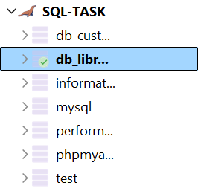

**Step 2: Create the Library Database and Table**

CREATE TABLE books (

book_id INT AUTO_INCREMENT PRIMARY KEY,

title VARCHAR(255) NOT NULL,

author VARCHAR(255) NOT NULL,

borrowed_date DATE

);





**Step 3: Data Entry (Add Sample Books)**

INSERT INTO books (title, author, borrowed_date)

VALUES

('The Great Gatsby', 'F. Scott Fitzgerald', '2024-06-01'),

('To Kill a Mockingbird', 'Harper Lee', '2024-06-05'),

('1984', 'George Orwell', '2024-06-10'),

('Pride and Prejudice', 'Jane Austen', '2024-06-12'),

('The Catcher in the Rye', 'J.D. Salinger', '2024-06-15'),

('Harry Potter and the Sorcerer\'s Stone', 'J.K. Rowling', '2024-06-18'),

('The Hobbit', 'J.R.R. Tolkien', '2024-06-20'),

('The Alchemist', 'Paulo Coelho', '2024-06-22'),

('The Diary of a Young Girl', 'Anne Frank', '2024-06-25'),  
('Animal Farm', 'George Orwell', '2024-06-28');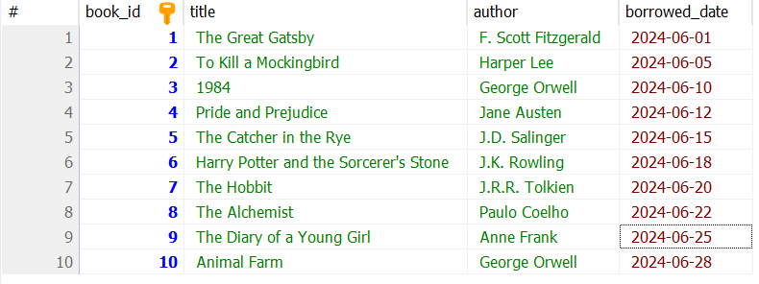

## **Step 4: Query Operations**

### **4.1 Find Books by Author**

Find all books by "George Orwell":

SELECT * FROM books

WHERE author = 'George Orwell';  
  
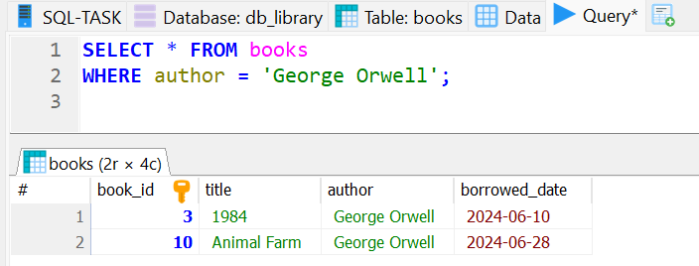

### **4.2 Find Books Borrowed on a Specific Date**

Find books borrowed on 2024-06-25:

SELECT * FROM books

WHERE borrowed_date = '2024-06-25';  
  
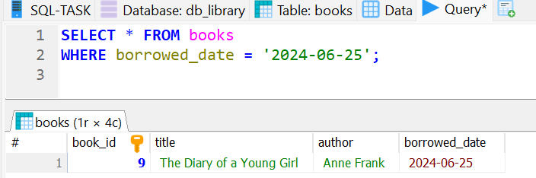

### **4.3 Find Books Borrowed After a Certain Date**

Find books borrowed after 2024-06-15:

SELECT * FROM books

WHERE borrowed_date > '2024-06-15';

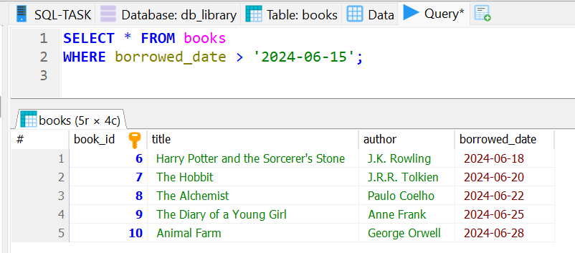

## **Step 5: Data Manipulation**

### **5.1 Update borrowed_date**

Update the borrowed date of the book "1984" to 2024-07-01:

UPDATE books

SET borrowed_date = '2024-07-01'

WHERE title = '1984';  
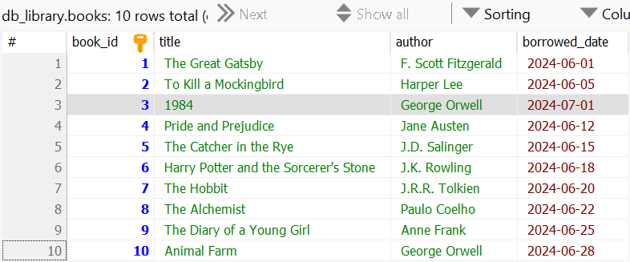

### **5.2 Delete a Book**

Delete "The Alchemist" from the database:

DELETE FROM books

WHERE title = 'The Alchemist';  
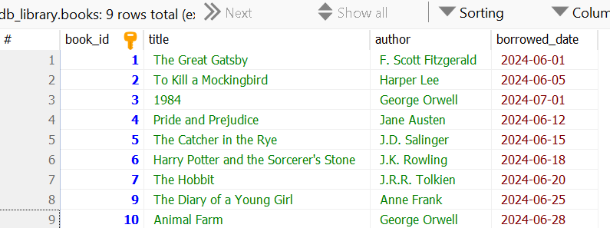

### **5.3 Re-add the Deleted Book**

Re-insert "The Alchemist" into the database:

INSERT INTO books (title, author, borrowed_date)

VALUES ('The Alchemist', 'Paulo Coelho', '2024-06-22');

