Lesson Plan for Pythagoras theorem:

1. Introduce students to right angled triangles.
2. Hypotenuse is the longest side as it is opposite to the greatest angle.
3. Introduction to Pythagorean theorem .

In a right angled triangle the square on the hypotenuse is equal to the sum of the squares on the other two sides.

A

B C

In the triangle ABC, AC is the hypotenuse, AB and BC are the legs of the triangle.

AC² = AB² + BC²

1. Introduction to Pythagorean triplets

3, 4, 5

5² = 3² + 4²

8. 6. 10

10² = 8² + 6²

General formula to form Pythagorean triples when one side is given

2m , m² - 1 , m² + 1

Eg. One side of a right angled triangle is 65, find the other two sides

m² + 1 = 65

m² = 64, m = 8

m² - 1 = 63

m² + 1 = 65

2m = 2 x 8 = 16

65² = 63² + 16²

4225 = 256 + 3969

1. Find the missing sides of the given triangles.

A

B C

Find the length of AB, if AC is 16 cm and BC is 12 cm.

a 12

9

14

9

X

Mr A leaves school to go home. He walks 4 blocks North and then3 blocks west. How far is he from the school?

Solution: 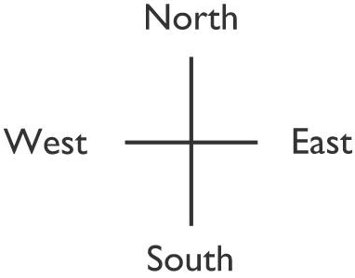

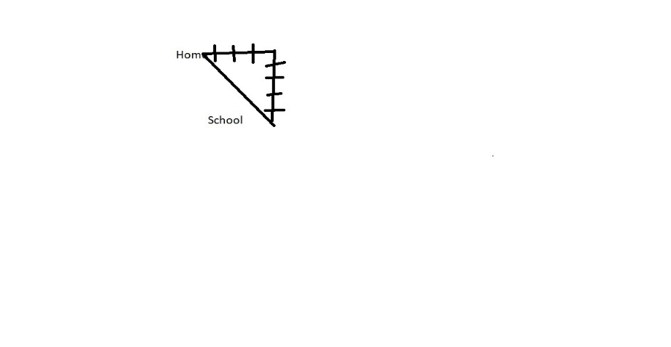

The missing side can be found using Pythagoras theorem

3² + 4² = 5²