## OLAH DANIEL CHIBUEZE

ENG1406196

DOOR COMBINATION LOCK ASSIGNMENT

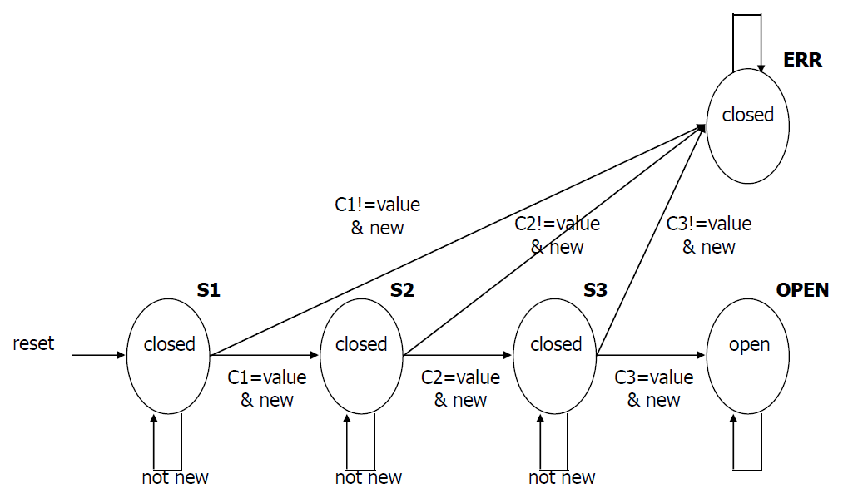

Fig 1.1 Door Combination Lock State Diagram

### 1.1 STATE TRANSITION TABLE

|  |  |  |  |  |  |  |
| --- | --- | --- | --- | --- | --- | --- |
| Reset | New | Equal | Current State | Next  State | Next  Mux | Open / Closed |
| 1 | X | X | X | S1 | C1 | closed |
| 0 | 0 | X | S1 | S1 | C1 | closed |
| 0 | 1 | 0 | S1 | ERR | X | closed |
| 0 | 1 | 1 | S1 | S2 | C2 | closed |
| 0 | 0 | X | S2 | S2 | C2 | closed |
| 0 | 1 | 0 | S2 | ERR | X | closed |
| 0 | 1 | 1 | S2 | S3 | C3 | closed |
| 0 | 0 | X | S3 | S3 | C3 | closed |
| 0 | 1 | 0 | S3 | ERR | X | closed |
| 0 | 1 | 1 | S3 | OPEN | X | closed |
| 0 | X | X | OPEN | OPEN | X | open |
| 0 | X | X | ERR | ERR | X | closed |

### 1.2 TABLE FOR ENCODING

|  |  |
| --- | --- |
| SYMBOLS | ENCODING |
| STATES | |
| S1 | 000 |
| S2 | 001 |
| S3 | 010 |
| OPEN | 011 |
| ERR | 100 |
| NEXT MUX | |
| C1 | 00 |
| C2 | 01 |
| C3 | 10 |

### 1.3 STATE TRANSITION TABLE WITH ENCODING

|  |  |  |  |  |  |  |
| --- | --- | --- | --- | --- | --- | --- |
| Reset | New | Equal | Current State  s0, s1, s2 | Next  State  n0, n1, n2 | Next  Mux  c0, c1 | Open / Closed |
| 1 | x | x | xxx | 000 | 00 | 0 |
| 0 | 0 | x | 000 | 000 | 00 | 0 |
| 0 | 1 | 0 | 000 | 100 | xx | 0 |
| 0 | 1 | 1 | 000 | 001 | 01 | 0 |
| 0 | 0 | x_ | 001 | 001 | 01 | 0 |
| 0 | 1 | 0 | 001 | 100 | xx | 0 |
| 0 | 1 | 1 | 001 | 010 | 10 | 0 |
| 0 | 0 | x | 010 | 010 | 10 | 0 |
| 0 | 1 | 0 | 010 | 100 | xx_ | 0 |
| 0 | 1 | 1 | 010 | 011 | xx | 0 |
| 0 | x | x_ | 011 | 011 | xx_ | 1 |
| 0 | __ | __ | 100 | 100 | xx | 0 |

## 2.0 OUTPUTS

The outputs are $n0,n1,n2,c0,c1∧Open$. The input variables are $r,n,e,s0,s1,s2$. The AtozMath’s Online Quine McCluskey tool was used to find the minimal expression for each output as shown in the following sections.

### 2.1 for n0

Minterm = 16,17,18,4,12,20,28

Don't Care = 5,6,7,13,14,15,21,22,23,29,30,31

Variable = r,n,e,s0,s1,s2

Prime implicant chart

|  |  |  |  |  |  |  |  |  |
| --- | --- | --- | --- | --- | --- | --- | --- | --- |
| PIs\Minterms | 4 | 12 | 16 | 17 | 18 | 20 | 28 | r,n,e,s0,s1,s2 |
| 16,17,20,21 |  |  | X | X |  | X |  | 010-0- |
| 16,18,20,22 |  |  | X |  | X | X |  | 010--0 |
| 4,5,6,7,12,13,14,15,20,21,22,23,28,29,30,31 | X | X |  |  |  | X | X | 0--1-- |

Extracted essential prime implicants : 0--1--,010-0-,010--0

All extracted essential prime implicants : 0--1--,010-0-,010--0

Minimal QuineMcCluskey Expression = $r's0+r'ne's1'+r'ne's2'$

### 2.2 for n1

Minterm = 25,2,10,26,3,11,19,27

Don't Care = 5,6,7,13,14,15,21,22,23,29,30,31

Variable = r,n,e,s0,s1,s2

Prime implicant chart

|  |  |  |  |  |  |  |  |  |  |
| --- | --- | --- | --- | --- | --- | --- | --- | --- | --- |
| PIs\Minterms | 2 | 3 | 10 | 11 | 19 | 25 | 26 | 27 | r,n,e,s0,s1,s2 |
| 25,27,29,31 |  |  |  |  |  | X |  | X | 011--1 |
| 2,3,6,7,10,11,14,15 | X | X | X | X |  |  |  |  | 00--1- |
| 3,7,11,15,19,23,27,31 |  | X |  | X | X |  |  | X | 0---11 |
| 10,11,14,15,26,27,30,31 |  |  | X | X |  |  | X | X | 0-1-1- |
| 5,7,13,15,21,23,29,31 |  |  |  |  |  |  |  |  | 0--1-1 |
| 6,7,14,15,22,23,30,31 |  |  |  |  |  |  |  |  | 0--11- |

Extracted essential prime implicants : 00--1-,0---11,011--1,0-1-1-

All extracted essential prime implicants : 00--1-,0---11,011--1,0-1-1-

Minimal QuineMcCluskey Expression = $r'n's1+r's1s2+r'nes2+r'es1$

### 2.3 for n2

Minterm = 24,1,9,26,3,11,19,27

Don't Care = 5,6,7,13,14,15,21,22,23,29,30,31

Variable = r,n,e,s0,s1,s2

Prime implicant chart

|  |  |  |  |  |  |  |  |  |  |
| --- | --- | --- | --- | --- | --- | --- | --- | --- | --- |
| PIs\Minterms | 1 | 3 | 9 | 11 | 19 | 24 | 26 | 27 | r,n,e,s0,s1,s2 |
| 24,26 |  |  |  |  |  | X | X |  | 0110-0 |
| 26,27,30,31 |  |  |  |  |  |  | X | X | 011-1- |
| 1,3,5,7,9,11,13,15 | X | X | X | X |  |  |  |  | 00---1 |
| 3,7,11,15,19,23,27,31 |  | X |  | X | X |  |  | X | 0---11 |
| 5,7,13,15,21,23,29,31 |  |  |  |  |  |  |  |  | 0--1-1 |
| 6,7,14,15,22,23,30,31 |  |  |  |  |  |  |  |  | 0--11- |

Extracted essential prime implicants : 00---1,0---11,0110-0

All extracted essential prime implicants : 00---1,0---11,0110-0

Minimal QuineMcCluskey Expression = $r'n's2+r's1s2+r'nes0's2'$

### 2.4 for c0

Minterm = 25,2,10

DontCare = 16,17,18,26,4,12,20,28,3,11,19,27,5,6,7,13,14,15,21,22,23,29,30,31

Variable = r,n,e,s0,s1,s2

Prime implicant chart

|  |  |  |  |  |
| --- | --- | --- | --- | --- |
| PIs\Minterms | 2 | 10 | 25 | r,n,e,s0,s1,s2 |
| 16,17,18,19,20,21,22,23 |  |  |  | 010--- |
| 17,19,21,23,25,27,29,31 |  |  | X | 01---1 |
| 2,3,6,7,10,11,14,15,18,19,22,23,26,27,30,31 | X | X |  | 0---1- |
| 4,5,6,7,12,13,14,15,20,21,22,23,28,29,30,31 |  |  |  | 0--1-- |

Extracted essential prime implicants : 0---1-,01---1

All extracted essential prime implicants : 0---1-,01---1

Minimal QuineMcCluskey Expression = $r's1+r'ns2$

### 2.5 for c1

Minterm = 24,1,9

DontCare = 16,17,18,26,4,12,20,28,3,11,19,27,5,6,7,13,14,15,21,22,23,29,30,31

Variable = r,n,e,s0,s1,s2

Prime implicant chart

|  |  |  |  |  |
| --- | --- | --- | --- | --- |
| PIs\Minterms | 1 | 9 | 24 | r,n,e,s0,s1,s2 |
| 1,3,5,7,9,11,13,15 | X | X |  | 00---1 |
| 1,3,5,7,17,19,21,23 | X |  |  | 0-0--1 |
| 16,18,20,22,24,26,28,30 |  |  | X | 01---0 |
| 16,17,18,19,20,21,22,23 |  |  |  | 010--- |
| 3,7,11,15,19,23,27,31 |  |  |  | 0---11 |
| 18,19,22,23,26,27,30,31 |  |  |  | 01--1- |
| 4,5,6,7,12,13,14,15,20,21,22,23,28,29,30,31 |  |  |  | 0--1-- |

Extracted essential prime implicants : 00---1,01---0

All extracted essential prime implicants : 00---1,01---0

Minimal QuineMcCluskey Expression = $r'n's2+r'ns2'$

### 2.6 for Open

Minterm = 3,11,19,27

DontCare = 5,6,7,13,14,15,21,22,23,29,30,31

Variable = r,n,e,s0,s1,s2

Prime implicant chart

|  |  |  |  |  |  |
| --- | --- | --- | --- | --- | --- |
| PIs\Minterms | 3 | 11 | 19 | 27 | r,n,e,s0,s1,s2 |
| 3,7,11,15,19,23,27,31 | X | X | X | X | 0---11 |
| 5,7,13,15,21,23,29,31 |  |  |  |  | 0--1-1 |
| 6,7,14,15,22,23,30,31 |  |  |  |  | 0--11- |

Extracted essential prime implicants : 0---11

All extracted essential prime implicants : 0---11

Minimal QuineMcCluskey Expression = $r's1s2$