System Design Document

XENO

**Client**

**Shawn Squire**

**Team 1**

Vesh Bhatt

Michael Bishoff

Edward LaFemina

Michael Lee

John Swank

2 March 2015

**1. Introduction**

Welcome to the XENO System Design Document.

**1.1 Purpose of This Document**

This document is to describe the design of the XENO application. This includes a high level system architecture and a lower level class designs.

**1.2 References**

Throughout this document references will be made to

1. System Requirements Specifications document
   1. Title: System Requirement Specifications
   2. Author: Team XENO
   3. Date: 2 March 2015

**2. System Architecture**

**2.1 Architectural Design**

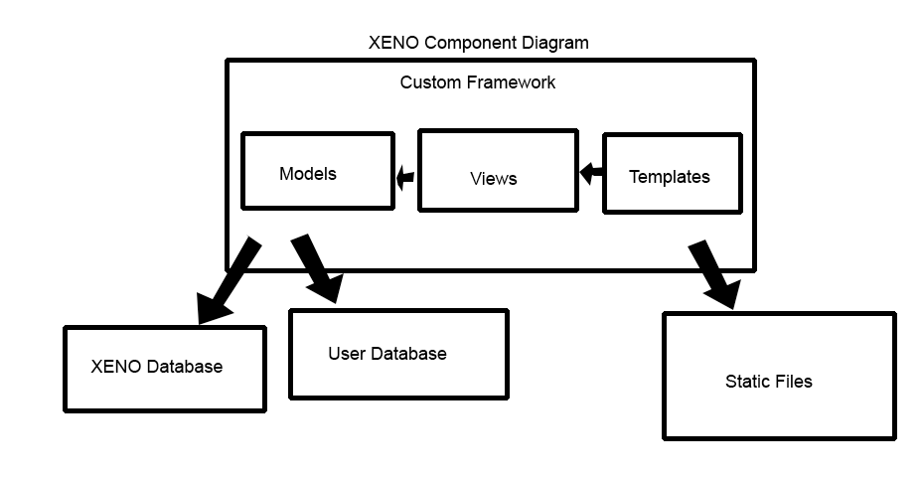

The XENO application will be built using the Python Flask framework. The basic components of the framework include Models, Views, and Templates which follow the Model View Controller architecture. The application will also use Python to complete the reoccurring tasks (i.e. queuing, adding points to all users, etc.)

The model layer consists of functions, each of which will refer to a specific table in MariaDB. All the data used in our application will be presented by a model object, with attributes from our database. The model functions will define car data and user data. The model object will be mapped to a database whether or not it is a car or user.

Templates are pages that are tailored to what the user is supposed to view and allow the reuse of HTML, CSS, and JavaScript without duplication. There is a single template (that consists of HTML, CSS, and JavaScript) for the parts of the website that remain the same through out the various pages, such as the menu bar. Using the Jinga2 language there is a special section defined within the template that allows other templates/pages to extend it.

More information can be found in the User Interface Design Document.

The views layer is a Flask function that will be a combination of both the models and templates layer. Our controller will take in the users request and populate a completed template to the user. For example, if a user searches for a certain car, it will interact with the model function and will get a response back with data for the car, which will then allow the users to see the completed template with information on the car.

**2.2 Decomposition Description**

When the XENO application receives a request for a web page, the request will be routed through the Apache Web Server into the Flask application, or controller. This controller will route the URI through the registered views. If the view is not found it will redirect the user to the 404 page. If the view is found, it will access the template file and any parent template files it extends, then any database calls required to substitute the model into the template (i.e. list of cars), and finally present the view to the user.

Access to the private pages, for which a user must be logged into access, are routed through the Flask framework’s Flask-Login module. This module provides the session management for users, i.e. sending cookies to users to maintain persistence of user validation and preferences.

Forms throughout the website are routed through the Flask framework’s Flask-WTForms module. This module provides form validation on both the Server and Client side all from one central place. Client side validation provides instant feedback to users and Server side validation ensures that no malformed data or commands are sent back to the database.

The main views in the XENO application are login, search, profile, account management, car management, car reservation, car maintenance, and Twitter integration. For each view there is one or more template(s) and models from the database. For example, the login view has one template and one model that has the fields presented to the user (username and password).

The diagram below depicts the low-level design for the XENO application and the Server and Client side interaction as described above:

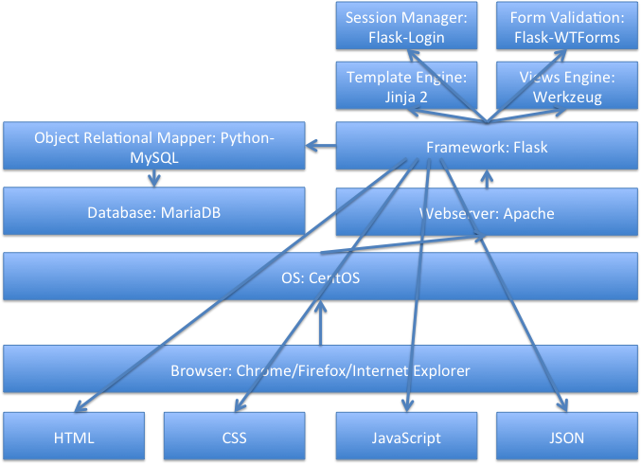

The queuing system in XENO is designed specifically to accommodate the lifestyle of our users. The queuing system consists of a python script that runs a check_avail_cars function every hour. This function queries the cars table to see which cars are available for checkout at that moment. It then send an email to the first N users in the queue for each car available, i.e. if 3 cars are available at that moment, the first 3 users on the queue will get an email stating those 3 cars are available to checkout, and then removed from the queue. The users can click on the link they received and checkout the car.

**3. Persistent Data Design**

**3.1 Database Description**

The XENO application utilizes the free and open-source MariaDB database to provide data persistence. An entity-relationship diagram of the XENO database schema can be found below. As seen in the diagram, the database is normalized and optimized specifically for the XENO application based on various factors, such as access specifications (read vs. write for fields). The XENO team also developed a custom abstraction class on top of the Python MySQL library to simplify database operations and reduce code duplication.

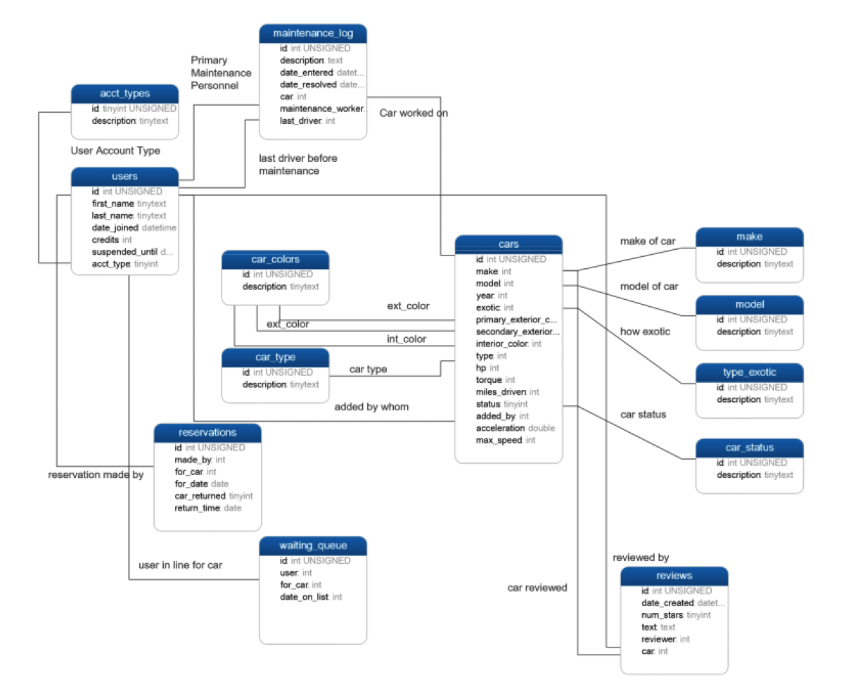

**4. Requirements Matrix**

Please refer to the System Requirements Specifications for details regarding the corresponding use cases.

XENO Requirements Matrix

**Search Car: Use Case #1**

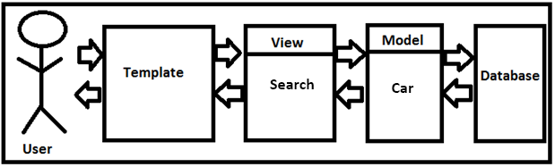

**Login: Use Case #2**

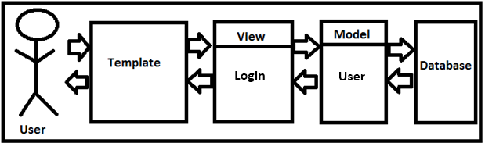

**View User Profile: Use Case #3**

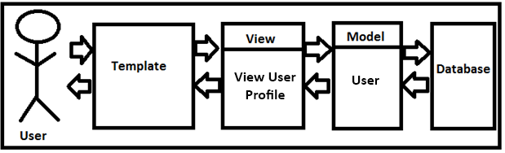

**Create Account: Use Case #4**

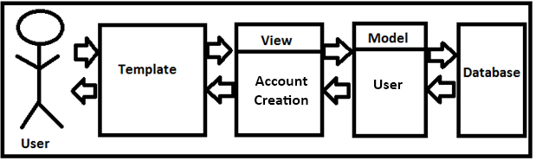

**Add Car: Use Case #5**

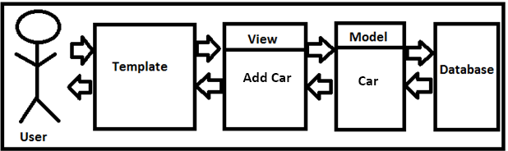

**Show/Hide/Remove Car: Use Case #6**

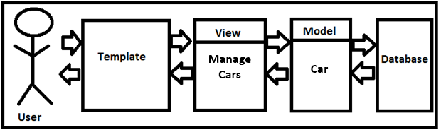

**Account Creation Management: Use Case #7**

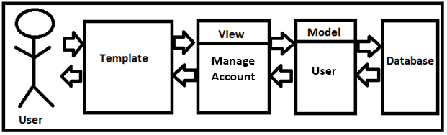

**Suspend/Ban Account: Use Case #8**



**Maintenance Disable/Enable Car: Use Case #9**



**Check In Car: Use Case #10**

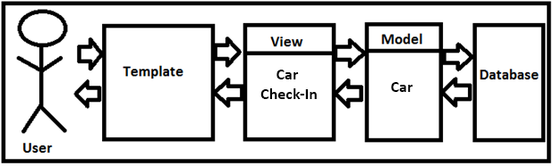

**View Maintenance Log: Use Case #11**



**Reserve Car: Use Case #12**

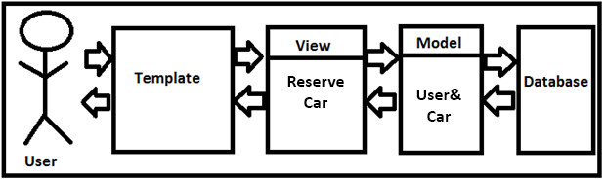

**Car Rental Queuing: Use Case #13**

**Queue Management (python)**

**Database**

**Email to User**

**Appendix A – Agreement Between Customer and Contractor**

The contractor, XENO, has met with customer Shawn Squire on February 13, 2015 to discuss what web application XENO will be creating. During the meeting, both parties agreed on what must be done and have informed one another about the procedure that must take place in the event there is a change to the document. In the event where there must be changes made to the document, XENO will email Shawn Squire with a draft of the modified document immediately, asking for approval.

**Customer: Shawn Squire**

Email: ssquire1@umbc.edu

Signature:_________________________________________________________________

Date:______________________________________________________________________

Comments:_____________________________________________________________________________________________________________________________________________

**Team: XENO**

Name: Edward LaFemina

Signature:_________________________________________________________________

Date:______________________________________________________________________

Comments:_____________________________________________________________________________________________________________________________________________

Name: John Swank

Signature:_________________________________________________________________

Date:______________________________________________________________________

Comments:_____________________________________________________________________________________________________________________________________________

Name: Michael Bishoff

Signature:_________________________________________________________________

Date:______________________________________________________________________

Comments:_____________________________________________________________________________________________________________________________________________

Name: Michael Lee

Signature:_________________________________________________________________

Date:______________________________________________________________________

Comments:_____________________________________________________________________________________________________________________________________________

Name: Vesh Bhatt

Signature:_________________________________________________________________

Date:______________________________________________________________________

Comments:_____________________________________________________________________________________________________________________________________________

**Appendix B – Team Review Sign-off**

As of 3/2/2015, all group members of XENO have reviewed the System Requirements Specifications (SRS) document and all have agreed the content and format of this document is correct. This document has been tailored to meet the client’s necessities for an online web application which will offer an online exotic car rental service to VIP customers.

**Team: XENO**

Name: Edward LaFemina

Signature:_________________________________________________________________

Date:______________________________________________________________________

Comments:_____________________________________________________________________________________________________________________________________________

Name: John Swank

Signature:_________________________________________________________________

Date:______________________________________________________________________

Comments:_____________________________________________________________________________________________________________________________________________

Name: Michael Bishoff

Signature:_________________________________________________________________

Date:______________________________________________________________________

Comments:_____________________________________________________________________________________________________________________________________________

Name: Michael Lee

Signature:_________________________________________________________________

Date:______________________________________________________________________

Comments:_____________________________________________________________________________________________________________________________________________

Name: Vesh Bhatt

Signature:_________________________________________________________________

Date:______________________________________________________________________

Comments:_____________________________________________________________________________________________________________________________________________

**Appendix C – Document Contributions**

Michael Lee - Was responsible for creating the diagrams for the System Design Document. Also, created Appendix A & B. Contributed work is around 60%

Edward LaFemina – Contributed by explaining how our model classes are designed. Contributed work is around 10%.

John Swank – Worked with Vesh on how the database will be set up and provided information on what model will be mapped to a database. Contributed work is around 10%.

Michael Bishoff – Contributed work by explaining how our template and view layer will work. Contributed work is around 10%

Vesh Bhatt – Worked with John on how the database will be set up and provided information on what model will be mapped to a database. Also documented the low-level system design and diagrams. Contributed work is around 10%.