System Design Document

XENO

**Client**

**Shawn Squire**

**Team 1**

Vesh Bhatt

Michael Bishoff

Edward LaFemina

Michael Lee

John Swank

25 February 2015

**1. Introduction**

Welcome to the XENO System Design Document.

**1.1 Purpose of This Document**

This document is to describe the design of the XENO application. This includes a high level system architecture and a lower level class designs.

**1.2 References**

Throughout this document references will be made to

1. System Requirements Specifications document
   1. Title: System Requirement Specifications
   2. Author: Team Xeno
   3. Date: February 25, 2015

**2. System Architecture**

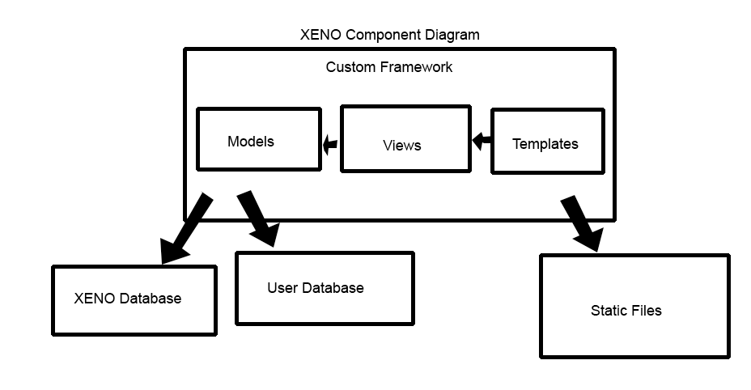**2.1 Architectural Design**

The XENO application will be built using a custom framework. The basic components of our framework include Models, Views, and Templates which follow the Model View Controller architecture.

The model layer consists of classes, each of which will refer to a specific table in MariaDB. All the data used in our application will be presented by a model object, with attributes from our database. The model classes will define car data and user data. The model object will be mapped to a database whether or not it is a car or user.

Templates are pages that are tailored to what the user is supposed to view. The pages will consist of HTML, CSS, Javascript, and other static files. More information can be found in the User Interface Design Document.

The views layer will be a combination of both the models and templates layer. Our controller will take in the users request and populate a completed template to the user. For example, if a user searches for a certain car, it will interact with the model class and will get a response back with data for the car, which will then allow the users to see the completed template with information on the car.

**4. Requirements Matrix**

Please refer to the System Requirements Specifications for details regarding the corresponding use cases.

XENO Requirements Matrix

**Search Car: Use Case #1**

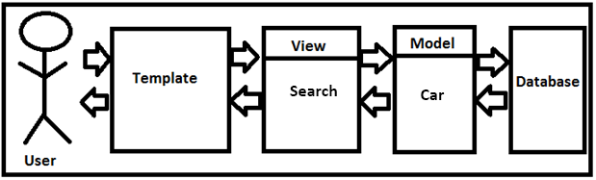

**Login: Use Case #2**

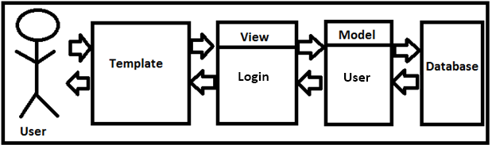

**View User Profile: Use Case #3**

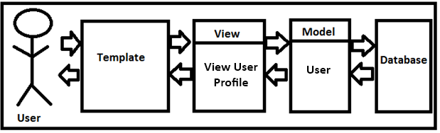

**Create Account: Use Case #4**

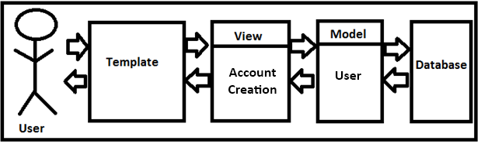

**Add Car: Use Case #5**

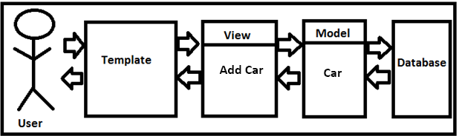

**Show/Hide/Remove Car: Use Case #6**

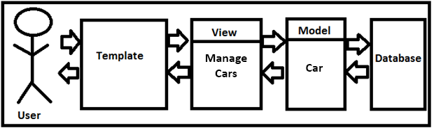

**Account Creation Management: Use Case #7**

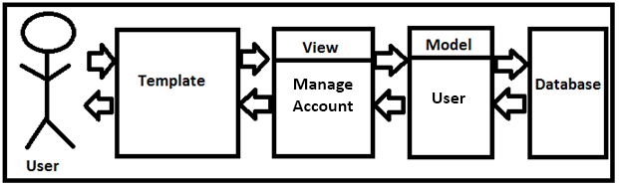

**Suspend/Ban Account: Use Case #8**



**Maintenance Disable/Enable Car: Use Case #9**



**Check In Car: Use Case #10**

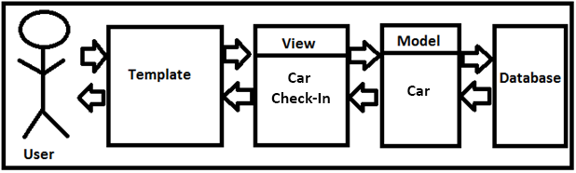

**View Maintenance Log: Use Case #11**



**Reserve Car: Use Case #12**

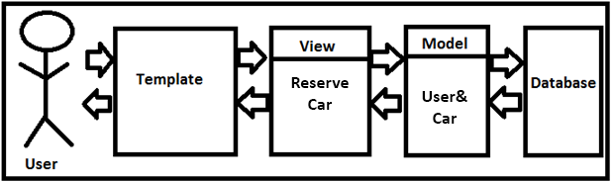

**Twitter Integration: Use Case #13**

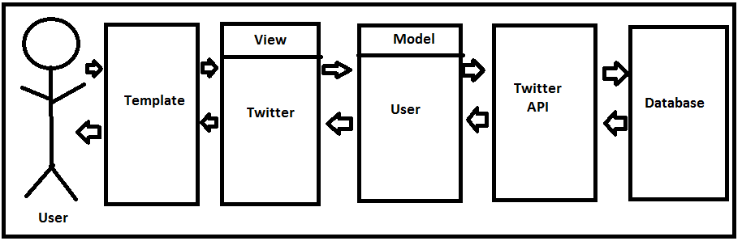

**Appendix A – Agreement Between Customer and Contractor**

The contractor, XENO, has met with customer Shawn Squire on February 13, 2015 to discuss what web application XENO will be creating. During the meeting, both parties agreed on what must be done and have informed one another about the procedure that must take place in the event there is a change to the document. In the event where there must be changes made to the document, XENO will email Shawn Squire with a draft of the modified document immediately, asking for approval.

**Customer: Shawn Squire**

Email: ssquire1@umbc.edu

Signature:________________________________________________________________

Date:_____________________________________________________________________

Comments:___________________________________________________________________________________________________________________________________________

**Team: XENO**

Name: Edward LaFemina

Signature:________________________________________________________________

Date:_____________________________________________________________________

Comments:___________________________________________________________________________________________________________________________________________

Name: John Swank

Signature:________________________________________________________________

Date:_____________________________________________________________________

Comments:___________________________________________________________________________________________________________________________________________

Name: Michael Bishoff

Signature:________________________________________________________________

Date:_____________________________________________________________________

Comments:___________________________________________________________________________________________________________________________________________

Name: Michael Lee

Signature:________________________________________________________________

Date:_____________________________________________________________________

Comments:___________________________________________________________________________________________________________________________________________

Name: Vesh Bhatt

Signature:________________________________________________________________

Date:_____________________________________________________________________

Comments:___________________________________________________________________________________________________________________________________________

**Appendix B – Team Review Sign-off**

As of 3/2/2015, all group members of XENO have reviewed the System Requirements Specifications (SRS) document and all have agreed the content and format of this document is correct. This document has been tailored to meet the client’s necessities for an online web application which will offer an online exotic car rental service to VIP customers.

**Team: XENO**

Name: Edward LaFemina

Signature:________________________________________________________________

Date:_____________________________________________________________________

Comments:___________________________________________________________________________________________________________________________________________

Name: John Swank

Signature:________________________________________________________________

Date:_____________________________________________________________________

Comments:___________________________________________________________________________________________________________________________________________

Name: Michael Bishoff

Signature:________________________________________________________________

Date:_____________________________________________________________________

Comments:___________________________________________________________________________________________________________________________________________

Name: Michael Lee

Signature:________________________________________________________________

Date:_____________________________________________________________________

Comments:___________________________________________________________________________________________________________________________________________

Name: Vesh Bhatt

Signature:________________________________________________________________

Date:_____________________________________________________________________

Comments:___________________________________________________________________________________________________________________________________________

**Appendix C – Document Contributions**

Michael Lee - Was responsible for creating the diagrams for the System Design Document. Also, created Appendix A & B. Contributed work is around 60%

Edward LaFemina – Contributed by explaining how our model classes are designed. Contributed work is around 10%.

John Swank – Worked with Vesh on how the database will be set up and provided information on what model will be mapped to a database. Contributed work is around 10%.

Michael Bishoff – Contributed work by explaining how our template and view layer will work. Contributed work is around 10%

Vesh Bhatt – Worked with John on how the database will be set up and provided information on what model will be mapped to a database. Contributed work is around 10%.