User Interface Design Document

XENO

**Client**

**Sha**w**n Squire**

**Team 1**

Vesh Bhatt

Michael Bishoff

Edward LaFemina

Michael Lee

John Swank

25 February 2015

**Table of Contents**

1. Introduction

1.1 Purpose of This Document

1.2 References

2. User Interface Standards

2.1 Top Menu Bar

2.2 Home Page (Use Case 2)

2.3 Create Account (Use Case 4)

2.4 Dashboard (Use Case 1)

2.5 Profile (Use Case 3)

2.6 Account Suspension/Ban Management (Use Case 8)

2.7 Search Car Database (Use Case 1)

2.8 Select Car (Use Case 12)

2.9 Check-in Car, Edit/Hide/Show Car, Flag for Maintenance (Use Cases 6, 9, & 10)

2.10 Add Car (Use Case 5)

2.11 Account Creation Management (Use Case 7)

2.12 View Maintenance Log (Use Case 11)

3. User Interface Walkthrough

3.1 XENO Navigation Diagram

3.1.1 Client

3.1.2 Maintenance

3.1.3 Administrator

3.2 XENO Walkthrough

4. Data Validation

Appendix A – Agreement Between Customer and Contractor

Appendix B – Team Review Sign-off

Appendix C – Document Contributions

# **1. Introduction**

## 1.1 Purpose of This Document

The purpose of this document is to define what the user interface looks like, standard fonts and colors that will be used throughout the website, and how a user interacts with the website. This document also provides a walkthrough of how a user can traverse the website and what data they can enter on the site.

## 1.2 References

* Class lecture notes
* First Customer Meeting Notes.docx
  + Title: First Customer Meeting Notes
  + Author: Team XENO
  + Date: February 20, 2015
* XENO Product
  + Title: XENO
  + Author: Team XENO
  + Date: February 12, 2015
  + URL: http://userpages.umbc.edu/~bishoff1/xeno
* Balsamic Wireframing Tool
  + http://balsamiq.com/products/mockups/

# **2. User Interface Standards**

This section provides an overview of the design standards that are maintained throughout the website. There are three different types of accounts, clients, maintenance, and administrator. Each account type will be able to interact with the content on the site differently. A client is a user who checks out a car, maintenance are workers who manage the cars and repair them, and administrators manage the cars and other account types.

## 2.1 Top Menu Bar

The entire website, except for the Home Page (2.2), features a menu bar at the top of the page that has various buttons that are used to navigate around the website. On the menu bar, client and maintenance account types will be able to access the dashboard (2.4), access their user profile (2.5), search for cars (2.7), check the maintenance log (2.12), and logout (2.2). In addition to the client and maintenance menu bar options, admin account types will be able to manage client and maintenance accounts (2.10).

## 2.2 Home Page (Use Case 2)

The Home Page is the first page a user sees when they go to the website. As shown in Figure 1, below, the Home Page has the XENO name at the top, login fields in the middle, and a Signup and About Us button at the bottom. This page also features a car of the day as the background.

**Figure 1**

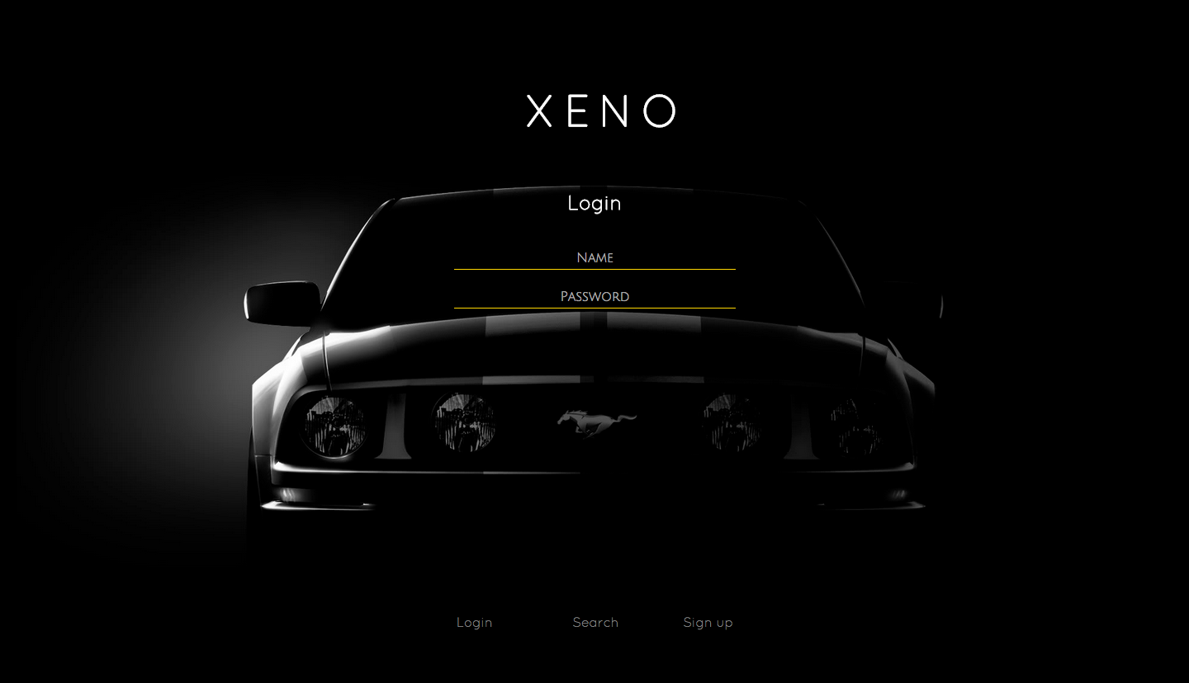

## 

## 

## 2.3 Create Account (Use Case 4)

The Create Account page is very similar to the Home Page. As shown in Figure 2, it also has the XENO name at the top, signup fields in the middle, and a Login and About Us button at the bottom. This page also features a car of the day as the background.

**Figure 2**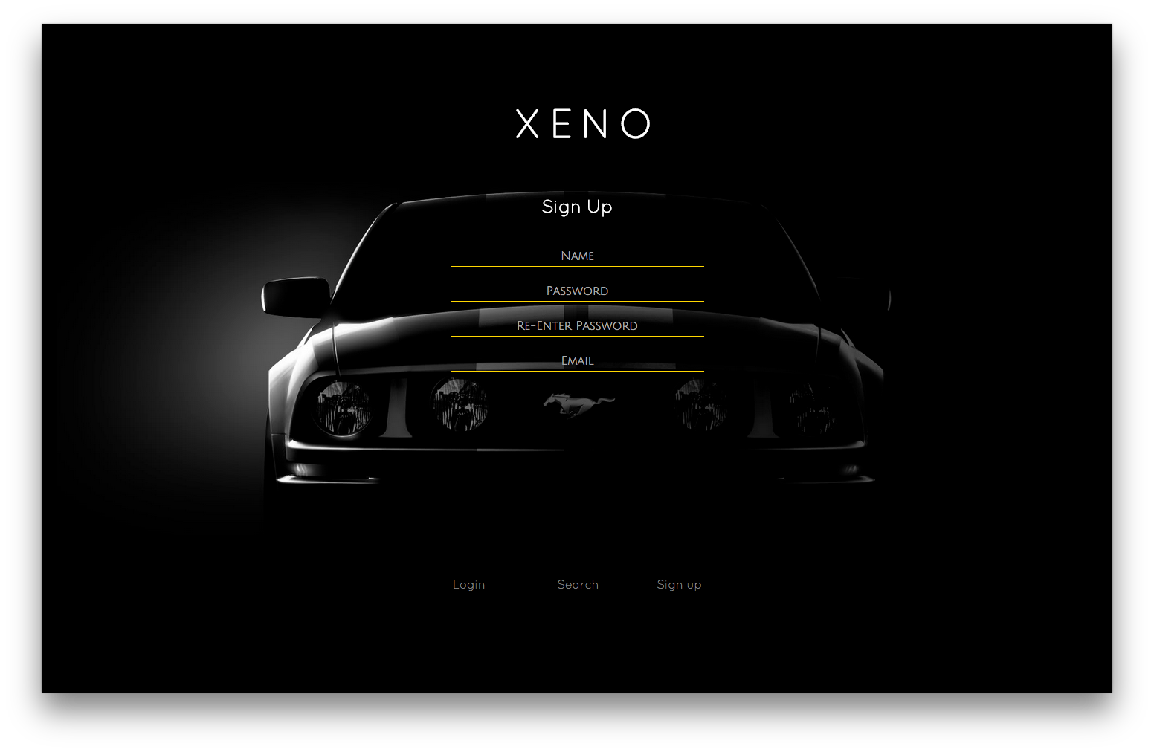

## 

## 2.4 Dashboard (Use Case 1)

The Dashboard is the page that the user is directed to once they log in. The Dashboard features the top menu bar (2.1), featured cars, and newly added cars. If the user is a client, then it feature a list of their upcoming car rentals, see Figure 3. If the user is a maintenance worker, then it features a list of cars that are flagged as in need of repair. If the user is an admin, then it features a list of cars that are flagged as in need of repair, a list of clients that have registered for the website and need approval to join, and a button to add a new car.

**Figure 3**

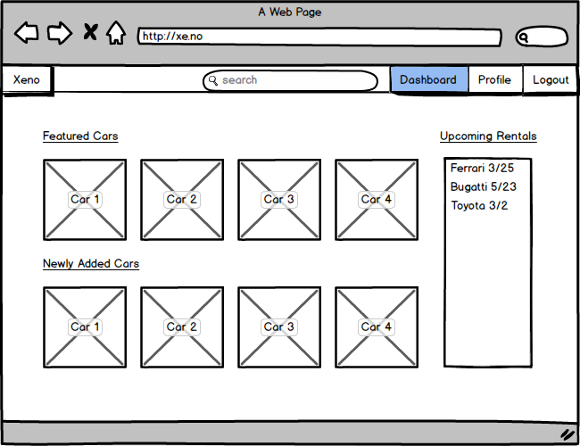

## 

## 

## 2.5 Profile (Use Case 3)

The Profile is a description of a user’s account. This includes a picture of the user, their name, their type of account, and cars they reviewed, see Figure 4. If the user is viewing their own profile, then they will be able to edit their public and private information.

**Figure 4**

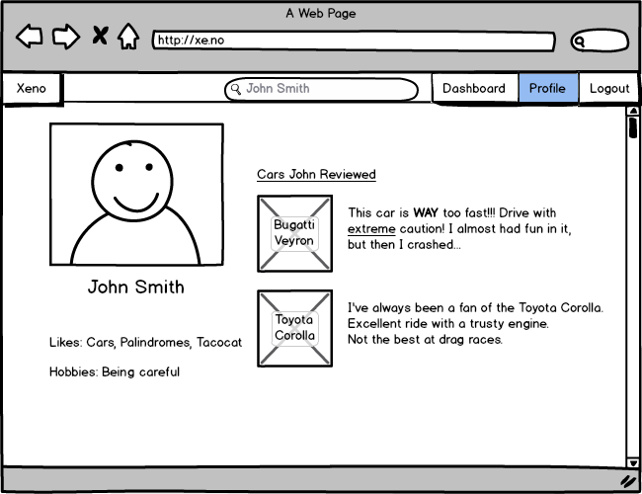

## 

## 

## 2.6 Account Suspension/Ban Management (Use Case 8)

This feature is only accessible to admins when they access another user’s profile. As shown in Figure 5, there is a button in the top right of the user’s profile page which can enable/disable a user’s account.

**Figure 5**

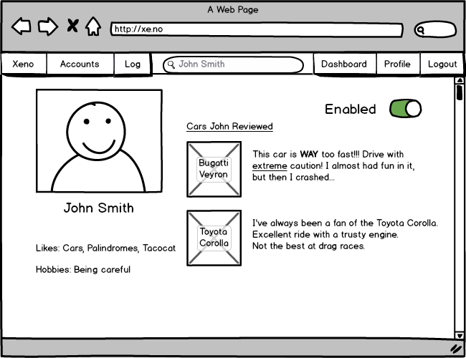

## 

## 

## 2.7 Search Car Database (Use Case 1)

The Search page is accessed after a user searches for a car from the menu bar. This page has various cars, in a grid layout, with the name and small details about the car below a picture of the car, see Figure 6.

**Figure 6**

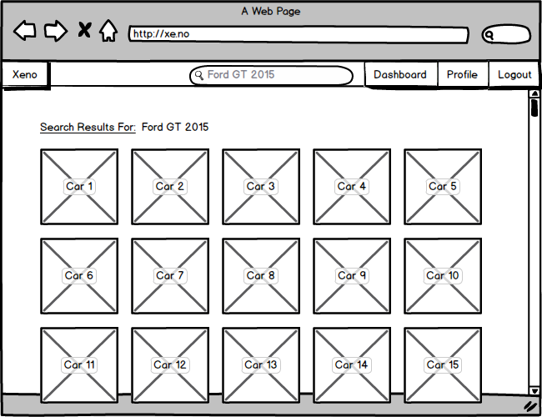

## 

## 

## 2.8 Select Car (Use Case 12)

From the Select Car page, clients will be able to view information and pictures about a car, read reviews about the car, and check out the car, see Figure 7. When admins and maintenance workers view this page, they will be able to edit/hide/show the car or flag the car as in need of maintenance.

**Figure 7**

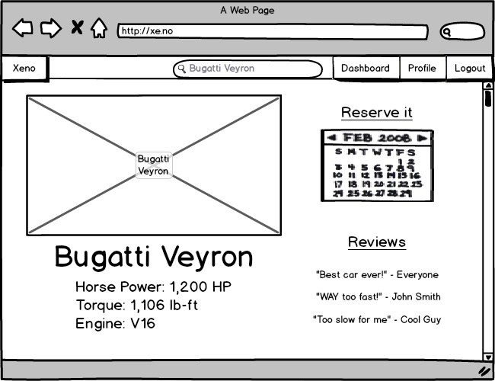

## 

## 

## 2.9 Check-in Car, Edit/Hide/Show Car, Flag for Maintenance (Use Cases 6, 9, & 10)

These features are only accessible to admins and maintenance workers when they view the Select Car page. This page show various text boxes with information about the car already filled in so that the user can edit the information. There are also buttons, in the top right of the car’s page, which allow the user to check the car in/out, hide/show the car, or flag the car for maintenance, see Figure 8.

**Figure 8**

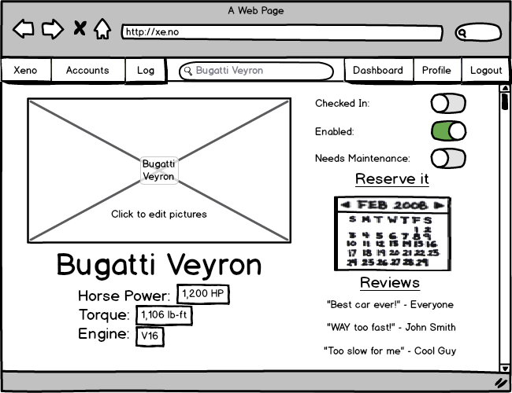

## 

## 

## 2.10 Add Car (Use Case 5)

The Add Car page is only accessible from an admin account. The Add Car page has various text fields in the center of the page where the admin can enter various information about the car, such as make, model, and year. The admin can also include a picture of the car, see Figure 9.

**Figure 9**

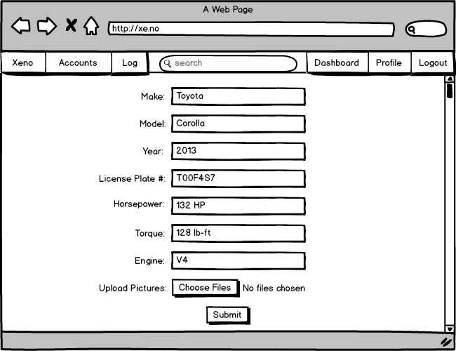

## 

## 

## 2.11 Account Creation Management (Use Case 7)

This page is where admins can approve accounts who have registered for the service once they have paid. As shown in Figure 10, it features a list, in the middle of the page, that shows the names and accounts of the people who have recently registered. There is an “Approve” button to the right of each person’s name.

**Figure 10**

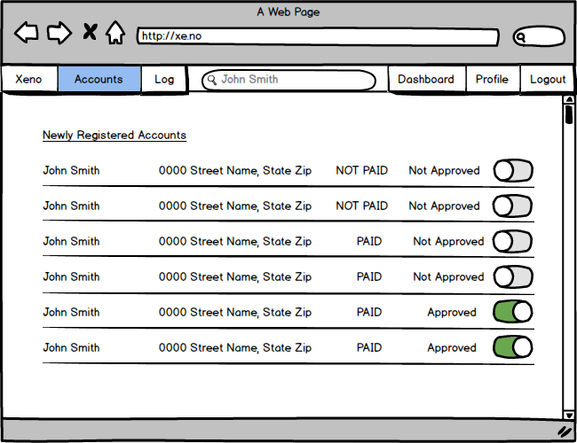

## 

## 

## 2.12 View Maintenance Log (Use Case 11)

This page is only accessible to admins and maintenance workers. As shown in Figure 11, this page shows a list of cars, in the middle of the page, that shows the names of the cars that have recently been through maintenance or are flagged as maintenance. If a car has been flagged as in need of maintenance, then there will be a button to the right of the car so that it can be unflagged.

**Figure 11**

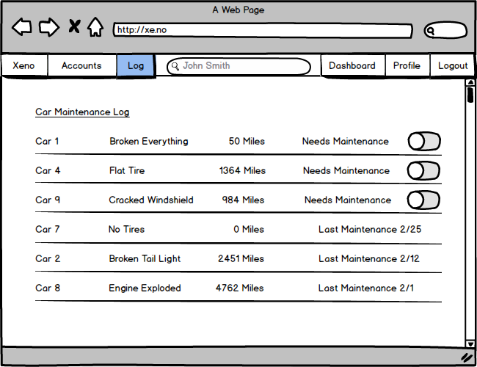

# **3. User Interface Walkthrough**

## 3.1 XENO Navigation Diagram

The following is a navigation diagram of how a user could interact with the system.

### 3.1.1 Client

How a client of XENO could use use the website.

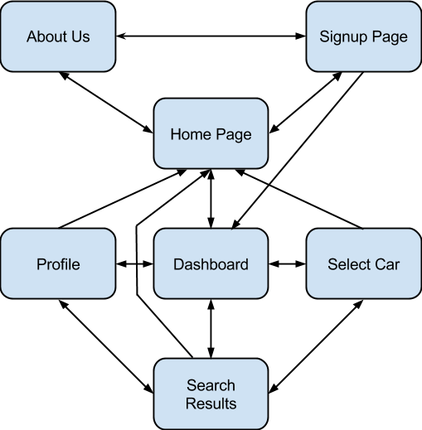

### 3.1.2 Maintenance

How a maintenance worker of XENO could use use the website.

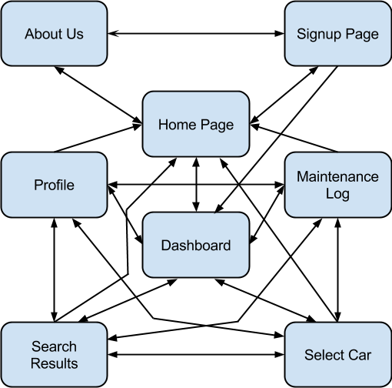

### 3.1.3 Administrator

How an administrator of XENO could use use the website.

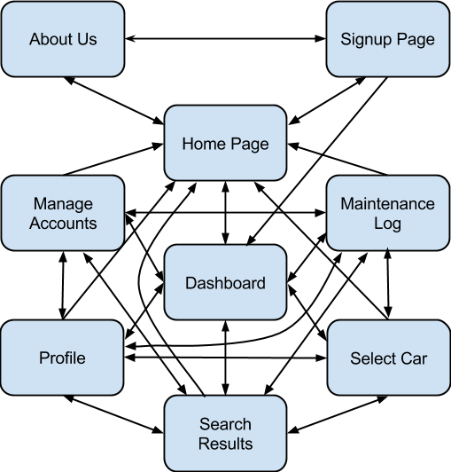

## 3.2 XENO Walkthrough

The following walkthrough applies to the above diagrams in section 3.1. Before a user is logged in, they can navigate between the Home Page, the About Us page, and the Signup page via the labeled buttons at the bottom of each screen. Once logged in, the user is taken to the Dashboard. Then, navigation through XENO is achieved through the navigation bar at the top of every screen, until they log out. The Dashboard, Profile, Search Results, Manage Accounts, Maintenance Log, and Home Page screens are all accessible via the navigation bar at the top. The Select Car screen can be accessed when either: there are featured cars or newly added cars to the Dashboard, a search for a car has been made, there are car reviews on a profile that the user is viewing, or there are cars in the maintenance log.

See the above mockups in section 2 for pictures and explanations of each page.

# **4. Data Validation**

When a user accesses XENO, they may enter data to log in, signup, search for a car, enter information about a car, or enable/disable/flag cars/accounts. These actions require different data types and formats to work properly. The following tables explain what data formats each type of user can enter and the limits of the data.

|  |  |  |  |  |  |
| --- | --- | --- | --- | --- | --- |
| **Entry Location** | **Data Type** | **Limits** | **Client** | **Maintenance** | **Admin** |
| Login Name | String | <= 200 Characters | X | X | X |
| Login Password | String | <= 200 Characters | X | X | X |
| Signup Fields | Strings | <= 200 Characters | X | X | X |
| Search Field | String | <= 200 Characters | X | X | X |
| Reserve Car | Date | MM-DD-YYYY Integer Format | X | X | X |
| Car Checked In/Out | Boolean | On (1) or Off (0) |  | X | X |
| Car Enabled /Disabled | Boolean | On (1) or Off (0) |  | X | X |
| Car Flagged for Maintenance | Boolean | On (1) or Off (0) |  | X | X |
| Car Information | Strings | <= 200 Characters |  |  | X |
| Account Ban/Enable | Boolean | On (1) or Off (0) |  |  | X |
| Account Approval | Boolean | On (1) or Off (0) |  |  | X |

# **Appendix A – Agreement Between Customer and Contractor**

The contractor, XENO, has met with customer Shawn Squire on February 13, 2015 to discuss what web application XENO will be creating. During the meeting, both parties agreed on what must be done and have informed one another about the procedure that must take place in the event there is a change to the document. In the event where there must be changes made to the document, XENO will email Shawn Squire with a draft of the modified document immediately, asking for approval.

**Customer: Shawn Squire**

Email: ssquire1@umbc.edu

Signature: ________________________________________________________________

Date: _____________________________________________________________________

Comments:_____________________________________________________________________________________________________________________________________________

**Team: XENO**

Name: Edward LaFemina

Signature: ______________________

Date: __________________________

Comments:_____________________________________________________________________________________________________________________________________________

Name: John Swank

Signature: ______________________

Date: __________________________

Comments:_____________________________________________________________________________________________________________________________________________

Name: Michael Bishoff

Signature: ______________________

Date: __________________________

Comments:_____________________________________________________________________________________________________________________________________________

Name: Michael Lee

Signature: ______________________

Date: __________________________

Comments:_____________________________________________________________________________________________________________________________________________

Name: Vesh Bhatt

Signature: ______________________

Date: __________________________

Comments:_____________________________________________________________________________________________________________________________________________

# **Appendix B – Team Review Sign-off**

As of 3/2/2015, all group members of XENO have reviewed the System Requirements Specifications (SRS) document and all have agreed the content and format of this document is correct. This document has been tailored to meet the client’s necessities for an online web application which will offer an online exotic car rental service to VIP customers.

**Team: XENO**

Name: Edward LaFemina

Signature: ________________________________________________________________

Date: _____________________________________________________________________

Comments:_____________________________________________________________________________________________________________________________________________

Name: John Swank

Signature: ________________________________________________________________

Date: _____________________________________________________________________

Comments:_____________________________________________________________________________________________________________________________________________

Name: Michael Bishoff

Signature: ________________________________________________________________

Date: _____________________________________________________________________

Comments:_____________________________________________________________________________________________________________________________________________

Name: Michael Lee

Signature: ________________________________________________________________

Date: _____________________________________________________________________

Comments:_____________________________________________________________________________________________________________________________________________

Name: Vesh Bhatt

Signature: ________________________________________________________________

Date: _____________________________________________________________________

Comments:_____________________________________________________________________________________________________________________________________________

# **Appendix C – Document Contributions**

Vesh Bhatt: Contributed checks for thoroughness and consistency with other documents. Gave input on the design of the mockups. Estimated percent of work is about 5%.

Michael Bishoff: As the design leader, he was responsible for creating the design mockups of XENO and guiding the walkthrough. He reviewed and edited all other sections before submission. Estimated percent of work is about 70%

Edward LaFemina: Contributed checks for thoroughness and consistency with other documents. Gave input on the design of the mockups. Estimated percent of work is about 10%.

Michael Lee: Michael worked on Appendix A & B, and References. Gave input on the design of the mockups. Estimated percent of work is about 10%.

John Swank: Also contributed checks for thoroughness as well as completeness. Gave input on the design of the mockups. Estimated percent of work is about 5%.