|  |  |  |  |
| --- | --- | --- | --- |
| **Cash Flow Activity** | **Q2 2024** | **Q2 2023** | **% Change** |
| Net Cash Provided by Operating Activities | $1.5 billion | $1.45 billion | 3.4 |
| Net Cash Used in Investing Activities | $750 million | $725 million | 3.4% |
| Net Cash Used in Financing Activities | $400 million | $380 million | 5.3% |

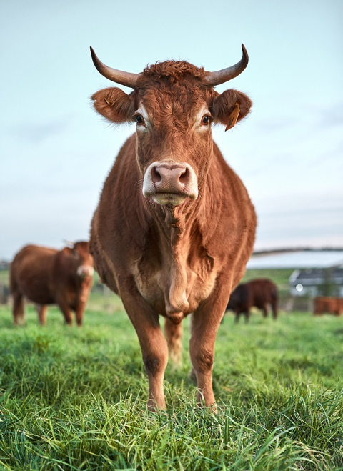

End of report