Date: 2007-06-17

Database Modeling Excel
Help

Version: 4.0

Dream Inc.

Table of Contents
1 Document Usage 3
2 Features 3
2.1 Support Databases 3
2.2 Function List 3
3 Before running 3
3.1 How to enable macros in Excel 3
4 How to 4
4.1 What meaning of every sheet? 4
4.2 How to adjust page number in index sheet 5
4.3 How to edit database schema? 5
4.4 Where is the menu-bar? 5
4.5 How to generate script 5
4.6 How to import 5
4.7 What meaning of Makeup→Set sheet name 5
4.8 What meaning of Makeup→Sort sheets by sheet name 5
4.9 How to ignore a worksheet when generating script 5
4.10 How to let it work in my build process 5
5 Tools 6
5.1 What is Tools\DBEM_CopyToFile.vbs 6
6 Our website 6
7 Support the project 6
8 Author 6
9 License 7

Document Usage
It’s a help document for the project.

Features

Support Databases
- SQL Server
- My SQL
- Oracle
- SQLite

Function List
- Design and maintenance database schema
- Generate script of database schema using workbook’s content.
- Create Tables SQL
- Drop Tables SQL
- Drop and Create Tables SQL
- Create Tables IF Not Exists SQL
- Support ignore some worksheets when generating SQL scripts
- Import database schema from database into the workbook
- Support automatic build process
- Fine print (A4 paper)

Before running
The utility is implemented by VBA, so need the Excel application enables macros.

How to enable macros in Excel
- Excel 2003 or earlier versions
Click Tools→Macro→Security…
Choose Medium in Security Level tab.
Restart excel application

When launch the excel workbook, click “Enable Macros” button.
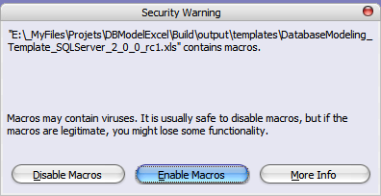

- In Excel 2007 or later versions
Click the options…
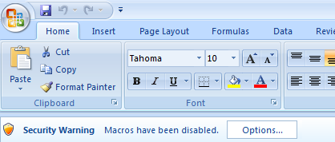

Select “Enable this content” and Click OK
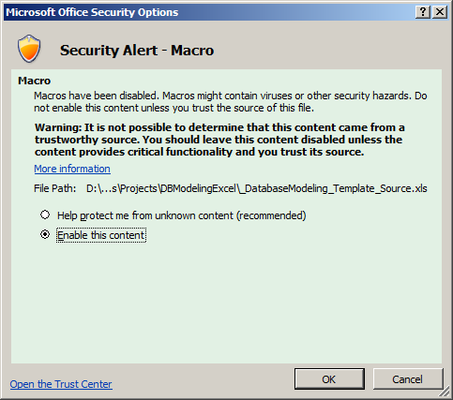

How to

What meaning of every sheet?
- Index sheet:
- Update history: like sheet name, you can fill you update history here
- Rules: you can write your define schema rules here
- Others: after 4th sheet, there are table worksheets, you can edit you table schema in these sheets and every sheet only contain one table schema definition.

How to adjust page number in index sheet
If you know some sheet will be printed more than one page, ex: 2 pages, you can fill corresponding row’s ‘F’ column with value “2”, you will see the page number changed as you except.

How to edit database schema?
Look “rules” sheet for details.

Where is the menu-bar?
When the workbook running, you can see:
- In Excel 2003 or earlier versions

- In Excel 2007 or later versions
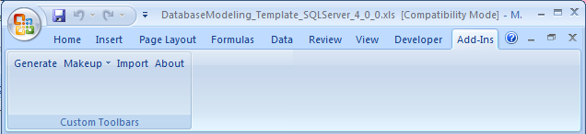

How to generate script
Click Menu-bar “Generate” item.

How to import
Click Menu-bar “Import” item.

What meaning of Makeup→Set sheet name
The function is set all table worksheets’ sheet name to contained table name.

What meaning of Makeup→Sort sheets by sheet name
The function is arranging all table worksheets’ in sheet name alphabet order.

How to ignore a worksheet when generating script
When you develop a new version of your application, database schema will be changed; you may add some new tables into your database.
So what you wanted is just generating script for these new tables.
You can do it! Just add "ignore" text to B1 Cell in the worksheet which you want to skip when generating scripts.

For the situation: some old tables’ schema changed, there is no good solution to meet it.

How to let it work in my build process
Please have a look section: What is Tools\DBEM_CopyToFile.vbs

Tools

What is Tools\DBEM_CopyToFile.vbs
Usage of the script is helping your automatic build process.
In our excel file, there are some macros which are located at basSQLCommand. These macros can generate SQL script you wanted and copy it to clipboard.
They are:
CopyAllCreateTableSQL
CopyAllCreateTableWithDescriptionSQL
CopyAllDropTableSQL
CopyAllDropAndCreateTableSQL
CopyAllCreateTableIfNotExistsSQL
CopyAllDropAndCreateTableWithDescriptionSQL

And the file DBEM_CopyToFile.vbs can help you run the macro and copy clipboard content to a file you indicated.
For more detail:
'------------------------------------------------------------------------------------------------
'
' Usage: DBEM_CopyToFile <--filename|-f ExcelFilename>
' <--macroname|-m macroName >
' [--arguments|-a arg1[,arg2,arg3...]]
' <--targetfilename|-t TargetFilename>
' [--verbose|-v]
' [--help|-?]
'
' Example 1: DBEM_CopyToFile -f "D:\DBModelExcel\DatabaseModeling_Template.xls" -m "CopyAllCreateTableIfNotExistsSQL" -t "D:\DBModelExcel\CreateTables.sql"
'------------------------------------------------------------------------------------------------

Our website
- CodePlex
http://www.codeplex.com/dbmodelexcel/Release/ProjectReleases.aspx
http://www.codeplex.com/dbmodelexcel
- SourceForge
http://sourceforge.net/projects/db-model-excel

Support the project
There are some ways to support the project.
- Feedback your information
If you find any bug or want some new features, please notice me. Let us make the project better.
- Write comment in our website
It will encourage project developer.
- Denote the project
http://sourceforge.net/donate/index.php?group_id=171489

Author
Yang Ning (Steven) Email: steven.n.yang@gmail.com

License
New BSD License

