**Software Requirements Specification**

**for**

**The Project**

**Version 2.0 approved**

**Prepared by**

* **Avi Gupta(U101116FCS018)**
* **Dhruva Agarwal(U101116FCS177)**
* **Shivam Goel(U101116FCS115)**
* **Ronak Jain(U101116FCS102)**

**NIIT University**

**10th October 2018**

**Table of Contents**

|  |  |
| --- | --- |
| **Name of the Topic** | **Page Number** |
| 1. **Introduction**   1.1 Purpose 1.2 Document Conventions 1.3 Intended Audience and Reading Suggestions 1.4 Product Scope 1.5 References | **4-5** 4 4 4-5 5 5 |
| **2. Overall Description**  2.1 Product Per**s**pective  2.2 Product Functions  2.3 User Classes and Characteristics  2.4 Operating Environment  2.5 Design and Implementation Constraints   2.6 User Documentation  2.7 Assumptions and Dependencies | **5-7** 5 5-6 6 6 6 6 7 |
| **3. External Interface Requirements** 3.1 User Interfaces  3.2 Hardware Interfaces  3.3 Software Interfaces  3.4 Communication Interfaces | **7-8** 7 7 7 8 |
| **4. System Features** 4.1 Login/Sign Up  4.2 Profile  4.3 Verify Account  4.4 Get in Touch  4.5 Trending  4.6 Use Case Diagram  4.7 Use Case Description Table | **8-13**  8  9  10-11  11  11  12  13 |
| **5. Other Non-functional Requirements** 5.1 Performance Requirements  5.2 Safety Requirements  5.3 Security Requirements  5.4 Software Quality Attributes  5.5 Business Rules | **13-14** 13 13 14 14 14 |
|  |  |
|  |  |

**Revision History**

|  |  |  |  |
| --- | --- | --- | --- |
| **Name** | **Date** | **Reason For Changes** | **Version** |
| TheProject | 5th September | INITIAL DRAFT | 1.0 |
| TheProject | 9th October | FINAL SUBMISSION | 2.0 |

# **Introduction**

This document is a Software Requirement Specification (SRS) for the TheProject. This is the initial draft for the SRS and it will be used for the extensions. TheProject’s web application aim to provide the opportunities for project seekers and to create a hassle free hiring process for project creators by inducing a trust factor and a trust-coefficient which will be provided by some industry experts. Students, Freelancers, Job/Avenue seekers can register on the portal, then they can add their skills, certificates, experiences & then go through various evaluations which would all contribute to a rating(or Trust coefficient), a unique feature for employer/avenue creators to take note of. Employers or Avenue Creators can register on the platform and then search for a candidate according to their requirements. TheProject target audiences are Job seekers, Students, Employers and any one who wants to freelance.

## **Purpose**

The aim of this document is to specify complete description of web application to be developed. It is the basis for agreement between the developers and user about the product to be developed. Through this document, the workload needed for development, validation and verification will ease. To be specific, this document is going to describe functionality, external interfaces, performance, attributes and the design constraints of the system which is going to be developed. Therefore, intended reader groups for this software requirement specification are members of TheProject, developers and users.

## **Document Conventions**

There are no such conventions required in this document.

## **Intended Audience and Reading Suggestions**

This document is to be read by the development team, the project managers, marketing staff, testers and documentation writers. Our stakeholders, shareholders of TheProject and distributors who markets the finished product, may review the document to learn about the project and to understand the requirements. The SRS has been organized approximately in order of increasing specificity. The developers and project managers need to become intimately familiar with the SRS.

Others involved need to review the document as such:

* Overall Description – Marketing staff have to become accustomed to the various product features in order to effectively advertise the product.
* System features – Testers need an understanding of the system features to develop meaningful test cases and give useful feedback to the developers.
* External Interface Requirements – The marketing staff also needs to understand the external interface requirements to sell the product by describing the user-friendly features of the TheProject.

## **Product Scope**

This project is intended for making use of internet as a medium for the project creators and project seekers to connect without any difficulties. Currently, there are few websites which provide internship, freelance project and jobs in the market. Usually they provide lots of features to the seekers and creators. However, there is simple but substantial problem with current websites. They are present as individual websites, there is no single platform that provide all three opportunities all together. Also, none of them provide any kind of trust factor to the seeker as well as creator, which poses as the biggest problem for hiring or applying for any vacancy anywhere. By taking extensive measures we will make everything on the web application foolproof and try to make this process hassle free.

## **References**

No references used as for now.

# **Overall Description**

This section gives background information about specific requirements of the web based integrated development environment service to be developed in brief. Although we will not describe every requirement in detail, this section will describe the factors that affect the final product.

## **Product Perspective**

Our product is a brand new project which does not have any past records. It is similar to the ideology in which the different job searching websites work. It provides job opportunities and internships to the people who have the right knowledge and who deserve to be chosen for a job. Even though it has a perspective similar to the websites like internshala and freelancer, TheProject is loaded with many added features and options for both, the project creators as well as the seekers which were never added to any such websites.

## **Product Functions**

User interface will be very simple. Project seekers can register on our website and subsequently login and apply for internships/jobs/training courses. Project creators can register on our website and put forward their opportunities and requirements to choose among the candidates who suit their job the best.

## **User Classes and Characteristics**

Web page will be accessed by 2 kinds of users as follows :

**2.3.1 Project Seekers**

Seekers will be all those user who would majorly access our website, Job finders, Intern finders and freelancers who are looking for the projects. They will have to login on the portal then upload all details of their experience which include all certificates, job profiles, internships. to very verify their account they will have to go through an extensive questionnaire which will be provided by the industry experts. only they will be able to apply for the opportunity.

**2.3.2 Project Creators**  
Creators will be ones who create the opportunity on the website to which all the seekers would b applying. they will have to login as creators where they will have to upload the certificates of genuinity of their venture only then they will be verified to create opportunities. They will also have the option to access the pro feature where they will gain more access to the functionality of the website like generating their own questionnaire, having a skype call and much more.

**2.3.3 Panelist**

They play the most crucial role as they will b industry experts who will be rating the seekers based on their past experience and will provide the Trust-Coefficient.

## **Operating Environment**

Laptop/PC with a working internet connection and a web browser of latest version.

## **Design and Implementation Constraints**

As for now blockchain is not being implemented in our website for the rating system. So, this is a limitation in version 1.0. But in future version we will be implementing blockchain for the same. The mobile app for TheProject will be worked upon in the coming future.

## **User Documentation**

To be added

## **Assumptions and Dependencies**

* MySql is a relational database management system which will be used as the main database for our website.
* Hibernate framework will be used as the object relational mapping tool for our project. It will be used for connecting the database with our portal.
* Spring Boot will be used to work in developing the java application. It also supports hibernate in order to develop the application.
* Full working of TheProject is dependent on the availability of Internet connection after the hosting of the website.
* The Blockchain technology will be used for safe and secure transactions including the judgements given by the industry experts for rating purposes.
* HTML and CSS will be used for the front end development part of the web-application.

# **External Interface Requirements**

## **User Interfaces**

Users can register, login, create jobs and apply for them through their portals of job seeker and job creator. Also, from the dashboard of their portal, the user can update their personal information and their resume and experiences. The project seekers can take retests for their particular fields.

## **Hardware Interfaces**

The users will need a proper functioning computer system with a working internet connection in it. It will be used to take in input from the user and store it in our database.

## **Software Interfaces**

The softwares used in our project are -

* MySql for Database
* HTML, CSS, BOOTSTRAP for frontend development
* Advanced Java (inclusive of JDBC,(HERE)) for backend development

In order for the database to interact with java, we will be using JDBC. For the HTML pages to work with java, we will apply JSP to it. We will use Servlet technology for hosting and interacting with the server.

## **Communications Interfaces**

Primarily, the website will be used as a user interface. In future versions we will also produce a mobile app for the same.

# 4. System Features

This template explains all the features and description of the Web Portal.

## 4.1 Login/SignUp

**4.1.1 Description and Priority**

The system’s users are given a workspace from which all of their communication will take place where the user can login to the app and will be able to access the Web Application.The priority here is that the user will be authenticated to the Web Application.

**4.1.2 Stimulus/Response Sequences**

There will be a login and signup button which will enable the Seeker and creator to either login into their pre-existing accounts or create a new one as a Seeker or Creator.

**4.1.3 Functional Requirements**

The Login/Sign-up Page will help to authenticate the user and display an error if the password or the user name is invalid.

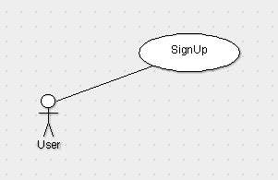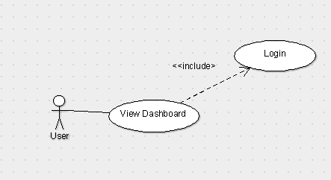

## 

## 4.2 Profile

**4.2.1** **View/Edit Profile(Seeker)**

**4.2.1.1 Description and Priority**

Through this functionality Seeker will be able to view and edit his details that he has entered while creating the account.

**4.2.1.2 Stimulus/Response Sequences**

If the Seeker wants to view his profile then there will be a button as Profile where he can see all his details and all the opportunities that he/she has already applied to.

**4.2.1.3 Functional Requirements**

He will be given a list of opportunities that he has applied to or got a response from any Creator.

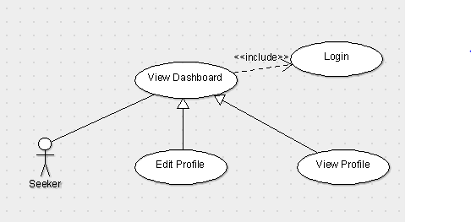

**4.2.2** **View/Edit Profile(Creator)**

**4.2.1.1 Description and Priority**

For Creator, profile would consist of details of his venture and his ratings.

**4.2.1.2 Stimulus/Response Sequences**

There will be a Profile button on the dashboard similar to that of creator but the profile section will differ as it will have different details than the seeker.

**4.2.1.3 Functional Requirements**

In this section creator can see the details he uploaded during the creation and can also manage his seekers who he have selected or will be selecting

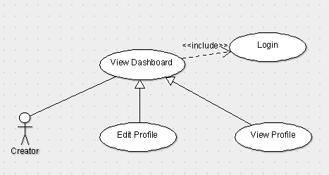

## 

## 4.3 Verify Account

**4.3.1 Verify Account (Seeker)**

**4.3.1.1 Description and priority**

To verify the account user will have to take the questionnaire which will be mandatory in order to verify the account and also take rating.

**4.3.1.2 Stimulus/Response Sequences**

There will be a ‘Verify Account’ button on the profile section from where the user can access this functionality.

**4.3.1.3 Functional Requirements**

To maintain the genuinity of the user so that he cannot bluf with his skills and eventually develop a trust factor.

**4.3.2 Verify Account (Creator)**

**4.3.2.1 Description and priority**

This function will enable the creator to go further and post opportunities. we require this function so that we have genuine and valid creators.

**4.3.2.2 Stimulus/Response Sequences**

There will be a ‘verify Account’ button which when pressed will show list of all the required documents that are to be uploaded by the creator in order to verify that it is a valid venture and registered with the government.

**4.3.2.3 Functional Requirements**

Requirements fr this functionality would be the legal documents such as registry of the venture, GST Certificate, PAN, Bank Details.

**4.4 Get in Touch**

**4.4.1 Description and priority**

This functionality is the most essential as the seeker will be clicking on this function to notify the creator, that he is interested in the available opportunity.

**4.4.2 Stimulus/Response Sequences**

In this there will be a button “Get In Touch” in which user can apply for the opportunity.

**4.4.3 Functional Requirements**

If the user is logged in, then he can edit his detail but if he is not a user than he needs to sign up and only then he can edit his details.

**4.5 Trending**

**4.5.1 Description and priority**

This functionality will provide both the seekers and creators, top users with maximum trust-Coefficient.

**4.5.2 Stimulus/Response Sequences**

In this user will be provided a button “Trending/Top Charts” in this there will be a **Leaderboard** which will provide ratings category wise.

**4.5.3 Functional Requirements**

This function will help the user to view the rating wise list of the seekers in a particular category.

***The following is the use case diagram for the application:***

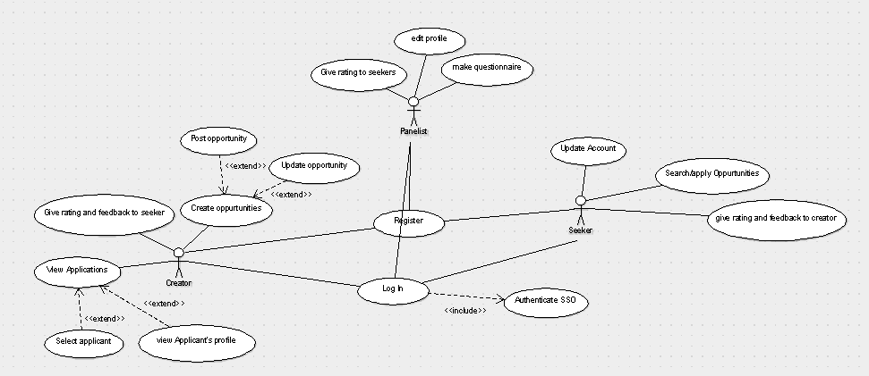

## 

## 

## 

## 

## *Use Case Description Table :*

|  |  |
| --- | --- |
| ***Use Case Title*** | ***Description*** |
| **1.Seeker Login** | The Seeker needs to login to perform any actions |
| **2.Creator Login** | The Creator needs to login to perform any actions |
| **3.Panelist Login** | The Panelist needs to login to perform any actions |
| **4. SignUp** | New user needs to Sign up and select its respective category to further perform actions. |
| **5. Profile View/edit(Seeker)** | Seeker will be able to view and edit his details |
| **6. Profile View/edit(Creator)** | Creator will be able to view and edit his details |
| **7. Profile View/edit(panelist)** | Panelist will be able to view and edit his details |
| **8.Verify Account(Seeker)** | Seeker will have to verify his account by answering the questionnaire and getting rated based on his skills. |
| **9. Verify Account(Creator)** | Creator will have to upload necessary legal documents to verify as the a valid creator. |
| **10.Verify Account(Panelist)** | Panelist will have get account verified by the backend Team. |
| **11.Get In Touch** | This Function Will help Seekers and creators to get in touch with each other. |
| **12.Trending** | Seekers and Creators both can see trending opportunities and seekers based on having maximum rating. |

# 5. **Other Nonfunctional Requirements**

## 5.1 **Performance Requirements**

A working pc/laptop/smartphone/tablet with an internet connection is required for operating this website smoothly.

## 5.2 **Safety Requirements**

Project seeker’s and Project creator’s username and password will be used for authentication. These should not be shared.

## 5.3 **Security Requirements**

1. Web software applications should be developed per secure coding guidelines such as the Open Web Application Security Project (OWASP) guidelines.
2. Peer-review code with at least one other technically trained individual.
3. Validate all data received via the HTTP Request. Not validating data can result in attacks such as Cross Site Scripting, SQL Injection, HTTP Response Splitting, Log Injection, and Directory Traversal.
4. Validate the data on the server-side.  All data (even hidden fields and data from pull down lists) are subject to being modified by a malicious user and should be validated server-side.
5. Pass session IDs and cookies via SSL (HTTPS). Hackers can intercept unprotected session IDs and cookies and use them to compromise the user’s session (session hijacking), and the security of your system.
6. Vulnerability scans should be performed before moving application to production or whenever there are changes to the application.
7. Review the OWASP guidelines. Identify those potential vulnerabilities that may apply to your web application. Review your code and test your application to ensure that your application is not vulnerable.

## 5.4 **Software Quality Attributes**

* **CORRECTNESS:** The Rating given by the panelist will be anonymous and should not be biased towards any user.
* **MAINTAINABILITY:** The **Database** must be Correctly maintained and updated regularly
* **USABILITY:** The Website must satisfy all the needs of the Seekers and the Creators.6.

**5.5 Business Rules**

Only developers are allowed to modify the software and to fix the bugs. This source code cannot be used anywhere without giving credits to the development team (if possible you can give us royalty for using the source code).

x

**Thank You**