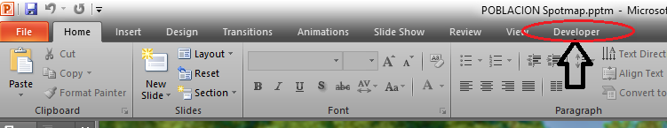To Functions the *search name bar* you must go to developer click macro and run the 13, 14 items.

1. Click Developer
2. 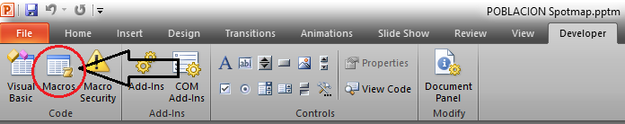Click Macros
3. 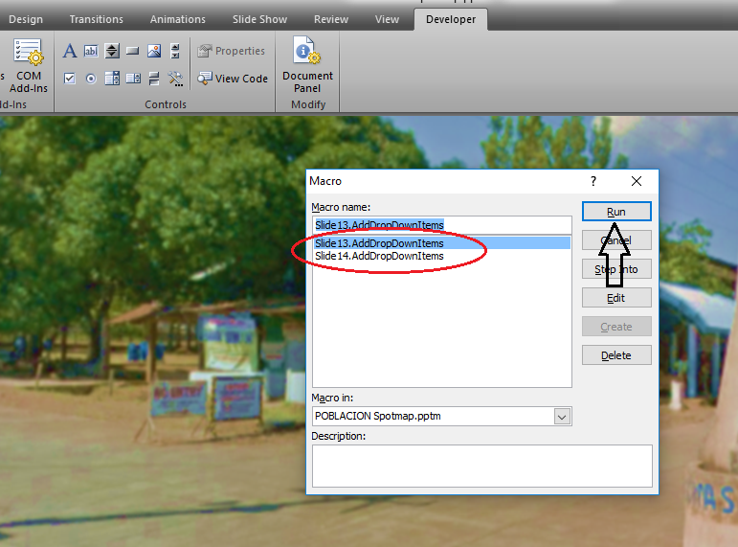Select 13 and 14 items and click RUN.