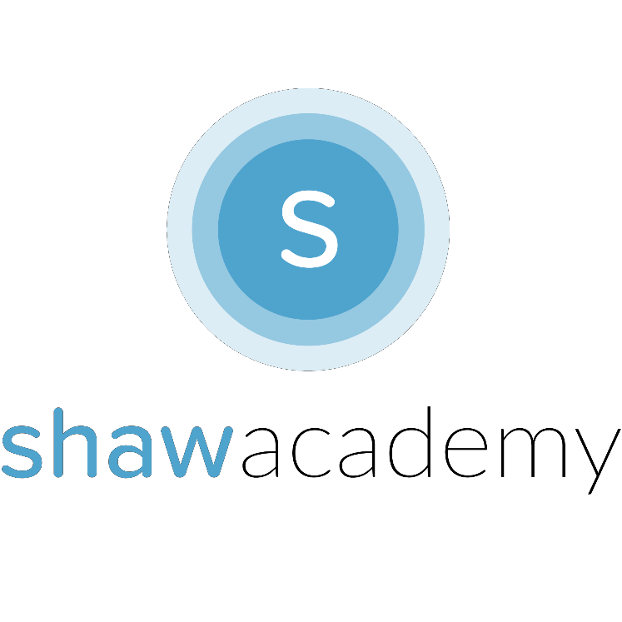
Launching Your App

y.
So now you’ve been through it all, you’ve seen the Design Stages in Full, you’ve created your working MVP of the App and you’re ready to get some early testing done by Launching your App. Well, almost. Here’s what you need to prepare before releasing your App.

Materials Needed
As a Developer, you’ll want to keep the Rights to your App or ensure that your Company keeps the Rights to your App and its Usage. To prevent users misusing the App and blaming the developer for any misgivings (see S.M.T.H. for an example) To avoid any legal ramifications you can protect your App by getting users to sign a EULA before they begin.

www.termsfeed.com/blog/sample-eula-template/

END USE LICENSE AGREEMENT: Common Clauses: Restrictions on Use, Termination Agreement & Copyright Information, all part of the End User Licence Agreement. You can download a template from the address listed above and fill out the relevant information pertaining to your App. This will allow you to take control of some of the more Ad-Hoc Terms & Conditions when releasing your App. You can also provide a link to view the full list of terms & conditions available online if you wish.

App Icon
Developers often forget about how they’re App will look as they come to the end of Development. It’s always good to keep an idea of what your App tells the User and if it reflects what your App does. Check out App Design related to Photography or Business
to see what the App Icons say about this particular Categor
Configuration Testing
better
When Configuring your App, it is recommended to think carefully about what you are going to Name the App. If you have previously given it a reference name, make sure to clean it up. The reason for this is that the Play Store Ranks Apps based-on Downloads.
People looking for specific Apps will need to search for your App and using key words to describe the App itself will go a long way to helping your App reach more people.

For example: An App named RunFit will do better than one called Run as anyone searching for Running Apps will see this app without a doubt. People looking to get into Fitnesss and Start working out will not however. The RunFit App will appeal to both searches moving it into a higher position through downloads.

Luckily, App Inventor gets rid of any Debugging Options that are exposable when the App has been built through App Inventor. It is important to note that for other IDE’s and SDK’s that you may have to Clean-Up the Directories in your Source Code Folder. Ensuring all images and files used in the Project are all stored
under the 1 Project-Name.

Finally, as you complete the Configuration of your Final Product, you now need to Test the App on a Device. This phase can be quite rigorous and you can expect, as a beginner to find yourself going backwards to fix errors multiple times. When Testing, make sure to test from every conceivable viewpoint, even the ridiculous “not-paying-attention-to-what-I’ve-done” viewpoints to really stress-test the performance of your App.

The goal here is create an App that consistently runs without fail
Versioning & Signing the App
Version Control
Version Control allows you to maintain and make updates even after months of not coding. Even when you come back to the App and wreck everything by creating bugs, you can always roll-back
to the initial MVP and start over from the last working point. From a Marketing perspective, you can also release updates and add events to increase your User Engagement through well- established Version Control.

Signing your App
Cryptogrpahic Keys are used to keep track of your apps and secure them. When a .apk file is built, it is not possible to reverse engineer the code inside as it has been protected by your keystore. To make a back-up of your keystore in AI2 you can Export the keystore relating to the App and, if you are working from a new server you can then import the key to another profile.

By Signing your App digitally you also allow your Apps to communicate with each other as you develop more Apps. This way you can link from 1 App to another to drive your Apps as a Marketing Channel for Apps that have been more successful than others.
Preparing for Release
Now that all the Materials have been prepared you are ready to Release the App on the Play Store. Be sure to purchase your Developer Licence to gain access to the Developer Console where you will be able to publish and maintain the release of your App.

Depending on what type of App Launch you are hoping to
achieve, you may want to prepare some Materials in Advance such as:

Promotional Videos

Graphics for Special Discounts

Promotional Offers or Game Events

These Materials can be added to the Developer Console Checklist to prepare your App for Release.


