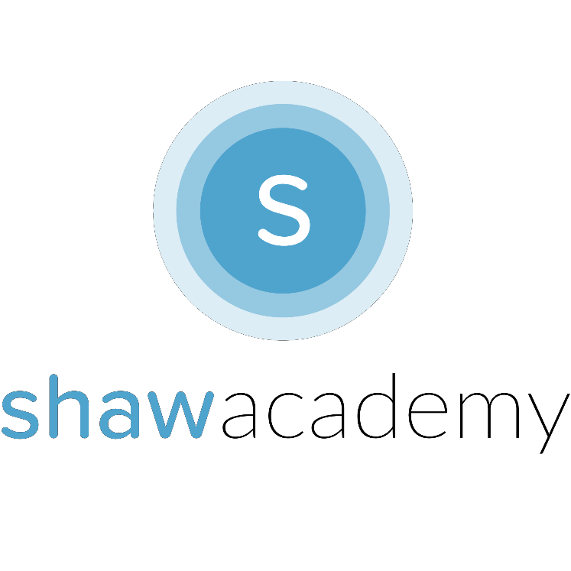
Making Money with your App
it
What options are available to you if you wish to Generate Revenue from your App? Will you make it a Paid or App or Free? Can you make money from a Free App? The Answer is Yes! We’ll outline the most common options that Developers Have for Making Money with Mobile.

Free Apps
There are lots of reasons you should make your App a Free App, it is one of the most common Monetization Strategies used by Developers on the Play Store. This allows users to download the App and get a Feel for the App before any real commitment on the User’s part.

Freemium Apps
A Pricing Strategy used to provide an App free of charge, but money is charged for proprietary features, functionality or virtual goods. The goal is to accumulate and engage users until they see the value of the app and are willing to pay to access additional in- app tools. Extremely popular with Games as it allows users to engage enough to want to pay for the full-version. It must be easy to upgrade to the Premium Version in this case.

In-App Advertising
Mobile Ads allow you to monetize your App without asking your Users directly from your Users. Your goal should be to create a large user-base and gather relevant information to sell to other brands and app publishers who pay you to place targeted ads in your App. This option allows you to gain and retain new users without distracting from the User Experience. (When done correctly!) This model requires care and attention to ensure doesn’t overrun your App.
In-App Purchases
why it’s
ince
This model does exactly what it says on the tin. The goal here is to turn your App into another sales channel for either physical products or virtual goods to be used in the app to retain the profits. This model affords the most comfortable profits with the lowest amount of risk. Unlocking virtual Achievements can also lead to deeper levels of User Engagement.

Sponsorship
The latest monetization strategy. Partnering up with advertisers can allow you to reward users when they complete certain actions in your App. In this model, your App earns money by taking a
share of the revenue earned from rewards. These rewards and promotions come from the advertiser directly allowing the User to engage with the App while the Advertiser is able to gain click- throughs and conversions. This option can help you to avoid Ads while still earning Revenue in your App.

Paid Apps
Surely your Users won’t mind paying $2.99 for all of the hard work you’ve put in. Or would they? Should you make it free? Or should you only charge $0.99 for it. Or maybe even as high as $1.99? Surely your Users won’t mind paying $2.99 for all of the hard work you’ve put in. Or would they? There are no alt facts at play here,
95% of total revenue generated is coming from Free Apps with In- App Purchases, while only 5% from Paid Apps combined with Paid Apps that have In-App Purchases.

$0.99 is the minimum you can charge for an App in most Distribution Stores. Most Users are unwilling to invest their money in an App they haven’t sampled first-hand. That’s always a good idea to sample screenshots & videos to conv
the User its worthwhile. Apps that cost money are described as App’s you can Invest in. This is why 70% of Productivity-Based Apps are Paid Apps and why only 8% of Games are Paid. People who want to be productive will invest in how they spend their time, those who are looking for entertainment and fun are not.

Maximising Revenue
The goal overall of course is to Generate Revenue from your App to earn money from it. Of course, not all apps can be expected to make a billion dollars overnight. Apps which do require 1 important aspect. User Conversion. When a Person makes a purchase, they have gone through what’s known as a Consumer’s Journey.

Sales Funnel
The 4 Stages of the Sales Funnel is a Marketing Strategy that can be applied to almost all forms of User Conversion. While Apps are notorious for being free, you can still generate a huge amount of revenue by guideing those Users through the Sales Funnel and into the role of a Loyal Buyer.

Awareness
This is the First Stage of your User’s Journey, where they her or find out about the App. It’d what brings your App to the forefront of their mind when they need it.

Interest
This is the second stage and while we cannot expect all Users to Buy, we can focus on those who do. By nurturing these Users, giving them extra value that allows them to reflect on the Value of the App itself, it gently guides your Users to the next stage.
Decision
In this stage, the “Decision” is all about your Offer. Now that your App User has sampled the App, seen the value in it, what are their options? Can they unlock the full version? Can they make the App even more valuable? This is where your Offer comes into play.

Action
The Final Stage in a User’s Journey is to make the commitment or invest in your App. At the end of the stage it really depends on where your User’s interests lie. Do they prefer to keep the Free App and don’t mind watching Ads? Are they willing to make In- App Purchases instead to avoid Ads? Each User will be different, so it’s a good idea when starting out to customize your Users Experience and provide them with the opportunities to engage with your App the way they prefer.


