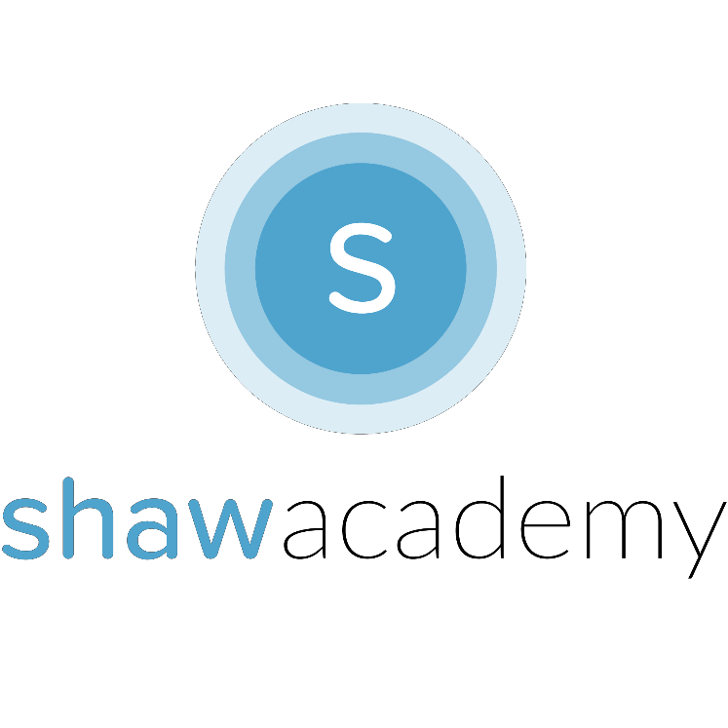
Third Party Tools Used n Dev While Most App Development Tools are Free to Use, Professionals tend to use third-party tools to produce the best quality images, keep their files secure and backed-up and tools to manage development.

For Branding, Graphics & Logo Design tools akin to PhotoShop are a great resource for creating icons that Users will see in your App.

GitHub is a Version Control Tool that is used to Manage the different versions your App will go through during Development. To avoid making umpteen copies of files that might branch off in different directions, you can securely add your code to GitHub and invite other Developers to collaborate and help if you need it.

Scrumwise is a Tool for Managing the Agile Development Model. With it, provides a tutorial for creating week-by-week Sprints to ensure you are on top of the tasks needed to be completed and your deadlines have been met. It is a good idea to get familiar with these tools as Employers will want to check your progress regularly.

In terms of Hardware, costs can rise significantly if you plan to purchase a testing device for each team member or indeed test on multiple devices. You may also need to upgrade your machine to be used in the Development Process to run 3D Modelling Rendering Software or the Emulator on Android Studio for example. It’s a good idea to check out software requirements before committing to the tools you will be using.
Keeping your Users
The goal here is create a consistent amount of revenue generated. By engaging your Users regularly with your App, you are then
open to target your User’s Interests and create Ads that are more likely to interest a User as opposed to annoying them. Another great use for Engaged Users is finding out more about how your App works. If there is a bug or a feature that no one wants, you can remove the bug or integrate a feature that your Users are more likely to enjoy.

User Experience (UX)
In order to create these Loyal Users who will engage with your app and bring your App to Success, you need to provide the User with a First-Time Great User Experience. This is done through a polished, functional app with no surprises. Make sure to tell your User if you have Ads or In-App Purchases, this will go a long way to help them to understand the layout of your App.

Push Notifications
It has always seemed to me that one day I wake up and that world I have been immersed in, inside of the App has been completely wiped from my memory. Push Notifications allow you to remind the User about an Event or a Special Offer that can help in spiking the User’s Interest after a month in absence.

Product Iteration & Customization
Everyone wants their own unique experience when trying out an App. By providing this through regular updates and promotional announces you can get your Users excited about what’s yet to come to continue to improve their experience of the App itself.


