**J.H. CERILLES STATE COLLEGESCHOOL OF ENGINEERING AND TECHNOLOGY**

*Mati, San Miguel Zamboanga del Sur*

**IT404**

**Data Analytics and Visualization Final Project**

**Most Pressured Subject in BSIT Program**

Submitted to:

Mrs. Maribel Macapala Estioco

Submittted by:

Gabule, Jhunpeil T.

**Purpose and Description**

The project aims to identify the most challenging subjects within the BSIT Program. The project will help by developing a web-based system and incorporating Most Pressured subject in BSIT Program. The goal is to provide a web-based system that allows different subject to entry in BSIT Program to point out what most pressured subject in BSIT Program.

**Scope and Limitations**

This web-based system scope includes allowing the students select the most pressured subject in BSIT to the web-based system. Through web-based system it makes easily point it out what subject that most pressured subject about them. The student can add subject that they feel this subject is most pressured subject and then the web-based system will display the data stored based on the data stored, displaying the most pressured subject in BSIT Program. The added Most Pressured subject in BSIT Program only focuses on the BSIT students in JHCSC Main Campus.

This web-based system has certainly limitations around JHCSC and BSIT students only, students from other school will not able to take the survey.

**Objectives**

The researcher aims to create an interactive web-based system to track which subjects are the most stressful.

1. Design a system that can help visualize which most pressured subject in BSIT Program.

2. Develop a system to help easily point it out which subject are the most pressured subject.

3. Display what subject are the most pressured subject in BSIT Program.

**System Life Cycle 4D Model**

**Define**

The proponent has collected data to identify and determine the number of respondents who has more struggling and which subject they are struggling.

**Data Gathering**

The proponent has undergone the online survey. BSIT students will receive a link to perform interview on individuals regarding on Most Pressured Subject in BSIT Program. After gathering data, the proponent found out that most of the respondents struggled in major subject.

**Design**

**Conceptual Framework**

**INPUT PROCESS OUTPUT**

Input most pressured subjects.

Display graphical status.

View the Most Pressured subject in BSIT Program.

Calculate what subject are the most pressured in BSIT Program.

Diagram above shows the conceptual framework of the system. The user will input respondents subject, and will save respondents data, and the display graphical status, view the most stressful subject in BSIT Program.

**Structured Diagram**

System

Submit

Course

Year Level

Sex

Figure above represents the structural diagram of the system, where the user will visit the form that displays the Sex, Year Level, and select one of the most pressured Course. After filled up, the user can now submit the form and save it to the database.

**Coding**

The proponent used HTML, CSS, Tailwind and JavaScript to deliver the visualization to the users, Django (the Python framework for backend) will handle MySQL database of the system to store data save by the proponent.

**Result and Discussion**

This implementation result shows the screenshot of all the user interface and a sequence of processes within web-based system.

**Screenshot of the System**

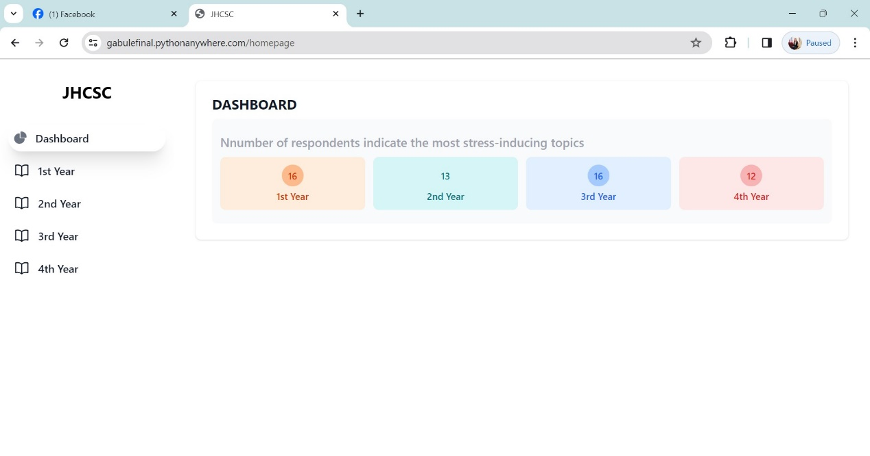

The image above shows the homepage of the system where it shows the overall respondents, and number of respondents indicate struggling in subjects.

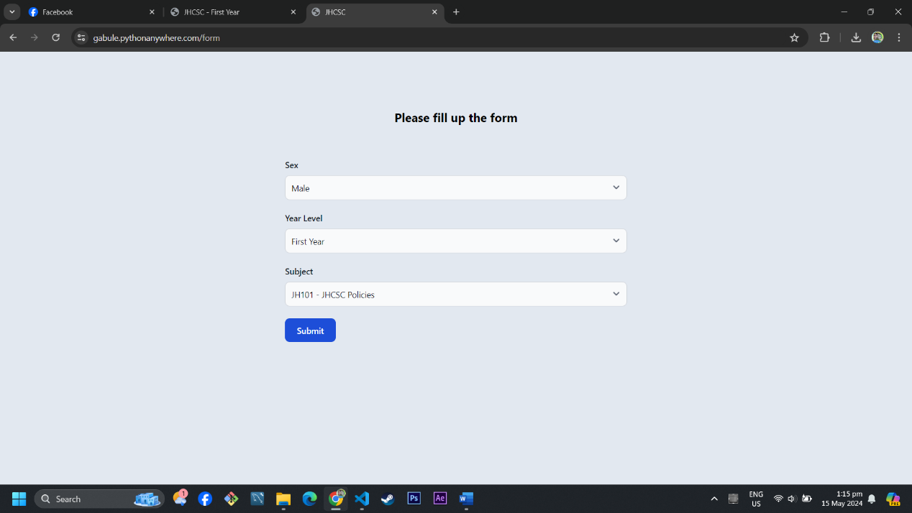

The image above shows the form page of the system where the BSIT students can fill up the form and submit it.

**Result and Conclusion**

The proponent concluded that the Most Pressured Subject we-based system help track the students of JHCSC BSIT Program what subject are the most stressful and not stressful. The user easily interact with the system for it is user-friendly design.

**Sample Output**

The image above shows number of respondents in each subject where the majority of the respondents are struggling in GEC 102.