**Date:** August 2014

Financial Industry Business Ontology Foundations

*FTF – Beta2*

*__________________________________________________*

**OMG Document Number:** dtc/2014-08-22

**Standard document URL: http://www.omg.org/spec/FIBO/1.0**

**Normative Machine Consumable File(s):**

**http://www.omg.org/spec/FIBO/20140801/EDMC-FIBO/FND/Accounting/AccountingEquity.rdf**

**http://www.omg.org/spec/FIBO/20140801/EDMC-FIBO/FND/Accounting/CurrencyAmount.rdf**

**http://www.omg.org/spec/FIBO/20140801/EDMC-FIBO/FND/AgentsAndPeople/Agents.rdf**

**http://www.omg.org/spec/FIBO/20140801/EDMC-FIBO/FND/AgentsAndPeople/People.rdf**

**http://www.omg.org/spec/FIBO/20140801/EDMC-FIBO/FND/Agreements/Agreements.rdf**

**http://www.omg.org/spec/FIBO/20140801/EDMC-FIBO/FND/Agreements/Contracts.rdf**

**http://www.omg.org/spec/FIBO/20140801/EDMC-FIBO/FND/Arrangements/Arrangements.rdf**

**http://www.omg.org/spec/FIBO/20140801/EDMC-FIBO/FND/Arrangements/IdentifiersAndIndices.rdf**

**http://www.omg.org/spec/FIBO/20140801/EDMC-FIBO/FND/GoalsAndObjectives/Goals.rdf**

**http://www.omg.org/spec/FIBO/20140801/EDMC-FIBO/FND/GoalsAndObjectives/Objectives.rdf**

**http://www.omg.org/spec/FIBO/20140801/EDMC-FIBO/FND/Law/Jurisdiction.rdf**

**http://www.omg.org/spec/FIBO/20140801/EDMC-FIBO/FND/Law/LegalCapacity.rdf**

**http://www.omg.org/spec/FIBO/20140801/EDMC-FIBO/FND/Law/LegalCore.rdf**

**http://www.omg.org/spec/FIBO/20140801/EDMC-FIBO/FND/Organizations/FormalOrganizations.rdf**

**http://www.omg.org/spec/FIBO/20140801/EDMC-FIBO/FND/Organizations/LegitimateOrganizations.rdf**

**http://www.omg.org/spec/FIBO/20140801/EDMC-FIBO/FND/Organizations/Organizations.rdf**

**http://www.omg.org/spec/FIBO/20140801/EDMC-FIBO/FND/OwnershipAndControl/Control.rdf**

**http://www.omg.org/spec/FIBO/20140801/EDMC-FIBO/FND/OwnershipAndControl/Ownership.rdf**

**http://www.omg.org/spec/FIBO/20140801/EDMC-FIBO/FND/Parties/Parties.rdf**

**http://www.omg.org/spec/FIBO/20140801/EDMC-FIBO/FND/Parties/Roles.rdf**

**http://www.omg.org/spec/FIBO/20140801/EDMC-FIBO/FND/Places/Addresses.rdf**

**http://www.omg.org/spec/FIBO/20140801/EDMC-FIBO/FND/Places/Countries.rdf**

**http://www.omg.org/spec/FIBO/20140801/EDMC-FIBO/FND/Places/Locations.rdf**

**http://www.omg.org/spec/FIBO/20140801/EDMC-FIBO/FND/Relations/Relations.rdf**

**http://www.omg.org/spec/FIBO/20140801/EDMC-FIBO/FND/Utilities/AnnotationVocabulary.rdf**

**http://www.omg.org/spec/FIBO/20140801/EDMC-FIBO/FND/Utilities/BusinessFacingTypes.rdf**

**http://www.omg.org/spec/FIBO/20140801/EDMC-FIBO/FND/AccountingEquity.xml**

**http://www.omg.org/spec/FIBO/20140801/EDMC-FIBO/FND/CurrencyAmount.xml**

**http://www.omg.org/spec/FIBO/20140801/EDMC-FIBO/FND/Agents.xml**

**http://www.omg.org/spec/FIBO/20140801/EDMC-FIBO/FND/People.xml**

**http://www.omg.org/spec/FIBO/20140801/EDMC-FIBO/FND/Agreements.xml**

**http://www.omg.org/spec/FIBO/20140801/EDMC-FIBO/FND/Contracts.xml**

**http://www.omg.org/spec/FIBO/20140801/EDMC-FIBO/FND/Arrangements.xml**

**http://www.omg.org/spec/FIBO/20140801/EDMC-FIBO/FND/IdentifiersAndIndices.xml**

**http://www.omg.org/spec/FIBO/20140801/EDMC-FIBO/FND/Goals.xml**

**http://www.omg.org/spec/FIBO/20140801/EDMC-FIBO/FND/Objectives.xml**

**http://www.omg.org/spec/FIBO/20140801/EDMC-FIBO/FND/Jurisdiction.xml**

**http://www.omg.org/spec/FIBO/20140801/EDMC-FIBO/FND/LegalCapacity.xml**

**http://www.omg.org/spec/FIBO/20140801/EDMC-FIBO/FND/LegalCore.xml**

**http://www.omg.org/spec/FIBO/20140801/EDMC-FIBO/FND/FormalOrganizations.xml**

**http://www.omg.org/spec/FIBO/20140801/EDMC-FIBO/FND/LegitimateOrganizations.xml**

**http://www.omg.org/spec/FIBO/20140801/EDMC-FIBO/FND/Organizations.xml**

**http://www.omg.org/spec/FIBO/20140801/EDMC-FIBO/FND/Control.xml**

**http://www.omg.org/spec/FIBO/20140801/EDMC-FIBO/FND/Ownership.xml**

**http://www.omg.org/spec/FIBO/20140801/EDMC-FIBO/FND/Parties.xml**

**http://www.omg.org/spec/FIBO/20140801/EDMC-FIBO/FND/Roles.xml**

**http://www.omg.org/spec/FIBO/20140801/EDMC-FIBO/FND/Addresses.xml**

**http://www.omg.org/spec/FIBO/20140801/EDMC-FIBO/FND/Countries.xml**

**http://www.omg.org/spec/FIBO/20140801/EDMC-FIBO/FND/Locations.xml**

**http://www.omg.org/spec/FIBO/20140801/EDMC-FIBO/FND/Relations.xml**

**http://www.omg.org/spec/FIBO/20140801/EDMC-FIBO/FND/AnnotationVocabulary.xml**

**http://www.omg.org/spec/FIBO/20140801/EDMC-FIBO/FND/BusinessFacingTypes.xml**

**http://www.omg.org/spec/FIBO/20140801/EDMC-FIBO/FND/Accounting/AccountingEquity.xmi**

**http://www.omg.org/spec/FIBO/20140801/EDMC-FIBO/FND/Accounting/CurrencyAmount.xmi**

**http://www.omg.org/spec/FIBO/20140801/EDMC-FIBO/FND/AgentsAndPeople/Agents.xmi**

**http://www.omg.org/spec/FIBO/20140801/EDMC-FIBO/FND/AgentsAndPeople/People.xmi**

**http://www.omg.org/spec/FIBO/20140801/EDMC-FIBO/FND/Agreements/Agreements.xmi**

**http://www.omg.org/spec/FIBO/20140801/EDMC-FIBO/FND/Agreements/Contracts.xmi**

**http://www.omg.org/spec/FIBO/20140801/EDMC-FIBO/FND/Arrangements/Arrangements.xmi**

**http://www.omg.org/spec/FIBO/20140801/EDMC-FIBO/FND/Arrangements/IdentifiersAndIndices.xmi**

**http://www.omg.org/spec/FIBO/20140801/EDMC-FIBO/FND/GoalsAndObjectives/Goals.xmi**

**http://www.omg.org/spec/FIBO/20140801/EDMC-FIBO/FND/GoalsAndObjectives/Objectives.xmi**

**http://www.omg.org/spec/FIBO/20140801/EDMC-FIBO/FND/Law/Jurisdiction.xmi**

**http://www.omg.org/spec/FIBO/20140801/EDMC-FIBO/FND/Law/LegalCapacity.xmi**

**http://www.omg.org/spec/FIBO/20140801/EDMC-FIBO/FND/Law/LegalCore.xmi**

**http://www.omg.org/spec/FIBO/20140801/EDMC-FIBO/FND/Organizations/FormalOrganizations.xmi**

**http://www.omg.org/spec/FIBO/20140801/EDMC-FIBO/FND/Organizations/LegitimateOrganizations.xmi**

**http://www.omg.org/spec/FIBO/20140801/EDMC-FIBO/FND/Organizations/Organizations.xmi**

**http://www.omg.org/spec/FIBO/20140801/EDMC-FIBO/FND/OwnershipAndControl/Control.xmi**

**http://www.omg.org/spec/FIBO/20140801/EDMC-FIBO/FND/OwnershipAndControl/Ownership.xmi**

**http://www.omg.org/spec/FIBO/20140801/EDMC-FIBO/FND/Parties/Parties.xmi**

**http://www.omg.org/spec/FIBO/20140801/EDMC-FIBO/FND/Parties/Roles.xmi**

**http://www.omg.org/spec/FIBO/20140801/EDMC-FIBO/FND/Places/Addresses.xmi**

**http://www.omg.org/spec/FIBO/20140801/EDMC-FIBO/FND/Places/Countries.xmi**

**http://www.omg.org/spec/FIBO/20140801/EDMC-FIBO/FND/Places/Locations.xmi**

**http://www.omg.org/spec/FIBO/20140801/EDMC-FIBO/FND/Relations/Relations.xmi**

**http://www.omg.org/spec/FIBO/20140801/EDMC-FIBO/FND/Utilities/AnnotationVocabulary.xmi**

**http://www.omg.org/spec/FIBO/20140801/EDMC-FIBO/FND/Utilities/BusinessFacingTypes.xmi**

_________________________________________________

This OMG document replaces the submission document (finance/2013-09-02, Alpha). It is an OMG Adopted Beta specification and is currently in the finalization phase. Comments on the content of this document are welcome, and should be directed to [issues@omg.org](mailto:issues@omg.org) by February 28, 2014.

You may view the pending issues for this specification from the OMG revision issues web page <http://www.omg.org/issues/>.

The FTF Recommendation and Report for this specification will be published on June 27, 2014. If you are reading this after that date, please download the available specification from the OMG Specifications Catalog.

Copyright © 2014, EDM Council  
Copyright © 2014, Object Management Group, Inc.

USE OF SPECIFICATION - TERMS, CONDITIONS & NOTICES

The material in this document details an Object Management Group specification in accordance with the terms, conditions and notices set forth below. This document does not represent a commitment to implement any portion of this specification in any company's products. The information contained in this document is subject to change without notice.

LICENSES

The companies listed above have granted to the Object Management Group, Inc. (OMG) a nonexclusive, royalty-free, paid up, worldwide license to copy and distribute this document and to modify this document and distribute copies of the modified version. Each of the copyright holders listed above has agreed that no person shall be deemed to have infringed the copyright in the included material of any such copyright holder by reason of having used the specification set forth herein or having conformed any computer software to the specification.

Subject to all of the terms and conditions below, the owners of the copyright in this specification hereby grant you a fully-paid up, non-exclusive, nontransferable, perpetual, worldwide license (without the right to sublicense), to use this specification to create and distribute software and special purpose specifications that are based upon this specification, and to use, copy, and distribute this specification as provided under the Copyright Act; provided that: (1) both the copyright notice identified above and this permission notice appear on any copies of this specification; (2) the use of the specifications is for informational purposes and will not be copied or posted on any network computer or broadcast in any media and will not be otherwise resold or transferred for commercial purposes; and (3) no modifications are made to this specification. This limited permission automatically terminates without notice if you breach any of these terms or conditions. Upon termination, you will destroy immediately any copies of the specifications in your possession or control.

PATENTS

The attention of adopters is directed to the possibility that compliance with or adoption of OMG specifications may require use of an invention covered by patent rights. OMG shall not be responsible for identifying patents for which a license may be required by any OMG specification, or for conducting legal inquiries into the legal validity or scope of those patents that are brought to its attention. OMG specifications are prospective and advisory only. Prospective users are responsible for protecting themselves against liability for infringement of patents.

GENERAL USE RESTRICTIONS

Any unauthorized use of this specification may violate copyright laws, trademark laws, and communications regulations and statutes. This document contains information which is protected by copyright. All Rights Reserved. No part of this work covered by copyright herein may be reproduced or used in any form or by any means--graphic, electronic, or mechanical, including photocopying, recording, taping, or information storage and retrieval systems--without permission of the copyright owner.

DISCLAIMER OF WARRANTY

WHILE THIS PUBLICATION IS BELIEVED TO BE ACCURATE, IT IS PROVIDED "AS IS" AND MAY CONTAIN ERRORS OR MISPRINTS. THE OBJECT MANAGEMENT GROUP AND THE COMPANIES LISTED ABOVE MAKE NO WARRANTY OF ANY KIND, EXPRESS OR IMPLIED, WITH REGARD TO THIS PUBLICATION, INCLUDING BUT NOT LIMITED TO ANY WARRANTY OF TITLE OR OWNERSHIP, IMPLIED WARRANTY OF MERCHANTABILITY OR WARRANTY OF FITNESS FOR A PARTICULAR PURPOSE OR USE. IN NO EVENT SHALL THE OBJECT MANAGEMENT GROUP OR ANY OF THE COMPANIES LISTED ABOVE BE LIABLE FOR ERRORS CONTAINED HEREIN OR FOR DIRECT, INDIRECT, INCIDENTAL, SPECIAL, CONSEQUENTIAL, RELIANCE OR COVER DAMAGES, INCLUDING LOSS OF PROFITS, REVENUE, DATA OR USE, INCURRED BY ANY USER OR ANY THIRD PARTY IN CONNECTION WITH THE FURNISHING, PERFORMANCE, OR USE OF THIS MATERIAL, EVEN IF ADVISED OF THE POSSIBILITY OF SUCH DAMAGES.

The entire risk as to the quality and performance of software developed using this specification is borne by you. This disclaimer of warranty constitutes an essential part of the license granted to you to use this specification.

RESTRICTED RIGHTS LEGEND

Use, duplication or disclosure by the U.S. Government is subject to the restrictions set forth in subparagraph (c) (1) (ii) of The Rights in Technical Data and Computer Software Clause at DFARS 252.227-7013 or in subparagraph (c)(1) and (2) of the Commercial Computer Software - Restricted Rights clauses at 48 C.F.R. 52.227-19 or as specified in 48 C.F.R. 227-7202-2 of the DoD F.A.R. Supplement and its successors, or as specified in 48 C.F.R. 12.212 of the Federal Acquisition Regulations and its successors, as applicable. The specification copyright owners are as indicated above and may be contacted through the Object Management Group, 109 Highland Avenue, Needham, MA 02494, U.S.A.

TRADEMARKS

IMM®, MDA®, Model Driven Architecture®, UML®, UML Cube logo®, OMG Logo®, CORBA® and XMI® are registered trademarks of the Object Management Group, Inc., and Object Management Group™, OMG™ , Unified Modeling Language™, Model Driven Architecture Logo™, Model Driven Architecture Diagram™, CORBA logos™, XMI Logo™, CWM™, CWM Logo™, IIOP™ , MOF™ , OMG Interface Definition Language (IDL)™ , and OMG SysML™ are trademarks of the Object Management Group. All other products or company names mentioned are used for identification purposes only, and may be trademarks of their respective owners.

COMPLIANCE

The copyright holders listed above acknowledge that the Object Management Group (acting itself or through its designees) is and shall at all times be the sole entity that may authorize developers, suppliers and sellers of computer software to use certification marks, trademarks or other special designations to indicate compliance with these materials.

Software developed under the terms of this license may claim compliance or conformance with this specification if and only if the software compliance is of a nature fully matching the applicable compliance points as stated in the specification. Software developed only partially matching the applicable compliance points may claim only that the software was based on this specification, but may not claim compliance or conformance with this specification. In the event that testing suites are implemented or approved by Object Management Group, Inc., software developed using this specification may claim compliance or conformance with the specification only if the software satisfactorily completes the testing suites

**OMG’s Issue Reporting Procedure**

All OMG specifications are subject to continuous review and improvement. As part of this process we encourage readers to report any ambiguities, inconsistencies, or inaccuracies they may find by completing the Issue Reporting Form listed on the main web page http://www.omg.org, under Documents, Report a Bug/Issue (http://www.omg.org/report_issue.htm.)

Table of Contents

1 Scope 7

1.1 Overview 7

1.2 Applications and Uses of FIBO 7

1.3 How FIBO is Different from Operational Ontologies 8

1.4 How FIBO is Different from Data Models 8

1.5 Definitions 8

1.5.1. Definitions Policy 9

2 Conformance 9

2.1 Overview 9

2.2 Conformant Technical Applications of Model Content 9

2.2.1 Assessing Model Conformance 10

2.2.2 Assessing FIBO ODM Conformance 10

2.3 Conformant Extensions of FIBO Content 10

2.3.1 Labeling 10

2.3.2 Model Consistency 11

2.3.3 Relationship to Subject Matter 11

2.4 Conformant Business Presentation of Model Content 11

2.4.1 General Requirements 11

2.4.2 Business Diagram Conformance 12

2.4.3 Business Table Conformance 12

3 References 13

3.1 Normative References 13

3.2 Non Normative References 15

3.3 Changes to Adopted OMG Specifications 15

4 Terms and Definitions 15

5 Symbols and Abbreviations 18

5.1 Symbols 18

5.2 Abbreviations 18

6 Additional Information 18

6.1 How to Read this Specification 18

6.1.1 Audiences 18

6.2 Acknowledgements 19

6.3 Interpreting the Business Model Content 21

6.3.1 Introduction 21

6.3.2 The Model 21

6.3.3 Interpretation 22

7 Introduction 25

7.1.1 Reading this Standard 25

7.2 Usage Scenarios 25

7.2.1 Model Driven Development 25

7.2.2 Semantic Technology Development 26

7.2.3 Integration of systems and/or data feeds 26

8 Architecture 27

8.1 Ontology Definition Metamodel (ODM) Usage and Adaptations 27

8.1.1 Introduction 27

8.1.2 ODM Constructs Usage 27

8.2 Ontology Architecture and Namespaces 29

8.3 FIBO-Based Reporting 32

8.3.1 Business-Facing Approach 32

9 Additional Metadata 34

9.1 Introduction 34

9.2 Ontology-Level Metadata 34

9.3 Ontology Entity-Level Metadata 37

9.3.1 Definitions, Notes, and Labels 37

9.3.2 Synonymous Terms 37

9.3.3 Provenance and Cross-reference Annotation 37

9.3.4 Change Management Annotation 38

10. Model Content Reports 39

10.1 Module: Utilities 41

10.1.1 Ontology: Annotation Vocabulary 41

10.1.2 Ontology: Business Facing Types 48

10.2 Module: Relations 53

10.2.1 Ontology: Relations 53

10.3 Module: Goals and Objectives 69

10.3.1 Ontology: Goals 69

10.3.2 Ontology: Objectives 71

10.4 Module: Parties 73

10.4.1 Ontology: Parties 73

10.4.2 Ontology: Roles 79

10.5 Module: Arrangements 82

10.5.1 Ontology: Arrangements 83

10.5.1 Ontology: IdentifiersAndIndices 85

10.6 Module: Agents and People 89

10.6.1 Ontology: Agents 89

10.6.2 Ontology: People 92

10.7 Module: Places 106

10.7.1 Ontology: Locations 106

10.7.2 Ontology: Countries 109

10.7.3 Ontology: Addresses 112

10.8 Module: Organizations 116

10.8.1 Ontology: Organizations 117

10.8.2 Ontology: Formal Organizations 119

10.8.3 Ontology: Legitimate Organizations 123

10.9 Module: Agreements 126

10.9.1 Ontology: Agreements 126

10.9.2 Ontology: Contracts 131

10.10 Module: Law 146

10.10.1 Ontology: Legal Core 147

10.10.2 Ontology: Jurisdiction 152

10.10.3 Ontology: Legal Capacity 162

10.11 Module: Ownership and Control 168

10.11.1 Ontology: Control 168

10.11.2 Ontology: Ownership 174

10.12 Module: Accounting 181

10.12.1 Ontology: Accounting Equity 181

10.12.2 Ontology: Currency Amount 187

Annex A: Machine Readable Files Part of This Specification 194

(normative) 194

Annex B: Shared Semantics Treatments 195

B.1 Introduction 195

B.2 Shared Semantics Treatments 195

Annex C: Logical versus Conceptual Models comparison 197

C.1 Comparison Table 197

C.2 Detailed Models Comparison 197

C.3 Model Partitioning 199

C.3.1 Independent, Relative and Mediating Things 200

C.3.2 Concrete and Abstract Things 200

C.3.3 Continuant and Occurrent Things 201

Annex D: How to extend FIBO ontologies 202

D.1 Terminology used in this Annex 202

D.2 Overview 202

D.2.1 Classes of Thing 202

D.2.2 Model relationship to Subject Matter 202

D.2.3 How to Model New Classes 203

D.2.4 Declaring Class Disjointness 203

D.2.5 How to Model New Facts about Things 203

D.2.6 Inverse Relationships 205

D.2.7 How and When to Use Enumerations 205

D.2.8 Foundations Concepts Usage 206

D.2.9 Content Creation Summary 206

D.3 Presentation Considerations 207

D.3.1 Labeling 207

D.3.2 Ontologies 208

D.3.3 UML Considerations 208

Annex E: Creating Applications with FIBO (Informative) 210

E1. Introduction 210

E.1.1 Principles 210

E.1.2 Operational Ontologies 210

E.1.3 Conventional Applications 211

Preface

**OMG**

Founded in 1989, the Object Management Group, Inc. (OMG) is an open membership, not-for-profit computer industry standards consortium that produces and maintains computer industry specifications for interoperable, portable, and reusable enterprise applications in distributed, heterogeneous environments. Membership includes Information Technology vendors, end users, government agencies, and academia.

OMG member companies write, adopt, and maintain its specifications following a mature, open process. OMG’s specifications implement the Model Driven Architecture® (MDA®), maximizing ROI through a full-lifecycle approach to enterprise integration that covers multiple operating systems, programming languages, middleware and networking infrastructures, and software development environments. OMG’s specifications include: UML® (Unified Modeling Language™); CORBA® (Common Object Request Broker Architecture); CWM™ (Common Warehouse Metamodel); and industry-specific standards for dozens of vertical markets.

More information on the OMG is available at http://www.omg.org/.

**OMG Specifications**

As noted, OMG specifications address middleware, modeling and vertical domain frameworks. All OMG Specifications are available from the OMG website at:

*http://www.omg.org/spec*

Specifications are organized by the following categories:

Business Modeling Specifications

Middleware Specifications

1. CORBA/IIOP
2. Data Distribution Services
3. Specialized CORBA

IDL/Language Mapping Specifications

Modeling and Metadata Specifications

1. UML, MOF, CWM, XMI
2. UML Profile

Modernization Specifications

Platform Independent Model (PIM), Platform Specific Model (PSM), Interface Specifications

1. CORBAServices
2. CORBAFacilities

OMG Domain Specifications

CORBA Embedded Intelligence Specifications

CORBA Security Specifications

All of OMG’s formal specifications may be downloaded without charge from our website. (Products implementing OMG specifications are available from individual suppliers.) Copies of specifications, available in PostScript and PDF format, may be obtained from the Specifications Catalog cited above or by contacting the Object Management Group, Inc. at:

OMG Headquarters  
109 Highland Avenue  
Needham, MA 02494  
USA  
Tel: +1-781-444-0404  
Fax: +1-781-444-0320  
Email: *pubs@omg.org*

Certain OMG specifications are also available as ISO standards. Please consult http://www.iso.org

**Typographical Conventions**

The type styles shown below are used in this document to distinguish programming statements from ordinary English. However, these conventions are not used in tables or section headings where no distinction is necessary.

Times/Times New Roman - 10 pt.: Standard body text

**Helvetica/Arial - 10 pt. Bold:** OMG Interface Definition Language (OMG IDL) and syntax elements.

**Courier/Courier New - 10 pt. Bold:** Programming language elements.

Helvetica/Arial - 10 pt: Exceptions

NOTE: Terms that appear in italics are defined in the glossary. Italic text also represents the name of a document, specification, or other publication.

# Scope

## 1.1 Overview

This specification is part of a family of specifications called the Financial Industry Business Ontology (FIBO).

FIBO is a modularized formal model of the concepts represented by finance industry terms as used in official financial organization documents such as contracts, product/service specifications and governance and regulatory compliance documents. This is referred to as a *Business Conceptual Model* as distinct from models or descriptions of data or IT implementations.

The scope of *finance industry* encompasses a broad range of organizations that manage money, including [credit unions](http://en.wikipedia.org/wiki/Credit_union), [banks](http://en.wikipedia.org/wiki/Bank), [credit card](http://en.wikipedia.org/wiki/Credit_card) companies, [insurance](http://en.wikipedia.org/wiki/Insurance) companies, [consumer finance](http://en.wikipedia.org/wiki/Consumer_finance) companies, [stock brokerages](http://en.wikipedia.org/wiki/Brokerage_firm), [investment funds](http://en.wikipedia.org/wiki/Investment_management) and some [government sponsored enterprises](http://en.wikipedia.org/wiki/Government_sponsored_enterprise).

This particular specification defines the **Foundations** module of FIBO: a set of business concepts which are intended to support the financial industry terms semantics presented in other FIBO specifications.

Foundations is itself segmented into a number of models or ontologies.

The FIBO Foundations models define general concepts that are not unique to the financial industry, but needed to help define the financial concepts. FIBO Foundations therefore includes a number of basic legal, contractual and organizational concepts, among others. Concepts which are available in other industry standards are not included, but in some cases a “Proxy” concept is included for reference, for example for address and country concepts. The rationale for including these is two-fold:

* Concepts in the financial industry are generally specializations of more general, non-financial concepts such as contracts, commitments, transactions, organizations and so on, These are included in FIBO Foundations so that specializations of them may be defined in other FIBO specifications;
* Properties of financial industry concepts frequently need to be framed in terms of relationships to non-financial concepts such as countries, jurisdictions, addresses and the like. These are included in FIBO Foundations so that properties in other FIBO specifications may make reference to them.

FIBO concepts are documented using two forms of definition:

1. a structured ontology specification of the concept, and its relationships to others, represented using the Web Ontology Language (OWL).
2. natural language definitions which represent the concepts in natural language using the vocabulary of the finance industry.

This specification covers both the content of the models, and the underlying architecture employed for producing and presenting the model.

A number of informative annexes are provided to assist potential users with adoption and implementation of this and other FIBO specifications.

## 1.2 Applications and Uses of FIBO

One of the key benefits of FIBO with respect to data, message or reasoning metamodels is that it can provide a semantic anchor firmly rooted in the concepts as understood and used by people in the finance industry. FIBO enables the creation of logical data models such that those logical models derive their formal semantics from FIBO.

FIBO supports the derivation of ontologies to support semantic reasoning and querying applications. Since FIBO itself is framed using the formal constructs of the OWL language, such operational ontologies may be derived directly from the FIBO conceptual ontologies, with adaptation as necessary to support any application specific constraints.

FIBO allows disambiguation of new and existing regulation. To the extent that regulatory requirements reference the formal concepts in FIBO, terms referred to in these regulatory requirements, or in reports that are mandated, would be semantically unambiguous.

One important goal of FIBO is for the formal business definitions to be used in legal documents such as contracts, terms and conditions of sales and payment, IP protection, compliance reports; and to underpin less formal language used in advertising and customer-facing websites.

The business terms and definitions in this specification may be used as a reference model to which firms would tie their own proprietary models (semantic models or ontologies); and also as a catalog for all of the relevant data models.

## 1.3 How FIBO is Different from Operational Ontologies

**Intended Audiences*:*** *Technical modellers, data architects*

An ontology, regardless of how it is to be used, sets out formally a representation of items in a real-world domain of discourse. There are two distinct uses to which this applies:

* A business ontology (business conceptual model) as described in this specification – this uses the full expressive power of the chosen notation to formally define items in the domain of discourse, without taking application technical constraints into account
* An operational ontology is constrained to operate within the parameters of a specific semantic application. Typically, this will contain a sub-set of the constructs in the business conceptual ontology, and that sub-set will typically comprise a decidable ontology.

It is necessarily the case that when something is to be used in an application, there will be technical constraints imposed upon that application. This is just as true when the application includes an ontology, as for other technologies.

The technical constraints that may apply to an operational ontology, necessarily do not apply to a business conceptual ontology. That is, the existence of some technical constraint in the application domain should not in any way influence the way in which business facts are formally captured and modeled in a business conceptual ontology.

## 1.4 How FIBO is Different from Data Models

FIBO can be distinguished from document/message/data/reasoning schemas of all kinds.

* FIBO models things in the real or planned world of the finance industry.
* FIBO will only contain instances of its own concepts under the specific conditions listed below. With these exceptions, FIBO contains only concepts - even if those concepts have just single instances in the real or planned world of finance.
  + Instances which are needed in order to define properties which refer to them;
  + Classes of thing which are defined extensionally; and
  + Examples
* FIBO is not any kind of a data, message or reasoning model, although it adds great value to these. It does not model document/message/data content or schemas optimized for reasoning.

FIBO will not include concepts about the structure of content, messages, information or data, even if that data is in turn about the finance industry.

The FIBO model, is referred to here as a "Business Conceptual Model”, corresponding to Level 2 of the Zachman Framework for Information Architecture.

The distinctions between the scope of the FIBO model, and that of both logical and physical models, are further described in Annex C.

## 1.5 Definitions

The human readable definitions have been constructed by and with the input of business subject matter experts.

Many definitions have been derived from definitions of data elements corresponding to those terms in industry data or messaging standards. These have been adapted where necessary to ensure that they are descriptive of the thing or fact itself and not of data elements for data about those things or facts, and have then been reviewed by industry subject matter experts to ensure that such adaptation accurately captures the sense of the business concept. In cases where the definition in a data or message standard was incomplete, context-specific or tautologous, a fresh definition was framed by the industry subject matter experts who participated in these reviews, or a third party definition was proposed and adopted.

### 1.5.1. Definitions Policy

In some cases, definitions have been obtained from third party sources. The policy for arriving at definitions for the FIBO industry terms was as follows (and remains so for future iterations and extensions):

1. In the absence of a definition endorsed by the subject matter experts for a term, "Barrons DICTIONARY OF FINANCE AND INVESTMENT TERMS, 8th Edition John Downes and Jordan Elliot Goodman" shall be used.

2. If a term and its acceptable definition is not in the Barrons Dictionary, then http://www.investopedia.com/dictionary/ shall be the authoritative source, subject to licensing requirements being met.

3. If a term and its acceptable definition is not in either the Barrons Dictionary or the investopedia dictionary, then http://www.bankersalmanac.com/addcon/dictionary/ shall be the authoritative source.

4. If a term has no acceptable definition in these Financial Industry sources or does not exist in these Financial Industry sources then http://www.merriam-webster.com shall be the authoritative source.

5. When there is a conflict with the definition of a Financial Industry term with the same term in another Industry, the Financial Industry definition will be used within FIBO.

In all cases the source from which the definition was obtained, or from which it was adapted, is recorded in annotation metadata for that concept.

# Conformance

## 2.1 Overview

This clause defines conformance points for the following types of artifacts:

* Technical applications of FIBO such as logical data models, XML schemas, operational ontologies, code, and other technical artifacts
* Extensions of FIBO
* Representations of FIBO for business consumption
  + In diagrams
  + In spreadsheets or tables

Conformance of technical applications of FIBO is the most important conformance point, because it addresses the core issue of what it means to conform to the ontologies that FIBO defines. In comparison, conformance of extensions and representations, while still important, are somewhat secondary concerns.

Note that in addition to conformant applications, there are a number of scenarios in which someone may make use of the FIBO ontologies as a business conceptual model while applying their own design to meet their requirements. It is not possible to define specific conformance points for each of the possible ways in which one may legitimately develop a conventional database application or an operational OWL ontology that would be a good application. The non-normative annex [Annex E] describes a number of acceptable model architectures which may adequately reflect the material in FIBO Foundations and any of the other FIBO specifications.

## 2.2 Conformant Technical Applications of Model Content

Technical applications of FIBO content are logical data models, XML schemas, operational ontologies, code artifacts, and other technical artifacts that purport to conform to FIBO.

### 2.2.1 Assessing Model Conformance

Given that a technical application includes a set of information elements some of which correspond to the concepts in FIBO, then the application is FIBO Model Conformant if and only if:

* At least one of those information elements corresponds to a concept in the FIBO ontology for which conformance is claimed
* The application does not permit actual data to exist which would not be valid set of instances of those corresponding FIBO concepts: in other words if the data is represented as a set of individuals of the corresponding FIBO concepts then they will constitute a valid FIBO model with no contradictions

It is permissible for the information elements to have additional information or to be more constrained than those in FIBO.

#### 2.2.1.1 Full FIBO Foundations Model Conformance

If a technical application is FIBO Model Conformant with the complete set of FIBO Foundations ontologies, then the application satisfies Full FIBO Model Conformance.

#### 2.2.1.2 FIBO Ontology Model Conformance

If a technical application is FIBO Model Conformant with a particular FIBO Foundations ontology, then the application satisfies FIBO Ontology Conformance for that particular ontology. There is thus a separate compliance point for each ontology in Clause 10.

### 2.2.2 Assessing FIBO ODM Conformance

An extension of FIBO is FIBO ODM conformant if it is expressed in ODM (the OMG Ontology Definition Metamodel) and also restricts itself to using only the sub-set of ODM modeling constructs defined in the Architecture clause of this specification (8)

If the technical application is not an OWL ontology, then by definition the application is not FIBO ODM Conformant.

## 2.3 Conformant Extensions of FIBO Content

This definition of conformance points applies both to extension of the model content for use locally and to the preparation for submission of new model content for FIBO itself. The following conformance points may be asserted for each ontology that extends FIBO itself:

* FIBO-Full Extension in ODM: Satisfies FIBO Extension Conformance (see below) and FIBO ODM Conformance
* FIBO-Full Extension in OWL: Satisfies FIBO Extension Conformance (see below) and OWL2 Conformance

In turn, for FIBO Extension Conformance an ontology must satisfy FIBO Model Conformance (see 2.3.1) and the rules in the following three sub-clauses related to labeling, model consistency and relationship to subject matter.

### 2.3.1 Labeling

Business-facing labels shall be provided for all named model constructs. These labels must conform to the following formal requirements:

* Labels shall use normal English expression including spaces and punctuation, using lowercase except for proper nouns.
* Labels shall represent a plain English name (in US English spelling) which is that most commonly used by the finance industry.
* Labels do not need to be unique across the model.
* At least one business-facing label shall be present which is not in the form of, or contain, acronyms (including business acronyms) except where these are the only means by which the concept may be referred in the business domain (for example "CDO Squared").

### 2.3.2 Model Consistency

Reasoning is the mechanism by which the logical assertions made in an ontology and related knowledge base are evaluated by an inference engine. A logical assertion is simply an explicit statement that declares that a certain premise is true. Such assertions, taken together, form a logical theory, and a consistent theory is one that does not contain any logical contradictions. This means that there is at least one interpretation of the theory in which all of the axioms contained therein are provably true. The logical assertions expressed in the FIBO Foundations ontologies have been checked using multiple inference engines, designed specifically to support OWL 2, for internal logical consistency *(i.e*., for consistency within that single ontology), and for logical consistency with imports closure (meaning, consistency including all axioms in any imported ontology in addition to those in the single ontology in question).

In order for any extension to FIBO to be conformant, it must be verified as being logically consistent (internally and with respect to imports) in addition to syntactically correct according to the OWL specifications. Examples of reasoning engines that can be used to verify logical consistency of an OWL 2 ontology are discussed in an article on Wikipedia[1]. Members of the OMG Ontology Special Interest Group ([ontology@omg.org](mailto:ontology@omg.org)) can also make recommendations for tooling that might assist FIBO users in verifying their extensions.

### 2.3.3 Relationship to Subject Matter

In any extension to FIBO model content each model element which is a class, an object property or a datatype property shall correspond to some item in the real world. No model element shall refer to some technical construct such as a database field, internal identifier, database key and the like.

An exception is made for information constructs which are themselves important and publicly shared parts of the business domain, such as publicly issued identifiers, security identifiers, ratings codes and the like. In each such case, there shall be some formally identified scheme in which the code in question is defined.

A suitable test for types of "Information" to be considered real is whether that information is publicly shared or, if private, made available across the business supply chain. Examples include Legal Entity Identifier, securities prospectuses, published indices, interest rates.

## 2.4 Conformant Business Presentation of Model Content

There are two conformance points for presentation of FIBO content:

* FIBO Business Diagram
* FIBO Business Table

Any tool which asserts support for one or other or both of business presentation conformance points must be able to import the available FIBO content in at least one of the available serialization formats (UML XMI, ODM XMI or OWL), and produce diagrams and/or tables which conform with the requirements defined for the conformance point.

### 2.4.1 General Requirements

It is a requirement of this specification that content of the models is made available to people in the business domain in one or more of a set of diagrams and tables which are described in this specification.

A presentation of FIBO model content is not a conformant FIBO Business Presentation (i.e. a conformant FIBO Business Diagram or a conformant FIBO Business Table) if the only means for the reader to view the model’s terms, definitions and relationships is one which requires some formal understanding of some model language such as UML or OWL, beyond the knowledge conveyed by the annexes to this specification. For the avoidance of doubt, a non-conformant business presentation is any format which contains symbols, whether diagrammatic or textual, which have a meaning other than the meaning which a reasonably educated but non-technical person would ascribe to those items

### 2.4.2 Business Diagram Conformance

OWL features such as restrictions on properties or classes, where these are present in the model content, shall be rendered in some way that communicates their business intent without reference to the way in which the OWL syntax represents these constructions.

OWL constructs shall be represented by simple constructs which do not require specialist technical training, such as boxes, arrows and lines.

All notation on all diagrams shall only represent features of OWL, except where this is clearly identified as additional annotation (intended to enhance an understanding of the business content of the model and not part of the model itself).

In diagrams generated from OWL tools or other non UML based tooling, no features shall be present which do not represent some feature of OWL except where these are clearly identified as visual decorations intended to enhance an understanding of the business content of the model.

If UML Generalization notation is used, this shall be laid out with the "arrowhead" pointing vertically upwards, in either the vertical tree style or direct style of routing. Generalization relationships may also be represented using more intuitive, non UML notations, in which case this requirement shall not apply.

### 2.4.3 Business Table Conformance

This sub clause concerns two kinds of tabular presentations: Basic Table and Extended Table. Conformant FIBO Business Tables may be rendered as spreadsheets or as textual documents in a tabular layout.

#### 2.4.3.1 Basic Table

A conformant FIBO Business Table using the "Basic" tabular format shall show only the following entries:

* Term (preferred label for concept)
  + Classes and properties may be in the same column or different columns
* Definition
* Synonym

These shall be labeled as such.

This table shall only show those constructs from the FIBO model content which represent meaningful business concepts, and not the additional constructs which deal with the set theoretic logic of the model. That is, the basic table shall show only (differentiating between them):

* Class
* Relationship Property
* Simple Property

#### 2.4.3.2 Extended Table

A conformant FIBO Business Table using the Extended Tabular format shall conform with the following requirements:

The extended table shall have column entries for each of the basic model features, as follows:

* Term
* Definition
* Synonym
* Range of Simple Properties (titled as "Simple Type")
* Range of Relationship Properties (titled as "Related Thing")
* Property type
* Super (class or property) (can be labeled as “Parent”)
* Disjoints (labeled "mutually exclusive")
* Additional metadata may or may not be shown, at the discretion of the modeler and as appropriate to the intended usage (for example, review notes annotations).

The following model constructs shall be included in the Extended Table reports, in or near the following order:

* Class
* Union Relationships
  + labeled "In Union" when reported for members of the union
  + labeled "Union Of" when reported as the relationships from the Union Class
* Relationship Property
* Simple Property
* Union Class
* Individuals
  + 'typeOf ' relationships from Individual to Class (labeled "type of")
* Annotations – there are no specific requirements for how these are presented.

Object Properties and Datatype Properties shall only be included once in all reports across the model, and this shall be for the class which is the domain of that property.

The intention of these requirements is that the report shows each type of fact, once only and in a logical order.

# References

## 3.1 Normative References

The following normative documents contain provisions which, through reference in this text, constitute provisions of this specification. For dated references, subsequent amendments to, or revisions of, any of these publications do not apply.

| **Reference** | **Description** |
| --- | --- |
| [Dublin Core] | DCMI Metadata Terms, Issued 2013-06-14 by the Dublin Core Metadata Initiative. Available at http://www.dublincore.org/documents/dcmi-terms/. |
| [ISO 1087] | ISO 1087-1:2000 Terminology — Vocabulary — Part 1: Theory and application |
| [MOF Core] | Meta Object Facility (MOF™) Core, v2.4.1. OMG Available Specification, formal/2011-08-07. Available at http://www.omg.org/spec/MOF/2.4.1/. |
| [MOF XMI] | MOF 2/XMI (XML Metadata Interchange) Mapping Specification, v2.4.1. OMG Available Specification, formal/2011-08-09. Available at http://www.omg.org/spec/XMI/2.4.1/. |
| [ODM 1.0] | Ontology Definition Metamodel (ODM), v1.0. Available Specification, formal/2009-05-01. Available at http://www.omg.org/spec/ODM/1.0/. |
| [ODM 1.1] | Convenience Specification for the Ontology Definition Metamodel (ODM), v1.1, available from the ODM 1.1 RTF. |
| [OMG AB Specification Metadata] | OMG Architecture Board recommendations for specification of ontology metadata, Available at http://www.omg.org/techprocess/ab/SpecificationMetadata/ |
| [OWL 2] | OWL 2 Web Ontology Language Quick Reference Guide (Second Edition), W3C Recommendation 11 December 2012. Available at http://www.w3.org/TR/2012/REC-owl2-quick-reference-20121211/. |
| [RDF 1.1] | RDF 1.1 Concepts and Abstract Syntax, W3C Last Call Working Draft. Latest version Available at http://www.w3.org/TR/2013/WD-rdf11-concepts-20130723/ |
| [RDF Concepts] | Resource Description Framework (RDF): Concepts and Abstract Syntax. Graham Klyne and Jeremy J. Carroll, Editors. W3C Recommendation, 10 February 2004. Latest version is available at http://www.w3.org/TR/rdf-concepts/. |
| [RDF Schema] | RDF Vocabulary Description Language 1.0: RDF Schema. Dan Brickley and R.V. Guha, Editors. W3C Recommendation, 10 February 2004. Latest version is available at http:// www.w3.org/TR/rdf-schema/. |
| [SKOS] | SKOS Simple Knowledge Organization System Reference, W3C Recommendation 18 August 2009. Available at http://www.w3.org/TR/2009/REC-skos-reference-20090818/. |
| [UML2] | Unified Modeling Language™ (UML®), version 2.4.1. OMG Specification, formal/2011-08-06. Available at http://www.omg.org/spec/UML/2.4.1/. |
| [Unicode] | *The Unicode Standard, Version 3*, The Unicode Consortium, Addison-Wesley, 2000. ISBN 0-201-61633-5, as updated from time to time by the publication of new versions. (See http:// www.unicode.org/unicode/standard/versions/ for the latest version and additional information on versions of the standard and of the Unicode Character Database). |
| [UTF-8] | RFC 3629: UTF-8, a transformation format of ISO 10646. F. Yergeau. IETF, November 2003, <http://www.ietf.org/rfc/rfc3629.txt> |
| [W3C Datatypes in RDF and OWL] | XML Schema Datatypes in RDF and OWL, W3C Working Group Note 14 March 2006, Available at http://www.w3.org/TR/2006/NOTE-swbp-xsch-datatypes-20060314/. |
| [XML Schema Datatypes] | XML Schema Part 2: Datatypes. W3C Recommendation 02 May 2000. Latest version is available at http://www.w3.org/TR/xmlschema-2/. |

## 3.2 Non Normative References

The following informative documents are referenced throughout this text or in parts of the Annexes:

| **Reference** | **Description** |
| --- | --- |
| [DOLCE] | A. Gangemi, N. Guarino, C. Masolo, A. Oltramari, and L. Schneider. Sweetening ontologies with DOLCE. In Proceedings of EKAW, Siguenza, Spain, 2002. |
| [ISO Common Logic] | Information Technology - Common Logic ISO/IEC 24707:2007 http://www.iso.org/iso/iso_catalogue/catalogue_tc/catalogue_detail.htm?csnumber=39175 |
| [Knowledge Representation] | *Knowledge Representation: Logical, Philosophical and Computational Foundations*, Sowa, John F., Brooks/Cole. 2000 |
| [Model Theory] | *Mathematical Logic: An Introduction to Model Theory*, Lightstone, A. H., New York: Plenum Press, 1978, H. B. Enderton (ed). |
| [OMV] | Ontology Metadata Vocabulary (OMV) - http://omv2.sourceforge.net/ (a standard giving metadata for ontology-level information) |
| [C S Peirce] | *A Comprehensive Bibliography and Index of the Published Works of Charles Sanders Peirce, with a Bibliography of Secondary Studies*, Ketner, K. L. et al., Johnson Associates (Greenwich, Connecticut): 1977 |
| [W3C Organization Ontology] | W3C Organization Ontology. Available at: http://www.w3.org/TR/vocab-org/ |
| [Zachman] | Zachman Framework http://www.zachman.com/ |

## 3.3 Changes to Adopted OMG Specifications

This specification does not change or replace any OMG specifications. It does, however, depend on pending changes to the Ontology Definition Metamodel (ODM), in support of OWL 2 and RDF 1.1.

# Terms and Definitions

For the purposes of this specification, the following terms and definitions apply.

**Content**

1. Subject matter or meta-content.

Business conceptual model

1. A model which represents and only represents business subject matter without reference to the design of any solution or data model representation.

**Business publication**

1. Representation of a subject matter view in a form that is understandable and usable by business users.
2. Text document, web page, audio recording, interactive search dialog

**Business subject matter**

1. Subject matter that defines and describes the kinds of people (and the roles they play), organizations and other things that an enterprise has to deal with in the course of its operational business, regardless of how this content is presented to the people in the organization (e.g. in text documents, web pages, audio broadcasts).
2. Business concepts, such as: *OTC derivative*, *business day*
3. Relationships between business concepts, such as: *swap transaction has ISDA confirmation*
4. Constraints, such as: Each ISDA confirmation is of exactly one swap transaction
5. Descriptions, such as: ISDA is the largest trade organization of participants in the OTC derivatives market.
6. Business processes (defined in terms of the business concepts), such as:

*If a Disputing Party reasonably disputes the Value of any transfer of Eligible Credit Support, then the Disputing Party will notify the other party not later than the close of business on the Local Business Day following.*

1. Business subject matter is mainly about kinds of thing, but may include individuals, in three roles: (1) as one-of-a-kind things referenced in the subject matter, such as *ISDA*, *Dodd-Frank Act*, *EC Treaty*; (2) As types defined by enumeration, such as the currencies in which a trading business maintains accounts; (3) in examples.
2. Business subject matter is usually scoped by area of business jurisdiction (or something similar), such as, say, derivatives trading. The business subject matter is about the business of derivatives trading.

Other areas of responsibility in the enterprise have different subject matter. For example, the IS department’s subject matter includes information models of things in the operational business (including derivatives trading). The finance department’s subject matter includes financial models of things in the operational business.

From the derivatives trading perspective (the relevant parts of) these information and financial models would be considered meta-content.

**Business subject matter view**

1. Subset of business subject matter that is intended to be presented in some business publication.
2. Concept definitions; relationship definitions with constraints.

**Extension**

1. The membership of some class of thing. This is distinct from its intension, that is the properties intrinsic to that class of thing. In applying the intension of some class to some collection of individuals, one arrives at the extension of that class for that collection.

**Extensional**

1. Logic explicable solely in terms of extensions; ignoring differences of meaning that do not affect the extension.

**Extensional Definition of Class Membership**

1. The definition of membership of a class by direct articulation of those members (that is, by articulation of the Extension of that class.

**Intension**

1. The properties intrinsic to some class of thing.

**Intensional**

1. Logic (of a predicate) incapable of explanation solely in terms of the set of objects to which it is applicable; requiring explanation in terms of meaning or understanding.

**Intensional Definition of Class Membership**

1. The definition of membership of a class according to properties intrinsic to members of that class.

**Meta-content**

1. Information about subject matter
2. Control information, such as: date and author of last update, external source, owner
3. Connection of subject matter items to content outside the subject matter scope, such as data model elements that correspond to them (and point to the storage of instance data).

**Model-Theoretic Conformance**

1. The manner in which some model conforms with some theory about what it is intended to model and how it is intended to model it.

Ontology

1. A formalization of a conceptualization. For the purposes of this specification the formalization is in OWL, using ODM as a means to render this, and the conceptualization is that of business subject matter.

**Operational Ontology**

1. An ontology which is intended for use within some application.

**Subject matter**

1. Information about things in the universe of discourse; the essential facts, data, or ideas that constitute the basis of spoken, written, or artistic expression or representation; often : the substance as distinguished from the form especially of an artistic or literary production.

Taxonomy

1. A set of terms which stand in some classification relation to one another.

Terminology

1. The overall disposition of ontologies of concepts and vocabularies of terms, in relation to one another.

Vocabulary

1. A set of words, each giving one or more formal definitions which apply to a meaningful concept that is referred to by that word.

# Symbols and Abbreviations

## Symbols

There are no symbols introduced by this specification.

## 5.2 Abbreviations

The following abbreviations are used throughout this specification:

* OWL – Web Ontology Language
* ODM – Ontology Definition Metamodel
* RDF – Resource Definition Framework
* SME – Subject Matter Expert
* UML – Unified Modeling Language
* URI – Uniform Resource Identifier
* URL – Uniform Resource Locator
* XMI – XML Metadata Interchange
* XML – eXtensible Markup Language

Additional symbols and abbreviations that are used only in annexes to this specification are given in those annexes.

# Additional Information

## How to Read this Specification

### Audiences

This specification has the following audiences:

* The standards community
* The finance industry business community
* The regulatory community
* Technical architects
* Semantic Modelers

Each clause opens with a statement identifying the intended audience for that clause. The language in that clause is then framed appropriately for readers from that audience. Where “Intended Audience” is not stated the material in that clause is intended to be comprehensible to all general readers.

#### Standards Community

This audience is intended to be able to follow and validate the way in which this specification sets out the arrangements for the production and maintenance of model content, and the production of business facing reports and diagrams representing parts of that content.

#### The Finance Industry Business Community

As noted in the clause on conformance (2) this specification includes detailed requirements for the production of diagrams and reports that are intended for consumption by business subject matter experts. This specification also contains material addressed at this audience, this being an informative annex on “Interpreting Model Content”. This audience is not intended to read and understand the remaining parts of this specification.

#### The Regulatory Community

As for Finance Industry Business Community.

#### Technical Architects

These include but are not limited to:

* + Tooling vendors and developers
  + Other content providers / enriched content providers
  + Business Analysts – anyone who use the model on site, whether they are a modeler, a metadata analyst, etc.
  + Technology Management

The bulk of the “Architecture” clause is intended to be read and understood by these audiences and by the ‘Semantic Modelers’ audience.

#### Semantic Modelers

Much of the material in this specification is intended to be read and understood by semantic modelers. This includes the 'Conformance' clause (2), the ‘Architecture’ clause (8) and the non normative Annex D on implementing and extending this model and proposing new model content.

The Semantic modeler audience is not the same as the technical audience, although some individuals may possess skills in both. clauses of this specification which are written for a semantic modeling audience do not require any training in any formal technology in order to understand and act upon their contents. These clauses do require a clear understanding of semantics and formal logic. It is not necessarily the case that technical readers are expected to be able to read and understand all aspects of the semantic modeling material. It should also be noted that some terms which have specific meanings in one or more technology environments, may have different (or often only subtly different) meanings to the semantic modeling audience. Where both semantics and technical audiences are intended to read a clause, care has been taken to try to use all of the applicable terms and qualify words which have multiple different usages to these audiences.

## 6.2 Acknowledgements

The following organization submitted this specification:

* Enterprise Data Management Council

The following companies have provided significant expertise and resources in the development of its content and architecture:

* Adaptive Inc.
* Australia and New Zealand Banking Group
* AVOX/DTCC
* Bank of America
* Barclays Capital
* BBH
* Bloomberg
* Business Semantics
* CIBC
* Citigroup Inc.
* Credit Suisse Group AG
* CUSIP
* The Federal National Mortgage Association (Fannie Mae)
* David Frankel Consulting
* FacetApp
* Fidelity
* GoldenSource Corporation
* HSBC Holdings plc
* JPMorgan Chase & Co.
* The Manufacturers Life Insurance Company
* Michigan State University
* Model Driven Solutions
* Model Systems
* Morgan Stanley
* MphasiS
* National Australia Bank
* No Magic
* Nomos Software
* Nordea Bank
* Oakland University
* OntoAge
* OpenFinance
* PricewaterhouseCoopers LLP
* Revelytix
* Sallie Mae
* SAP
* Semantic Arts
* State Street
* Sungard
* SWIFT
* Tahoe Blue
* Thematix Partners LLC
* Thomson Reuters
* UBS AG
* University of British Columbia
* University College Cork
* Wells Fargo
* Wizdom Systems, Inc.

## 6.3 Interpreting the Business Model Content

**Intended Audiences***: Business Subject Matter experts*

### 6.3.1 Introduction

The model content is intended by read and understood by business domain experts with knowledge of business entities and legal concepts. It requires no knowledge of modeling theory, technical modeling languages, technology development or data modeling.

The following knowledge is required to interpret the model content:

* Set theory
* Logic
* Business (commerce, law, finance)

### 6.3.2 The Model

#### 6.3.2.1 What the Model Contains

The model described in this specification contains elements called 'Things', Simple Properties about those things in the form of unstructured information, and Relationship Properties in the form of relationships between one 'Thing' and another. Things, Simple Properties and Relationship Properties all have as a minimum the definition for the term that they represent, plus additional information on usage, review history, sources of terms and definitions and so forth.

#### 6.3.2.2 Model Views

Whereas the information given in this specification conveys all of the model content, the diagrams and tables that are created for a business audience will not show all of this information, but only a sub-set. This sub clause describes those formats and views, and is to be read by a business audience to understand what those views show. This sub clause contains no technical language about OWL or other modeling constructs but uses the plain English alternative terms for those concepts.

The content of the model is rendered in two basic forms: visual information in the form of diagrams, and textual information in the form of tables. The diagrams are available in varying levels of detail and are created to show different sets of terms and relationships across or within sections of the model. The textual information is created as web based tabular reports and as spreadsheets. These contain basic information of term, definition and synonym and in some cases will contain additional information about the types of thing or the types of information to which facts in the model refer. Business tables and spreadsheets do not show relationships between relationships as such information would be difficult to visualize in the tabular format.

Diagrams and tables reflect the information retained in the underlying model repository directly. For example, if two 'Thing' elements have a relationship between them and they appear on the same diagram, the relationship between them will always appear.

#### 6.3.2.3 Business Diagrams

Business diagrams reflect any set of terms in the model, within or across sections of the content. These may be rendered with varying levels of detail. Diagrams created during reviews of the subject matter will typically contain a greater range of terms than diagrams created for presentation to the wider community of potential users.

### 6.3.3 Interpretation

The model conveys 'Things' and 'Facts'. Facts are in two forms:

* 'Simple Properties': these are a statement about something which is framed in terms of some simple type of information, such as textual entries, yes/no answers, dates, numbers and selections of textual information
* 'Relationship Properties': these are a statement about something which is framed in terms of something else, that other thing also being framed as a kind of 'Thing'.

In addition, there are relationships which represent additional set theory concepts, notably logical unions, mutual exclusivity.

Each 'Thing' also has a 'Parent' relationship, with the sense of 'is a', shown as an upward point arrow on the diagrams. This relationship indicates that the thing from the non-arrowed end is “a kind of” the thing at the end with the arrow.

These concepts are described in the sub clauses which follow.

#### 6.3.3.1 Thing

A Thing is a set theory construct. This is shown on the diagrams as a box with a name. On some diagrams, additional textual entries in the box show the Simple Properties about that thing.

A Thing is defined as the set of individuals which are defined according the facts (properties) given for that kind of thing. Membership of the set is defined in the sense that any individual in the world of which the stated facts are true or applicable, is a member of that set. In terms of logical theory, these sets are defined intensionally. It is also possible to define a set explicitly as a list of its members (in logical theoretic terms, an extensional definition) but this is not used in practice in the model.

#### 6.3.3.2 Inheritance: the Parent 'is a' relationship

Each Thing in the model has one or more parent Things. The relationship between the Thing and its parent may be interpreted as an 'is a' form of relationship, meaning that the thing of which the parent relationship is shown is a kind of the thing to which the arrow in the Parent relationship is pointing.

This relationship formally indicates that the thing that has the Parent, inherits all of the facts about that parent. In addition, this relationship is transitive, meaning that the parent relationships of the parent are passed on to the child term. For example, if a share is a security and a security is a transferable contract then a share is a transferable contract.

The relationships of this type create a formal inheritance structure called a Taxonomy. Taxonomies in this sense may be single inheritance (as is often seen in technical model designs) or multiple inheritance. In the FIBO models these are multiple inheritance, meaning that types of thing (such as types of contract) may be classified in more than one way. So for example an interest rate swap is both a swap and an interest rate derivative.

As an example of multiple inheritance, one might say that in terms of the Linnaeus Taxonomy of Species, a whale is a mammal, while one may also create a set of taxonomic classifications based on habitat, in terms of which a whale may also be a marine animal.

On a technical note, the Parent relationship is functionally identical to the relationship known as 'Generalization' in the UML modeling language.

#### 6.3.3.3 Simple Properties

Simple Properties are assertions about things in a class, which may be framed in terms of some simple type of information.

Types of information about which Simple Properties are asserted are:

* Text
* Date
* Number
* Whole number
* Yes/no answer
* Selection of textual descriptors

To a technical person these may easily be identified with what are called 'datatypes'. However these represent the types of information not data as such. A special case is the selection of possible answers - this refers to a list of entries (see Selection Lists).

#### 6.3.3.4 Relationship Properties

A Relationship Property is defined as a fact about something which is framed in terms of a relationship to some other thing.

These are indicated on the diagrams as a blue arrowed line. Some diagrams additionally show a box attached to this blue line; this is used to indicate relationships between those Relationship Properties, which are shown as lines between those boxes.

Relationship Properties are of the form subject-relationship-object where the subject is the Thing from which the line is drawn and the object is the thing to which the blue arrow points.

The label on the line is the verb itself, while the attached box indicates the full name of the Relationship Property. Relationship Properties are unique across the model and each belongs to one Thing only.

There are additional pieces of information about these Relationship Properties, such as whether they are symmetric, transitive and so on. The use and interpretation of these refinements to Relationship Properties are beyond the scope of this explanatory sub clause.

#### 6.3.3.5 Logical Unions

Logical unions indicate that any individual which is a member of any of the classes of 'Thing' of which the union is a union, are members of that union.

The Union is shown as a box on the diagrams, similar to the boxes used for classes of 'Thing' but without the coloring given for archetypes (no Union has an archetype), that is these have the default gold box appearance of an OWL Class.

Membership of the union is indicated by a purple relationship similar in appearance to the Parent / 'is a' relationship. The Union (set) shown at the top of the arrow is thereby indicated as being a logical union of all the sets indicated as classes of Thing at the bottom of the purple arrows.

Relationship Properties may refer to unions in the same way that they refer to other classes of Thing.

#### 6.3.3.6 Mutually Exclusive sets

Given that each thing is a set of potential members defined by their properties (facts), it is possible for any one thing in the world to be defined as being a member of more than one set, if the properties asserted for one set are not related to the properties asserted for another set.

Where membership of one set necessarily precludes membership of another set (that is, where a set is defined such as to specifically exclude members of another set), this is shown by a red line on the diagrams, labeled 'mutually exclusive'.

Where classes of 'Thing' are not indicated as being mutually exclusive (or have parents which belong to classes of Thing which are mutually exclusive), then any individual in the domain of discourse (the world) may belong to both sets.

This is formally known as a 'disjoint' relationship.

#### 6.3.3.7 Relationship Properties hierarchies

Relationship Properties are themselves disposed in a hierarchy similar to that given for the classes of 'Thing'. These are indicated on more advanced diagrams by a green upward pointing line in the same style as the Parent relationship line. The Relationship Property to which the arrow points represents a more general meaning, of which the Relationship Property at the bottom of the relationship represents a narrower definition of the same meaning.

The narrowing of these meanings frequently occurs in conjunction with the narrowing of the meanings of classes of 'Thing' in the taxonomy. For example, types of bond are classified (a narrowing or specialization of the meaning of 'bond') according to, among other things, a narrowing of the relationship 'issued by' with the latter relationships being distinguished form one another by the nature of the kind of party which is the issuer.

This is formally known as a “sub property of' relationship.

#### 6.3.3.8 Inverse relationships

These are only shown on diagrams that show the Relationship Properties with their boxes, i.e. diagrams that show relationships between relationships.

Relationship Properties in the model are all one-directional, by virtue of their being framed as 'subject-verb-object' triples. In the business domain, meaningful terms and definitions may exist in either direction between one class of thing and another (for example, a bank has a customer versus a person has an account at the bank.

These are indicated as a red dotted arrowed line between one relationship and the relationship to which it is the inverse.

In theoretical terms, this relationship only applies between relationships which are known as 'functional' relationships. An explanation of this is beyond the scope of this sub clause.

#### 6.3.3.9 Selection Lists

A list of possible entries for a simple type is displayed as a box on the diagrams, with a list of the possible entries. These are displayed as text, and generally refer to lists of possible textual values for the Simple Property.

It should be noted that these do not or should not represent lists of kinds of 'Thing' - those would be represented as a taxonomy of actual things. This is an important difference between this and a data model, since many data models have similar selection lists, called 'enumerations' in the data modeling world, which may represent kinds of thing or classifications of the thing which has these as a property.

#### 6.3.3.10 Selections of Things

This is a class or set of things of which the members are explicitly listed (in theoretical terms, an extensional definition of the class).

These are not used at present in the model but are provided for in the modeling notation.

# Introduction

### 7.1.1 Reading this Standard

Technical audiences (in both conventional and semantic technology) are directed at the “Architecture” clause (8).

Business audiences (financial industry participants, regulators and others) are directed at the sub clause on interpreting model content (6.3) and the model content itself in Clause 10.

The business content defined in this standard is intended to be presented both in a business-facing format and in a complete, technical format. The latter is intended for consumption by technical and standards audiences only. This specification defines the content of the standard and the ways in which it is to be presented to business readers.

## 7.2 Usage Scenarios

**Intended Audiences:** *Technical implementers (conventional and semantic technology); technology management*

The model defined in this specification is intended for use as a business conceptual model.

The uses envisaged for the model are as follows:

* Model driven development
  + Of database schemas
  + Of message schemas
  + Of common messaging across a business unit or organization
* Semantic Technology development
* Integration of systems and/or data feeds

In addition, the model may be extended locally to extend the scope of what is modeled, prior to using such local extensions in any of the above usage scenarios.

### 7.2.1 Model Driven Development

Model Driven Development refers to the top town development of technical artifacts starting with a high level, business view of the requirements (for programs) or the data semantics (for data).

The model defined in this specification is intended to be situated within any model driven development framework, as a conceptual model and potentially extended locally with additional concepts. This is the case whether the development is for databases, messages or a combination of the two.

Analysis of the model and metadata provided may enable the automation or partial automation of the production of logical data models, or at least of a candidate starting point for the development of the logical data model prior to the addition of keys and other database requirements.

The model described and presented within this specification supports multiple inheritance between classes, whereas most logical data models would be developed using a single inheritance taxonomy (as this is often a constraint on the logical or physical models development). This model will contain metadata which defines, for multiple inheritance taxonomies, Such information can be interrogated to extract from the model a suitable single inheritance taxonomy appropriate to the requirements of the development.

If this model is used within a UML tool, users may create formal mappings between logical data model constructs and the semantics corresponding to these in the FIBO model content. This simplifies the validation and verification of technical data model artifacts.

### 7.2.2 Semantic Technology Development

As part of this specification, model content is made available in the Web Ontology Language (OWL) format, which is the format used in semantic technology applications.

However, semantic technology developers should be aware that the physical and technical constraints, which rightly apply to semantic technology applications, have not been imposed, since its primary purpose is to serve as a conceptual model at the business level.

Similarly, it should be noted that in defining the formal meanings of terms in the business domain, most of those meanings are “grounded” with reference to legal constructs, accounting constructs and so on. This may or may not correspond to instance data in the application. Typically a semantic technology application, like any other application, will operate on actual data.

There is therefore a distinct difference between the terms defined in this model to satisfy the requirements of a business conceptual model, and the terms required or to be found in an ontology that would be used in a semantic technology application.

Semantic Technology developers will therefore need to extract from the model content, some suitable and decidable sub-set of that content.

This specification does not detail exactly how to derive decidable sub-sets of the content, such as OWL-DL. It is left to the semantic technology developer to make the necessary transformations.

Some of the metadata provided with this model may assist in this.

### 7.2.3 Integration of systems and/or data feeds

The simplest application of this conceptual model is to simply use the terms as a common point of reference when comparing terms within different logical or physical data models. This would be of value for example when integrating different systems.

Many systems may not have a formally stated ontology for the data elements that they use, or the database schema may be considered to be the only record of the meanings of the terms therein. Typically, whenever two or more systems need to be integrated, there is a time consuming and almost open ended “mapping” exercise in which the meanings of each of the terms in each of the databases or message schemas involved in the integration, are guessed and perhaps written down.

In reality, even when the intended meanings of the elements in each database and message schema are known, there is not an easy one-to-one mapping between one system and another. This is typically the result of good design: the more the designs have made use of reusable common data structures, the more efficient that design is, but correspondingly the less explicit is the semantics of the terms.

In an integration project that brings together data elements from more than two systems or data feeds, the number of mappings that need to be carried out between one system or feed and another is a geometrical function of the number of such data sources and feeds. In order to have a mapping exercise which is only arithmetically related to the number of data sources and feeds, it is necessary to have a single “hub” of terms which are able to be used as a common point of reference between each of the data models.

While this can often be achieved using a single data model, in practice the limitations on data models (such as single inheritance taxonomies in many cases, though not all) mean that no one model can be found against which all terms in all data models and feeds may be cross referenced. The model presented as part of this specification, being a semantic model, contains full definitions of the meaningful concepts which may be referred to by any of the data elements in the data sources or feeds that need to be integrated, as long as this model may be extended locally to cover areas of scope which are not part of the current specification.

# Architecture

***Intended Audience:*** *Technical, including Enterprise and Information Architects, Implementers.*

This clause provides an overview of the ontology architecture and modeling strategies used to develop the Foundations ontology.

* Usage and restriction of the Ontology Definition Metamodel (ODM) standard
* Notional architecture and intended use of the Foundations ontologies
* Application and adaptation of semantic modeling techniques and notations for business presentation.

The technical content, including diagrams, incorporated in Clause 10 of this specification, was generated from the same models used to generate the RDF/XML serialized OWL, further ensuring correctness and completeness of the specification itself.

## 8.1 Ontology Definition Metamodel (ODM) Usage and Adaptations

### 8.1.1 Introduction

The model content is developed and maintained using the Unified Modeling Language as a modeling tool framework, but with all model content built using the formal constructs of the Web Ontology Language (OWL). This is achieved using the OMG's Ontology Definition Metamodel (ODM) specification.

The Ontology Definition Metamodel (ODM) specification provides a means to represent OWL constructs using UML tools. This is achieved using UML’s extension capability called 'profiles' for OWL and for RDF Schema. The ODM UML Profiles define a number of stereotypes which apply to standard UML metaclasses and may be used to represent OWL constructs in a consistent and meaningful way. The FIBO specifications use an explicit subset of ODM as detailed in Table 8.1 below. This subset eliminates some of the flexibility that ODM provides in exchange for consistency in terms of the graphical notation.

### 8.1.2 ODM Constructs Usage

Table 8.1 shows the RDF, RDF Schema and OWL model constructs, the names of the ODM stereotypes and their corresponding UML base classes. Where many stereotypes are listed, the base classes apply in order.

Full details of these stereotypes and how they are used are given in the ODM Specification.

Table 8.1. ODM Constructs Usage

| Construct | Stereotype | UML Base Class or Element |
| --- | --- | --- |
| **RDF/RDF Schema Constructs** |  |  |
| **Vocabulary Reference** | references | Dependency |
| **Namespace Definition** | namespaceDefinition | InstanceSpecification |
| **Datatype** | rdfsDatatype | Class |
| **Instance type relationship (rdf:type)** | rdfType | Dependency |
| **Literal Data** | literal | InstanceSpecification, LiteralString |
| **URI/IRI** | IRI | InstanceSpecification |
| **Simple Property** | fact, predicate | InstanceSpecification, Dependency |
| **Sub-class** | subClassOf | Generalization |
| **Sub-property** | subPropertyOf | Generalization |
| **rdf:about** | about | Generalization, Dependency |
| **Cross reference** | seeAlso | Dependency |
| **Comment** | comment | Dependency |
| **Label** | label | tagged value, Dependency |
| **Is Defined By** | isDefinedBy | Dependency |
| **OWL Constructs** |  |  |
| **OWL Ontology** | owlOntology | Package |
| **OWL Import** | owlImports | Dependency |
| **Class** | owlClass | Class |
| **Complement** | ComplementClass, ComplementDatatype, complementOf | Class, DataType, Dependency |
| **Data range** | DataRange | DataType |
| **Enumeration (selection list)** | EnumerationClass, DataEnumeration, oneOf | Class, DataType, Dependency |
| **Intersection** | IntersectionClass, IntersectionDatatype, intersectionOf | Class, DataType, Generalization |
| **Union** | UnionClass, UnionDatatype, unionOf, disjointUnionOf | Class, DataType, Generalization, Generalization |
| **Restrictions** |  |  |
| **Value Restrictions** | owlRestriction, onProperty, allValuesFrom, someValuesFrom, hasValue | Class, Dependency, Dependency, Dependency, Dependency |
| **Number Restrictions on Classes** | owlRestriction, onProperty, cardinality, minCardinality, maxCardinality, onClass | Class, Dependency, tagged value, tagged value, tagged value, Dependency |
| **Number Restrictions on Data ranges** | owlRestriction, onProperty, cardinality, minCardinality, maxCardinality, onDataRange | Class, Dependency, tagged value, tagged value, tagged value, Dependency |
| **Datatype Restrictions** | DatatypeRestriction, onDatatype, langRange, length, maxExclusive, minExclusive, maxInclusive, minInclusive,  maxLength, minLength, pattern | Class, Dependency, tagged value, tagged value, tagged value, tagged value, tagged value, tagged value, tagged value, tagged value, tagged value |
| **Object Property** | objectProperty | AssociationClass |
| **Datatype Property** | datatypeProperty | AssociationClass |
| **Annotation Property** | annotationProperty | AssociationClass |
| **Disjoint relation** | disjointWith | Dependency |
| **Equivalent Class** | equivalentClass | Dependency |
| **Inverse relationship** | inverseOf | Dependency |
| **Named Individual** | NamedIndividual | InstanceSpecification |
| **Same As** | sameAs | Dependency |
| **Different From** | differentFrom | Dependency |
| **Annotation instance** | annotationFact | Dependency |

## 8.2 Ontology Architecture and Namespaces

The ontology architecture for FIBO is designed to facilitate reuse and ontology evolution to the degree possible. It is also designed to facilitate mapping to other standards, in particular, to financial industry domain standards, such as FpML (Financial Products Mark-up Language[2]). There are countless standards used for financial reporting, many of which are complex and lengthy, with overlap and jurisdiction-specific semantics. An approach to the foundational terminology that provides very high-level, abstract conceptual knowledge designed to facilitate mapping is an important design goal of FIBO Foundations.

Proxy concepts for Goal, Objective, Address, and Country, for example, that are included in the Foundations with little embellishment, are designed to provide hooks for mapping to the OMG’s Business Motivation Model, ISO standards for Country code representations, US Publication 28 and other national postal addressing standards, and so forth. The basic building blocks for the Foundations Ontology are shown in Figure 8.1, below.

As shown in the diagram, the Foundations ontologies are divided up into a number of *modules*. For example, the Utilities module includes: a general purpose BusinessTypes.owl ontology, a general Relations.owl ontology, and an AnnotationVocabulary.owl ontology, that captures FIBO-specific annotations.

The Foundations modules will ultimately depend on (1) Basic Terminology and Ontology Metadata (in light gray in the figure), and (2) a number of external modules, representing concepts for Natural Language, Geopolitical Entities (for example ISO 3166 Country codes, regional and municipal designations), Postal Addressing (from standards such as US Publication 28), and concepts defining dates, times, calendars, and schedules. A sample set of these anticipated external resources are given in the dark gray layer in the figure.

In this initial version, the Foundations standard reuses metadata definitions, as highlighted in Figure 8.1 in the Basic Terminology and Ontology Metadata layer, from:

* The Dublin Core Metadata Terms Standard
* The W3C Simple Knowledge Organization System (SKOS)
* The OMG Architecture Board’s Specification Metadata Recommendation

SKOS and the OMG Specification Metadata are explicitly imported, while the Dublin Core is not , due to the fact it is an RDF Vocabulary and only OWL ontologies may be formally imported.

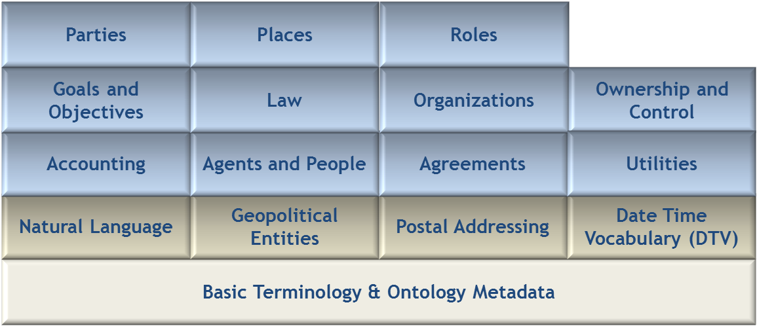

**Arrangements**

Figure 8.1 Foundations Ontology Architecture

The namespaces and their well-known prefixes corresponding to external elements required for use of FIBO Foundations include the following:

Table 8-2. Prefix and Namespaces for referenced/external vocabularies

|  |  |  |
| --- | --- | --- |
| Namespace Prefix | | Namespace |
| **rdf** | **http://www.w3.org/1999/02/22-rdf-syntax-ns#** | |
| **rdfs** | http://www.w3.org/2000/01/rdf-schema# | |
| **owl** | http://www.w3.org/2002/07/owl# | |
| **xsd** | http://www.w3.org/2001/XMLSchema# | |
| **dct** | http://purl.org/dc/terms/ | |
| **skos** | http://www.w3.org/2004/02/skos/core# | |
| **sm** | http://www.omg.org/techprocess/ab/SpecificationMetadata/ | |

The namespace approach taken for FIBO is based on OMG guidelines and is constructed as follows:

* A standard prefix http://www.omg.org/spec/
* The family name, EDMC-FIBO
* The abbreviation for the specification: in this case FND
* The module name
* The ontology name

Note that the URI/IRI strategy for the ontologies in FIBO takes a “slash” rather than “hash” approach, in order to accommodate server-side applications. Though not technically necessary, this specification does mandate namespace prefixes to be used. These are constructed as follows with the components separate by “-“:

* The specification family name fibo
* The specification abbreviation: fnd
* An abbreviation for the module name
* An abbreviation for the ontology name

The namespaces and prefixes corresponding to FIBO Foundations ontologies are summarized in Table 8-3 for convenience. These are given in alphabetical order, by module, rather than with any intent to show imports relationships.

Table 8-3. Prefix and Namespaces for FIBO Foundations

| Namespace Prefix | Namespace |
| --- | --- |
| **fibo-fnd-acc-aeq** | http://www.omg.org/spec/EDMC-FIBO/FND/Accounting/AccountingEquity/ |
| **fibo-fnd-acc-cur** | http://www.omg.org/spec/EDMC-FIBO/FND/Accounting/CurrencyAmount/ |
| **fibo-fnd-aap-agt** | http://www.omg.org/spec/EDMC-FIBO/FND/AgentsAndPeople/Agents/ |
| **fibo-fnd-aap-ppl** | http://www.omg.org/spec/EDMC-FIBO/FND/AgentsAndPeople/People/ |
| **fibo-fnd-agr-agr** | http://www.omg.org/spec/EDMC-FIBO/FND/Agreements/Agreements/ |
| **fibo-fnd-agr-ctr** | http://www.omg.org/spec/EDMC-FIBO/FND/Agreements/Contracts/ |
| **fibo-fnd-gao-gl** | http://www.omg.org/spec/EDMC-FIBO/FND/GoalsAndObjectives/Goals/ |
| **fibo-fnd-gao-obj** | http://www.omg.org/spec/EDMC-FIBO/FND/GoalsAndObjectives/Objectives/ |
| **fibo-fnd-law-jur** | http://www.omg.org/spec/EDMC-FIBO/FND/Law/Jurisdiction/ |
| **fibo-fnd-law-lcap** | http://www.omg.org/spec/EDMC-FIBO/FND/Law/LegalCapacity/ |
| **fibo-fnd-law-cor** | http://www.omg.org/spec/EDMC-FIBO/FND/Law/LegalCore/ |
| **fibo-fnd-org-fm** | http://www.omg.org/spec/EDMC-FIBO/FND/Organizations/FormalOrganizations/ |
| **fibo-fnd-org-lg** | http://www.omg.org/spec/EDMC-FIBO/FND/Organizations/LegitimateOrganizations/ |
| **fibo-fnd-org-org** | http://www.omg.org/spec/EDMC-FIBO/FND/Organizations/Organizations/ |
| **fibo-fnd-oac-ctl** | http://www.omg.org/spec/EDMC-FIBO/FND/OwnershipAndControl/Control/ |
| **fibo-fnd-oac-own** | http://www.omg.org/spec/EDMC-FIBO/FND/OwnershipAndControl/Ownership/ |
| **fibo-fnd-pty-pty** | http://www.omg.org/spec/EDMC-FIBO/FND/Parties/Parties/ |
| **fibo-fnd-pty-rl** | http://www.omg.org/spec/EDMC-FIBO/FND/Parties/Roles/ |
| **fibo-fnd-plc-adr** | http://www.omg.org/spec/EDMC-FIBO/FND/Places/Addresses/ |
| **fibo-fnd-plc-cty** | http://www.omg.org/spec/EDMC-FIBO/FND/Places/Countries/ |
| **fibo-fnd-plc-loc** | http://www.omg.org/spec/EDMC-FIBO/FND/Places/Locations/ |
| **fibo-fnd-rel-rel** | http://www.omg.org/spec/EDMC-FIBO/FND/Relations/Relations/ |
| **fibo-fnd-utl-av** | http://www.omg.org/spec/EDMC-FIBO/FND/Utilities/AnnotationVocabulary/ |
| **fibo-fnd-utl-bt** | http://www.omg.org/spec/EDMC-FIBO/FND/Utilities/BusinessFacingTypes/ |

## 8.3 FIBO-Based Reporting

### 8.3.1 Business-Facing Approach

There are a number of ways of presenting the ontology to domain experts, and the intent is to standardize two of these.

**Diagrammatic Presentation**

The FIBO ontologies (model) may be presented to business domain experts in a number of forms, with views that express different levels of detail and different aspects of the model to aid in understanding. Critical requirements for business-facing diagrams include limiting or eliminating technical detail while retaining it in the underlying model, and hiding, to the degree possible:

* stereotype names on diagrams, although English labels and icons may be used where important to express the meaning of a line or box,
* technical tags, such as visibility, and optionally names, on property endpoints,
* empty partitions in boxes representing classes and association classes, and
* the class in an association class representation of an object, data, or annotation property.

This does not preclude the incorporation of diagramming elements to represent fundamental concepts from set theory, first order logic, etc., that are needed to understand the ontology. Other requirements for diagramming style will be forthcoming as the specification achieves broader adoptions.

An example, showing a simplified OWL diagram, is given in Figure 8.2.

Legal Capacity Simple

**Figure 8.2 Example Business-Facing FIBO Diagram**

The strategy for representation for subject matter experts may include use of color to highlight certain lines, in addition to labeling them in English, for example, by using blue lines for object properties, green lines for data properties (if they are not shown using an attribute style, inside the class box), dashed red dependency for disjointness, and so forth.

**Tabular or Textual Presentation**

In addition to the presentation via diagrams, there is a need to provide business domain experts with a more spreadsheet-like view of the terms, relationships, formal definitions, and other annotations in particular, for review, understanding, and use.

There are two levels of detail that shall be made available in reports. These are the 'Basic' view of Term, Definition and Synonym, and an extended view giving most or all of the same information that is seen in the diagrams. This shall include line entries for each thing and each fact (Relationship Property and Simple Property) as well as the set theory constructs and relationships modeled (unions, parent terms etc.). It is not necessary to show relationships between relationships in these tables, such as sub property hierarchies or property inverses.

The constructs shall be represented with an English language name, including spaces between words rather than camel case; those that are substantially different from their OWL language equivalents include: “Is A” for subclass relationships, “Type” for datatypes, “type of” rather than rdfType, “Simple Property” for datatype properties, “Relationship Property” for object properties, and “mutually exclusive” for disjointness relationships. These names are in US English and may be replaced in reports with definitionally equivalent labels in other natural languages and possibly additional terms that may be added to support parallel, collaborative development processes required for FIBO financial product-specific ontologies.

# 9 Additional Metadata

## 9.1 Introduction

As discussed in Clause 8, the FIBO Foundations and specifications that depend on it reuse existing metadata standards, including:

* The Dublin Core Metadata Terms Standard
* The W3C Simple Knowledge Organization System (SKOS)
* The OMG Architecture Board’s Specification Metadata Recommendation

These metadata definitions are not inherent elements of RDF Schema or OWL, although the standard makes extensive use of rdfs:label in particular. This clause of the specification describes the metadata used throughout the standard and provides examples where appropriate for clarification purposes.

## 9.2 Ontology-Level Metadata

Each Foundations ontology has a set of common metadata which is specified in this sub clause rather than being repeated for each ontology. This information is included regardless of whether the ontology is serialized as RDF/XML OWL, UML/XMI with the ODM profiles for RDF and OWL applied, or as ODM XMI.

The use of the “sm” namespace prefix in the abbreviated IRI for the metadata term refers to the Specification Metadata ontology, as described in Table 8-2, above.

Table 9-1. FIBO Foundations Specification Family Metadata

|  |  |
| --- | --- |
| **Metadata Term** | **Value** |
| **sm:familyTitle** | Financial Industry Business Ontology (FIBO) |
| **sm:familyAbbreviation** | FIBO |
| **sm:familyURL** | http://www.omg.org/spec/EDMC-FIBO/ |
| **sm:familyAbstract** | The content that comprises the Financial Industry Business Ontology (FIBO) is documentation, interpretable in formal logic, of the concepts represented by finance industry terms as used in official financial organization documents such as contracts, product/service specifications and governance and regulatory compliance documents. |
| **sm:technologyArea** | **formal semantics** |
| **sm:topicArea** | **finance** |
| **sm:keyword** | **Financial Industry Business Ontology, FIBO, ontology, vocabulary** |

Table 9-2. FIBO Foundations Specification Metadata

|  |  |
| --- | --- |
| **Metadata Term** | **Value** |
| **sm:specificationTitle** | Financial Industry Business Ontology (FIBO) Foundations Specification |
| **sm:specificationAbbreviation** | FIBO-FND |
| **sm:specificationURL** | http://www.omg.org/spec/EDMC-FIBO/FND/ |
| **sm:specificationAbstract** | FIBO Foundations is a set of business concepts which are intended to support the financial industry terms semantics presented in other FIBO specifications.  The FIBO Foundations models define concepts which are not unique to the financial services industry. From these, financial industry terms in other FIBO specifications may be derived by extension. Terms are also included which may be referred to by properties of things in those specifications. FIBO Foundations therefore includes a number of basic terms about legal, contractual and organizational concepts, among others. |
| sm:dependsOn | http://www.omg.org/techprocess/ab/SpecificationMetadata/ |
| sm:keyword | Foundational vocabulary |

Table 9-3. FIBO Foundations Specification Version Metadata

| **Metadata Term** | **Value** |
| --- | --- |
| **sm:thisVersion** | 1.0 |
| sm:publicationDate | 2013-08-26T18:00:00 |
| **sm:specificationVersionURL** | http://www.omg.org/spec/EDMC-FIBO/FND/1.0/ |
| **sm:specificationVersionStatus** | Request For Comments (RFC) |
| skos:historyNote | This version of the FIBO Foundations Specification was revised primarily to reflect comments received at the March 2013 OMG Technical Meeting in Reston and reflected in the Errata discussed at the June 2013 OMG Technical Meeting in Berlin.  Revisions to FIBO Foundations are managed per the process outlined in the Policies and Procedures for OMG standards, with the intent to maintain backwards compatibility in the ontologies to the degree possible.    The RDF/XML serialized OWL for the Foundations ODM/OWL ontologies have been checked for syntactic errors and logical consistency with Protege 4 (http://protege.stanford.edu/), HermiT 1.3.7 (http://www.hermit-reasoner.com/) and Pellet 2.2 (http://clarkparsia.com/pellet/). |
| **sm:addressForComments** | http://www.omg.org/issues/ |

Every module will have unique metadata specific to that module, as given in Clause 10, below. Additionally, every ontology will include curation metadata. Explicit use of the MIT License[3] for software (including OWL ontologies, UML models, ODM XMI) is intended to assure users of the ontologies that the ontologies are freely available, for use with attribution, and without warranty.

Table 9-4. FIBO Foundations Specification Curation and Rights Metadata

| **Metadata Term** | **Value** |
| --- | --- |
| **sm:copyright** | Copyright (c) 2013-2014 EDM Council, Inc.  Copyright (c) 2013-2014 Object Management Group, Inc. |
| **dct:license** | <http://www.omg.org/techprocess/ab/SpecificationMetadata/MITLicense> |
| **sm:responsibleTaskForce** | http://fdtf.omg.org/ |

Finally, each ontology will also include ontology-specific specific metadata, using the OMG Specification Metadata ontology. Again, these details are provided with the individual ontologies in Clause 10.

## 9.3 Ontology Entity-Level Metadata

This sub clause describes the metadata that are applied to each named concept (Class and Property) in the ontologies.

### 9.3.1 Definitions, Notes, and Labels

Table 9-5. Definitions, Labeling, and Notes

|  |  |  |  |
| --- | --- | --- | --- |
| **Term Requirement** | **Term Type** | **Annotation** | **Usage Notes** |
| **Definition** | Definition | skos:definition | Main formal definition of term. Must always be present |
| **Change history** | Note | skos:changeNote | Notes indicating why something was modified |
| **General note, editorial comment** | Note | skos:editorialNote | The bulk of the “Further Notes” narrative is expressed this way |
| **Examples** | Note | skos:example | Examples |
| **Explanatory note** | Note | fibo-utl-av:explanatoryNote | Notes providing additional explanation about the concept |
| **Historical note** | Note | skos:historyNote | Notes regarding the history of the concept |
| **Note** | Note | skos:note | Used when no specific note annotation is appropriate |
| **Scope note** | Note | skos:scopeNote | Clarifying information about the scope of the term or concept |
| **Usage note** | Note | fibo-utl-av:usageNote | Used to suggest how a particular concept is intended to be used |
| **Preferred Label** | Label | skos:prefLabel | Replaces rdfs:label if there is a preferred label for the concept |
| **Alternate Label** | Label | skos:altLabel | Alternate label additional to prefLabel. Should be used instead of rdfs:label for alternatives |

### 9.3.2 Synonymous Terms

Synonyms are fundamental to the reporting required for business domain view and review of the ontologies, which, at a basic level, may only require the concept, a label, its formal definition in text form, and any synonyms.

Fundamentally, an ontology, and any extensions derived from it, should contain only a single element defining a given concept, with synonyms captured using the fibo-utl-av:synonym annotation property. Within a given ontology, use of separate classes with the same meaning, together with the OWL construct for class equivalence (equivalentClass) is not considered best practice. Such an approach may be necessary to align or map ontologies to one another, however, where the same concepts exist in different namespaces. fibo-utl-av:abbreviation may be used to specify abbreviations and acronyms associated with concepts as appropriate.

### 9.3.3 Provenance and Cross-reference Annotation

Where possible, every effort is made in the FIBO ontologies to provide references for the origin of terms and their definitions, including cases where those definitions have been adapted for FIBO usage. While less important for Foundations, any FIBO ontology that includes terminology from a particular standard, such as FpML, ISO 20022, any regulatory publication, and so forth should note it as the source for a given concept or its definition.

Four annotation properties are provided in the FIBO AnnotationVocabulary to facilitate provenance documentation for the terminology and definitions specified in the standard. These are:

* fibo-utl-av:adaptedFrom – used where the text in the skos:definition is adapted from the definition of the term defined in the range of this property (range can be a string, URI, or BibliographicCitation). Note that this initial version of Foundations does not recommend a specific standard for citatations. There are a number of ontologies that might be considered for this purpose, and the OMG Specification Metadata provides a class called BibliographicCitation that can be used as the range of this annotation and can be mapped to the preferred citation definition for a given application, organization, or repository.
* fibo-utl-av:definitionOrigin – used where the text in the skos:definition is a direct copy of the definition of the term defined in the range of this property (range can be a string, URI, or BibliographicCitation).
* fibo-utl-av:termOrigin – which provides the means to document the source of a term, in a standard, in some other document, or by some organization. The range of this property is the document and / or organization from which the term was derived (range can be a string, URI, or BibliographicCitation).
* fibo-utl-av:nameOrigin – which provides the means to document the name of the original term in the standard, other document or organization referenced via the annotation fibo-utl-av:termOrigin

### 9.3.4 Change Management Annotation

In addition to the version information provided at the specification level for a given FIBO ontology, additional annotations for change management purposes may be appropriate at the concept level. These may include:

* skos:changeNote
* fibo-utl-av:modifiedBy – identifying the person and/or organization responsible for the change
* fibo-utl-av:modifiedOn – identifying the date and time of the change

# 10. Model Content Reports

***Intended Audience:*** *Business Analysts, other business stakeholders*

This clause shows the content of the model from a business perspective. Model content is presented both as diagrams and as tables. Readers do not need to be conversant with the Web Ontology Language or other modeling languages in order to be able to interpret what is presented here. However some familiarity with the “set theoretic” interpretation of the model content is required.

This clause has a sub clause for each ontology that is automatically generated from the ODM representation of that ontology, and is designed to be more human-readable than the raw OWL file.

The following Table 10.1 explains the headings used and what these mean in terms of the semantics of the model elements presented.

Table 10-1. Table Guide

NOTE: Not all of these entries are provided in every sub clause.

| **Heading** | **Description** |
| --- | --- |
| **Name** | The formal name of the model element. This is in the “CamelCase” format. |
| **Type of Thing** | The name of the class of “Thing” or, for properties, the class of thing for which that is a property. Note that properties which are intended to be widely used will state “anything” in this column, meaning that it is intended to be a property of “Thing”, the set of which everything is a member. |
| **Property** | The name of the property (blank for entries which describe a type of thing). |
| **Definition** | The formal written definition of the type of thing or the property. |
| **Synonyms** | The or any synonyms which are identified for the concept. |
| **Equivalent To** | Identifies a class or property restriction which is the same in meaning |
| **Parent** | For types of thing, the type of thing for which it is a sub-type, sharing properties of that thing. |
| **Mutually Exclusive With** | Indicates that a type of thing is mutually exclusive with the other type of thing identified in this column. This means that no individual thing may be a member of both sets. |
| **Related Thing Or Type** | For relationship properties, the type of thing in terms of which the property is framed or (in subject-predicate-object terms) the object of the property. For example a property like “has jurisdiction” would be framed in terms of the type of thing, which is a jurisdiction.  For simple properties, the type of information in terms of which the property is framed (e.g. text, date, yes/no or selection of textual descriptors) |
| **Inverse of Property** | Identifies a property which is the opposite or inverse of the one in this line. For example is a customer holds an account, and an account is held by a customer, these properties are the inverse of one another. |
| **Multiples** | Indicates where a property may have specific multiples of the item identified as the related thing or simple type. Where properties are reused or refined, this indicates specific limitations on the numbers of the kind of thing identified as the related thing for the reused property. |
| **Concept type** | Gives the natural language description of what kind of concept is being reported on in this line of the table, e.g. class (type of thing), Simple Property, Relationship Property and so on. |
| **Explanatory Note** | Provides any textual information that has been included about the concept, over and above the formal definition for the concept. |
| **Term Origin** | For concepts, which have been included with reference to, some other source (typically an industry standard data model) this column identifies the document, standard or other resource from which the term was derived. |
| **Definition Source** | For concepts for which a definition has been taken from some other source this column identifies the document, standard or other resource from which the definition was directly taken. |
| **Adapted From** | Where definitions have been taken from other sources but adapted, this column identifies the source of the original definition. This is typically the case when a definition is taken from some technical industry standard, and the description of a data field or message element is re-worded to describe the real world thing to which that element applies. |

## 10.1 Module: Utilities

Table 10-2. Utilities Module Metadata

|  |  |
| --- | --- |
| **Metadata Term** | **Value** |
| **sm:moduleName** | Utilities |
| **sm:moduleAbbreviation** | FIBO-FND-UTL |
| **sm:moduleVersion** | 1.0 |
| **sm:moduleAbstract** | Ontologies which provide annotations and business facing datatypes to be used in other ontologies. These ontologies are not expected to be used directly by business stakeholders and are for the definition of material which is used by semantic modelers in Foundations and in other FIBO ontologies. |

### 10.1.1 Ontology: Annotation Vocabulary

This vocabulary provides a set of metadata annotations for use in describing FIBO ontology elements. The annotations extend properties defined in the OMG's Specification Metadata Recommendation, in the Dublin Core Metadata Terms Vocabulary and in the W3C Simple Knowledge Organization System (SKOS) Vocabulary, and have been customized to suit the FIBO specification development process.

Note that any of the original properties provided in Dublin Core and SKOS can be used in addition to the terms provided herein. However, any Dublin Core terms that are not explicitly defined as OWL annotation properties in this ontology or in any of its imports must be so declared in the ontologies that use them.

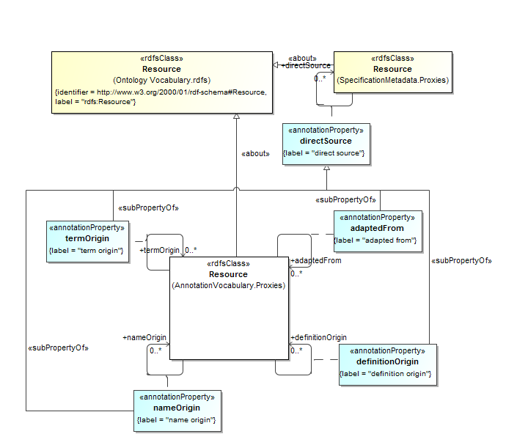

**Figure 10.1 Term and Definition Annotations**

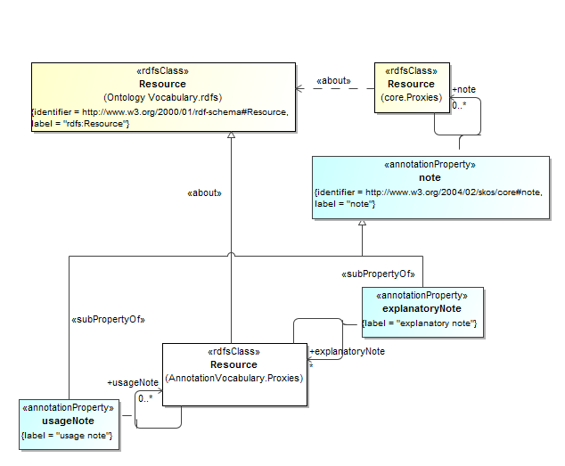

**Figure 10.2 Explanatory Annotations**

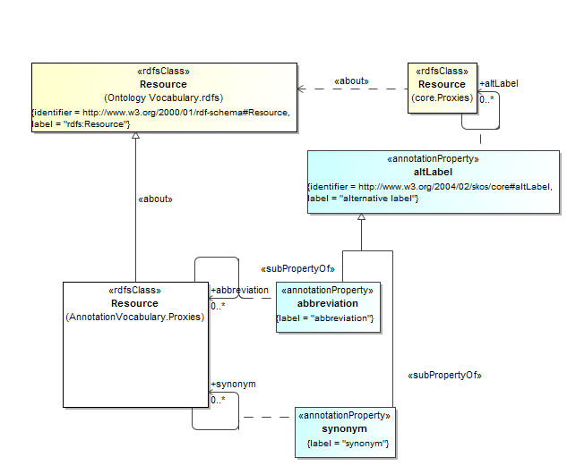

**Figure 10.3 Alternate Label Annotations**

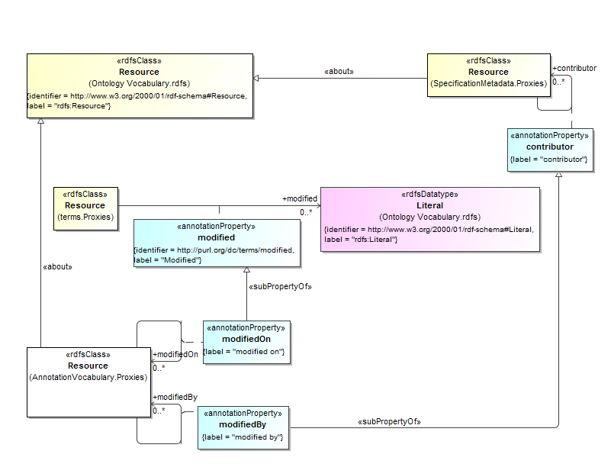

**Figure 10.4 Element Change Management Annotations**

Table 10-3. Annotation Vocabulary Metadata

|  |  |
| --- | --- |
| **Metadata Term** | **Value** |
| **sm:filename** | Annotation Vocabulary |
| **sm:fileAbbreviation** | fibo-fnd-utl-av |
| **OntologyIRI** | http://www.omg.org/spec/EDMC-FIBO/FND/Utilities/AnnotationVocabulary/ |
| **owl:versionIRI** | http://www.omg.org/spec/EDMC-FIBO/FND/20140801/Utilities/AnnotationVocabulary/ |

Table 10-4. Annotation Vocabulary Details

| **Type Of Thing** | **Property** | **Definition** | **Equivalent to** | **Parent** | **Mutually Exclusive With** | **Simple Type** | **Related Thing** | **Inverse Of Property** | **Concept Type** | **Editorial Note** | **Explanatory Note** | **Definition Adapted From** |
| --- | --- | --- | --- | --- | --- | --- | --- | --- | --- | --- | --- | --- |
| resource | directSource | reference used as a primary, direct source for content in developing this specification or model (range can be a string, URI, or BibliographicCitation) |  |  |  |  | resource |  | Annotation Property |  |  |  |
| resource | termOrigin | Document from which a given term was taken directly; the range for this annotation can be a string (either xsd:string or fibo-fnd-utl-bt:text), URI (either xsd:anyURI or fibo-fnd-utl-bt:uri), or BibliographicCitation |  | sm:directSource |  |  | resource |  | Annotation Property |  |  |  |
| resource | nameOrigin | provides the means to document the name of the original term in the source referenced via termOrigin; the range for this annotation can be a string (either xsd:string or fibo-fnd-utl-bt:text), URI (either xsd:anyURI or fibo-fnd-utl-bt:uri), or BibliographicCitation |  | sm:directSource |  |  | Resource |  | Annotation Property |  |  |  |
| resource | definitionOrigin | document from which a given definition was taken directly; the range for this annotation can be a string (either xsd:string or fibo-fnd-utl-bt:text), URI (either xsd:anyURI or fibo-fnd-utl-bt:uri), or BibliographicCitation |  | sm:directSource |  |  | Resource |  | Annotation Property |  |  |  |
| resource | adaptedFrom | the document from which a given term (or its definition) was adapted; the range for this annotation can be a string (either xsd:string or fibo-fnd-utl-bt:text), URI (either xsd:anyURI or fibo-fnd-utl-bt:uri), or BibliographicCitation |  | sm:directSource |  |  | resource |  | Annotation Property |  |  |  |
| resource | modifiedon | identifies the date an entity in the body of an ontology was changed. |  | terms:modified |  | Literal |  |  | Annotation Property |  |  |  |
| resource | modifiedBy | identifies the organization or person responsible for making a change to an entity in the body of an ontology. |  | sm:contributor |  |  | resource |  | Annotation Property |  |  |  |
| resource | abbreviation | an abbreviation is short form for a particular designation that can be substituted for the primary representation. |  | core:altLabel |  |  | resource |  | Annotation Property |  |  | ISO 1087-1 Terminology work - Vocabulary |
| resource | synonym | a synonym is another designation that can be substituted for the primary representation. It is a designation for the same concept. |  | core:altLabel |  |  | resource |  | Annotation Property |  |  | ISO 1087-1 Terminology work - Vocabulary |
| resource | explanatoryNote | a note that provides additional explanatory information about a given concept |  | core:note |  |  | resource |  | Annotation Property |  |  |  |
| resource | usageNote | a note that provides information about how a given concept is used in the FIBO context |  | core:note |  |  | resource |  | Annotation Property |  |  |  |

### 10.1.2 Ontology: Business Facing Types

This ontology provides high level definitions for business facing datatypes for use in other FIBO ontology elements. These types are essentially aliases of existing RDF datatypes, and are provided in order to be able to present datatype properties to a business audience with non technical names, for example yes or no in place of boolean and text in place of string. All datatype properties in the FIBO ontologies are framed in terms of these business-facing types and not in terms of the underlying technically-named datatypes.

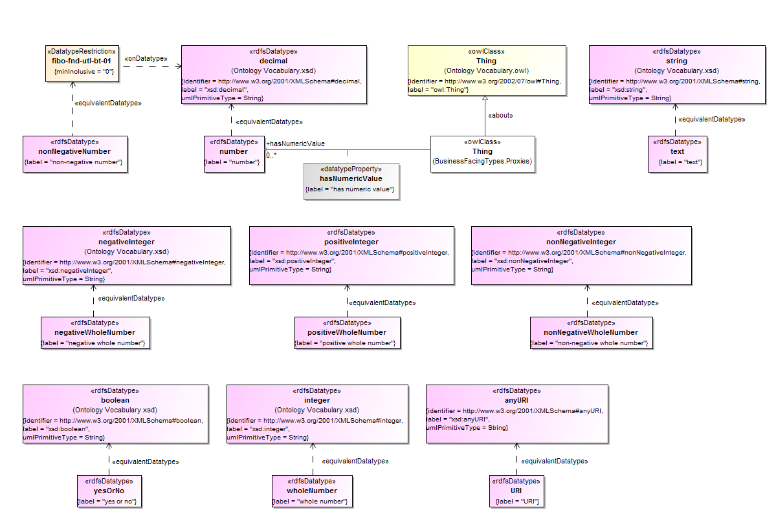

**Figure 10.5 General Purpose Business Types**

As shown in Figure 10.5, a number of business types are defined for use in other definitions in FIBO. These are provided to facilitate understanding by business subject matter experts, using common language rather than technical nomenclature. Note that a non-negative number is defined using a datatype restriction, fibo-fnd-utl-bt-01, that can be interpreted as saying that a non-negative number is declared to be of type xsd:decimal whose values must be greater than or equal to zero.

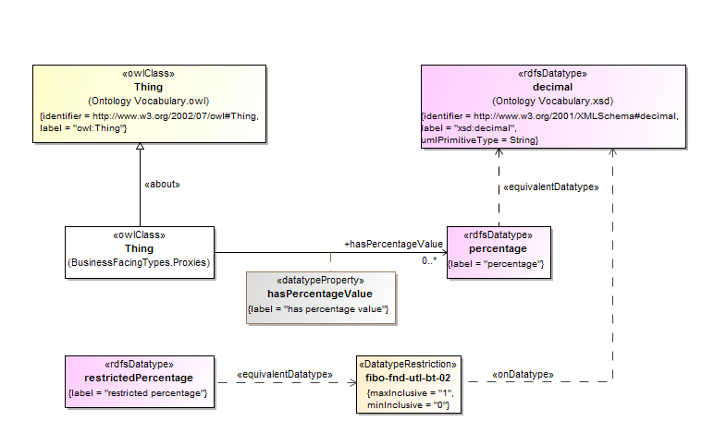

**Figure 10.6 Percentage Definitions**

Figure 10.6 depicts the definition of two datatypes that can be used in other FIBO definitions for the purposes of specifying percentage values. These include (1) percentage, which is declared as an xsd:decimal (and can be negative), and (2) restricted percentage, which must be an xsd:decimal whose values are restricted (in fibo-fnd-utl-bt-02) to range from zero to one.

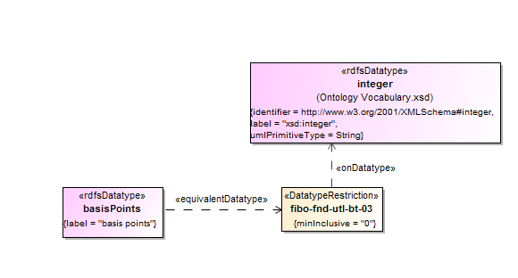

**Figure 10.7 Basis Points Definition**

Figure 10.7 declares the definition of basis points to be an xsd:integer whose values must be greater than or equal to zero (fibo-fnd-utl-bt-03).

Table 10-5. Business-Facing Types Ontology Metadata

| **Metadata Term** | **Value** |
| --- | --- |
| **sm:filename** | Business Facing Types Ontology |
| **sm:fileAbbreviation** | fibo-fnd-utl-bt |
| **OntologyIRI** | http://www.omg.org/spec/EDMC-FIBO/FND/ Utilities/BusinessFacingTypes/ |
| **owl:versionIRI** | http://www.omg.org/spec/EDMC-FIBO/FND/20140801/ Utilities/BusinessFacingTypes/ |
| sm:dependsOn | http://www.omg.org/spec/EDMC-FIBO/FND/Utilities/AnnotationVocabulary/ |

Table 10-6. Business Facing Types Details

| Datatype | **Definition** | **Equivalent Datatype** | **Concept Type** | **Definition Source** |
| --- | --- | --- | --- | --- |
| basisPoints | A basis point is a unit equal to one hundredth of a percentage point, or one part per ten thousand, 1/10000. | fibo-fnd-utl-bt-03 | Datatype |  |
| negativeWholeNumber |  | negativeInteger | Datatype |  |
| nonNegativeNumber |  | fibo-fnd-utl-bt-01 | Datatype |  |
| nonNegativeWholeNumber |  | nonNegativeInteger | Datatype |  |
| number | A number is a mathematical object used to count, label, and measure. | decimal | Datatype |  |
| percentage | In mathematics, a percentage is a number or ratio as a fraction of 100. It is often denoted using the percent sign, %, or the abbreviation, pct. | decimal | Datatype |  |
| positiveWholeNumber |  | positiveInteger | Datatype |  |
| restrictedPercentage | A type defining a percentage specified as decimal from 0 to 1. A percentage of 5% would be represented as 0.05. The maximum value is 100%, i.e., 1. | fibo-fnd-utl-bt-02 | Datatype |  |
| text | the contents of an ordinary sequential file readable as textual material without much processing | String | Datatype |  |
| URI | a uniform resource identifier (URI) is a string of characters used to identify a name or a web resource. | anyURI | Datatype |  |
| wholeNumber |  | integer |  |  |
| yesOrNo | something which has two states, interpreted as Yes and No in the context in which this is used | boolean |  |  |

## 10.2 Module: Relations

Table 10-7. Relations Module Metadata

|  |  |
| --- | --- |
| **Metadata Term** | **Value** |
| **sm:moduleN6me** | Relations |
| **sm:moduleAbbreviation** | FIBO-FND-REL |
| **sm:moduleVersion** | 1.0 |
| **sm:moduleAbstract** | This module contains an ontology defining a number of reusable relationships. These are used, refined or restricted to define relationships among more specific concepts in other FIBO ontologies. Some of these relationships stand in for relationships which are defined in external standards ontologies. |

### 10.2.1 Ontology: Relations

This ontology defines a set of general-purpose relations for use in other FIBO ontology elements. These include a number of properties required for reuse across the foundations and business entities models.

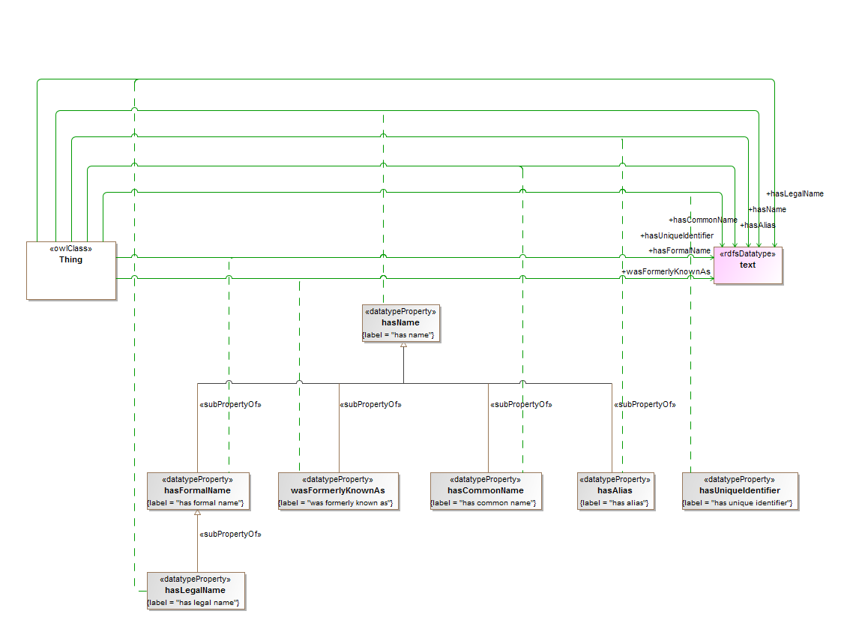

**Figure 10.8 Data Properties Textual**

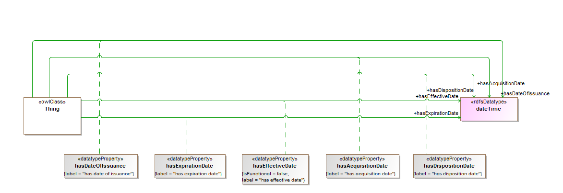

**Figure 10.9 Data Properties Numeric**

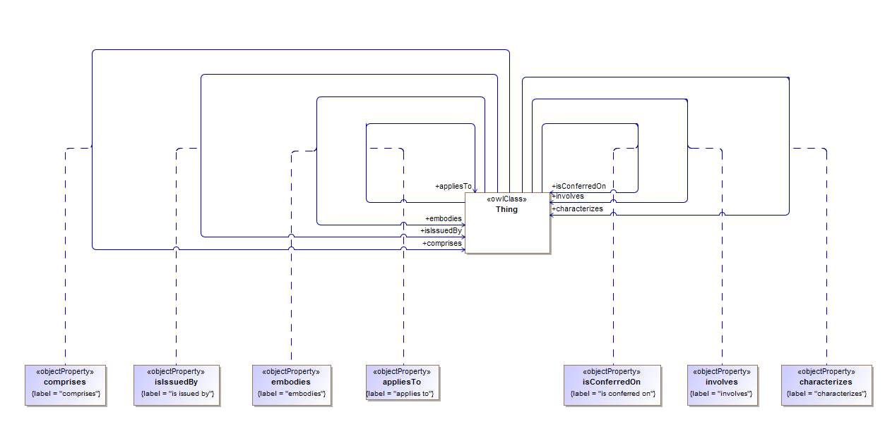

**Figure 10.10 Singular Relations**

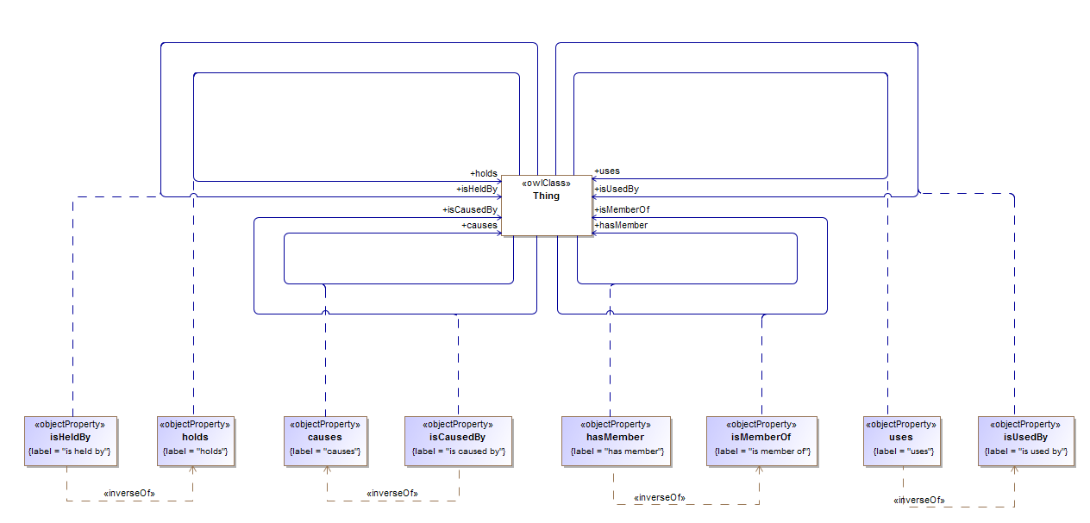

**Figure 10.11 Simple Physical Relations**

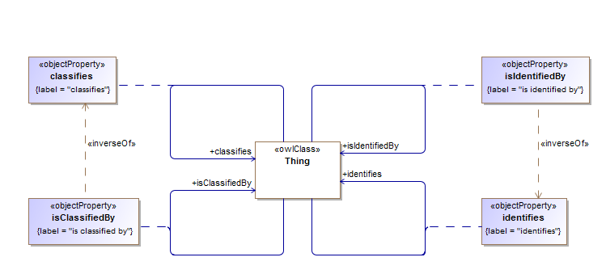

**Figure 10.12 Information Relations**

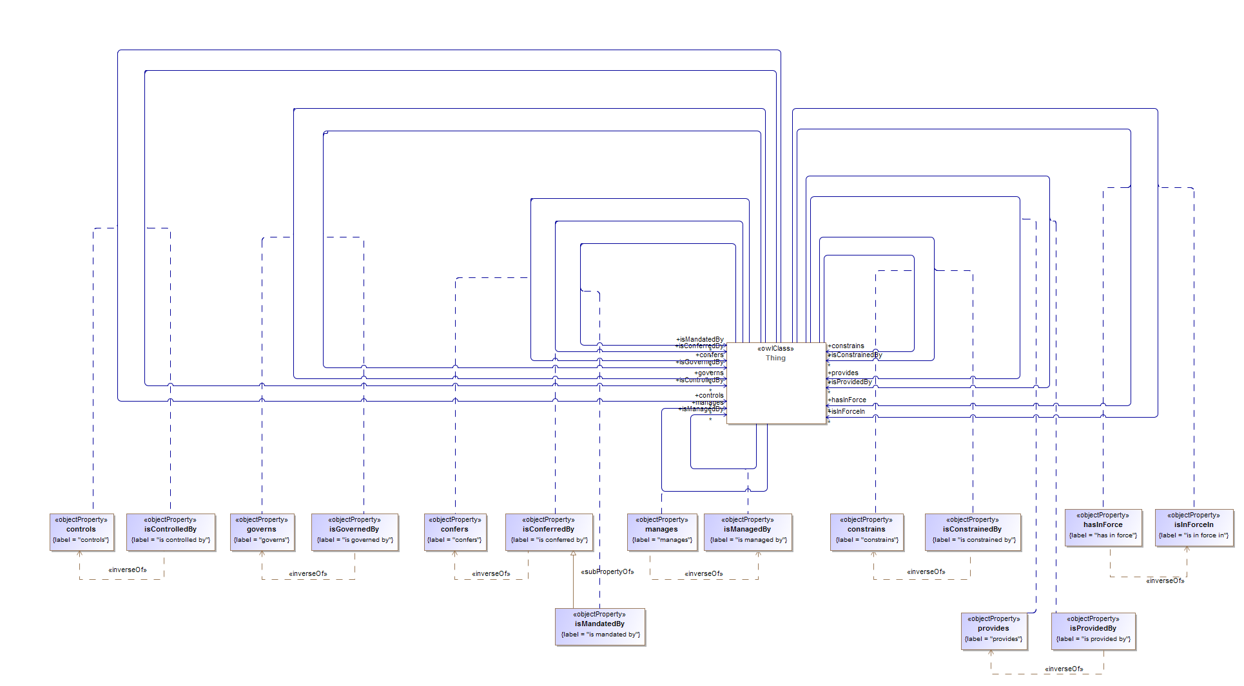

**Figure 10.13 Construct Relations**

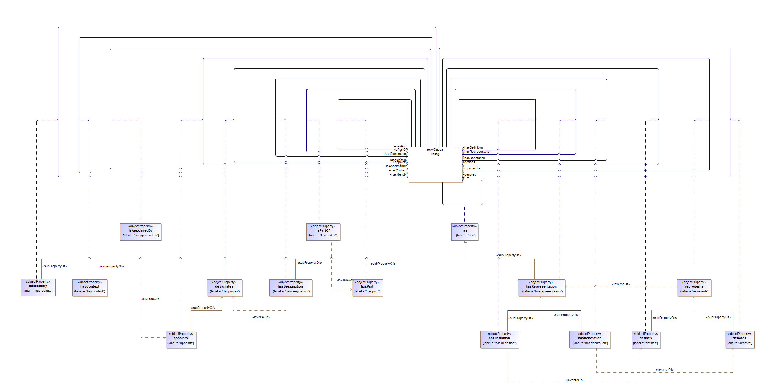

**Figure 10.14 The ‘has’ Relations**

Table 10-8. Relations Ontology Metadata

|  |  |
| --- | --- |
| **Metadata Term** | **Value** |
| **sm:filename** | Relations Ontology |
| **sm:fileAbbreviation** | fibo-fnd-rel-rel |
| **OntologyIRI** | http://www.omg.org/spec/EDMC-FIBO/FND/Relations/Relations/ |
| **owl:versionIRI** | http://www.omg.org/spec/EDMC-FIBO/FND/20140801/Relations/Relations/ |
| sm:dependsOn | http://www.omg.org/spec/EDMC-FIBO/FND/Utilities/AnnotationVocabulary/  http://www.omg.org/spec/EDMC-FIBO/FND/Utilities/BusinessFacingTypes/ |

Table 10-9. Relations Details

| **Name** | **Type Of Thing** | **Property** | **Definition** | **Equivalent to** | **Parent** | **Mutually Exclusive With** | **Related Thing or Type** | **Inverse Of Property** | **Concept Type** | **Editorial Note** | **Explanatory Note** | **Definition Source** |
| --- | --- | --- | --- | --- | --- | --- | --- | --- | --- | --- | --- | --- |
| Thing | anything | was formerly known as | A name by which the entity was known in the past |  | has name |  | text |  | Simple Property |  |  |  |
| Thing | anything | uses | relates an entity to another entity that has the ability to employ it in some way |  |  |  | anything | is used by | Relationship Property |  |  |  |
| Thing | anything | represents | relates an entity (which is some textual or other symbol or some set of words) to some entity or concept that has the sense or meaning the representation is intended to convey |  |  |  | anything | has representation | Relationship Property |  |  |  |
| Thing | anything | provides | makes something available to |  |  |  | anything | is provided by | Relationship Property |  |  |  |
| Thing | anything | manages | relates an entity to another entity that it directs in some way |  |  |  | anything | is managed by | Relationship Property |  |  |  |
| Thing | anything | is used by | relates an entity to another entity that has the ability to employ or deploy that entity as appropriate |  |  |  | anything | uses | Relationship Property |  |  |  |
| Thing | anything | is provided by | is made available by |  |  |  | anything | provides | Relationship Property |  |  |  |
| Thing | anything | is a part of | relates a given entity to another that it is some component or portion of, regardless of how that whole-part relationship is manifested, i.e., attached to the remainder or detached; cognitively salient or arbitrarily demarcated; self-connected or disconnected; homogeneous or gerrymandered; material or immaterial; extended or unextended; spatial or temporal; the most generic part relation, reflexive, asymmetric, and transitive. |  |  |  | anything | has part | Relationship Property |  |  |  |
| Thing | anything | is member of | belonging, either individually or collectively, to a group |  |  |  | anything | has member | Relationship Property |  |  |  |
| Thing | anything | is mandated by | relates a responsibility, capacity, or action to the entity that requires it |  | is conferred by |  | anything |  | Relationship Property |  |  |  |
| Thing | anything | is managed by | relates an entity to another entity that has some role in directing its affairs |  |  |  | anything | manages | Relationship Property |  |  |  |
| Thing | anything | is issued by | identifies an office or organization responsible for circulating, distributing, or publishing something |  |  |  | anything |  | Relationship Property |  |  |  |
| Thing | anything | is in force in | identifies a jurisdiction in which something (e.g. a law or policy) has effect |  |  |  | anything | has in force | Relationship Property |  |  |  |
| Thing | anything | is identified by | provides a unique identifier for an entity |  |  |  | anything | identifies | Relationship Property |  |  |  |
| Thing | anything | is held by | something that is possessed by and at least partially under the control of some entity, which can be used or acted on by the holder, regardless of ownership |  |  |  | anything | holds | Relationship Property |  |  |  |
| Thing | anything | is governed by | a relationship between a contract, agreement, jurisdiction, or other legal construct and the regulation, policy, procedure, or legal entity that regulates or oversees (governs) it |  |  |  | anything | governs | Relationship Property | This property is framed as abstractly as possible, and has at present a domain and range of thing. If in future the domain and range are more explicltly stated then this definition should be reviewed in the light of that; however the intention is for this property to be as broad as possible. Other more industry-specific properties may be defined as sub properties of this. |  |  |
| Thing | anything | is controlled by | is influenced, managed, or directed by |  |  |  | anything | controls | Relationship Property |  |  |  |
| Thing | anything | is constrained by | identifies the policy, rule, regulation, contract, or other thing that compels or obliges someone to act in some way |  |  |  | anything | constrains | Relationship Property |  |  |  |
| Thing | anything | is conferred on | that on which the conferred thing is conferred |  |  |  | anything |  | Relationship Property |  |  |  |
| Thing | anything | is conferred by | a relationship between a right or obligation and the vehicle, such as an agreement or contract, that vests (or confers) said right or obligation |  |  |  | anything | confers | Relationship Property | This property is framed as abstractly as possible, and has at present a domain and range of thing. If in future the domain and range are more explicltly stated then this definition should be reviewed in the light of that; however the intention is for this property to be as broad as possible. Other more industry-specific properties may be defined as sub properties of this. |  |  |
| Thing | anything | is classified by | indicates the classification scheme used to classify an entity |  |  |  | anything | classifies | Relationship Property |  |  |  |
| Thing | anything | is caused by | is the relationship between an event (the effect) and a second event (the cause), where the first event is understood as a consequence of the second; also, the relationship between a set of factors (causes) and a phenomenon (the effect) |  |  |  | anything | causes | Relationship Property |  |  |  |
| Thing | anything | is appointed by | indicates the individual or group that has assigned or appointed someone to an office or position |  |  |  | anything | appoints | Relationship Property |  |  |  |
| Thing | anything | involves | (of a situation or event) includes (something) as a necessary part or result |  |  |  | anything |  | Relationship Property |  |  |  |
| Thing | anything | identifies | is the relationship between an entity and another that provides a unique reference for it |  |  |  | anything | is identified by | Relationship Property |  |  |  |
| Thing | anything | holds | is the relationship between an entity and something it possesses, or over which it exercises some ownership or control or has at its discretion the ability to dispose of it as it sees fit |  |  |  | anything | is held by | Relationship Property |  |  |  |
| Thing | anything | has unique identifier | has some textual or numeric information which when taken in combination with some associated scheme is unique to the thing and may be used to distinguish it from other things of the same or different type |  |  |  | text |  | Simple Property |  | With reference to a given (possibly implicit) set of objects, a unique identifier (UID) is any identifier which is guaranteed to be unique among all identifiers used for those objects and for a specific purpose. |  |
| Thing | anything | has representation | relates a concept to some textual or other symbol which is intended to convey the sense of that concept or to some form of words which sets out the meaning of that concept |  | has |  | anything | represents | Relationship Property |  |  |  |
| Thing | anything | has part | indicates any portion of a given entity, regardless of whether the portion itself is attached to the remainder or detached; cognitively salient or arbitrarily demarcated; self-connected or disconnected; homogeneous or gerrymandered; material or immaterial; extended or unextended; spatial or temporal |  | has |  | anything | is a part of | Relationship Property |  |  |  |
| Thing | anything | has name | that by which some thing is known; may apply to anything |  |  |  | text |  | Simple Property |  |  |  |
| Thing | anything | has member | relates an entity, typically a group or organization, to some discrete entity identified as a part (member) of that entity |  |  |  | anything | is member of | Relationship Property |  |  |  |
| Thing | anything | has legal name | the name used to refer to an entity in legal communications |  | has formal name |  | text |  | Simple Property |  |  |  |
| Thing | anything | has in force | relates a jurisdiction or situation to a policy, rule, regulation or law that is currently in force in that situation or jurisdiction |  |  |  | anything | is in force in | Relationship Property |  |  |  |
| Thing | anything | has identity | provides a means for identifying something that fills a particular role |  | has |  | anything |  | Relationship Property |  |  |  |
| Thing | anything | has formal name | a name by which the entity is known for some official purpose or context, or which is structured in some way such as to always follow the same format regardless of usage. |  | has name |  | text |  | Simple Property |  |  |  |
| Thing | anything | has expiration date | links something, typically an agreement, contract, document, or perishable item, with an expiration date |  |  |  | xsd:dateTime |  | Simple Property |  |  |  |
| Thing | anything | has effective date | the date a contract, relationship, or policy comes into force |  |  |  | xsd:dateTime |  | Simple Property |  |  |  |
| Thing | anything | has disposition date | links something, such as an asset or its owner/controller/controllee to the date something was sold, transferred, destroyed, etc. |  |  |  | xsd:dateTime |  | Simple Property |  |  |  |
| Thing | anything | has designation | relates an individual or entity to a position, role, or other designation |  | has |  | anything | designates | Relationship Property |  |  |  |
| Thing | anything | has denotation | relates a concept (or something else, but typically a concept) to a representation or denotation for that concept |  | has representation |  | anything | denotes | Relationship Property |  |  |  |
| Thing | anything | has definition | specifies a form of words that conveys the meaning associated with an entity |  | has representation |  | anything | defines | Relationship Property |  |  |  |
| Thing | anything | has date of issuance | links something, typically an agreement, contract, or document, with the date it was issued |  |  |  | xsd:dateTime |  | Simple Property |  |  |  |
| Thing | anything | has context | provides a context in which something is defined, expressed, or represented |  | has |  | anything |  | Relationship Property |  |  |  |
| Thing | anything | has common name | a name by which the entity is frequently referred, without reference to any formal usage or structure |  | has name |  | text |  | Simple Property |  |  |  |
| Thing | anything | has alias | Any other name by which an individual or entity is known |  | has name |  | text |  | Simple Property | Added at SME Review, to meet AML requirements |  |  |
| Thing | anything | has acquisition date | links an asset or owner/controller/controllee to the date of acquisition |  |  |  | xsd:dateTime |  | Simple Property |  |  |  |
| Thing | anything | has | indicates that someone (or something) possesses something, as a characteristic, attribute, feature, capability, and so forth |  |  |  | anything |  | Relationship Property | As used in FIBO, this definition of has specifically excludes possession in the sense of ownership. |  |  |
| Thing | anything | governs | prevails or has decisive influence over; exercises authority |  |  |  | anything | is governed by | Relationship Property |  |  |  |
| Thing | anything | embodies | is an expression of, or gives a tangible or visible form to (an idea, quality, or feeling), makes concrete and perceptible |  |  |  | anything |  | Relationship Property |  |  |  |
| Thing | anything | designates | to name something officially or appoint someone to a position officially |  |  |  | anything | has designation | Relationship Property |  |  |  |
| Thing | anything | denotes | represents, calls by a distinctive title, term, or expression |  | represents |  | anything | has denotation | Relationship Property |  |  |  |
| Thing | anything | defines | determines or identifies the essential qualities or meaning of, discovers and sets forth the meaning of, fixes or marks the limits of, demarcates |  | represents |  | anything | has definition | Relationship Property |  |  |  |
| Thing | anything | controls | exercises authoritative or dominating influence over; directs |  |  |  | anything | is controlled by | Relationship Property |  |  |  |
| Thing | anything | constrains | forces, compels, or obliges |  |  |  | anything | is constrained by | Relationship Property |  |  |  |
| Thing | anything | confers | grants or bestows by virtue of some authority |  |  |  | anything | is conferred by | Relationship Property |  |  |  |
| Thing | anything | comprises | includes, especially within a particular scope, is made up of |  |  |  | anything |  | Relationship Property |  |  |  |
| Thing | anything | classifies | arranges in classes; assigns to a category |  |  |  | anything | is classified by | Relationship Property |  |  |  |
| Thing | anything | characterizes | describes the character or quality of |  |  |  | anything |  | Relationship Property |  |  |  |
| Thing | anything | causes | the relationship between an event (the cause) and a second event (the effect), where the second event is understood as a consequence of the first; also, the relationship between a set of factors (causes) and a phenomenon (the effect) |  |  |  | anything | is caused by | Relationship Property |  |  |  |
| Thing | anything | appoints | assigns a job or role to someone, selects or designates to fill an office or a position, fixes or sets by authority or by mutual agreement |  | designates |  | anything | is appointed by | Relationship Property |  |  |  |

## 10.3 Module: Goals and Objectives

Table 10-10. Goals and Objectives Module Metadata

|  |  |
| --- | --- |
| **Metadata Term** | **Value** |
| **sm:moduleName** | Goals and Objectives |
| **sm:moduleAbbreviation** | FIBO-FND-GAO |
| **sm:moduleVersion** | 1.0 |
| **sm:moduleAbstract** | This module includes ontologies for goals and objectives which may be pursued by people or organizations. Goals form the basis for the definition of an organization, and objectives and related concepts are required for describing business plans. |

### 10.3.1 Ontology: Goals

This ontology defines the concept of a goal, for use in other FIBO ontology elements. Goal is defined in general terms and forms one of the basic properties of organizations.

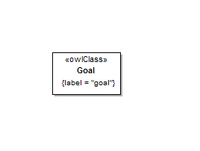

**Figure 10.15 Goals Concepts**

Table 10-11. Goals Ontology Metadata

| **Metadata Term** | **Value** |
| --- | --- |
| **sm:filename** | Goals Ontology |
| **sm:fileAbbreviation** | fibo-fnd-gao-gl |
| **OntologyIRI** | http://www.omg.org/spec/EDMC-FIBO/FND/GoalsAndObjectives/Goals/ |
| **owl:versionIRI** | http://www.omg.org/spec/EDMC-FIBO/FND/20140801/GoalsAndObjectives/Goals/ |
| sm:dependsOn | http://www.omg.org/spec/EDMC-FIBO/FND/Utilities/AnnotationVocabulary/ |

Table 10-12. Goals Details

|  |  |  |  |  |  |  |  |  |  |  |  |  |
| --- | --- | --- | --- | --- | --- | --- | --- | --- | --- | --- | --- | --- |
| **Name** | **Type Of Thing** | **Property** | **Definition** | **Equivalent to** | **Parent** | **Mutually Exclusive With** | **Related Thing or Type** | **Inverse Of Property** | **Concept Type** | **Editorial Note** | **Explanatory Note** | **Definition Adapted From** |
| Goal | goal |  | a goal is a desired result that a person, organization or system envisions or plans, or to which it commits, in order to achieve a desired state |  |  |  |  |  | Class |  | Many people endeavor to reach goals within a finite time by setting deadlines. | http://en.wikipedia.org/wiki/Goal |

### 10.3.2 Ontology: Objectives

This ontology defines the concept of an objective, for use in other FIBO ontology elements. Objectives are defined as being distinct from goals, in that they constitute time limited and measurable targets which some entity may seek to attain in pursuit of its goals.

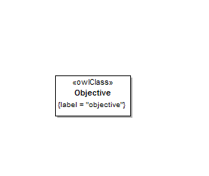

**Figure 10.16 Objectives Concepts**

Table 10-13. Objectives Ontology Metadata

| **Metadata Term** | **Value** |
| --- | --- |
| **sm:filename** | Objectives Ontology |
| **sm:fileAbbreviation** | fibo-fnd-gao-obj |
| **OntologyIRI** | http://www.omg.org/spec/EDMC-FIBO/FND/GoalsAndObjectives/Objectives/ |
| **owl:versionIRI** | http://www.omg.org/spec/EDMC-FIBO/FND/20140801/GoalsAndObjectives/Objectives/ |
| sm:dependsOn | http://www.omg.org/spec/EDMC-FIBO/FND/Utilities/AnnotationVocabulary/ |

Table 10-14. Objectives Details

|  |  |  |  |  |  |  |  |  |  |  |  |  |
| --- | --- | --- | --- | --- | --- | --- | --- | --- | --- | --- | --- | --- |
| **Name** | **Type Of Thing** | **Property** | **Definition** | **Equivalent to** | **Parent** | **Mutually Exclusive With** | **Related Thing or Type** | **Inverse Of Property** | **Concept Type** | **Editorial Note** | **Explanatory Note** | **Definition Source** |
| Objective | objective |  | a statement of a quantitative, measurable result that a person, organization, or system seeks to attain in order to achieve its goals |  |  |  |  |  | Class |  | This provides an attainable, time-limited, and measurable result that defines strategy and that a person, organization, or system seeks to meet in order to achieve its goals. | Forrester Research |

## 10.4 Module: Parties

Table 10-15. Parties Module Metadata

|  |  |
| --- | --- |
| **Metadata Term** | **Value** |
| **sm:moduleName** | Parties |
| **sm:moduleAbbreviation** | FIBO-FND-PTY |
| **sm:moduleVersion** | 1.0 |
| **sm:moduleAbstract** | This module includes ontologies defining concepts that are highly contextual in nature, such as the meaning of a party in a role, an agent playing a role, and so on. Also covers independent roles themselves.  The definitions for agents and parties in roles provide general, reusable patterns for talking about agents performing roles in specific contexts. For example the same person in the context of aviation could be a pilot, and in the context of family could be a mother. These pattern will be refined in other FIBO ontologies to define concepts such as issuer, counterparty, underwriter, etc. |

### 10.4.1 Ontology: Parties

This ontology defines the high-level concepts of parties in roles, for use in other FIBO ontology elements. The concept of a party in a role describes some entity defined specifically in terms of some role which it performs in some formal contractual or transactional relationship. The ontology includes one or more basic party in role concepts. The ontology also includes one or more logical combinations of types of autonomous entity which may perform some of the party roles defined elsewhere in this ontology, such as the role of ownership.

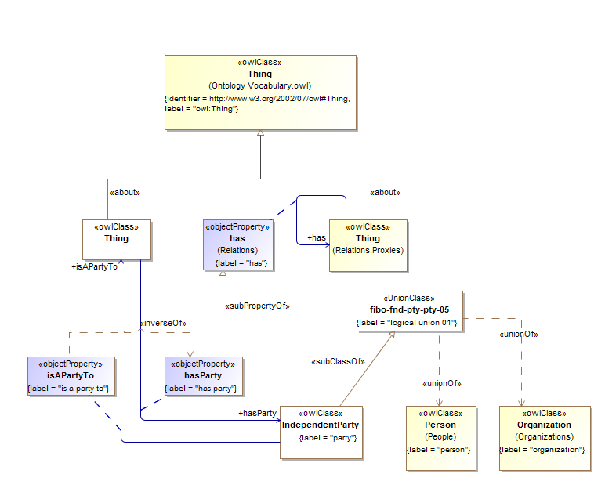

**Figure 10.17 Independent Parties**

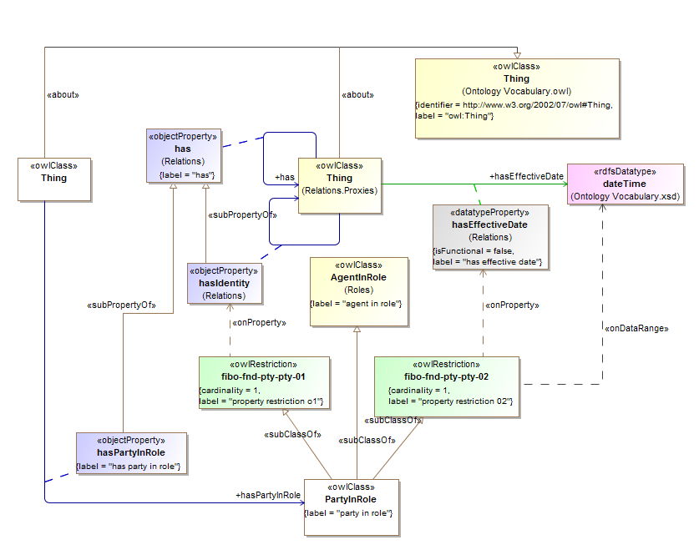

**Figure 10.18 Party In Role**

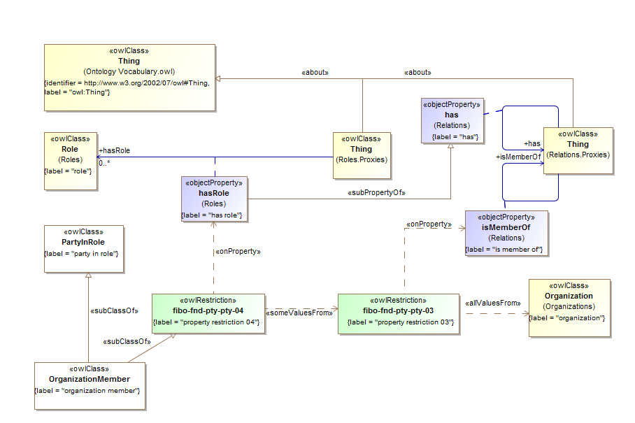

**Figure 10.19 Organization Member**

Table 10-16. Parties Ontology Metadata

| **Metadata Term** | **Value** |
| --- | --- |
| **sm:filename** | Parties Ontology |
| **sm:fileAbbreviation** | fibo-fnd-pty-pty |
| **OntologyIRI** | http://www.omg.org/spec/EDMC-FIBO/FND/Parties/Parties/ |
| **owl:versionIRI** | http://www.omg.org/spec/EDMC-FIBO/FND/20140801/Parties/Parties/ |
| sm:dependsOn | http://www.omg.org/spec/EDMC-FIBO/FND/Utilities/AnnotationVocabulary/  http://www.omg.org/spec/EDMC-FIBO/FND/Utilities/BusinessFacingTypes/  http://www.omg.org/spec/EDMC-FIBO/FND/Relations/Relations/  http://www.omg.org/spec/EDMC-FIBO/FND/AgentsAndPeople/Agents/  http://www.omg.org/spec/EDMC-FIBO/FND/Places/Locations/  http://www.omg.org/spec/EDMC-FIBO/FND/Places/Countries/  http://www.omg.org/spec/EDMC-FIBO/FND/Places/Addresses/  http://www.omg.org/spec/EDMC-FIBO/FND/GoalsAndObjectives/Goals/  http://www.omg.org/spec/EDMC-FIBO/FND/Organizations/Organizations/  http://www.omg.org/spec/EDMC-FIBO/FND/Organizations/FormalOrganizations/  http://www.omg.org/spec/EDMC-FIBO/FND/AgentsAndPeople/People/  http://www.omg.org/spec/EDMC-FIBO/FND/Parties/Roles/ |

Table 10-17. Parties Details

| **Name** | **Type Of Thing** | **Property** | **Definition** | **Equivalent to** | **Parent** | **Mutually Exclusive With** | **Related Thing or Type** | **Inverse Of Property** | **Concept Type** | **Editorial Note** | **Explanatory Note** | **Definition Adapted From** |
| --- | --- | --- | --- | --- | --- | --- | --- | --- | --- | --- | --- | --- |
| hasPartyInRole | anything | has party in role | identifies a party acting in a specific role as related to the particular agreement, contract, policy, regulation, or other business relationship |  | has |  | party in role |  | Relationship Property |  |  |  |
| hasParty | anything | has party | identifies an independent party associated with an agreement, contract, policy, regulation, or other business arrangement |  | has |  | party | is a party to | Relationship Property |  |  |  |
| PartyInRole | party in role |  | a relative concept that ties an independent party to a specific role they are standing in, and in which they play some part, i.e. are party to. |  | property restriction 02 agent in role property restriction 01 |  |  |  | Class |  |  |  |
| fibo-fnd-pty-pty-01 | property restriction 01 |  | Set of things that must have property "has identity" exactly 1 "party" |  |  |  |  |  | Property Restriction |  |  |  |
| fibo-fnd-pty-pty-02 | property restriction 02 |  | Set of things that must have property "has effective date" exactly 1 "dateTime" |  |  |  |  |  | Property Restriction |  |  |  |
| OrganizationMember | organization member |  | identifies an entity that has a membership role in some organization |  | party in role property restriction 04 |  |  |  | Class |  |  |  |
| fibo-fnd-pty-pty-04 | property restriction 04 |  | Set of things with property "has role" some "property restriction 03" |  |  |  |  |  | Property Restriction |  |  |  |
| fibo-fnd-pty-pty-03 | property restriction 03 |  | Set of things with property "is member of" only "organization" |  |  |  |  |  | Property Restriction |  |  |  |
| IndependentParty | party |  | anything which is capable of performing any business party role, such as an individual, a corporation, a partnership, an association, a joint-stock company, a business trust, or an unincorporated organization |  |  |  |  |  | Class |  |  | www.ecfr.gov |
| isAPartyTo | party | is a party to | identifies an agreement, contract, policy, regulation, or other business transaction that an independent party is associated with |  |  |  | anything | has party | Relationship Property |  |  |  |

### 10.4.2 Ontology: Roles

This ontology defines some high-level concepts of roles for use in other FIBO ontology elements. These concepts include the basic property whereby something has some role, along with the high-level concept of an agent in a role. The agent in role concept provides the basis for party in role concepts in the PartyRoles ontology and is framed as some entity defined specifically in respect to some role which it performs in some context.

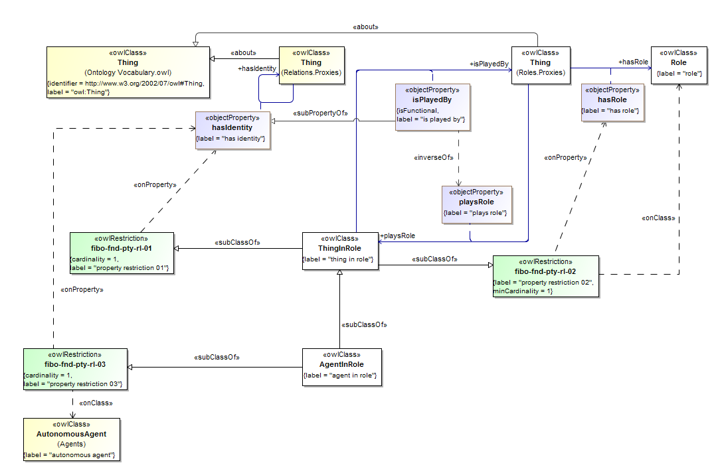

**Figure 10.20 Role Definitions**

Table 10-18. Roles Ontology Metadata

| **Metadata Term** | **Value** |
| --- | --- |
| **sm:filename** | Roles Ontology |
| **sm:fileAbbreviation** | fibo-fnd-pty-rl |
| **OntologyIRI** | http://www.omg.org/spec/EDMC-FIBO/FND/Parties/Roles/ |
| **owl:versionIRI** | http://www.omg.org/spec/EDMC-FIBO/FND/20140801/Parties/Roles/ |
| sm:dependsOn | http://www.omg.org/spec/EDMC-FIBO/FND/Utilities/AnnotationVocabulary/  http://www.omg.org/spec/EDMC-FIBO/FND/Utilities/BusinessFacingTypes/  http://www.omg.org/spec/EDMC-FIBO/FND/Relations/Relations/  http://www.omg.org/spec/EDMC-FIBO/FND/AgentsAndPeople/Agents/ |

Table 10-19. Roles Details

| **Name** | **Type Of Thing** | **Property** | **Definition** | **Equivalent to** | **Parent** | **Mutually Exclusive With** | **Related Thing or Type** | **Inverse Of Property** | **Concept Type** | **Editorial Note** | **Explanatory Note** | **Definition Source** |
| --- | --- | --- | --- | --- | --- | --- | --- | --- | --- | --- | --- | --- |
| hasRole | anything | has role | provides a means for relating a person, organization, group, or other entity to a role that entity plays in some relationship and context |  | has |  | role |  | Relationship Property |  |  |  |
| Role | role |  | A role is a set of connected behaviors, rights, obligations, beliefs, and norms as conceptualized by actors in the context of some situation. |  |  |  |  |  | Class |  |  |  |
| AgentInRole | agent in role |  | An agent-in-role is a relative concept that ties an autonomous agent to a role they are playing in a given situational context. |  | property restriction 03 thing in role |  |  |  | Class |  |  |  |
| ThingInRole | thing in role |  | A thing-in-role is a relative concept that ties some thing to a role it plays in a given situational context. |  | property restriction 01 property restriction 02 |  |  |  | Class |  |  |  |
| fibo-fnd-pty-rl-01 | property restriction 01 |  | Set of things that must have property "has identity" exactly 1 |  |  |  |  |  | Property Restriction |  |  |  |
| fibo-fnd-pty-rl-02 | property restriction 02 |  | Set of things that must have property "has role" at least 1 taken from "role" |  |  |  |  |  | Property Restriction |  |  |  |
| isPlayedBy | thing in role | is played by |  |  | has identity |  | Anything | plays role | Relationship Property |  |  |  |
| playsRole | Anything | plays role |  |  |  |  | thing in role | is played by | Relationship Property |  |  |  |
| fibo-fnd-pty-rl-03 | property restriction 03 |  | Set of things that must have property "has identity" exactly 1 taken from “autonomous agent” |  |  |  |  |  |  |  |  |  |

## 10.5 Module: Arrangements

Table 10-20. Arrangements Module Metadata

|  |  |
| --- | --- |
| **Metadata Term** | **Value** |
| **sm:moduleName** | Arrangements |
| **sm:moduleAbbreviation** | FIBO-FND-ARR |
| **sm:moduleVersion** | 1.0 |
| **sm:moduleAbstract** | This module contains ontologies that define abstract concepts, structures and schemata, such as identifiers and identification schemes, indices and indexing schemes, codes and coding schemes, classification strategies, and quantities. |

### 10.5.1 Ontology: Arrangements

This ontology defines abstract structural concepts, including arrangement and collection, for use in other FIBO ontology elements. These abstract concepts are further refined to support definition of identifiers, codes, quantities, and schemata that organize and classify such identifiers and codes.

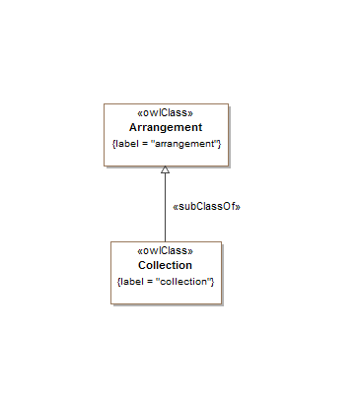

**Figure 10.21 Arrangements Concepts**

Table 10-21. Arrangements Ontology Metadata

|  |  |
| --- | --- |
| **Metadata Term** | **Value** |
| **sm:filename** | Arrangements.rdf |
| **sm:fileAbbreviation** | fibo-fnd-arr-arr |
| **OntologyIRI** | http://www.omg.org/spec/EDMC-FIBO/FND/Arrangements/Arrangements/ |
| **owl:versionIRI** | http://www.omg.org/spec/EDMC-FIBO/FND/20140801/ Arrangements/Arrangements/ |
| sm:dependsOn | http://www.omg.org/spec/EDMC-FIBO/FND/Utilities/AnnotationVocabulary/ |

Table 10-22. Arrangements Details

| **Name** | **Type Of Thing** | **Property** | **Definition** | **Parent** | **Mutually Exclusive With** | **Related Thing or Type** | **Inverse Of Property** | **Concept Type** | **Definition Source** |
| --- | --- | --- | --- | --- | --- | --- | --- | --- | --- |
| Arrangement | arrangement |  | a structure or means of organizing information such as a schema, numbering system, organization scheme, measurement system, taxonomy, or language for organizing information |  |  |  |  | Class |  |
| Collection | collection |  | a grouping of some variable number of things (may be zero) that have some shared significance | arrangement |  |  |  | Class |  |

### 10.5.1 Ontology: IdentifiersAndIndices

This ontology defines abstract concepts for representation of identifiers, identification schemes, indices and indexing schemes for use in other FIBO ontology elements.

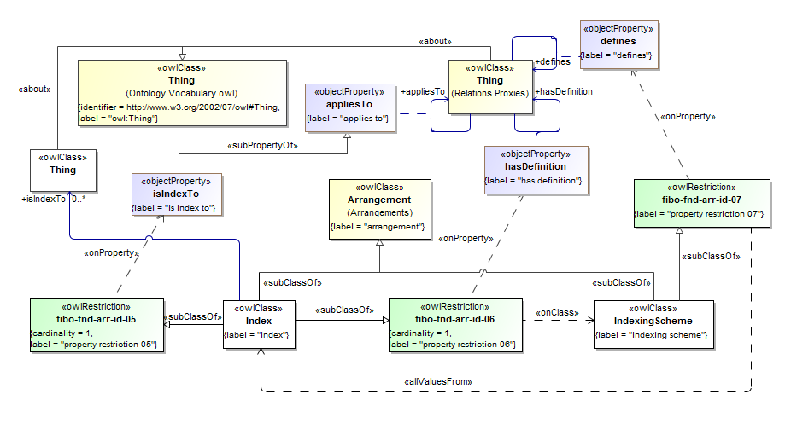

**Figure 10.22 Indices and Indexing Schemes**

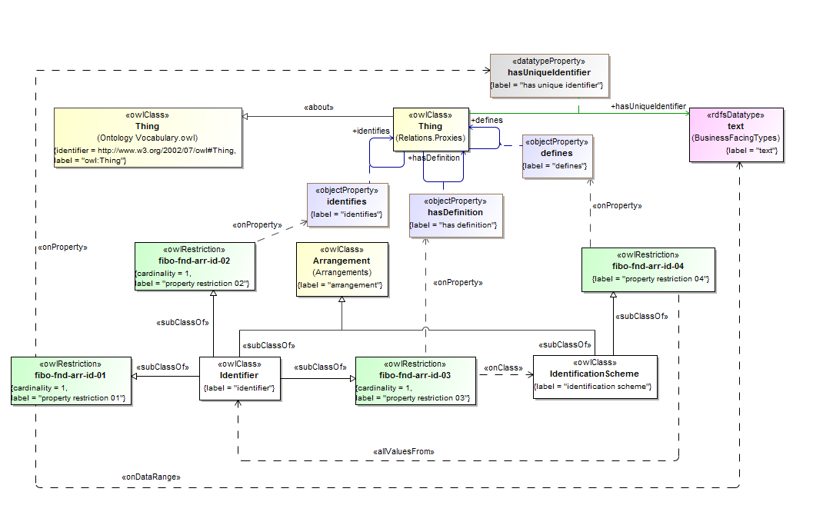

**Figure 10.23 Identifiers and Identification Schemes**

Table 10-23. IdentifiersAndIndices Ontology Metadata

|  |  |
| --- | --- |
| **Metadata Term** | **Value** |
| **sm:filename** | IdentifiersAndIndices.rdf |
| **sm:fileAbbreviation** | fibo-fnd-arr-id |
| **OntologyIRI** | http://www.omg.org/spec/EDMC-FIBO/FND/Arrangements/IdentifiersAndIndices/ |
| **owl:versionIRI** | http://www.omg.org/spec/EDMC-FIBO/FND/20140801/ Arrangements/IdentifiersAndIndices/ |
| sm:dependsOn | http://www.omg.org/spec/EDMC-FIBO/FND/Arrangements/Arrangements/  http://www.omg.org/spec/EDMC-FIBO/FND/Relations/Relations/  http://www.omg.org/spec/EDMC-FIBO/FND/Utilities/AnnotationVocabulary/  http://www.omg.org/spec/EDMC-FIBO/FND/Utilities/BusinessFacingTypes/ |

Table 10-24. IdentifiersAndIndices Details

| **Name** | **Type Of Thing** | **Property** | **Definition** | **Parent** | **Mutually Exclusive With** | **Related Thing or Type** | **Inverse Of Property** | **Concept Type** | **Definition Source** |
| --- | --- | --- | --- | --- | --- | --- | --- | --- | --- |
| IdentificationScheme | identification scheme |  | system for allocating identifiers to objects | property restriction 04 arrangement |  |  |  | Class | ISO/IEC 11179-3 Information technology - Metadata registries (MDR) - Part 3: Registry metamodel and basic attributes, Third edition, 2013-02-15 |
| Identifier | identifier |  | sequence of characters, capable of uniquely identifying that with which it is associated, within a specified context | property restriction 03 property restriction 02 arrangement property restriction 01 |  |  |  | Class | ISO/IEC 11179-3 Information technology - Metadata registries (MDR) - Part 3: Registry metamodel and basic attributes, Third edition, 2013-02-15 |
| Index | index |  | an indirect shortcut derived from and pointing into, a greater volume of values, data, information or knowledge | property restriction 05 property restriction 06 arrangement |  |  |  | Class | http://en.wikipedia.org/wiki/Index |
| IndexingScheme | indexing scheme |  | system for indexing values, data, information, or knowledge | property restriction 07 arrangement |  |  |  | Class |  |
| isIndexTo | index | is index to | that to which the index refers | applies to |  |  |  | Relationship Property |  |
| fibo-fnd-arr-id-01 | property restriction 01 |  | Set of things that must have property "has unique identifier" exactly 1 taken from "text" |  |  |  |  | Property Restriction |  |
| fibo-fnd-arr-id-02 | property restriction 02 |  | Set of things that must have property "identifies" exactly 1 |  |  |  |  | Property Restriction |  |
| fibo-fnd-arr-id-03 | property restriction 03 |  | Set of things that must have property "has definition" at least 1 taken from "identification scheme" |  |  |  |  | Property Restriction |  |
| fibo-fnd-arr-id-04 | property restriction 04 |  | Set of things that must have property "defines" may only be taken from "identifier" |  |  |  |  | Property Restriction |  |
| fibo-fnd-arr-id-05 | property restriction 05 |  | Set of things that must have property "is index to" exactly 1 |  |  |  |  | Property Restriction |  |
| fibo-fnd-arr-id-06 | property restriction 06 |  | Set of things that must have property "has definition" exactly 1 taken from "indexing scheme" |  |  |  |  | Property Restriction |  |
| fibo-fnd-arr-id-07 | property restriction 07 |  | Set of things that must have property "defines" may only be taken from "index" |  |  |  |  | Property Restriction |  |

## 10.6 Module: Agents and People

Table 10-25. Agents and People Module Metadata

|  |  |
| --- | --- |
| **Metadata Term** | **Value** |
| **sm:moduleName** | Agents and People |
| **sm:moduleAbbreviation** | FIBO-FND-AAP |
| **sm:moduleVersion** | 1.0 |
| **sm:moduleAbstract** | This module contains ontologies of concepts relating to types of autonomous entity, that is things in the world which are able to determine their own behavior. Includes ontologies for people and for autononomous entities in general. |

### 10.6.1 Ontology: Agents

This ontology defines the concept of autonomous agent for use in other FIBO ontology elements. As defined here, autonomous agent corresponds to what is often referred to as "agent" in software and other systems. It is defined as any entity which is able to act on its own part, and embraces all such things, including people, animals, software agents organizations and all forms of legal persons, although not all of these concepts are elaborated in FIBO as not all are relevant to financial services.

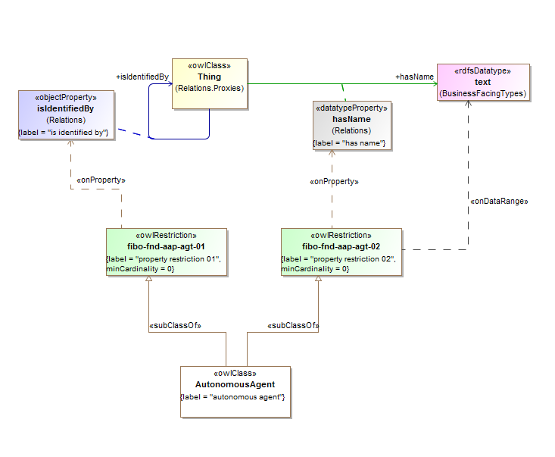

**Figure 10.24 Agents Concepts**

Table 10-26. Agents Ontology Metadata

|  |  |
| --- | --- |
| **Metadata Term** | **Value** |
| **sm:filename** | Agents Ontology |
| **sm:fileAbbreviation** | fibo-fnd-aap-agt |
| **OntologyIRI** | http://www.omg.org/spec/EDMC-FIBO/FND/AgentsAndPeople/Agents/ |
| **owl:versionIRI** | http://www.omg.org/spec/EDMC-FIBO/FND/20140801/AgentsAndPeople/Agents/ |
| sm:dependsOn | http://www.omg.org/spec/EDMC-FIBO/FND/Utilities/AnnotationVocabulary/  http://www.omg.org/spec/EDMC-FIBO/FND/Utilities/BusinessFacingTypes/  http://www.omg.org/spec/EDMC-FIBO/FND/Relations/Relations/ |

Table 10-26. Agents Details

| **Name** | **Type Of Thing** | **Property** | **Definition** | **Parent** | **Mutually Exclusive With** | **Related Thing or Type** | **Inverse Of Property** | **Concept Type** | **Definition Source** |
| --- | --- | --- | --- | --- | --- | --- | --- | --- | --- |
| AutonomousAgent | autonomous agent |  | An agent is an autonomous individual that can adapt to and interact with its environment. |  |  |  |  | Class |  |
| fibo-fnd-aap-agt-01 | property restriction 11.5.1-2 |  |  |  |  |  |  | Other |  |
| fibo-fnd-aap-agt-02 | property restriction 11.5.1-1 |  |  |  |  |  |  | Other |  |

### 10.6.2 Ontology: People

This ontology defines concepts for people and human related terms, for use in other FIBO ontology elements. People as defined here are human persons only. This ontology sets out a number of basic properties that are held by people or are definitive of a small number of specific types of people such as minors or adults. Primary use cases for determining the set of personal information definitions included are the common elements required to (1) open a bank account, (2) identify a sophisticated investor, and (3) establish foreign account ownership for money laundering purposes.

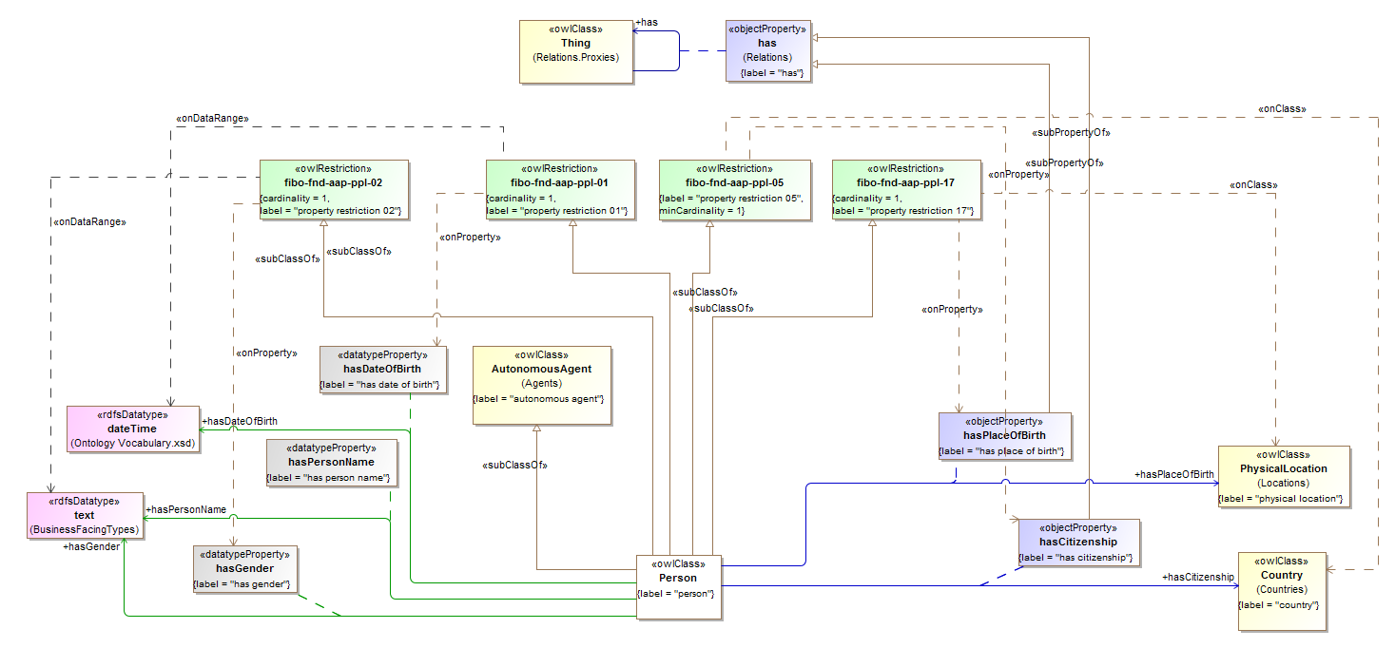

**Figure 10.25 Person Fundamentals**

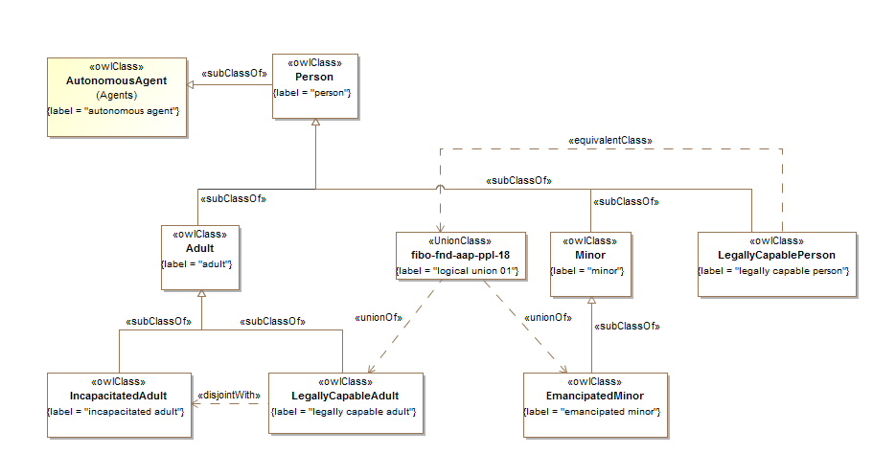

**Figure 10.26 Person Types**

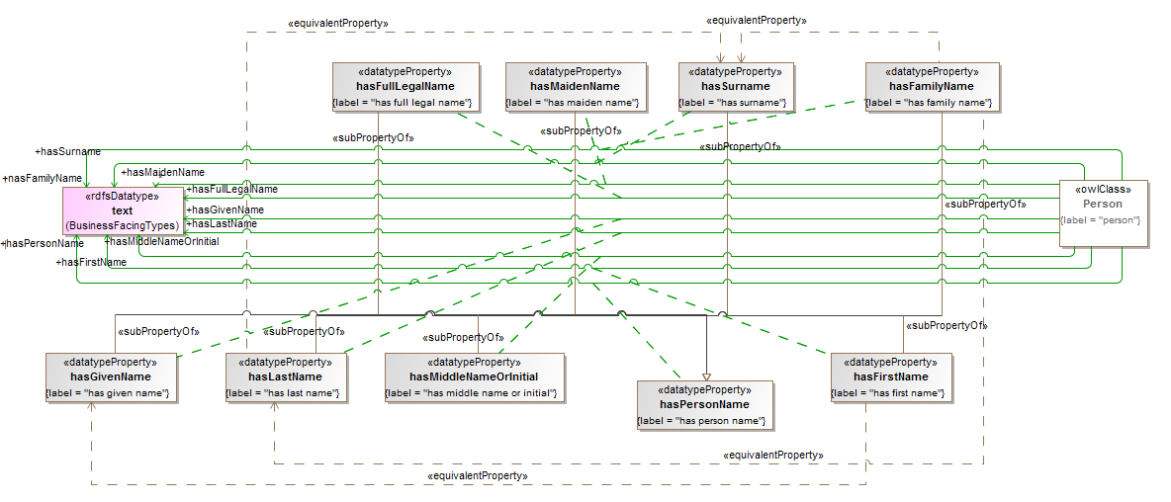

**Figure 10.27 People Names**

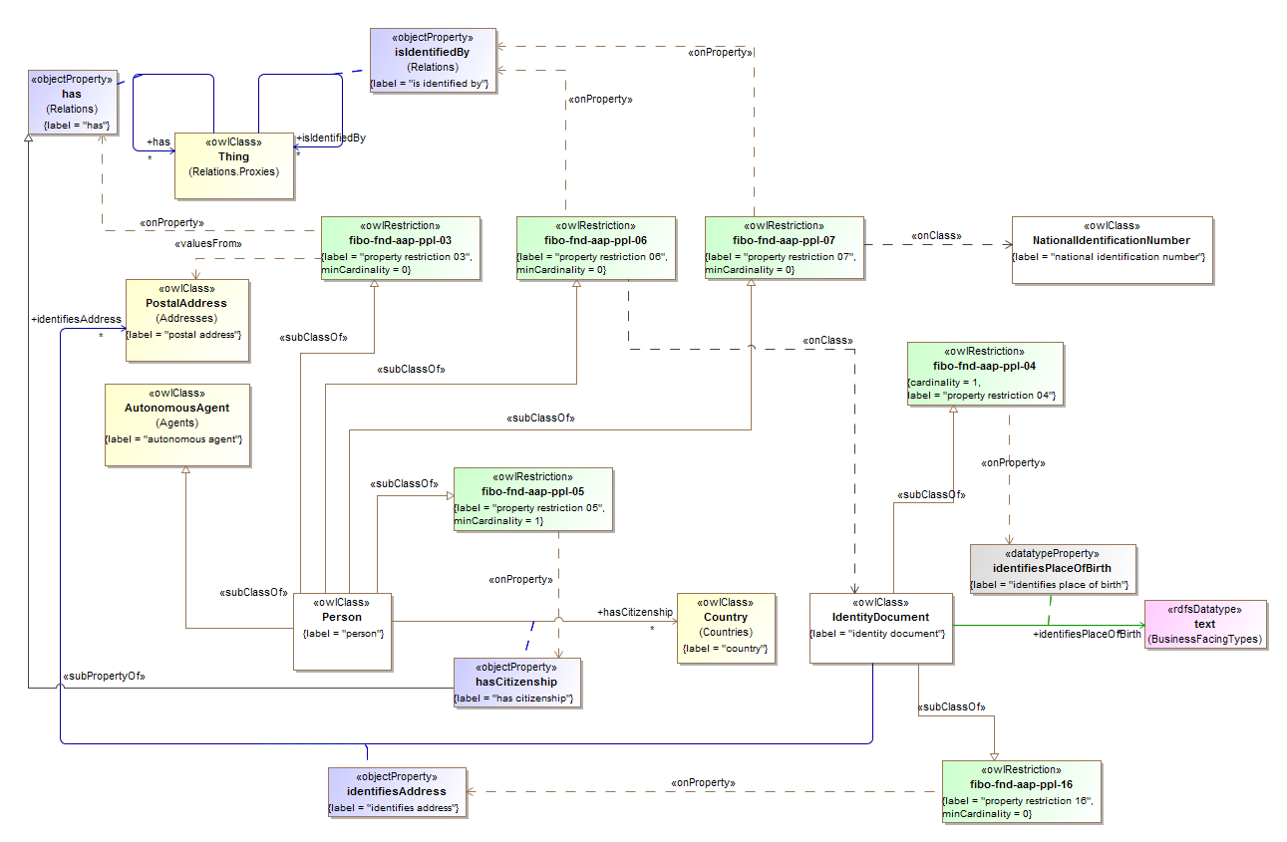

**Figure 10.28 People Identification Basics**

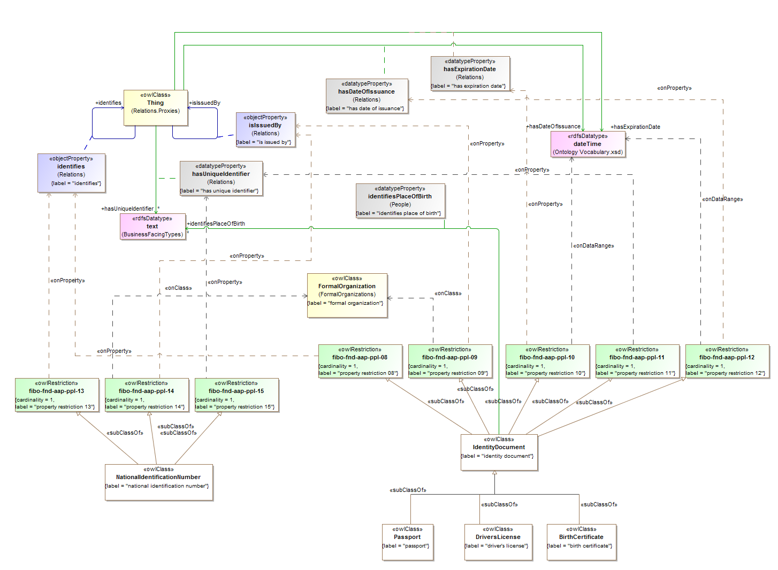

**Figure 10.29 Identification Documents**

Table 10-27. People Ontology Metadata

|  |  |
| --- | --- |
| **Metadata Term** | **Value** |
| **sm:filename** | People Ontology |
| **sm:fileAbbreviation** | fibo-fnd-aap-ppl |
| **OntologyIRI** | http://www.omg.org/spec/EDMC-FIBO/FND/AgentsAndPeople/People/ |
| **owl:versionIRI** | http://www.omg.org/spec/EDMC-FIBO/FND/20140801/AgentsAndPeople/People/ |
| sm:dependsOn | http://www.omg.org/spec/EDMC-FIBO/FND/Utilities/AnnotationVocabulary/  http://www.omg.org/spec/EDMC-FIBO/FND/Utilities/BusinessFacingTypes/  http://www.omg.org/spec/EDMC-FIBO/FND/Relations/Relations/  http://www.omg.org/spec/EDMC-FIBO/FND/AgentsAndPeople/Agents/  http://www.omg.org/spec/EDMC-FIBO/FND/Places/Locations/  http://www.omg.org/spec/EDMC-FIBO/FND/Places/Countries/  http://www.omg.org/spec/EDMC-FIBO/FND/Places/Addresses/  http://www.omg.org/spec/EDMC-FIBO/FND/GoalsAndObjectives/Goals/  http://www.omg.org/spec/EDMC-FIBO/FND/Organizations/Organizations/  http://www.omg.org/spec/EDMC-FIBO/FND/Organizations/FormalOrganizations/ |

Table 10-28. People Details

| **Name** | **Type Of Thing** | **Property** | **Definition** | **Equivalent to** | **Parent** | **Mutually Exclusive With** | **Related Thing or Type** | **Inverse Of Property** | **Concept Type** | **Editorial Note** | **Explanatory Note** | **Definition Source** |
| --- | --- | --- | --- | --- | --- | --- | --- | --- | --- | --- | --- | --- |
| Person | Person |  | A person; any member of the species homo sapiens. |  | property restriction 05 property restriction 06 property restriction 03  property restriction 02 property restriction 01 property restriction 07 autonomous agent  property restriction 17 |  |  |  | Class |  |  |  |
| fibo-fnd-aap-ppl-01 | property restriction 01 |  | Set of things that must have property "has date of birth" exactly 1 taken from "dateTime" |  |  |  |  |  | Property Restriction |  |  |  |
| fibo-fnd-aap-ppl-02 | property restriction 02 |  | Set of things that must have property "has gender" exactly 1 taken from "gender" |  |  |  |  |  | Property Restriction |  |  |  |
| fibo-fnd-aap-ppl-03 | property restriction 03 |  | Set of things that must have property "has" at least 0 taken from "postal address" |  |  |  |  |  | Property Restriction |  |  |  |
| fibo-fnd-aap-ppl-04 | property restriction 04 |  | Set of things that must have property "has place of birth" exactly 1 taken from "string" |  |  |  |  |  | Property Restriction |  |  |  |
| fibo-fnd-aap-ppl-05 | property restriction 05 |  | Set of things that must have property "has citizenship" at least 1 taken from "country" |  |  |  |  |  | Property Restriction |  |  |  |
| fibo-fnd-aap-ppl-06 | property restriction 06 |  | Set of things that must have property "is identified by" at least 0 taken from "identity document" |  |  |  |  |  | Property Restriction |  |  |  |
| fibo-fnd-aap-ppl-07 | property restriction 07 |  | Set of things that must have property "is identified by" at least 0 taken from "national identification number" |  |  |  |  |  | Property Restriction |  |  |  |
| hasSurname | Person | has surname | the patronymic or family name of a person |  | has person name |  | text |  | Simple Property |  |  |  |
| hasPlaceOfBirth | Person | has place of birth | links a person with their place of birth |  |  |  | physical location |  | Relationship Property |  |  |  |
| hasPersonName | Person | has person name | links any sort of name to an individual person |  | has name |  | text |  | Simple Property |  |  |  |
| hasMiddleNameOrInitial | Person | has middle name or initial |  |  | has person name |  | text |  | Simple Property |  |  |  |
| hasMaidenName | Person | has maiden name | the patronymic or family name which a person was born with and which predates any changes of name due to marriage |  | has person name |  | text |  | Simple Property |  |  |  |
| hasLastName | Person | has last name | the patronymic or family name of a person |  | has person name |  | text |  | Simple Property |  |  |  |
| hasGivenName | Person | has given name | the given name or first name of a person, that is the name chosen for them at birth or changed by them subsequently from the name given at birth |  | has person name |  | text |  | Simple Property |  |  |  |
| hasGender | Person | has gender | links a particular gender value with a person |  |  |  | gender |  | Simple Property |  |  |  |
| hasFullLegalName | Person | has full legal name | the legally complete name of a person, as used in formal dealings of a legal or contractual nature |  | has person name |  | text |  | Simple Property |  |  |  |
| hasFirstName | Person | has first name | the given name or first name of a person, that is the name chosen for them at birth or changed by them subsequently from the name given at birth |  | has person name |  | text |  | Simple Property |  |  |  |
| hasFamilyName | Person | has family name | the patronymic or family name of a person |  | has person name |  | text |  | Simple Property |  |  |  |
| hasDateOfBirth | Person | has date of birth | links a person with their date of birth |  |  |  | xsd:dateTime |  | Simple Property |  |  |  |
| hasCitizenship | Person | has citizenship | links a person to their country of citizenship |  | has |  | country |  | Relationship Property |  |  |  |
| Passport | passport |  | a document, issued by a national government, which certifies the identity and nationality of its holder for the purpose of international travel. |  | identity document |  |  |  | Class |  | The elements of identity contained in all standardized passports include information about the holder, including name, date of birth, gender and place of birth. | https://en.wikipedia.org/wiki/Passport |
| NationalIdentificationNumber | national identification number |  | a number or text which appears on an identity document issued by a country or jurisdiction. |  | property restriction 14 property restriction 13 property restriction 15 |  |  |  | Class |  | A national identification number, national identity number, or national insurance number is used by the governments of many countries as a means of tracking their citizens, permanent residents, and temporary residents for the purposes of work, taxation, government benefits, health care, and other governmentally-related functions. The number will appear on an identity document issued by a country. The ways in which such a system is implemented are dependent on the country, but in most cases, a citizen is issued an identification number at birth or when they reach a legal age (typically the age of 18). Non-citizens may be issued such numbers when they enter the country, or when granted a temporary or permanent residence permit. Many countries issued such numbers ostensibly for a singular purpose, but over time, they become a de facto national identification number. For example, the United States originally developed its Social Security number system as a means of disbursing Social Security benefits. However, due to function creep, the number has become utilized for other purposes to the point where it is almost essential to have one to, among other things, open a bank account, obtain a credit card, or drive a car. | http://en.wikipedia.org/wiki/National_identification_number |
| fibo-fnd-aap-ppl-13 | property restriction 13 |  | Set of things that must have property "identifies" exactly 1 taken from "person" |  |  |  |  |  | Property Restriction |  |  |  |
| fibo-fnd-aap-ppl-14 | property restriction 14 |  | Set of things that must have property "is issued by" exactly 1 taken from "formal organization" |  |  |  |  |  | Property Restriction |  |  |  |
| fibo-fnd-aap-ppl-15 | property restriction 15 |  | Set of things that must have property "has unique identifier" exactly 1 taken from "literal" |  |  |  |  |  | Property Restriction |  |  |  |
| Minor | minor |  | a person under a certain age, usually the age of majority, which legally demarcates childhood from adulthood |  | Person |  |  |  | Class |  | The age depends upon jurisdiction and application, but is generally 18. | https://en.wikipedia.org/wiki/Minor_(law) |
| IncapacitatedAdult | incapacitated adult |  | An individual who is over the age of majority in a given jurisdiction but who is legally identified as not having legal capacity, typically as a result of some inherent physical or mental incapacity or as a result of having contracted some illness which temporarily deprives them of such capacity. |  | adult |  |  |  | Class |  | Individuals may have an inherent physical condition which prevents them from achieving the normal levels of performance expected from persons of comparable age, or their inability to match current levels of performance may be caused by contracting an illness. Whatever the cause, if the resulting condition is such that individuals cannot care for themselves, or may act in ways that are against their interests, those persons are vulnerable through dependency and require the protection of the state against the risks of abuse or exploitation. Hence, any agreements that were made are voidable, and a court may declare that person a ward of the state and grant power of attorney to an appointed legal guardian. | https://en.wikipedia.org/wiki/Capacity_(law) |
| IdentityDocument | identity document |  | any document which may be used to verify aspects of a person's identity. |  | property restriction 12 property restriction 10 property restriction 11 property restriction 08 property restriction 09  property restriction 04  property restriction 16 |  |  |  | Class |  | If issued in the form of a small, mostly standard-sized card, it is usually called an identity card (IC). Countries which do not have formal identity documents may require informal documents. In the absence of a formal identity document, driving licences can be used in many countries as a method of proof of identity, although some countries do not accept driving licences for identification, often because in those countries they don't expire as documents and can be old and easily forged. Most countries accept passports as a form of identification. Most countries have the rule that foreign citizens need to have their passport or occasionally a national identity card from their country available at any time if they do not have residence permit in the country. | https://en.wikipedia.org/wiki/Identification_card |
| identifiesPlaceOfBirth | identity document | identifies place of birth | identifies the person's place of birth as a textual element |  |  |  | text |  | Simple Property |  |  |  |
| identifiesAddress | Identity document | Identifies address | identifies the person's address as it is recorded in the identity document |  |  |  | postal address |  | Relationship Property |  |  |  |
| fibo-fnd-aap-ppl-08 | property restriction 08 |  | Set of things that must have property "identifies" exactly 1 taken from "person" |  |  |  |  |  | Property Restriction |  |  |  |
| fibo-fnd-aap-ppl-09 | property restriction 09 |  | Set of things that must have property "is issued by" exactly 1 taken from "formal organization" |  |  |  |  |  | Property Restriction |  |  |  |
| fibo-fnd-aap-ppl-10 | property restriction 10 |  | Set of things that must have property "has expiration date" exactly 1 taken from "dateTime" |  |  |  |  |  | Property Restriction |  |  |  |
| fibo-fnd-aap-ppl-11 | property restriction 11 |  | Set of things that must have property "has unique identifier" exactly 1 taken from "literal" |  |  |  |  |  | Property Restriction |  |  |  |
| fibo-fnd-aap-ppl-12 | property restriction 12 |  | Set of things that must have property "has date of issuance" exactly 1 taken from "dateTime" |  |  |  |  |  | Property Restriction |  |  |  |
| fibo-fnd-aap-ppl-16 | property restriction 16 |  | Set of things that must have property "identifiesAddress" at least 0 taken from "postal address" |  |  |  |  |  | Property Restriction |  |  |  |
| EmancipatedMinor | emancipated minor |  | a minor who is allowed to conduct a business or any other occupation on his or her own behalf or for their own account outside the influence of a parent or guardian. |  | minor |  |  |  | Class |  | The minor will then have full contractual capacity to conclude contracts with regard to the business. Whether parental consent is needed to achieve emancipated status varies from case to case. In some cases, court permission is necessary. Protocols vary by jurisdiction. | https://en.wikipedia.org/wiki/Emancipated_minor |
| DriversLicense | driver's license |  | A driver's license or driving licence is an official document which states that a person may operate a motorized vehicle, such as a motorcycle, car, truck or a bus, on a public roadway. |  | identity document |  |  |  | Class |  |  | https://en.wikipedia.org/wiki/Non-driver_identification_card#Non-driver_identification_cards |
| BirthCertificate | birth certificate |  | either the original document certifying the circumstances of the birth or a certified copy of or representation of the ensuing registration of that birth. |  | identity document |  |  |  | Class |  | A birth certificate is a vital record that documents the birth of a child. Depending on the jurisdiction, a record of birth might or might not contain verification of the event by such as a midwife or doctor. | http://en.wikipedia.org/wiki/Birth_certificate |
| Adult | adult |  | a person who has attained the age of majority as defined by given jurisdiction |  | Person |  |  |  | Class |  | In addition, human adulthood encompasses psychological adult development. | https://en.wikipedia.org/wiki/Adult |
| fibo-fnd-aap-ppl-17 | property restriction 17 |  | Set of things that must have property "has place of birth" exactly 1 taken from "physical location" |  |  |  |  |  | Property Restriction |  |  |  |
| LegallyCpableAdult | legally capable adult |  | a person who has attained the age of majority as defined by given jurisdiction and is allowed to conduct a business or any other occupation on his or her own behalf or for their own account |  | Adult | Incapacitated adult |  |  | Class |  |  |  |
| LegallyCapablePerson | legally capable person |  | a person who is allowed to conduct a business or any other occupation on his or her own behalf or for their own account | logical union 01 | Person |  |  |  | Class |  |  |  |
| fibo-fnd-aap-ppl-18 | logical union 01 |  |  | Legally capable person |  |  |  |  | Union Class |  |  |  |

## 10.7 Module: Places

Table 10-29. Places Module Metadata

|  |  |
| --- | --- |
| **Metadata Term** | **Value** |
| **sm:moduleName** | Places |
| **sm:moduleAbbreviation** | FIBO-FND-PLC |
| **sm:moduleVersion** | 1.0 |
| **sm:moduleAbstract** | This module includes ontologies defining concepts to do with real or virtual places and the addresses to such places. Note that most of these terms are proxies for terms which exist or which are expected to be published in the future in formal ontologies for those concepts (e.g. geophysical, geopolitical, as well as the address components in physical standards like VCard). |

### 10.7.1 Ontology: Locations

This ontology provides a placeholder for use in mapping geographic location-oriented concepts to the appropriate standards.

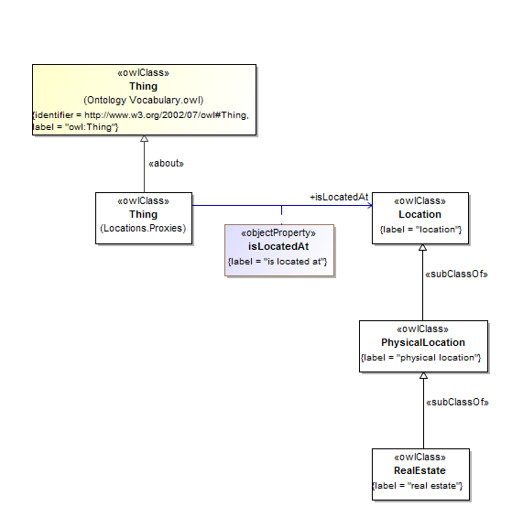

**Figure 10.30 Locations Concepts**

Table 10-30. Locations Ontology Metadata

|  |  |
| --- | --- |
| **Metadata Term** | **Value** |
| **sm:filename** | Locations Ontology |
| **sm:fileAbbreviation** | fibo-fnd-plc-loc |
| **OntologyIRI** | http://www.omg.org/spec/EDMC-FIBO/FND/Places/Locations/ |
| **owl:versionIRI** | http://www.omg.org/spec/EDMC-FIBO/FND/20140801/Places/Locations/ |
| sm:dependsOn | http://www.omg.org/spec/EDMC-FIBO/FND/Utilities/AnnotationVocabulary/ |

Table 10-31. Locations Details

| **Name** | **Type Of Thing** | **Property** | **Definition** | **Equivalent to** | **Parent** | **Mutually Exclusive With** | **Related Thing or Type** | **Inverse Of Property** | **Concept Type** | **Editorial Note** | **Explanatory Note** | **Definition Source** |
| --- | --- | --- | --- | --- | --- | --- | --- | --- | --- | --- | --- | --- |
| RealEstate | real estate |  | Land plus anything permanently fixed to it, including buildings, sheds and other items attached to the structure. |  | physical location |  |  |  | Class |  | Although media often refers to the "real estate market" from the perspective of residential living, real estate can be grouped into three broad categories based on its use, namely residential, commercial and industrial. Examples of real estate include undeveloped land, houses, condominiums, townhomes, office buildings, retail store buildings and factories. | http://www.investopedia.com/terms/r/realestate.asp |
| PhysicalLocation | physical location |  | A location in physical space |  | location |  |  |  | Class |  |  |  |
| Location | location |  | Anything that can be defined as the answer to a question of the form, Where is...? |  |  |  |  |  | Class |  |  |  |

### 10.7.2 Ontology: Countries

This ontology provides a very high level definition of country related concepts, essentially a placeholder for use in mapping countries and intra-country concepts to the appropriate regional standards or to some as yet undefined global address ontology, for use in other FIBO ontology elements. A minimal set of geopolitical and geophysical terms are included as required for financial risk management and other application use cases, and these are all to be considered as placeholders for suitable standard ontologies for these concepts as these become available. These terms may also be mapped to controlled vocabulary standards such as ISO 3166.

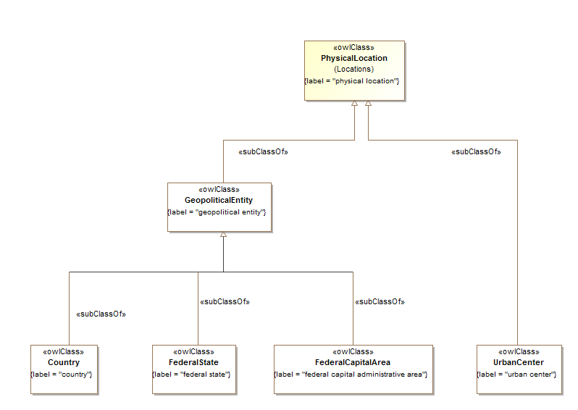

**Figure 10.31 Countries Concepts**

Table 10-32. Countries Ontology Metadata

|  |  |
| --- | --- |
| **Metadata Term** | **Value** |
| **sm:filename** | Countries Ontology |
| **sm:fileAbbreviation** | fibo-fnd-plc-cty |
| **OntologyIRI** | http://www.omg.org/spec/EDMC-FIBO/FND/Places/Countries/ |
| **owl:versionIRI** | http://www.omg.org/spec/EDMC-FIBO/FND/20140801/Places/Countries/ |
| sm:dependsOn | http://www.omg.org/spec/EDMC-FIBO/FND/Utilities/AnnotationVocabulary/  http://www.omg.org/spec/EDMC-FIBO/FND/Places/Locations/ |

Table 10-33. Countries Details

| **Name** | **Type Of Thing** | **Property** | **Definition** | **Equivalent to** | **Parent** | **Mutually Exclusive With** | **Related Thing or Type** | **Inverse Of Property** | **Concept Type** | **Editorial Note** | **Explanatory Note** | **Definition Source** |
| --- | --- | --- | --- | --- | --- | --- | --- | --- | --- | --- | --- | --- |
| UrbanCenter | urban center |  | a large and densely populated urban area |  | physical location |  |  |  | Class |  |  | http://www.thefreedictionary.com/urban+center |
| GeopoliticalEntity | geopolitical entity |  | Any country, federal province, city or other entity which is both geographical and political in its identity. |  | physical location |  |  |  | Class |  |  |  |
| FederalState | federal state |  | A self-governing geopolitical entity which forms part of a wider geopolitical entity recognized as a country. |  | geopolitical entity |  |  |  | Class |  | This type of entity, variously referred to as a state, province or canton, has a level of self government including its own legal system and court jurisdiction, but cedes a level of autonomy to the federation of which it forms a part. |  |
| FederalCapitalArea | federal capital administrative area |  | The capital administrative region of a country which is a federation, if the physical area of this region does not form a part of any of the states or pronvinces which make up the federal country. |  | geopolitical entity |  |  |  | Class |  |  |  |
| Country | country |  | A self-governing geopolitical entity that is recognized as a country by the United Nations |  | geopolitical entity |  |  |  | Class |  |  |  |

### 10.7.3 Ontology: Addresses

This ontology provides a very high level definition of address, essentially a placeholder for use in mapping addresses to the appropriate regional standards or to some as yet undefined global address ontology, for use in other FIBO ontology elements. A minimal set of address related terms are included as required for financial risk management and other application use cases, and these are all to be considered as placeholders for suitable global address standards as these become available.

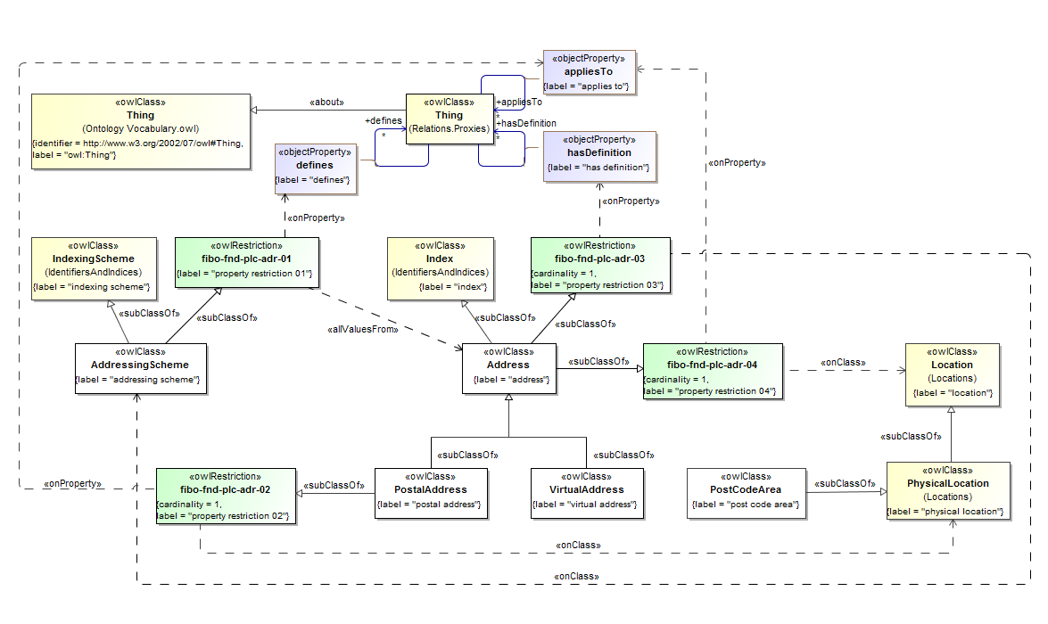

**Figure 10.32 Addresses Concepts**

Table 10-34. Addresses Ontology Metadata

| **Metadata Term** | **Value** |
| --- | --- |
| **sm:filename** | Addresses Ontology |
| **sm:fileAbbreviation** | fibo-fnd-plc-adr |
| **OntologyIRI** | http://www.omg.org/spec/EDMC-FIBO/FND/Places/Addresses/ |
| **owl:versionIRI** | http://www.omg.org/spec/EDMC-FIBO/FND/20140801/Places/Addresses/ |
| sm:dependsOn | http://www.omg.org/spec/EDMC-FIBO/FND/Utilities/AnnotationVocabulary/  http://www.omg.org/spec/EDMC-FIBO/FND/Utilities/BusinessFacingTypes/  http://www.omg.org/spec/EDMC-FIBO/FND/Relations/Relations/  http://www.omg.org/spec/EDMC-FIBO/FND/Places/Locations/  http://www.omg.org/spec/EDMC-FIBO/FND/Places/Countries/ |

Table 10-35. Addresses Details

| **Name** | **Type Of Thing** | **Property** | **Definition** | **Equivalent to** | **Parent** | **Mutually Exclusive With** | **Related Thing or Type** | **Inverse Of Property** | **Concept Type** | **Editorial Note** | **Explanatory Note** | **Definition Source** |
| --- | --- | --- | --- | --- | --- | --- | --- | --- | --- | --- | --- | --- |
| PostalAddress | postal address |  | A physical and postal address where communications can be addressed, papers served or representatives located for any kind of business or legal entity |  | property restriction 02 address |  |  |  | Class | There are existing international and regional standards for defining postal addresses. This is a place holder for mapping to regional standards for postal address representation |  |  |
| fibo-fnd-plc-adr-02 | property restriction 02 |  | Set of things that must have property "appliesTo" exactly 1 taken from "physical location" |  |  |  |  |  | Property Restriction |  |  |  |
| PostCodeArea | post code area |  | The physical area uniquely identified by some postal code. |  | physical location |  |  |  | Class |  |  |  |
| Address | address |  | An index to a location to which communications may be delivered |  | property restriction 04 property restriction 03 |  |  |  | Class | This came from FDTF Address Reviews Aug/Sept 2011. It represents a place holder for mapping to other standards, such as those for email, network, and other electronic addresses as well as physical and mailing addresses. |  |  |
| AddressingScheme | addressing scheme |  | a system for allocating addresses to objects |  | property restriction 01 indexing scheme |  |  |  | Class |  |  |  |
| fibo-fnd-plc-adr-01 | property restriction 01 |  | Set of things that may only have property “defines” taken from “Address” |  |  |  |  |  | Property Restriction |  |  |  |
| fibo-fnd-plc-adr-03 | property restriction 03 |  | Set of things that must have property “hasDefinition” exactly 1 taken from “AddressingScheme” |  |  |  |  |  | Property Restriction |  |  |  |
| fibo-fnd-plc-adr-04 | property restriction 04 |  | Set of things that must have property "appliesTp" exactly 1 taken from "location" |  |  |  |  |  | Property Restriction |  |  |  |
| VirtualAddress | virtual address |  | an address identifying a virtual, i.e. non-physical, entity |  | address |  |  |  | Class |  |  |  |

## 10.8 Module: Organizations

Table 10-36. Organizations Module Metadata

|  |  |
| --- | --- |
| **Metadata Term** | **Value** |
| **sm:moduleName** | Organizations |
| **sm:moduleAbbreviation** | FIBO-FND-ORG |
| **sm:moduleVersion** | 1.0 |
| **sm:moduleAbstract** | This module includes several ontologies defining organizations, features of an organization and different types of organization. These include formal versus informal organizations, legitimate and illicit organizations and so on. They are purposefully underspecified to facilitate mapping to specific organization ontologies, such as the emerging W3C organization and formal organization ontologies, organization from a BMM or BPMN perspective, organization from a records management (RMS) perspective, and so forth. |

### 10.8.1 Ontology: Organizations

This ontology defines high-level concepts for organizations and related terms, for use in other FIBO ontology elements. It is purposefully underspecified to facilitate mapping to specific organization ontologies, such as the emerging W3C organization ontology, organization from a BMM or BPMN perspective, organization from a records management (RMS) perspective, and so forth.

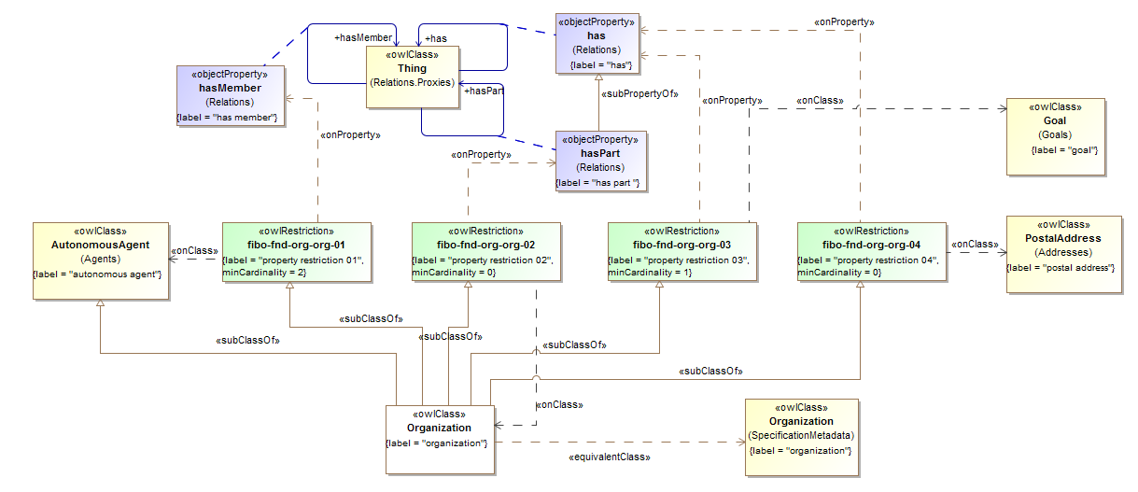

**Figure 10.33 Organizations Concepts**

Table 10-37. Organizations Ontology Metadata

| **Metadata Term** | **Value** |
| --- | --- |
| **sm:filename** | Organizations Ontology |
| **sm:fileAbbreviation** | fibo-fnd-org-org |
| **OntologyIRI** | http://www.omg.org/spec/EDMC-FIBO/FND/20130801/ Organizations/Organizations/ |
| **owl:versionIRI** | http://www.omg.org/spec/EDMC-FIBO/FND/20140801/ Organizations/Organizations/ |
| sm:dependsOn | http://www.omg.org/spec/EDMC-FIBO/FND/Utilities/AnnotationVocabulary/  http://www.omg.org/spec/EDMC-FIBO/FND/Utilities/BusinessFacingTypes/  http://www.omg.org/spec/EDMC-FIBO/FND/Relations/Relations/  http://www.omg.org/spec/EDMC-FIBO/FND/AgentsAndPeople/Agents/  http://www.omg.org/spec/EDMC-FIBO/FND/Places/Locations/  http://www.omg.org/spec/EDMC-FIBO/FND/Places/Countries/  http://www.omg.org/spec/EDMC-FIBO/FND/Places/Addresses/  http://www.omg.org/spec/EDMC-FIBO/FND/GoalsAndObjectives/Goals/ |

Table 10-38. Organizations Details

| **Name** | **Type Of Thing** | **Property** | **Definition** | **Equivalent to** | **Parent** | **Mutually Exclusive With** | **Related Thing or Type** | **Inverse Of Property** | **Concept Type** | **Editorial Note** | **Explanatory Note** | **Definition Source** |
| --- | --- | --- | --- | --- | --- | --- | --- | --- | --- | --- | --- | --- |
| Organization | organization |  | A social unit of people, systematically structured and managed to meet a need or pursue collective goals on a continuing basis. |  | property restriction 04 autonomous agent property restriction 01 property restriction 03 property restriction 02 |  |  |  | Class |  |  | http://www.BusinessDictionary.com/ |
| fibo-fnd-org-org-04 | property restriction 04 |  | Set of things that may have property "has" taken from "postal address" |  |  |  |  |  | Property Restriction |  |  |  |
| fibo-fnd-org-org-03 | property restriction 03 |  | Set of things that must have property "has" at least 1 taken from "goal" |  |  |  |  |  | Property Restriction |  |  |  |
| fibo-fnd-org-org-02 | property restriction 02 |  | Set of things that may have property "has part" taken from "organization" |  |  |  |  |  | Property Restriction |  |  |  |
| fibo-fnd-org-org-01 | property restriction 01 |  | Set of things that must have property "has member" at least 2 taken from "autonomous agent" |  |  |  |  |  | Property Restriction |  |  |  |

### 10.8.2 Ontology: Formal Organizations

This ontology defines the high level concept of formal organization for use in other FIBO ontology elements. It is purposefully underspecified to facilitate mapping to other formal organization ontologies, such as the emerging W3C formal organization ontology, or others defined for specific business and financial services standards. The concepts in this ontology extend those in the Organizations ontology.

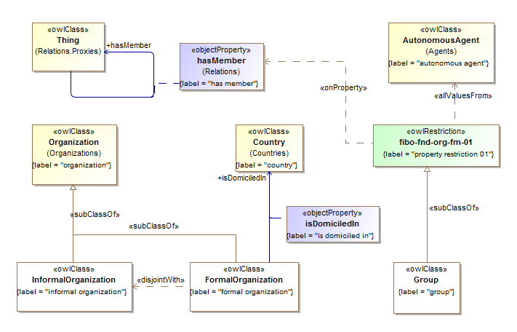

**Figure 10.34 Formal Organizations Concepts**

Table 10-39. Formal Organizations Ontology Metadata

| **Metadata Term** | **Value** |
| --- | --- |
| **sm:filename** | Formal Organizations Ontology |
| **sm:fileAbbreviation** | fibo-fnd-org-fm |
| **OntologyIRI** | http://www.omg.org/spec/EDMC-FIBO/FND/Organizations/FormalOrganizations/ |
| **owl:versionIRI** | http://www.omg.org/spec/EDMC-FIBO/FND/20140801/Organizations/FormalOrganizations/ |
| sm:dependsOn | http://www.omg.org/spec/EDMC-FIBO/FND/Utilities/AnnotationVocabulary/  http://www.omg.org/spec/EDMC-FIBO/FND/Utilities/BusinessFacingTypes/  http://www.omg.org/spec/EDMC-FIBO/FND/Relations/Relations/  http://www.omg.org/spec/EDMC-FIBO/FND/AgentsAndPeople/Agents/  http://www.omg.org/spec/EDMC-FIBO/FND/Places/Locations/  http://www.omg.org/spec/EDMC-FIBO/FND/Places/Countries/  http://www.omg.org/spec/EDMC-FIBO/FND/Places/Addresses/  http://www.omg.org/spec/EDMC-FIBO/FND/GoalsAndObjectives/Goals/  http://www.omg.org/spec/EDMC-FIBO/FND/Organizations/Organizations/ |

Table 10-40. Formal Organizations Details

| **Name** | **Type Of Thing** | **Property** | **Definition** | **Equivalent to** | **Parent** | **Mutually Exclusive With** | **Related Thing or type** | **Inverse Of Property** | **Concept Type** | **Editorial Note** | **Explanatory Note** | **Definition Source** |
| --- | --- | --- | --- | --- | --- | --- | --- | --- | --- | --- | --- | --- |
| InformalOrganization | informal organization |  | An organization which is not formally constituted in some way. |  | organization | formal organization |  |  | Class |  |  |  |
| Group | group |  | A group of autonomous entities |  | property restriction 01 |  |  |  | Class |  |  |  |
| fibo-fnd-org-fm-01 | property restriction 01 |  | Set of things with property "has member" only "autonomous agent" |  |  |  |  |  | Property Restriction |  |  |  |
| FormalOrganization | formal organization |  | An Organization that is recognized in some legal jurisdiction, with associated rights and responsibilities. Examples include a Corporation, Charity, Government or Church. |  | organization | informal organization |  |  | Class | W3C Definition - An Organization which is recognized in the world at large, in particular in legal jurisdictions, with associated rights and responsibilities. Examples include a Corporation, Charity, Government or Church. |  | Adapted from W3C Organization Ontology |
| isDomiciledIn | formal organization | is domiciled in | the country in which the formal organization is officially domiciled |  |  |  | country |  | Relationship Property |  | This would normally be the country corresponding to the jurisdiction in which the formal organization is constituted or incorporated. For some primarily federal countries, the domicile is the country that makes up the federation while the jurisdiction under which the entity is registered (if it is a registered entity) would be that of some state in that federation. |  |

### 10.8.3 Ontology: Legitimate Organizations

This ontology defines the concepts of legitimate and illicit organizations for use in other FIBO ontology elements. These distinctions are provided in order to facilitate modeling of concepts relevant to money laundering. Legitimate organizations such as clubs are defined. These, along with the distinctions of formal versus informal organizations, provide the universe of possible kinds of organizations which may perform specific roles such as holding shares, having control of assets of companies and so on.

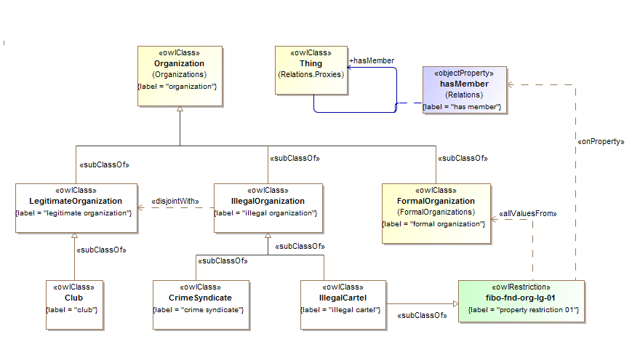

**Figure 10.35 Legitimate and Illicit Organizations Concepts**

Table 10-41. Legitimate Organizations Ontology Metadata

| **Metadata Term** | **Value** |
| --- | --- |
| **sm:filename** | Legitimate Organizations Ontology |
| **sm:fileAbbreviation** | fibo-fnd-org-lg |
| **OntologyIRI** | http://www.omg.org/spec/EDMC-FIBO/FND/ Organizations/LegitimateOrganizations/ |
| **owl:versionIRI** | http://www.omg.org/spec/EDMC-FIBO/FND/20140801/ Organizations/LegitimateOrganizations/ |
| sm:dependsOn | http://www.omg.org/spec/EDMC-FIBO/FND/Utilities/AnnotationVocabulary/  http://www.omg.org/spec/EDMC-FIBO/FND/Utilities/BusinessFacingTypes/  http://www.omg.org/spec/EDMC-FIBO/FND/Relations/Relations/  http://www.omg.org/spec/EDMC-FIBO/FND/AgentsAndPeople/Agents/  http://www.omg.org/spec/EDMC-FIBO/FND/Places/Locations/  http://www.omg.org/spec/EDMC-FIBO/FND/Places/Countries/  http://www.omg.org/spec/EDMC-FIBO/FND/Places/Addresses/  http://www.omg.org/spec/EDMC-FIBO/FND/GoalsAndObjectives/Goals/  http://www.omg.org/spec/EDMC-FIBO/FND/Organizations/Organizations/  http://www.omg.org/spec/EDMC-FIBO/FND/Organizations/FormalOrganizations/ |

Table 10-42. Legitimate and Illicit Organizations Details

| **Name** | **Type Of Thing** | **Property** | **Definition** | **Equivalent to** | **Parent** | **Mutually Exclusive With** | **Related Thing or Type** | **Inverse Of Property** | **Concept Type** | **Editorial Note** | **Explanatory Note** | **Definition Source** |
| --- | --- | --- | --- | --- | --- | --- | --- | --- | --- | --- | --- | --- |
| LegitimateOrganization | legitimate organization |  | An organization that exists to serve some lawful purpose |  | organization | illegal organization |  |  | Class |  |  |  |
| IllegalOrganization | illegal organization |  | A kind of organization which has been set up specifically to perform illegal acts or has become such |  | organization | legitimate organization |  |  | Class |  | This is not to do with performing illicit acts. We can narrow down on a definition for Illicit Organization - one which has been set up specifically to perform illicit acts or has become such. This relates to the purpose of the organization, and the purposes of the entities which control that entity. And the acts which the entity may perform. (definition adopted from the above note, with Illicit changed to Illegal for clarity). Typically, a money laundering entity may perform (will perform) legal acts and is explicitly set up for such, but will also perform illicit acts. The definition of illicit is framed entirely with respect to law and not morality. |  |
| IllegalCartel | illegal cartel |  | A collection of companies that come together to manipulate the market in some way, e.g. price fixing |  | property restriction 01 illegal organization |  |  |  | Class |  |  |  |
| fibo-fnd-org-lg-01 | property restriction 01 |  | Set of things with property "has member" only "formal organization" |  |  |  |  |  | Property Restriction |  |  |  |
| CrimeSyndicate | crime syndicate |  | An informal grouping formed for the purposes of organized criminal activities |  | illegal organization |  |  |  | Class |  |  |  |
| Club | club |  | An informal organization formed to pursue some common interest among its members |  | legitimate organization |  |  |  | Class |  |  |  |

## 10.9 Module: Agreements

Table 10-43. Agreements Module Metadata

|  |  |
| --- | --- |
| **Metadata Term** | **Value** |
| **sm:moduleName** | Agreements |
| **sm:moduleAbbreviation** | FIBO-FND-AGR |
| **sm:moduleVersion** | 1.0 |
| **sm:moduleAbstract** | This module includes ontologies describing agreements between parties and contracts that formalize those agreements. These cover written and verbal contracts, including contracts which may be transferred from one party to another. The latter form the basis for financial securities contracts. The Contracts ontology also describes fundamental properties of contracts such as contractual terms, contract parties and so on, many of which form the basis for more specialized financial industry concepts such as interest payment terms, bond issuers and so on. |

### 10.9.1 Ontology: Agreements

This ontology defines concepts for agreements, for use in other ontology elements. Agreements as defined here are the actual agreements between parties, and this ontology is intended to be referred to in conjunction with the contracts ontology which defines the actual contracts which formalize such agreements. The concepts of agreement and contract are intended to be kept distinct in the FIBO ontologies, that is neither is intended to be regarded as a sub type of the other.

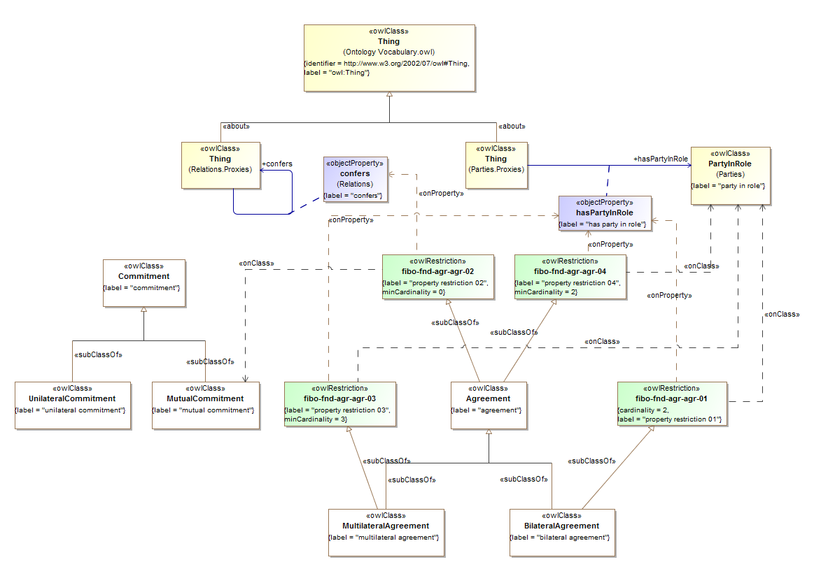

**Figure 10.36 Agreements Concepts**

Table 10-44. Agreements Ontology Metadata

| **Metadata Term** | **Value** |
| --- | --- |
| **sm:filename** | Agreements Ontology |
| **sm:fileAbbreviation** | fibo-fnd-agr-agr |
| **OntologyIRI** | http://www.omg.org/spec/EDMC-FIBO/FND/Agreements/Agreements/ |
| **owl:versionIRI** | http://www.omg.org/spec/EDMC-FIBO/FND/20140801/Agreements/Agreements/ |
| sm:dependsOn | http://www.omg.org/spec/EDMC-FIBO/FND/Utilities/AnnotationVocabulary/  http://www.omg.org/spec/EDMC-FIBO/FND/Utilities/BusinessFacingTypes/  http://www.omg.org/spec/EDMC-FIBO/FND/Relations/Relations/  http://www.omg.org/spec/EDMC-FIBO/FND/AgentsAndPeople/Agents/  http://www.omg.org/spec/EDMC-FIBO/FND/Places/Locations/  http://www.omg.org/spec/EDMC-FIBO/FND/Places/Countries/  http://www.omg.org/spec/EDMC-FIBO/FND/Places/Addresses/  http://www.omg.org/spec/EDMC-FIBO/FND/GoalsAndObjectives/Goals/  http://www.omg.org/spec/EDMC-FIBO/FND/Organizations/Organizations/  http://www.omg.org/spec/EDMC-FIBO/FND/Organizations/FormalOrganizations/  http://www.omg.org/spec/EDMC-FIBO/FND/AgentsAndPeople/People/  http://www.omg.org/spec/EDMC-FIBO/FND/Parties/Roles/  http://www.omg.org/spec/EDMC-FIBO/FND/Parties/Parties/ |

Table 10-45. Agreements Details

| **Name** | **Type Of Thing** | **Property** | **Definition** | **Equivalent to** | **Parent** | **Mutually Exclusive With** | **Related Thing or Type** | **Inverse Of Property** | **Concept Type** | **Editorial Note** | **Explanatory Note** | **Definition Source** |
| --- | --- | --- | --- | --- | --- | --- | --- | --- | --- | --- | --- | --- |
| UnilateralCommitment | unilateral commitment |  | A commitment made by one party without reference to the party to which the commitment is made. |  | commitment |  |  |  | Class |  |  |  |
| MutualCommitment | mutual commitment |  | A commitment between two or more parties |  | commitment |  |  |  | Class |  |  |  |
| MultilateralAgreement | multilateral agreement |  | An agreement between three or more parties |  | agreement property restriction 03 |  |  |  | Class |  |  |  |
| fibo-fnd-agr-agr-03 | property restriction 03 |  | Set of things that must have property "has party in role" at least 3 taken from "party in role" |  |  |  |  |  | Property Restriction |  |  |  |
| Commitment | commitment |  | A legal construct which represents the undertaking on the part of some party to act or refrain from acting in some manner. |  |  |  |  |  | Class | The undertaking by some party to act or refrain from acting results in an obligation on the part of that party, and usually results in the existence of some corresponding right on the party of some other party, in the event that the commitment is to such party. Thus Obligations and Rights are considered as reciprocal aspects of this Commitment concept. |  |  |
| BilateralAgreement | bilateral agreement |  | An agreement between two parties |  | property restriction 04 agreement |  |  |  | Class |  |  |  |
| fibo-fnd-agr-agr-04 | property restriction 04 |  | Set of things that must have property "has party in role" exactly 2 taken from "party in role" |  |  |  |  |  | Property Restriction |  |  |  |
| Agreement | agreement |  | A negotiated and usually legally enforceable understanding between two or more legally competent parties. |  | property restriction 01 property restriction 02 |  |  |  | Class |  | Some mutual undertaking or set of undertakings between two or among several parties.  Although a binding contract can (and often does) result from an agreement, an agreement typically documents the give-and-take of a negotiated settlement and a contract specifies the minimum acceptable standard of performance.  An agreement provides language that defines the terms and conditions of a legally binding contract among the identified parties, ordinarily leading to a contract. | http://www.businessdictionary.com/definition/agreement.html |
| fibo-fnd-agr-agr-01 | property restriction 01 |  | Set of things that may have property "confers" taken from "mutual commitment" |  |  |  |  |  | Property Restriction |  |  |  |
| fibo-fnd-agr-agr-02 | property restriction 02 |  | Set of things that must have property "has party in role" at least 2 taken from "party in role" |  |  |  |  |  | Property Restriction |  |  |  |

### 10.9.2 Ontology: Contracts

This ontology defines concepts relating to contracts, for use in other FIBO ontology elements. These include written contracts which are the concrete evidence of agreements between parties, along with verbal contracts. Contracts are further broken down into bilateral and transferable contracts, the latter being the basis for most financial instruments. Properties of contracts are also defined, in particular contractual terms and contract parties. These concepts all form the basis of concepts in the financial services industry, for example interest payment terms are a kind of contract terms set, and security holders are a kind of contract counterparty.

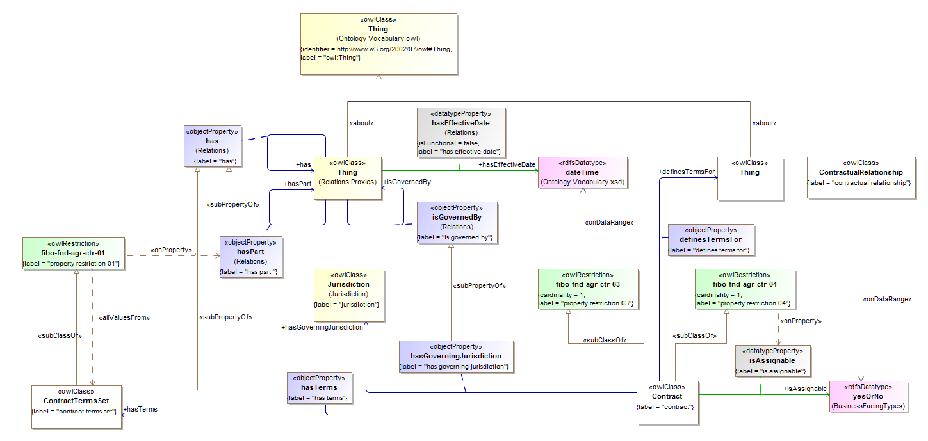

**Figure 10.37 Contracts Basic Concepts**

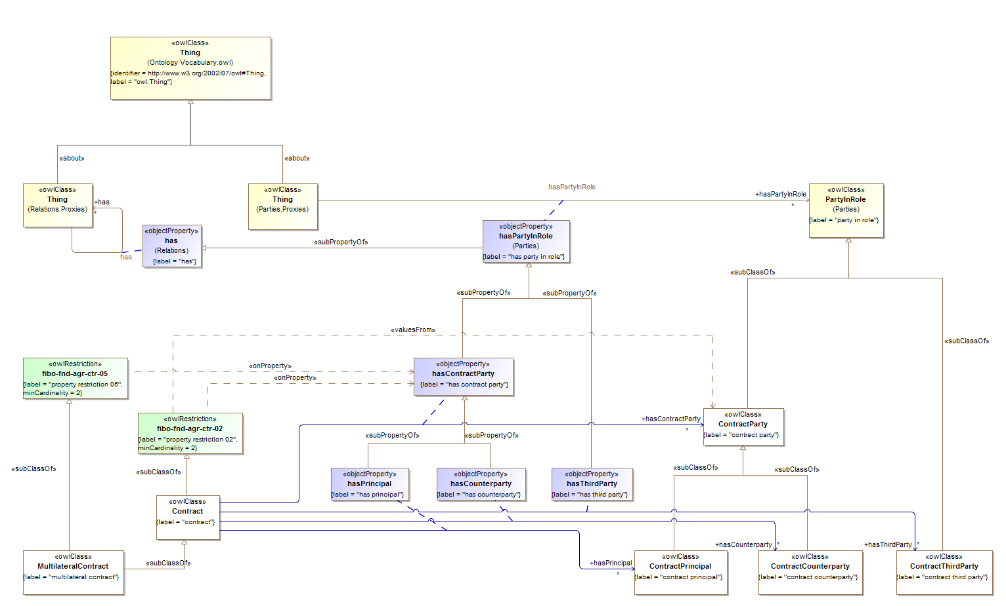

**Figure 10.38 Contract Parties**

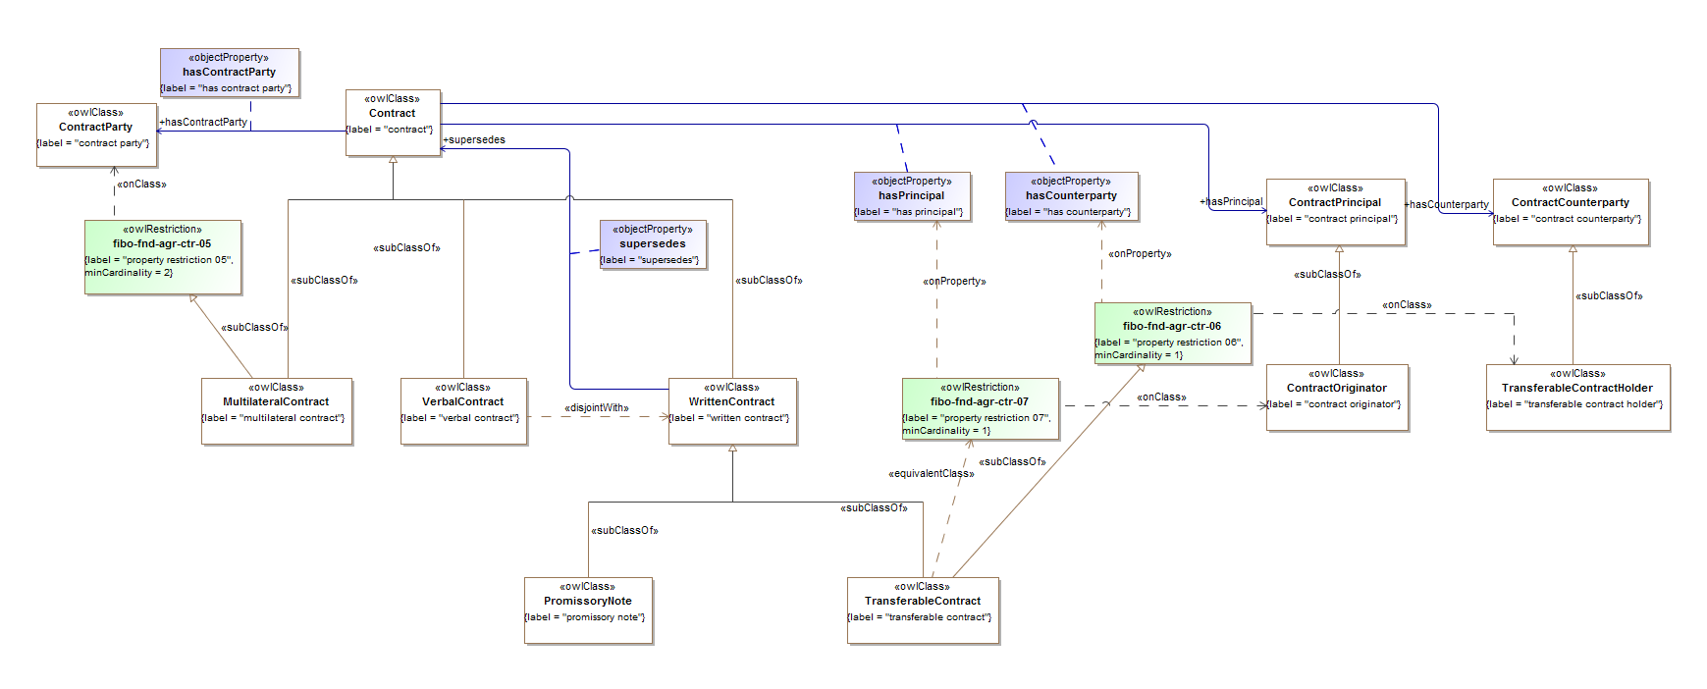

**Figure 10.39 Contract Types**

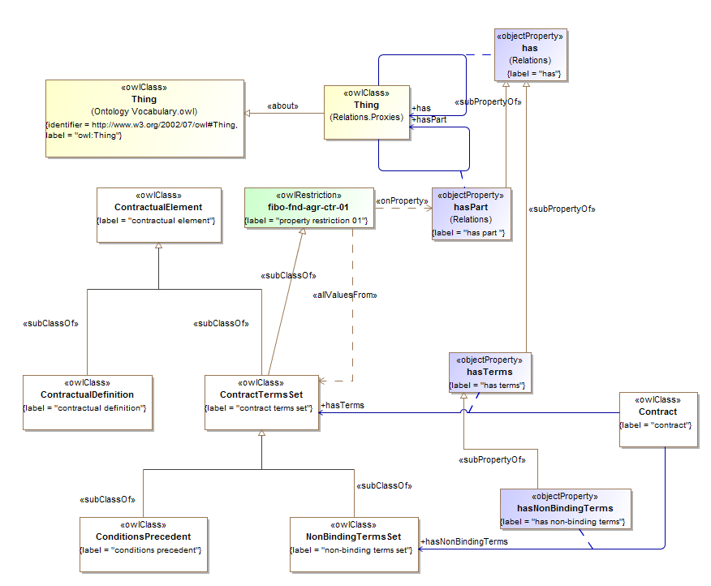

**Figure 10.40 Contract Terms and Elements**

Table 10-46. Contracts Ontology Metadata

| **Metadata Term** | **Value** |
| --- | --- |
| **sm:filename** | Contracts Ontology |
| **sm:fileAbbreviation** | fibo-fnd-agr-ctr |
| **OntologyIRI** | http://www.omg.org/spec/EDMC-FIBO/FND/20130801/Agreements/Contracts/ |
| **owl:versionIRI** | http://www.omg.org/spec/EDMC-FIBO/FND/20140801/Agreements/Contracts/ |
| sm:dependsOn | http://www.omg.org/spec/EDMC-FIBO/FND/Utilities/AnnotationVocabulary/  http://www.omg.org/spec/EDMC-FIBO/FND/Utilities/BusinessFacingTypes/  http://www.omg.org/spec/EDMC-FIBO/FND/Relations/Relations/  http://www.omg.org/spec/EDMC-FIBO/FND/AgentsAndPeople/Agents/  http://www.omg.org/spec/EDMC-FIBO/FND/Places/Locations/  http://www.omg.org/spec/EDMC-FIBO/FND/Places/Countries/  http://www.omg.org/spec/EDMC-FIBO/FND/Places/Addresses/  http://www.omg.org/spec/EDMC-FIBO/FND/GoalsAndObjectives/Goals/  http://www.omg.org/spec/EDMC-FIBO/FND/Organizations/Organizations/  http://www.omg.org/spec/EDMC-FIBO/FND/Organizations/FormalOrganizations/  http://www.omg.org/spec/EDMC-FIBO/FND/AgentsAndPeople/People/  http://www.omg.org/spec/EDMC-FIBO/FND/Parties/Roles/  http://www.omg.org/spec/EDMC-FIBO/FND/Parties/Parties/  http://www.omg.org/spec/EDMC-FIBO/FND/Law/LegalCore/  http://www.omg.org/spec/EDMC-FIBO/FND/Law/Jurisdiction/  http://www.omg.org/spec/EDMC-FIBO/FND/Agreements/Agreements/ |

Table 10-47. Contracts Details

| **Name** | **Type Of Thing** | **Property** | **Definition** | **Equivalent to** | **Parent** | **Mutually Exclusive With** | **Related Thing orType** | **Inverse Of Property** | **Concept Type** | **Editorial Note** | **Explanatory Note** | **Definition Source** |
| --- | --- | --- | --- | --- | --- | --- | --- | --- | --- | --- | --- | --- |
| isAssignable | contract | is assignable | indicates whether the contract and the rights thereunder may be assigned by one of the signatories to some other party |  |  |  | yes or no |  | Simple Property | This is believed to be the basis on which transferable contracts such as financial securities and software licenses may be bought and sold on some market, and also the basis on which a bilateral contract such as an over the counter derivative may be novated so that a new party becomes one of the parties. There are subtle distinctions between these three concepts which are not yet represented here. | An assignment (Latin cessio) is a term used with similar meanings in the law of contracts and in the law of real estate. In both instances, it encompasses the transfer of rights held by one party, the assignor, to another party, the assignee. The details of the assignment determines some additional rights and liabilities (or duties). Typically a third-party is involved in a contract with the assignor, and the contract is in effect transferred to the assignee. |  |
| WrittenContract | written contract |  | A formal Contract which is written and signed by the parties thereto. |  | contract | verbal contract |  |  | Class |  |  |  |
| supersedes | written contract | supersedes | The or any earlier contract which this written contract supersedes, whether that earlier contract is written or verbal or implied. |  |  |  | contract |  | Relationship Property |  |  |  |
| VerbalContract | verbal contract |  | A contract which exists as a result of some verbal exchange. |  | contract | written contract |  |  | Class |  |  |  |
| TransferableContractHolder | transferable contract holder |  | The party which holds a transferable contract and enjoys the benefits defined in that contract while they hold it. |  | contract counterparty |  |  |  | Class | This party may transfer the contract to another party without reference to the issuer, for example by selling it in some marketplace. |  |  |
| TransferableContract | transferable contract |  | a contract in which the rights and obligations of one party (the holder) may be transferred to another party, which thereby takes on the same rights and obligations with respect to the other party to the contract. | property restriction 06 | property restriction 07 written contract |  |  |  | Class | Note that the ability to transfer ownership of one side of a contract, and the concept of assignability, are distinct. In one case the contract may be freely traded; in the other case, some legal transfer of rights to a third party takes place, without a change in who are the signatories of a (typically bilateral) contract |  |  |
| fibo-fnd-agr-ctr-06 | property restriction 06 |  | Set of things that must have property "has principal" at least 1 taken from "contract originator" | transferable contract |  |  |  |  | Property Restriction |  |  |  |
| fibo-fnd-agr-ctr-07 | property restriction 07 |  | Set of things that must have property "has counterparty" at least 1 taken from "transferable contract holder" |  |  |  |  |  | Property Restriction |  |  |  |
| PromissoryNote | promissory note |  | A promissory note is a written, signed, unconditional, and unsecured promise by one party (the maker or promisor) to another (the payee or promisee) that commits the maker to pay a specified sum on demand, or on a fixed or a determinable date. |  | written contract |  |  |  | Class | Unlike a contract, a Promissory Note does not need to be signed by both parties. It is essentiually a promise from one party to the holder, of some good or benefit. Promissory notes would generally by fully fungible. These are modeled as a kind of contract but are essentially a kind of unilateral contract between the issuer and the holder, and some authorities might not see this as a contract at all. Cash is a kind of promissory note, with the issuer being a central bank. | Promissory notes (such as bank or currency notes) are negotiable instruments. | http://www.businessdictionary.com/definition/promissory-note.html |
| NonBindingTermsSet | non-binding terms set |  | Terms which do not have binding legal standing on the Issuer or Holder. |  | contract terms set |  |  |  | Class |  |  |  |
| ContractualRelationship | contractual relationship |  | A contractual relationship is evidenced by (1) an offer, (2) acceptance of the offer, and a (3) valid (legal and valuable) consideration. |  |  |  |  |  | Class |  | Each party to a contract acquires rights and duties relative to the rights and duties of the other parties. However, while all parties may expect a fair benefit from the contract (otherwise courts may set it aside as inequitable) it does not follow that each party will benefit to an equal extent. Existence of contractual-relationship does not necessarily mean the contract is enforceable, or that it is not void (see void contract) or voidable (see voidable Contract). | http://www.businessdictionary.com/definition/contract.html |
| ContractualElement | contractual element |  | Anything which relates to contracts. |  |  |  |  |  | Class | The concept "contractual element" does not exist in any dictionary I could find. Can we change this to ContractElement? (efk) |  |  |
| ContractualDefinition | contractual definition |  | The definition of something in some contract or other legal instrument. |  | contractual element |  |  |  | Class | These are agreed definitions which are then referred to in terms in contracts or other legal instruments. The concept "contractual definition" does not exist in any dictionary I could find. Can we change this to ContractTermOrDefinition? (efk) |  |  |
| ContractThirdParty | contract third party |  | Someone who may be indirectly involved but is not a principal party to an arrangement, contract, deal, lawsuit, or transaction. |  | party in role |  |  |  | Class | The concept "contract third party" does not exist in any dictionary I could find, however "third-party" does, and could be used for this purpose. Can we change this to ThirdParty? (efk) |  | http://www.businessdictionary.com/definition/third-party.html |
| ContractTermsSet | contract terms set |  | the terms and conditions that set the rights and obligations of the contracting parties when a contract is awarded or entered into |  | property restriction 01 contractual element |  |  |  | Class |  |  | http://www.businessdictionary.com/definition/conditions-of-contract.html  http://www.businessdictionary.com/definition/terms-and-conditions.html |
| fibo-fnd-agr-ctr-01 | property restriction 01 |  | Set of things with property "has part" only "contract terms set" |  |  |  |  |  | Property Restriction |  |  |  |
| ContractPrincipal | contract principal |  | the party identified as being the principal or first party to a contract, in the event that the contract distinguishes any party as the principal |  | contract party |  |  |  | Class |  | In law, the principal is the party that has the primary responsibility in a liability or obligation, as opposed to an endorser, guarantor, or surety. | http://www.businessdictionary.com/definition/principal.html |
| ContractOriginator | contract originator |  | The party which originates the transferable contract and acts as the Principal in that contract regardless of the owner or counterparty. |  | contract principal |  |  |  | Class |  |  |  |
| ContractCounterparty | contract counterparty |  | In the event that a contract identifies either party to that contract as being the principal, this is the other party to that contract. |  | contract party |  |  |  | Class | The parent concept of ContractParty is the one to use when no participant in the contract is identified as being the principal; where one entity is identified as being the principal to a contract, then the other party or parties to the contract are to be identified as counterparties. Note that the alternative usage of the word 'counterparty', being a given person's opposite number in some contract, is not the concept intended here, and those two concepts are disjoint. | Where no party is identified as the principal to a contract, both or all parties are simply identified as being parties to the contract. That is, the concept 'counterparty' as defined here is specifically in opposition to 'principal'; other usages of the word counterparty exist. |  |
| Contract | contract |  | a voluntary, deliberate, and legally binding agreement between two or more competent parties |  | property restriction 04  property restriction 03 property restriction 02 |  |  |  | Class |  | Contracts are usually written but may be spoken or implied, and generally have to do with employment, sale or lease, or tenancy. | http://www.businessdictionary.com/definition/contract.html |
| fibo-fnd-agr-ctr-02 | property restriction 02 |  | Set of things that must have property "has party in role" at least 2 taken from "party in role" |  |  |  |  |  | Property Restriction |  |  |  |
| fibo-fnd-agr-ctr-03 | property restriction 03 |  | Set of things that must have property "has effective date" exactly 1 taken from "dateTime" |  |  |  |  |  | Property Restriction |  |  |  |
| fibo-fnd-agr-ctr-04 | property restriction 04 |  | Set of things that must have property "is assignable" exactly 1 taken from "yes or no" |  |  |  |  |  | Property Restriction |  |  |  |
| hasThirdParty | contract | has third party | identifies a party which is not signatory to the party but has some role in the overall context defined by the contract. |  | has party in role |  | contract third party |  | Relationship Property |  |  |  |
| hasTerms | contract | has terms | identifies the written terms which define and describe the commitments, rights and obligations of the parties to the contract and set out commonly agreed definitions, calculations and the like, and which form part of the contract |  | has |  | contract terms set |  | Relationship Property |  | These are generally grouped for convenience as definitions, such as debt repayment terms, and may or may not equate to a formal clause, section, paragraph or other textual construct of the contract. |  |
| hasPrincipal | contract | has principal | identifies the main or principal party to a contract |  | has contract party |  | contract principal |  | Relationship Property |  |  |  |
| hasNonBindingTerms | contract | has non-binding terms | refers to terms that are included in the contract but are not considered binding. In other words, a breach of such terms in the future would not be considered to be a breach of the contract. |  | has terms |  | non-binding terms set |  | Relationship Property |  |  |  |
| hasGoverningJurisdiction | contract | has governing jurisdiction | the jurisdiction governing the contract, as agreed by all parties |  | is governed by |  | jurisdiction |  | Relationship Property | As modeled, this relationship combines two slightly different senses in which a Jurisdiction may be named in some Contract: the jurisdiction under whose laws the contract is deemed to be in force, and the jurisdiction under which the parties agree to submit in the event of any dispute resolution. Scope Note: One thing to tease out is whether "Dispute Resolution" and other forms of "Governing Law" are one and the same thing or not. Dispute Resolution is uncontroversial, the question is whether there are other implications to Governing Law or if it's the same thing. For instance I may undertake to behave as though I were responsible to a particular authority i.e. a particular set of statutes. | In a written contract this is generally identified, for example, as Governing Law, namely the jurisdiction in which any disputes arising from the contract are to be resolved. |  |
| hasCounterparty | contract | has counterparty | identifies a counterparty to a contract |  | has contract party |  | contract counterparty |  | Relationship Property |  |  |  |
| definesTermsFor | contract | defines terms for | the contract sets out the terms for the something |  |  |  | anything |  | Relationship Property |  |  |  |
| ConditionsPrecedent | conditions precedent |  | Conditions precedent on some obligation. These are conditions which would alter the Obligation as it is otherwise stated. |  | contract terms set |  |  |  | Class | Introduced for ISDA Master Agreement. It is likely that the Conditions Precedent defined for OTC Derivatives Master Agreements are actually applicable more widely. However, they are defined within the ISDA terms for now. Modeling note / review question: Modeled as a kind of Terms Set, combining terms and conditions. Should consider whether terms and conditions are distinct (Condition would then be a separate archetype). |  |  |
| MultilateralContract | multilateral contract |  | A contract between two or more specific named parties. The rights and obligations pertaining to either party cannot be transferred to another party without prior written permission or a change to the contract itself. |  | property restriction 05 contract |  |  |  | Class |  |  |  |
| fibo-fnd-agr-ctr-05 | property restriction 05 |  | Set of things that must have property "has party in role" exactly 2 taken from "party in role" |  |  |  |  |  | Property Restriction |  |  |  |
| ContractParty | contract party |  | a party to the contract, that is a contractually capable entity which is a signatory to the contract, and which grants or concedes certain rights and obligations as defined in the contract |  | party in role |  |  |  | Class |  |  |  |
| hasContractParty | contract | has contract party | has a party which is a signatory to the contract and to which is granted certain rights and obligations as defined in the contract and which concedes certain rights to and imposes certain obligations upon the other party as defined in the contract. |  | has party in role |  | contract party |  | Relationship Property |  |  |  |

## 10.10 Module: Law

Table 10-48. Law Module Metadata

| **Metadata Term** | **Value** |
| --- | --- |
| **sm:moduleName** | Law |
| **sm:moduleAbbreviation** | FIBO-FND-LAW |
| **sm:moduleVersion** | 1.0 |
| **sm:moduleAbstract** | This module includes several ontologies defining legal concepts, including constitutions, laws and jurisdictions. It also includes the definition of legal capacities such as signatory capacity, contractual capability and the like. |

### 10.10.1 Ontology: Legal Core

This ontology defines high-level legal concepts for use in other FIBO ontology elements. These concepts include law and constitution, both of which are framed at a more abstract level than national or state laws and constitutions, so that law forms the basis both for statutes and for company by-laws, and constitution forms the basis both for national or state constitutions and for instruments which are constitutive of incorporated legal entities. This ontology also defines some of the variants of these such as governmental constitutions and ordinances. Other types of law are provided in the Jurisdictions ontology as extensions of concepts in this ontology. Court of Law is also defined here.

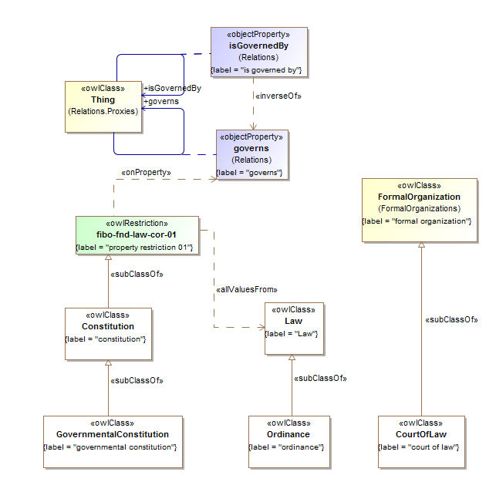

**Figure 10.41 Legal Core Concepts**

Table 10-49. Legal Core Ontology Metadata

|  |  |
| --- | --- |
| **Metadata Term** | **Value** |
| **sm:filename** | Legal Core Ontology |
| **sm:fileAbbreviation** | fibo-fnd-law-cor |
| **OntologyIRI** | http://www.omg.org/spec/EDMC-FIBO/FND/Law/LegalCore/ |
| **owl:versionIRI** | http://www.omg.org/spec/EDMC-FIBO/FND/20140801/Law/LegalCore/ |
| sm:dependsOn | http://www.omg.org/spec/EDMC-FIBO/FND/Utilities/AnnotationVocabulary/  http://www.omg.org/spec/EDMC-FIBO/FND/Utilities/BusinessFacingTypes/  http://www.omg.org/spec/EDMC-FIBO/FND/Relations/Relations/  http://www.omg.org/spec/EDMC-FIBO/FND/AgentsAndPeople/Agents/  http://www.omg.org/spec/EDMC-FIBO/FND/Places/Locations/  http://www.omg.org/spec/EDMC-FIBO/FND/Places/Countries/  http://www.omg.org/spec/EDMC-FIBO/FND/Places/Addresses/  http://www.omg.org/spec/EDMC-FIBO/FND/GoalsAndObjectives/Goals/  http://www.omg.org/spec/EDMC-FIBO/FND/Organizations/Organizations/  http://www.omg.org/spec/EDMC-FIBO/FND/Organizations/FormalOrganizations/ |

Table 10-50. Legal Core Details

| **Name** | **Type Of Thing** | **Property** | **Definition** | **Equivalent to** | **Parent** | **Mutually Exclusive With** | **Related Thing or type** | **Inverse Of Property** | **Concept Type** | **Editorial Note** | **Explanatory Note** | **Definition Source** |
| --- | --- | --- | --- | --- | --- | --- | --- | --- | --- | --- | --- | --- |
| Ordinance | ordinance |  | An authoritative rule or law; a decree or command; a public injunction or regulation, such as a city ordinance against excessive horn blowing. (Source: Dictionary.com) |  | law |  |  |  | Class |  |  |  |
| Law | law |  | a system of rules and guidelines which are enforced through social institutions to govern behavior. |  |  |  |  |  | Class | Any law or body of law, which may have force in some context, including national laws, company bylaws and the like. | Law is a term which does not have a universally accepted definition. Certain Laws are made by governments, specifically by their legislatures. The formation of laws themselves may be influenced by a constitution (written or unwritten) and the rights encoded therein. The law shapes politics, economics and society in countless ways and serves as a social mediator of relations between people. | http://en.wikipedia.org/wiki/Law |
| GovernmentalConstitution | governmental constitution |  | a set of rules and principles that define the nature and extent of government. |  | constitution |  |  |  | Class | This defines the framework in which laws are made and in which they have force. | Most constitutions seek to regulate the relationship between institutions of the state, in a basic sense the relationship between the executive, legislature and the judiciary, but also the relationship of institutions within those branches. For example, executive branches can be divided into a head of government, government departments/ministries, executive agencies and a civil service/administration. Most constitutions also attempt to define the relationship between individuals and the state, and to establish the broad rights of individual citizens. It is thus the most basic law of a territory from which all the other laws and rules are hierarchically derived; in some territories it is in fact called Basic Law. | http://en.wikipedia.org/wiki/Constitution#Governmental_constitutions |
| CourtOfLaw | court of law |  | A court of law is a court that hears cases and decides them on the basis of statutes or the common law. |  | formal organization |  |  |  | Class |  |  | Merriam-Webster Online Dictionary |
| Constitution | constitution |  | A constitution defines the basic principles and laws of a nation, state, or social group that determine the powers and duties of the government and guarantee certain rights to the people in it. |  | property restriction 01 |  |  |  | Class | This defines the framework in which laws (for a country constitution), rules and regulations (for a party or organization constitution) or contractual commitments are made and in which they have force. |  | Merriam-Webster Online Dictionary |
| fibo-fnd-law-cor-01 | property restriction 01 |  | Set of things with property "governs" only "law" |  |  |  |  |  | Property Restriction |  |  |  |

### 10.10.2 Ontology: Jurisdiction

This ontology defines high level concepts relating to jurisdictions for use in other FIBO ontology elements. This includes a general definition of jurisdiction along with some basic types of jurisdiction, along with the factors which distinguish one type of jurisdiction from another. This ontology also defines basic types of legal system, and extends the basic concept of law which is in the LegalCore ontology.

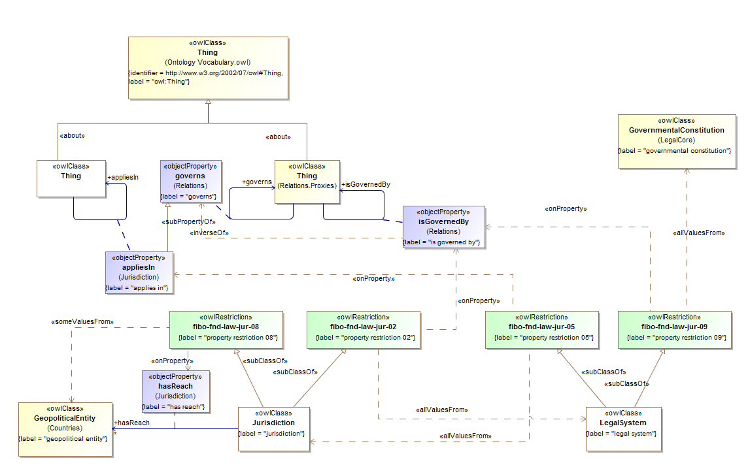

**Figure 10.42 Jurisdiction Basic Concepts**

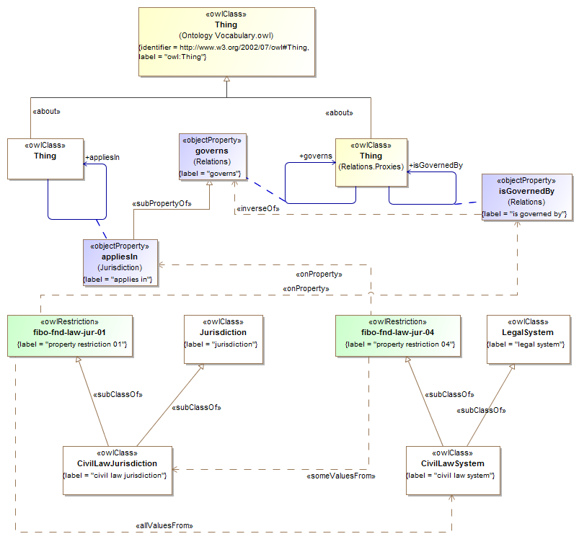

**Figure 10.43 Civil Law Jurisdiction**

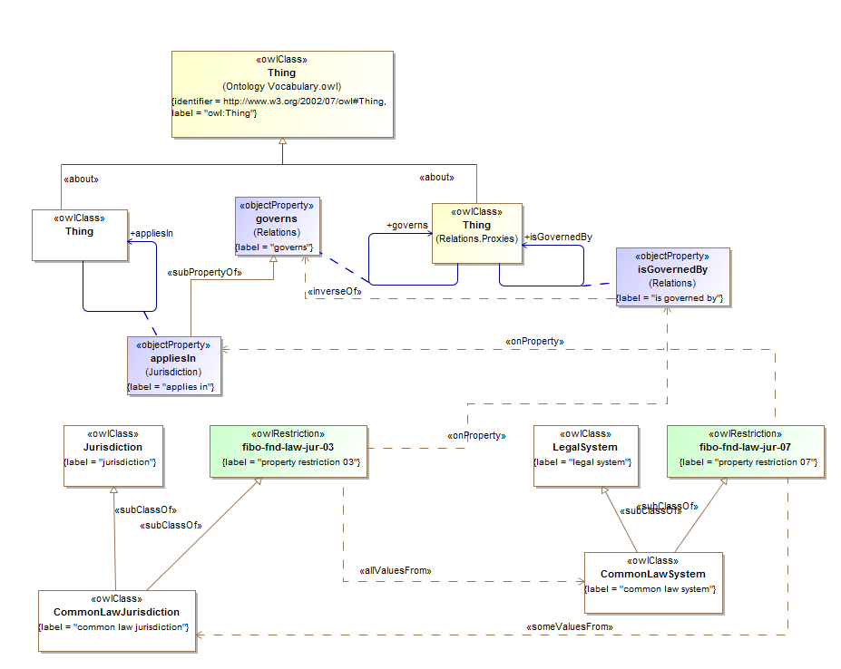

**Figure 10.44 Common Law Jurisdiction**

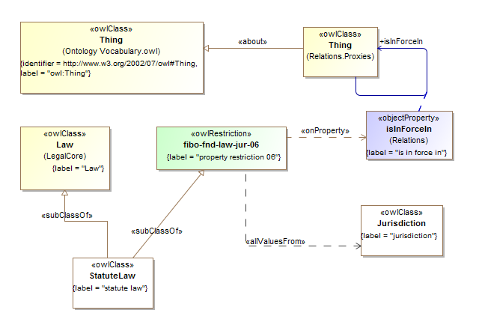

**Figure 10.45 Statute Law**

Table 10-51. Jurisdiction Ontology Metadata

| **Metadata Term** | **Value** |
| --- | --- |
| **sm:filename** | Jurisdiction Ontology |
| **sm:fileAbbreviation** | fibo-fnd-law-jur |
| **OntologyIRI** | http://www.omg.org/spec/EDMC-FIBO/FND/Law/Jurisdiction/ |
| **owl:versionIRI** | http://www.omg.org/spec/EDMC-FIBO/FND/20140801/Law/Jurisdiction/ |
| sm:dependsOn | http://www.omg.org/spec/EDMC-FIBO/FND/Utilities/AnnotationVocabulary/  http://www.omg.org/spec/EDMC-FIBO/FND/Utilities/BusinessFacingTypes/  http://www.omg.org/spec/EDMC-FIBO/FND/Relations/Relations/  http://www.omg.org/spec/EDMC-FIBO/FND/AgentsAndPeople/Agents/  http://www.omg.org/spec/EDMC-FIBO/FND/Places/Locations/  http://www.omg.org/spec/EDMC-FIBO/FND/Places/Countries/  http://www.omg.org/spec/EDMC-FIBO/FND/Places/Addresses/  http://www.omg.org/spec/EDMC-FIBO/FND/GoalsAndObjectives/Goals/  http://www.omg.org/spec/EDMC-FIBO/FND/Organizations/Organizations/  http://www.omg.org/spec/EDMC-FIBO/FND/Organizations/FormalOrganizations/  http://www.omg.org/spec/EDMC-FIBO/FND/Law/LegalCore/ |

Table 10-52. Jurisdiction Details

| **Name** | **Type Of Thing** | **Property** | **Definition** | **Equivalent to** | **Parent** | **Mutually Exclusive With** | **Related Thing or Type** | **Inverse Of Property** | **Concept Type** | **Editorial Note** | **Explanatory Note** | **Definition Source** |
| --- | --- | --- | --- | --- | --- | --- | --- | --- | --- | --- | --- | --- |
| appliesIn | anything | applies in | indicates the jurisdiction in which a particular legal system applies |  | governs |  | anything |  | Relationship Property |  |  |  |
| StatuteLaw | statute law |  | written law (as opposed to oral or customary law) set down by a legislature or by a legislator (in the case of an absolute monarchy). |  | Law property restriction 09 |  |  |  | Class |  | Statutes may originate with national, state legislatures or local municipalities. Statutory laws are subordinate to the higher constitutional laws of the land. | http://en.wikipedia.org/wiki/Statute_law |
| fibo-fnd-law-jur-09 | property restriction 09 |  | Set of things with property "is in force in" only "jurisdiction" |  |  |  |  |  | Property Restriction |  |  |  |
| LegalSystem | legal system |  | Legal regimen of a country consisting of (1) a written or oral constitution, (2) primary legislation (statutes) enacted by the legislative body established by the constitution, (3) subsidiary legislation (bylaws) made by person or bodies authorized by the primary legislation to do so, (4) customs applied by the courts on the basis of traditional practices, and (5) principles or practices of civil, common, Roman, or other code of law. |  | property restriction 03 property restriction 04 |  |  |  | Class | This is a Mediating Thing, that is some context in which things have their meaning and existence - in this case, laws and the interpretation thereof by courts. | The contemporary legal systems of the world are generally based on one of three basic systems: civil law, common law, and religious law, or combinations of these. However, the legal system of each country is shaped by its unique history and so incorporates individual variations. | http://www.businessdictionary.com/definition/legal-system.html |
| fibo-fnd-law-jur-03 | property restriction 03 |  | Set of things with property "applies in" only "jurisdiction" |  |  |  |  |  | Property Restriction |  |  |  |
| fibo-fnd-law-jur-04 | property restriction 04 |  | Set of things with property "is governed by" only "governmental constitution" |  |  |  |  |  | Property Restriction |  |  |  |
| Jurisdiction | jurisdiction |  | the limits or territory within which authority may be exercised; the power, right, or authority to interpret and apply the law |  | property restriction 02 property restriction 01 |  |  |  | Class |  |  | Merriam-Webster Online Dictionary |
| fibo-fnd-law-jur-01 | property restriction 01 |  | Set of things with property "has reach" some "geopolitical entity" |  |  |  |  |  | Property Restriction |  |  |  |
| fibo-fnd-law-jur-02 | property restriction 02 |  | Set of things with property "is governed by" only "legal system" |  |  |  |  |  | Property Restriction |  |  |  |
|  | jurisdiction | has reach | indicates the geopolitical entity (country, federal province or municipality) in which the jurisdiction has effect |  |  |  | geopolitical entity |  | Relationship Property |  |  |  |
| CommonLawSystem | common law system |  | Common law, also known as case law or precedent, is law developed by judges through decisions of courts and similar tribunals |  | legal system property restriction 06 |  |  |  | Class |  | A jurisdiction which is based in Common Law will also have alongside a legislature that passes statutes.  By contrast, civil law (codified/continental law) is set on statutes adopted through the legislative/parliamentary process and/or regulations issued by the executive branch on base of the parliamentary statutes. A common law system is a legal system that gives great potential precedential weight to common law, on the principle that it is unfair to treat similar facts differently on different occasions. The body of precedent is called common law and it binds future decisions. In cases where the parties disagree on what the law is, a common law court looks to past precedential decisions of relevant courts. If a similar dispute has been resolved in the past, the court is bound to follow the reasoning used in the prior decision (this principle is known as stare decisis). If, however, the court finds that the current dispute is fundamentally distinct from all previous cases (called a matter of first impression), judges have the authority and duty to make law by creating precedent. Thereafter, the new decision becomes precedent, and will bind future courts. | http://en.wikipedia.org/wiki/Common_law |
| fibo-fnd-law-jur-06 | property restriction 06 |  | Set of things with property "applies in" some "common law jurisdiction" |  |  |  |  |  | Property Restriction |  |  |  |
| CommonLawJurisdiction | common law jurisdiction |  | a jurisdiction based on common law |  | property restriction 08 jurisdiction |  |  |  | Class |  |  |  |
| fibo-fnd-law-jur-08 | property restriction 08 |  | Set of things with property "is governed by" only "common law system" |  |  |  |  |  | Property Restriction |  |  |  |
| CivilLawSystem | civil law system |  | a legal system originating in Europe, intellectualized within the framework of late Roman law, and whose most prevalent feature is that its core principles are codified into a referable system which serves as the primary source of law |  | property restriction 05 legal system |  |  |  | Class |  | This can be contrasted with common law systems whose intellectual framework comes from judge-made decisional law which gives precedential authority to prior court decisions on the principle that it is unfair to treat similar facts differently on different occasions (doctrine of judicial precedent). | http://en.wikipedia.org/wiki/Civil_law_(legal_system) |
| fibo-fnd-law-jur-05 | property restriction 05 |  | Set of things with property "applies in" some "civil law jurisdiction" |  |  |  |  |  | Property Restriction |  |  |  |
| CivilLawJurisdiction | civil law jurisdiction |  | a civil law jurisdiction |  | property restriction 07 jurisdiction |  |  |  | Class |  |  |  |
| fibo-fnd-law-jur-07 | property restriction 07 |  | Set of things with property "is governed by" only "civil law system" |  |  |  |  |  | Property Restriction |  |  |  |

### 10.10.3 Ontology: Legal Capacity

This ontology defines high-level legal concepts, especially those related to legal responsibilities, for use in other FIBO ontology elements. The ontology defines things which are conferred upon some entity by some legal instrument, and elaborates this into a number of specific capacities, responsibilities and powers, each of which forms the basis for many of the concepts used elsewhere in FIBO in defining legal personhood, executive powers and the like.

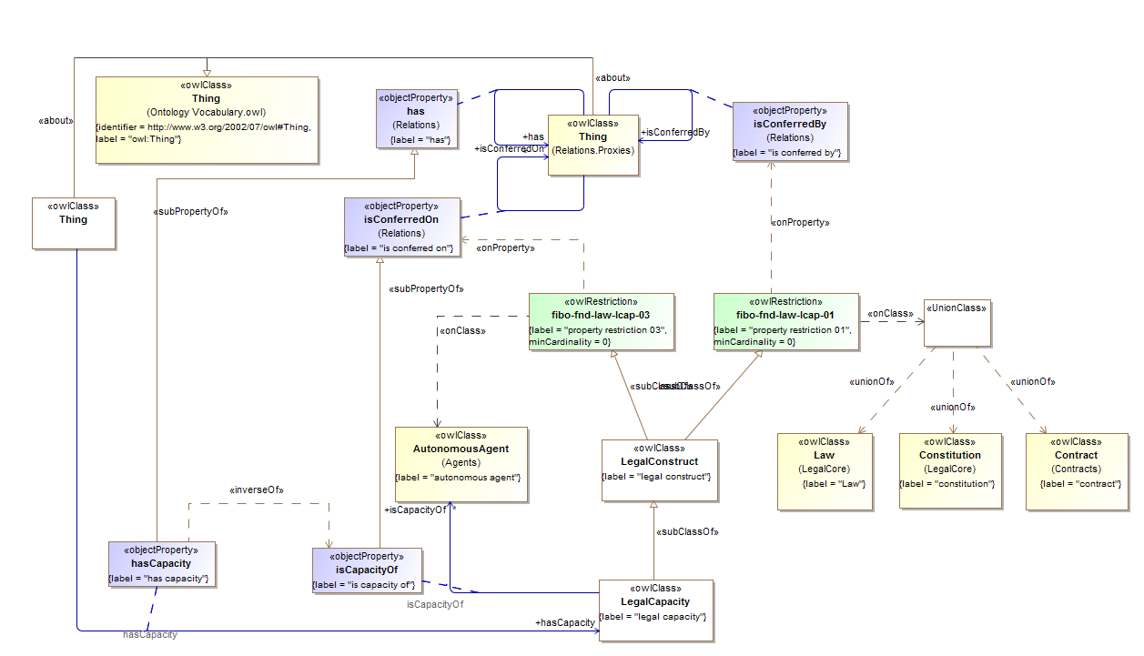

**Figure 10.46 Legal Capacity Concepts**

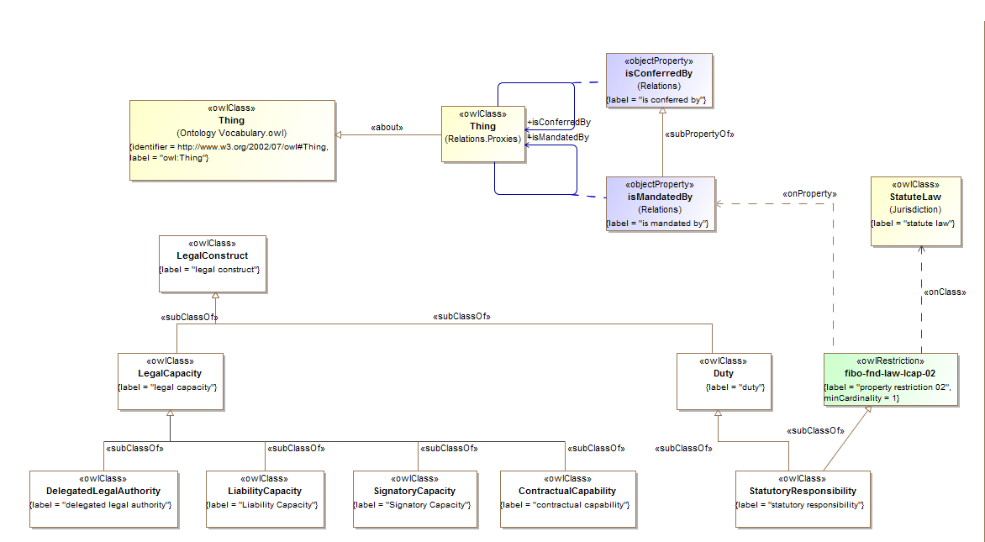

**Figure 10.47 Legal Capacity Types**

Table 10-53. Legal Capacity Ontology Metadata

| **Metadata Term** | **Value** |
| --- | --- |
| **sm:filename** | Legal Capacity Ontology |
| **sm:fileAbbreviation** | fibo-fnd-law-lcap |
| **OntologyIRI** | http://www.omg.org/spec/EDMC-FIBO/FND/Law/LegalCapacity/ |
| **owl:versionIRI** | http://www.omg.org/spec/EDMC-FIBO/FND/20140801/Law/LegalCapacity/ |
| sm:dependsOn | http://www.omg.org/spec/EDMC-FIBO/FND/Utilities/AnnotationVocabulary/  http://www.omg.org/spec/EDMC-FIBO/FND/Utilities/BusinessFacingTypes/  http://www.omg.org/spec/EDMC-FIBO/FND/Relations/Relations/  http://www.omg.org/spec/EDMC-FIBO/FND/AgentsAndPeople/Agents/  http://www.omg.org/spec/EDMC-FIBO/FND/Places/Locations/  http://www.omg.org/spec/EDMC-FIBO/FND/Places/Countries/  http://www.omg.org/spec/EDMC-FIBO/FND/Places/Addresses/  http://www.omg.org/spec/EDMC-FIBO/FND/GoalsAndObjectives/Goals/  http://www.omg.org/spec/EDMC-FIBO/FND/Organizations/Organizations/  http://www.omg.org/spec/EDMC-FIBO/FND/Organizations/FormalOrganizations/  http://www.omg.org/spec/EDMC-FIBO/FND/AgentsAndPeople/People/  http://www.omg.org/spec/EDMC-FIBO/FND/Parties/Roles/  http://www.omg.org/spec/EDMC-FIBO/FND/Parties/Parties/  http://www.omg.org/spec/EDMC-FIBO/FND/Law/LegalCore/  http://www.omg.org/spec/EDMC-FIBO/FND/Law/Jurisdiction/  http://www.omg.org/spec/EDMC-FIBO/FND/Agreements/Agreements/  http://www.omg.org/spec/EDMC-FIBO/FND/Agreements/Contracts/ |

Table 10-54. Legal Capacity Details

| **Name** | **Type Of Thing** | **Property** | **Definition** | **Equivalent to** | **Parent** | **Mutually Exclusive With** | **Related Thing or Type** | **Inverse Of Property** | **Concept Type** | **Editorial Note** | **Explanatory Note** | **Definition Source** |
| --- | --- | --- | --- | --- | --- | --- | --- | --- | --- | --- | --- | --- |
| hasCapacity | anything | has capacity | identifies an entity that has some capability to carry out certain actions, or has certain rights or obligations |  | has |  | legal capacity | is capacity of | Relationship Property |  |  |  |
| StatutoryResponsibility | statutory responsibility |  | An obligation which is defined under some body of law (statute). |  | duty property restriction 03 |  |  |  | Class |  |  |  |
| fibo-fnd-law-lcap-03 | property restriction 03 |  | Set of things that must have property "is mandated by" at least 1 taken from "statute law" |  |  |  |  |  | Property Restriction |  |  |  |
| SignatoryCapacity | Signatory Capacity |  | The capacity of some natural person to sign agreements on the part of some entity. |  | legal capacity |  |  |  | Class |  |  |  |
| LiabilityCapacity | Liability Capacity |  | The ability to be sued at law |  | legal capacity |  |  |  | Class | Note that for the purposes of this model, this is distinct from culpability (the ability to commit criminal acts). That would be a separate and analogous term but with grounding in criminal rather than civil law. |  |  |
| LegalConstruct | legal construct |  | Something which is conferred by way of law or contract, such as a right. |  | property restriction 02 property restriction 01 |  |  |  | Class | Obligations are an aspect of this category of thing, as are rights. |  |  |
| fibo-fnd-law-lcap-01 | property restriction 01 |  | Set of things that may have property "is conferred on" taken from "autonomous agent" |  |  |  |  |  | Property Restriction |  |  |  |
| fibo-fnd-law-lcap-02 | property restriction 02 |  | Set of things that may have property "is conferred by" taken from "logical union 01" |  |  |  |  |  | Property Restriction |  |  |  |
| LegalCapacity | legal capacity |  | The capacity to carry out certain actions or to have certain rights. |  | legal construct |  |  |  | Class | suggested definition only |  |  |
| isCapacityOf | legal capacity | is capacity of | identifies an entity on which a given legal capacity has been conferred |  | is conferred on |  | autonomous agent | has capacity | Relationship Property |  |  |  |
| Duty | duty |  | Some obligation which exists and is imposed on some individual. |  | legal construct |  |  |  | Class | This can also be thought of as an obligation - not in the sense in which an obligation and a right are the converse aspects of one another, but in and of itself, independent of the perspective from which it is considered. Examples include statutory obligations, reporting obligations and so on. |  |  |
| DelegatedLegalAuthority | delegated legal authority |  | institutionalized and legal power inherent in a particular job, function, or position that is meant to enable its holder to successfully carry out his or her responsibilities, where such power has been delegated through some formal means |  | legal capacity |  |  |  | Class |  | This is always accompanied by an equal responsibility for one's actions or a failure to act. | http://www.businessdictionary.com/definition/authority.html |
| ContractualCapability | contractual capability |  | The capacity to enter into legally binding contracts. |  | legal capacity |  |  |  | Class | This is the capacity which defines Contractually Capable Entity (sometimes labeled as 'Legal Entity') as distinct from 'Legal Person'. In the latter case the liabilities incurred in the contract accrue also to the Legal Person. In the case of contractual capability, the entity has the authority to enter into contracts, whether or not the liabilities accrue to that same entity (which they do if it is also a Legal Person). For Legal Entities which are not Legal Persons, the liability unwinds to some legal person within the structure of the entity, for example a General Partner or a Trustee. |  |  |

## 10.11 Module: Ownership and Control

Table 10-55. Ownership and Control Module Metadata

| **Metadata Term** | **Value** |
| --- | --- |
| **sm:moduleName** | Ownership and Control |
| **sm:moduleAbbreviation** | FIBO-FND-OAC |
| **sm:moduleVersion** | 1.0 |
| **sm:moduleAbstract** | This module includes ontologies defining the meanings of ownership, asset and owner, and of types of control such as de jure and de facto control. These form the basis of ownership and control relationship hierarchies as well as what it means to own or to control something. |

### 10.11.1 Ontology: Control

This ontology defines high-level, control-related concepts for use in other FIBO ontology elements. The ontology covers basic concepts around control, along with a distinction between de jure and de facto control, the former being derived with reference to terms in the LegalCapacity ontology.

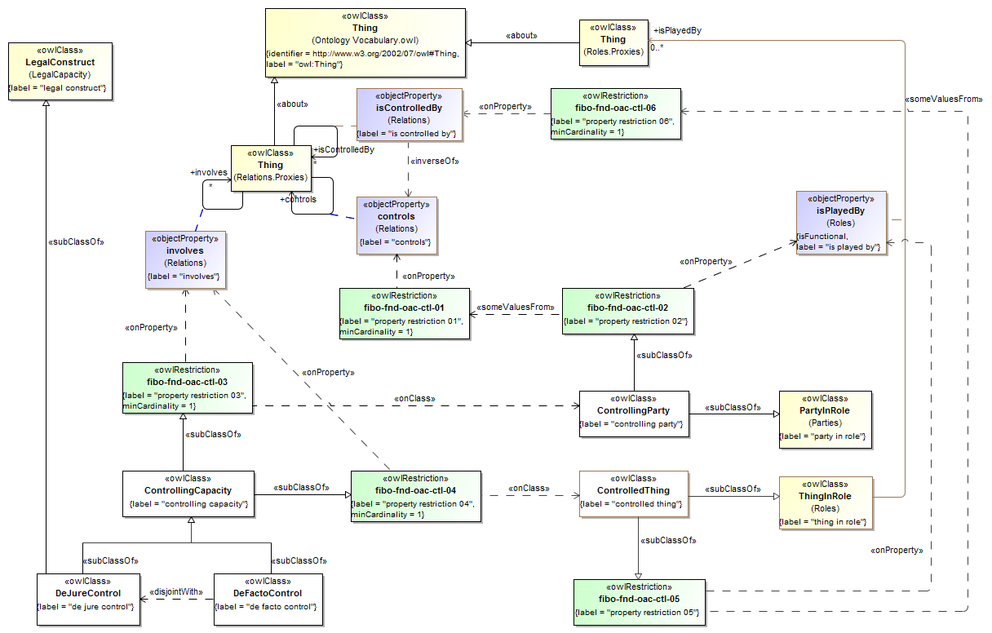

**Figure 10.48 Controlling Capacity Definitions**

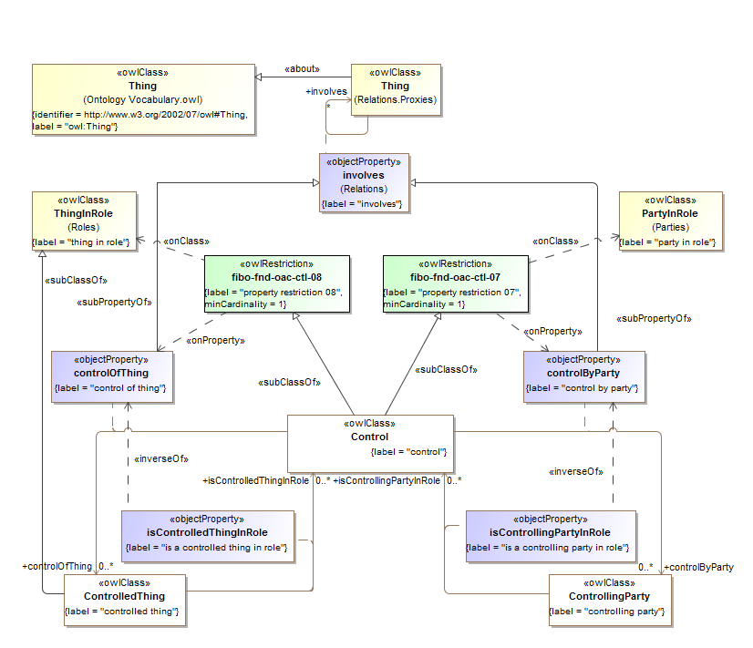

**Figure 10.49 Control Property Definitions**

Table 10-56. Control Ontology Metadata

| **Metadata Term** | **Value** |
| --- | --- |
| **sm:filename** | Control Ontology |
| **sm:fileAbbreviation** | fibo-fnd-oac-ctl |
| **OntologyIRI** | http://www.omg.org/spec/EDMC-FIBO/FND/OwnershipAndControl/Control/ |
| **owl:versionIRI** | http://www.omg.org/spec/EDMC-FIBO/FND/20140801/OwnershipAndControl/Control/ |
| sm:dependsOn | http://www.omg.org/spec/EDMC-FIBO/FND/Utilities/AnnotationVocabulary/  http://www.omg.org/spec/EDMC-FIBO/FND/Utilities/BusinessFacingTypes/  http://www.omg.org/spec/EDMC-FIBO/FND/Relations/Relations/  http://www.omg.org/spec/EDMC-FIBO/FND/AgentsAndPeople/Agents/  http://www.omg.org/spec/EDMC-FIBO/FND/Places/Locations/  http://www.omg.org/spec/EDMC-FIBO/FND/Places/Countries/  http://www.omg.org/spec/EDMC-FIBO/FND/Places/Addresses/  http://www.omg.org/spec/EDMC-FIBO/FND/GoalsAndObjectives/Goals/  http://www.omg.org/spec/EDMC-FIBO/FND/Organizations/Organizations/  http://www.omg.org/spec/EDMC-FIBO/FND/Organizations/FormalOrganizations/  http://www.omg.org/spec/EDMC-FIBO/FND/AgentsAndPeople/People/  http://www.omg.org/spec/EDMC-FIBO/FND/Parties/Roles/  http://www.omg.org/spec/EDMC-FIBO/FND/Parties/Parties/  http://www.omg.org/spec/EDMC-FIBO/FND/Law/LegalCore/  http://www.omg.org/spec/EDMC-FIBO/FND/Law/Jurisdiction/  http://www.omg.org/spec/EDMC-FIBO/FND/Agreements/Agreements/  http://www.omg.org/spec/EDMC-FIBO/FND/Agreements/Contracts/  http://www.omg.org/spec/EDMC-FIBO/FND/Law/LegalCapacity/ |

Table 10-57. Control Details

| **Name** | **Type Of Thing** | **Property** | **Definition** | **Equivalent to** | **Parent** | **Mutually Exclusive With** | **Related Thing or Type** | **Inverse Of Property** | **Concept Type** | **Editorial Note** | **Explanatory Note** | **Definition Source** |
| --- | --- | --- | --- | --- | --- | --- | --- | --- | --- | --- | --- | --- |
| DeJureControl | de jure control |  | control that is formalized in law, or codified in some legal instrument |  | legal construct control | de facto control |  |  | Class |  |  |  |
| DeFactoControl | de facto control |  | control that is understood, due to condition or situation treated as standard or official, even if not explicitly stated (or actually standardized) |  | control | de jure control |  |  | Class |  |  |  |
| ControllingParty | controlling party |  | Party which exercises some form of control in some context. |  | property restriction 02 party in role |  |  |  | Class | At this level of abstraction it is not defined whether the control is some degree of controlling interest, or some level of actual control (asserted or calculated) in some entity. |  |  |
| fibo-fnd-oac-ctl-02 | property restriction 02 |  | Set of things with property "has role" some "property restriction 01" |  |  |  |  |  | Property Restriction |  |  |  |
| fibo-fnd-oac-ctl-01 | property restriction 01 |  | Set of things that must have property "controls" at least 1 |  |  |  |  |  | Property Restriction |  |  |  |
| ControllingCapacity | Controlling capacity |  | the possession, direct or indirect, of the power to direct or cause the direction of the thing which is controlled. |  | property restriction 03  property restriction 04 |  |  |  | Class |  |  |  |
| fibo-fnd-oac-ctl-03 | property restriction 03 |  | Set of things that must have property "involves" at least 1 taken from "controlling party" |  |  |  |  |  | Property Restriction |  |  |  |
| Control | control |  |  |  | property restriction 08 property restriction 07 |  |  |  | Class |  |  |  |
| ControlledThing | controlled thing |  |  |  | thing in role property restriction 05 |  |  |  | Class |  |  |  |
| controlByParty | control | control by party |  |  | involves |  | controlling party | is a controlling party in role | Relationship Property |  |  |  |
| controlOfThing | control | control of thing |  |  | involves |  | controlled thing | is a controlled thing in role | Relationship Property |  |  |  |
| isControlledThingInRole | controlled thing | is a controlled thing in role |  |  |  |  | control | control of thing | Relationship Property |  |  |  |
| isControllingPartyInRole | controlling party | is a controlling party in role |  |  |  |  | control | control by party | Relationship Property |  |  |  |
| Restrictions | fibo-fnd-oac-ctl-04 | property restriction 04 | Set of things that must have property "involves" at least 1 taken from "controlled thing" |  |  |  |  |  |  |  |  |  |
| Restrictions | fibo-fnd-oac-ctl-05 | property restriction 05 | Set of things that must have property "is played by" must be some taken from "property retriction 06" |  |  |  |  |  |  |  |  |  |
| Restrictions | fibo-fnd-oac-ctl-06 | property restriction 06 | Set of things that must have property "is controlled by" at least 1 |  |  |  |  |  |  |  |  |  |
| Restrictions | fibo-fnd-oac-ctl-07 | property restriction 07 | Set of things that must have property "control by party" at least 1 taken from “party in role” |  |  |  |  |  |  |  |  |  |
| Restrictions | fibo-fnd-oac-ctl-08 | property restriction 08 | Set of things that must have property "control of thing" at least 1 taken from “thing in role” |  |  |  |  |  |  |  |  |  |

### 10.11.2 Ontology: Ownership

This ontology defines high-level, ownership-related concepts for use in other FIBO ontology elements. These include the concept of owner, asset and ownership along with relationships between them whereby an asset is something owned by some owner.

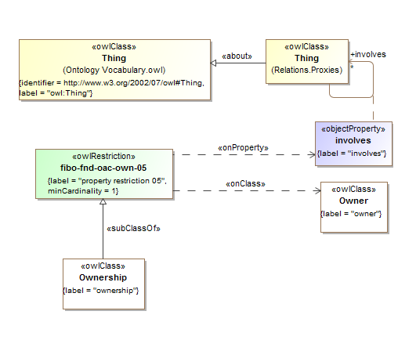

**Figure 10.50 Ownership Definition**

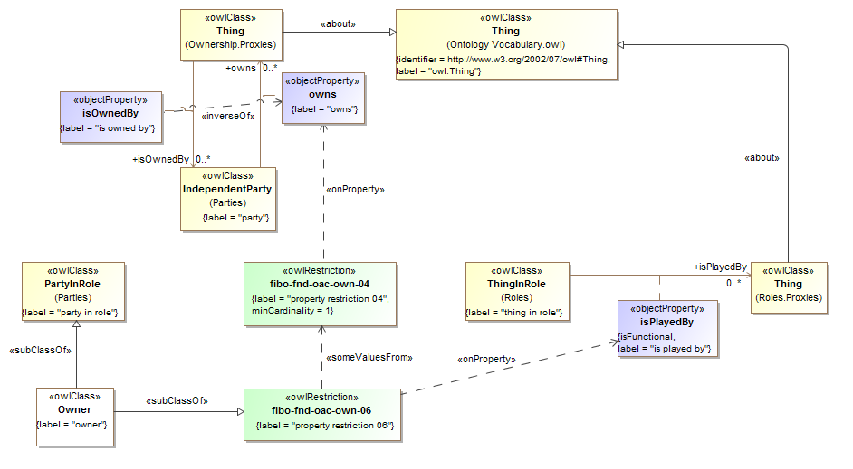

**Figure 10.51 Owner Definition**

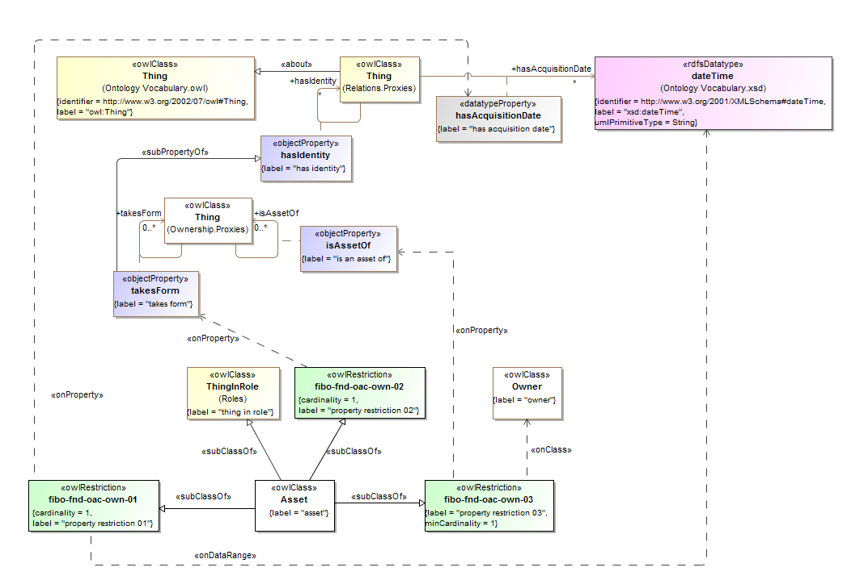

**Figure 10.52 Asset Definition**

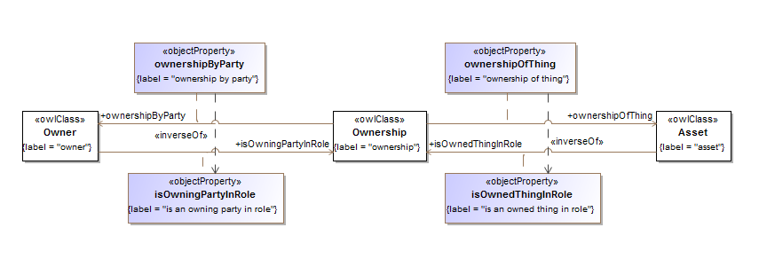

**Figure 10.53 Relative Ownership Relations**

Table 10-58 Ownership Ontology Metadata

| **Metadata Term** | **Value** |
| --- | --- |
| **sm:filename** | Ownership Ontology |
| **sm:fileAbbreviation** | fibo-fnd-oac-own |
| **OntologyIRI** | http://www.omg.org/spec/EDMC-FIBO/FND/OwnershipAndControl/Ownership/ |
| **owl:versionIRI** | http://www.omg.org/spec/EDMC-FIBO/FND/20140801/OwnershipAndControl/Ownership/ |
| sm:dependsOn | http://www.omg.org/spec/EDMC-FIBO/FND/Utilities/AnnotationVocabulary/  http://www.omg.org/spec/EDMC-FIBO/FND/Utilities/BusinessFacingTypes/  http://www.omg.org/spec/EDMC-FIBO/FND/Relations/Relations/  http://www.omg.org/spec/EDMC-FIBO/FND/AgentsAndPeople/Agents/  http://www.omg.org/spec/EDMC-FIBO/FND/Places/Locations/  http://www.omg.org/spec/EDMC-FIBO/FND/Places/Countries/  http://www.omg.org/spec/EDMC-FIBO/FND/Places/Addresses/  http://www.omg.org/spec/EDMC-FIBO/FND/GoalsAndObjectives/Goals/  http://www.omg.org/spec/EDMC-FIBO/FND/Organizations/Organizations/  http://www.omg.org/spec/EDMC-FIBO/FND/Organizations/FormalOrganizations/  http://www.omg.org/spec/EDMC-FIBO/FND/AgentsAndPeople/People/  http://www.omg.org/spec/EDMC-FIBO/FND/Parties/Roles/  http://www.omg.org/spec/EDMC-FIBO/FND/Parties/Parties/ |

Table 10-59. Ownership Details

| **Name** | **Type Of Thing** | **Property** | **Definition** | **Equivalent to** | **Parent** | **Mutually Exclusive With** | **Related Thing or type** | **Inverse Of Property** | **Concept Type** | **Editorial Note** | **Explanatory Note** | **Definition Source** |
| --- | --- | --- | --- | --- | --- | --- | --- | --- | --- | --- | --- | --- |
| takesForm | anything | takes form | identifies the form the entity takes |  | has identity |  | anything |  | Relationship Property |  |  |  |
| owns | anything | owns | to have (something) as one's own, possess |  |  |  | anything | is owned by | Relationship Property |  |  |  |
| isOwnedBy | anything | is owned by | a relationship between some thing and the party that owns it |  |  |  | anything | Owns | Relationship Property |  |  |  |
| isAssetOf | anything | is an asset of | identifies the party that owns the asset |  |  |  | anything |  | Relationship Property |  |  |  |
| Ownership | ownership |  | Ownership is the context in which some Party is said to own some Independent Thing. The Party is defined as such due to its being the owning party to that Thing. |  | property restriction 05 |  |  |  | Class |  |  |  |
| fibo-fnd-oac-own-05 | property restriction 05 |  | Set of things that must have property "involves" at least 1 taken from "owner" |  |  |  |  |  | Property Restriction |  |  |  |
| Owner | owner |  | A party in the ownership role; one that owns something. The thing owned is an Asset to that Party. |  | party in role property restriction 06 |  |  |  | Class |  |  |  |
| fibo-fnd-oac-own-06 | property restriction 06 |  | Set of things with property "has role" some "property restriction 04" |  |  |  |  |  | Property Restriction |  |  |  |
| fibo-fnd-oac-own-04 | property restriction 04 |  | Set of things that must have property "owns" at least 1 |  |  |  |  |  | Property Restriction |  |  |  |
| Asset | asset |  | A thing held by some party and having some value. |  | property restriction 02 property restriction 03 property restriction 01 |  |  |  | Class |  |  |  |
| fibo-fnd-oac-own-03 | property restriction 03 |  | Set of things that must have property "is asset of" at least 1 taken from "owner" |  |  |  |  |  | Property Restriction |  |  |  |
| fibo-fnd-oac-own-02 | property restriction 02 |  | Set of things that must have property "takes form" exactly 1 |  |  |  |  |  | Property Restriction |  |  |  |
| fibo-fnd-oac-own-01 | property restriction 01 |  | Set of things that must have property "has acquisition date" exactly 1 taken from "dateTime" |  |  |  |  |  | Property Restriction |  |  |  |
| isOwnedThingInRole | asset | is an owned thing in role |  |  |  |  | ownership | ownership of thing | Relationship Property |  |  |  |
| isOwningPartyInRole | owner | is an owning party in role |  |  |  |  | ownership | ownership by party | Relationship Property |  |  |  |
| ownershipByParty | ownership | ownership by party |  |  |  |  | owner | is an owning party in role | Relationship Property |  |  |  |
| ownershipOfThing | ownership | ownership of thing |  |  |  |  | asset | is an owned thing in role | Relationship Property |  |  |  |

## 10.12 Module: Accounting

Table 10-60. Accounting Module Metadata

| **Metadata Term** | **Value** |
| --- | --- |
| **sm:moduleName** | Accounting |
| **sm:moduleAbbreviation** | FIBO-FND-ACC |
| **sm:moduleVersion** | 1.0 |
| **sm:moduleAbstract** | This module contains ontologies of general accounting concepts including debt, equity, interest and so on, as well as currency amounts. |

### 10.12.1 Ontology: Accounting Equity

This ontology defines equity-related concepts for use in defining other FIBO ontology elements. These are based on basic accounting principles as they relate to equity, debt, assets and liabilities of a firm. Equity forms the basis for ownership of certain forms of corporate body.

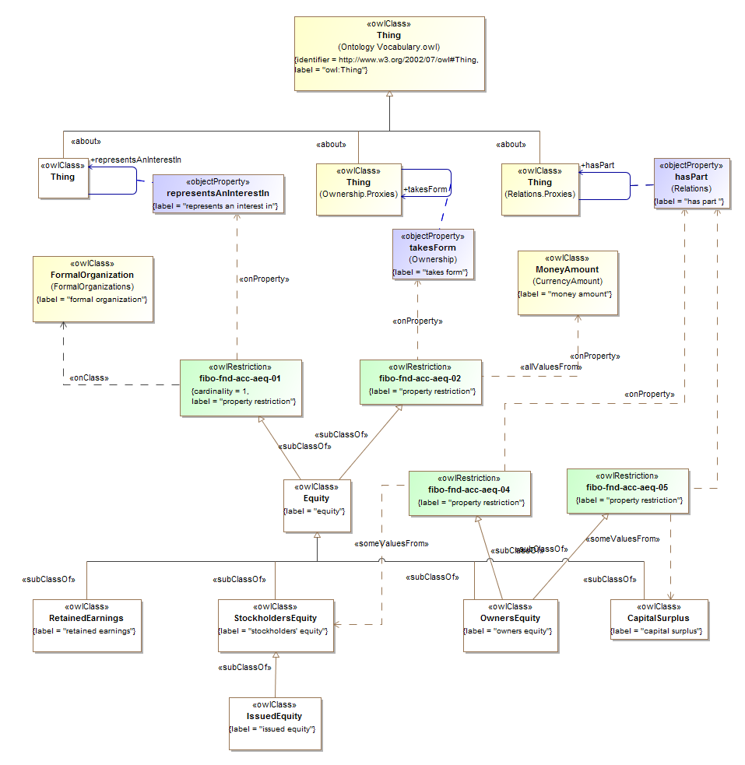

**Figure 10.54 Equity Concepts**

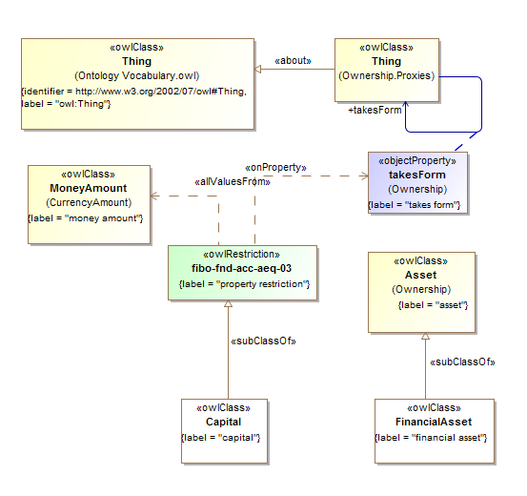

**Figure 10.55 Capital and Asset**

Table 10-61. Accounting Equity Ontology Metadata

| **Metadata Term** | **Value** |
| --- | --- |
| **sm:filename** | Accounting Equity Ontology |
| **sm:fileAbbreviation** | fibo-fnd-acc-aeq |
| **OntologyIRI** | http://www.omg.org/spec/EDMC-FIBO/FND/Accounting/AccountingEquity/ |
| **owl:versionIRI** | http://www.omg.org/spec/EDMC-FIBO/FND/20140801/Accounting/AccountingEquity/ |
| sm:dependsOn | http://www.omg.org/spec/EDMC-FIBO/FND/Utilities/AnnotationVocabulary/  http://www.omg.org/spec/EDMC-FIBO/FND/Utilities/BusinessFacingTypes/  http://www.omg.org/spec/EDMC-FIBO/FND/Relations/Relations/  http://www.omg.org/spec/EDMC-FIBO/FND/AgentsAndPeople/Agents/  http://www.omg.org/spec/EDMC-FIBO/FND/Places/Locations/  http://www.omg.org/spec/EDMC-FIBO/FND/Places/Countries/  http://www.omg.org/spec/EDMC-FIBO/FND/Places/Addresses/  http://www.omg.org/spec/EDMC-FIBO/FND/GoalsAndObjectives/Goals/  http://www.omg.org/spec/EDMC-FIBO/FND/Organizations/Organizations/  http://www.omg.org/spec/EDMC-FIBO/FND/Organizations/FormalOrganizations/  http://www.omg.org/spec/EDMC-FIBO/FND/AgentsAndPeople/People/  http://www.omg.org/spec/EDMC-FIBO/FND/Parties/Roles/  http://www.omg.org/spec/EDMC-FIBO/FND/Parties/Parties/  http://www.omg.org/spec/EDMC-FIBO/FND/OwnershipAndControl/Ownership/  http://www.omg.org/spec/EDMC-FIBO/FND/Accounting/CurrencyAmount/ |

Table 10-62. Accounting Equity Details

| **Name** | **Type Of Thing** | **Property** | **Definition** | **Equivalent to** | **Parent** | **Mutually Exclusive With** | **Related Thing or Type** | **Inverse Of Property** | **Concept Type** | **Editorial Note** | **Explanatory Note** | **Definition Source** |
| --- | --- | --- | --- | --- | --- | --- | --- | --- | --- | --- | --- | --- |
| representsAnInterestIn | anything | represents an interest in | Equity always represents an interest in some business organization. This is the organization, company or venture in which the holder of the equity has a stake in by virtue of holding that equity |  |  |  | anything |  | Relationship Property |  |  |  |
| StockholdersEquity | stockholders’ equity |  | equity held in an entity by stockholders |  | equity |  |  |  | Class | When total assets are greater than total liabilities, stockholders have a positive equity (positive book value). Conversely, when total liabilities are greater than total assets, stockholders have a negative stockholders equity (negative book value, also sometimes called stockholders deficit. paid in capital, donated capital, and retained earnings less the liabilities of a corporation (Barron's) |  |  |
| RetainedEarnings | retained earnings |  | the portion of net income which is retained by the corporation rather than distributed to its owners as dividends. |  | equity |  |  |  | Class |  | If the corporation takes a loss, then that loss is retained and called variously retained losses, accumulated losses or accumulated deficit. Retained earnings and losses are cumulative from year to year with losses offsetting earnings. | http://en.wikipedia.org/wiki/Retained_earnings |
| OwnersEquity | owners equity |  | Equity owned in the entity as recorded on the books of that entity. |  | property restriction 05 property restriction 04 equity |  |  |  | Class |  |  |  |
| fibo-fnd-acc-aeq-05 | property restriction 05 |  | Set of things with property "has part" some "capital surplus" |  |  |  |  |  | Property Restriction |  |  |  |
| fibo-fnd-acc-aeq-04 | property restriction 04 |  | Set of things with property "has part" some "stockholders equity" |  |  |  |  |  | Property Restriction |  |  |  |
| IssuedEquity | issued equity |  | externally-held stockholders equity that may be transferred from one party to another |  | stockholders equity |  |  |  | Class |  |  |  |
| FinancialAsset | financial asset |  | An asset consisting of one or more financial instruments, treated as an asset |  | asset |  |  |  | Class |  |  |  |
| Equity | equity |  | the value of an ownership interest in property, including shareholders equity in a business |  | property restriction 01 property restriction 02 |  |  |  | Class |  |  | http://en.wikipedia.org/wiki/Equity |
| fibo-fnd-acc-aeq-02 | property restriction 02 |  | Set of things with property "takes form" only "money amount" |  |  |  |  |  | Property Restriction |  |  |  |
| fibo-fnd-acc-aeq-01 | property restriction 01 |  | Set of things that must have property "represents an interest in" exactly 1 taken from "formal organization" |  |  |  |  |  | Property Restriction |  |  |  |
| CapitalSurplus | capital surplus |  | Capital surplus is that amount which a firm raises in excess of the par value (nominal value) of the shares (common stock). |  | equity |  |  |  | Class |  | Capital surplus is a term that frequently appears as a balance sheet item as a component of shareholders equity. | http://en.wikipedia.org/wiki/Additional_paid_in_capital |
| Capital | capital |  | financial capital, which represents obligations, and is liquidated as money for trade, and owned by legal entities |  | property restriction 03 |  |  |  | Class |  | Financial capital is in the form of capital assets, traded in financial markets. Its market value is not based on the historical accumulation of money invested but on the perception by the market of its expected revenues and of the risk entailed. | http://en.wikipedia.org/wiki/Capital_(economics) |
| fibo-fnd-acc-aeq-03 | property restriction 03 |  | Set of things with property "takes form" only "money amount" |  |  |  |  |  | Property Restriction |  |  |  |

### 10.12.2 Ontology: Currency Amount

This ontology defines monetary amount related concepts for use in defining other FIBO ontology elements. There are two distinct kinds of concepts that correspond to money and amounts: a concrete, actual amount of money, and the monetary measure of something denominated in some currency. These are dimensionally the same but whereas "money amount" is defined as an amount of money, "monetary amount" is an abstract monetary measure. This ontology also defines related terms such as currency.

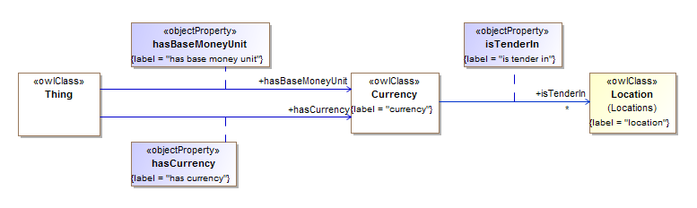

**Figure 10.56 Currency Concepts**

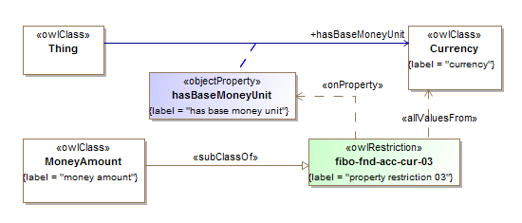

**Figure 10.57 Physical Money Amount Concepts**

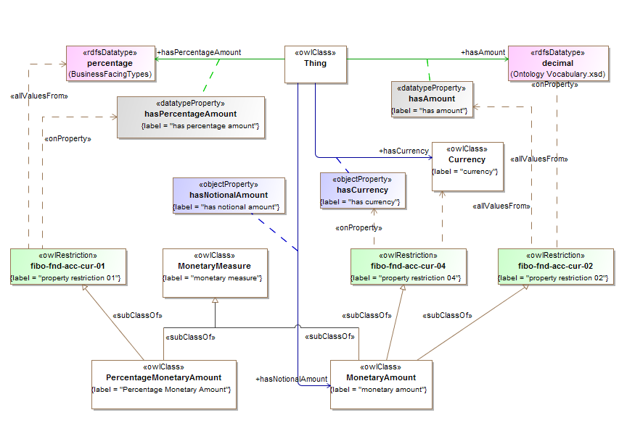

**Figure 10.58 Monetary Amounts and Measures**

Table 10-63. Currency Amount Ontology Metadata

|  |  |
| --- | --- |
| **Metadata Term** | **Value** |
| **sm:filename** | Currency Amount Ontology |
| **sm:fileAbbreviation** | fibo-fnd-acc-cur |
| **OntologyIRI** | http://www.omg.org/spec/EDMC-FIBO/FND/Accounting/CurrencyAmount/ |
| **owl:versionIRI** | http://www.omg.org/spec/EDMC-FIBO/FND/20140801/Accounting/CurrencyAmount/ |
| sm:dependsOn | http://www.omg.org/spec/EDMC-FIBO/FND/Utilities/AnnotationVocabulary/  http://www.omg.org/spec/EDMC-FIBO/FND/Utilities/BusinessFacingTypes/  http://www.omg.org/spec/EDMC-FIBO/FND/Relations/Relations/  http://www.omg.org/spec/EDMC-FIBO/FND/Places/Locations/  http://www.omg.org/spec/EDMC-FIBO/FND/Places/Countries/ |

Table 10-64. Currency and Amount Details

| **Name** | **Type Of Thing** | **Property** | **Definition** | **Equivalent to** | **Parent** | **Mutually Exclusive With** | **Related Thing or Type** | **Inverse Of Property** | **Concept Type** | **Editorial Note** | **Explanatory Note** | **Definition Source** |
| --- | --- | --- | --- | --- | --- | --- | --- | --- | --- | --- | --- | --- |
| hasPercentageAmount | anything | has percentage amount | a number or quantity represented as a percentage |  |  |  | percentage |  | Simple Property |  |  |  |
| hasNotionalAmount | anything | has notional amount | has a notional value expressed as some monetary amount, that is a number and a currency in which that number is denominated |  | has |  | monetary amount |  | Relationship Property |  |  |  |
| hasCurrency | anything | has currency | the currency in which the monetary amount is defined |  | has |  | currency |  | Relationship Property |  |  |  |
| hasBaseMoneyUnit | anything | has base money unit | the currency in which the money amount is denominated |  | has |  | currency |  | Relationship Property |  |  |  |
| hasAmount | anything | has amount | a total number or quantity |  |  |  | xsd:decimal |  | Simple Property |  |  |  |
| PercentageMonetaryAmount | Percentage Monetary Amount |  | A measure of some amount of money expressed as a percentage of some other amount, some notional amount or some concrete Money Amount. |  | property restricton 01 monetary measure |  |  |  | Class | This will have a relationship to what it is a percentage of. Alternatively and for some applications of this term, there may be an enumerated list of possible things it is a percentage of. |  |  |
| fibo-fnd-acc-cur-01 | property restricton 01 |  | Set of things with property "has percentage amount" only "percentage" |  |  |  |  |  | Property Restriction |  |  |  |
| MoneyAmount | money amount |  | A sum of money. |  | property restricton 04 |  |  |  | Class | This is an actual sum of money, not the measure of a sum of money in monetary units, although it has the same basic properties (decimal number with a currenct unit). Update 14 June 2011: Renamed from "Monetary Amount" to "Money Amount" to make this perhaps clearer. This term here should not be the Referenceable Archetype used to denote monetary amounts as a measure. ACTION: Across the model, all references to "Money Amount" (which was called 'Monetary Amount' when these were entered), so be the abstract quantity "Monetary Amount". |  |  |
| fibo-fnd-acc-cur-04 | property restricton 04 |  | Set of things with property "has currency" only "currency" |  |  |  |  |  | Property Restriction |  |  |  |
| MonetaryMeasure | monetary measure |  | Some measure of some sum of money. |  |  |  |  |  | Class | This may be a measure expressed in terms of decimal plus currency, or it may be a measure expressed in terms of a percentage amount with reference to some other monetary amount or to some Money Amount (actual amount of money). |  |  |
| MonetaryAmount | monetary amount |  | the measure which is an amount of money specified in monetary units |  | monetary measure property restricton 02 property restricton 03 |  |  |  | Class | This is an abstract concept, not to be confused with a sum of money (Money Amount). |  |  |
| fibo-fnd-acc-cur-02 | property restricton 02 |  | Set of things with property "has amount" only "decimal" |  |  |  |  |  | Property Restriction |  |  |  |
| fibo-fnd-acc-cur-03 | property restricton 03 |  | Set of things with property "has currency" only "currency" |  |  |  |  |  | Property Restriction |  |  |  |
| Currency | currency |  | medium of exchange value, defined by reference to the geographical location of the authorities responsible for it |  |  |  |  |  | Class |  |  | Codes for the representation of currencies and funds, ISO 4217, Sixth edition, 2001-08-15, sub clause 3.1. |
| isTenderIn | currency | is tender in | A region or country in which the currency is exchangeable for goods and services. |  |  |  | location |  | Relationship Property |  | Commonly referred to also as legal tender, however this definition does not hold literally in some countries e.g. Scotland. |  |

# Annex A: Machine Readable Files Part of This Specification

# (normative)

The FIBO ontologies are delivered as (1) RDF/XML serialized OWL (normative and definitive), (2) UML XMI, serialized from UML with the ODM profiles for RDF and OWL applied (normative), (3) ODM XMI, serialized based on the ODM MOF metamodels for RDF and OWL (normative), and (4) Visual Ontology Modeler (VOM) model files, based on the VOM plug-in to MagicDraw (informative). If there are differences between the OWL files, ODM XMI, and UML XMI, the OWL files take precedence, followed by the UML XMI, and finally the ODM XMI.

Regardless of their form, each of the ontologies included in Foundations makes normative reference to the DCMI Dublin Core Metadata Terms[4], W3C Simple Knowledge Organization System (SKOS) Recommendation[5], and the OMG Architecture Board’s Specification Metadata Recommendation[6], which are not part of this specification.

The individual RDF/XML files are organized by module (directory), and within a given module, alphabetically by name, as shown in the URI structure for each individual OWL file. These files are UTF-8 conformant XML Schema files that are also OWL 2 compliant, and may be examined using any text editor, XML editor, or RDF or OWL editor. They have been verified for syntactic correctness via the W3C RDF Validator and University of Manchester OWL 2 Validator. They have also been checked for logical consistency using the Pellet OWL 2 reasoner from Clark & Parsia as well as the HermiT OWL 2 reasoner from Oxford University. It is anticipated that the OWL ontologies will be dereference-able, together with technical documentation (HTML) from the OMG site once the specification is adopted.

Note that the ontologies use features of the OWL 2 language and other ODM revisions that will not be available in the Ontology Definition Metamodel (ODM) until the ODM 1.1 specification is published. The ODM RTF has published a convenience document, available to OMG members, that incorporates specification changes required for FIBO that have already been resolved by the working group, and which we anticipate will be available later this year once the report and related specification is published.

# Annex B: Shared Semantics Treatments

(normative)

## B.1 Introduction

**Intended Audiences:** *Semantic Modelers; Technical architects*

The model content is grounded in terms which come from outside the realm of business entities of financial services. These are maintained in the Foundations ontology. Wherever possible, terms in this annex are cross referenced to terms set out by suitable standards bodies and academic bodies, so that the meanings of these terms are grounded in a broader community of semantics modeling.

Some of these external standards are in the form of formal ontologies, modeled typically but not necessarily in the Web Ontology Language (OWL) and in any case grounded in formal first order logic. In addition, some terms are derived from models which are not formally grounded in first order logic but which in some way or another are identified as meaningful concepts, either by explicit mark-up of the model content, by some separate theory of meaning, or by some statement at the level of the model identifying it as a semantic model. Such models are typically in the Unified Modeling Language (UML) or some other formalism such as that of the eXtensible Business Reporting Language (XBRL).

Some of the models are only referred to in part, for example because the scope of the standard, as identified by its business requirement, is very different to the scope of the concepts in the Foundations ontologies, or because the ontology contains formal axioms or facts which are at odds with Foundations.

This annex describes the range of treatments by which such external standards are cross referenced in the Foundations ontologies. A number of such treatments have been identified, depending on the nature of the standard or vocabulary referred to in FIBO Foundations, the language in which it is framed or the extent to which we are confident of making direct formal reference to it. For example, for some ontologies we wish to make direct, explicit reference, whereas for others we may have less visibility or confidence in the maintenance arrangements of that model's content and so have elected to create a local 'snapshot' of that ontology with its own namespace.

## B.2 Shared Semantics Treatments

Case 1: Complete, stable OWL Ontologies

**Treatment:** If an ODM representation does not already exist as part of the standard, create a surrogate of the ontology using ODM.

Because this is in ODM, it shall have the actual URIs of the external standard. The material in FIBO represents a direct use of that ontology with its original namespace.

Case 2: Ontology Snapshot

If the external ontology is in OWL but we want to make a snapshot of it at a point in time

**Treatment:**

* Create clone copy of the ontology in our repository
* Allocate a URI which identifies this as a clone (to include the elements of the original URI plus "/fiboclone/")
* Use OWL equivalentClass, to point from an element in the FIBO clone to the corresponding element in that ontology.

**When to use snapshot**

This is used when for any reason we don't want to reference changes to the external ontology.

Case 3: Partial Snapshot

This treatment is for when the external ontology has a broader or different business requirement and range of concepts, such that we may not wish to refer to or replicate them all.

**Treatment:** Create a clone of only those the parts of the ontology we wish to refer to.

Otherwise the treatment is the same as for Case 2, except that in place of the URI fragment “/fiboclone”, the fragment “/fibopartialclone” should be used.

# Annex C: Logical versus Conceptual Models comparison

(informative)

**Intended Audiences:** *Technology Management*

## C.1 Comparison Table

The principal differences between a logical data model and a semantic model are shown in Table C1.1.

**Table C1.1 Model Comparisons**

|  |  |
| --- | --- |
| **Logical Data Model** | **Semantic Model** |
| Represents elements in a database design | Should not include design information but is a model of business concepts |
| Represents data model design components (Classes in OO design; tables in relational database design) | Represents "Things" using set theory concepts |
| Combines common data structures for reuse and efficiency | No efficiency considerations because it is not a design; reiterates concepts as they apply |
| Single inheritance hierarchy | Multiple inheritance |
| May define a number of optional properties of a class, such that the application developer would know whether these apply or not | Defines what facts are applicable to a given type of thing. |
| Uses enumerations to quality classes | Enumerates classes ("Things") |
| Closed World Assumption (CWA) | Open World Assumption (OWA) |

These are explained further in the sub clauses which follow.

## C.2 Detailed Models Comparison

**Design Elements versus Business Concepts**

A logical data model represents the design of some data structure such as a database or a message design. This differs from a physical data model in that it is not specific to any one implementation or platform. That is, a logical data model is a kind of "Platform Independent Model" or PIM, as distinct from a "Platform Specific Model" or PSM.

While a logical data model is not specific to any one physical implementation, it does represent some design. That is, the logical data model, like any logical design, represents the results of some design effort by some designer.

A semantic model does not represent any design of any solution, but explicitly represents facts about the problem domain.

If a designer sets out to design something, there should normally be something that they are working from. In the design of software, designers work from formal business requirements statements, such as "Use Case" models or a requirements specification document. For data, the equivalent is a semantic model. That is to say, a designer of a data model should be expected to work from some source of knowledge of the items which are to be catered for in the database or messages for which they are carrying out the design.

**Components that are Represented (Classes, Tables or Things)**

In order to create a model which represents the logical design of some database or message scheme, the modeler will create a model which represents components of that design. For example, in a relational database they will create a model of database tables, along with relationships between those tables, public and private keys and so on. A logical representation of the design is therefore a representation of database constructs, namely tables, relationships, keys and so forth. The logical data model design is therefore couched in a notation which has formal representations of those elements. This may take the form of an Entity Relationship Model (ERM) or an object oriented model in the form of a Class Model in the UML design notation.

Depending on the model notation chosen by the developer therefore, the model may be an ERM model of data entities and relationships, or a UML class model of classes, associations, composition relationships and so on. These are the items to which elements of the model refer.

By contrast, a semantic model does not represent a logical design, and the things in the semantic model represent instead the real world entities in the business domain itself.

For example, a logical data model for securities may contain a representation of data tables for data about shares, bonds and so on, whereas a semantic model of the securities domain will contain representations of shares and bonds themselves, as kinds of "Thing".

The relationship between a semantic model element and the things it represents is made explicit in the Semantic Web "Web Ontology Language" or OWL notation. In an OWL model, every kind of "Thing" in the model (also known as "Classes") is a set theory construct which defines membership of the set in terms of the properties of its members. All classes in an OWL ontology model are sub-classes of a class known as the "Universal" set, commonly labeled as "Thing". This is the set of which everything is a member. In this way it is made explicit that everything in the model is some thing.

**Reuse**

It is sensible when carrying out data model design, to identify similar sets of terms and combine these into reusable sets. A semantic model may end up combining common concepts if the concept can be described as a more general, more abstract variant of the kind of thing. However, this is not a requirement for model design - things may be combined according to similarity in the data structures without reference to their meaning.

This is really another aspect of the basic fact that, since a semantic model is not a design, it has no design constraints (note this may not the case for an individual semantic technology application, where constraints are rightly applied but are very different to those for relational database or message design).

**Single versus Multiple Inheritance**

A limitation of some (though not all) relational design environments and notations is that the classes would be arranged in a hierarchy of classes. These would be in a single inheritance "tree" i.e. each class has only one parent class of which it is a specialization (ignoring polymorphism for now).

Semantic models more closely reflect the real world dispensation of taxonomies of kinds of thing, namely that a set of classes may defined according to more than one property. For example, a whale is both a marine animal and a mammal according to two different kinds of classification hierarchy, and an individual whale, being a member of the class of things which are a whale, is classified as both kinds of thing.

This is particularly valuable in modeling of kinds of security for different applications. For example risk management and securities trading performance analysis have different requirements, based on asset types, cash flow behaviors and so on. One application would need to classify things according to one set of requirements. Regulators have different requirements to traders, and even different regulators or different areas of regulatory analysis and systemic risk analysis may dictate different ways in which the universe of instruments may be "sliced" for analysis.

**Optionality**

In standards, particularly message standards, it is good practice to have a number of properties that may or may not apply to a given category of data element (for example, for a data element for a debt security), and make all of these optional. This is practical: for any debt instrument, not all the properties necessarily apply, but someone wanting to send a message from one point to another will be able to populate the message with those properties that exist for that security.

This, by definition, does not represent the knowledge that business practitioners may have about what facts necessarily must apply for a given instrument of a given type. In order to provide a message which is complete and correct, the sending party needs to apply knowledge from outside the model, about what facts necessarily apply to a given instrument. This intelligence would typically need to be built into the application that builds the message which is sent according to that schema. The knowledge is not represented in the schema.

At base this is simply another way of saying that the logical design of the message is not a representation of the knowledge about the instrument. Needless to say, this is not a criticism of such a message, it is simply a statement of why the message schema is not a record of the knowledge about the instruments.

**Enumerations**

A valid and good design approach to different kinds of thing is to provide a single data element which is an enumeration, containing entries for each of a number of entries that distinguish these things.

In a semantic model, each thing in the enumeration is a separate class of "Thing". The presence of enumerations in a model indicates that this is a logical model.

Note that for simplicity is it sometimes the practice to provide an enumeration (of textual strings, or 'literals') in a semantic model. However this is usually a pointer to the need to develop the semantics of the model further.

**Open versus Closed World Assumption**

FIBO specifications are expressed in OWL, which uses the Open World Assumption.

* Open World Assumption: Absence of evidence is not evidence of absence
* Closed World Assumption: Absence of evidence is evidence of absence

What this means in practice is that facts can be asserted about a thing in a semantic model without consideration to whether these facts are represented by actual data. For example, a fact about any event is that it has a cause, however causes of events need not be known or represented.

On a more detailed level, a semantic model can describe and represent facts about things without those facts being represented as data. Very often the facts, which define the nature of a thing, may not correspond directly to data. For example, many financial instrument types are defined in terms of the legal rights and obligations that they represent to one or other party to the contract. These rights and obligations may correspond indirectly to data elements, but the legal facts themselves may be more abstract, i.e. a fact stated in terms of "has right to" or "commits to" may refer to the abstract concept of a right, while the data may contain details of those rights and obligations, which may be regarded as a sort of signature revealing the existence of those rights and obligations.

This would be true of anything which is defined and classified according to facts which are themselves abstract. This would include most legal concepts.

## C.3 Model Partitioning

The FIBO Foundations concepts are partitioned into several non-mutually exclusive categories, in the sense in which the term “partition” is used in the semantic modeling community. These are:

* Independent, Relative and Mediating things
* Concrete and Abstract things
* Continuant and Occurrent things.

Each partition is represented as a class of OWL Thing and as a sub-type of the OWL Thing class, without additional archetype indications.

Terms defined in the model in this specification, and any terms defined in future additions to this specification or in local ontologies derived by extension of this specification, may not have a direct parent class of 'OWL Thing'. All classes of thing in the model described in this specification are given a parent which is either an archetype class of Thing or has an archetype as an ancestor, and all archetypes are given a parent from each of the three partitions listed above, with the exception of temporal terms which exist in a separate partition to the above.

Users of parts of this model may optionally ignore the above partitions in order to dispose model content under separate partitions of their own.

### C.3.1 Independent, Relative and Mediating Things

This set of partitions provides a division into the model according to categories which have been arrived at through a considerable body of philosophical literature, notably that of C. S. Peirce. This partitioning relies on the claim in that literature that all things which can be named and classified fall into one and only one of these categories. This principle is reflected in the model described in this specification.

An independent thing is something which is defined in its own right and without reference to any context. For example, a business entity is an independent thing.

A relative thing is something the definition and meaning of which is specific to some specific context. That which is defined in that context is itself identified as some independent thing, or in some cases some other kind of relative thing, which stands in the role or relationship defined as the relative thing. For example a party to a contract is a relative thing, being itself some independent thing, in this case some business entity.

A mediating thing is the context in which some thing is defined as being some relative thing. For example, the context of contractual relationships, or of the context in which some specific kind of contract is entered into, is the mediating thing in which the business entity is identified as being some contract party. The term 'Mediating Thing' is synonymous with 'context' in the broadest sense of that term.

Relative things always have a relationship of 'identity' with some thing which may stand in the role identified by the relative thing. This is usually but not always some independent thing. In some cases the identity relationship may refer to some other relative thing, for example a securities issuer may be a 'Special Purpose Vehicle' which itself is defined as a kind of relative entity, the identity of which may be a company incorporated by the issue of shares, a limited liability partnership or some other form of legal entity. For this reason, while relative things should normally have an identity relationship to some independent thing, the most general application of this relationship is to the universal class 'Thing'.

### C.3.2 Concrete and Abstract Things

This partition simply identifies whether something is a concrete item with weight and mass, or an abstract construct. Many of the concepts formally identified in the financial services industry are by their nature abstract.

Archetypes may only be identified as concrete or abstract if this is necessarily the case for all things of that archetype.

Note that things which have legal standing and which may be either provided on paper or in a dematerialized form are identified in this model as concrete. The intention of the Abstract partition is to define things which by their very nature are abstractions, such as goals.

One important class of abstract things is those things that are made up of information. According to the modeling principals, only things which are real may be represented in this model. This necessarily excludes things like database keys and locally defined identifiers. A common sense test needs to be applied to any kind of information before it is considered to be real and therefore able to be modeled here. Public information constructs such as security identifiers, business entity identifiers, credit ratings and the like pass this test because they are published by some party. In addition, documents and messages and the like which are passed between entities or parties in the course of carrying out some business process are equally real even though they are not published. The test for their reality is passed because information constructs such as documents have some real business, legal or financial import, that is some impact on something which is itself modeled as being part of the real world and not part of the technical design of some data or application.

### C.3.3 Continuant and Occurrent Things

This partition segregates things which by their nature have some existence of a period of time, with a beginning and an end to their existence, and things which by their nature occur at a point in time. The precise timescales on which a thing may be said to occur or to have an ongoing existence is itself dependent on the domain being modeled, in this case all concepts relating to business entities and more broadly to the carrying out of business activities in the human world. So for example a human being would be considered on an astronomical scale as an occurrent thing, the difference in granularity in the time scales being determined according to the context in which the ontology is to be used. More precisely, a human being could still be considered as a Continuant Thing, with a human life being the corresponding Occurrent Thing, so in many cases it is reasonable to try to frame definitions of things which are clearly either continuant or occurrent.

For the avoidance of doubt, the partitioning of continuant from occurrent things is not formally represented by any axioms, and is definitional only. This means that terms in this model may be cross referenced to terms in models which use different formal ways of distinguishing continuant from occurrent things, for example what are called four dimensional, three dimensional, and similar modeling arrangements. The partitioning given in the model described in this specification contains no such assertions and is provided to enable the problem domain to be partitioned according to the basic nature of what is defined. This enables the model to contain concepts to do with events, processes, states and the like, though these are not utilized in the business entities semantic model.

# Annex D: How to extend FIBO ontologies

(informative)

**Intended Audiences:** *The intended audience for this Annex is semantic modelers, who are expected to have some familiarity with the basic principles of semantic modeling but not necessarily with the principles specific to FIBO. Basic OWL principles are also reiterated here. This annex is not intended for purely business audiences or purely technical audiences.*

This Annex should be read in conjunction with the clause on Conformance (2).

## D.1 Terminology used in this Annex

There are several sets of terminology in use throughout this specification, and the meanings of some terms (such as 'thing') may be different in different specialized usages. Here the intended sense of these words, unless otherwise stated, is the sense used for business communication of the ontology content, and not the sense used in technical modeling or conventional Semantic Web terminology. If a formal definition of a term is not given or referred to via the "Definitions" clause of this specification (4), the normal, English language sense of a word should be assumed, and not that of any technical body of knowledge or community of practice.

The model described in this specification follows the principles of the Web Ontology Language (OWL). This defines the concept of a 'Class' as a set theory construct and is not to be confused with the usage of the word ‘Class’ in the UML modeling paradigm. In descriptions aimed as business audiences, we usually use the word ‘Thing’ in place of this, and on the basis that the OWL library class “Thing” is the ultimate parent of all classes in an OWL model (so they are all things). This also precludes having to explain to a business audience the very nuanced distinctions between UML and OWL Classes. The specialized technical usage of the word 'Thing' to refer to an OWL individual is not the sense used in this Annex.

In this Annex, the term 'class' and 'thing' will be used interchangeably to describe the OWL classes as set theory constructs, that is in the natural language (dictionary) sense in which one speaks of classes of thing (for example in the sentence "what class of locomotive is this?" or "what class of animal is a fish?"). This corresponds to the OWL usage of the term but not (or not without some qualification) to the UML usage of the term.

## D.2 Overview

### D.2.1 Classes of Thing

In OWL and therefore in FIBO models, membership of a class may be defined intensionally by way of properties which define the membership (the extension) of that class, or extensionally by way of listing the members of the set which makes up that class.

In the model described in this specification, all classes are defined intensionally except where extensional models are unavoidable. The modeling notation employed here supports the definition of extensional classes but this is discouraged except for the definition of classes which are necessarily extensional such as days of the week.

### D.2.2 Model relationship to Subject Matter

The formal statement by which everything in the model has an ultimate super-class which is the universal set of 'Thing' is the means by which this model is formally identified as being a business conceptual model and not a data model representation.

In order to preserve the integrity of the model as a model of business concepts, all classes which are added to the model must:

1. Be given a superclass (a class with which the new class has a sub-class relationship) from one of the existing classes in the model;
2. Represent something in the business domain itself, and
3. Represent a set of possible members which in all cases would also be members of the set defined by the superclass in (1)

### D.2.3 How to Model New Classes

In modeling semantics, it is a requirement to model each new kind of "Thing" (hereafter referred to as 'classes') in the model according to the following two criteria:

* What kind of thing is this?
* What facts distinguish it from other things?

The consequence of addressing these questions is that for each kind (or class) of thing in the domain of discourse (in this case business entities and legal entities), this will be defined in terms of the following question:

"What is the simplest kind of thing that this is one of?"

By defining classes in terms of simpler kinds of thing, future changes will be additive. This benefit only applies if each class in the model is adequately generalized into some more abstract concept.

Failure to adequately generalize classes of "Thing" in the taxonomic hierarchy will have the result that future additions to that part of the taxonomy may prove to be disruptive. When the model is extended in the future to cover additional concepts, if the model components are not adequately abstracted then it will become necessary to break the existing chain of generalization to interpose new terms to support these new concepts. It is therefore important that modelers exercise imagination in this regard.

### D.2.4 Declaring Class Disjointness

A disjointness relationship indicates that two classes of thing are mutually exclusive, that is that members of one may not also be members of the other.

Class disjointness refers to the situation whereby the members of one class may not also be members of another class when there is a disjoint relationship between the two. In OWL this relationship uses the 'isDisjoint' construct.

New 'isDisjoint' relationships should be labeled with the natural language label of "mutually exclusive"

Classes may have several separate sets of sub-classes which are mutually disjoint.

Note that disjointness is inherited through sub-class relationships. If a disjoint is misapplied this may cause inconsistencies. Conversely, if there is an inconsistency and disjointness has been correctly applied, then somewhere in the model there is an incorrect statement which would assert that some individual may be a member of more than one mutually disjoint class. The application of disjoint relationships therefore provides a useful diagnostic for subsequent extensions to the model, provided it is implemented correctly.

### D.2.5 How to Model New Facts about Things

There are two kinds of "fact" in the model (in formal modeling terms, two kinds of "Property"):

1. Relationship Properties (known in OWL as Object Properties);
2. Simple Properties (known in OWL as Datatype Properties)

These are similar in their intent, in that they assert something about the class of which they are a property, but are shown differently in model diagrams.

Facts (properties) should be presented in the model only at the level of the class to which they apply. If a fact is not always applicable or relevant to the meaning of some concept, it should be applied to one or more sub-types of that class where it would be applicable. Similarly a property should not be applied to sub-classes where they would not always be true.

As an example, vertebrates are a class of things which are an animal and which have a backbone. It would not be appropriate to model the term "has backbone" as an optional property of all animals. Nor would it be sensible to say, for each class of things which is a vertebrate, that this class of vertebrates also has a backbone.

Note that there is a difference here from data modeling. In a data model it may be more efficient to assign a property to a class, make it optional, and then have some sub-classes which use that property and some which do not. This is appropriate for a data model because such a model is not intended to convey the meanings of those classes; rather, the user of the model has to know which sub-classes would have data for that property and which of them would not. In contrast, the semantic model in FIBO is intended to convey the knowledge that such a user would need to have. For this reason, considerations of efficiency which would be brought to bear on a data model design exercise, should not be considered when extending FIBO models.

#### Impact on Sub-classes

When adding a new Relationship Property or Simple Property to an existing class, ensure that this fact would be true of all the classes that are sub-classes of this class, and that are sub-classes of their classes and so on. If the meaning asserted by the addition of the new property is not necessarily true of all the descendent classes of thing, then it would not be correct to add it to this class. Instead it should be added to those of the sub-classes to which it does apply (that is, those to which it contributes something of the meaning of what it is to be a member of that class).

If there is a clearly identifiable group of those sub-classes for which the property is applicable, then it is possible that these could be grouped together as a new sub-class with that property. However, the addition of such a class, being as it would be interposed into an existing class hierarchy, should be handled with care - this constitutes a disruptive rather than an additive change, and will have different and more stringent change management requirements.

#### Adding a Relationship Property

Wherever possible, a Relationship Property should be a specialization of another Relationship Property which is already in the model. When adding the Relationship Property, the RDF construct "subPropertyOf" should be used to assert what is the parent property.

The new property should extend or refine the meaning of the parent property in some way.

It is also allowable to have more than one parent property. This is appropriate in cases where the meaning of one Relationship Property is recognizably derivable from the meanings of two or more other Relationship Properties. This construction should be used sparingly and with care.

#### Types of Relationship Property

In terms of the OWL language, there are a number of distinctions between kinds of relationship which may be asserted in this model. For example, it is possible to assert that a relationship is symmetric, or that it is 'functional'. Functional relationships are relationships where only one individual of the type that's shown as the range of the property, may be that thing.

In the UML modeling environment, the information about what kind of relationship a given relationship is, is provided by means of tagged values.

At present the terms distinguishing different types of relationship are not widely used in the model. If in doubt, relationships should be added without attempting to populate this information.

When adding a new relationship and making it a sub-property of some existing relationship, modelers should check the parent relationship and any of its parents, to verify whether these are defined as being one of these specialized types of OWL object property. If they are, then the new relationship will also take on this type, so modelers must ensure that this would be correct for the relationship being added.

#### Adding a Simple Property

Simple Properties may only have a range (the object of the predicate) which is a simple information type or an enumerated data range.

The simple information types may be found in the model sub clause "Business Types". These include concepts such as text, numbers, dates and yes/no answers.

Simple Properties should not have ranges which are technical datatypes (the XML primitive datatype set or the datatypes made available within a UML modeling framework). XML primitive datatypes are allowable in RDF/XML based OWL ontologies, and would be used in an operational ontology derived from these models, but for the purposes of business understanding of the model these are all either given aliases (like 'yes/no' for boolean), or have more detailed types derived from them such as the various kinds of number.

There are no "Complex Types" in FIBO. For presentation purposes in different UML editing environments it is possible to consider rendering certain Relationship Properties (OWL object properties) as if they were simple types, i.e. using the UML "attribute" construct, but this is not formally supported in the sub-set of ODM defined in this specification. If this technique is used, such properties must be formally identified as OWL object properties; datatypes properties may not refer to classes which themselves have properties, such as monetary amounts or dated values.

### D.2.6 Inverse Relationships

Whenever two relationships are in an inverse pair, this must be indicated by adding a relationship between those relationships, using the OWL construct 'inverseOf'. This should be labeled with the natural language label of 'inverse'.

Many Relationship Properties about things in the real world come in pairs, where one is the inverse of the other. For example "Account held by Account Holder" and "Account Holder holds Account" are two ways of saying the same thing, from the two perspectives of the Account and the Account Holder.

All relationships in the semantic notation used here and in the Semantic Web are unidirectional, that is they are 'triples' of the form Sub verb Object.

This is different to the way relationships are treated in data modeling. The 'ends' of a relationship in a data modeling format may be considered as being analogous to the separate relationships in a semantic model.

**When to add these:** Where it is considered relevant in defining the meanings of concepts, Relationship Properties (other than symmetric ones - see 'Types of Relationship Property') may also be given an inverse. It is not a formal requirement to indicate all the inverses that may possibly exist. Such relationships should be present in the model and extensions to the model if the two senses are in common use, if they correspond to a named term for which there is a formal definition in use in the financial industry, or if Relationship Properties that are commonly defined for sub-types of the class that they are a fact about, are commonly specified or referred to in the opposite direction to the one which has already been specified.

For this reason, the addition of new classes of thing in the model, given that these specialize existing things, may sometimes require the addition of the inverse of some existing Relationship Property, which was previously implied but not present as a property in the model.

### D.2.7 How and When to Use Enumerations

There are two kinds of enumeration in the modeling notation:

* Enumerated Data Range
* Enumerated Class

Enumerated data ranges look a lot like enumerated datatypes in data models. However, these are used differently and will not usually correspond.

The 'Enumerated Data Range' construct should be used to enumerate possible data literals, that is pieces of text, numbers and so on, any one and only one of which may be the literal value of that datatype property for one instance of that class.

Where a data model enumerations may enumerate types of real thing and are frequently used to "flag" some class to say what kind of thing this is, this arrangement cannot be used in the FIBO semantic model. If a class of thing may be of several types, then these should be modeled as distinct classes, each of them a sub-class of the class of thing that they are all types of.

Where a class is to be defined by enumerating its members (extensional definition of the class), then the class itself should be modeled not as an OWL Class but as an OWL Enumeration Class.

### D.2.8 Foundations Concepts Usage

Because it was a requirement that classes of thing be abstracted to their simplest possible types, the modeling already carried out in FIBO necessarily required the creation of a set of classes which, by their nature, are not unique to business entities or financial services terms and definitions.

There is a second scenario in which terms are required which are not unique to financial services. This is when a relationships fact (OWL object property) about some business entity has a relationship to something which is not itself a concept unique to the context of the financial services sector.

The terms which are not unique to the financial services sector are maintained in a separate part of the model repository and are given a separate namespace. These are packaged as the FIBO Foundations ontologies. Use of the appropriate terms in these ontologies is normative for this specification, but in many cases these ontologies are being evolved, improved upon and better aligned with other publicly available standard ontologies and with relevant academic work.

In Semantic Web terms, these are mid level ontologies. These are additionally supplemented by the inclusion of an "Upper Ontology" consisting of three sets of underspecified, high level partitions into which all model content is divided.

When adding new classes or Relationship Properties, modelers should seek out and select concepts from within the Foundations ontologies which represent the terms they need to specialize or refer to. They should also recognize and adequately respect the 'Archetype' of that term, if available. In particular, the ontology partitions under which the required archetype term resides should be inspected and understood, in order not to give rise to inconsistencies in the resultant ontology.

New general terms should not be added without first seeking the appropriate terms in these Foundations ontologies or in some recognized external ontology, which must itself be cross referenced using one of the methods described in Annex C (Shared Semantics Treatments), in order to create the necessary relationships.

### D.2.9 Content Creation Summary

In summary, there are two scenarios where classes of thing are needed in any ontology for business entities, for financial securities, loans, derivatives and so on:

* The kind of "Thing" which something is;
* Things which are referred to in facts about things.

The first question will lead the modeler to find a more general class of thing of which to make the new class a sub-class. This should be sought initially in the ontology which is being extended, and after exhausting this, in the appropriate Foundations ontology, which must be inspected and fully understood before implementing the new sub-class ('is a') relationship.

The second question will lead the modeler to seek out the appropriate class of thing to which they need to refer. Often, but not necessarily, this will require the creation of some new class of thing. For example, a new class of 'Interest Payment Terms' might be appropriate in order to define a property of a new class of interest-bearing instrument which is defined by way of unique interest payment terms.

Modelers should look in the first instance for some class of thing which is exactly appropriate to the new relationship. For example, concepts like "Monetary Amount" or "Dated Monetary Amount" may be appropriate targets ("Ranges" in Semantic Web parlance) for more than one Relationship Property about more than one class of thing.

In the absence of such a class, modelers should add a suitable sub-class of some existing class of thing which is broader in meaning but otherwise identical to the class to which the new Relationship Property is to refer. In the interest payment terms example above, they would add a new sub-type of the class which is 'Interest Payment Terms Set' or perhaps 'Fixed Interest Payment Terms Set' or 'Bond Fixed Interest Payment Terms Set' as appropriate. This should be labeled with a suitably business-facing label which uniquely describes it within that ontology and which as far as possible reflects what is unique about its meaning (note that meanings do not follow from these labels, but that business comprehension of the model follows from their allocation).

Where a term is not available for specialization within the ontology which the modeler is extending, these are to be found in the FIBO Foundations ontologies, which have been created for the purpose of providing such terms. These are ontologies of things which are not specific to financial services. These include legal concepts like contracts, business concepts such as service provision, as well as an extensive set of concepts for times, dates, mathematical constructs, events and activities, and so on.

If a suitable general term cannot be found then it may be necessary to extend one of the FIBO Foundations ontologies. This should be undertaken as a collaborative effort since this term will almost certainly be needed again in the future and by others. Such terms should be defined with formal reference to other, publicly available ontologies (these being defined either in Semantic Web formats or in some presentation, notation of theoretical grounding which makes it unambiguously clear that the terms in question are not part of a data model or other logical design).

## D.3 Presentation Considerations

The presentation conformance requirements described in this specification are mainly a consideration for those creating or setting up editing environments in different modeling tools, and are not covered in this Annex. However, in the course of creating extensions to the model content there are a number of considerations which the modeler should keep in mind, as described in this sub clause.

### D.3.1 Labeling

All classes, Relationship Properties and Simple Properties should be given natural language labels. These should be rendered with spaces just as normal text is written.

These labels should conform to the following style requirements:

* Classes: Names should be in Upper Sentence Case
  + Abbreviations (if used) should be in their normal upper case rendition e.g. ABC.
  + Small words (of, and etc.) should also be capitalized (this is to enable technical users to compress the names without loss of sense)
* Relationship Properties: Names should take the form Subject predicate Object with the casing as shown
  + Subject and Object to have the full name of the classes themselves except where this is cumbersome
  + The predicate (verb part) of the relationship name should be in all lower case, with spaces
    - If possible, relationship lines (which are displayed in 'simple' diagrams that don't have the boxes that come with the Relationship Properties), should be labeled with only the predicate.
* Simple Properties: Names should be in Upper Sentence Case
* Other types of "Thing" construct (OWL Union Classes, Intersection Classes, Enumerated Classes and Enumerated Data Ranges) should follow the same naming convention as classes.

In addition to the above constructs, which define the terms in the business domain, there are a number of built in constructs which make additional statements, in set theory terms, about the classes and properties. These should be labeled as follows:

* Logical Union relationships: these are rendered using the UML construct of a generalization set (UML "GeneralizationSet"). Such sets have one name. This name should be a natural language label, with spaces and in lower case. The label should make clear the sense that it is a union relationship defining the logical union of the classes which participate in the generalization set, for example by ending the label with the word 'union'.
* Disjoints (OWL disjointWith): should always have the label "mutually exclusive"
* Inverses of relationships (OWL inverseOf): should always have the label "inverse"

### D.3.2 Ontologies

These are implemented using the UML base class of 'Package'. Names for these should be in Upper Sentence Case. Wherever possible short or one word names should be considered.

### D.3.3 UML Considerations

#### UML Diagrams

Diagrams are not transferred from any modeling environment into or out of the model repository. Diagrams are to be created by the modeler for presentation to business domain experts in the area in which they are working, or in the case of new submissions of the model content for future updates, to the wider community, and must be designed to be readable by business domain experts.

#### UML Notation

No explicitly UML notation should be present on any diagram.

The guiding principle here is one of language: any diagram which includes anything which belongs in or looks as though it belongs in some technical notation, will signal to the business reviewer that this diagram is in a language for which they have had no formal training. No matter how obvious the meaning of a diagram appears to be, the appearance of any technical notation means that it will appear to be something that requires some technical training to parse its meaning.

This means that

* no repurposed punctuation marks may be present on the diagrams. For example:
  + no curly braces and therefore no OCL
  + no guillemets - so stereotype indications must be disabled
  + no plus signs at the ends of relationships or next to attribute names
* UML class partitions that are unused (such as the operations partition) must be made invisible - either by manually resizing the class box until the extra line disappears, or by some other means;
* Exceptions may be made for relationship multiplicities, but the implications of these must be clearly explained to business domain experts who are expected to review the model content
* The Generalization arrowhead is an exception to the above: although this represents a technical notation (Generalization in UML), its meaning is more universal and can be explained to business domain experts ahead of any review. Such explanations must either reference Aristotelian syllogisms or be described in terms of the "is a" relationship with examples from natural taxonomy, depending on the knowledge of the business audience, but should not make reference to UML or words like Generalization or transitivity.
* Namespace indications: in some tools these are indicated with a double colon, which breaks the first rule above. Diagrams with these on may be created and maintained so that maintainers of the content can keep track of what is in what ontology, but these diagrams should not be considered as suitable for general business domain distribution.

#### Diagram Layout

Modelers should take care to lay out these in a clear and consistent way.

Generalization relationships should be laid out with the "arrowhead" pointing vertically upwards, in either the vertical tree style or direct style of routing. This is because this relationship, while technology neutral (it represents a basic Aristotelian syllogism), has to be explained to business domain experts and should therefore be presented in the same visual layout in which it has been explained, namely to represent taxonomic hierarchies with the most general terms at the top and the most specific at the bottom. These generalization relationships should never be drawn or found pointing downwards or sideways.

Where possible, the physical arrangement of the concepts in a diagram should try to follow the layout of the corresponding concepts in the archetype diagrams for those concepts.

Where large numbers of concepts are found in the same ontology, modelers should try to create separate diagrams which emphasize separate aspects of the subject matter (for example segregating contractual terms from legal obligations, or events from parties).

The relationship sub-property relationships are a particular hazard to creating clear, clean diagrams. However, these should rarely be shown to business domain experts. Where practicable, modelers are encouraged to create, for each separate thematic diagram, a set of three diagrams: one with all the material that needed to be modeled, one without the class component of the Relationship Properties, and one without the Simple Properties (compressing the class glyph as needed to remove the appearance of the attributes partition boundary).

#### Diagram Notes

Diagrams may also be decorated with informative notes. However, nothing of substance to the model content should be included in these, since these will not be retained when the model is transferred into the model repository or into other modeling environments.

#### UML Diagram Boundaries

As with notes, these may be included in business diagrams to aid in readability, but these UML boundaries do not form part of the model content and are not retained when the model content is transferred between environments.

#### UML Packages

UML Packages do not form part of the model, unless the package is stereotyped as an OWL Ontology.

OWL ontology packages may not be nested within other OWL ontology packages.

Modelers may arrange packages as appropriate for the usage to which they intend to put the model, and as part of this they may elect to make hierarchical structures of packages. Packages which are not stereotypes as OWL ontologies may be used for the purposes of such organization. Such packages may only contain other such packages or OWL ontology packages (that is, they should contain no loose classes or other constructs). Such packages do not form part of the model content, and will not be retained when the model content is transferred between environments.

No relationships between packages should be interpreted as, or created to imply, any relationship between ontologies.

All ontology imports must be explicitly modeled using the ODM "owlImports" construct. Each ontology should contain a diagram showing the full set of OWL imports required for that ontology, up to and including the "Lattice" ontology.

# Annex E: Creating Applications with FIBO (Informative)

## E1. Introduction

This annex contains guidelines on the production of operational applications that take the various FIBO Business Conceptual Ontologies as a point of reference. Such applications include operational OWL ontologies and applications based on conventional data models. The sub clauses below set out the overarching principles for creating such applications, and itemize the things to consider when deriving operational ontologies or logical data models from the content in those FIBO specifications.

### E.1.1 Principles

These are the basic principles in order to avoid making assertions which contradict those assertions already made in FIBO:

1. It is not necessary to include all the ancestor classes but disjoints asserted between those ancestor classes must be respected
2. Two classes cannot be introduced into the same logical class hierarchy which have ancestors which are disjoint in FIBO. This is because otherwise it becomes possible to introduce contradictions or data structures which correspond to contradictory or untrue (or absurd) facts about the world.
3. Relationships which have restrictions defined for them (for example functional object properties) may not be extended to have looser multiplicity in logical data models but they may be further restricted.
4. New facts or relationships should not be introduced which directly contradict some fact in the FIBO terms which are used, or in any FIBO terms which are not directly used but which *have a bearing* on the terms which are used.

### E.1.2 Operational Ontologies

The following questions are to be considered when creating an operational OWL ontology using terms set out in one or more of the FIBO Business Conceptual Ontologies:

* When to replace an object property with a Boolean
* Shortening the inheritance hierarchy
* Using independent things without relative things
* Redefining Relative Things as Independent Things
  + This is valid when the context of the application matches the “Mediating Thing” that is the context in which the Relative Thing is defined
  + Example: Legal Entity is a relative thing but for an application whose scope is constrained to one jurisdiction or LEI issuer, it can be treated as an Independent Thing
* Use of property chains
* Extraction of single-inheritance (monohierarchical) taxonomy
  + May also be conformant, as a sub-set of the FIBO material
* OWL Restrictions versus rdfsSubPropertyOf relations between multiple object properties.

### E.1.3 Conventional Applications

The following questions are to be considered when creating a logical data model using terms set out in one or more of the FIBO Business Conceptual Ontologies:

* Possible architectures
  + Use of semantically under-specified classes, with enumerations to identify semantics
  + Other styles –e.g. a direct rendition of the ontology with addition of database keys
* General
  + Enumerations – don’t have mixed semantics in one enumerated datatype (causes combinational explosions)
  + Text: when to collapse a chain of properties that end in a text field, with just an attribute that has text as a datatype
  + Combining pairs of object properties into one association – with the object property names as the labels of the ends of the association
* UML considerations
  + When to render object properties with a specific archetype, as UML Associations or Generalizations
  + Multiplicity
* Relative Things
  + These may be treated as independent classes when the context of the application matches the “Mediating Thing” that is the context in which the Relative Thing is defined
  + Example: Legal Entity is a relative thing but for an application whose scope is constrained to one jurisdiction or LEI issuer, it can be treated as an Independent Thing
* Localization within a part of the taxonomy
  + Patterns for taking a starting point within the hierarchy (e.g. MBS versus Bond versus Security), and navigating each of the object properties that apply at that level, navigating downwards (but not upwards) in the taxonomy of things that are the range of the object property, and defining these as the full possible scope of the model
* Extraction via Context
  + From a given “Mediating Thing”, navigate to each of the “Relative Things” defined in that context, and each of the “Independent Things” that may take on the “identity” property of those relative things – this should result in a set of all and only those things needed for the application

1. <http://en.wikipedia.org/wiki/Semantic_reasoner>
2. See http://www.fpml.org/.
3. See http://opensource.org/licenses/mit-license.php
4. http://www.dublincore.org/documents/dcmi-terms/
5. http://www.w3.org/TR/2009/REC-skos-reference-20090818/
6. http://www.omg.org/techprocess/ab/SpecificationMetadata/