**Date:** June 2014

Financial Industry Business Ontology – Indices and Indicators

*Request for Comments*

*\_\_\_\_\_\_\_\_\_\_\_\_\_\_\_\_\_\_\_\_\_\_\_\_\_\_\_\_\_\_\_\_\_\_\_\_\_\_\_\_\_\_\_\_\_\_\_\_\_\_\_\_*

**OMG Document Number: finance/2014-06-01**

**Standard document URL: http://www.omg.org/spec/EDMC-FIBO/FIBO-IND/0.1/PDF**

**Associated File(s)\*: as indicated in inventory file finance/2014-06-02**

\_\_\_\_\_\_\_\_\_\_\_\_\_\_\_\_\_\_\_\_\_\_\_\_\_\_\_\_\_\_\_\_\_\_\_\_\_\_\_\_\_\_\_\_\_\_\_\_\_

Copyright © 2014, EDM Council  
Copyright © 2014, Object Management Group, Inc.

USE OF SPECIFICATION - TERMS, CONDITIONS & NOTICES

The material in this document details an Object Management Group specification in accordance with the terms, conditions and notices set forth below. This document does not represent a commitment to implement any portion of this specification in any company's products. The information contained in this document is subject to change without notice.

LICENSES

The companies listed above have granted to the Object Management Group, Inc. (OMG) a nonexclusive, royalty-free, paid up, worldwide license to copy and distribute this document and to modify this document and distribute copies of the modified version. Each of the copyright holders listed above has agreed that no person shall be deemed to have infringed the copyright in the included material of any such copyright holder by reason of having used the specification set forth herein or having conformed any computer software to the specification.

Subject to all of the terms and conditions below, the owners of the copyright in this specification hereby grant you a fully-paid up, non-exclusive, nontransferable, perpetual, worldwide license (without the right to sublicense), to use this specification to create and distribute software and special purpose specifications that are based upon this specification, and to use, copy, and distribute this specification as provided under the Copyright Act; provided that: (1) both the copyright notice identified above and this permission notice appear on any copies of this specification; (2) the use of the specifications is for informational purposes and will not be copied or posted on any network computer or broadcast in any media and will not be otherwise resold or transferred for commercial purposes; and (3) no modifications are made to this specification. This limited permission automatically terminates without notice if you breach any of these terms or conditions. Upon termination, you will destroy immediately any copies of the specifications in your possession or control.

PATENTS

The attention of adopters is directed to the possibility that compliance with or adoption of OMG specifications may require use of an invention covered by patent rights. OMG shall not be responsible for identifying patents for which a license may be required by any OMG specification, or for conducting legal inquiries into the legal validity or scope of those patents that are brought to its attention. OMG specifications are prospective and advisory only. Prospective users are responsible for protecting themselves against liability for infringement of patents.

GENERAL USE RESTRICTIONS

Any unauthorized use of this specification may violate copyright laws, trademark laws, and communications regulations and statutes. This document contains information which is protected by copyright. All Rights Reserved. No part of this work covered by copyright herein may be reproduced or used in any form or by any means--graphic, electronic, or mechanical, including photocopying, recording, taping, or information storage and retrieval systems--without permission of the copyright owner.

DISCLAIMER OF WARRANTY

WHILE THIS PUBLICATION IS BELIEVED TO BE ACCURATE, IT IS PROVIDED "AS IS" AND MAY CONTAIN ERRORS OR MISPRINTS. THE OBJECT MANAGEMENT GROUP AND THE COMPANIES LISTED ABOVE MAKE NO WARRANTY OF ANY KIND, EXPRESS OR IMPLIED, WITH REGARD TO THIS PUBLICATION, INCLUDING BUT NOT LIMITED TO ANY WARRANTY OF TITLE OR OWNERSHIP, IMPLIED WARRANTY OF MERCHANTABILITY OR WARRANTY OF FITNESS FOR A PARTICULAR PURPOSE OR USE. IN NO EVENT SHALL THE OBJECT MANAGEMENT GROUP OR ANY OF THE COMPANIES LISTED ABOVE BE LIABLE FOR ERRORS CONTAINED HEREIN OR FOR DIRECT, INDIRECT, INCIDENTAL, SPECIAL, CONSEQUENTIAL, RELIANCE OR COVER DAMAGES, INCLUDING LOSS OF PROFITS, REVENUE, DATA OR USE, INCURRED BY ANY USER OR ANY THIRD PARTY IN CONNECTION WITH THE FURNISHING, PERFORMANCE, OR USE OF THIS MATERIAL, EVEN IF ADVISED OF THE POSSIBILITY OF SUCH DAMAGES.

The entire risk as to the quality and performance of software developed using this specification is borne by you. This disclaimer of warranty constitutes an essential part of the license granted to you to use this specification.

RESTRICTED RIGHTS LEGEND

Use, duplication or disclosure by the U.S. Government is subject to the restrictions set forth in subparagraph (c) (1) (ii) of The Rights in Technical Data and Computer Software Clause at DFARS 252.227-7013 or in subparagraph (c)(1) and (2) of the Commercial Computer Software - Restricted Rights clauses at 48 C.F.R. 52.227-19 or as specified in 48 C.F.R. 227-7202-2 of the DoD F.A.R. Supplement and its successors, or as specified in 48 C.F.R. 12.212 of the Federal Acquisition Regulations and its successors, as applicable. The specification copyright owners are as indicated above and may be contacted through the Object Management Group, 140 Kendrick Street, Needham, MA 02494, U.S.A.

TRADEMARKS

MDA®, Model Driven Architecture®, UML®, UML Cube logo®, OMG Logo®, CORBA® and XMI® are registered trademarks of the Object Management Group, Inc., and Object Management Group™, OMG™ , Unified Modeling Language™, Model Driven Architecture Logo™, Model Driven Architecture Diagram™, CORBA logos™, XMI Logo™, CWM™, CWM Logo™, IIOP™ , MOF™ , OMG Interface Definition Language (IDL)™ , and OMG SysML™ are trademarks of the Object Management Group. All other products or company names mentioned are used for identification purposes only, and may be trademarks of their respective owners.

COMPLIANCE

The copyright holders listed above acknowledge that the Object Management Group (acting itself or through its designees) is and shall at all times be the sole entity that may authorize developers, suppliers and sellers of computer software to use certification marks, trademarks or other special designations to indicate compliance with these materials.

Software developed under the terms of this license may claim compliance or conformance with this specification if and only if the software compliance is of a nature fully matching the applicable compliance points as stated in the specification. Software developed only partially matching the applicable compliance points may claim only that the software was based on this specification, but may not claim compliance or conformance with this specification. In the event that testing suites are implemented or approved by Object Management Group, Inc., software developed using this specification may claim compliance or conformance with the specification only if the software satisfactorily completes the testing suites

**OMG’s Issue Reporting Procedure**

All OMG specifications are subject to continuous review and improvement. As part of this process we encourage readers to report any ambiguities, inconsistencies, or inaccuracies they may find by completing the Issue Reporting Form listed on the main web page http://www.omg.org, under Documents, Report a Bug/Issue (http://www.omg.org/report\_issue.htm.)

Table of Contents

[0. Submission-Specific Material v](#_Toc390532879)

[0.1 Submission Preface v](#_Toc390532880)

[0.2 Copyright Waiver v](#_Toc390532881)

[0.3 Submission Team v](#_Toc390532882)

[0.4 General Requirements v](#_Toc390532883)

[0.4.1 EDM Council Involvement with the OMG vi](#_Toc390532884)

[0.4.2 This FIBO Specification (FIBO Indices and Indicators) vi](#_Toc390532885)

[0.5 Future Changes to this Specification vi](#_Toc390532886)

[0.5.1 What is “Content”? vi](#_Toc390532887)

[0.6 Changes to Adopted OMG Specifications vii](#_Toc390532888)

[0.6.1 Changes to FIBO Foundations vii](#_Toc390532889)

[0.6.2 Changes to FIBO Business Entities vii](#_Toc390532890)

[0.7 Effect of Changes in Other FIBO Specifications viii](#_Toc390532891)

[0.7.1 Changes in FIBO Foundations dtc/2014-01-02 viii](#_Toc390532892)

[0.7.2 Changes to FIBO Business Entities Specification finance/13-11-01 xvii](#_Toc390532893)

[1 Scope 1](#_Toc390532894)

[1.1 Overview 1](#_Toc390532895)

[1.2 Scope of Financial Industry Business Ontologies: Indices and Indicators 1](#_Toc390532896)

[1.2.1 How This Specification fits with the overall FIBO 1](#_Toc390532897)

[1.2.2 Business Scope 2](#_Toc390532898)

[1.2.3 Relation to Existing Market Index and Economic Indicator Standards 2](#_Toc390532899)

[1.3 Definitions 3](#_Toc390532900)

[1.3.1. Definitions Policy 3](#_Toc390532901)

[2 Conformance 4](#_Toc390532902)

[2.1 Applications for which Conformance Points Exist 4](#_Toc390532903)

[2.2 Conformance Points 4](#_Toc390532904)

[2.3 Operational Ontology Conformance 4](#_Toc390532905)

[3 References 5](#_Toc390532906)

[3.1 Normative References 5](#_Toc390532907)

[3.2 Non Normative References 6](#_Toc390532908)

[4 Terms and Definitions 6](#_Toc390532909)

[5 Symbols and Abbreviations 7](#_Toc390532910)

[5.1 Symbols 7](#_Toc390532911)

[5.2 Abbreviations 7](#_Toc390532912)

[6 Additional Information 7](#_Toc390532913)

[6.1 How to Read this Specification 7](#_Toc390532914)

[6.1.1 Audience 7](#_Toc390532915)

[6.2 Acknowledgements 8](#_Toc390532916)

[7 Introduction 10](#_Toc390532917)

[7.1 Audiences 10](#_Toc390532918)

[7.1.1 Audience for this Section 10](#_Toc390532919)

[7.1.2 Reading this Standard 10](#_Toc390532920)

[7.2 Specification Overview 10](#_Toc390532921)

[7.2.1 Non Technical Overview 10](#_Toc390532922)

[7.2.2 Technical Overview 10](#_Toc390532923)

[7.3 Business Usage Scenarios 11](#_Toc390532924)

[7.3.1 Indices and Indicators Usage Scenarios 11](#_Toc390532925)

[8 Architecture 12](#_Toc390532926)

[8.1 Overview 12](#_Toc390532927)

[8.2 The Foundations Models 12](#_Toc390532928)

[8.3 Ontology Architecture and Namespaces 12](#_Toc390532929)

[9 Model Content Reports 17](#_Toc390532930)

[9.1 Overview 17](#_Toc390532931)

[9.1.1 Interpreting This Section 17](#_Toc390532932)

[9.2. Module: Indicators 19](#_Toc390532933)

[9.2.1 Ontology: Indicators 19](#_Toc390532934)

[9.3 Module: Foreign Exchange 25](#_Toc390532935)

[9.3.1 Ontology: Foreign Exchange 25](#_Toc390532936)

[9.4 Module: Interest Rates 31](#_Toc390532937)

[9.4.1 Ontology: Interest Rates 32](#_Toc390532938)

[9.4.2 Ontology: Interest Rate Publishers 38](#_Toc390532939)

[9.5 Module: Economic Indicators 45](#_Toc390532940)

[9.5.1 Ontology: Economic Indicators 46](#_Toc390532941)

[9.5.2 Ontology: Economic Indicator Publishers 55](#_Toc390532942)

[Annex A: Machine-readable files Accompanying this Specification 57](#_Toc390532943)

Preface

**OMG**

Founded in 1989, the Object Management Group, Inc. (OMG) is an open membership, not-for-profit computer industry standards consortium that produces and maintains computer industry specifications for interoperable, portable, and reusable enterprise applications in distributed, heterogeneous environments. Membership includes Information Technology vendors, end users, government agencies, and academia.

OMG member companies write, adopt, and maintain its specifications following a mature, open process. OMG’s specifications implement the Model Driven Architecture® (MDA®), maximizing ROI through a full-lifecycle approach to enterprise integration that covers multiple operating systems, programming languages, middleware and networking infrastructures, and software development environments. OMG’s specifications include: UML® (Unified Modeling Language™); CORBA® (Common Object Request Broker Architecture); CWM™ (Common Warehouse Metamodel); and industry-specific standards for dozens of vertical markets.

More information on the OMG is available at http://www.omg.org/.

**OMG Specifications**

As noted, OMG specifications address middleware, modeling and vertical domain frameworks. All OMG Specifications are available from the OMG website at:

*http://www.omg.org/spec*

Specifications are organized by the following categories:

Business Modeling Specifications

Middleware Specifications

1. CORBA/IIOP
2. Data Distribution Services
3. Specialized CORBA

IDL/Language Mapping Specifications

Modeling and Metadata Specifications

1. UML, MOF, CWM, XMI
2. UML Profile

Modernization Specifications

Platform Independent Model (PIM), Platform Specific Model (PSM), Interface Specifications

1. CORBAServices
2. CORBAFacilities

OMG Domain Specifications

CORBA Embedded Intelligence Specifications

CORBA Security Specifications

All of OMG’s formal specifications may be downloaded without charge from our website. (Products implementing OMG specifications are available from individual suppliers.) Copies of specifications, available in PostScript and PDF format, may be obtained from the Specifications Catalog cited above or by contacting the Object Management Group, Inc. at:

OMG Headquarters  
109 Highland Avenue  
Needham, MA 02494  
USA  
Tel: +1-781-444-0404  
Fax: +1-781-444-0320  
Email: *pubs@omg.org*

Certain OMG specifications are also available as ISO standards. Please consult http://www.iso.org

**Typographical Conventions**

The type styles shown below are used in this document to distinguish programming statements from ordinary English. However, these conventions are not used in tables or section headings where no distinction is necessary.

Times/Times New Roman - 10 pt.: Standard body text

**Helvetica/Arial - 10 pt. Bold:** OMG Interface Definition Language (OMG IDL) and syntax elements.

**Courier/Courier New - 10 pt. Bold:** Programming language elements.

Helvetica/Arial - 10 pt: Exceptions

NOTE: Terms that appear in italics are defined in the glossary. Italic text also represents the name of a document, specification, or other publication.

# Submission-Specific Material

## Submission Preface

The EDM Council, on behalf of its members and other industry participants, is pleased to present a standard set of terms and definitions for financial market indices and economic indicators.

Clause 0 of this document contains information specific to the OMG submission process and is not part of the proposed specification. The proposed specification starts with Clause 1 “Scope”. All clauses are normative unless explicitly marked as informative. The section numbering scheme, starting with Clause 1, represents the final numbering scheme and will remain stable throughout the submission process.

## Copyright Waiver

The entity listed above: (i) grants to the Object Management Group, Inc. (OMG) a nonexclusive, royalty-free, paid up, worldwide license to copy and distribute this document and to modify this document and distribute copies of the modified version, and (ii) grants to each member of the OMG a nonexclusive, royalty-free, paid up, worldwide license to make up to fifty (50) copies of this document for internal review purposes only and not for distribution, and (iii) has agreed that no person shall be deemed to have infringed the copyright in the included material of any such copyright holder by reason of having used any OMG specification that may be based hereon or having conformed any computer software to such specification.

## Submission Team

The FIBO RFCs are being submitted by the EDM Council, a membership organization in the financial sector, on behalf of its members. There is therefore not a FIBO-specific submission team; instead all submissions are by the EDM Council as representative of the community of its members.

Contact:

Mike Bennett, Head of Semantics and Standards

EDM Council Inc.,

10101 East Bexhill Drive, Kensington, MD, USA

[mbennett@edmcouncil.org](mailto:mbennett@edmcouncil.org)

## 0.4 General Requirements

The FIBO initiative started out as a collaborative project within the Enterprise Data Management Council, with the stated aims of:

1. Defining common terms, definitions and business relationships (i.e. common semantics) for the financial services industry, and
2. Presenting this for review, validation, completion and sign-off by industry subject matter experts (i.e. presentation)

The two business requirements for common semantics and for visual and textual presentation of these to industry subject matter experts led to the creation of the “Semantics Repository”, with the additional strong mandate to “keep the philosophy out of sight”, meaning that the repository was built along semantic web principles but with the more technical views of semantic web notations kept out of sight of industry subject matter experts.

This initial Semantics Repository was built using an early version of the Object Management Group’s standard Ontology Definition Metamodel (ODM) which at the time was in draft. Certain features of the then draft of ODM were not amenable to the stated EDM Council requirement to present the subject matter to business experts without the intrusion of technical modeling language constructs, and so considerable modification and customization of that ODM draft was undertaken. The resultant model, which was maintained within the Sparx Enterprise Architect modeling tool, was displayed on a custom-built website in the form of tables and diagrams at varying levels of detail and complexity, but free of semantic web notation.

This project brings the content developed within the above modeling framework and refactors it to the latest version of the ODM standard. Many of the customizations which the EDM Council undertook for the reasons described above have parallels in the most recent versions of ODM (versions 1.0 and version 1.1) and so it was deemed possible to retain the commitments made to business consumers of the content while upgrading the model to a fully conformant rendition of ODM.

### 0.4.1 EDM Council Involvement with the OMG

The EDM Council is submitting the Semantics Repository as a series of specifications under the FIBO umbrella for the following reasons:

* To leverage the OMG to manage these standards within a well-founded process as provided by the OMG;
* To bring our application of the OMG’s Ontology Definition Metamodel (ODM) standard up to date, based on our earlier usage and adaptation of what was an early draft of that specification.

### 0.4.2 This FIBO Specification (FIBO Indices and Indicators)

This FIBO specification depends on the FIBO Foundations (EDMC-FIBO/FND/1.0/Beta1) and FIBO Business Entities (EDMC-FIBO/BE/1.0/Beta1) specifications, and contains the “Semantics Repository” material specific to market indices, interest rates, foreign exchange rates and economic indicators.

## 0.5 Future Changes to this Specification

It is anticipated that aspects of this specification may need to be updated on an ongoing basis:

* Content: for the content in this specification it is expected that this will need to be extended and refined on an ongoing basis; in particular, a separate class of indicators will be included in a future iteration of this specification, being those based on baskets of traded securities, credit risk related instruments and loans;
* Conformance: it is anticipated that additional conformance points may be added to the ones in this specification on a more regular basis as new ways of applying the content of this and other FIBO content specifications are identified, for example operational ontologies may introduce new ways of applying this content, which may be determined to be conformant.

### 0.5.1 What is “Content”?

For the purposes of this and other FIBO specifications, “Content” is defined in Section 4 of [FIBO Foundations] as "Subject matter or meta-content", while “Subject matter" is defined as "Information about things in the universe of discourse; the essential facts, data, or ideas that constitute the basis of spoken, written, or artistic expression or representation; often : the substance as distinguished from the form especially of an artistic or literary production."

All content in the FIBO specifications is subject matter in the form of ontologies, that is models in which the model content has as its referent some feature of the business domain. This is described in further detail in the Conformance section of [FIBO Foundations], under “Model Theoretic Conformance”.

## 0.6 Changes to Adopted OMG Specifications

### 0.6.1 Changes to FIBO Foundations

This specification requires the following changes to [FIBO Foundations]:

* Relations ontology: addition of a new property, “appliesTo”
* BusinessFacingTypes ontology: two new properties, “hasNumericValue” and “hasPercentageValue”
  + Since these are the first properties to be defined in this ontology, this change entails the creation of a new diagram and table describing them
  + This change in the scope of this ontology also requires a change in the descriptive metadata of the ontology itself
* New ontology “Analytics”
  + Located in module “Utilities”
  + Additional concepts will be placed in this ontology to support future specifications.
* Module metadata changes for the “Utilities” module to reflect the above changes
* Module metadata changes for the “Relations” module to reflect the fact that the Relations ontology is updated

### 0.6.2 Changes to FIBO Business Entities

This specification also requires the following change to FIBO Business Entities [FIBO BE]:

* New ontology “Publishers”
  + Located in module “FunctionalEntities”
* Module metadata changes for the “FunctionalEntities” module to reflect the addition of this ontology.

These changes are detailed in the sub-clause which follows.

## 0.7 Effect of Changes in Other FIBO Specifications

The result of the changes to [FIBO Foundations] and [FIBO BE] itemized in sub-clause 6.4 of this specification will be the generation of new diagrams and tabular reports in those documents, in Clause 10 and Clause 9 respectively. These are replicated here so as to illustrate the heading and formatting, but would be generated directly from the model tool following implementation of the changes described here.

In the sub-clauses describing each ontology there will be a diagram and a detailed table of terms.

In this sub-clause, each figure number and table number is followed by the figure or table number for the new or changed material in the specifications identified here.

These changes are as follows:

### 0.7.1 Changes in FIBO Foundations dtc/2014-01-02

#### 0.7.1.1 Changes to Utilities Module Metadata

In sub-clause 10.1 in the “Utilities Module Metadata” table (Table 10.2) APPEND additional rows as shown in Table 0.1.

**Table 0.1 Utilities Module Metadata Additional row entries in Table 10.2**

|  |  |
| --- | --- |
| **Metadata Term** | **Value** |
| **sm:publicationDate** | 2014-05-19T18:00:00 |
| **sm:specificationVersionStatus** | Beta Specification |

#### 0.7.1.2 Changes to Business Facing Types Ontology Metadata

In sub-clause 10.1.2 in the “Business-Facing Types Ontology Metadata” table (Table 10.5) REPLACE the row text for owl:versionIRI (row 4) with that shown in Table 0.2 and APPEND two new rows as shown in Table 0.3

**Table 0.2 BusinessFacingTypes Ontology Metadata Change in Table 10.5**

|  |  |
| --- | --- |
| **Metadata Term** | **Value** |
| **owl:versionIRI** | http://www.omg.org/spec/EDMC-FIBO/FND/20140501/Utilities/BusinessFacingTypes/ |

**Table 0.3 BusinessFacingTypes Ontology Metadata additional row entries in Table 10.5**

|  |  |
| --- | --- |
| **Metadata Term** | **Value** |
| **sm:priorVersion** | http://www.omg.org/spec/EDMC-FIBO/FND/20130801/Utilities/BusinessFacingTypes/ |
| **skos:changeNote** | This version of the ontology was revised to add the datatype properties hasPercentageValue and hasNumericValue in support of the IND RFC. |

#### 0.7.1.3 Changes to Business Facing Types Ontology Content

Two new properties have been added to the ontology BusinessFacingTypes. This requires the addition of one new diagram and one new table.

After Figure 10.2 INSERT the diagram given as Figure 0.1, as Figure 10.3 and renumber all subsequent diagrams in Section 10.

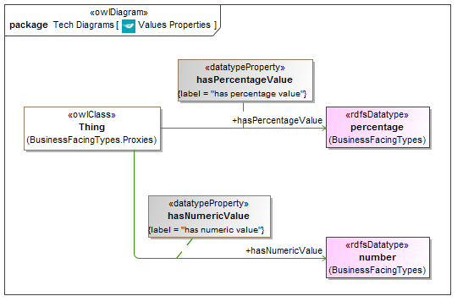

**Figure 0.1 New Diagram in BusinessFacingTypes to be identified as Figure 10.3 and captioned as:**

**“Figure 10.3 Business Facing Types Properties Concepts”**

After Table 10.6 INSERT the table given as Table 0.4 below. This is to be identified as Table 10.7 and all subsequent tables are to be re-numbered.

**Table 0.4 New Table in sub-clause 10.1.2 to be identified as Table 10.7 and captioned as:**

“Table 10.7 Business Facing Types Details”

| **Name** | **Property** | **Definition** | **Concept Type** |
| --- | --- | --- | --- |
| hasPercentageValue | has percentage value | indicates a value expressed as a number | Simple Property |
| hasNumericValue | has numeric value | indicates a value expressed as a percentage | Simple Property |

#### 0.7.1.4 Addition of Analytics Ontology

Add a new ontology to the Utilities module, called Analytics, as new sub-clause 10.1.3. This requires the addition of two new tables (one for the ontology metadata and one for the ontology content), and one new diagram.

After sub-clause 10.1.2 INSERT the new Clause 10.1.3 as given below. Subsequent tables and diagrams are to be re-numbered.

**New sub-clause heading: “10.1.3 Ontology: Analytics”**

This ontology provides mathematical abstractions for use in other ontologies, including for example the basic components of formulae, parameters and values.

**Table 0.5 New Table in new sub-clause 10.1.3 to be identified as Table 10.8 and captioned as:**

**“Table 10.8 Analytics Ontology Metadata”**

| **Metadata Term** | **Value** |
| --- | --- |
| **sm:filename** | Analytics |
| **sm:fileAbbreviation** | fibo-fnd-utl-alx |
| **OntologyIRI** | http://www.omg.org/spec/EDMC-FIBO/FND/Utilities/Analytics/ |
| **owl:versionIRI** | http://www.omg.org/spec/EDMC-FIBO/FND/20140501/Utilities/Analytics/ |
| **sm:dependsOn** | http://www.omg.org/spec/EDMC-FIBO/FND/Utilities/AnnotationVocabulary/  http://www.omg.org/spec/EDMC-FIBO/FND/Utilities/BusinessFacingTypes/ |

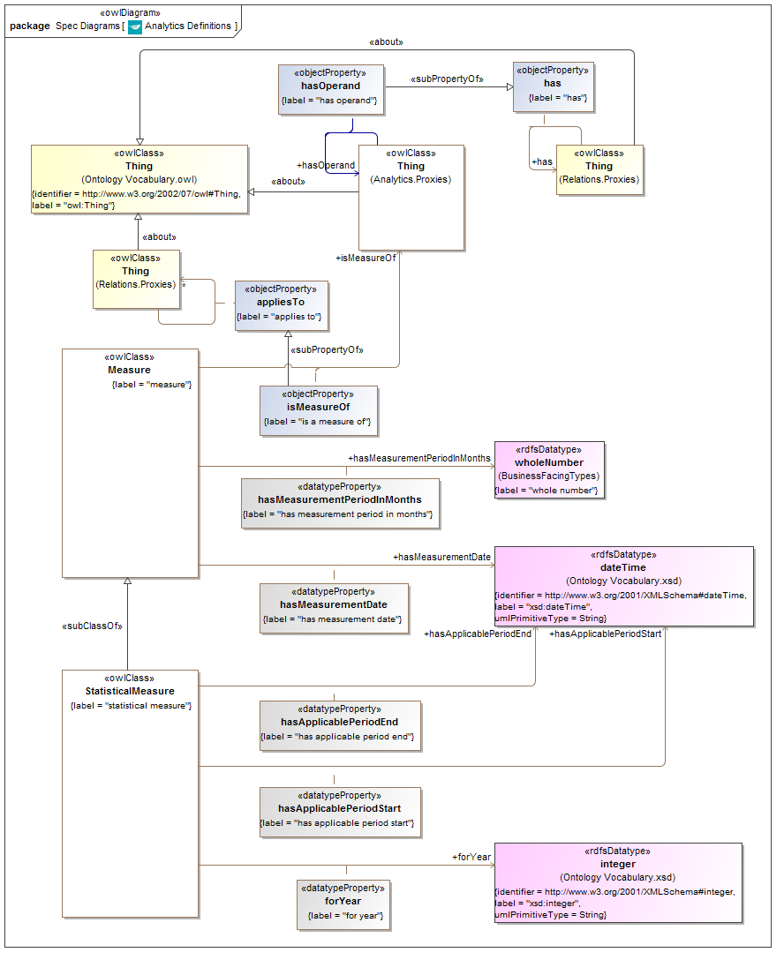

**Figure 0.2 New Diagram in Analytics to be identified as Figure 10.4 and captioned as:**

**“Figure 10.3 Analytics Ontology Concepts”**

**Table 0.6 New Table in new sub-clause 10.1.3 to be identified as Table 10.9 and captioned as:**

**“Table 10.9 Analytics Ontology Classes and Properties”**

**Stand-alone Properties (Domain = Thing)**

|  |  |  |  |  |  |
| --- | --- | --- | --- | --- | --- |
| **Name** | **Label** | **Domain** | **Range** | **Definition** | **Parent** |
| hasOperand | has operand | Thing | Thing | the predicate identifying the operand of a mathematical argument, parameter or other similar concept | has |

**Class: Measure**

|  |  |  |  |  |
| --- | --- | --- | --- | --- |
| **Name** | **Label** | **definition** | **parent** | **Definition Source** |
| Measure | measure | an amount or degree of something; the dimensions, capacity, or amount of something ascertained by measuring |  |  |

**Properties of Measure**

|  |  |  |  |  |  |
| --- | --- | --- | --- | --- | --- |
| **Name** | **Label** | **Domain** | **Range** | **Definition** | **Parent** |
| hasMeasurementDate | has measurement date | measure | xsd:dateTime | a predicate indicating the date on which the measure was taken |  |
| hasMeasurement  PeriodInMonths | has measurement period in months | measure | whole number | a predicate indicating the coverage period for which the measure is applicable expressed in months |  |
| isMeasureOf | is a measure of | measure | Thing | a predicate indicating the concept being measured | applies to |

**Class: StatisticalMeasure**

|  |  |  |  |  |
| --- | --- | --- | --- | --- |
| **Name** | **Label** | **definition** | **parent** | **Definition Source** |
| StatisticalMeasure | statistical measure | A summary (means, mode, total, index, etc.) of the individual quantitative variable values for the statistical units in a specific group (study domains). | measure | http://stats.oecd.org/  glossary/detail.asp?ID=5068 |

**Properties of Statistical Measure**

|  |  |  |  |  |  |
| --- | --- | --- | --- | --- | --- |
| **Name** | **Label** | **Domain** | **Range** | **Definition** | **Parent** |
| forYear | for year | statistical measure | xsd:integer | a predicate indicating the year for which the statistical measure is applicable |  |
| hasApplicablePeriodEnd | has applicable period end | statistical measure | xsd:dateTime | a predicate indicating the end of the period for which the statistical measure is applicable |  |
| hasApplicablePeriodStart | has applicable period start | statistical measure | xsd:dateTime | a predicate indicating the start of the period for which the statistical measure is applicable |  |

#### 0.7.1.5 Changes to Relations Module Metadata

In sub-clause 10.2 in the “Relations Module Metadata” table (Table 10.7) APPEND additional rows as shown in Table 0.7.

**Table 0.7 Relations Module Metadata Additional row entries in Table 10.7**

|  |  |
| --- | --- |
| **Metadata Term** | **Value** |
| **sm:publicationDate** | 2014-05-19T18:00:00 |
| **sm:specificationVersionStatus** | Beta Specification |

#### 0.7.1.6 Changes to Relations Ontology Metadata

In sub-clause 10.2.1 in the “Relations Ontology Metadata” table (Table 10.8) REPLACE the row text for owl:versionIRI (row 4) with that shown in Table 0.8 and APPEND two new rows as shown in Table 0.9

**Table 0.8 Relations Ontology Metadata Changes in Table 10.8**

|  |  |
| --- | --- |
| **Metadata Term** | **Value** |
| **owl:versionIRI** | http://www.omg.org/spec/EDMC-FIBO/FND/20140501/Relations/Relations/ |

**Table 0.9 Relations Ontology Metadata Additional Row entries in Table 10.8**

|  |  |
| --- | --- |
| **Metadata Term** | Value |
| **sm:priorVersion** | http://www.omg.org/spec/EDMC-FIBO/FND/20130801/Relations/Relations/ |
| **skos:changeNote** | This version of the ontology was revised to add the appliesTo object property in support of the IND RFC. |

#### 0.7.1.7 Changes to Relations Ontology Content

One new property has been added to the ontology Relations. This requires the addition of one new diagram (Figure 0.3 below), to follow after Figure 10.3 or any diagrams which may have replaced it. In addition, the information given in Table 0.10 is to be appended onto Table 10.9 (“Relations Details”) or added immediately following any tables which may have replaced Table 10.9.

After Figure 10.3 INSERT the diagram given as Figure 0.3:

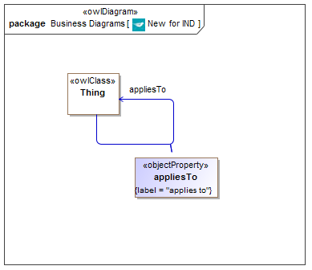

**Figure 0.3 New Object Property in Relations Ontology**

After Table 10.8 INSERT or APPEND the row entry in Table 0.10. Note that the precise table columnar format may have changed; insert the text in the appropriate columns, which will have retained the same names as below:

**Table 0.10 Details for the New appliesTo Property**

| **Name** | **Type Of Thing** | **Property** | **Definition** | **Equivalent to** | **Parent** | **Mutually Exclusive With** | **Related Thing or Type** | **Inverse Of Property** | **Concept Type** | **Editorial Note** | **Explanatory Note** | **Definition Source** |
| --- | --- | --- | --- | --- | --- | --- | --- | --- | --- | --- | --- | --- |
| Thing | anything | applies to | a relation indicating something that is pertinent or relevant to the concept |  |  |  | anything |  | Relationship Property |  |  |  |

### 0.7.2 Changes to FIBO Business Entities Specification finance/13-11-01

Add a new ontology to the FunctionalEntities module, called Publishers.

#### 0.7.2.1 Changes to Functional Entities Module Metadata

In sub-clause 9.7 in the “Functionally Defined Business Entities Metadata” table (Table 9.30) APPEND additional rows as shown in Table 0.11.

**Table 0.11 Functionally Defined Business Entities Module Metadata Additional row entries in Table 9.30**

|  |  |
| --- | --- |
| **Metadata Term** | **Value** |
| **sm:publicationDate** | 2014-05-19T18:00:00 |
| **sm:specificationVersionStatus** | Beta Specification |

#### 0.7.2.2 Addition of Publishers Ontology

Add a new ontology to the FunctionalEntities module. called Publishers, as new sub-clause 9.7.2. This requires the addition of two new tables (one for the ontology metadata and one for the ontology content), and one new diagram.

After sub-clause 9.7.1 INSERT the new sub-clause 9.7.2 as given below.

**New sub-clause heading: “9.7.2 Ontology: Publishers”**

This ontology defines the fundamental concepts for publishers of information, including entities whose primary function is to publish, and entities (whether or not they are publishers in that sense) which are in the role of the publisher of some information. This ontology also includes the published information itself, i.e. the publication.

**Table 0.12 New Table in new sub-clause 9.7.2 to be identified as Table 9.33 and captioned as:**

**“Table 9.33 Publishers Ontology Metadata”**

| **Metadata Term** | **Value** |
| --- | --- |
| **sm:filename** | Publishers |
| **sm:fileAbbreviation** | fibo-be-fct-pub |
| **OntologyIRI** | http://www.omg.org/spec/EDMC-FIBO/BE/FunctionalEntities/Publishers/ |
| **owl:versionIRI** | http://www.omg.org/spec/EDMC-FIBO/BE/20140501/FunctionalEntities/Publishers/ |
| **sm:dependsOn** | http://www.omg.org/spec/EDMC-FIBO/FND/Utilities/AnnotationVocabulary/  http://www.omg.org/spec/EDMC-FIBO/FND/Utilities/BusinessFacingTypes/ |

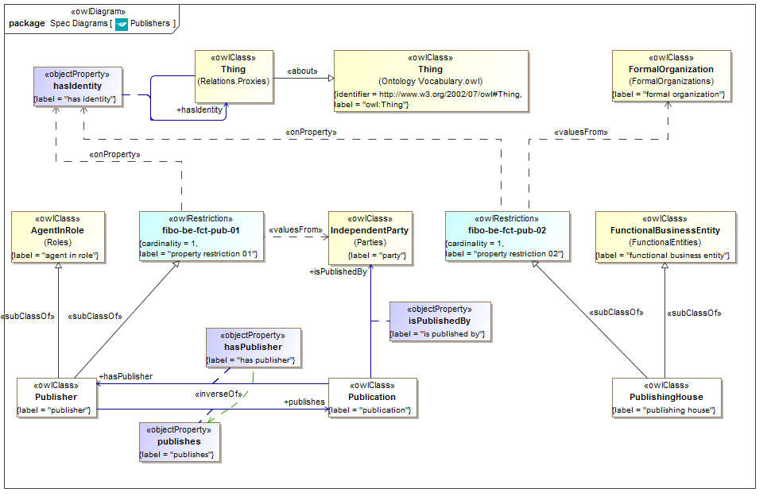

**Figure 0.4 New Diagram in new sub-clause 9.7.2 to be identified as Figure 9.42 and captioned as:**

**“Figure 9.42 Publishers Ontology Concepts”**

**Table 0.6 New Table in new sub-clause 9.7.2 to be identified as Table 9.34 and captioned as:**

**“Table 9.34 Publishers Ontology Classes and Properties”**

**Class: Publication**

| **Name** | **Label** | **Definition** | **Parent** | **Explanatory Note** |
| --- | --- | --- | --- | --- |
| Publication | publication | information which has been made publicly available to the world at large |  |  |

**Properties of Publication**

| **Name** | **Label** | **Domain** | **Range** | **Definition** | **Inverse Of** |
| --- | --- | --- | --- | --- | --- |
| hasPublisher | has publisher | publication | publisher | some person or organization whose role it has been to publish this information | publishes |
| isPublishedBy | is published by | publication | party | the individual or organization which has made this information available to the world at large |  |

**Class: Publisher**

| **Name** | **Label** | **Definition** | **Parent** | **Explanatory Note** |
| --- | --- | --- | --- | --- |
| Publisher | publisher | That which makes some information available to the world at large. | agent in role property restriction 01 | Typically this role is filled by some entity whose function is that of a publishing house (sometimes also referred to as a publisher, in that different sense). Publishers of information may frequently also include bank, government agencies and the like. |

**Properties of Publisher**

| **Name** | **Label** | **Domain** | **Range** | **Definition** | **Inverse Of** |
| --- | --- | --- | --- | --- | --- |
| Publishes | publishes | publisher | publication | information which the publisher has made available to the world at large | has publisher |

**Restrictions on Publisher**

| **Name** | **Label** | **Expression** |
| --- | --- | --- |
| fibo-be-fct-pub-01 | property restriction 01 | hasIdentity exactly 1 IndependentParty |

**Class: PublishingHouse**

|  |  |  |  |  |
| --- | --- | --- | --- | --- |
| **Name** | **Label** | **Definition** | **Parent** | **Explanatory Note** |
| PublishingHouse | publishing house | some organization whose principal role is to publish information | property restriction 02 functional business entity |  |

**Restrictions on PublishingHouse**

| **Name** | **Label** | **Expression** |
| --- | --- | --- |
| fibo-be-fct-pub-02 | property restriction 02 | hasIdentity exactly 1 FormalOrganization |

# Scope

This specification is a model of finance industry concepts in the subject area of market indices, interest rates, currency exchange rates and economic indicators. These have in common that they are all numeric measures (denominated variously as percentages, numbers or monetary amounts), published by some publisher or set by some public body, and providing information on the state of some economy, currency, basket of instruments or risks, formulated to reflect the behavior of some part of the global economy. These indices and indicators are widely referred to within the financial services industry, and many of them are also the subject of derivative contracts in which some part of that derivative is derived from the value of some such rate.

The types of indices and indicators included in this specification are intended to reflect the terms found in common securities and derivatives contracts and the level of detail of these is intended to reflect those details which are articulated in such contract terms. For this reason, details of the methods by which such figures are arrived at by their publishers are not included except where these serve to distinguish one such index from another. In keeping with the nature of FIBO as a series of specifications of business semantics, properties are included which capture the meaning of a concept whether or not these would be articulated in applications which may be derived from this specification – for example it is the case that certain economic indicators give a measure of the state of some economy, even though properties which assert this may not be required in some operational use case.

## 1.1 Overview

This specification is part of a family of specifications called the Financial Industry Business Ontology (FIBO).

FIBO is a modularized formal model of the concepts represented by finance industry terms as used in official financial organization documents such as contracts, product/service specifications and governance and regulatory compliance documents. This is referred to as a *Business Conceptual Model* as distinct from data models in IT implementations.

The scope of *finance industry* encompasses a broad range of organizations that manage money, including [credit unions](http://en.wikipedia.org/wiki/Credit_union), [banks](http://en.wikipedia.org/wiki/Bank), [credit card](http://en.wikipedia.org/wiki/Credit_card) companies, [insurance](http://en.wikipedia.org/wiki/Insurance) companies, [consumer finance](http://en.wikipedia.org/wiki/Consumer_finance) companies, [stock brokerages](http://en.wikipedia.org/wiki/Brokerage_firm), [investment funds](http://en.wikipedia.org/wiki/Investment_management) and some [government sponsored enterprises](http://en.wikipedia.org/wiki/Government_sponsored_enterprise).

The FIBO Indices and Indicators specification covers two considerations: the content of the model as a set of business concepts, and the presentation of this content for business domain expert review as described in [FIBO Foundations]. The latter requirement is important both for the use of the content as a formal business conceptual model within a technology development lifecycle, and for extension of this model content.

Extension of this model may be undertaken either by individual firms, or as part of the submission of model content for future versions of this specification.

This specification describes the content of FIBO Indices and Indicators. The [FIBO Foundations] specification describes the modeling notation which has been employed and the requirements for presentation of this material to domain experts.

## 1.2 Scope of Financial Industry Business Ontologies: Indices and Indicators

### 1.2.1 How This Specification fits with the overall FIBO

This specification describes a set of ontologies of and relating to interest rates, currency exchange rates, economic indicators and market indices, within the overall framework and heading of the Financial Industry Business Ontology (FIBO). The ontology content described in this specification is developed and maintained using the same modeling framework as all FIBO ontologies. It both extends and references a subset of the ontologies specified in FIBO Foundations [FIBO Foundations]. It also depends on a subset of the ontologies specified in FIBO Business Entities [FIBO BE].

### 1.2.2 Business Scope

The business scope of this specification is all terms relating to and definitive of a range of market and economic indicators that are considered by financial industry firms, regulators and other industry participants to be of relevance in the financial services domain.

The scope of the concepts in this specification is those common to

* Published rates about markets and about economic performance generally,
* Interest rates (lending rates, inter-bank rates, reference rates),
* Rates of exchange between currencies,
* Economic indicators which provide some measure of some economy (inflation rates, Gross Domestic Product, unemployment rates),
* Also in scope for FIBO-IND but not in this specification are market indices composed of simulated baskets of issued securities, credit indices based on baskets of risk-sensitive debts and so on.

These are concepts which have a temporal element, that is the value of each index and indicator has a current value, a number of past values the number of which varies according to the frequency with which that index is published, and an indefinite number of projected future values as determined by some party at some time by some means. The temporal aspects of Indices and Indicators are provided via the normative reference to [FIBO Foundations] and/or [DTV].

Many derivatives are named for the index or interest rate which is the underlying of that derivative, for example when a trader speaks of “selling the S&P500” index. It should be understood that, notwithstanding the commonality of names, there is a semantic and economic distinction between an index and a contract which gives the holder some participation in changes to that index. This specification deals only with the indices not the derivatives of those indices, which are to be provided in other FIBO specifications which will depend on the concepts here.

### 1.2.3 Relation to Existing Market Index and Economic Indicator Standards

The model defined in this specification is a “business conceptual model” as described in Section 1.2 of the [FIBO Foundations] specification. A business conceptual model in the sense used here is one which represents things in the business domain as distinct from data descriptions for data about those things, and which does not reflect the technical constraints of any given application. As such this specification is intended to be complementary to technical standards in the financial services industry, most of which were developed and are framed (positioned) either as logical data models or as physical message schemas. For this reason this specification includes concepts which contribute towards the definition of a concept or the disambiguation of concepts without reference to whether all of these individual properties would be used within a physical application.

To the extent that logical data model or physical message standards include content relating to indices and indicators, this specification defines the semantics of those data and message elements.

Standards for derivative transactions such as FpML are descriptive of derivatives including those which are derivative of indices and indicators, and are not definitive descriptions of the indices or indicators themselves. FpML does contain individual message terms which refer to these indices and indicators but these are intended to refer to these concepts in the definition of derivative instruments, they are not intended to define these concepts themselves. These message schema elements are framed at the physical level while the current specification is at the conceptual level. These FIBO models represent a computationally independent model.

The [ISO 20022] standard has a component referred to as the “Financial Industry Business Information Model” [FIBIM] which includes indices and indicators terms. Many of the terms in this specification were initially defined with reference to that specification and subsequently refined by subject matter expert reviews. As such, this specification is intended to provide the conceptual model business concepts which correspond to the more technical design models in the ISO 20022 FIBIM material.

## 1.3 Definitions

The human readable definitions have been constructed by and with the input of business subject matter experts.

Many definitions have been derived from definitions of data elements corresponding to those terms in industry data standards and messaging standards. These have been adapted where necessary to ensure that they are descriptive of the thing itself and not of data elements for data about those things. These have been reviewed by industry subject matter experts to ensure that such adaptation accurately captures the sense of the business concept. In cases where the definition in a technical industry standard was incomplete, context-specific or tautologous, a fresh definition was framed by the industry subject matter experts who participated in these reviews. Where this was not possible, a third party definition was proposed and adopted.

### 1.3.1. Definitions Policy

Many definitions in this specification were initially derived from terms given in the ISO 20022 FIBIM model, with adaptations to the definitions text where necessary to re-frame the definition from that of a data element, field or table to the definition of the thing in the world to which the FIBO concept refers. The exceptions to this approach are where additional concepts were added during industry subject matter expert reviews; in these cases the definition has been arrived at through consensus of the financial industry subject matter experts participating in those reviews. The policy which follows is given for FIBO specifications in general but has not needed to be called upon for this specification.

Where definitions for the FIBO industry terms are derived from third party sources, the policy for arriving at those definitions is as follows (and remains so for future iterations and extensions):

1. In the absence of a definition endorsed by the subject matter experts for a term, definitions will be sourced from US government sites, including the US Federal Reserve Bank of NY, and the Bureau of Labor and Statistics (BLS), as appropriate.

2. When there is a conflict with the definition of a Financial Industry term with the same term in another Industry, the Financial Industry definition will be used within FIBO.

In all cases the source from which the definition was obtained, or from which it was adapted, is recorded in annotation metadata for that concept.

# Conformance

**Audience:** Technical, semantic technology and standards audiences.

## 2.1 Applications for which Conformance Points Exist

This Clause defines conformance points for the following types of artifacts:

* Technical applications of FIBO such as logical data models, XML schemas, operational ontologies, code, and other technical artifacts
* Extensions of FIBO
* Representations of FIBO for business consumption
  + In diagrams
  + In spreadsheets and tables

Conformance of technical applications of FIBO is the most important conformance point, because it addresses the core issue of what it means to conform to the ontologies that FIBO defines.

Note that in addition to conformant applications, there are a number of scenarios in which someone may make use of the FIBO ontologies as a business conceptual model while applying their own design to meet their requirements. It is not possible to define specific conformance points for each of the possible ways in which one may legitimately develop a conventional database application or an operational OWL ontology that would be a good application.

## 2.2 Conformance Points

This specification has the following conformant points for the above applications:

* Conformant extension: as described in [FIBO Foundations] for conformant extensions to model content
* Operational ontologies: conformance may be asserted for
  + This entire specification (FIBO-Full conformance)
  + Ontology conformance – subject to the ontology dependencies;
* The content of this specification may be rendered conformant with the model presentation conformance points described under “Conformant Presentation of Model Content” in [FIBO Foundations] both for diagrams and for tabular reports.
* Spreadsheets may assert conformance to the “tabular presentation” conformance point described under “Conformant Presentation of Model Content” in [FIBO Foundations] without reference to other material.

## 2.3 Operational Ontology Conformance

An OWL ontology derived from this specification (known as an “operational ontology”) is conformant to this specification if:

* It uses individual ontologies in this specification along with imports of any ontologies that are shown as imported by the ontologies in this specification; or
* It uses some sub-set of the terms contained in individual ontologies in this specification, along with imports of any ontologies that are shown as imported by the ontologies in this specification and the terms which are used in the ontology make reference to the terms which are in the imported ontologies; there is no need to import ontologies which contain only terms which are not referred to by the terms that are used in the ontology which asserts such conformance.

When asserting conformance in terms of this conformance point, the operational ontology should identify and name to which of the individual ontologies in this specification the application is conformant.

For detailed descriptions of the above conformance points and others, please refer to [FIBO Foundations].

# References

## 3.1 Normative References

The following normative documents contain provisions which, through reference in this text, constitute provisions of this specification. For dated references, subsequent amendments to, or revisions of, any of these publications do not apply.

| **Reference** | **Description** |
| --- | --- |
| [Dublin Core] | DCMI Metadata Terms, Issued 2013-06-14 by the Dublin Core Metadata Initiative. Available at <http://www.dublincore.org/documents/dcmi-terms/>. |
| [DTV] | The OMG Date Time Vocabulary version 1.1. Anticipated Summer 2014 at <http://www.omg.org/spec/DTV/1.1/> |
| [FIBO BE] | Financial Industry Business Ontology (FIBO) – Business Entities (EDMC-FIBO/BE). Available at <http://www.omg.org/spec/EDMC-FIBO/BE/> |
| [FIBO Foundations] | Financial Industry Business Ontology (FIBO) – Foundations (EDMC-FIBO/FND). Available at <http://www.omg.org/spec/EDMC-FIBO/FND/> |
| [ISO 1087] | ISO 1087-1:2000 Terminology — Vocabulary — Part 1: Theory and application |
| [MOF Core] | Meta Object Facility (MOF™) Core, v2.4.2. Available at <http://www.omg.org/spec/MOF/2.4.2/>. |
| [MOF XMI] | MOF 2/XMI (XML Metadata Interchange) Mapping Specification, v2.4.2. Available at <http://www.omg.org/spec/XMI/2.4.2/>. |
| [ODM 1.1] | Ontology Definition Metamodel (ODM), v1.1. Available at <http://www.omg.org/spec/ODM/1.1/>. |
| [OMG AB Specification Metadata] | OMG Architecture Board recommendations for specification of ontology metadata, Available at http://www.omg.org/techprocess/ab/20130701/SpecificationMetadata.rdf |
| [OWL 2] | OWL 2 Web Ontology Language Quick Reference Guide (Second Edition), W3C Recommendation 11 December 2012. Available at <http://www.w3.org/TR/2012/REC-owl2-quick-reference-20121211/>. |
| [RDF 1.1] | RDF 1.1 Concepts and Abstract Syntax, W3C Proposed recommendation available at <http://www.w3.org/TR/2013/WD-rdf11-concepts-20130723/> |
| [RDF Concepts] | Resource Description Framework (RDF): Concepts and Abstract Syntax. Graham Klyne and Jeremy J. Carroll, Editors. W3C Recommendation, 10 February 2004. Latest version is available at http://www.w3.org/TR/rdf-concepts/. |
| [RDF Schema] | RDF Vocabulary Description Language 1.0: RDF Schema. Dan Brickley and R.V. Guha, Editors. W3C Recommendation, 10 February 2004. Latest version is available at http:// [www.w3.org/TR/rdf-schema/](http://www.w3.org/TR/rdf-schema/). |
| [SKOS] | SKOS Simple Knowledge Organization System Reference, W3C Recommendation 18 August 2009. Available at <http://www.w3.org/TR/2009/REC-skos-reference-20090818/>. |
| [UML2] | Unified Modeling Language™ (UML®), version 2.4.1. Available at <http://www.omg.org/spec/UML/2.4.1/>. |
| [Unicode] | *The Unicode Standard, Version 3*, The Unicode Consortium, Addison-Wesley, 2000. ISBN 0-201-61633-5, as updated from time to time by the publication of new versions. (See http:// www.unicode.org/unicode/standard/versions/ for the latest version and additional information on versions of the standard and of the Unicode Character Database). |
| [UTF-8] | RFC 3629: UTF-8, a transformation format of ISO 10646. F. Yergeau. IETF, November 2003, <http://www.ietf.org/rfc/rfc3629.txt> |
| [W3C Datatypes in RDF and OWL] | XML Schema Datatypes in RDF and OWL, W3C Working Group Note 14 March 2006, Available at <http://www.w3.org/TR/2006/NOTE-swbp-xsch-datatypes-20060314/>. |
| [XML Schema Datatypes] | XML Schema Part 2: Datatypes. W3C Recommendation 28 October 2004. Latest version is available at <http://www.w3.org/TR/xmlschema-2/>. |

## 3.2 Non Normative References

The following informative documents are referenced throughout this text or in parts of the Annexes:

|  |  |
| --- | --- |
| **Reference** | **Description** |
| [ISO 20022] | ISO 20022 Financial Services - Universal financial industry message scheme, available at [www.iso20022.org](http://www.iso20022.org) |
| [OMV] | Ontology Metadata Vocabulary (OMV) - <http://omv2.sourceforge.net/> (a standard giving metadata for ontology-level information) |
| [FIBIM] | ISO TC68/SC4/WG11 Document N012 version 3 |

# Terms and Definitions

For the purposes of this specification, the following terms and definitions apply.

**Content**

1. Subject matter

Business conceptual model

1. A model which represents and only represents business subject matter without reference to the design of any solution or data model representation.

Ontology

1. A formalization of a conceptualization. For the purposes of this specification the formalization is in OWL, using ODM as a means to render this, and the conceptualization is that of business subject matter.

**Operational Ontology**

1. An ontology which is intended for use within some application.

**Subject matter**

1. Information about things in the universe of discourse; the essential facts, data, or ideas that constitute the basis of spoken, written, or artistic expression or representation; often : the substance as distinguished from the form especially of an artistic or literary production.

Taxonomy

1. A set of terms which stand in some classification relation to one another.

# Symbols and Abbreviations

## Symbols

There are no symbols introduced by this specification.

## 5.2 Abbreviations

The following abbreviations are used throughout this specification:

* OWL – Web Ontology Language
* ODM – Ontology Definition Metamodel
* RDF – Resource Definition Framework
* SME – Subject Matter Expert
* UML – Unified Modeling Language
* URI – Uniform Resource Identifier
* URL – Uniform Resource Locator
* XMI – XML Metadata Interchange
* XML – eXtensible Markup Language

Additional symbols and abbreviations that are used only in annexes to this specification are given in those annexes.

# Additional Information

## How to Read this Specification

### Audience

This specification has the following audiences:

* The standards community
* The finance industry business community
* The regulatory community
* Technical architects
* Semantic Modelers

#### Standards Community

This audience is intended to be able to follow and validate the way in which this specification sets out the arrangements for the production and maintenance of model content, and the production of business-facing reports and diagrams representing parts of that content.

#### The Finance Industry Business Community

As noted in the section on conformance (section 2) this specification includes detailed requirements for the production of diagrams and reports which are intended for consumption by business subject matter experts. This specification also contains material addressed at this audience, this being an informative annex on “Interpreting Model Content”. This audience is not intended to read and understand the remaining parts of this specification.

#### The Regulatory Community

As for Finance Industry Business Community.

#### Technical Architects

These include but are not limited to:

* + Tooling vendors and developers
  + Other content providers / enriched content providers
  + Business Analysts – anyone who uses the model whether they are a modeler, a metadata analyst, etc.
  + Technology Management

The bulk of the “Architecture” section is intended to be read and understood by these audiences and by the ‘Semantic Modelers’ audience.

#### Semantic Modelers

Much of the material in this specification is intended to be read and understood by semantic modelers. This includes the 'Conformance' chapter (Chapter 2) and the ‘Architecture’ chapter (Chapter 8).

## 6.2 Acknowledgements

The following organization submitted this specification:

* Enterprise Data Management Council

The following companies have provided significant expertise and resources in the development of its content and architecture:

* Adaptive Inc.
* Australia and New Zealand Banking Group
* AVOX/DTCC
* Bank of America
* Barclays Capital
* BBH
* Bloomberg
* Business Semantics
* CIBC
* Citigroup Inc.
* Credit Suisse Group AG
* CUSIP
* The Federal National Mortgage Association (Fannie Mae)
* David Frankel Consulting
* FacetApp
* Fidelity
* GoldenSource Corporation
* HSBC Holdings plc
* JPMorgan Chase & Co.
* The Manufacturers Life Insurance Company
* Michigan State University
* Model Driven Solutions
* Model Systems
* Morgan Stanley
* MphasiS
* National Australia Bank
* No Magic
* Nomos Software
* Nordea Bank
* Oakland University
* OntoAge
* OpenFinance
* PricewaterhouseCoopers LLP
* Revelytix
* Sallie Mae
* SAP
* Semantic Arts
* State Street
* Sungard
* SWIFT
* Tahoe Blue
* Thematix Partners LLC
* Thomson Reuters
* UBS AG
* University of British Columbia
* University College Cork
* Wells Fargo
* Wizdom Systems, Inc.

# Introduction

## Audiences

Readers are encouraged to read Section 6.1 on the different intended audiences for this specification.

### 7.1.1 Audience for this Section

The audience for this section is anyone who wishes to understand this standard, whether from a business or a technical standpoint.

### 7.1.2 Reading this Standard

Technical audiences (in both conventional and semantic technology) are directed at the “Architecture” section (Section 8).

Business audiences (financial industry participants, regulators and others) are directed at this Introduction and at Annex A on interpreting model content (Annex B).

The business content defined in this standard is intended to be presented both in a business-facing format and in a complete, technical format. The latter is intended for consumption by technical and standards audiences only. This specification defines the content of the standard and the ways in which it is to be presented to business readers.

## Specification Overview

### 7.2.1 Non Technical Overview

**Audience:** Business.

This specification provides a model of financial market indices and economic indicators terms, definitions and relationships. The model contains no technical design content and is a representation of the indices and indicators concepts. This specification describes the technical arrangements by which this has been brought about, the requirements to be placed upon semantic modelers who are to extend this content locally or who propose updates to the model, and the requirements by which the content of this and future extensions are to be presented to business domain participants, so that they may understand and review the model content without the need for any formal technical training.

### 7.2.2 Technical Overview

**Audience:** Technical architects.

The model content is developed and maintained using the Unified Modeling Language as a modeling tool framework, but with all model content built using the formal constructs of the Web Ontology Language (OWL). This is achieved using the OMG's Ontology Definition Metamodel (ODM) specification.

The use of the ODM specification in this specification is limited to a specific sub-set of OWL constructs, and is also limited to the range of UML base classes that is allowed for each of the OWL constructs that are used, as defined in the [FIBO Foundations] specification.

The model content is made available as serialized ODM UML in the form of XMI files (“ODM XMI”); as serialized UML in the form of XMI files (“UML XMI”) and as OWL files in the RDF/XML syntax. The deliverables are described in Annex A.

## 7.3 Business Usage Scenarios

### 7.3.1 Indices and Indicators Usage Scenarios

A number of business scenarios are supported by this specification. These include:

* Formal definitions and concepts for market indices, interest rates and economic indicators for reference in integration of systems and data feeds and for model driven development of applications which refer to these concepts;
* Index and indicator terms for the definition of derivatives contracts as types of underlying variable;
* Index, interest rate and indicator terms for the definition of variable interest or variable amortization payments in negotiable securities (principally debt securities) and in loans;
* Development of semantic models (ontologies) of derivatives and securities contracts which have indices, indicators or interest rates as their underlying variables – ontologies for those contracts whether developed privately or as future FIBO specifications, would semantically import the concepts in this specification.
* Risk applications including credit risk, market risk.

# Architecture

**Intended Audiences:** Technologists, Semantic Technologists, Standards Implementers.

## 8.1 Overview

The architecture of FIBO is described in the [FIBO Foundations] specification.

Please also refer to the Scope section (Section 1) and the Definitions (Section 4) for detailed treatment of the terms and concepts referred to.

## 8.2 The Foundations Models

This specification makes reference to specific sets of concepts in the [FIBO Foundations] specification.

As a consequence of the modeling principles, the model requires ontologies of things which are not specific to indices and indicators. The Foundations ontologies include legal concepts like contracts, business concepts such as service provision, as well as an extensive set of concepts for times, dates, mathematical constructs, events and activities, and so on. FIBO Indices and Indicators draws extensively on abstractions for numeric measures as well as concepts in the area of business entities drawn from the [FIBO BE] Business Entities specification, to describe publishers of indicators, interest rates and economic indicators.

Models of these concepts are maintained as described in the [FIBO Foundations] specification and the [FIBO Business Entities] specification.

## 8.3 Ontology Architecture and Namespaces

As described in the [FIBO Foundations] specification in section 8.2, the ontology architecture for FIBO is designed to facilitate reuse and ontology evolution to the degree possible. An important goal of this specification is to provide the foundational terminology, including basic terminology describing amounts and rates, which provides high-level, abstract conceptual knowledge intended to facilitate mapping. The basic building blocks for the Indices and Indicators (IND) Ontology, building on the architecture provided in [FIBO Foundations], are shown in Figure 8.1, below.

As shown in the diagram, the IND ontologies are divided up into a number of *modules*. These include: indicators (concepts common to more than one type of index, rate or indicator), foreign exchange rates, interest rates and economic indicators.

The IND modules will ultimately depend on (1) Basic Terminology and Ontology Metadata (in light gray in the figure), (2) Foundations, (3) Business Entities and (4) a number of external modules, representing concepts for Natural Language, Geopolitical Entities (for example ISO 3166 Country codes, regional and municipal designations), and concepts defining dates, times, and durations. A sample set of these anticipated external resources are given in the dark gray layer in the figure.

**Basic Terminology & Ontology Metadata**

**Natural Language**

**Geopolitical Entities**

**Postal Addressing**

**Date Time Vocabulary (DTV)**

**Accounting**

**Agents and People**

**Organizations**

**Utilities**

**Parties**

**Places**

**Relations**

**Indicators**

**Foreign Exchange**

**Interest Rates**

**Economic Indicators**

**Economic Indicator Publishers**

**Interest Rate Publishers**

**Functional Entities**

**Legal Entities**

Figure 8.1 Indices and Indicators Ontology Architecture

The namespaces and their well-known prefixes corresponding to external elements required for use of FIBO Indices and Indicators include all of those listed in the FIBO Foundations specification and selected concepts from the FIBO Business Entities specification, as well as those required for the use of Foundations itself. Table 8.1 lists those prefixes and namespaces considered external to Foundations. Table 8.2 provides those required for use of Foundations while Table 8.3 provides those required for use of the Business Entities specification (repeated here for convenience).

Table 8.1 Prefix and Namespaces for referenced/external vocabularies

|  |  |
| --- | --- |
| Namespace Prefix | Namespace |
| rdf | http://www.w3.org/1999/02/22-rdf-syntax-ns# |
| rdfs | http://www.w3.org/2000/01/rdf-schema# |
| owl | http://www.w3.org/2002/07/owl# |
| xsd | http://www.w3.org/2001/XMLSchema# |
| dct | http://purl.org/dc/terms/ |
| skos | http://www.w3.org/2004/02/skos/core# |
| sm | http://www.omg.org/techprocess/ab/SpecificationMetadata/ |

Table 8.2 Prefix and Namespaces for FIBO Foundations

| Namespace Prefix | Namespace |
| --- | --- |
| fibo-fnd-acc-aeq | http://www.omg.org/spec/EDMC-FIBO/FND/Accounting/AccountingEquity/ |
| fibo-fnd-acc-cur | http://www.omg.org/spec/EDMC-FIBO/FND/Accounting/CurrencyAmount/ |
| fibo-fnd-aap-agt | http://www.omg.org/spec/EDMC-FIBO/FND/AgentsAndPeople/Agents/ |
| fibo-fnd-aap-ppl | http://www.omg.org/spec/EDMC-FIBO/FND/AgentsAndPeople/People/ |
| fibo-fnd-agr-agr | http://www.omg.org/spec/EDMC-FIBO/FND/Agreements/Agreements/ |
| fibo-fnd-agr-ctr | http://www.omg.org/spec/EDMC-FIBO/FND/Agreements/Contracts/ |
| fibo-fnd-gao-gl | http://www.omg.org/spec/EDMC-FIBO/FND/GoalsAndObjectives/Goals/ |
| fibo-fnd-gao-obj | http://www.omg.org/spec/EDMC-FIBO/FND/GoalsAndObjectives/Objectives/ |
| fibo-fnd-law-jur | http://www.omg.org/spec/EDMC-FIBO/FND/Law/Jurisdiction/ |
| fibo-fnd-law-lcap | http://www.omg.org/spec/EDMC-FIBO/FND/Law/LegalCapacity/ |
| fibo-fnd-law-cor | http://www.omg.org/spec/EDMC-FIBO/FND/Law/LegalCore/ |
| fibo-fnd-org-fm | http://www.omg.org/spec/EDMC-FIBO/FND/Organizations/FormalOrganizations/ |
| fibo-fnd-org-lg | http://www.omg.org/spec/EDMC-FIBO/FND/Organizations/LegitimateOrganizations/ |
| fibo-fnd-org-org | http://www.omg.org/spec/EDMC-FIBO/FND/Organizations/Organizations/ |
| fibo-fnd-oac-ctl | http://www.omg.org/spec/EDMC-FIBO/FND/OwnershipAndControl/Control/ |
| fibo-fnd-oac-own | http://www.omg.org/spec/EDMC-FIBO/FND/OwnershipAndControl/Ownership/ |
| fibo-fnd-pty-pty | http://www.omg.org/spec/EDMC-FIBO/FND/Parties/Parties/ |
| fibo-fnd-pty-rl | http://www.omg.org/spec/EDMC-FIBO/FND/Parties/Roles/ |
| fibo-fnd-plc-adr | http://www.omg.org/spec/EDMC-FIBO/FND/Places/Addresses/ |
| fibo-fnd-plc-cty | http://www.omg.org/spec/EDMC-FIBO/FND/Places/Countries/ |
| fibo-fnd-plc-loc | http://www.omg.org/spec/EDMC-FIBO/FND/Places/Locations/ |
| fibo-fnd-rel-rel | http://www.omg.org/spec/EDMC-FIBO/FND/Relations/Relations/ |
| fibo-fnd-utl-av | http://www.omg.org/spec/EDMC-FIBO/FND/Utilities/AnnotationVocabulary/ |
| fibo-fnd-utl-bt | http://www.omg.org/spec/EDMC-FIBO/FND/Utilities/BusinessFacingTypes/ |
| fibo-fnd-utl-alx | http://www.omg.org/spec/EDMC-FIBO/FND/Utilities/Analytics/ |

Table 8.3 Prefix and Namespaces for FIBO Business Entities

|  |  |
| --- | --- |
| Namespace Prefix | Namespace |
| fibo-be-oac-cpty | http://www.omg.org/spec/EDMC-FIBO/BE/OwnershipAndControl/ControlParties/ |
| fibo-be-le-cb | http://www.omg.org/spec/EDMC-FIBO/BE/LegalEntities/CorporateBodies/ |
| fibo-be-oac-cctl | http://www.omg.org/spec/EDMC-FIBO/BE/OwnershipAndControl/CorporateControl/ |
| fibo-be-oac-cown | http://www.omg.org/spec/EDMC-FIBO/BE/OwnershipAndControl/CorporateOwnership/ |
| fibo-be-corp-corp | http://www.omg.org/spec/EDMC-FIBO/BE/Corporations/Corporations/ |
| fibo-be-le-fbo | http://www.omg.org/spec/EDMC-FIBO/BE/LegalEntities/FormalBusinessOrganizations/ |
| fibo-be-oac-exec | http://www.omg.org/spec/EDMC-FIBO/BE/OwnershipAndControl/Executives/ |
| fibo-be-fct-fct | http://www.omg.org/spec/EDMC-FIBO/BE/FunctionalEntities/FunctionalEntities/ |
| fibo-be-fct-pub | http://www.omg.org/spec/EDMC-FIBO/BE/FunctionalEntities/Publishers/ |
| fibo-be-le-lp | http://www.omg.org/spec/EDMC-FIBO/BE/LegalEntities/LegalPersons/ |
| fibo-be-le-lei | http://www.omg.org/spec/EDMC-FIBO/BE/LegalEntities/LEIEntities/ |
| fibo-be-oac-opty | http://www.omg.org/spec/EDMC-FIBO/BE/OwnershipAndControl/OwnershipParties/ |
| fibo-be-ptr-ptr | http://www.omg.org/spec/EDMC-FIBO/BE/Partnerships/Partnerships/ |
| fibo-be-tr-tr | http://www.omg.org/spec/EDMC-FIBO/BE/Trusts/Trusts/ |

As described in the [FIBO Foundations] specification, the namespace approach taken for FIBO is based on OMG guidelines and is constructed as follows:

* A standard prefix http://www.omg.org/spec/
* The family name, EDMC-FIBO
* The abbreviation for the specification: in this case IND
* The module name
* The ontology name

Note that the URI/IRI strategy for the ontologies in FIBO takes a “slash” rather than “hash” approach, in order to accommodate server-side applications. Though not technically necessary, this specification does mandate namespace prefixes to be used. These are constructed as follows with the components separated by “-“:

* The specification family name fibo
* The specification abbreviation: ind
* An abbreviation for the module name
* An abbreviation for the ontology name

The namespaces and prefixes corresponding to FIBO Indices and Indicators ontologies are summarized in Table 8.4 for convenience. These are given in alphabetical order, by module, rather than with any intent to show imports relationships.

Table 8.4 Prefix and Namespaces for FIBO Indices and Indicators

|  |  |
| --- | --- |
| Namespace Prefix | Namespace |
| **fibo-ind-ind-ind** | **http://www.omg.org/spec/EDMC-FIBO/IND/Indicators/Indicators/** |
| **fibo-ind-fx-fx** | **http://www.omg.org/spec/EDMC-FIBO/IND/ForeignExchange/ForeignExchange/** |
| **fibo-ind-ir-ir** | **http://www.omg.org/spec/EDMC-FIBO/IND/InterestRates/InterestRates/** |
| **fibo-ind-ir-pub** | **http://www.omg.org/spec/EDMC-FIBO/IND/InterestRates/InterestRatePublishers/** |
| **fibo-ind-ei-ei** | **http://www.omg.org/spec/EDMC-FIBO/IND/EconomicIndicators/EconomicIndicators/** |
| **fibo-ind-ei-pub** | **http://www.omg.org/spec/EDMC-FIBO/IND/EconomicIndicators/EconomicIndicatorPublishers/** |

# 9 Model Content Reports

## 9.1 Overview

This section lists all the terms, definitions and relationships in the Indices and Indicators models defined in this specification.

Please note that this section is not intended to be read by business subject matter experts; for this purpose, tabular reports and spreadsheets should be produced for this audience as described elsewhere in this specification.

### 9.1.1 Interpreting This Section

This section shows each of the components of the model with their OWL construct names where applicable. These are:

| **Construct Name** | **Description** |
| --- | --- |
| **Module:** | A grouping of ontologies with some common theme. These also share a namespace fragment in the corresponding OWL files. |
| **Ontology** | A single OWL ontology. |
| **Class of Thing** | An OWL Class, that is, a set of individuals that share a common definition and common properties |
| **Relationship** | In OWL, relationships (object properties) between classes are binary, first class elements. The domain of a relationship is the class that has this relationship, i.e., the source; the range is the class that it is related to, or the target of the relationship. |
| **Parent** | **“is a”** relationships: these indicate that the child class is a sub-class of its parent class, in other words, the child class is a specialization of its parent class. |
| **Simple property** | Known as attributes in data modeling, and as data properties in OWL, simple properties are properties of their domain (source) class, whose values must be of the same type as their range (target) datatype, such as text or a numeric value.  Known as “datatype property” in OWL. |
| **Datatype Property Range** | The type of information in which the OWL Datatype Property is framed  Known as “Type” in the tables, where one column combines types of simple properties, and related things (ranges) of relationship properties  NOTE: for some simple properties, the range is a DataEnumeration (see below). |
| **Data Enumeration** | These items represent a selection of possible values, which are intended to be taken as literal (e.g. textual) values. A “Simple property” (OWL Datatype Property) may identify one of these as the Simple property Type; this means that any one of the values in the list may be a possible value for this property. |
| **Logical Union** | A logical union of Classes. The membership of the union is shown in this specification in the “Related thing or type” column. |
| **Mutually exclusive** | Identifies two sets of which no one individual may be a member of both.  Known as “disjoint” in OWL. |
| **Definition** | The SKOS Definition annotation, giving the formal definition of the concept |
| **Explanatory Note** | An annotation giving more detailed business-facing explanations for concepts. |
| **Term Origin** | The origin of the concept in some external source, which was directly used as a point of reference in deriving the concept indicated. |
| **Definition Origin** | The origin of the written definition for the concept in some external source, which was directly used as a point of reference in deriving the concept indicated. |
| **Definition Adapted From** | The origin of the written definition for the concept in some external source, which was adapted and used as a point of reference in deriving the concept indicated. |
| **Restriction** | A set theoretic construct representing the refinement of an existing relationship property. The restriction represents a set of things in the business domain, the set being everything which has the stated relationship restricted as shown. Restrictions may be a super-class of some class of thing (representing a necessary condition for membership of that class) or they may be shown as “equivalent to” that class of thing, meaning that the restriction represents necessary and sufficient conditions for membership of that class. |

## 9.2. Module: Indicators

Table 9.1 Indicators Module Metadata

|  |  |
| --- | --- |
| **Metadata Term** | **Value** |
| **sm:moduleName** | Indicators |
| **sm:moduleAbbreviation** | FIBO-IND-IND |
| **sm:moduleVersion** | 1.0 |
| **sm:moduleAbstract** | This module includes ontologies for concepts common to all types of market index and market indicator or economic measure. These are all types of numeric parameter which vary over time, and are published by some source. These are divided into concepts descriptive of the numeric parameter, and concepts descriptive of the values which those parameters take over time. |

### 9.2.1 Ontology: Indicators

This ontology provides the concepts common to all market rates, indices and indicators; that is concepts descriptive of the numeric parameters themselves. These are modeled independently of the values they may take over time.

Table 9.2 Indicators Ontology Metadata

| **Metadata Term** | **Value** |
| --- | --- |
| **sm:filename** | Indicators |
| **sm:fileAbbreviation** | fibo-ind-ind-ind |
| **OntologyIRI** | http://www.omg.org/spec/EDMC-FIBO/IND/Indicators/Indicators/ |
| **owl:versionIRI** | http://www.omg.org/spec/EDMC-FIBO/IND/20140601/Indicators/Indicators/ |
| **sm:dependsOn** | http://www.omg.org/techprocess/ab/SpecificationMetadata/  http://www.omg.org/spec/EDMC-FIBO/FND/Utilities/AnnotationVocabulary/  http://www.omg.org/spec/EDMC-FIBO/FND/Utilities/Analytics/  http://www.omg.org/spec/EDMC-FIBO/FND/Utilities/BusinessFacingTypes/  http://www.omg.org/spec/EDMC-FIBO/FND/Relations/Relations/  http://www.omg.org/spec/EDMC-FIBO/FND/Organizations/FormalOrganizations/  http://www.omg.org/spec/EDMC-FIBO/BE/FunctionalEntities/Publishers/ |

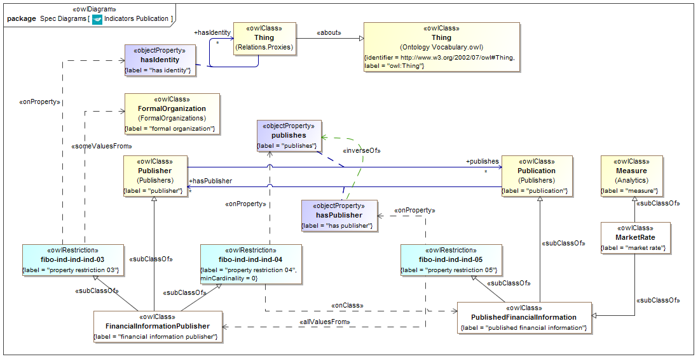

**Figure 9.1 Indicators Publication Concepts**

Diagram showing the basic concepts in the Indicators Publishers ontology for publication of market indices and indicators.

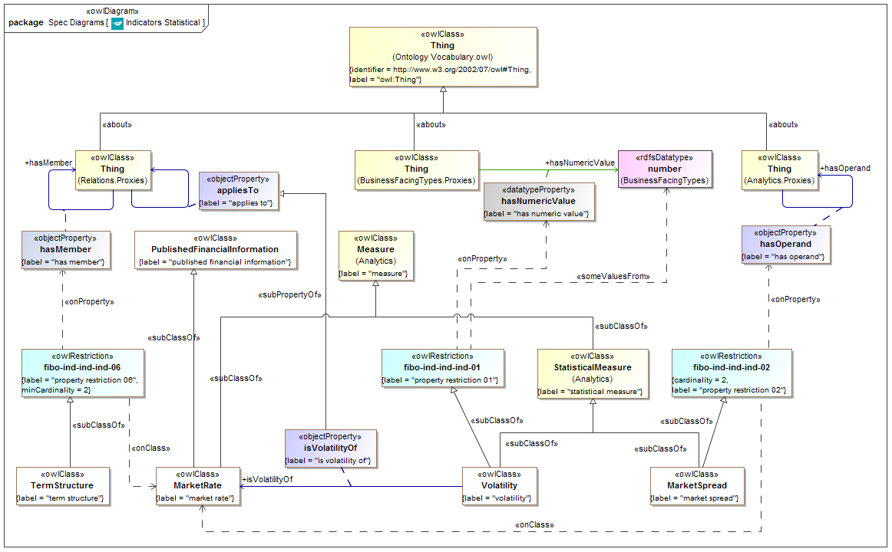

**Figure 9.2 Indicators Analytical Concepts**

Diagram showing the analytical or statistical types of indicator concept in the Indicators ontology.

Table 9.3 Indicators Details

**Classes**

| **Name** | **Label** | **Definition** | **Parent** | **Explanatory Note** |
| --- | --- | --- | --- | --- |
| FinancialInformation Publisher | financial information publisher | a formal organization acting as a publisher or provider of information related to the financial markets or of interest to financial market participants such as information on economies. | property restriction 04 property restriction 03 publisher |  |
| MarketRate | market rate | a measure that is also published financial information providing a rate used to measure market trends for a set of instruments (S&P500, NASDAQ composite, 30 day CD) or that describes the economic climate for an industry (DowJones Industrial, H&Q Growth Technologies) and/or political region (Libor, Prime) | measure published financial information |  |
| MarketSpread | market spread | a statistical measure providing the difference (or spread) between two market rates. | statistical measure property restriction 02 |  |
| PublishedFinancialInformation | published financial information | published information made available by a financial information publisher | property restriction 05 publication |  |
| TermStructure | term structure | two or more related instruments with different terms to maturity, such that a yield curve may be constructed for the structure | property restriction 06 |  |
| Volatility | volatility | a statistical measure of the rate of change in pricing for a given security or market index | statistical measure property restriction 01 | Volatility can be determined using the standard deviation or variance among prices for the security or market index over some period of time. For a specific security, volatility may measure the amount and frequency in rapid price fluctuation. It is computed as the annualized standard deviation of the percentage change in a security's daily price. |

**Properties for Volatility**

|  |  |  |  |  |  |
| --- | --- | --- | --- | --- | --- |
| **Name** | **Property** | **Domain** | **Range** | **Definition** | **Parent** |
| isVolatilityOf | is volatility of | volatility | market rate | a predicate indicating the market rate to which the volatility measure applies and of which it is a measure. | applies to |

**Restrictions**

|  |  |  |
| --- | --- | --- |
| **Name** | **Label** | **Expressions** |
| fibo-ind-ind-ind-01 | property restriction 01 | hasNumericValue some number |
| fibo-ind-ind-ind-02 | property restriction 02 | hasOperand exactly 2 MarketRate |
| fibo-ind-ind-ind-03 | property restriction 03 | hasIdentity some FormalOrganization |
| fibo-ind-ind-ind-04 | property restriction 04 | publishes min 0 PublishedFinancialInformation |
| fibo-ind-ind-ind-05 | property restriction 05 | hasPublisher only FinancialInformationPublisher |
| fibo-ind-ind-ind-06 | property restriction 06 | hasMember min 2 MarketRate |

## 9.3 Module: Foreign Exchange

Table 9.4 Foreign Exchange Module Metadata

|  |  |
| --- | --- |
| **Metadata Term** | **Value** |
| **sm:moduleName** | Foreign Exchange |
| **sm:moduleAbbreviation** | FIBO-IND-FX |
| **sm:moduleVersion** | 1.0 |
| **sm:moduleAbstract** | This module includes ontologies defining concepts to do with foreign exchange. |

### 9.3.1 Ontology: Foreign Exchange

This ontology provides the parameters for foreign exchange rates, covering spot and forward rates, as well as Fx spot rate volatilities.

Table 9.5 Foreign Exchange Ontology Metadata

|  |  |
| --- | --- |
| **Metadata Term** | **Value** |
| **sm:filename** | ForeignExchange |
| **sm:fileAbbreviation** | fibo-ind-fx-fx |
| **OntologyIRI** | http://www.omg.org/spec/EDMC-FIBO/IND/ForeignExchange/ForeignExchange/ |
| **owl:versionIRI** | http://www.omg.org/spec/EDMC-FIBO/IND/20140601/ForeignExchange/ForeignExchange/ |
| **sm:dependsOn** | http://www.omg.org/techprocess/ab/SpecificationMetadata/  http://www.omg.org/spec/EDMC-FIBO/FND/Utilities/AnnotationVocabulary/ |

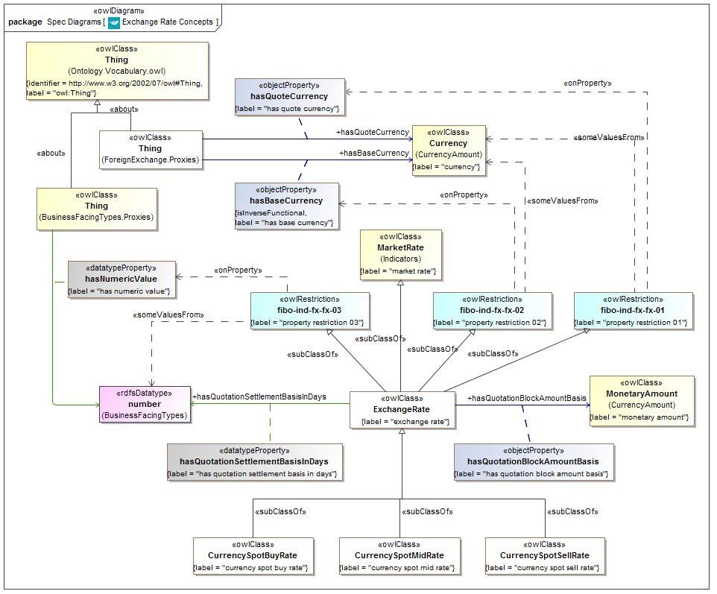

**Figure 9.3 Foreign Exchange: Exchange Rate Concepts**

Diagram showing the basic concepts in the Foreign Exchange ontology.

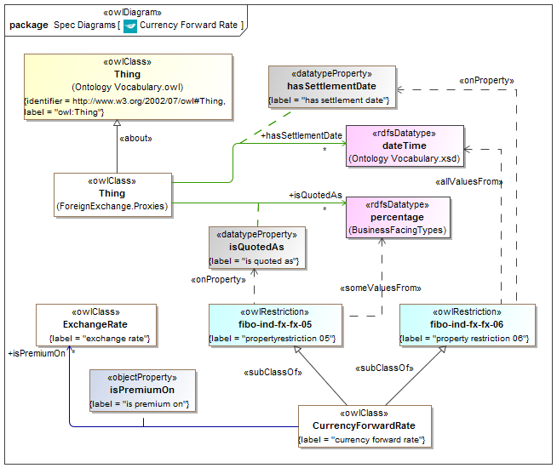

**Figure 9.4 Foreign Exchange: Forward Rate Concepts**

Diagram showing forward rate concepts in the Foreign Exchange ontology.

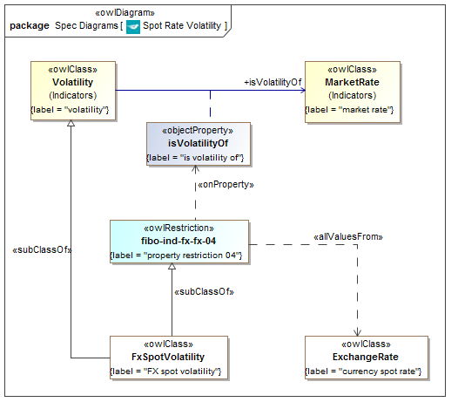

**Figure 9.5 Foreign Exchange: Spot Volatility Concepts**

Diagram showing the concepts of spot rate volatility in the Foreign Exchange ontology.

Table 9.6 Foreign Exchange Details

**Classes**

| **Name** | **Label** | **Definition** | **Parent** | **Explanatory Note** |
| --- | --- | --- | --- | --- |
| CurrencyForwardRate | currency forward rate | The rate of exchange between two currencies for settlement at some future point in time, expressed as a premium on the spot rate. | property restriction 06 property restriction 05 measure |  |
| CurrencySpotBuyRate | currency spot buy rate | an indicative spot buying market rate as observed by the reporting source. | exchange rate |  |
| CurrencySpotMidRate | currency spot mid rate | an indicative middle market (mean of spot buying and selling) rates as observed by the reporting source. | exchange rate |  |
| CurrencySpotSellRate | currency spot sell rate | an indicative spot selling market rate as observed by the reporting source. | exchange rate |  |
| ExchangeRate | exchange rate | An indicative, quoted exchange rate at a point in time, for a given block amount of currency as quoted against another (base) currency, for settlement at a defined point in the immediate future. | property restriction 03 property restriction 02 property restriction 01 market rate | For example an exchange rate of R represents a rate of R units of the dealt currency to 1 unit of the base currency. |
| FxSpotVolatility | FX spot volatility | A measure of exchange rate fluctuation. Mathematically the volatility is the annualized standard deviation of the daily changes in the exchange rate | volatility property restriction 04 |  |

**Properties**

| **Name** | **Label** | **Domain** | **Range** | **Definition** | **Explanatory Note** |
| --- | --- | --- | --- | --- | --- |
| hasBaseCurrency | has base currency |  | currency | a predicate indicating the base currency in an exchange rate; one unit of this currency represents R units of the dealt currency, where R is the exchange rate value |  |
| hasQuotationBlock AmountBasis | has quotation block amount basis | exchange rate | monetary amount | the amount of the dealt currency which would be exchanged in a trade for which the stated spot rate applies |  |
| hasQuotationSettlement BasisInDays | has quotation settlement basis in days | exchange rate | number | the settlement period in days for a trade for which the stated spot rate applies |  |
| hasQuoteCurrency | has quote currency |  | currency | a predicate indicating the quote currency in an exchange rate; R units of this currency represent one unit of the base currency |  |
| hasSettlementDate | has settlement date |  | xsd:dateTime | a predicate indicating the settlement date of a given transaction |  |
| isPremiumOn | is premium on | currency forward rate | exchange rate | The currency forward rate is expressed as a premium on the spot rate for the currency pair |  |
| isQuotedAs | is quoted as |  | percentage | the forward rate expressed as a percentage of the corresponding spot rate | the forward rate, being quoted as a premium on the spot rate, is quoted as a percentage figure |

**Restrictions**

|  |  |  |
| --- | --- | --- |
| **Name** | **Label** | **Expressions** |
| fibo-ind-fx-fx-01 | property restriction 01 | hasQuoteCurrency some Currency |
| fibo-ind-fx-fx-02 | property restriction 02 | hasBaseCurrency some Currency |
| fibo-ind-fx-fx-03 | property restriction 03 | hasNumericValue some number |
| fibo-ind-fx-fx-04 | property restriction 04 | isVolatilityOf only ExchangeRate |
| fibo-ind-fx-fx-05 | property restriction 05 | isQuotedAs some percentage |
| fibo-ind-fx-fx-06 | property restriction 06 | hasSettlementDate only dateTime |

## 9.4 Module: Interest Rates

Table 9.7 Interest Rates Module Metadata

| **Metadata Term** | **Value** |
| --- | --- |
| **sm:moduleName** | InterestRates |
| **sm:moduleAbbreviation** | FIBO-IND-IR |
| **sm:moduleVersion** | 1.0 |
| **sm:moduleAbstract** | This module includes ontologies defining concepts to do with interest rates, that is rates of interest paid on capital by banks and other lenders, including inter-bank lending rates and rates of certain representative debt instruments. |

### 9.4.1 Ontology: Interest Rates

This ontology provides the basic types of interest rate which are recognized in the financial markets, and the relationships between these where applicable. These include bank base rates, inter-bank offer rates, overnight rates of interest and the US Federal Funds rate which is widely used as a rate of reference. It also includes the concept of a market rate spread between two interest rates.

Table 9.8 Interest Rates Ontology Metadata

|  |  |
| --- | --- |
| **Metadata Term** | **Value** |
| **sm:filename** | InterestRates |
| **sm:fileAbbreviation** | fibo-ind-ir-ir |
| **OntologyIRI** | http://www.omg.org/spec/EDMC-FIBO/IND/InterestRates/InterestRates/ |
| **owl:versionIRI** | http://www.omg.org/spec/EDMC-FIBO/IND/20140201/InterestRates/InterestRates/ |
| **sm:dependsOn** | http://www.omg.org/techprocess/ab/SpecificationMetadata/  http://www.omg.org/spec/EDMC-FIBO/FND/Utilities/AnnotationVocabulary/ |

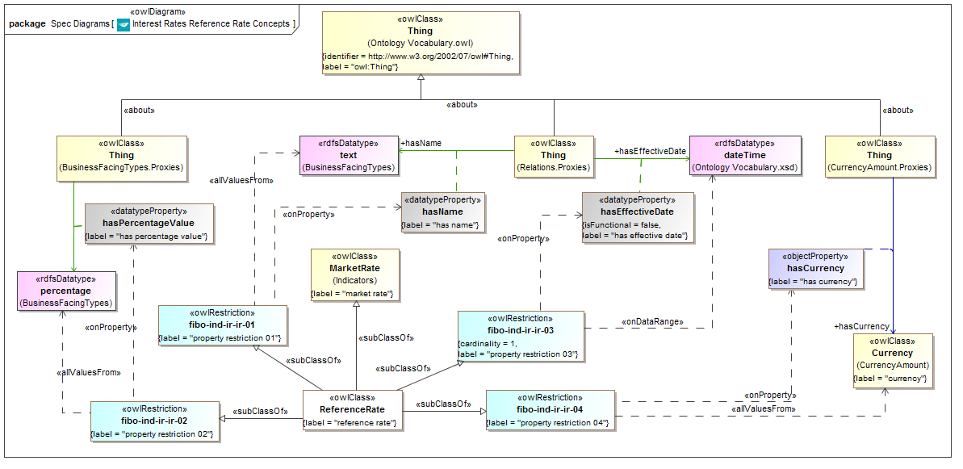

**Figure 9.6 Interest Rates Concepts**

Diagram showing the main concepts for interest reference rate in the Interest Rates ontology.

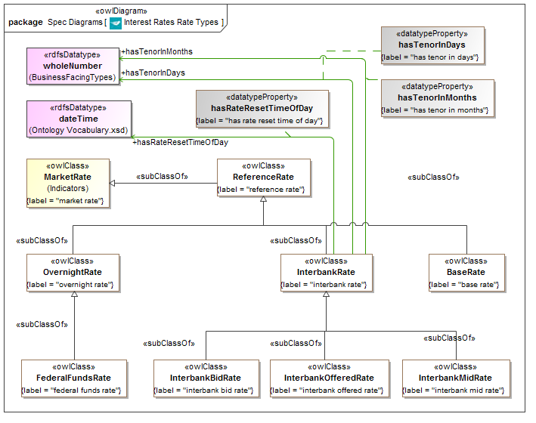

**Figure 9.7 Interest Rates Types**

Diagram showing the types of interest rate in the Interest Rates ontology.

Table 9.9 Interest Rates Details

**Classes**

| **Name** | **typeOfThing** | **definition** | **parent** | **explanatoryNote** |
| --- | --- | --- | --- | --- |
| ReferenceRate | reference rate | a market rate that is a rate of interest paid by or agreed among some bank or set of banks | property restriction 04 property restriction 03 property restriction 02 property restriction 01 market rate | The reference rate is a moving index such as LIBOR, the prime rate or the rate on benchmark U.S. Treasuries. |
| OvernightRate | overnight rate | a reference rate that is an interest rate at which a depository institution lends funds to another depository institution (short-term), or the interest rate the central bank charges a financial institution to borrow money overnight | reference rate | The overnight rate is the lowest available interest rate, and as such, it is only available to the most creditworthy institutions. It is the underlying rate for Overnight Interest Rate Swaps (IOS). |
| InterbankRate | interbank rate | a reference rate that is the rate of interest charged on short-term loans between banks | reference rate | Banks borrow and lend money in the interbank market in order to manage liquidity and meet the requirements placed on them. The interest rate charged depends on the availability of money in the market, on prevailing rates and on the specific terms of the contract, such as term length. |
| InterbankOfferedRate | interbank offered rate | an interbank rate that is the interest rate at which participating banks lend money | interbank rate |  |
| InterbankMidRate | interbank mid rate | an interbank rate that represents the mid-point between bid and offer rates | interbank rate |  |
| InterbankBidRate | interbank bid rate | an interbank rate that is the interest rate at which participating banks are willing to borrow deposits from other banks | interbank rate | Unlike an interbank offered rate, which is the rate at which banks lend money, an interbank bid rate is the rate at which banks ask to borrow. |
| FederalFundsRate | federal funds rate | a reference rate that is the interest rate at which a depository institution lends funds maintained at the Federal Reserve to another depository institution overnight. | overnight rate | By trading government securities, the New York Fed affects the federal funds rate, which is the interest rate at which depository institutions lend balances to each other overnight. The Federal Open Market Committee establishes the target rate for trading in the federal funds market. The federal funds rate is generally only applicable to the most creditworthy institutions when they borrow and lend overnight funds to each other. The federal funds rate is one of the most influential interest rates in the U.S. economy, since it affects monetary and financial conditions, which in turn have a bearing on key aspects of the broad economy including employment, growth and inflation. The Federal Open Market Committee (FOMC), which is the Federal Reserve's primary monetary policymaking body, telegraphs its desired target for the federal funds rate through open market operations. |
| BaseRate | base rate | a reference rate that is the base rate set by a central bank for a given currency | reference rate | This is set at intervals. |

**Properties**

|  |  |  |  |  |
| --- | --- | --- | --- | --- |
| **Name** | **Label** | **Domain** | **Range** | **Definition** |
| hasRateResetTimeOfDay | has rate reset time of day | interbank rate | xsd:dateTime | a predicate indicating the time of day when the rate is reset e.g., 11:00 |
| hasTenorInDays | has tenor in days | interbank rate | whole number | a predicate indicating the length of time for which the interbank rate is quoted expressed as a number of days |
| hasTenorInMonths | has tenor in months | interbank rate | whole number | a predicate indicating the length of time for which the interbank rate is quoted, e.g., 3 months, 6 months expressed as a number of months |

**Restrictions**

|  |  |  |
| --- | --- | --- |
| **Name** | **Label** | **Expressions** |
| fibo-ind-ir-ir-01 | property restriction 01 | hasName only text |
| fibo-ind-ir-ir-02 | property restriction 02 | hasPercentageValue only percentage |
| fibo-ind-ir-ir-03 | property restriction 03 | hasEffectiveDate exactly 1 dateTime |
| fibo-ind-ir-ir-04 | property restriction 04 | hasCurrency only Currency |

### 9.4.2 Ontology: Interest Rate Publishers

This ontology provides concepts descriptive of the publishers of interest rates, such as banks and the bodies which publish inter-bank offer rates.

Table 9.10 Interest Rate Publishers Ontology Metadata

|  |  |
| --- | --- |
| **Metadata Term** | **Value** |
| **sm:filename** | InterestRatePublishers |
| **sm:fileAbbreviation** | fibo-ind-ir-pub |
| **OntologyIRI** | http://www.omg.org/spec/EDMC-FIBO/IND/InterestRates/InterestRatePublishers/ |
| **owl:versionIRI** | http://www.omg.org/spec/EDMC-FIBO/IND/20140601/InterestRates/InterestRatePublishers/ |
| **sm:dependsOn** | http://www.omg.org/techprocess/ab/SpecificationMetadata/  http://www.omg.org/spec/EDMC-FIBO/FND/Utilities/AnnotationVocabulary/ |

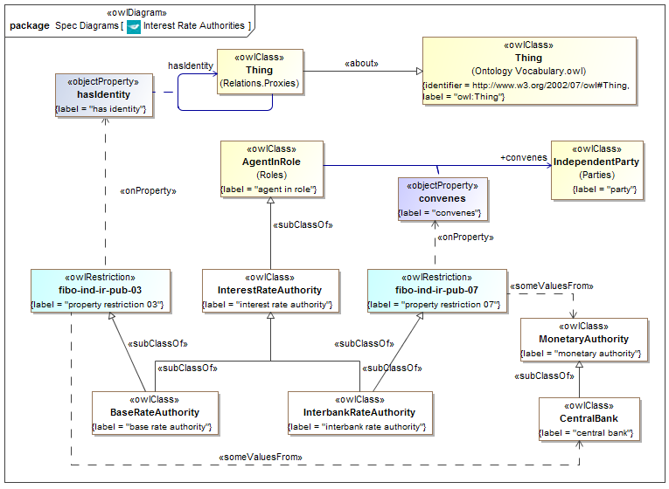

**Figure 9.8 Interest Rate Publishers Concepts**

Diagram showing the main types of Interest Rate Publishers.

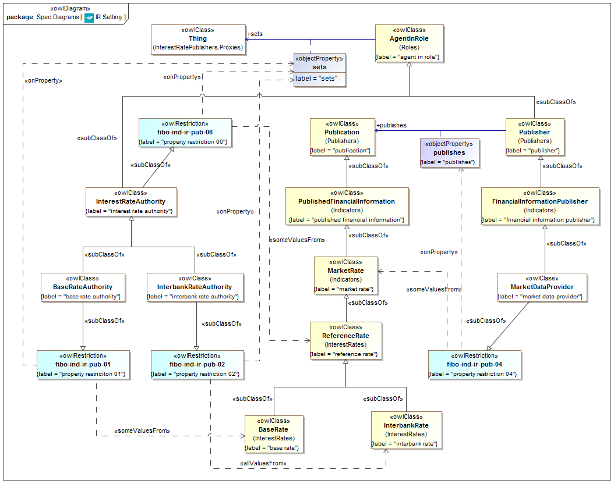

**Figure 9.9 Interest Rate Setting and Publishing Concepts**

Diagram showing the above Interest Rate Publishers in terms of what types of rates they set. This diagram also shows the role of the market data provider in publishing rates set by these (for example the LIBOR rate is set by a committee but subsequently published by a specific market data provider).

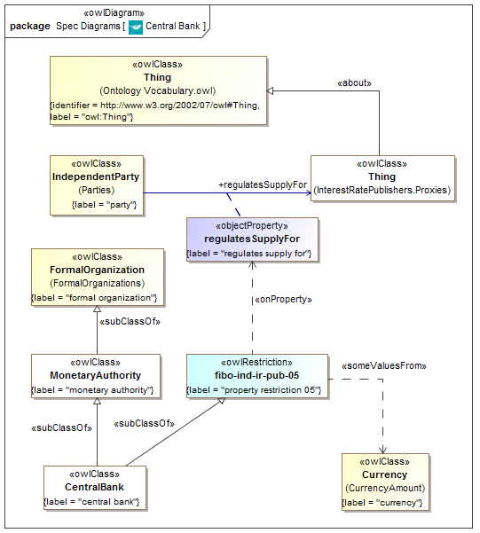

**Figure 9.10 Interest Rate Publishers Central Bank Concepts**

Diagram showing the concept of a central bank.

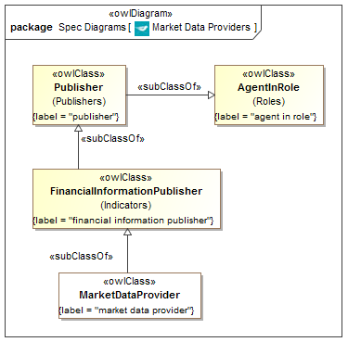

**Figure 9.11 Interest Rate Publishers Market Data Provider**

Diagram showing the concept of a market data provider.

Table 9.11 Interest Rate Publishers Details

**Classes**

| **Name** | **Label** | **definition** | **parent** | **explanatoryNote** |
| --- | --- | --- | --- | --- |
| BaseRateAuthority | base rate authority | an interest rate authority responsible for setting the base rate for a given currency, typically a central bank | interest rate authority property restriction 01 property restriction 03 |  |
| CentralBank | central bank | a monetary authority or institution that is a bank and that manages the currency, money supply, and interest rates for a state or group of states which share a currency | property restriction 05 monetary authority |  |
| InterbankRateAuthority | interbank rate authority | an interest rate authority responsible for setting the Interbank rate | interest rate authority property restriction 02 property restriction 07 | This is announced by the relevant Central Bank at intervals following a meeting of the relevant policy group or committee. Thomson Reuters is the publisher for LIBOR, but this is set by the British Bankers Association (BBA). |
| InterestRateAuthority | interest rate authority | an authority responsible for the publication of some interest rate | agent in role property restriction 06 | Interest rates which are referred to as market rates, for example as used in interest rate derivatives, are published by some authority responsible for the rate as a kind of market data. |
| MarketDataProvider | market data provider | a publisher that publishes data about the financial markets. | property restriction 04 financial information publisher |  |
| MonetaryAuthority | monetary authority | a formal organization that controls the monetary policy, regulation and supply of money in some country or group of countries | formal organization |  |

**Properties**

|  |  |  |  |  |  |
| --- | --- | --- | --- | --- | --- |
| **Name** | **Label** | **Domain** | **Range** | **Definition** | **Parent** |
| convenes | convenes | agent in role | party | a predicate indicating that someone acting in the role of convenor brings together some number of individuals for a meeting or conference; assembles; makes arrangements for a meeting to take place |  |
| regulatesSupplyFor | regulates supply for | party | Thing | a predicate indicating that someone controls or supervises the amount of something available in some market by means of rules and regulations | governs |
| sets | sets | agent in role | Thing | a predicate indicating that someone places something in some relationship to something or someone else | provides |

**Restrictions**

| **Name** | **Label** | **Expressions** |
| --- | --- | --- |
| fibo-ind-ir-pub-01 | property restriction 01 | sets some BaseRate |
| fibo-ind-ir-pub-02 | property restriction 02 | sets only InterbankRate |
| fibo-ind-ir-pub-03 | property restriction 03 | haIdentity some CentralBank |
| fibo-ind-ir-pub-04 | property restriction 04 | publishes some MarketRate |
| fibo-ind-ir-pub-05 | property restriction 05 | regulatesSupplyFor some Currency |
| fibo-ind-ir-pub-06 | property restriction 06 | sets some ReferenceRate |
| fibo-ind-ir-pub-07 | property restriction 07 | convenes some MonetaryAuthority |

## 9.5 Module: Economic Indicators

Table 9.12 Economic Indicators Module Metadata

|  |  |
| --- | --- |
| **Metadata Term** | **Value** |
| **sm:moduleName** | EconomicIndicators |
| **sm:moduleAbbreviation** | FIBO-IND-EI |
| **sm:moduleVersion** | 1.0 |
| **sm:moduleAbstract** | This module includes ontologies defining concepts to do with published economic indicators. These give some indication of the state of some economy. Indicators of this type are usually published by governments or government agencies, or by international agencies or agencies of countries other than the ones reported on. Examples include Gross Domestic Product (GDP) and unemployment rates. |

### 9.5.1 Ontology: Economic Indicators

This ontology provides the parameters which make up the various types of market economic indicators, along with basic facts about these such as the economies or countries they apply to.

Table 9.13 Economic Indicators Ontology Metadata

| **Metadata Term** | **Value** |
| --- | --- |
| **sm:filename** | EconomicIndicators |
| **sm:fileAbbreviation** | fibo-ind-ei-ei |
| **OntologyIRI** | http://www.omg.org/spec/EDMC-FIBO/IND/EconomicIndicators/EconomicIndicators/ |
| **owl:versionIRI** | http://www.omg.org/spec/EDMC-FIBO/IND/20140601/EconomicIndicators/EconomicIndicators/ |
| **sm:dependsOn** | http://www.omg.org/techprocess/ab/SpecificationMetadata/  http://www.omg.org/spec/EDMC-FIBO/FND/Utilities/AnnotationVocabulary/ |

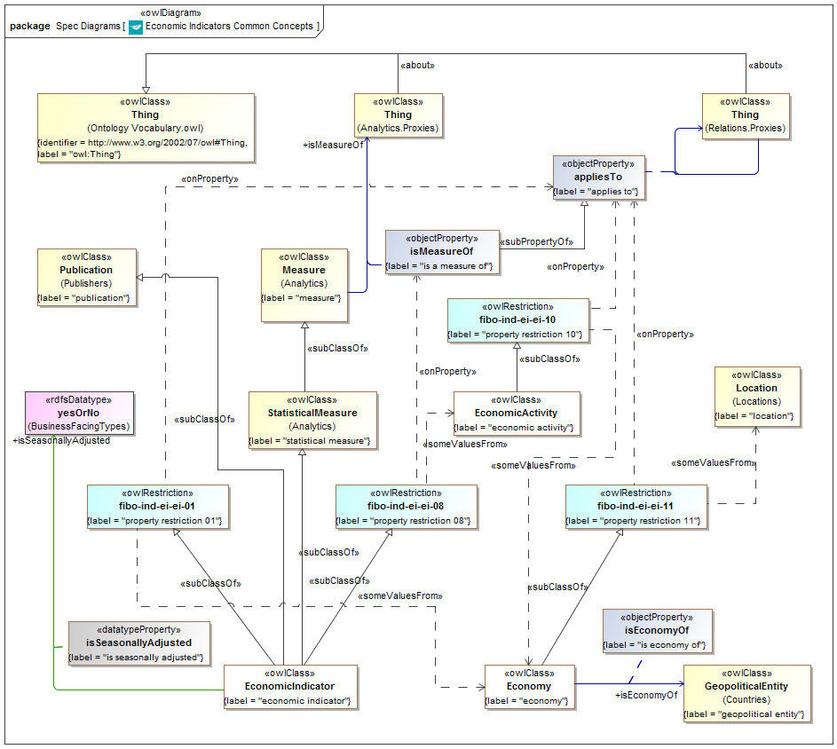

**Figure 9.12 Economic Indicators Common Concepts**

Diagram showing all the concepts common to economic indicators in the Economic Indicators ontology.

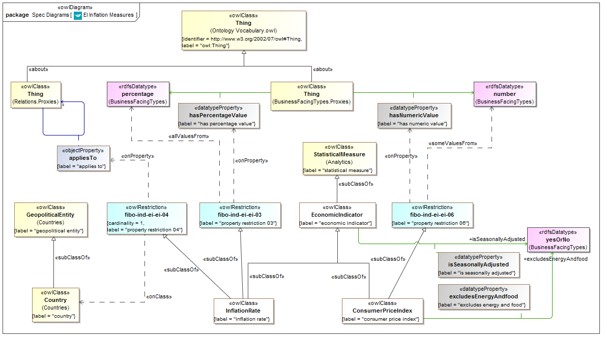

**Figure 9.13 Economic Indicators Inflation Measures**

Diagram showing inflation measures concepts in the Economic Indicators ontology.

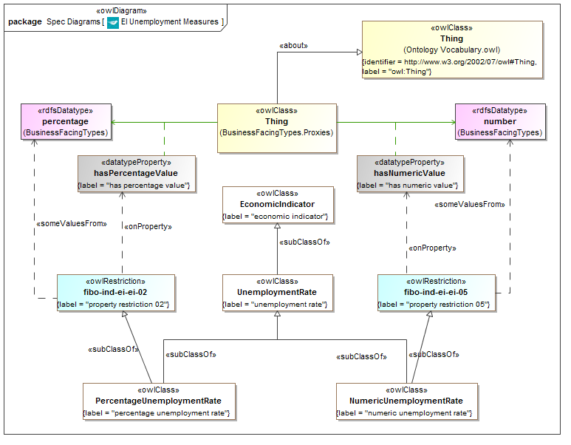

**Figure 9.14 Economic Indicators Unemployment Statistics**

Diagram showing unemployment index concepts in the Economic Indicators ontology.

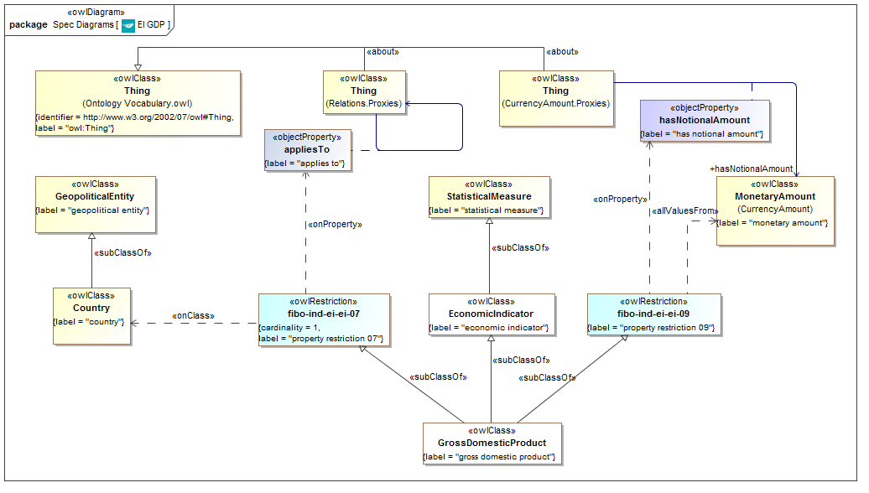

**Figure 9.15 Economic Indicators Gross Domestic Product**

Diagram showing GDP concepts in the Economic Indicators ontology.

Table 9.14 Economic Indicators Details

**Classes**

| **Name** | **Label** | **Definition** | **Parent** | **Disjoint with** | **Explanatory Note** | **Definition Source** |
| --- | --- | --- | --- | --- | --- | --- |
| ConsumerPriceIndex | consumer price index | an economic indicator representing a measure of the average change over time in the prices paid by urban consumers for a market basket of consumer goods and services | economic indicator property restriction 06 | gross domestic product unemployment rate |  | http://stats.bls.gov/ cpi/cpifaq.htm  #Question\_1 |
| EconomicActivity | economic activity | an aspect of the behavior of some economic actor in an economy, related to the production, distribution, and consumption of goods and services | property restriction 10 |  |  |  |
| EconomicIndicator | economic indicator | a statistical measure of an economic activity, used for analysis of economic performance and predictions of future performance | property restriction 01 property restriction 08 statistical measure  publication |  |  |  |
| Economy | economy | An economy consists of the production, distribution or trade, and consumption of limited goods and services by different economic actors in a given geographically distinct web of relationships. | property restriction 11 |  |  |  |
| GrossDomestic Product | gross domestic product | an economic indicator representing the broadest measure of aggregate economic activity, measuring the total value of all final goods and services produced within a country's borders during a specific period | property restriction 07 economic indicator property restriction 09 | consumer price index unemployment rate |  | [http://www.treasury.gov/ initiatives/ofr/about/](http://www.treasury.gov/initiatives/ofr/about/ Documents/AR2013_Back_ Matter_Glossary+Bib_Refs +Endnotes.pdf)  [Documents/ AR2013\_Back\_](http://www.treasury.gov/initiatives/ofr/about/ Documents/AR2013_Back_ Matter_Glossary+Bib_Refs +Endnotes.pdf)  [Matter\_Glossary +Bib\_Refs](http://www.treasury.gov/initiatives/ofr/about/ Documents/AR2013_Back_ Matter_Glossary+Bib_Refs +Endnotes.pdf)  [+Endnotes.pdf](http://www.treasury.gov/initiatives/ofr/about/ Documents/AR2013_Back_ Matter_Glossary+Bib_Refs +Endnotes.pdf) |
| InflationRate | inflation rate | an economic indicator representing a percent change in consumer prices for a specified, typically a one-year, period, for a given country | property restriction 04 economic indicator property restriction 03 |  |  |  |
| Numeric  UnemploymentRate | numeric unemployment rate | an economic indicator representing the number of unemployed in the labor force of a given economy for some specified period | property restriction 05 unemployment rate |  |  |  |
| Percentage  UnemploymentRate | percentage unemployment rate | an economic indicator representing the ratio of unemployment to the labor force of a given economy for some specified period expressed in percentage terms | property restriction 02 unemployment rate |  |  |  |
| UnemploymentRate | unemployment rate | an economic indicator representing the level of unemployment to the labor force of a given economy for some specified period | economic indicator | gross domestic product consumer price index | Persons are classified as unemployed if they do not have a job, have actively looked for work in the prior 4 weeks, and are currently available for work. Workers expecting to be recalled from layoff are counted as unemployed, whether or not they have engaged in a specific jobseeking activity. In all other cases, the individual must have been engaged in at least one active job search activity in the 4 weeks preceding the interview and be available for work (except for temporary illness). |  |

**Properties**

| **Name** | **Label** | **Domain** | **Range** | **Definition** | **Explanatory Note** |
| --- | --- | --- | --- | --- | --- |
| excludesEnergyAndfood | excludes energy and food | consumer price index | yes or no | a predicate indicating whether the index excludes energy and food prices |  |
| isEconomyOf | is economy of | economy | geopolitical entity | a predicate relating an economy to the geopolitical entity it refers to |  |
| isSeasonallyAdjusted | is seasonally adjusted | economic indicator | yes or no | a predicate indicating whether some published formal method is applied that compensates for seasonal variations in the index value | Example explanation from the US Bureau of Labor and Statistics: Because price data are used for different purposes by different groups, the Bureau of Labor Statistics publishes seasonally adjusted as well as unadjusted changes each month. ... Seasonal factors used in computing the seasonally adjusted indexes are derived by the X-13ARIMA-SEATS Seasonal Adjustment Method. Seasonally adjusted indexes and seasonal factors are computed annually. Each year, the last five years of seasonally adjusted data are revised. |

**Restrictions**

| **Name** | **Label** | **Expressions** |
| --- | --- | --- |
| fibo-ind-ei-ei-01 | property restriction 01 | appliesTo some Economy |
| fibo-ind-ei-ei-02 | property restriction 02 | hasPercentageValue some percentage |
| fibo-ind-ei-ei-03 | property restriction 03 | hasPercentageValue only percentage |
| fibo-ind-ei-ei-04 | property restriction 04 | appliesTo exactly 1 Country |
| fibo-ind-ei-ei-05 | property restriction 05 | hasNumericValue some number |
| fibo-ind-ei-ei-06 | property restriction 06 | hasNumericValue some number |
| fibo-ind-ei-ei-07 | property restriction 07 | appliesTo exactly 1 Country |
| fibo-ind-ei-ei-08 | property restriction 08 | isMeasureOf some EconomicActivity |
| fibo-ind-ei-ei-09 | property restriction 09 | hasNotionalValue only MonetaryAmount |
| fibo-ind-ei-ei-10 | property restriction 10 | appliesTo some Economy |
| fibo-ind-ei-ei-11 | property restriction 11 | appliesTo some Location |

### 9.5.2 Ontology: Economic Indicator Publishers

This ontology provides concepts descriptive of the publishers of market indicators, such as gross domestic product, employment statistics, inflation rates and so on. These may include government or quasi-government bodies, international agencies, third parties and data providers.

Table 9.15 Economic Indicator Publishers Ontology Metadata

| **Metadata Term** | **Value** |
| --- | --- |
| **sm:filename** | EconomicIndicatorPublishers |
| **sm:fileAbbreviation** | fibo-ind-ei-pub |
| **OntologyIRI** | http://www.omg.org/spec/EDMC-FIBO/IND/EconomicIndicators/EconomicIndicatorPublishers/ |
| **owl:versionIRI** | http://www.omg.org/spec/EDMC-FIBO/IND/20140601/EconomicIndicators/EconomicIndicatorPublishers/ |
| **sm:dependsOn** | http://www.omg.org/techprocess/ab/SpecificationMetadata/  http://www.omg.org/spec/EDMC-FIBO/FND/Utilities/AnnotationVocabulary/ |

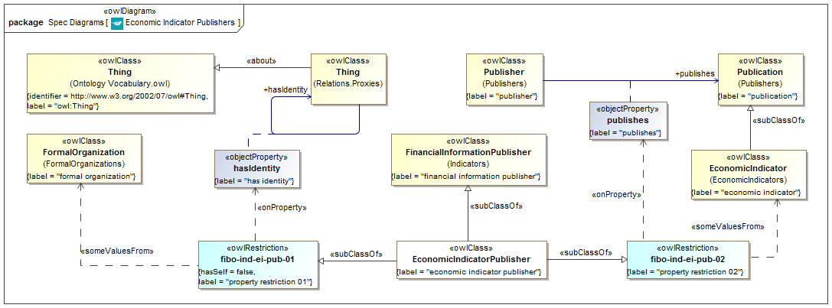

**Figure 9.16 Economic Indicator Publishers Concepts**

Diagram showing all of the concepts in the Economic Indicators Publishers ontology.

Table 9.16 Economic Indicator Publishers Details

**Classes**

| **Name** | **Label** | **definition** | **parent** |
| --- | --- | --- | --- |
| EconomicIndicatorPublisher | economic indicator publisher | a financial information publisher that publishes economic indicators | financial information publisher property restriction 01 property restriction 02 |

**Restrictions**

|  |  |  |
| --- | --- | --- |
| **Name** | **Label** | **Expressions** |
| fibo-ind-ei-pub-01 | property restriction 01 | hasIdentity some FormalOrganization |
| fibo-ind-ei-pub-02 | property restriction 02 | publishes some EconomicIndicator |

# Annex A: Machine-readable files Accompanying this Specification

(normative)

The FIBO ontologies are delivered as (1) RDF/XML serialized OWL (normative and definitive), (2) UML XMI, serialized from UML with the ODM profiles for RDF and OWL applied (normative), (3) ODM XMI, serialized based on the ODM MOF metamodels for RDF and OWL (normative), and (4) ancillary Visual Ontology Modeler (VOM) model files, based on the VOM plug-in to MagicDraw (informative). If there are differences between the OWL files, ODM XMI, and UML XMI, the OWL files take precedence, followed by the UML XMI, and finally the ODM XMI.

Regardless of their form, each of the ontologies included in Indices and Indicators makes normative reference to the DCMI Dublin Core Metadata Terms [Dublin Core], W3C Simple Knowledge Organization System (SKOS) Recommendation [SKOS] and the OMG Architecture Board’s Specification Metadata Recommendation [OMG AB Specification Metadata], which are not part of this specification.

The individual RDF/XML files are organized by module (directory), and within a given module, alphabetically by name, as shown in the URI structure for each individual OWL file. These files are UTF-8 conformant XML Schema files that are also OWL 2 compliant, and may be examined using any text editor, XML editor, or RDF or OWL editor. They have been verified for syntactic correctness via the W3C RDF Validator and University of Manchester OWL 2 Validator. They have also been checked for logical consistency using the Pellet OWL 2 reasoner from Clark & Parsia as well as the HermiT OWL 2 reasoner from Oxford University. It is anticipated that the OWL ontologies will be dereference-able, together with technical documentation (HTML) from the OMG site once the specification is adopted.