Functional Specification

Purpose

To instruct a user on how to build a 3D-gaming quality desktop computer from its individual components.

Scope

The guide will explain all the components that a desktop computer comprises of. It will cover the functionality of each component and will advise making informed decisions on purchases. Installation of hardware will be detailed with the user’s safety in mind. Operating system software setup will also be covered.

With the exception of the processor, installation and setup of specific makes and models of hardware will not be included. The instructions are intended to be brand-agnostic, though the technologies will be constant. For example, there can only be one way to install an Intel processor regardless of what motherboard is used.

Installation of software such as games and productivity software will also not be covered.

Prerequisites/Requirements

The audience for this guide will be individuals who have never built a personal computer given individual components like memory modules or hard drives. The user may be familiar with the function of each component and can visually identify them, but will not have a technical background.

A user should be comfortable using simple tools, specifically screwdrivers. A Philips screwdriver is necessary to complete the steps, though a flathead will be handy to have nearby. Use of an antistatic wrist strap is also recommended. Many of items to be handled are sensitive to static electricity discharge and can be damaged easily. Wearing the wrist strap while working grounds the user and will reduce the risk of damage from electrostatic discharge.

The procurement of the hardware and software required for this task deserves attention on its own separate from the steps described in the guide.

Preliminary Steps

Acquiring the correct components is more important than the act of installing the hardware and software. Time and research must be conducted

Setting a Budget

Since the intention of the guide is to build a 3D-gaming quality computer, a premium must be paid on certain components. This allows the gaming experience to be much more fulfilling while preventing undue stress when hardware cannot keep up with a resource-intensive game.

Expect to spend approximately $2000 purchasing the computer hardware. Most of this expenditure comes from the processor and video card, and more details on each component are given below.

Hardware and Software

The only software required when building a new desktop is an operating system. Because most 3D games are developed for Windows users, it is recommended to purchase and install Windows 7.

Because computer hardware improves at a rapid pace, it is important to purchase components that will not become outdated in the few years after building the computer. It is equally important to not purchase the newest parts because they tend to be the most expensive and have not proven their reliability. It is advisable to purchase parts that have been on the market for several months, allowing for time help lower the prices of such parts as newer, more expensive parts become available for purchase.

Purchasing Components

Most components may be purchased at a local Fry’s Electronics or at smaller individually run shops. Be advised that if looking for a particular model of an item, a larger store such as Fry’s will more likely carry the part.

Purchasing online is also an excellent option. The added benefit of online shopping is reading the reviews and feedback given by other users. This information is particularly useful during the decision process as other users will often write about incompatibilities with other hardware in their reviews. Newegg.com and tigerdirect.com are excellent stores and carry a large inventory of computer products and other electronics.

Procedures

The following procedures should be performed in the order specified. Before handling any of the computer’s components, it is advisable to wear an anti-static wrist strap to minimize the chance of damage from static electricity.

1. Prepare the case and install the motherboard.
2. Install the CPU.
3. Attach the CPU fan.
4. Insert RAM modules.
5. Install hard drive and DVD-ROM drive.
6. Insert video card.
7. Reconnect power supply and connect cables.
8. Connect monitor and other external devices.
9. Install operating system.
10. Configure hardware.

Prepare the Case and Install the Motherboard

1. Remove the side of the case. Many cases will have a way of easily detaching the side, usually with screws in the back that loosen by hand. Remove the screws and slide the side of the case towards the back. Finally lift the side away.
2. Remove the power supply (optional). Depending on the height of the case, removing the power supply may allow for more room to work. To remove the power supply, find the four screws that secure it to the back of the case. Remove the screws one by one, taking care to hold the bottom of the power supply so that it doesn’t fall.
3. Secure the motherboard. The motherboard can now be secured to the inside of the case on the side that we did not remove in step one. Holes will be in the motherboard that align with holes in the side of the case. Use a screwdriver and screws that came with the case to secure the motherboard. It should not move at all when screwed in properly.

Install the CPU

The 1366 socket on the motherboard is where the CPU is placed. The socket has a locking mechanism for keeping the CPU in place (see figure 3).

1. Lift the handle to move the covering plate from the socket. Lift the handle on the side of the socket away from the motherboard. This allows for the plate to move aside.
2. Place the CPU in the socket. The CPU has 2 small indentations that will match with marks on the socket. The CPU must align correctly or the system will not function properly and the CPU may become damaged.
3. Secure the CPU. Move the cover plate back so that it sits on top of the CPU. Push the handle from step one back towards the motherboard until it clicks in place and the CPU is secured.

Attach the CPU Fan

Without a CPU fan to disperse the heat generated during operation, the CPU may overheat and be damaged.

1. Apply thermal paste to the top of the CPU. Spread a very thin layer of thermal grease on the CPU, just enough so that you can’t see the top of the CPU and just the white of the paste.
2. Screw the fan into the motherboard. The fan will have four screws that align with four holes located around the CPU socket. Center the fan over the center of the CPU. With a screwdriver, turn each screw until they cannot be turned further, about 1-1.5 turns.

Insert RAM Modules

RAM may be bundled in one, two, or three modules, called “sticks”. If you purchased a bundle containing more than one stick, all must be installed.

1. Align RAM in the slot. There will be notch in the pins at the bottom of the RAM stick. The notch aligns with a mark on the slot on the motherboard.
2. Push the stick into the slot. Holding the stick with your index fingers on the edges and your thumbs on the top, push the stick down directly into the motherboard. If successful, the stick will audibly click into place.
3. Repeat the process for remaining sticks. Each RAM slot will be directly next to another one. This pair of slots is called a “bank” and the motherboard may have several banks. When installing a 2nd or 3rd stick of RAM, any stick beyond the first must be installed in a separate bank from the first.

Install Hard Drive and DVD-ROM Drive

Locate the “cage” inside the case. This metal part of the chassis is located near the front of the case and contains slots for securing the hard drive, DVD-ROM drive, and any other such devices you may have, like floppy or ZIP drives.

1. Remove plastic plate from front of case. This plastic plate corresponds to where the DVD-ROM drive will stay. Remove it by pushing on it from inside the case. It should pop off and expose a slot for a device.
2. Slide the DVD-ROM drive into the slot. Push the drive back-first into the slot created in step one. Looking at the drive from the side of the case, align the drive such that the holes on the side of the drive align with slots in the chassis for securing.
3. Screw the drive into the chassis. Using screws that were either included with the case or the drive, secure the drive in place.
4. Slide the hard drive into an available slot. It is not necessary to install the hard drive in one of the larger slots that a device like the DVD-ROM drive requires. Select one below the larger slots and insert the hard drive such that the back of the drive (the back will have slots for cables) is facing the back of the case.
5. Screw the hard drive in place. Like securing the DVD-ROM drive, align the holes in the side of the hard drive with slots in the chassis and secure the hard drive using screws.
6. Connect the SATA cable from the hard drive to the motherboard. The motherboard will allow for several SATA devices to connect at the same time. Plug the cable from the hard drive into any one of these slots.
7. Connect the IDE cable from the DVD-ROM drive to the motherboard. Like the SATA interfaces, the motherboard will have several slots for connectivity to IDE devices like the DVD-ROM drive or floppy drives.

Insert Video Card

1. Remove metal plates from the back of the case. A high-end video card will have a large fan attached to it. One end of the video card will have a metal plate going along the height of the card and from which connectors available for connecting to your monitor. Temporary metal plates must be removed from the back of the case so that the video card may slide into the place where these plates previously occupied.
2. Align the video card in the slot. There will be notches in the pins at the bottom of the video card stick. These notches will align with a mark on the slot on the motherboard.
3. Push the video card into the slot. Holding the video card with your thumbs on top, push the video card into the motherboard until you hear an audible click.

Connect Power Supply

If you removed the power supply when preparing the case and installing the motherboard, then it must be reattached at this time. Align the holes in the back of the power supply with those in the back of the case and screw the power supply back into place.

1. Attach the power supply to the motherboard. Attach the cable from the power supply that has a 20-pin connector to the slot in the motherboard.
2. Connect the power switch to the motherboard. This cable will be long and thin, and the connector will be labeled “power”. This is connected to pins that stick out from the motherboard near the bottom right.
3. Attach fan cables. Each fan in the computer, including the CPU fan, video card fan, and one or more case fans will have a 3 pin connector that will plug in to exposed sets of 3 pins distributed around the motherboard. If you run out of pins to plug into, the power supply may have extra cables with appropriate terminating connectors to plug in to.
4. Connect hard drive and DVD-ROM drive to the power supply. The power supply will have several cables with 4-pin molex connectors which interface with hard drives, the DVD-ROM drive, and any other IDE devices you may have.

Connect Monitor and Other External Devices

Installation of all the computer’s internal components is now complete and peripherals are to be connected to appropriate ports.

1. Connect the monitor. Use a DVI cable to connect the monitor to the port on the back of the video card. DVI transfers a digital signal and will provide a slightly better visual experience.
2. Connect networking. If you have a wired connection to your home network or the internet, connect your RJ-45 cable to the Ethernet port. Most modern motherboards will have built-in Ethernet and will have a port. If you use wireless networking in the form of a USB wireless adapter, attach it to a USB port. If you have a wireless card that installs into a PCI slot on your motherboard, then follow installation steps similar to those of installing the video card.
3. Connect keyboard and mouse. For wired mice and keyboards, connect them to available USB ports. For wireless devices, connect the sensor to a USB port.

Install the Operating System

Windows 7 is a good choice for the operating system for several reasons. Most 3D games are developed for the Windows platform, though many are available for Mac as well. Almost no games are developed for other operating systems such as Linux or BSD. Windows 7 also supports a large amount of RAM, only being limited in the most basic version (Home Basic) at 8GB. Windows 7 has also been stable during use and many hardware manufacturers provide drivers for Windows.

1. Auto-boot using the Windows disc. When the computer is booting up, you may eject the DVD-ROM drive and insert the Windows disc. You may need to restart the system by pressing Ctrl-Alt-Delete.
2. Follow the steps in the Windows installation. The software will guide you through the installation process. You will be prompted to set up a username and password for future logging in to the computer.
3. Run Windows Update. After successfully completing installation and logging in for the first time, run Windows Update to bring the system up to date with security fixes and updated drivers. Click on the Windows button on the bottom left of the screen. In the search dialog box, type “Windows Update” and hit enter. Follow the prompts and select “update automatically”.

Configure Hardware

Windows will automatically detect and install drivers for most hardware. In general, the drivers provided by the video card manufacturer are preferable over those that are included with Windows. In addition to continual updates from the video card manufacturer, the drivers are often bundled with software that allows you to adjust your video settings to improve performance.

1. Download and install the video card driver from the card’s manufacturer.

* For Nvidia cards, go to <http://www.geforce.com/Drivers>
* For AMD cards, go to

<http://support.amd.com/us/gpudownload/Pages/index.aspx>

Double-click on the file after downloading and follow the prompts to install the updated video card driver.

1. Install drivers for all components Windows does not recognize. Click on the Windows button on the bottom left of the screen. In the search dialog box, enter “device manager” and hit enter. For each item in the list that has a yellow exclamation mark next to it, a driver needs to be installed. To do so, right click on the name of the device and select “properties”. In the window that opens up, click on the “Driver” tab, then click on the “Update Driver” button. If you have a driver disc from the manufacturer, insert that into the DVD-ROM drive now and follow the prompts onscreen for “browse my computer”. Otherwise, select “search automatically”.

|  |  |
| --- | --- |
|  |  |
| Glossary | This is a short list of names of components that the user will be purchasing and installing.   * **Case.** A metal enclosure that will protect the internal hardware components of the computer such as CPU and RAM. * **CPU/Processor.** The central processing unit is a chip that does all the computer’s computations and is essential in operation. * **Motherboard.** A circuit board which all other internal hardware components will attach to either directly or indirectly using cables. * **RAM/Memory.** Chips that attach to the motherboard and assist in operation by storing data, making operation faster. * **Video Card.** Hardware that outputs the digital signals to the monitor for display and is a major component in gaming and animation. * **Hard Drive.** A storage device for saving files. This is where files for the operating system and other applications are stored. * **Sound Card.** Outputs sound generating from software applications to external devices such as speakers or headphones. * **Heatsink.** A component that effectively moves heat away from temperature-sensitive hardware such as the CPU and video card. * **Network Card.** This provides connectivity to home networks and the internet and can come in wired or wireless varities. * **Operating System.** The software that communicates with all system components and acts as an interface for user actions. In this guide, we will install and configure Windows. |
| Troubleshooting | There are two major categories of problems that can occur during the system building and configuration process – power not being provided, or hardware is misconfigured. When powering on the computer, if nothing happens, then the likely cause is a faulty installation of any one of the components described in this document.   * **Properly seat the CPU.** The CPU must be oriented precisely with the grooves in the side of the CPU socket. If done correctly, the CPU will lie flush in the socket and will not move, even before holding it in place with the socket’s metal plate and fastener. * **RAM not installed properly.** Each stick of RAM must click into place when pushed into their respective slots. If any of the metal pins is exposed, use a little bit of downward force. A small groove on the bottom of the RAM will align with a mark on the slot to ensure proper orientation. * **Video or other card not seated properly.** The system will not power on if any card is not seated properly. Like the RAM, the video card needs to snap into place after being inserted into the PCI-E slot. And like the RAM, applying some downward force until it clicks in place may be necessary. * **Ensure good connectivity of power cables.** The power supply will provide electrical power for the system and thus needs to be connected to every component, either by directly plugging in to each device, or indirectly by having the components connect to the motherboard which in turn connects to the power supply. * **Computer powers off after some time or operation becomes very slow.** This is typically due to a CPU fan that is not installed properly, thus causing the CPU to overheat and shut down the system after some time as a safety precaution. Ensure that the four screws that hold the fan in place against the CPU are securely fastened on the motherboard. A good trick to test a good installation is that you should be able to lift the entire motherboard by just holding onto the fan. * **Hardware device is misconfigured.** One of the hardware components may not be operating properly. Windows must use the appropriate software driver for the device which may come pre-installed or is provided by the manufacturer either on a CDROM or as an installation file downloadable from the internet. Components may function intermittently indicating a physical problem with the device. A device that does not appear in Windows may be defective or seated improperly on the motherboard. * **There is no display but the computer is powered on.** Check connectivity between the monitor and the video card. Make sure the DVI (or VGA) cable is connected tightly to both the monitor and the video card. * **Windows does not install.** The computer may not read from the DVD-ROM drive when booting up. Check the system’s BIOS setting and enable booting from DVD-ROM. To enter your BIOS settings, hit the “Del” key when booting up the computer. |

Pictures

* CPU. The central processing unit controls the computer and is integral in a working system.

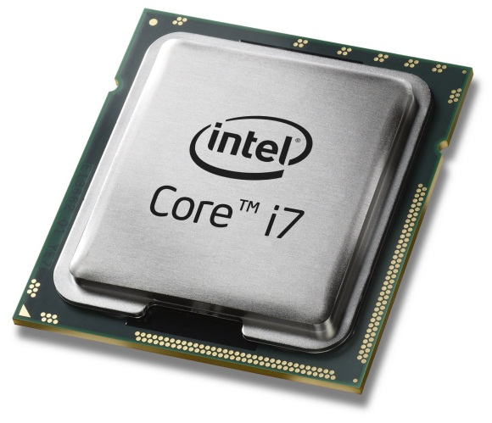

Figure 1 - CPU

* Motherboard. Provides connectivity for all the components of the system. Every component connects via a socket on the board or with a port (such as for USB devices).

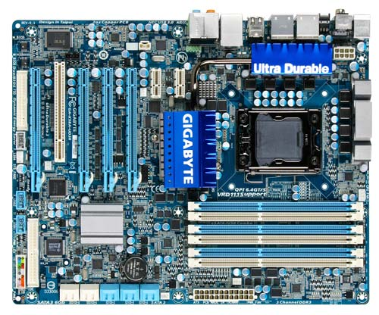

Figure 2 -Motherboard

* CPU Socket. The CPU is secured to the motherboard by inserting into this socket and is held in place with a locking mechanism.

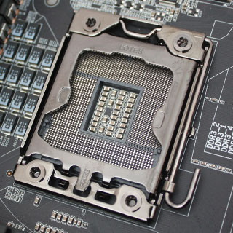

Figure 3 - CPU Socket

* CPU Fan. Attaches firmly to the top of the CPU after it has been seated in its socket. Four screws hold it in place and are screwed into the motherboard.

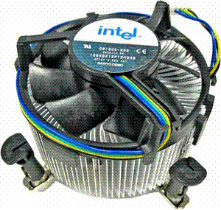

Figure 4 - CPU Fan

* Graphics Card. Provides graphical output to the monitor. Snaps in to one of the motherboard’s PCI Express slots.

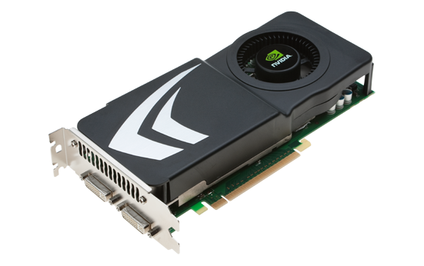

Figure 5 - Graphics Card

* RAM. Memory module which provides increased system performance. Installs on memory slots on the motherboard.

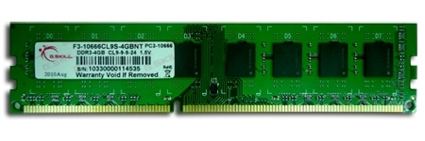

Figure 6 - RAM Module

* Hard Drive. Stores data including all programs and the operating system. Connects to the motherboard via SATA cable and is secured with screws on the case chassis.

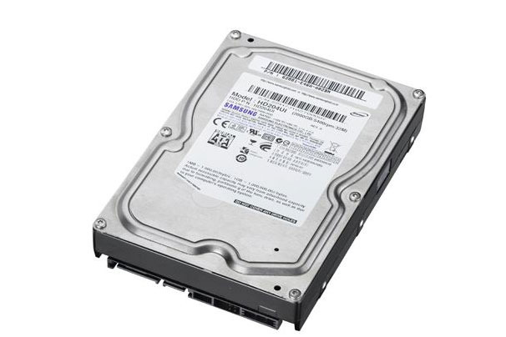

Figure 7 - Hard Drive

* Case. Houses all the components of the computer. Its chassis allows the motherboard to be secured on one side. Hard drives and other drives screw directly into the case.

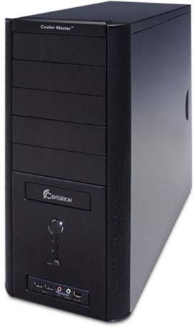

Figure 8 - Case

* Power Supply. Provides electrical power for the computer. Plugs into a wall outlet and is secured internally in the back of the case. Connects directly with drives, fans, and the motherboard.

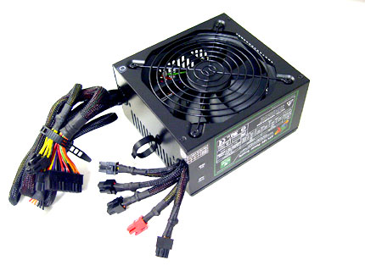

Figure 9 - Power Supply

* DVD-ROM Drive. Allows for the running and installation of programs that are distributed on DVD discs. Like the hard drive, this is screwed into the chassis of the case.

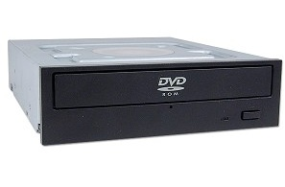

Figure 10 - DVDROM Drive

* Power Cables from Case. These cables in particular connect to exposed pins on the motherboard. The pins are typically located in the bottom right of the board.

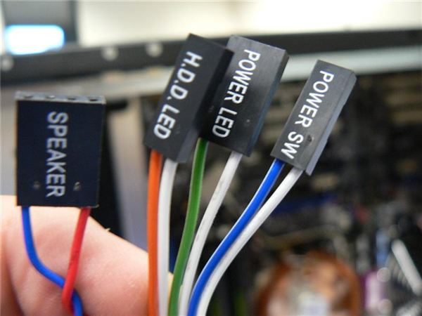

Figure 11 - Power cables connect directly to the motherboard

* Motherboard Power Connector. This plugs directly into the motherboard from the power supply, giving the rest of the system electrical power.

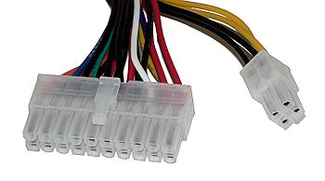

Figure 12 - power connector for motherboard

* Fan Connector. The system fans including the CPU and video card fans will have 3-pin connectors and plug in to the motherboard as shown here.

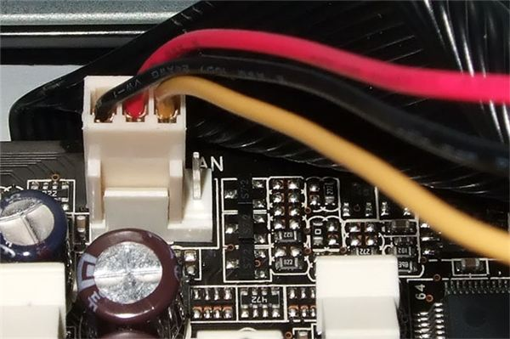

Figure 13 - Fan cable plugged into motherboard

* SATA Cable. Provides connectivity from the hard drive to the motherboard.

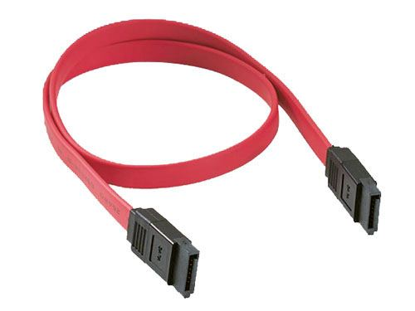

Figure 14 - SATA Cable

* IDE Cable. This provides connectivity from the hard drive, DVD-ROM drive, and other IDE devices to the motherboard, enabling communication from these devices to the rest of the system.

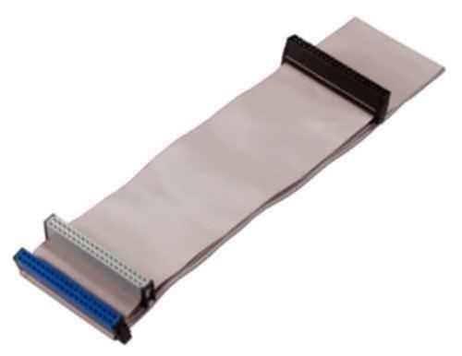

Figure 15- IDE Cable