LIMKOKWING UNIVERSITY OF CREATIVE TECHNOLOGY
SIERRA LEONE
Department of Information and Communication Technology
Semester 01: September 2026 to January 2027
PROG101
PRINCIPLES OF PROGRAMMING LOGIC AND DESIGN
Individual Assignment 1
Designing Logical Solutions for Sierra Leone Community Challenges
Project Title: WasteTrack SL
A Community Waste Collection Scheduling and Missed-Pickup Reporting System
Detail | Information
Student Name | [Your Full Name]
Student ID | [Your Student ID]
Examiner | Elijah Fullah
Submission Deadline | Week 4
GitHub Repository | PROG101_Assignment1_[StudentName]_[StudentID]

Table of Contents

1. Rationale

1.1 Problem Description
For this assignment I chose the problem of irregular and poorly coordinated household waste collection in Sierra Leonean communities. In many neighbourhoods, residents do not know when the waste collectors will come, collection crews do not have a shared and trackable schedule, and there is no simple way for a resident to report that their waste was not collected. As a result, waste stays on the roadside for days, people dump it in drains and streams, and nobody can easily see which areas are being missed again and again.
The people affected include households and market traders, schools and clinics located near dumping points, the community-based collection groups and crews who do the work, and the city council that is responsible for keeping the environment clean. The problem exists because scheduling and complaints are usually handled informally, by word of mouth or by phone calls to individuals. There is no central record, so the same zones can be missed repeatedly without anyone noticing. Limited internet access and data costs also mean that any solution must be able to work through simple SMS or USSD messages and not only through a smartphone app.

1.2 Background
Sierra Leone's towns and cities, especially Freetown, have grown quickly, and waste services have not always kept pace with the number of people living in them. Uncollected waste can block drainage channels, and blocked drains are commonly linked with flooding during the rainy season. Piles of rubbish also attract flies and rodents and make it easier for diseases such as cholera and typhoid to spread. For these reasons, waste management is not only an environmental issue, it is also a public health and safety issue.
Because I was asked to design the logic and not to write a program, this report focuses on how the system should think and make decisions. I used computational thinking to break the problem into smaller parts, and then designed the algorithm, pseudocode, flowcharts and modules that together describe how WasteTrack SL would work.

1.3 Community Impact
If WasteTrack SL were built from this design, residents would receive reminders before collection day and could report a missed pickup in a few steps. Crews would know exactly which zones need to be revisited, and supervisors would see which zones are failing repeatedly and could act early. The expected benefits are cleaner streets, fewer blocked drains, better public health, and more trust between communities and the people who provide waste services. The main beneficiaries are residents, traders, schools, clinics, collection crews and the local council. For long-term sustainability, the system is designed to be cheap to run (SMS-based, low data use), simple enough for community groups to manage, and open so that local developers can maintain it without depending on a single company.

1.4 Proposed Solution
The proposed solution is a logical system called WasteTrack SL. It registers households into collection zones, stores a weekly collection day for every zone, sends reminders the day before collection, and allows a resident to report a missed pickup. When a report is received, the system checks whether the household is registered, whether it is a collection day, and whether the crew has already marked the zone as collected. It then records the report, assigns a crew, and escalates the problem to a supervisor if the zone has had three or more missed pickups in the last seven days. Supervisors can also generate a weekly report showing which zones perform well and which do not.

1.5 Computational Thinking Process
Decomposition. I broke the large problem into six smaller problems: household registration, schedule management, notifications, missed-pickup reporting, crew tracking, and supervisor reporting. Each one became a separate module.
Pattern recognition. I noticed that collection repeats on a weekly cycle for each zone, that every missed-pickup report follows the same steps (receive, validate, record, assign, resolve), and that the same zones tend to be missed repeatedly. These patterns suggested using loops for reminders and a counter for escalation.
Abstraction. I ignored details that do not affect the logic, such as the type of truck, the exact shape of the streets or the size of bins. A household is represented only by an ID, a name, a phone number, a zone and a status. A zone is represented by its name, collection day and crew.
Algorithm design. I then wrote the step-by-step procedure (Section 2), converted it to pseudocode (Section 3) and drew flowcharts (Section 4).

1.6 Algorithm Design
The main algorithm handles a missed-pickup report using sequence, selection and iteration. It uses decision structures (IF/ELSE) to validate the household and check the schedule, a counter and a comparison with a constant to decide on escalation, and a repetition structure (FOR EACH loop) to send daily reminders to every household in every zone scheduled for the next day. The full algorithm is given in Section 2.

1.7 SDG Alignment
This project mainly supports Sustainable Development Goal 11: Sustainable Cities and Communities, especially the target about reducing the adverse environmental impact of cities through better municipal waste management. It also supports SDG 3: Good Health and Well-being, because cleaner surroundings reduce the spread of disease, and SDG 12: Responsible Consumption and Production, because tracking waste collection encourages responsible handling of waste.

1.8 Open Source Justification
WasteTrack SL should be open source because waste collection is a public service and the system should not be locked inside one company. Open source software has no licence fees, which is important for councils and community groups with small budgets. Local developers and students at universities such as ours could study the code, fix problems, translate messages into Krio, Mende or Temne, and adapt the system to different towns and districts. Potential community contributions include new language packs, improved SMS or USSD flows, new report types, bug fixes, documentation, and support for other cities that want to reuse the same logic. Open source also builds local technical skills and reduces dependence on foreign vendors.

1.9 Digital Public Goods Justification
WasteTrack SL could become a Digital Public Good by releasing its design, code and documentation under an approved open licence, by using open standards so it works with other systems, by protecting the privacy of residents' phone numbers, and by being designed to help reach the SDGs. It promotes accessibility because it works by SMS on basic phones. It promotes openness because anyone can inspect, reuse and improve it. It promotes public benefit because the main goal is cleaner and healthier communities and not profit. Other councils and countries facing the same challenge could reuse it at no cost.

2. Algorithm
Below are the step-by-step algorithms for the two main processes of WasteTrack SL.

2.1 Algorithm A: Handle a Missed-Pickup Report
- Start.
- Receive the resident's phone number and zone name (input).
- Check whether the household is registered.
- If it is not registered, show a registration prompt and go to step 17.
- Look up the zone's scheduled collection day.
- If today is not the collection day, show the next collection date and go to step 17.
- Check whether the crew has marked the zone as collected today.
- If it was collected, record the report as "Disputed", notify the supervisor to verify, and go to step 17.
- If it was not collected, record the report as "Missed Pickup".
- Count the missed-pickup reports for this zone in the last 7 days.
- If the count is 3 or more, escalate to the supervisor.
- Otherwise, assign the zone to the next available crew.
- Send a confirmation message to the resident (output).
- Wait until the crew marks the zone as collected.
- Update the report status to "Resolved".
- Notify the resident that the waste has been collected (output).
- End.

2.2 Algorithm B: Send Daily Reminders
- Start.
- Set tomorrow equal to today plus one day.
- Get the list of zones that are scheduled for collection tomorrow.
- Set sentCount to 0.
- For each zone in the list, get the households registered in that zone.
- For each household, send an SMS reminder to its phone number.
- Add 1 to sentCount after each message is sent.
- Repeat steps 5 to 7 until all zones have been processed.
- Display the total number of reminders sent (output).
- End.

3. Pseudocode

3.1 Constants
CONSTANT ESCALATION_LIMIT = 3 // missed reports that trigger escalation
CONSTANT REPORT_WINDOW_DAYS = 7 // days used when counting missed reports
CONSTANT MIN_PHONE_LENGTH = 8 // minimum digits in a valid phone number

3.2 Variables and Data Types
Variable | Data Type | Purpose
householdID | String | Unique ID given to each registered household
residentName | String | Name of the household contact person
phoneNumber | String | Phone number used for SMS messages (kept as text so leading zeros are not lost)
zoneName | String | Name of the collection zone, e.g. "Zone A"
collectionDay | String | Day of the week the zone is collected, e.g. "Thursday"
missedCount | Integer | Number of missed reports in the last 7 days
sentCount | Integer | Number of reminders sent
isRegistered | Boolean | TRUE if the household exists in the system
isCollectionDay | Boolean | TRUE if today matches the zone's collection day
isCollected | Boolean | TRUE if the crew has marked the zone collected today
reportStatus | String | "Missed Pickup", "Disputed" or "Resolved"
pickupRate | Real (Float) | Percentage of successful collections in a zone for the week

3.3 Functions
FUNCTION validatePhone(phoneNumber) RETURNS Boolean
IF LENGTH(phoneNumber) >= MIN_PHONE_LENGTH AND isAllDigits(phoneNumber) THEN
RETURN TRUE
ELSE
RETURN FALSE
END IF
END FUNCTION

FUNCTION registerHousehold(residentName, phoneNumber, zoneName) RETURNS String
IF NOT validatePhone(phoneNumber) THEN
DISPLAY "Invalid phone number"
RETURN ""
END IF
IF NOT zoneExists(zoneName) THEN
DISPLAY "Zone not found"
RETURN ""
END IF
householdID = generateID()
SAVE householdID, residentName, phoneNumber, zoneName
sendNotification(phoneNumber, "Registered. ID: " + householdID)
RETURN householdID
END FUNCTION

FUNCTION checkSchedule(zoneName) RETURNS Boolean
collectionDay = getCollectionDay(zoneName)
IF collectionDay == getTodayName() THEN
RETURN TRUE
ELSE
RETURN FALSE
END IF
END FUNCTION

FUNCTION sendNotification(phoneNumber, message)
IF validatePhone(phoneNumber) THEN
SEND SMS(phoneNumber, message)
LOG "Sent to " + phoneNumber
END IF
END FUNCTION

FUNCTION escalateToSupervisor(zoneName, missedCount)
supervisor = getSupervisor(zoneName)
sendNotification(supervisor.phone, zoneName + " has " + missedCount + " missed pickups")
SET zone status = "Escalated"
END FUNCTION

3.4 Main Process: Report a Missed Pickup
FUNCTION reportMissedPickup(phoneNumber, zoneName)
isRegistered = householdExists(phoneNumber)

IF NOT isRegistered THEN
DISPLAY "Please register first"
RETURN
END IF

isCollectionDay = checkSchedule(zoneName)
IF NOT isCollectionDay THEN
DISPLAY "Next collection: " + getNextCollectionDate(zoneName)
RETURN
END IF

isCollected = isCollectedToday(zoneName)
IF isCollected THEN
SAVE report WITH status = "Disputed"
sendNotification(getSupervisor(zoneName).phone, "Disputed report in " + zoneName)
RETURN
END IF

SAVE report WITH status = "Missed Pickup"
missedCount = countMissedReports(zoneName, REPORT_WINDOW_DAYS)

IF missedCount >= ESCALATION_LIMIT THEN
escalateToSupervisor(zoneName, missedCount)
ELSE
assignCrew(zoneName)
END IF

sendNotification(phoneNumber, "Report received. A crew will be sent.")
END FUNCTION

3.5 Repetition: Send Daily Reminders
FUNCTION sendDailyReminders()
tomorrow = getTodayDate() + 1 DAY
zoneList = getZonesScheduledFor(tomorrow)
sentCount = 0

FOR EACH zone IN zoneList
householdList = getHouseholds(zone)
FOR EACH household IN householdList
sendNotification(household.phoneNumber, "Waste collection tomorrow in " + zone)
sentCount = sentCount + 1
END FOR
END FOR

DISPLAY sentCount + " reminders sent"
END FUNCTION

3.6 Weekly Report (Uses a Loop and Boolean Logic)
FUNCTION generateWeeklyReport()
FOR EACH zone IN getAllZones()
total = countScheduledCollections(zone, 7)
missed = countMissedReports(zone, 7)
IF total > 0 THEN
pickupRate = ((total - missed) / total) * 100
ELSE
pickupRate = 0
END IF

IF pickupRate >= 90 THEN
rating = "Good"
ELSE IF pickupRate >= 60 AND pickupRate < 90 THEN
rating = "Needs Improvement"
ELSE
rating = "Critical"
END IF

DISPLAY zone, total, missed, pickupRate, rating
END FOR
END FUNCTION

3.7 Main Program
START
running = TRUE
WHILE running == TRUE
DISPLAY menu: 1.Register 2.Report Missed Pickup 3.Send Reminders 4.Weekly Report 5.Exit
INPUT choice
SWITCH choice
CASE 1: INPUT name, phone, zone; registerHousehold(name, phone, zone)
CASE 2: INPUT phone, zone; reportMissedPickup(phone, zone)
CASE 3: sendDailyReminders()
CASE 4: generateWeeklyReport()
CASE 5: running = FALSE
DEFAULT: DISPLAY "Invalid choice, try again"
END SWITCH
END WHILE
END

4. Flowcharts
The flowcharts below use the standard symbols: oval for start/end, parallelogram for input/output, rectangle for a process, and diamond for a decision.

4.1 System Overview (Modular Design)
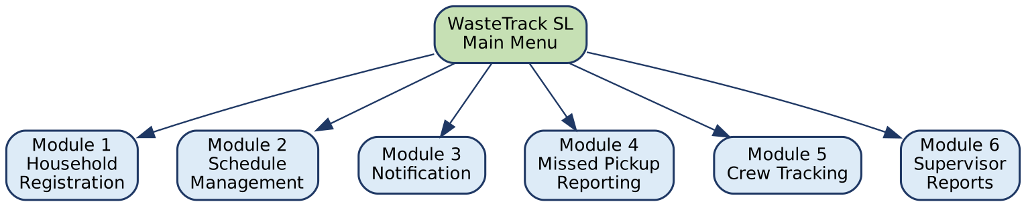
Figure 1: WasteTrack SL modules

4.2 Flowchart A: Handle a Missed-Pickup Report
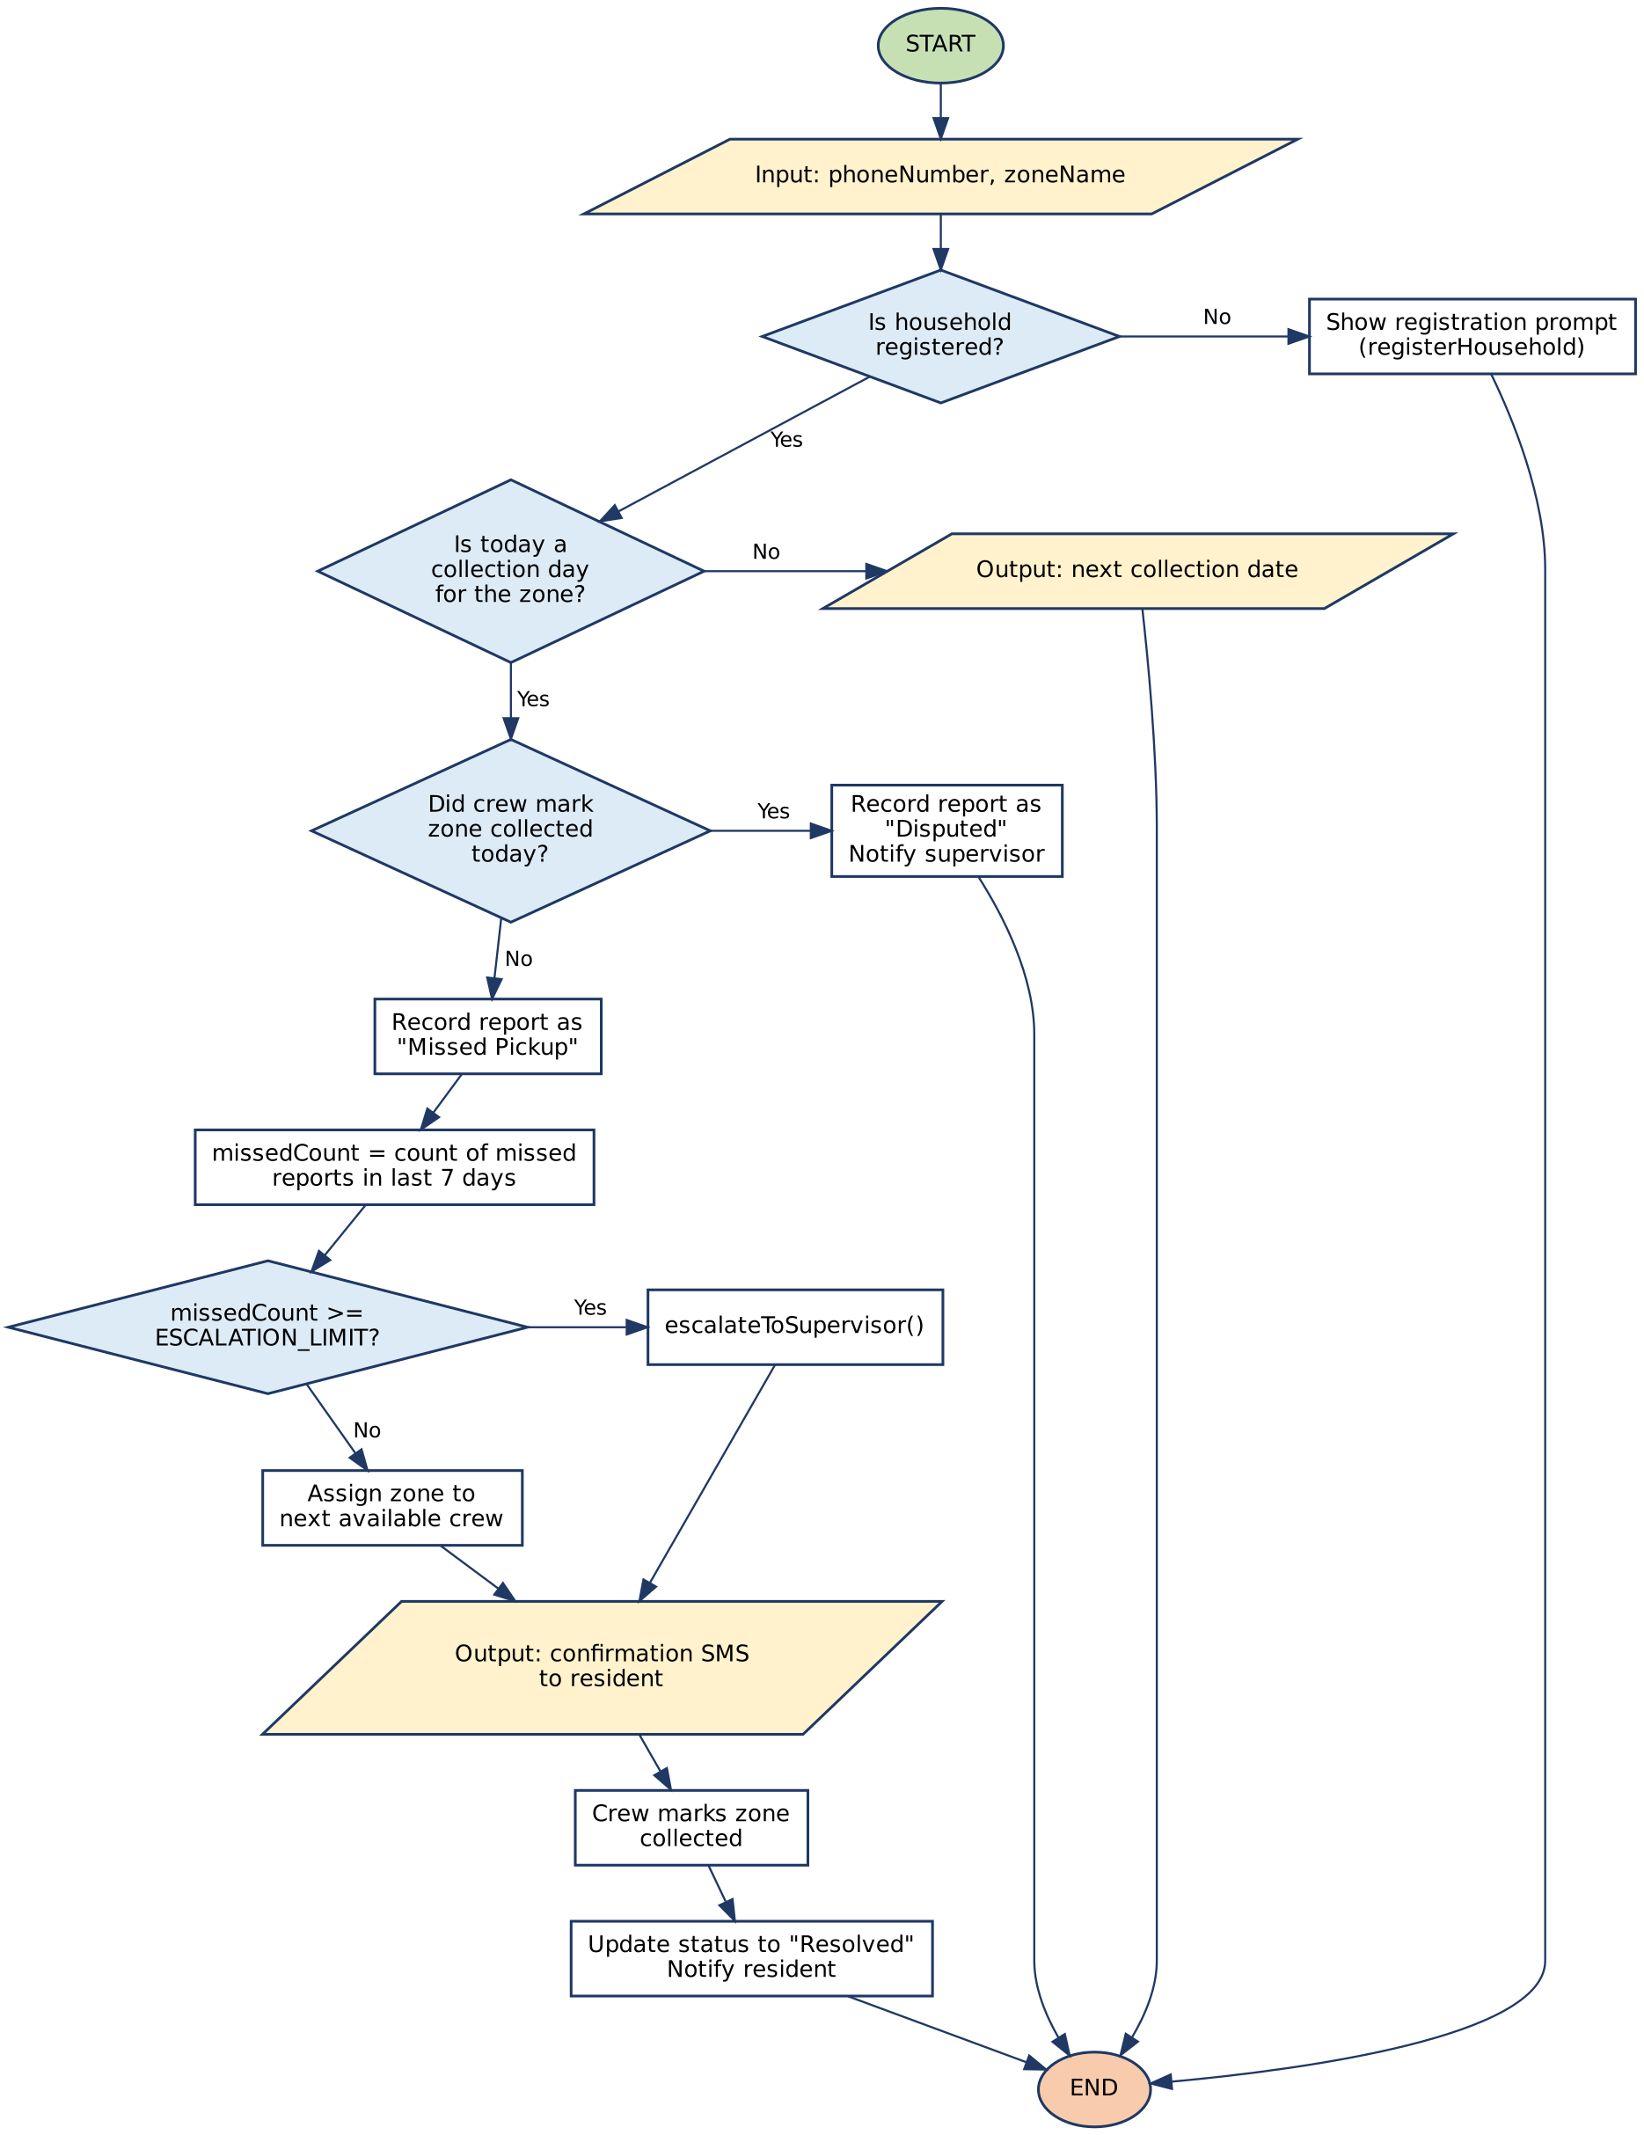
Figure 2: Missed-pickup report flowchart

4.3 Flowchart B: Send Daily Reminders
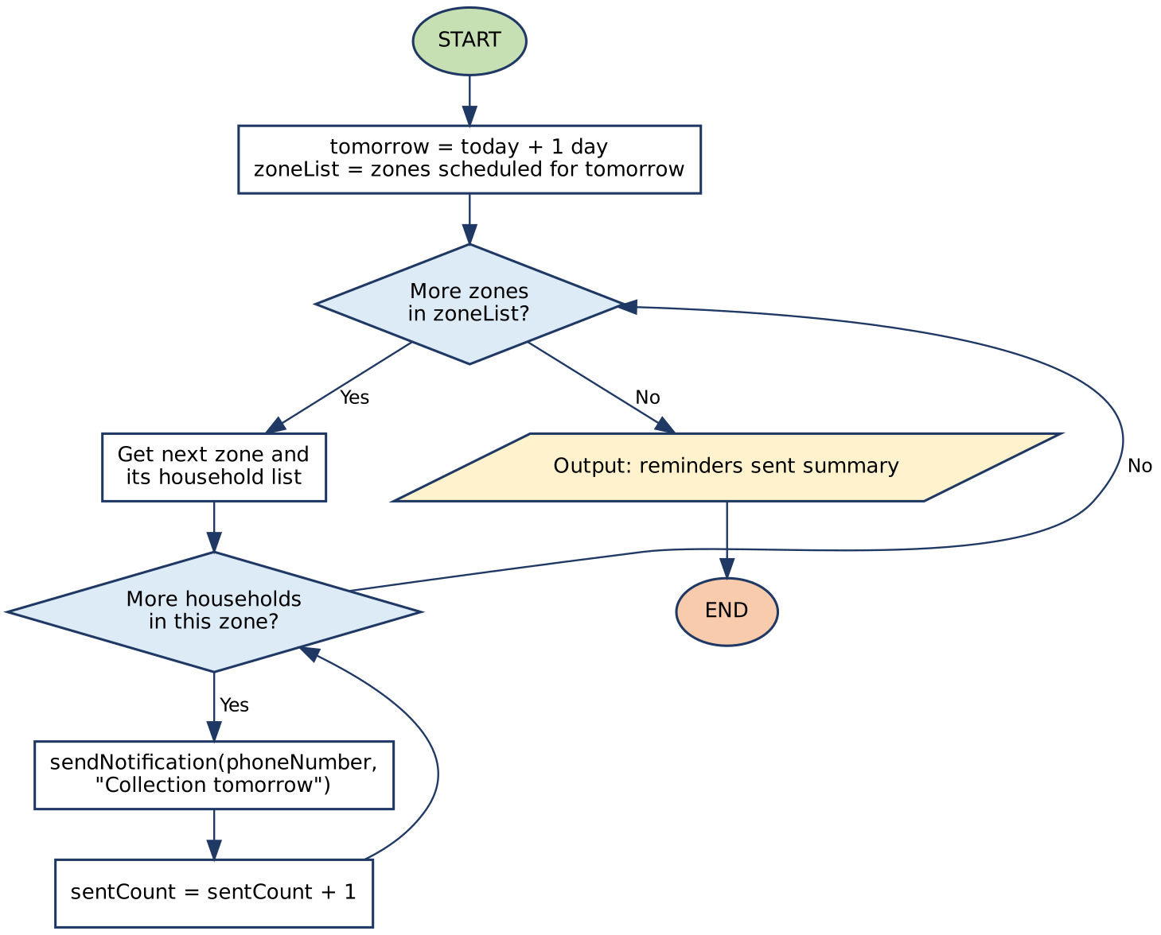
Figure 3: Daily reminder flowchart (repetition structure)

5. Functional Modules
Modular design means each part of the system has one clear job, which makes it easier to test, fix and reuse. The table below shows the modules and the functions inside them.
No. | Module | Functions | Responsibility
1 | Household Registration | validatePhone(), registerHousehold() | Checks the phone number and zone, creates a household ID
2 | Schedule Management | checkSchedule(), getCollectionDay(), getNextCollectionDate() | Stores and checks the weekly collection day for each zone
3 | Notification | sendNotification(), sendDailyReminders() | Sends SMS reminders, confirmations and alerts
4 | Missed Pickup Reporting | reportMissedPickup(), countMissedReports() | Validates and records reports, decides on escalation
5 | Crew Tracking | assignCrew(), isCollectedToday() | Assigns crews and records when a zone is collected
6 | Supervisor Reports | escalateToSupervisor(), generateWeeklyReport() | Shows problem zones and weekly performance

Input, Processing and Output summary. Input: phone number, zone name, resident name, menu choice, crew confirmation. Processing: validation, schedule checking, counting reports, comparing with ESCALATION_LIMIT, assigning crews, calculating pickup rate. Output: confirmation messages, reminders, next collection date, escalation alerts and weekly reports.

6. Expected Outputs
The following sample scenarios show what the system should output for different inputs. The names, zones and numbers are sample data created only to demonstrate the logic.
No. | Scenario (Input) | Decision Path | Expected Output
1 | Phone 076000001 is not registered and reports a missed pickup | isRegistered = FALSE | "Please register first." Process ends.
2 | Registered resident in Zone A (collected on Thursday) reports on a Tuesday | isRegistered = TRUE, isCollectionDay = FALSE | "Next collection: Thursday." No report saved.
3 | Resident in Zone A reports on Thursday, but the crew marked the zone collected | isCollected = TRUE | Report saved as "Disputed". Supervisor receives an alert to verify.
4 | Resident in Zone B reports on collection day, zone not collected, 1 missed report this week | missedCount = 1 < 3 | Report saved as "Missed Pickup". Crew assigned. SMS: "Report received. A crew will be sent."
5 | Resident in Zone C reports on collection day, zone not collected, 3 missed reports this week | missedCount = 3 >= ESCALATION_LIMIT | Supervisor alert: "Zone C has 3 missed pickups." Resident receives confirmation.
6 | Admin runs reminders; 3 zones are scheduled tomorrow with 40, 25 and 35 households | Nested FOR EACH loops | "100 reminders sent."
7 | Registration with phone number "12ab" | validatePhone = FALSE | "Invalid phone number." No household created.

6.1 Sample Weekly Report Output
Zone | Scheduled | Missed | Pickup Rate | Rating
Zone A | 7 | 0 | 100% | Good
Zone B | 7 | 2 | 71.4% | Needs Improvement
Zone C | 7 | 5 | 28.6% | Critical (Escalated)

Calculation check for Zone B: pickupRate = ((7 - 2) / 7) x 100 = 71.4%, which is between 60 and 90, so the rating is "Needs Improvement".

7. GitHub Evidence
This section shows my use of Git and GitHub for version control. I will insert the screenshots after I finish my commits.
Item | Details
Repository name | PROG101_Assignment1_[StudentName]_[StudentID]
Repository URL | https://github.com/[your-username]/PROG101_Assignment1_[StudentName]_[StudentID]
Files uploaded | Report (PDF/DOCX), flowcharts (PNG and .dot/.mermaid source), pseudocode (.txt), README.md
Commit history | [Insert screenshot of the commit history]
README.md | [Insert screenshot of README.md]
Repository screenshot | [Insert screenshot of the repository home page]

Suggested commit history: (1) Initial commit with README; (2) Add problem analysis; (3) Add algorithm; (4) Add pseudocode; (5) Add flowcharts; (6) Add expected outputs; (7) Add final report.

8. References
- United Nations (n.d.) Goal 11: Make cities and human settlements inclusive, safe, resilient and sustainable. Available at: https://sdgs.un.org/goals/goal11
- United Nations (n.d.) Goal 3: Ensure healthy lives and promote well-being for all at all ages. Available at: https://sdgs.un.org/goals/goal3
- United Nations (n.d.) Goal 12: Ensure sustainable consumption and production patterns. Available at: https://sdgs.un.org/goals/goal12
- Digital Public Goods Alliance (n.d.) Digital Public Goods. Available at: https://digitalpublicgoods.net
- Open Source Initiative (n.d.) The Open Source Definition. Available at: https://opensource.org/osd
- GitHub (n.d.) GitHub Docs. Available at: https://docs.github.com
- Limkokwing University of Creative Technology, Sierra Leone (2026) PROG101 Assignment Brief: Designing Logical Solutions for Sierra Leone Community Challenges.
- [Add one or two local sources you actually read, for example a Freetown City Council or Ministry of Environment publication on waste management.]

