Introduction
This note is mostly based on Vanderbilt’s book Berry Phases in Electronic Structure Theory: Electric Polarization, Orbital Magnetization and Topological Insulators, Cambridge University Press, 2018 [1].
A Berry phase is the phase difference acquired by a wavefunction that depends on parameters that are varied a closed loop. An example is the ground state of a Hamiltonian determined by parameters that vary continuously so that it is the same at the start and finish. Here, a vector could represent the ground state of the electrons in a molecule with fixed nuclear coordinates. Consider a gradual variation of the nuclear coordinates such that the system returns to its starting point at the end of the loop,
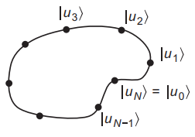
Figure 1 Illustration of a discrete set of steps along a path.
States , ..., correspond to the points around the loop. The Berry phase for the path can be written as,

Recall that for a complex number , the expression just takes the complex phase and discards the magnitude. Thus, the Berry phase is minus the complex phase of the product of inner products of the state vectors at neighbouring points around the loop.
The need to impose a branch choice on the definition of , as by restricting it to the interval , Eq. 1 always results in the Berry phase lying in this interval, while the nominally equivalent expression,

Can yield a result that differs by an integer multiple of . If we take the viewpoint that is just a shorthand for a phase angle, so that only and matter, then this distinction can be safely ignored. However, in any practical implementation the phase angles are normally mapped onto some interval on the real axis, and we can claim only that the Berry phase should be gauge-invariant modulo in the context of an expression like that of Eq. 2.
If we require that be a smooth, differentiable function of , then each step becomes,

So that the Berry phase can be written as,

The integrand on the right-hand side of Eq. 4 is known as the Berry connection or Berry potential,

So that the Berry phase can be written as,

The Berry connection is not gauge invariant. Similarly, for a two-dimensional parameter space, we have vectors as a function of , so we define the two-component vector Berry connection as,

Where , and the Berry phase becomes the line integral around a loop in the plane,

The expressions so far have given it only as a sum or integral of quantities that are gauge dependent. Consider the Berry phase integrated around one of the small squares of the grid which called the Berry flux through the square,
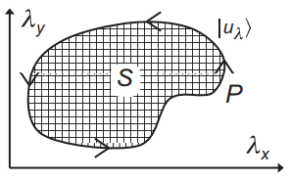
Figure 2 Illustration of the area bounded by a loop in two dimensions.
The Berry curvature is defined to be the Berry flux per unit area in the continuum limit, so it just the curl of the Berry connection,

The total Berry flux is the Berry curvature integrated over the area bounded by the loop. Stokes theorem says the flux through the surface is the integral around the boundary ,

Where is the area vector directed along the normal to the surface.
Polarization
One tempting approach is to identify with,

Where the integral represents the dipole moment of the charge distribution inside one unit cell. It does not give a unique definition because of a dependence on the choice of unit cell. If a crystal has an inversion or mirror symmetry, it may be possible to argue for a “most natural” choice of unit cell, but these are typically the cases where vanishes anyway. One clever suggestion could be to average over all possible unit cell locations, but unfortunately the result of this procedure is always exactly zero, which is hardly useful!
Consider a system evolving adiabatically with the current and polarization related by,

Introducing the Sternheimer-like equation,

Where

We define the projection operator onto all states,

Where

The Sternheimer-like equation has solution,

For any real , as can be checked by plugging it into Eq. 12 and multiplying on the left by an eigenstate . The first term is dropped in because it does not represent a physical change of state, while the second term we include a factor,

Introducing the definition,

Then the first-order change in an occupied-state wave function with the perturbation becomes,

Consider how the expectation value of some Hermitian observable changes as a result of the perturbation,

Since the contribution from the first term in Eq. 12 is purely imaginary, then the above equation becomes,

Using Hermitian conjugation,

And summing over all the occupied bands , the total change is,

Consider the velocity operator,

Involving matrix elements between different Bloch states (empty) and (occupied),

Multiplying both sides by and summing over all unoccupied bands ,

The electric polarization should be dipole moment per unit volume,

Plugging in Eq. 26 into Eq. 22,

Eq. 27 is expressing the derivatives of the polarization with respect to various perturbations such as sublattice displacements, but no formal expression for the polarization itself. To convert the equation into a path-independent form, we introduce the simple identity,

Plugging in Eq. 28 into Eq. 19,

Combining Eq. 29 with Eq. 25 yields,

Plugging in Eq. 29 into Eq. 27,

Using Eq. 14 into Eq. 31,

The integrand on the right-hand side of Eq. 32 is known as the Berry curvature Eq. 9, so the change in polarization is,

According to Resta [2], the change of during an adiabatic evolution of the system from some initial configuration to a final one ,

Where , and is an open path,
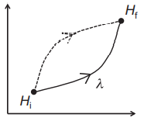
Figure 3 An open path from Hamiltonian to .
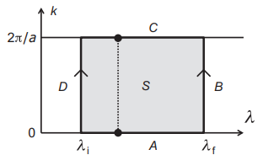
Figure 4 Region of integration of Berry curvature .
For a single occupied band in a 1D system of lattice constant , Eq. 32 reduces to the form,

Eq. 35 means the first-order change in polarization is proportional to the Brillouin zone integral of the Berry curvature in space. Plugging in Eq. 35 into Eq. 34,

Eq. 36 means is proportional to the Berry flux of band passing through the rectangle . But the equation is still depending on the details of the path. If surface is wrapped into a cylinder,
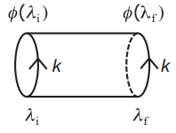
Figure 5 Cylinder
Then the Berry flux is proportional to the Berry phase in Eq. 10,

Plugging in Eq. 37 into Eq. 36,

From the above equation, the polarization is defined to be,

In terms of the Berry connection, we can use Eq. 10 for the polarization,

Eq. 40 means each band is isolated. For the entire group of occupied bands as a unit, Eq. 40 becomes,

When generalized to 3D system, Eq. 41 becomes,

It is usually better to avoid working with gauge-dependent quantities such , and the “modulo a quantum” nature of is not obvious in this framework. It is convenient to express the contribution from band in terms of a triplet of reduced-polarization variables ,

Where is reciprocal lattice vector. Using , Eq. 43 becomes,

We define the wavevector to be,

Where is arbitrary integer, is large integer, and is phase angle. Using this notation and Eq. 44, Eq. 32 becomes,

The integrand on the right is the Berry curvature of with respect to variables and . Taking volume element by , Eq. 45 becomes,

Which is similar with Eq. 33. For 1D system ,

The integral inside the square bracket is analogous to Eq. 35, except that we are working in reduced coordinates, and all quantities carry an extra dependence. Using Eq. 36-37, the above formula becomes,

Where, using Eq. 4, the Berry phase of band computing along a string of -vectors in the Brillouin zone extending parallel to ,

For 2D system,

Where the bar is an average over the 2D Brillouin zone in the directions complementary to . For 3D system, plugging in Eq. 50 into Eq. 44, and restoring the sum over bands,

References
- D. Vanderbilt, 2018, Berry Phases in Electronic Structure Theory: Electric Polarization, Orbital Magnetization and Topological Insulators, Cambridge University Press.
- R. Resta, 1992, Theory of the electric polarization in crystals, Ferroelectrics, 136:1, 51-55.

