Introduction
A Berry phase is the phase difference acquired by a wavefunction that depends on parameters that are varied a closed loop. An example is the ground state of a Hamiltonian determined by parameters that vary continuously so that it is the same at the start and finish. Here, a vector could represent the ground state of the electrons in a molecule with fixed nuclear coordinates. Consider a gradual variation of the nuclear coordinates such that the system returns to its starting point at the end of the loop,
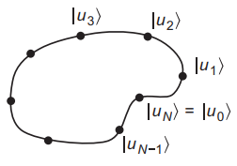
Figure 1 Illustration of a discrete set of steps along a path.
States , ..., correspond to the points around the loop. The Berry phase for the path can be written as,

To impose a branch choice to the interval , the Berry phase can be written as,

If we require that be a smooth, differentiable function of , then each step becomes,

So that the Berry phase can be written as,

The integrand on the right-hand side of Eq. 4 is known as the Berry connection or Berry potential,

So that the Berry phase can be written as,

The Berry connection is not gauge invariant. Similarly, for a two-dimensional parameter space, we have vectors as a function of , so we define the two-component vector Berry connection as,

Where , and the Berry phase becomes the line integral around a loop in the plane,

The expressions so far have given it only as a sum or integral of quantities that are gauge dependent. Consider the Berry phase integrated around one of the small squares of the grid which called the Berry flux through the square,
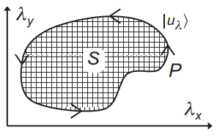
Figure 2 Illustration of the area bounded by a loop in two dimensions.
The Berry curvature is defined to be the Berry flux per unit area in the continuum limit, so it just the curl of the Berry connection,

The total Berry flux is the Berry curvature integrated over the area bounded by the loop. Stokes theorem says the flux through the surface is the integral around the boundary ,

Where is the area vector directed along the normal to the surface.
Polarization
Consider a system evolving adiabatically with the current and polarization related by,

Introducing the Sternheimer equation,

Where

We define the projection operator onto all states,

Where

The Sternheimer equation has solution,

The first term is dropped in, while the second term includes a factor,

Introducing the definition,

Then the first-order change in an occupied-state wave function with the perturbation becomes,

Consider how the expectation value of some Hermitian observable changes as a result of the perturbation,

Using Hermitian conjugation,

And summing over all the occupied bands , the total change is,

Consider the velocity operator,

Involving matrix elements between different Bloch states (empty) and (occupied),

Multiplying both sides by and summing over all unoccupied bands ,

The electric polarization should be dipole moment per unit volume,

Plugging in Eq. 26 into Eq. 22,

