## Regression with binary outcomes

## Logistic regression

## This far we have used the lm' function to fit our regression models. ##lm’ is great, but limited in particular it only fits models for continuous dependent variables. For categorical dependent variables we can use the `glm()’ function.

## For these models we will use a different dataset, drawn from the National Health Interview Survey. From the [CDC website]:

## The National Health Interview Survey (NHIS) has monitored the health of the nation since 1957. NHIS data on a broad range of health topics are collected through personal household interviews. For over 50 years, the U.S. Census Bureau has been the data collection agent for the National Health Interview Survey. Survey results have been instrumental in providing data to track health status, health care access, and progress toward achieving national health objectives.

## Load the National Health Interview Survey data:

NH11 <- readRDS("dataSets/NatHealth2011.rds")  
labs <- attributes(NH11)$labels

## Logistic regression example

## Let’s predict the probability of being diagnosed with hypertension based on age, sex, sleep, and bmi.

str(NH11$hypev) # check stucture of hypev

## Factor w/ 5 levels "1 Yes","2 No",..: 2 2 1 2 2 1 2 2 1 2 ...

levels(NH11$hypev) # check levels of hypev

## [1] "1 Yes" "2 No" "7 Refused"   
## [4] "8 Not ascertained" "9 Don't know"

# collapse all missing values to NA  
NH11$hypev <- factor(NH11$hypev, levels=c("2 No", "1 Yes"))  
# run our regression model  
hyp.out <- glm(hypev~age_p+sex+sleep+bmi,  
 data=NH11, family="binomial")  
coef(summary(hyp.out))

## Estimate Std. Error z value Pr(>|z|)  
## (Intercept) -4.269466028 0.0564947294 -75.572820 0.000000e+00  
## age_p 0.060699303 0.0008227207 73.778743 0.000000e+00  
## sex2 Female -0.144025092 0.0267976605 -5.374540 7.677854e-08  
## sleep -0.007035776 0.0016397197 -4.290841 1.779981e-05  
## bmi 0.018571704 0.0009510828 19.526906 6.485172e-85

## Logistic regression coefficients

## Generalized linear models use link functions, so raw coefficients are difficult to interpret. For example, the age coefficient of .06 in the previous model tells us that for every one unit increase in age, the log odds of hypertension diagnosis increases by 0.06. Since most of us are not used to thinking in log odds this is not too helpful! One solution is to transform the coefficients to make them easier to interpret.

hyp.out.tab <- coef(summary(hyp.out))  
hyp.out.tab[, "Estimate"] <- exp(coef(hyp.out))  
hyp.out.tab

## Estimate Std. Error z value Pr(>|z|)  
## (Intercept) 0.01398925 0.0564947294 -75.572820 0.000000e+00  
## age_p 1.06257935 0.0008227207 73.778743 0.000000e+00  
## sex2 Female 0.86586602 0.0267976605 -5.374540 7.677854e-08  
## sleep 0.99298892 0.0016397197 -4.290841 1.779981e-05  
## bmi 1.01874523 0.0009510828 19.526906 6.485172e-85

## Generating predicted values

## In addition to transforming the log-odds produced by glm' to odds, we ## can use thepredict()’ function to make direct statements about the predictors in our model. For example, we can ask “How much more likely ## is a 63 year old female to have hypertension compared to a 33 year old ## female?”

# Create a dataset with predictors set at desired levels

predDat <- with(NH11,  
 expand.grid(age_p = c(33, 63),  
 sex = "2 Female",  
 bmi = mean(bmi, na.rm = TRUE),  
 sleep = mean(sleep, na.rm = TRUE)))

# predict hypertension at those levels

cbind(predDat, predict(hyp.out, type = "response",  
 se.fit = TRUE, interval="confidence",  
 newdata = predDat))

## age_p sex bmi sleep fit se.fit residual.scale  
## 1 33 2 Female 29.89565 7.86221 0.1289227 0.002849622 1  
## 2 63 2 Female 29.89565 7.86221 0.4776303 0.004816059 1

## This tells us that a 33 year old female has a 13% probability of having been diagnosed with hypertension, while and 63 year old female has a 48% probability of having been diagnosed.

## Packages for computing and graphing predicted values

## Instead of doing all this ourselves, we can use the effects package to compute quantities of interest for us (cf. the Zelig package).

library(effects)

## Warning: package 'effects' was built under R version 3.4.4

## Loading required package: carData

## Warning: package 'carData' was built under R version 3.4.4

## lattice theme set by effectsTheme()  
## See ?effectsTheme for details.

plot(allEffects(hyp.out))

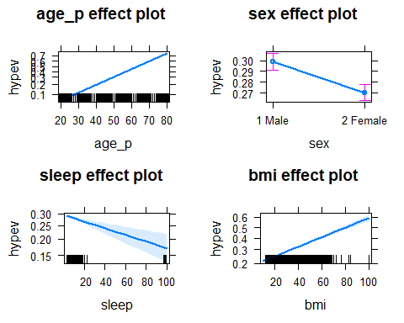

## Exercise: logistic regression

## Use the NH11 data set that we loaded earlier.

## 1. Use glm to conduct a logistic regression to predict ever worked (everwrk) using age (age_p) and marital status (r_maritl).

## First, I noticed that (everwrk) has many NA values. I will use the ‘mice’ library to fill in any missing values.

library(mice)

## Warning: package 'mice' was built under R version 3.4.4

## Loading required package: lattice

##   
## Attaching package: 'mice'

## The following objects are masked from 'package:base':  
##   
## cbind, rbind

set.seed(123)  
simple = NH11[c("age_p","r_maritl","everwrk")]  
imputed = complete(mice(simple))

##   
## iter imp variable  
## 1 1 everwrk  
## 1 2 everwrk  
## 1 3 everwrk  
## 1 4 everwrk  
## 1 5 everwrk  
## 2 1 everwrk  
## 2 2 everwrk  
## 2 3 everwrk  
## 2 4 everwrk  
## 2 5 everwrk  
## 3 1 everwrk  
## 3 2 everwrk  
## 3 3 everwrk  
## 3 4 everwrk  
## 3 5 everwrk  
## 4 1 everwrk  
## 4 2 everwrk  
## 4 3 everwrk  
## 4 4 everwrk  
## 4 5 everwrk  
## 5 1 everwrk  
## 5 2 everwrk  
## 5 3 everwrk  
## 5 4 everwrk  
## 5 5 everwrk

## Warning: Number of logged events: 25

NH11$everwrk = imputed$everwrk

# Now I can build my model with the new values added back to the original dataset. Training will consist of 70% of the data, and the other 30% will be for testing.

index = sample(1:nrow(NH11), 0.7*nrow(NH11))  
training = NH11[index, ]  
testing = NH11[-index, ]

# Model

model = glm(everwrk~age_p+r_maritl, data=training, family="binomial")  
summary(model)

##   
## Call:  
## glm(formula = everwrk ~ age_p + r_maritl, family = "binomial",   
## data = training)  
##   
## Deviance Residuals:   
## Min 1Q Median 3Q Max   
## -1.0024 -0.6210 -0.4862 -0.3520 2.7014   
##   
## Coefficients:  
## Estimate Std. Error z value  
## (Intercept) -0.51369 0.06898 -7.447  
## age_p -0.02795 0.00138 -20.263  
## r_maritl2 Married - spouse not in household -0.03096 0.15824 -0.196  
## r_maritl4 Widowed 0.61823 0.07901 7.824  
## r_maritl5 Divorced -0.81659 0.08232 -9.919  
## r_maritl6 Separated 0.03888 0.10580 0.367  
## r_maritl7 Never married 0.37926 0.04696 8.075  
## r_maritl8 Living with partner -0.55522 0.09187 -6.044  
## r_maritl9 Unknown marital status 0.62431 0.34610 1.804  
## Pr(>|z|)   
## (Intercept) 9.58e-14 ***  
## age_p < 2e-16 ***  
## r_maritl2 Married - spouse not in household 0.8449   
## r_maritl4 Widowed 5.10e-15 ***  
## r_maritl5 Divorced < 2e-16 ***  
## r_maritl6 Separated 0.7133   
## r_maritl7 Never married 6.74e-16 ***  
## r_maritl8 Living with partner 1.51e-09 ***  
## r_maritl9 Unknown marital status 0.0713 .   
## ---  
## Signif. codes: 0 '***' 0.001 '**' 0.01 '*' 0.05 '.' 0.1 ' ' 1  
##   
## (Dispersion parameter for binomial family taken to be 1)  
##   
## Null deviance: 19842 on 23108 degrees of freedom  
## Residual deviance: 18673 on 23100 degrees of freedom  
## AIC: 18691  
##   
## Number of Fisher Scoring iterations: 5

### From the model you can see that age and the majority of marital statuses had a very high impact on ever worked.

# Baseline Model

table(NH11$everwrk)

##   
## 1 Yes 2 No 7 Refused 8 Not ascertained   
## 27998 4955 44 0   
## 9 Don't know   
## 17

### From the table output, out of 33,014 responses 84.8% (27,998) of participants have worked, 15% (4,955) have not ever worked, and < 1% have either refused (44) or don’t know (17).

## 2. Predict the probability of working for each level of marital status.

pred1 = predict(model, newdata=testing, type="response")  
final = table(testing$r_maritl, pred1)  
plot(allEffects(model))

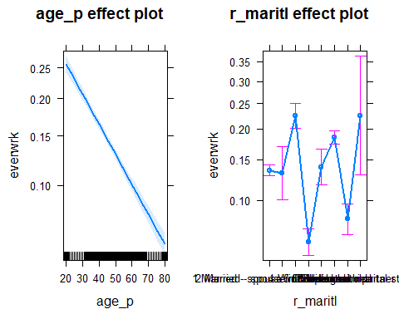

## Note that the data is not perfectly clean and ready to be modeled. You will need to clean up at least some of the variables before fitting the model.