

TDS 3751 Social Media Computing

Assignment 2

Analyzing User Sentiment towards Industries & Brands

Report

Prepared by:

|  |  |  |  |  |
| --- | --- | --- | --- | --- |
| Name | ID | Tutorial Section | Email | Phone No. |
| Lim You Qian | 1141128343 | TT02 | limyq0202@gmail.com | 019 - 383 9366 |
| Kew Wai Chun | 1141128080 | TT02 | 1141128080@student.mmu.edu.my | 016 - 203 2189 |
| Kevin Toh Huat Xiang | 1141128390 | TT02 | kevinthx0000@gmail.com | 011 - 1229 6088 |
| Nur Nadhirah Bt Nazarudin | 1142700151 | TT02 | nazanadhirah@gmail.com | 019 - 669 1226 |

# Table of Contents

Table of Contents 1

Introduction 2

Project Scope 2

Dataset 3

Data Preprocessing 3

Methodology 4

Overall Sentiment Analysis 5

Monthly Sentiment Analysis 5

Sentiment Analysis on frequent topics and aspect of the campaign’s product 5

Result Evaluation 6

Overall Sentiment Analysis 6

Monthly Sentiment Analysis 7

Samsung 7

OnePlus 9

Summary of Monthly Sentiment Analysis 10

Sentiment Analysis on frequent topics and aspects of the campaign’s product 11

Samsung 11

Giveaway 11

Battery 12

Camera 13

S-pen 14

Oneplus 15

Giveaway 15

Collaboration with TMobile 16

Fingerprint 17

Price 18

Earphone Jack 19

Conclusion 20

References 20

# 

# Introduction

Microblogging today has become a very popular communication tool among Internet users. Millions of users share opinions on different aspects of life every day. Therefore microblogging websites are rich sources of data for opinion mining and sentiment analysis. In previous work, we have performed multiple analysis on the campaign tweets such as engagement rate and posting habits. Even though we have found plenty of insights regarding the campaign tweets, but we do not acquire the insights of audiences’ feedbacks. In this assignment, we focus on using Twitter, the most popular microblogging platform, for the task of sentiment analysis specifically on Oneplus and Samsung company towards their newly launch product that is Galaxy Note 9 for Samsung and Oneplus 6T for Oneplus company. With the numbers of engagement between Oneplus and Samsung towards its’ respective audience takes into account, It enables evaluation and gains insights of the feedback from the audience through sentiment analysis.

# Project Scope

Due to resource and time limitations, there are several scopes to be applied in order to achieve an appropriate result for this assignment.

1. The assumptions and methods are not based on any literature review.
2. We focus on all the tweets that are talking about the campaign or campaigns' product instead of the direct replies toward the campaign tweets.
3. The dashboard shows visualizations that is meaningful and contains interesting information only.
4. Objective/subjective identification is not being utilized in this assignment due to the inaccurate identification result.

# Dataset

Due to Twitter API limitation, we are unable to collect the tweets that directly reply to the campaign tweets. The alternative solution to overcome this issue is to collect all the tweets that mentioned the companies (@SamsungMobile & @oneplus) and hashtag (#galaxynote9 & #oneplus6t). This solution will collect all the tweets that are related to the campaign’s product. In other words, we will analyze all the tweets that are talking about the campaign or campaigns’ product. The timeline of the data we collected is same as Assignment 1, which is from July - December 2018 (6 months). The number of replies we collected are 1481 and 3745 for SamsungMobile and Oneplus.

# Data Preprocessing

Firstly, we removed all the tweets that are posted by the company account including all the subsidiary accounts using regular expression method. Next, we transformed all abbreviation into its original words.

Apart from that, in order to determine frequent topics or aspects, we performed stopwords and punctuation removal. Moreover, we also manually remove meaningless words such as the name of the products and mentions until we found interesting keywords that lead to topics/aspect.

On top of that, there are several data preprocessing is applied to achieve a more accurate result of sentiment analysis. The steps are: -

1. Remove redundant texts such as different types of URLs, mentions, and hashtags. These texts are meaningless in term of sentiment analysis.
2. Remove punctuations. Punctuation makes no impact on the analysis of text and is hence removed.
3. Word stemming. In text analysis, stemming is the process of reducing inflected (or sometimes derived) words to their word stem, base or root form.
4. Stripping. This will remove the redundant whitespace and retains only the words themselves.

# Methodology

Sentiment Analysis that carried on this process is by using document-level sentiment analysis. The similar approach is carried out on getting the analyzed result of both product Galaxy Note 9 and Oneplus 6T. This method analyzes the text from pre-processed data tweets and indicates the value of sentiment whether it expressed positive, neutral or negative sentiment of a complete document. The conjunction of this approach is to relate the effectiveness of each company received products’ opinion sentiment result that benefits on plotting company's product marketing strategy and customer feedback by understanding and measure broadly on how people are talking about them online. In this assignment, the TextBlob sentiment package is used to perform sentiment analysis. **All approaches will be analyzed based on the number of positive, negative and neutral reply.**

## Overall Sentiment Analysis

In this section, the overall replies’ sentiment will be summarized for both products throughout the 6 months of tweets. We may obtain a general idea or picture of sentiments toward both products.

## Monthly Sentiment Analysis

Capturing the monthly engagement rate of your campaign only explain the impact of the campaign quantitatively. A high or low engagement rate does not reflect the opinion of the audience towards the campaign or product. In this case, we perform monthly sentiment analysis that allows us to understand engagements are showing positive, negative or neutral feedbacks. Moreover, we may also capture the general topics for each month and compare the sentiment of each topic to understand the short term trends so that the company can tune into specific topic next time when launching a new product.

## Sentiment Analysis on frequent topics and aspect of the campaign’s product

In order to understand what are the topics or aspects regarding the product that the audience cares about, we perform sentiment analysis based on popular topics and aspects. We acquire the popular topics and aspect by calculating the frequency of meaningful keywords such as “battery”, “camera” and “win”. “Battery” and “camera” represent the aspect of the product while “win” represents a giveaway activity of the product. We use some Natural Language Processing (NLP) technique as well as removing non-informative keywords manually to acquire the frequent topics discussed by the audience. By understanding the popular topic and aspect and its sentiment of the audience towards the topic and aspect, the company may know what are the aspect of the product that they should emphasize as well as their advertising and promotion strategy.

# Result Evaluation

## Overall Sentiment Analysis

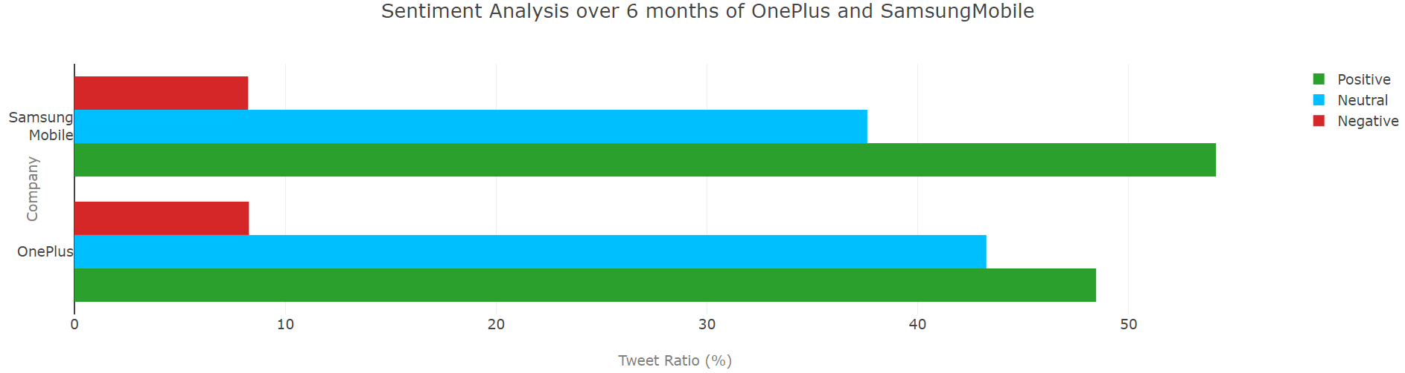

The figure above illustrates the monthly sentiment analysis trend for both SamsungMobile (Galaxy Note 9) and Oneplus (Oneplus 6T). Both of the companies show a significant result on positive sentiment gained compare to negative replies. For Samsung, most positive highlights received is from its device compatibility towards Fortnite game while Oneplus is about the giveaway contest by well known social media influencer and Amazon India. From this result, the company able to emphasize on collaborating with trending entity and well-versed social media influencer to promote their product towards its respective fans or follower. This method may require a huge amount of costs but it shows a big impact from this analysis. In conclusion, the overall sentiment reflects that the product is generally acknowledged by the audience. A lower level analysis is required to understand the opinion of the audience.

## Monthly Sentiment Analysis

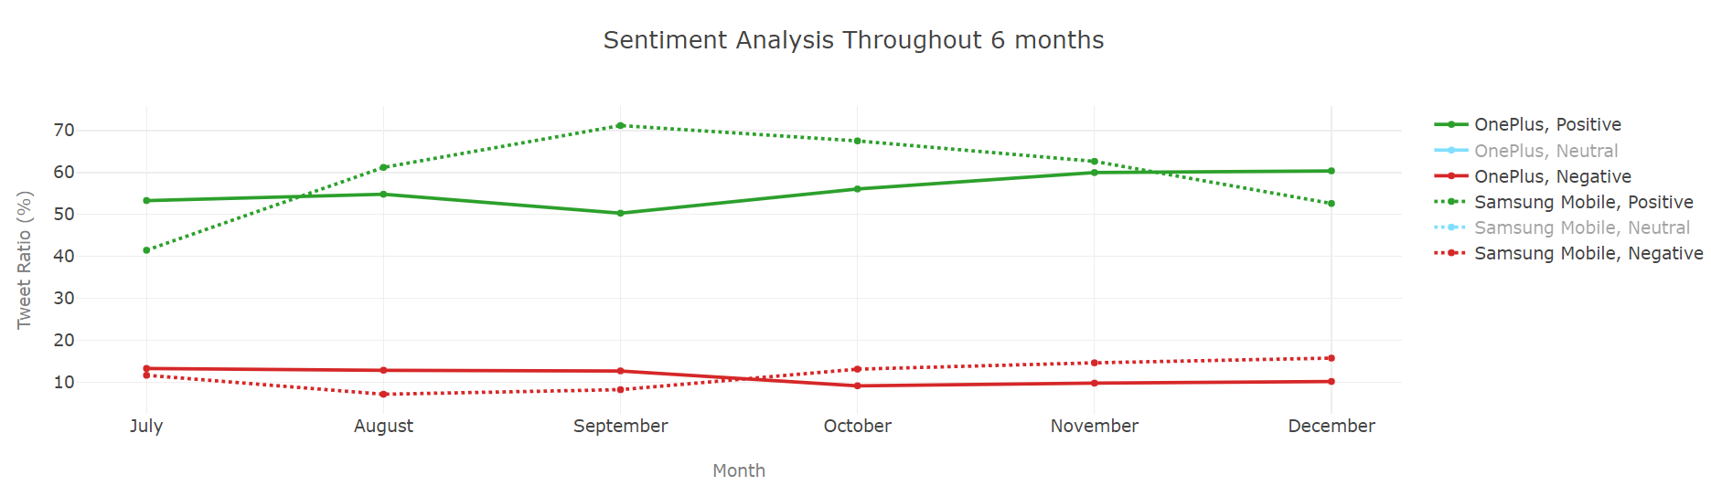

### Samsung

In July, 94 replies are gained which consist the buzz of leak image and information of Galaxy Note 9 that is going to launch in August in terms of its aspect such as the price according to its features and multiple color variants with a new multi-functional s-pen. This leak information became the wow factor of the month with the lowest positive sentiment tweet ratio throughout the 6 months. This analysis leads to confidential information that can harm the reputation of your company in the marketplace. Perform a regular check on the outflow of confidential information from the company might be required for SamsungMobile.

In August, 766 replies are gained which flooded with the recent launch of Galaxy Note 9 as well as some unboxing and first-hand experience tweet. Performance, functionality and the size of the device’s screen are mentioned. Moreover, the compatibility of Galaxy Note 9 on famous game, Fortnite which require high resolution and strong internal performance to accommodate the quality of the game that leads to Fortnite fans floods Twitter with the excitement towards the device. Therefore, the ratio of positive tweet increases compares to July.

Next, in September, 375 replies are collected which is down in numbers compared to last month but the ratio of positive tweets has reached its peak throughout the 6 months. This is a very good result achieve by SamsungMobile because the topics discussed in this month is not only about a giveaway, but also the promotional tweets of Galaxy Note 9 Battery Case and some reviews and opinions from the audience. It shows that the audience is showing a positive response towards the product.

On top of that, from October onwards, the number of tweets is decreased from month to month. The ratio of the positive replies is also decreasing while the ratio of negative tweet slightly increases. From the analysis gained, in these three months, the contents are covered with reviews of Note 9 device. The topics discussed by the audience in October are the giveaway activity in previous month and reviews while most of the replies in November and December are reviews from the audience. This is not an ideal result because the ratio of positive reply increases while negative decreases when most of the replies are reviewing the product. The company should start to analyze the reviews of the product from the audience for future product enhancement.

### OnePlus

In July, only 15 replies are obtained whereby upcoming device OnePlus 6T is rumored to be launch in the same year. It is not appropriate to drop any conclusion for this month because the number of replies obtained is too less where it does not represent the audience. As for the suggestion to elevate the hype and excitement of the audience towards the product, the company can promote more teasers about the uniqueness of the product.

Moreover, in August, a total of 62 replies is collected. Most of the replies are discussion regarding the leaked information of One Plus 6T such as the external design of the phone and its specifications. This is a serious issue because the rumors will draw the attention of the audience while the audience might take the rumors as their first impression of the product. But somehow there are no interesting insights to be interpreted but the feedback from the audience towards the rumors of the product is acceptable because the ratio of positive and negative reply is on average level. As for suggestion towards the company is to improve internal privacy and security for confidential information protection.

On top of that, in September, for Oneplus company has elevated to 314 replies. Due to the vast discussion on rumors regarding the upcoming Oneplus 6T device comes without earphone jack with the mixture of teasers regarding Oneplus 6T, the ratio of positive replies dropped 4% while the ratio of negative replies remains the same. The company could take the negativity and the opinion that explains the negative feedback into consideration for future product enhancement. The company may overcome with some supporting accessories.

Apart from that, with 1676 replies being collected in October, the ratio of positive reply increases while the negative ratio decreases. Even though there is plenty of complaints regarding the earphone jack, but the sentiment result still appears to be better than last month. This is because there is a giveaway activity by Amazon India as well as the announcement of the release date of the product. This proof that giveaway and announcement regarding release date will cause excitement towards the audience.

Moreover, almost 12000 replies have been collected in November and December. The frequent topics in both of the months are regarding giveaways from last month as well as other giveaways by social media influencer, reviews, and product unboxing videos. Firstly, it shows that the intervention of social media influencer towards the product increases the pace of spreading the product. Other than assumption and conclusion can be made for November and December due to multiple topics were discussed in the same period of time.

### Summary of Monthly Sentiment Analysis

Firstly, the sentiment of the feedback from the audience is strongly affected by the topics. For instances, the ratio of positive reply increase when the audience discussed giveaways and excitement towards the products but the positive ratio drops when due to unsatisfactory of the product such as removal of the earphone jack on One Plus 6T. Even though we stated that leaking information about the product before the announcement might bring an impact on the product and company, but we cannot rule out that the information leaking is done with purpose. The company may want to analyze the feedback of the audience towards the product before the official announcement of the product so that they can tune the way of announcing and promoting the product. Last but not least, monthly sentiment analysis does not show us the sentiment in terms of the quality of the product or campaign directly. Hence, the sentiment analysis on frequent topics and aspect is performed.

## Sentiment Analysis on frequent topics and aspects of the campaign’s product

## Samsung

### Giveaway

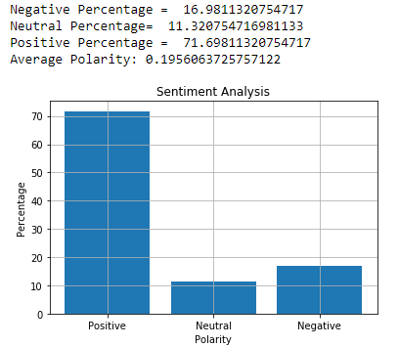

Giveaway is the most frequent topic engaged by the audience. The sentiment result shows 71% high in positive where else negative and neutral is down to 16% and 11% respectively. The insight of the positive result is due to the giveaway contest made by a popular influencer @OMGitsalia. She uplifts the giveaway hype double time by not only giving free device but with adding with free Fortnite skin. Audience submitting praising reasons to win the contest where it contributed a high amount of the positive statement. Appointing influencer as a representative for the giveaway is the most effective ways to advertise the product in social media platform as well as indirectly introduces the product specification spontaneously social media users.

### Battery

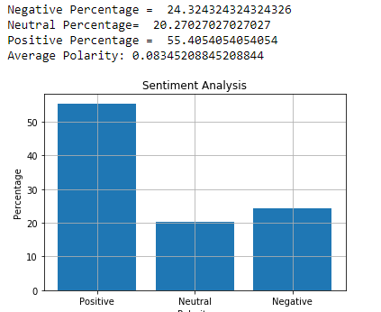

The sentiment result regarding the battery of Galaxy Note 9 shows 55% of positive replies where else negative and neutral is down to 24% and 20%. The reason for high positive ratio is because of the contribution from the giveaway replies. Meanwhile, there are some complaints regarding the batter where the battery life is decent but not able to stand for a day as claimed.

### Camera

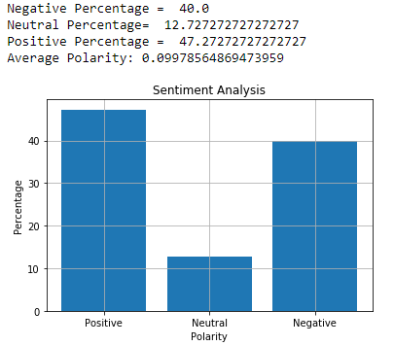

The sentiment regarding the camera of Galaxy Note 9 shows 47% of positive ratio 40% of negative ratio and 12% of neutral ratio. The talk within the positive sentiment is regarding built-in 20+ megapixels camera with AI as well as pdf document scanning functionality. In the other hand, the audience expresses their negative feedback from their experience on the camera quality where it shows crisps and flare image quality. With the high negative ratio of 40% on the camera of Galaxy Note 9, it shows that the audience is not satisfied with the camera quality. For company advice, it's vital to take note of such aspect due to the phone’s major component competition is the camera that plays an important role.

### S-pen

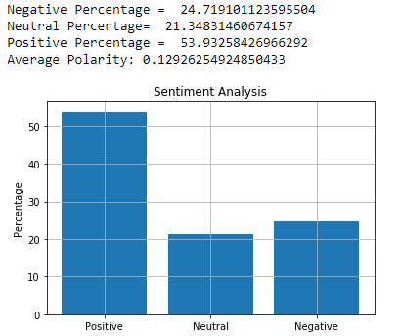

The sentiment of S-pen shows 53% high in positive while the negative and neutral ratio is 24% and 21%. Most of the replies praise that the new functionality of S-pen, Bluetooth connectivity to take selfies which prove that this innovative upgrade of the S-pen is a success. Besides, even though 24% of the replies are negative, but the content negative replies included other aspects such as battery life. This result shows that the company shall emphasize its major component towards innovative ideas.

## Oneplus

### Giveaway

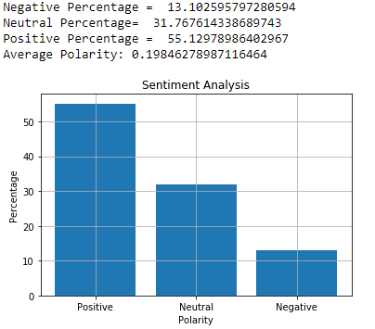

Giveaway topic of One Plus 6T is also the most frequent topic that is being discussed on Twitter like SamsungMobile.The sentiment of this topic is 55% positive, 31% neutral and 13% negative. We have mentioned the benefit of giveaway event several times above. In conclusion, this topic is able to keep the word of mouth going to reach to new consumers as the acknowledgment.

### Collaboration with TMobile

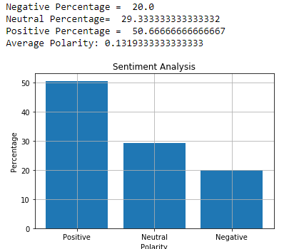

There is a collaboration between One Plus and TMobile, where TMobile is selling another version of One Plus 6T with some limitation such as non-dual sim system but users may enjoy the benefit of trade-in offer. The sentiment of the collaboration between One Plus and TMobile are 50% positive, 29% neutral and 20% negative. It shows a positive outcome because the company is able to sell their product across 5000 TMobile franchise around the United State of America. It is advisable to collaborate with international companies to increase the market of the product.

### Fingerprint

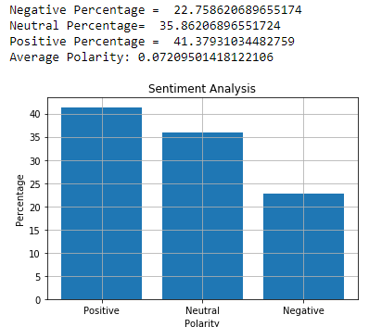

The sentiment of the fingerprint is 41% positive, 35% neutral and 22% negative. The insight of positive result is because One Plus 6T embedded a screen fingerprint functionality where it increases the size of the screen. Besides, the audience has shown negative feedback towards the combination of on-screen fingerprint and no earphone jack. Moreover, plenty of audiences mention that the fingerprint unlock functionality is unstable.

### Price

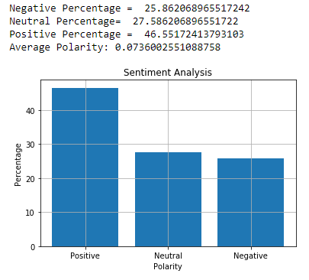

The sentiment regarding the price of the product is 46% positive, 27% neutral and 26% negative. Most of the positive opinion from the audience is saying that this product is more worth buying with better specifications compare to the other brand such as Apple. Besides, some audience voices up that the price is not worth buying because the price is paying for the removal of earphone jack where this removal is not the audience wants. In summary, the company may take these responses into consideration where only make necessary changes on the product to maintain a reasonable price.

### Earphone Jack

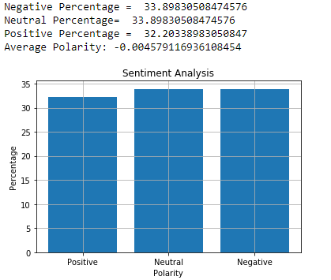

Figure 11. Oneplus Audio jack component Aspect Sentiment Result

The sentiment of earphone jack is a pretty balance which has 32% positive and 34% for neutral and negative. The audience is complaining about the removal of earphone jack because most of the audience are still prefer to use wired earphone. From this analysis, the company is advisable to stress on the decision of removing the basic components of a device and come out with alternatives to overcome the hassle towards the user.

# Conclusion

In conclusion, narrowing down the sentiment analysis into multiple parts is able to provide insight for the company. Different topics have different sentiment towards the product such as giveaway has shown a high positive sentiment from the audience. Besides, the company can study the monthly sentiment analysis so that they can plan for the next product campaign. For instance, the company can launch some giveaways or collaborate with popular entities to attract the attention of the audience then only focus on promoting the device’s specifications. Moreover, the company could have a clear image of the sentiment from the audience towards each aspect of the product. The company may emphasize innovative upgrades of the product when promoting it. Last but not least, the company may also need to reconsider some changes based on the user’s perspective such as the earphone hack. It might be innovative changes but that is not what the audience really wants in practice.

# References

<http://nitin-panwar.github.io/Text-prepration-before-Sentiment-analysis/>