## Usability Test Results

### 1st Card Sorting results

On Monday, we as a team discussed our findings and some noticeable results were:

* Resources - Our users were not sure what to make of this category. Some of our tested placed categories that we wanted into this column, others places nearly all the categories into this column. Unanimously, all the testers were a little perplexed by this column, with some mentioning that the column was too vague and not clear/specific enough.

Some of the Card Sorting results and images:

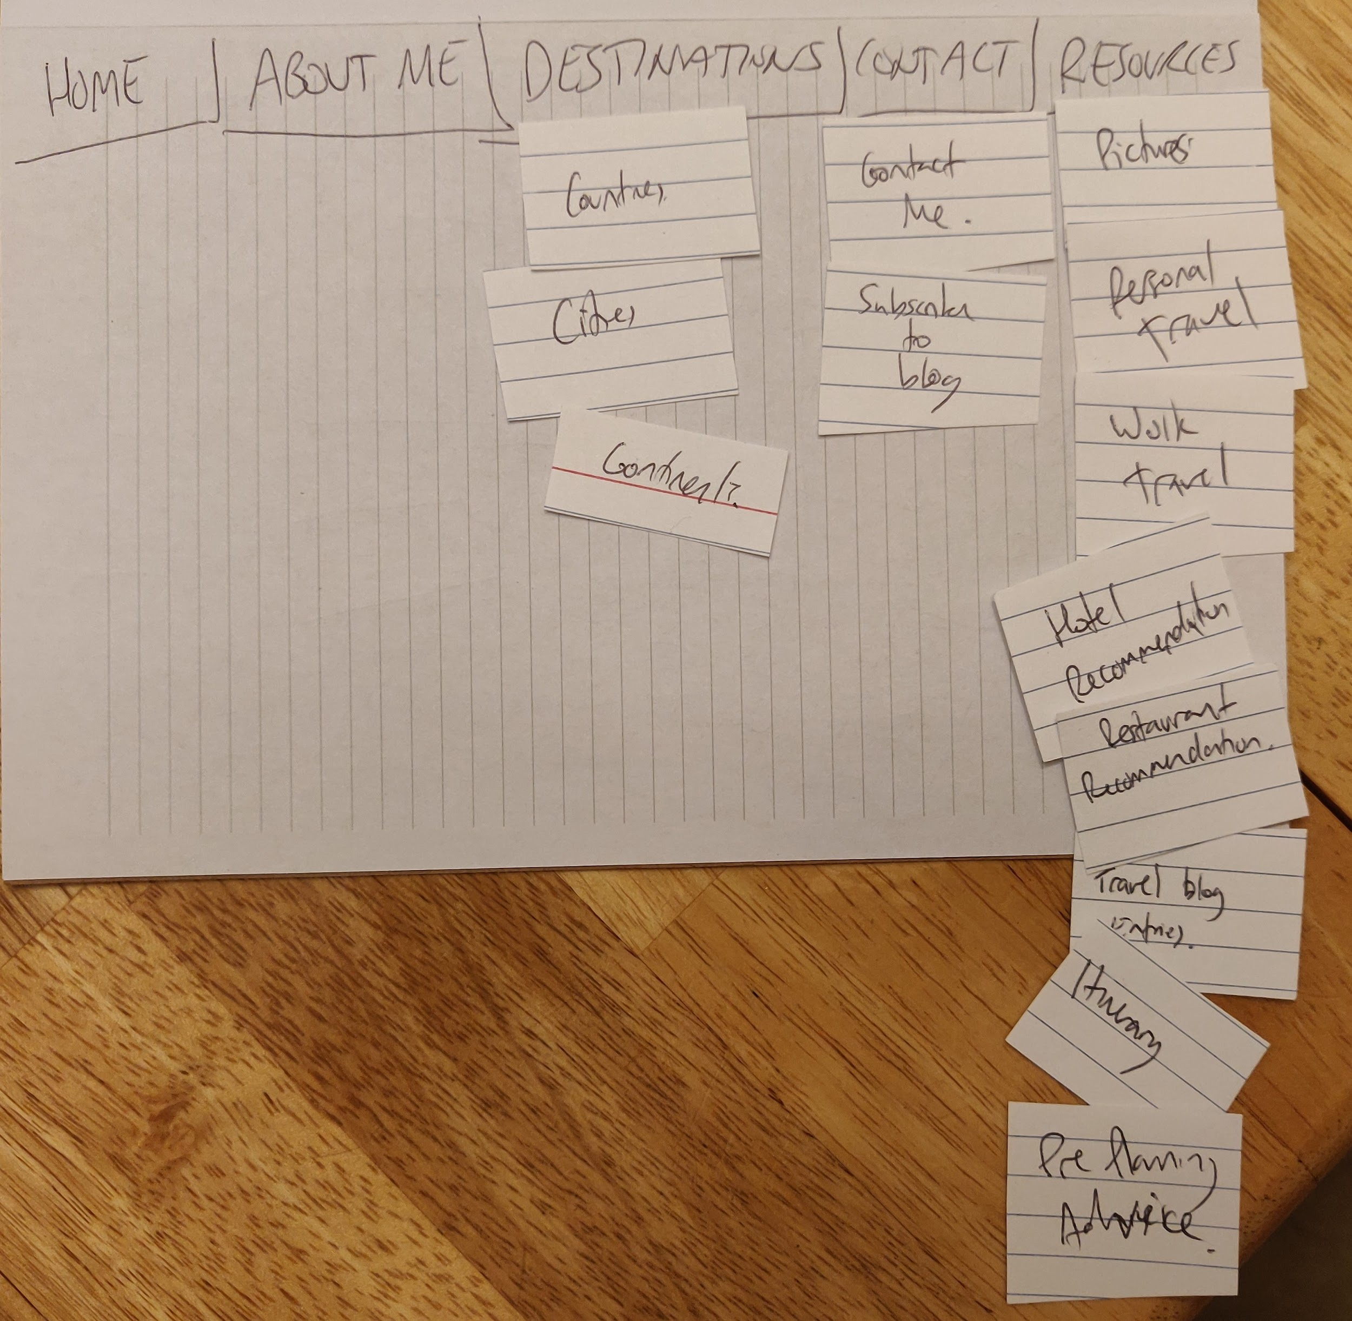

*Shota - 30 year old engineer designing electric bikes, very used to computers and the web*

*He mentioned he was not sure about the resources section*

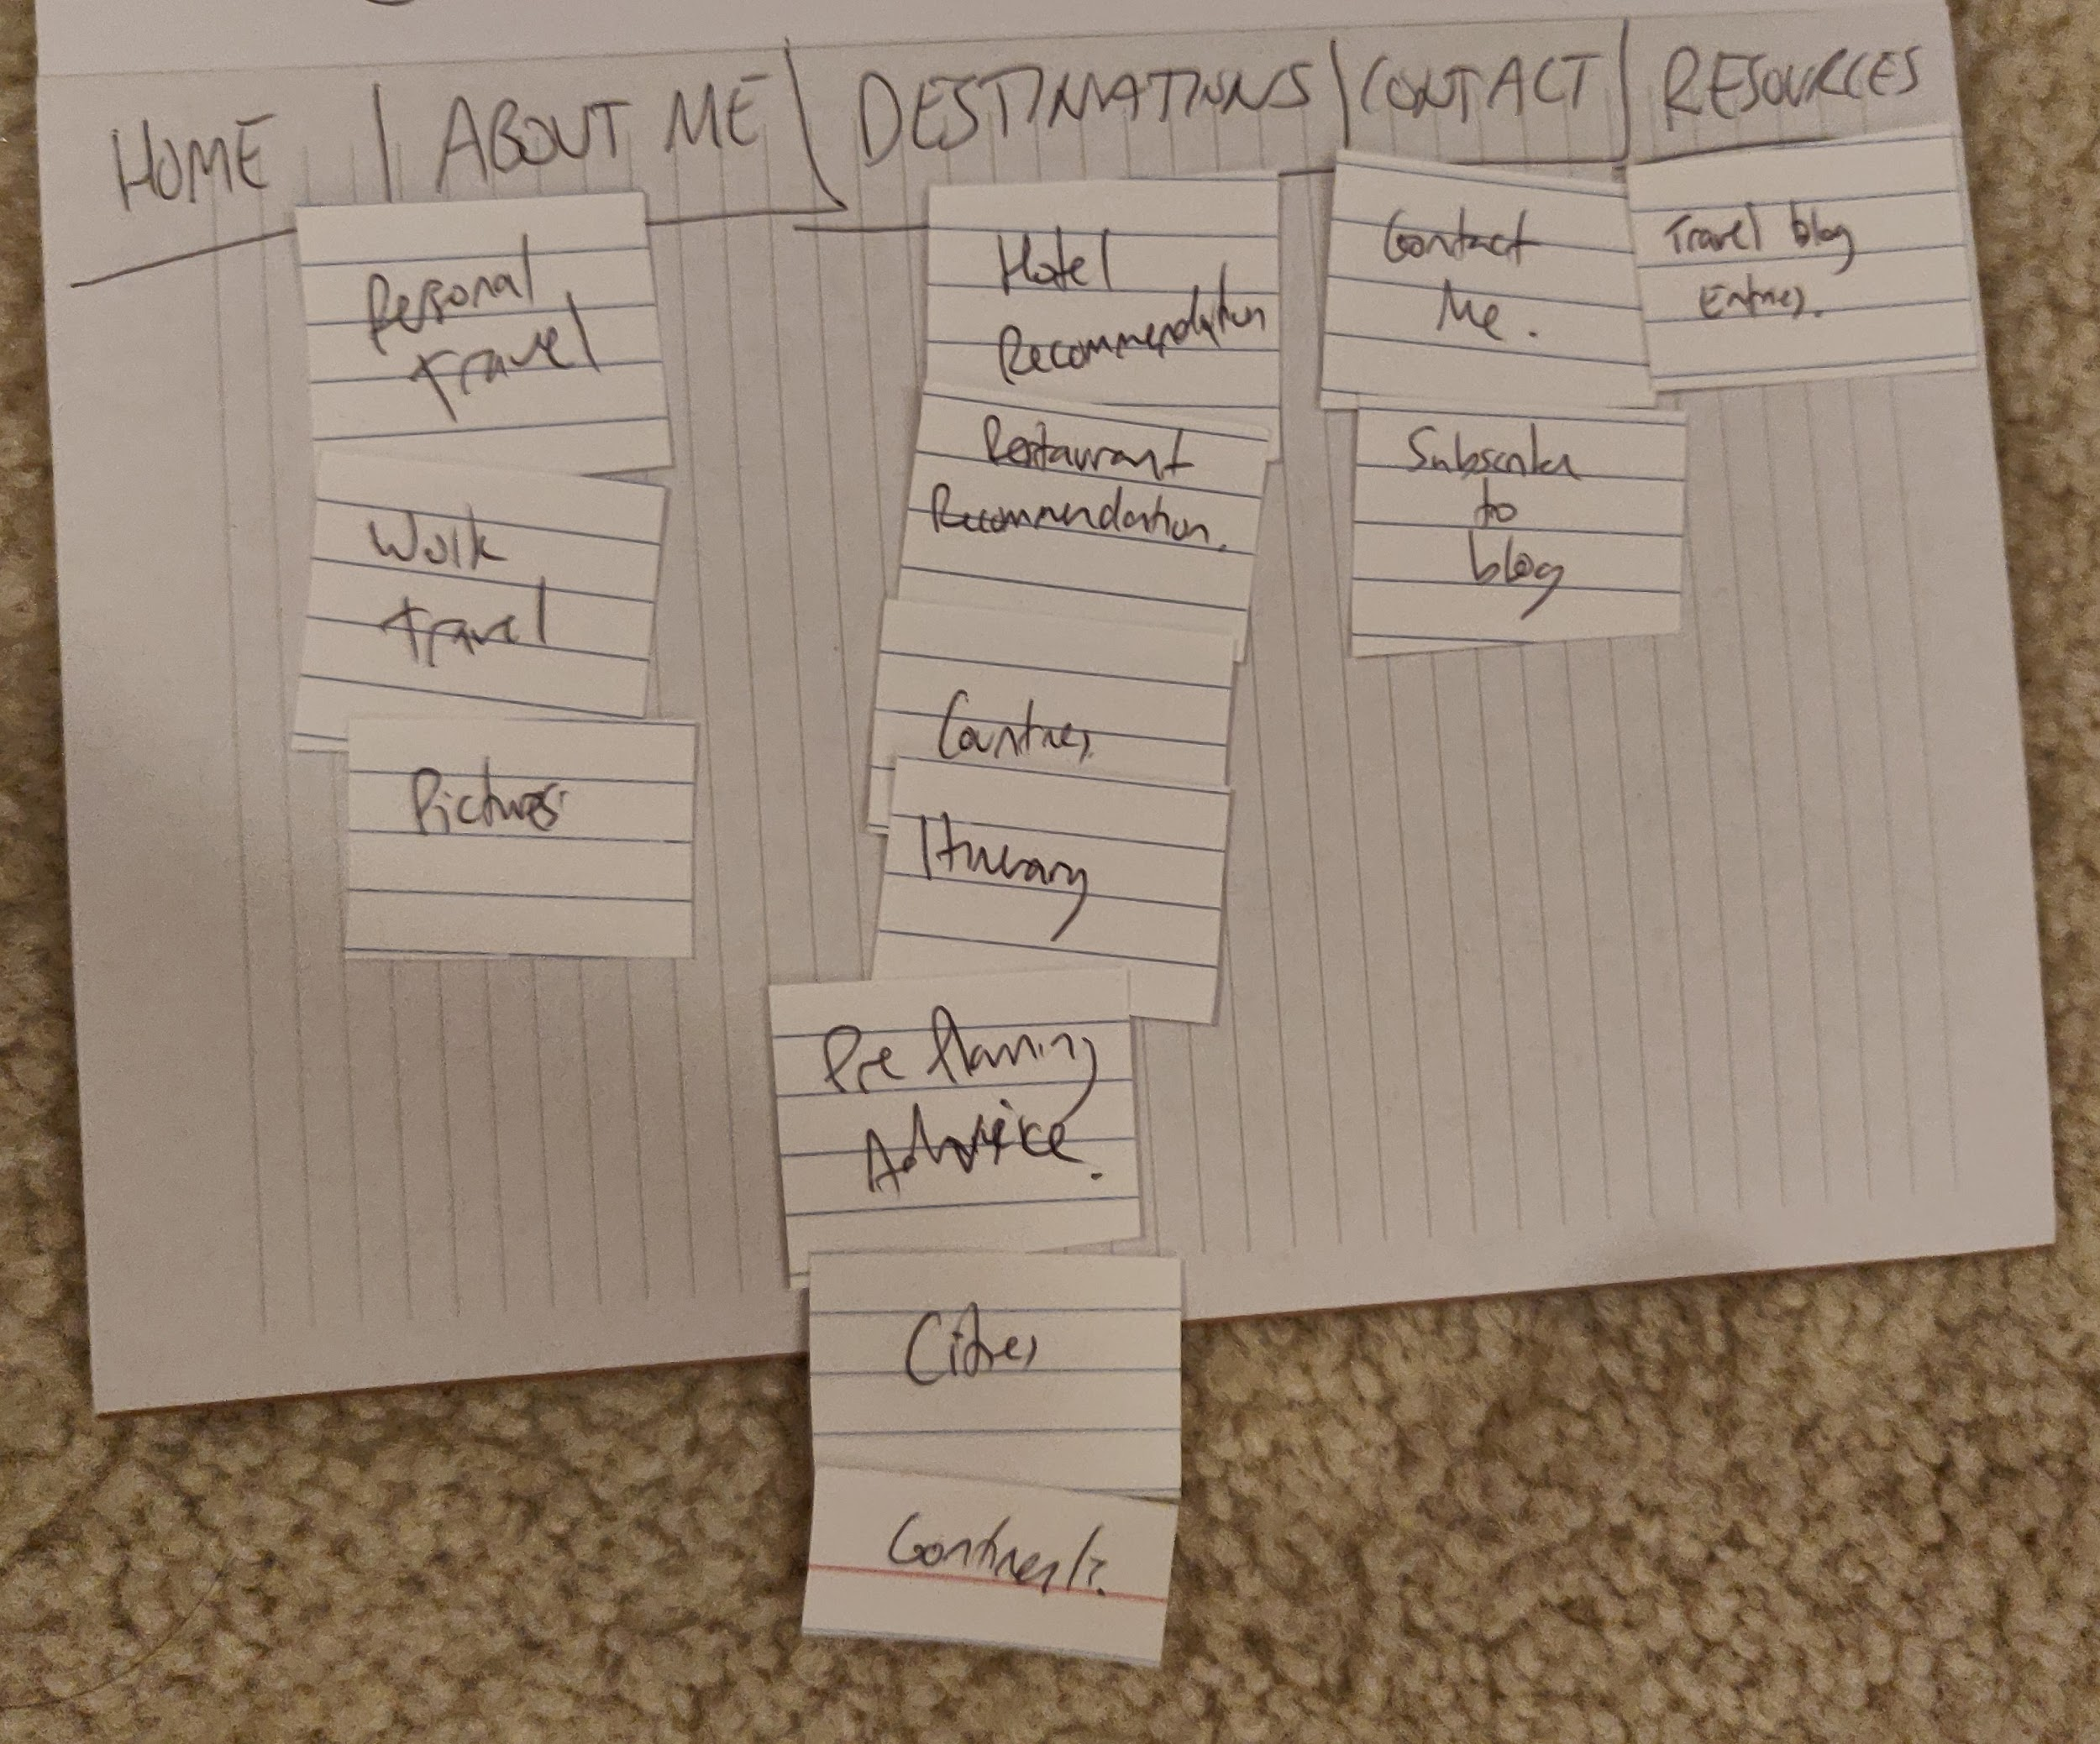

*Priscilla - 35 year old Clinic Administrator, familiar with computers and the web*

*Had a different approach to Shota placing lots of location relate topics under Destinations.*

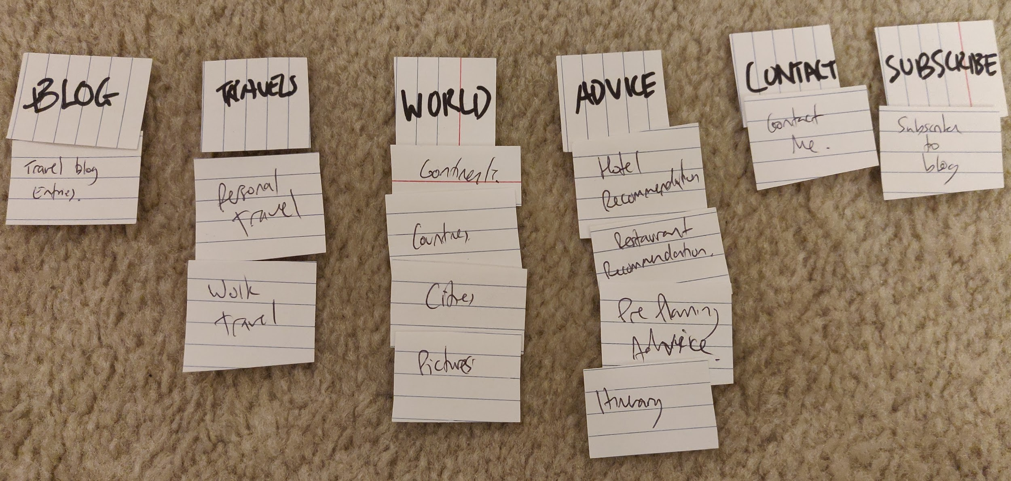

*Flora - 60 year old shop assistant. Non native speaker so had to explain more of the terminology to them, very varied results.*

After discussion as a team, we decided to change *Resources* to *Travel Tips*, which we felt was much clearer for the end user and more precise in explaining what this new section would include. By moving away from resources, we made the pictures category into a category called *'Gallery'* instead*.*

* Blog - This was another category that seemed a little out of place on the website and testers could not decide where this was to go. We do understand from our client Lisa that she isn't too fond of having multiple entries of the blog on the home page (without some sort of filter to manage it). As such, and on researching other travel websites, we decided to move this to its own category too.

### Extra - 2nd Card Sorting Test

Having redone our website layout, we used the new layout to test with a new bunch of users. Results from the next card sort were much better than the first. Participants were much quicker to place cards in what we thought would be appropriate categories.

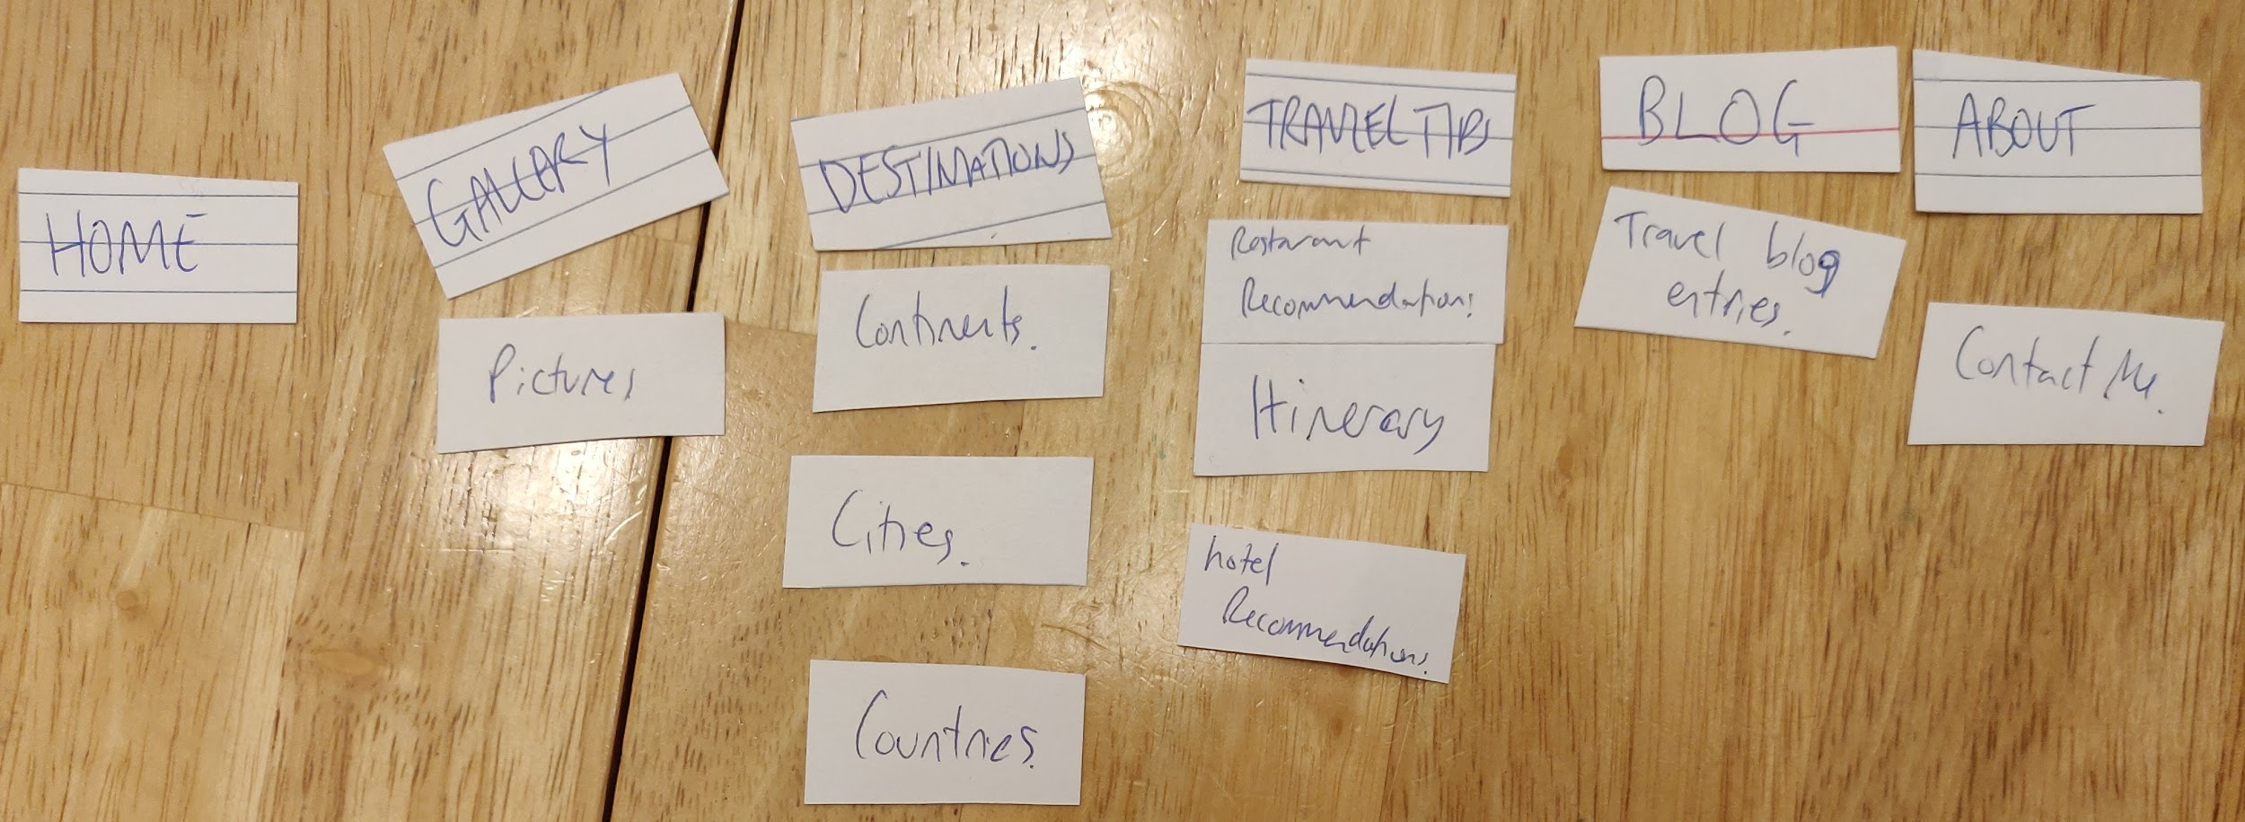

*Paul - 30 year old Support Representative.*

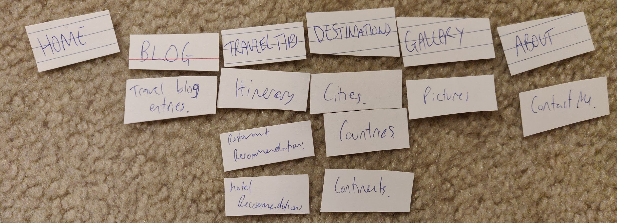

*Roderick - 63 year old Medical Records Administrator*

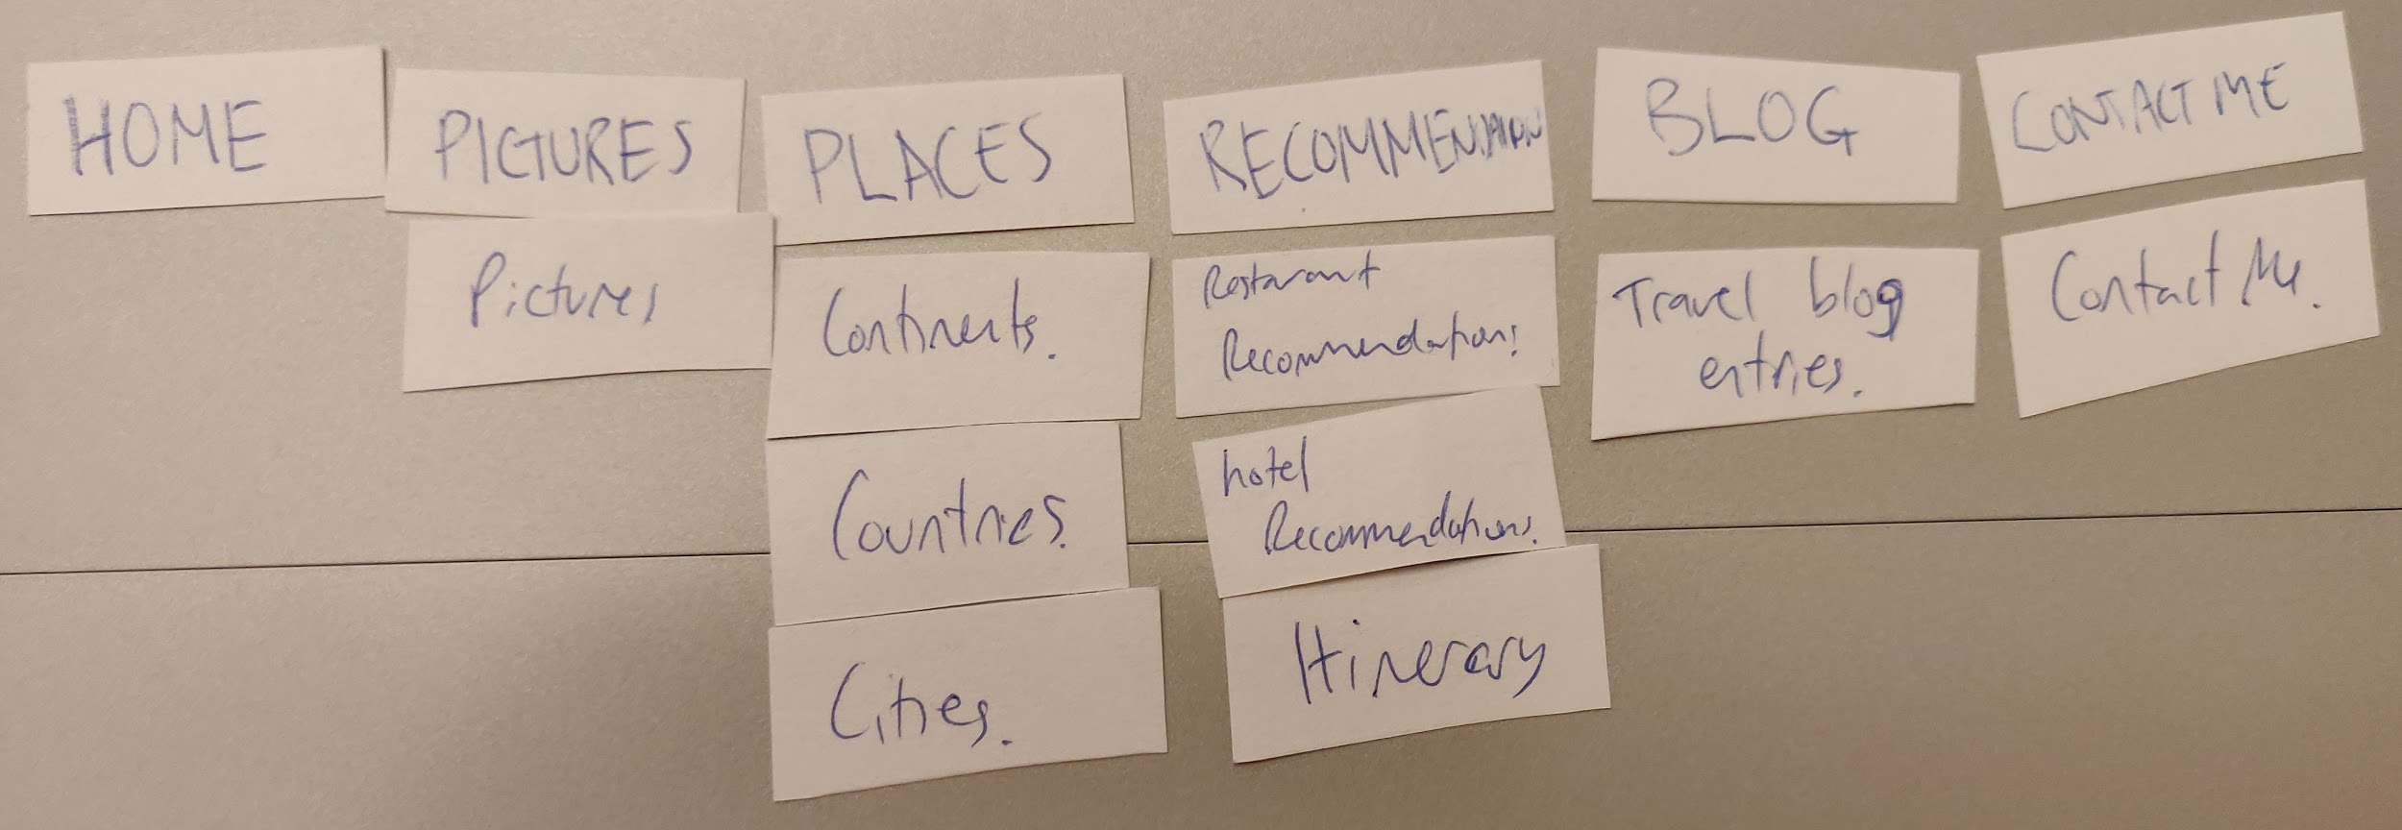

*Nick, 28 - Operations Manager.*

For one of our 2nd card sorting results, when we changed the options that were available to our users, we obtain fairly similar results. What I did notice was that the placing and ordering of columns were different. Some felt compelled to place the Gallery after Home while others felt, as this was a travel blog, that the blog section would come in after Home.