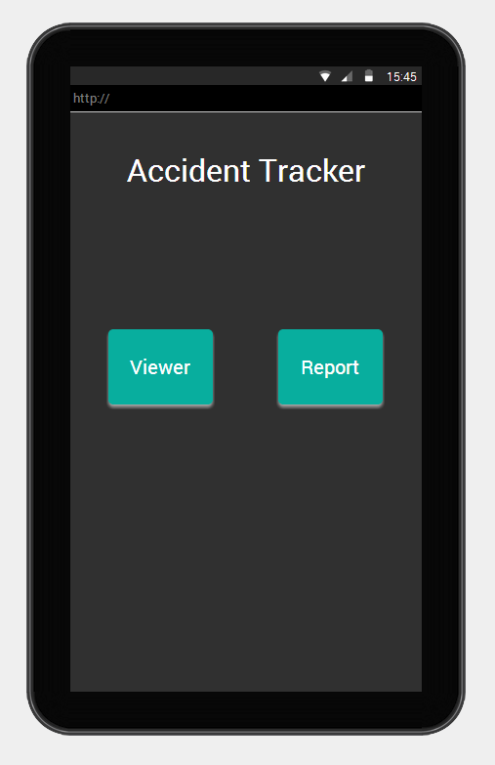

Header use angular material header with href

Button use md-button (<https://material.angularjs.org/latest/demo/button> )

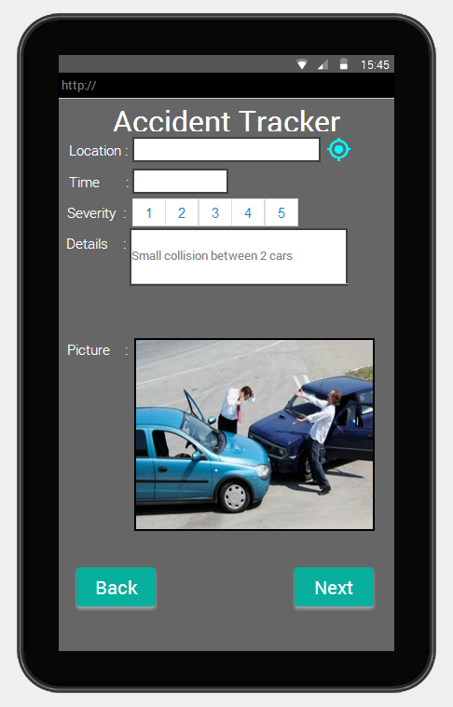

Input fields use md-input-container (<https://material.angularjs.org/latest/demo/input> )

Severity use md-slider (<https://material.angularjs.org/latest/demo/slider> )

GPS icon use svg-icon and reverse geocoding (<https://developers.google.com/maps/documentation/javascript/examples/geocoding-reverse> )

Button use md-button (<https://material.angularjs.org/latest/demo/button> )

Link phone to android browser – <https://github.com/don/html.com>

View of current page – hardcode it