**Singapore Institute of Technology**

**Infocomm Technology Cluster**

**ICT4002 Integrated Work Study Programme**

IWSP Status Report Submission Form (Form D)

# Preamble

This form duly filled and signed must be attached to each IWSP Status Report submitted.

**Reporting Period:**

(Reporting Period): 21/8/2017 to 15/12/2017

**Candidate Particulars:**

(Name of Candidate): Chow Jie Jin Edmund

(Organization): Mandai Park Development Pte Ltd

(IWSP Period): 9/1/2017 to 15/12/2017

**Main Academic Supervisor Details:**

(Name): Dr Tan Chek Tien

(Email Address): ChekTien.Tan@Singaporetech.edu.sg

(Contact Number): 9227 8780

(Designation): Assistant Professor

**Industry Supervisor Details:**

(Name): Danny Tan Wei Yang

(Email Address): danny.tan@mandai.com

(Contact Number): 9369 8836

(Designation): Assistant Vice President

(Department / Division): Digital

# Declaration of Conformity

### Declaration by Industry Supervisor

I hereby acknowledge that I have read and understood the contents of the IWSP Status Report, and deem the contents appropriate for release to the Singapore Institute of Technology for use in the assessment of the candidate.

|  |  |
| --- | --- |
| *Signature* |  |
| **Name of Industry Supervisor:** Danny Tan Wei Yang  **Designation:** Assistant Vice President  **Department:** Digital  **Contact No:** 9369 8836  **Email:** danny.tan@mandai.com  **Date:** 23/11/2017 | |

### Declaration by Candidate

I hereby acknowledge that I have engaged and discussed with my Industry Supervisor on the contents of the IWSP Status Report, and have sought approval for the release of the report to the Singapore Institute of Technology.

|  |  |
| --- | --- |
| *Signature* |  |
| **Name of Candidate:** Chow Jie Jin Edmund  **Contact No:** 9151 3429  **Email:** 14sic014c@sit.singaporetech.edu.sg  **Date:** 21/11/2017 | |

**END OF FORM D**

|  |
| --- |
| **Information and Communication Technology Cluster** |
| IWSP Status Report  (Mandai Park Development Pte Ltd)  For the reporting period from 21/8/2017 to 15/12/2017  Chow Jie Jin Edmund  14SIC014C |
| Name of Industry Supervisor: Danny Tan Wei Yang  Name of Academic Supervisor: Dr Tan Chek Tien |
| Submitted as part of the requirement for ICT4002 Integrated Work Study Programme |

**Customer Relationship Management System (CRM)**

# Specialised Terminology

|  |  |  |
| --- | --- | --- |
| Abbreviated | Full Name | Description |
| CRM | Customer Relationship Management | New system as an upgrade to the current CRM 2011 to act as centralized collection source of customer data |
| SOP | Standard Operating Procedures | Step by step instructions to help employees carry routine operations |
| SIT | System Integration Testing | Testing conducted by testers of the application |
| UAT | User Acceptance Testing | Testing conducted by users of the application |
| JIRA | JIRA | Online project management platform mainly used for task tracking and bug tracking. |

# Introduction

In the present moment, there are still quite a number of manual process handled by operational staffs when it comes to handling customer data. Because of this, there is a need for a new system to automate as much manual processes as possible. The new CRM will be based off CRM Dynamics 365, an improved version over the current CRM 2011 used. This project serves as an upgrade from the current CRM 2011 to act as a centralized database, a single source for collecting customer’s data from various sources. With the new system ready and in place, it will be able to improve the staff’s productivity. Operational staffs will be able to source for customer information at the tip of their fingertips whenever required.

The management of the project will be handled by the organization and the development work is outsourced to an external vendor. The software lifecycle of the project it undertakes is the waterfall model, however there is a bit of customization added into it. For example, a problem encountered during the design phase due to certain limitations will warrant a revisit into the requirements phase to relook at the requirements. This can result in the requirements changing. The vendor played a role in the requirements, design, implementation, verification and maintenance phases. I played a role in the requirements, design and verification phases. Communication for this project will mainly reside in JIRA, an online platform designed for project management.

# Tasks to accomplish/plan to do

This section lists the tasks that I was tasked to accomplish for the CRM project throughout the various phases I am involved in. As mentioned earlier in the introduction, my work in the CRM project involves in the stages of **requirements**, **design** and **verification**.

# Requirements Phase

During the requirements phase, the vendor, the project manager overseeing the project and I gathered requirements from internal stakeholders. The requirements gathering session was split into different sessions each catering to different departments. Several rounds of requirements gathering were required for each session. Requirements gathered were documented in the Requirements Documentation document which was presented to the internal stakeholders for confirmation. The finalised document is uploaded onto a JIRA ticket created by the project manager. Refer to xxx in the appendix for the uploaded document in JIRA.

During the requirements phase, I was tasked to accomplish the following:

* Set up meetings for requirements gathering for the project manager and the internal stakeholders
* Gather requirements from membership department with regards to the CRM project
* Analyse and propose new requirements whenever there are areas for improvement
* Document requirements gathered from membership department
* Confirm requirements with membership department
* Present the confirmed requirements to the project manager

Learned skills applied during the requirements phase:

* ICT 2108 – Software Modelling and Analysis
  + The techniques of requirements gathering, requirements specification and requirements analysis were being applied during the requirements phase

I managed to complete the above tasks assigned to me within the time given.

# Design Phase

During the design phase, the vendor is responsible for creating the foundations of the CRM based on the requirements collected in the earlier phase. Foundations can include architecture diagram, class diagrams, database models mapping and etc… I was responsible for creating workflows for operational process. Workflows based on current operational processes will be created first followed by new operational processes workflows when the new CRM system is in place. In order to map out the existing process workflow with the new CRM system, I had to analyse the areas of resource, performance, reliability and usability to see how can the new system fit in.

Microsoft Visio is used to draw the workflows. As the workflows reflect operational processes of staff, the different users/departments are used as the basis of drawing the workflow. To map out the different users/departments in the workflow, swimlane diagram is used. Swimlane diagram is a visual element that visually distinguishes which users or departments are responsible for each set of actions. Every set of action will have a unique identifier in the form of a number. **(See** Appendix A**)** As there will be multiple systems and users involved in a process workflow, there is a legend created by the project manager which indicates the specific symbol to be used for each unique action in the process workflow.**(See** Appendix B**)** Additional information regarding the process workflow will be kept in a separate word document.

Each process workflow will have its own JIRA ticket and all relevant documents is uploaded into the ticket as attachments. **(See** Appendix C**)** The ticket can be assigned to relevant stakeholders for review. **(See** Appendix D**)** Queries on the process workflow are written in the comments section of the ticket. **(See** Appendix E**)** If further discussion is required, the queries will be resolved through a meeting with the relevant parties. Every ticket has a status which is updated whenever necessary.

During the design phase, I was tasked to accomplish the following:

* Acquire the SOP from membership department
* Read through and understand the SOP provided by membership department
* Analyse the SOP and clarify any doubts with membership department
* Map out the existing operational process workflows based on existing systems involved
* Map out new operational process workflows based on the new CRM system
* Upload the new operational process workflows into the respective JIRA tickets and assign the ticket to a staff from the membership department for review
* Make changes to the new operational process workflow based on feedback received from membership department and assign the ticket to membership department for review again.
  + This step is repeated until the workflow has been agreed by membership department
* Assign the JIRA tickets containing the process workflows to project manager for review

Learned skills applied during the design phase:

* ICT 2102 – Human Computer Interaction
  + The knowledge of usability principles on how to create a user-friendly experience is required when mapping out the existing process workflow with the new CRM system
* ICT 2103 – Information Management
  + The understanding of how the database functions was required when connecting the dots between systems and their databases

New skills learned during the design phase:

* Usage of swimlane diagram as a method to map out process workflows

It took me longer than expected to complete the tasks assigned to me as I was still getting used to drawing process workflows using swimlane diagram in Microsoft Visio.

# Verification Phase

During the verification phase, the new CRM system is ready to be tested through a series of testing. System Integration Testing will be conducted followed by conducting User Acceptance Testing with the internal stakeholders. SIT mainly focused on testing every single functionality of the new CRM system and is conducted by the testers (Vendor and I) of the application. UAT mainly focused on testing the user interaction with the new CRM system and is conducted by the users of the application. UAT is also used to gather feedback on how can the usability be improved. To conduct testing, test cases were created as a form of checklist and guide to follow. Test cases created followed the back-box testing methodology. The vendor and I was responsible with coming up with test cases. Each test case consisted of inputs, expected output, actual output and dependencies. **(See** Appendix F**)**

I was responsible to conduct both the SIT and UAT. Several sessions were planned for SIT and UAT in the event that it is not completed in one session. During the course of SIT and UAT, any bugs/errors or non-conformed functionalities encountered were logged as a new ticket in JIRA of bug type. Every new ticket created is automatically assigned to the project manager. The ticket is then assigned to the relevant party to be resolved by the project manager.

During the verification phase, I was tasked to accomplish the following:

* Familiarise myself with the functionalities of the new CRM system
* Conduct SIT with the vendor
* Conduct UAT with the vendor and the internal stakeholders
* Log any bugs/errors or functionalities not conforming to the requirements specified in the requirements documentation in JIRA as a bug ticket **(See** Appendix G**)**
* Verify that bugs logged in JIRA has been resolved

Learned skills applied during the design phase:

* ICT 2101 – Introduction to Software Engineering
  + The knowledge of black-box testing learned in this module is applied in the creation of test cases

The testing phase took longer than planned due to a critical impact in some of the bugs encountered during SIT and UAT. Certain bugs also required additional time by the vendor to resolve. As a result, the launch date has been pushed back to the end of November.

**Micro Live View**

# Specialised Terminology

|  |  |  |
| --- | --- | --- |
| Abbreviated | Full Name | Description |
| Endoscope | Video Endoscope | An illuminated usually fibre-optic flexible or rigid tubular instrument for visualizing the interior of an object. Also used to navigate hard to see narrow passageways. |
| Quotation | Quotation | a formal statement setting out the estimated cost for a particular job or service. |
| POC | Proof of Concept | A demonstration, the purpose of which is to verify that certain concepts have potential for real-world application |

# Introduction

In the upcoming months, new exhibits will be installed in the Singapore Zoo. The theme of the exhibit revolves around insects such as ants, butterflies and etc… As part of the Digital Transformation department, it is out primary core function to find new ways to improve visitor’s park experience through the introduction of digital elements. The project mentioned here will be a POC and will be lead by the same project manager who managed the CRM project. JIRA will also be used as the main platform for communication, task tracking and assignment.

As for the ant exhibit, special ant species will be brought in and placed in a custom build ant nest to be displayed to park visitors. Not many people know how the interior of ant nest will look like. That is where we can leverage on to improve visitor experience, by broadcasting the ant’s nest interior to the park visitors. This will be a spectacular moment that visitors get to experience which can be part of the memory making process.

To broadcast the ant’s nest interior to the park visitors, special equipment will be needed. An endoscope will be required to view the interior of the ant nest and broadcast it to the public on an external display. To kick-start this project, requirements must be formalized follow by the search for three formal written quotations. The requirements will be used as a guide to narrow down the search for three potential vendors.

# Tasks to accomplish/plan to do

This section lists the tasks that I was tasked to accomplish for the Micro Live View project. As the project is still in it’s early stages, my work in this project lies in the **extensive research**, **the search for three potential vendors** and **meeting the vendors**. The completed tasks all resides in JIRA tickets.

I was tasked to accomplish the following:

* Gather requirements from the project manager
* Conduct research to identify the consumer grade and industrial grade endoscopes based on the requirements given by the project manager.
* Determine which grade of endoscope to use
* Determine the potential brands of endoscope that can be used
* Source for three potential vendors who can provide the selected endoscopes.
* Meet up with the potential vendors for a product demonstration for a better understanding
* Request quotation from vendor and upload into the JIRA tickets assigned to me. **(See** Appendix H**)**

I planned to accomplish the following for this project:

* Create a product comparison chart to identify the key differences between the various endoscopes out in the market. **(See** Appendix I**)**
* Record meeting minutes to keep track of what was being discussed during the meeting with the vendor. **(See** Appendix J**)**

Learned skills applied in this project:

* The fundamentals of concepts and techniques involved in the analysis of requirements were utilised in the above tasks mentioned.

I managed to accomplish all the tasks assigned to me in the given timeframe.

# Appendix A

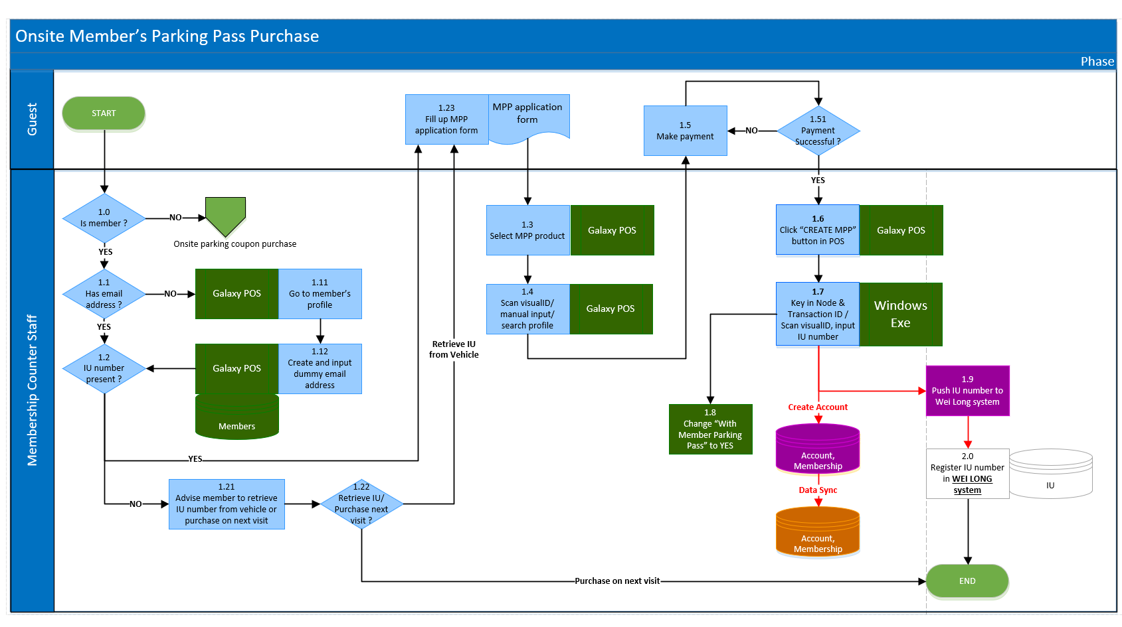The screenshot shown below depicts the workflow drawn in Microsoft Visio using swimlane diagram.

# Appendix B

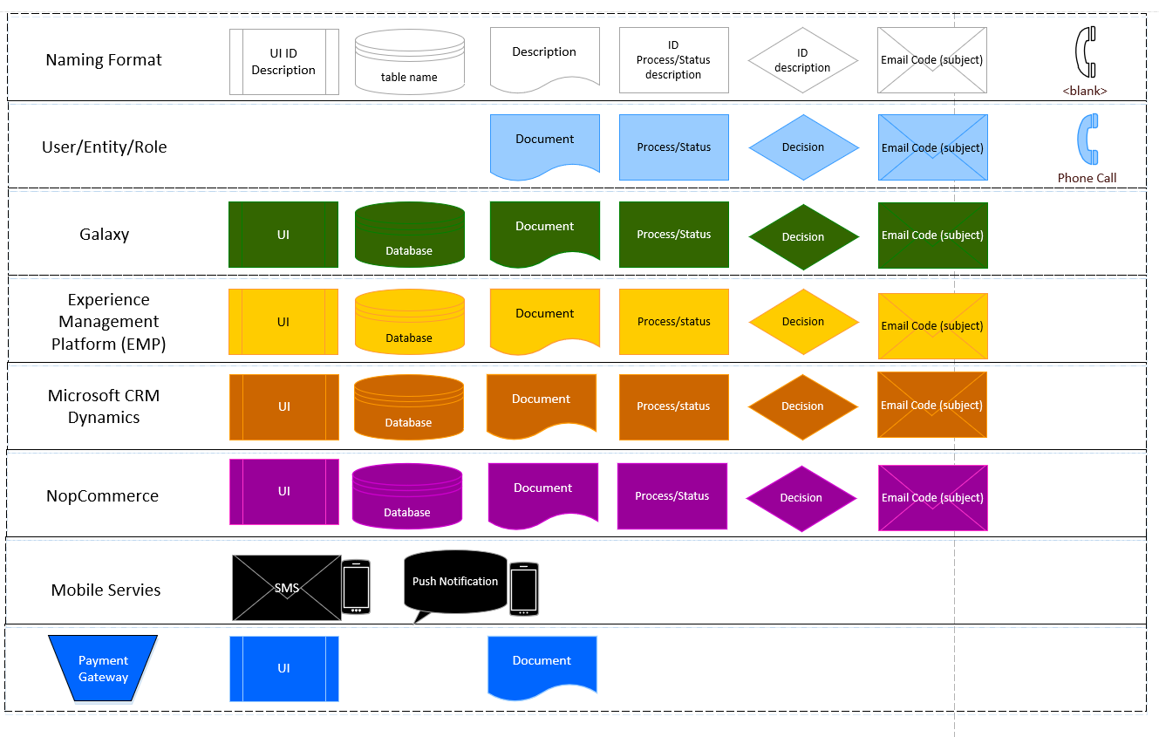The screenshot shown below depicts the legend to be used when drawing the workflow in Microsoft Visio

# Appendix C

The area boxed green shows the attachments area where files can be uploaded in a JIRA ticket.

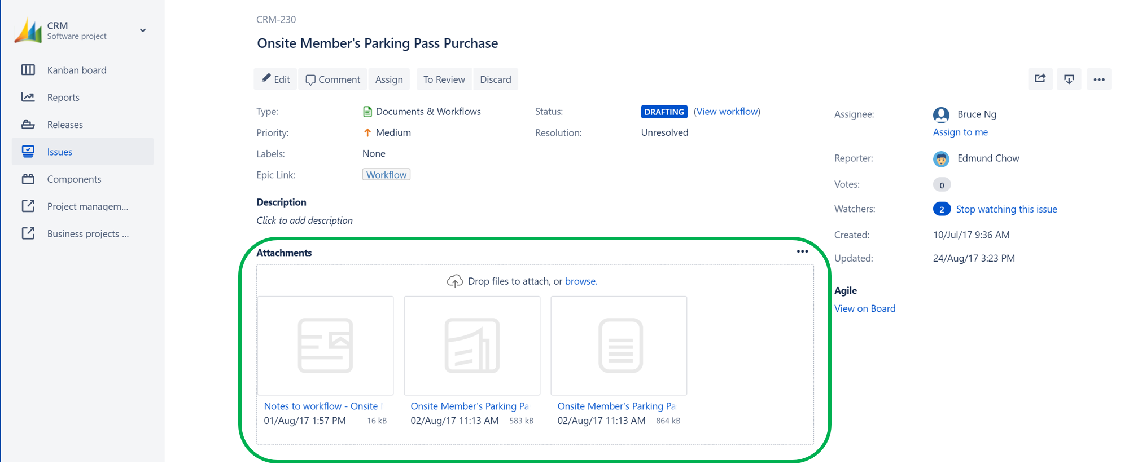

# Appendix D

The area boxed green shows that the ticket can be assigned to other people working on a project

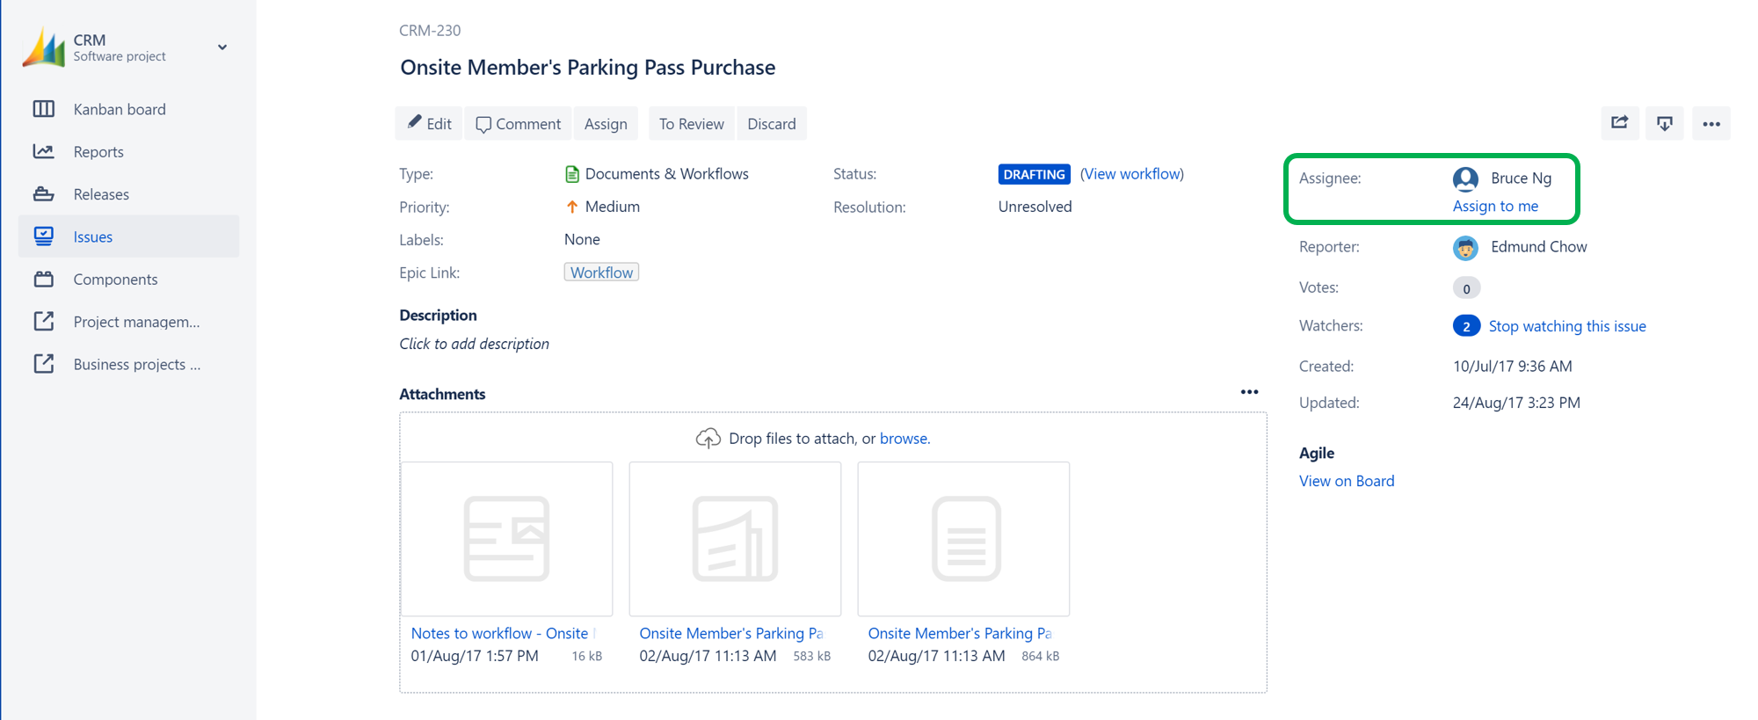

# Appendix E

The screenshot shown below shows the comments section whenever there is a query that needs to be answered

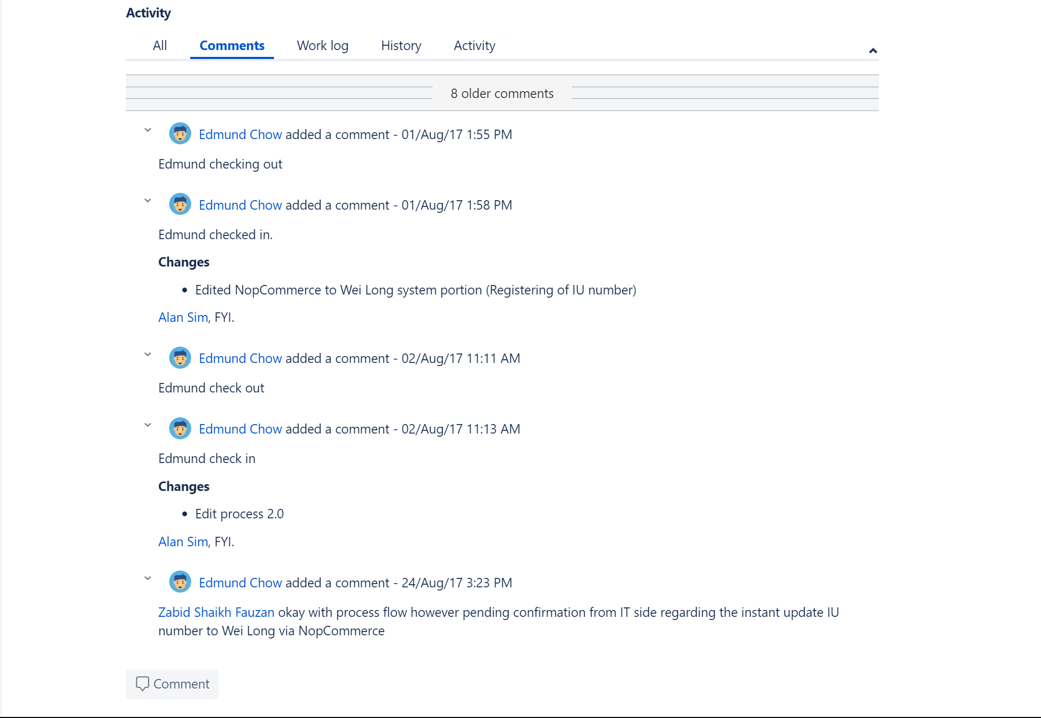

# Appendix F

The screenshot below shows a portion of the test case document

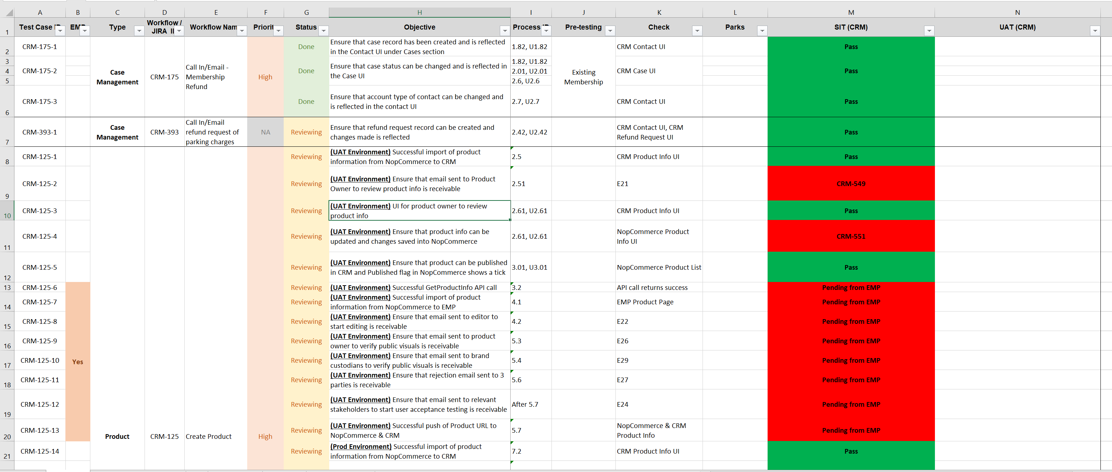

# Appendix G

The screenshot below shows an example of a bug ticket logged in JIRA

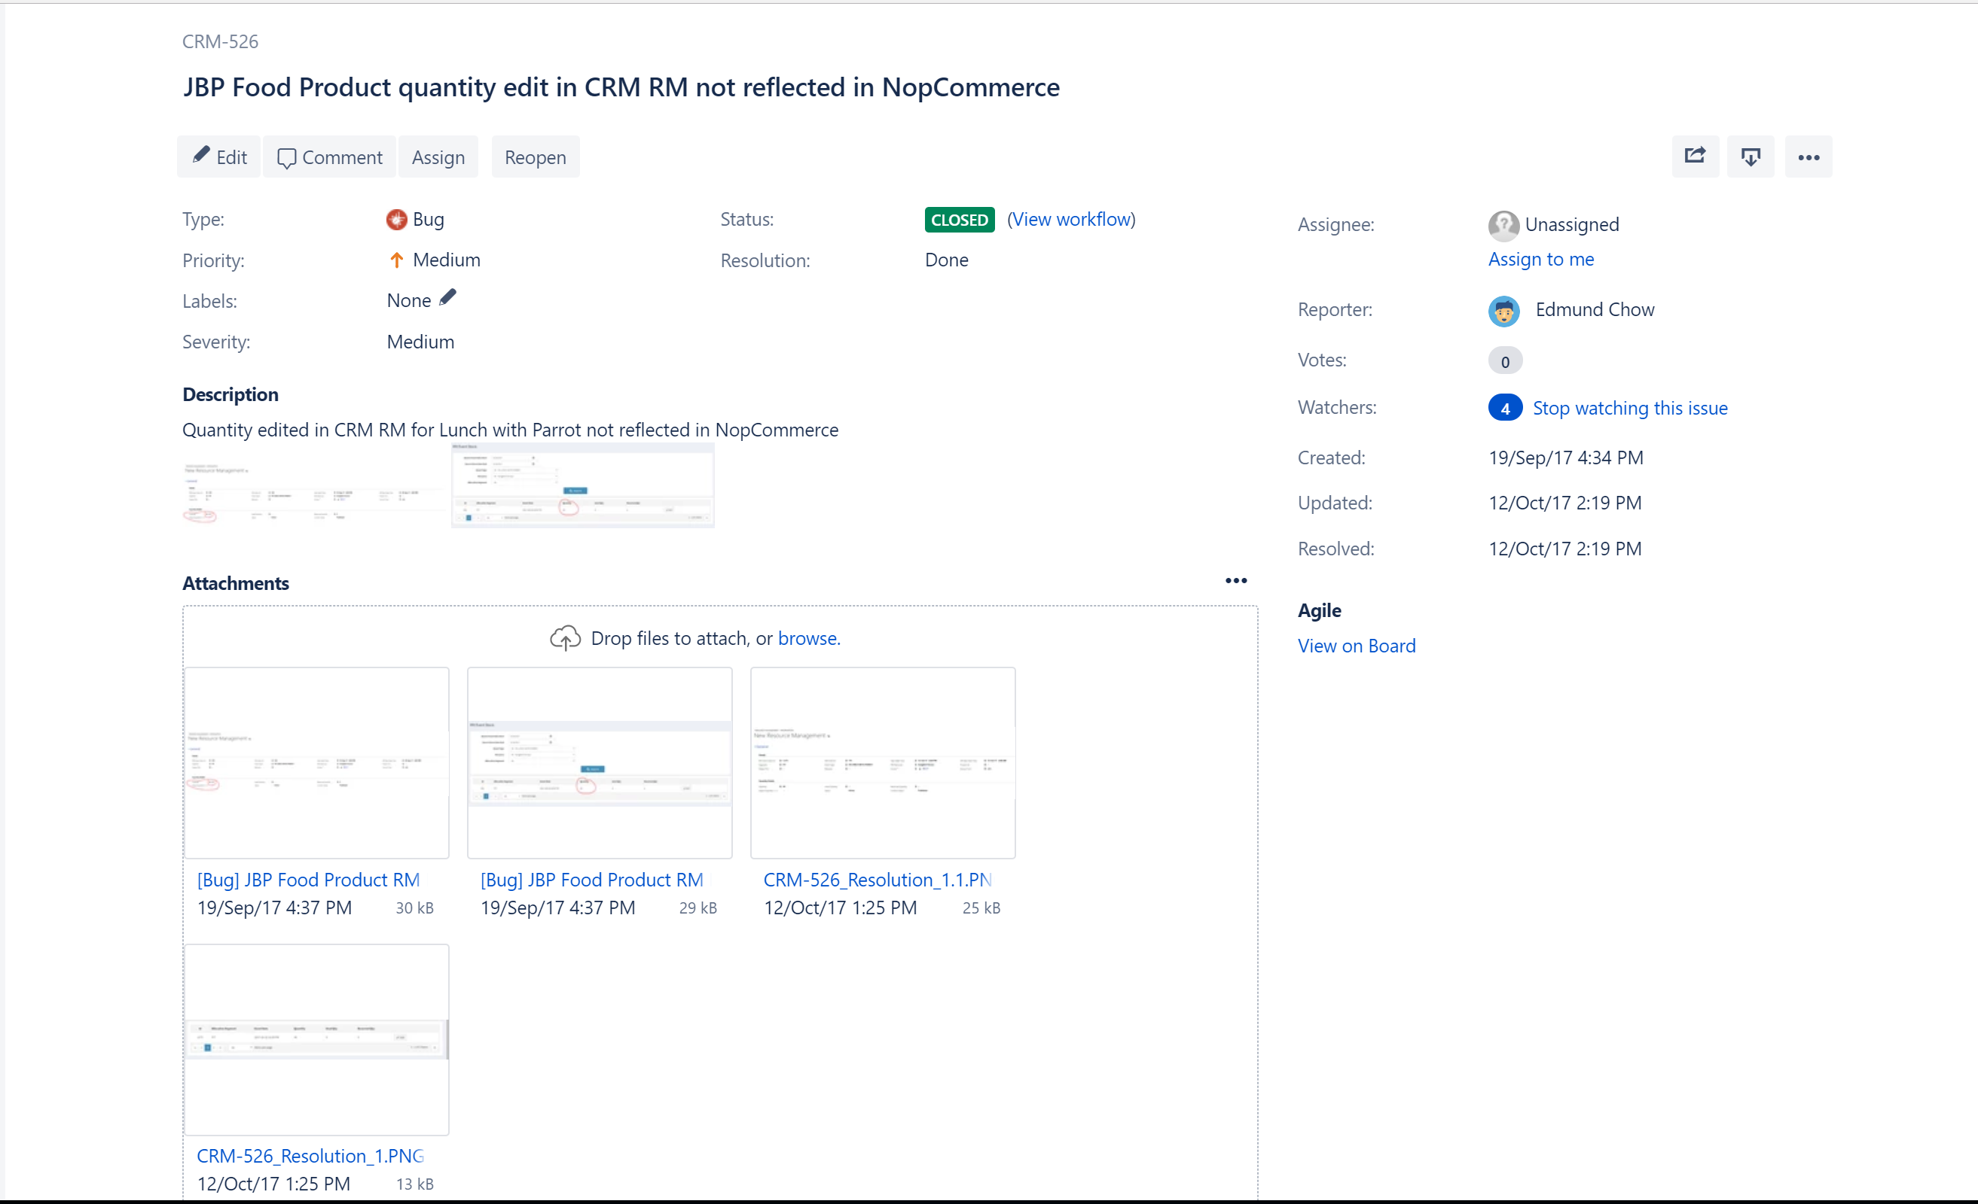

# Appendix H

The screenshot below shows the JIRA ticket for the task to get proposal from one of the vendor

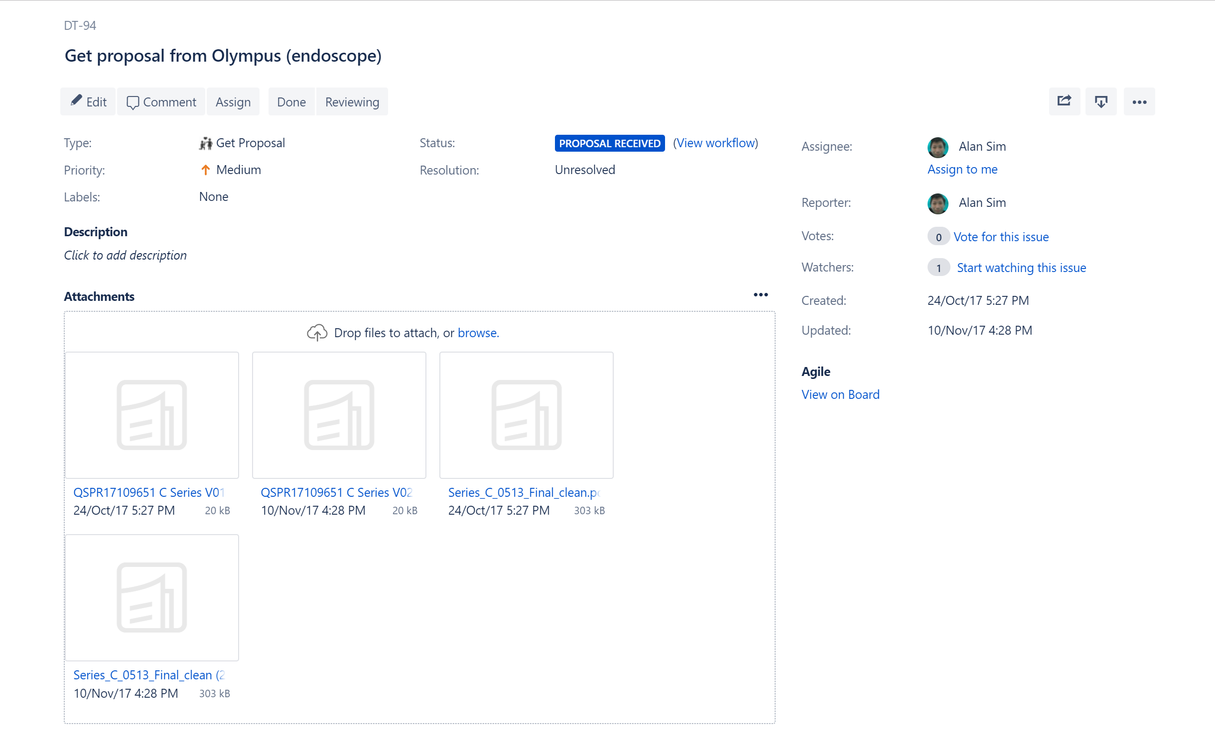

# Appendix I

The screenshot below shows the product comparison chart between the various endoscopes

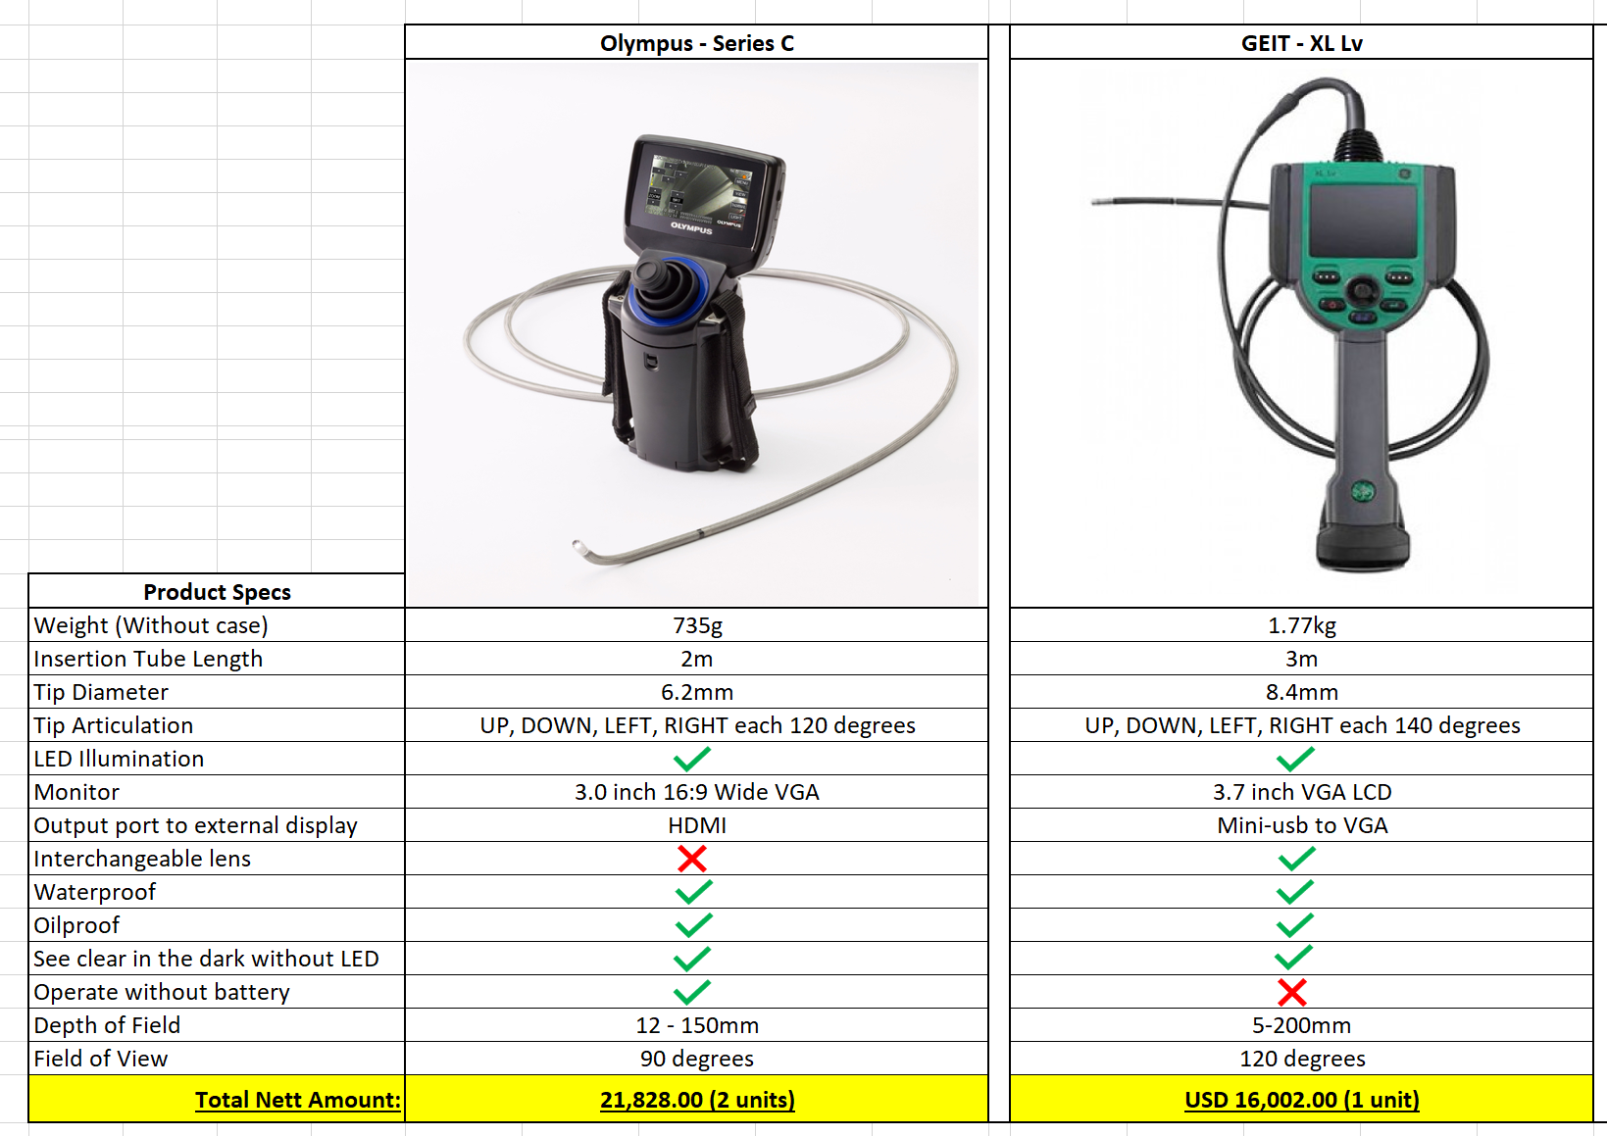

# Appendix J

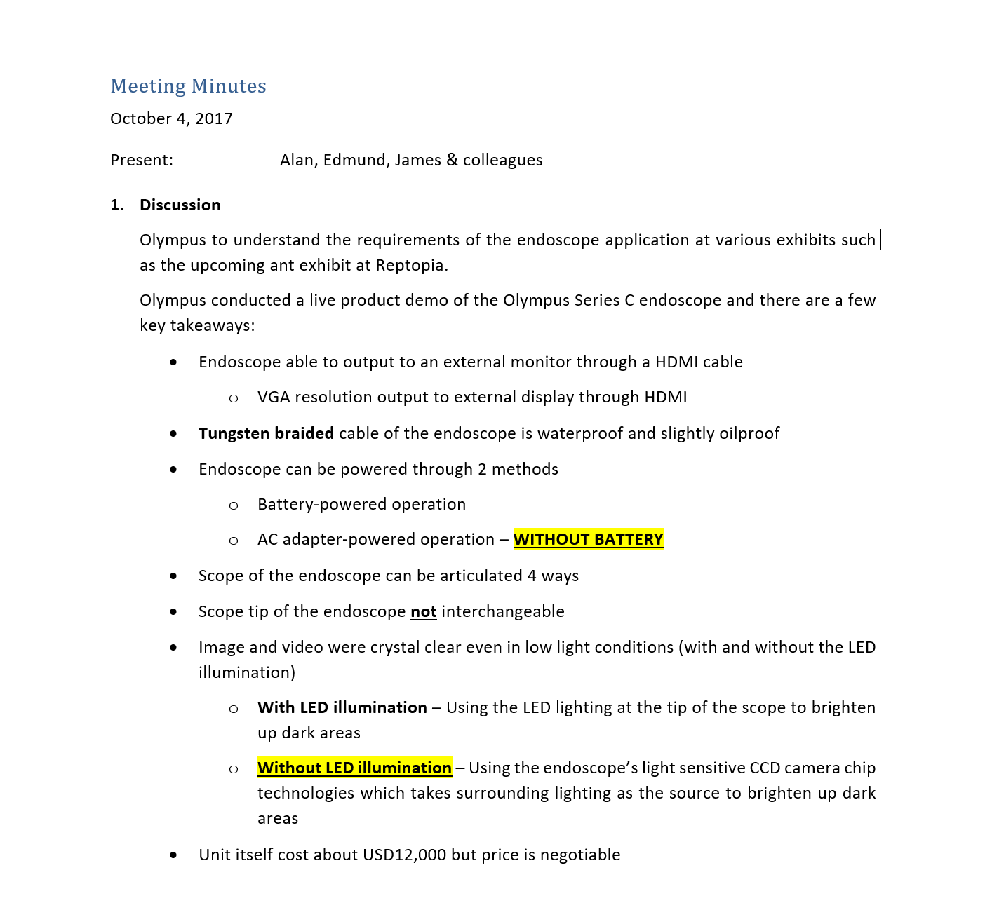The screenshot below shows the meeting minutes recorded for the meeting with one of the endoscope vendor