On Your Marks!!

Encouraging mark making-
developing writing

Children and Learning

‘Write Dance’ 3: children moving and making zigzag marks

Write Dance is a well-established scheme, originally developed in Holland, to develop children’s awareness of writing patterns through movement and dance.
Put simply. Write Dance is a series of ideas to help children learn the patterns of writing through stories, music, singing, rhyming, dance and movement. Each writing pattern has suggested stories, rhymes, songs and movements, and ideas for how children can transfer these movements into writing. As in ‘Brain Gym’ many of the activities encourage children to use both hands at the same time, and to move limbs across the ‘midline’ of the body.
Many practitioners and teachers in the UK testify to the major influence Write Dance has had on children’s awareness of handwriting and handwriting skills.
However many have found it necessary to adapt the programme, and particularly the music, stories and songs, to make them more relevant to UK children.

Here is an example of a session that we created for four-year olds in Luton.
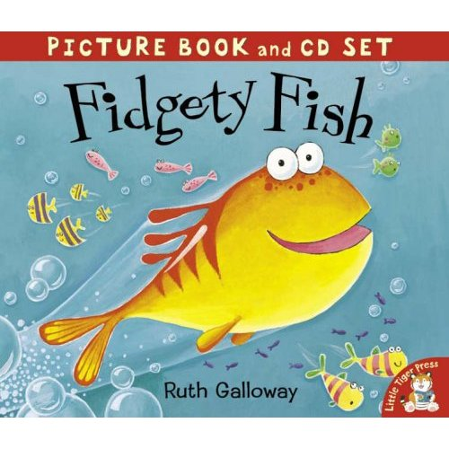
Theme: ‘Zigzags’
Vocabulary: sharp/ up and down/ jagged/ pointy
Music: ‘Popcorn’ by Hot Butter and the theme from ‘Jaws’
Books: Fidgety Fish by Ruth Galloway; Commotion in the Ocean by Giles Andreae; Hooray for Fish! By Lucy Cousins
Materials: For the movement activity: a parachute and small plastic/foam balls; large sheets of paper/roll of lining paper and stubby crayons.
Activities to put the ‘Write Dance’ activity in context:
In class, talk about the word ‘zigzag’. Has anyone seen one painted on the road outside the school gates? Play ‘Popcorn’ and the theme from ‘Jaws’. Make zigzag shapes with your hands, like the ones you will make to the music in the hall. Can anyone draw a zigzag pattern on the whiteboard? Talk about sharks’ teeth and how pointy they are, and how when you draw them they look like a zigzag. Has anyone in the class ever made a zigzag while riding their bike? Has anyone got a zigzag shape in their name (V or W, and also part of upper case M) Read ‘Fidgety Fish’, emphasising how Tiddler flashed around in zigzags. Play the ‘popcorn’ music: as you listen, can you imagine Tiddler making zigzags to this music? As Tiddler goes near the cave, play the theme from ‘Jaws’

The ‘Write Dance’ activity
In the hall, play parachute games. Ask the children to sit down with their legs outstretched under the parachute. Tell a story about sitting in a boat on calm seas. Gradually the wind started to pick up and the waves got stronger and stronger, and then suddenly stopped! As you say this, the children will spontaneously make waves with the parachute. Ask them to stand up and hold the parachute with two hands. Play the ‘popcorn’ music as you throw small balls onto the parachute.
To play ‘sharks’, ask the children to sit round the parachute with their legs straight in front of them, under the parachute. Go under the parachute and tap each child on the foot. When this happens they scream and ‘swim’ towards the middle of the parachute and lie still. When you have ‘eaten’ five children, ask the class to lift up the parachute and see the children underneath. (Advice: this is a very exciting activity, and you may want to introduce it in another parachute games session before ‘Write Dance’. Some children may not want to join in, so ask them to take their legs from under the parachute. Always make sure there is more than one adult involved when playing this game.)
Play the music, and children move around the room, making zigzag movements.

Give each child a large sheet of paper and two crayons. As you play the music, show the children how to make zigzag patterns with both hands, moving in opposite directions. (If they kneel on the edges of their sheets of paper, this stops the paper from slipping away).
Alternatively you can use a roll of lining paper (smooth white/cream wallpaper used for painting on), stuck to the floor at intervals with masking tape. Children can kneel at intervals along the length of the lining paper.

Extension activities
Zigzag patterns using paint and rollers; make a zigzag road with chalk/bollards for the children to drive along in their cars and bikes; paint zigzag fish, using ‘Hooray for Fish’ as a stimulus. Draw sharks and cut out sharp teeth to stick on. Contrast zigzags with waves in a giant sea world display.

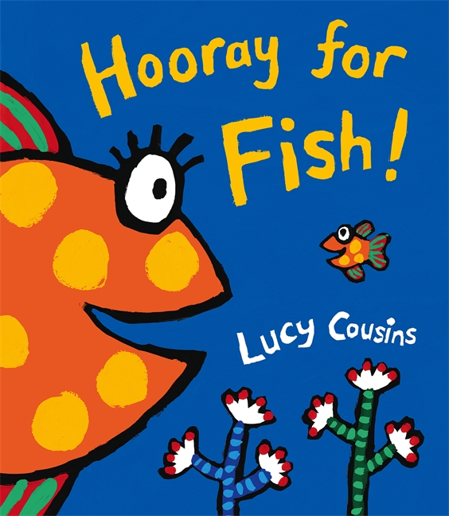
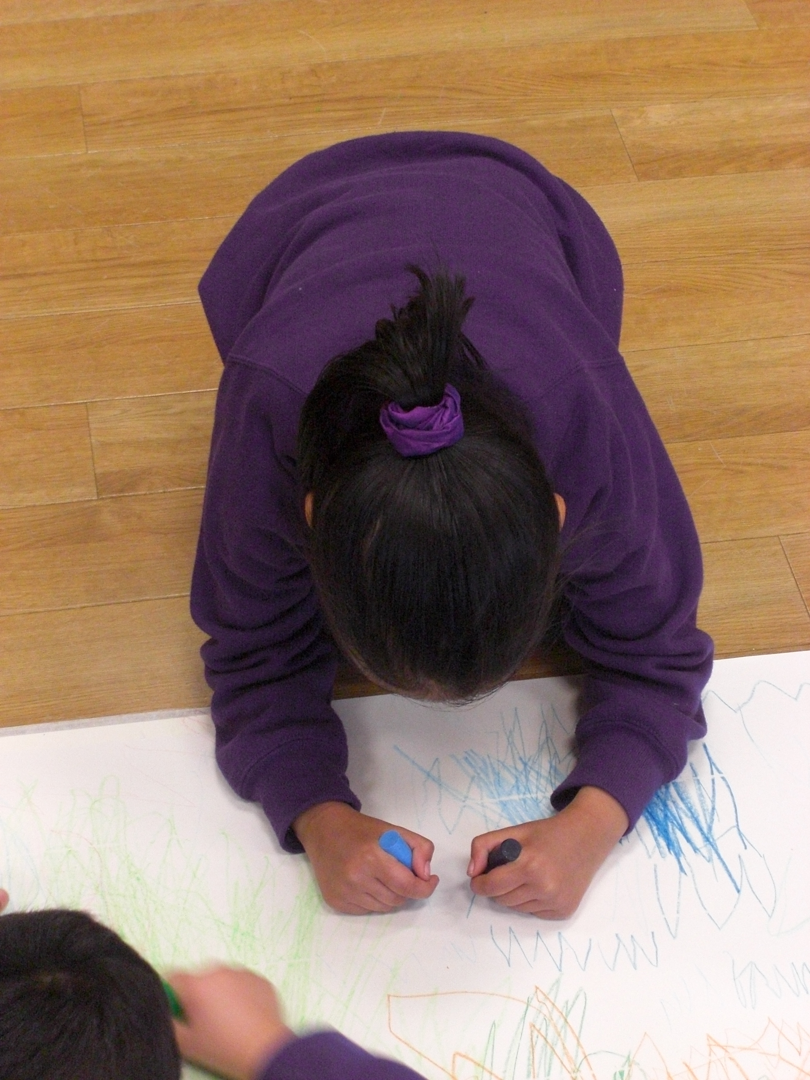

Write Dance: a pre-writing programme for children 3 to 5
Paul Chapman Publishing www.paulchapmanpublishing.co.uk

For more information contact Michael Jones on 07743 665100 jonmic57@yahoo.co.uk or visit www.talk4meaning.co.uk

