Forecasting Indoor Temperature One Hour Ahead from a Monash Environmental Sensor
MMA3001 Numerical Methods and Machine Learning, individual project. Edmund Leahy 33880867

Summary. I tested whether a simple linear regression could forecast the temperature one hour ahead better than assuming it stays the same. On the selected sensor over a 22-day test period, the regression reduced mean absolute error from 0.380°C to 0.365°C and root mean squared error from 0.697°C to 0.607°C. The MAE gain is small, at well under the 0.25 °C typical step between recorded values. All of it comes from the 7–9 am period, when a sharp temperature rise occurs, outside those hours’ persistence is slightly better.

1. Engineering problem
Mechanical engineers design and operate the heating, ventilation and air-conditioning systems that determine how buildings behave thermally. Modern buildings carry networks of sensors, and a practical question is what those sensors can tell us about the near future without a physical model of the room.
The problem: How accurately can indoor temperature be predicted one hour ahead using only recent readings from the same sensor, and does a lagged linear regression outperform a persistence forecast?
Why: A short forecast is only worth building if it beats the free alternative of assuming nothing changes. Over short horizons temperature is strongly autocorrelated, so persistence is a demanding baseline and a useful test of whether a model adds anything.
Intended use: A monitoring aid for one sensor's location: an estimate of the temperature an hour from now, in °C.
Limits of the scope: this is a sensor-specific statistical forecast. It is not a control system, and it does not show energy savings, occupant comfort or transfer to other rooms, buildings or seasons.

2. Inputs, outputs and data
Table 1. Top-level inputs and outputs. Function-level detail is in the generated HTML documentation (docs/index.html).
Item | Specification
Raw input | supplied by the unit as part of dataset 2. One CSV with a JSON array in the jsondata column.
Model inputs | T(t), T(t−20 min) and T(t−40 min), in °C, from one sensor. Observed domain on the selected sensor.
Output | Forecast temperature T̂(t+60 min) in °C, plus saved metrics and figures.
Time | Event time from the nested values[].time field, in Unix seconds UTC. Melbourne local time is used only for hour-of-day analysis and plot axes.
Invalid input | Bad JSON, missing or non-numeric values and implausible timestamps are counted by reason and skipped. Examples with any missing input or target are excluded and counted; gaps are never interpolated. Asking for an unknown sensor or a horizon that is not a multiple of the time step raises an error.

Data audit
I audited the full file before choosing anything, using a parser that streams the ZIP rather than extracting it. There were no parse errors and no duplicates with conflicting values, but the file differed considerably from what its name suggests:
- Row count is not data. The 179,447 rows hold only 42,843 unique temperature readings, because most rows repeat an earlier reading.
- Three of the five sensors are unusable, with 1 or 2 unique readings each despite having 10,926 to 58,908 rows.
- A stopped sensor can look alive. Sensor 6012002000869 (“869”) stopped producing new readings on 14 June 2024, yet its last reading was re-sent 15,431 times with ingestion dates running until October 2024. Event time, not ingestion time, is therefore essential.
- The filename does not describe the dates. Event times run from May 2023 to April 2026, and only the May–June 2024 part of 869 falls within “MayToDec2024”.
Table 2. The two usable sensors. Locations are from the supplied workbook, Sensor ID and Locations.xlsx.
Sensor | Listed location | Period (local) | Unique readings | 20-min slots filled
869 (primary) | Building 60, G.38, “Compactus_upper” | 29 Feb – 14 Jun 2024 | 13,800 | 99.99%
326 (check only) | Not listed | 11 Sep 2025 – 22 Apr 2026 | 29,037 | 97.1%

Sensor selection. I chose 869 because it is the only one of the five with a location I could verify, and the question concerns indoor temperature. Its longest gap is 30 minutes. Sensor 326 has twice the data but a 4.5-day outage, a much wider range (11.8–37.5 °C) and an unknown location, so I used it only as an independent check. Figure 1 shows the selected series and its partitions.
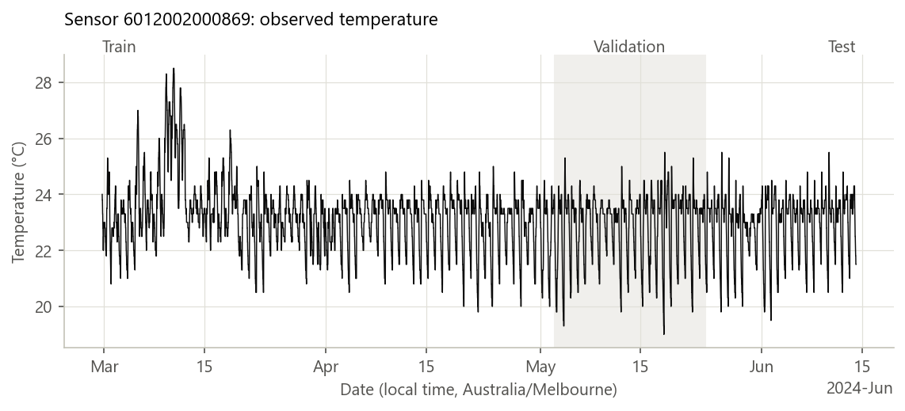
Figure 1. Sensor 869 on the 20-minute grid, showing the chronological train, validation and test periods.

3. Computational approach
Time grid. Readings arrive about every 10 minutes, but about 1 in 10 is missed. I resampled onto a 20-minute grid in which each slot holds the latest reading at or before the slot’s end time. Labelling at the slot’s end matters: its value was already known at that time, so no future information enters a feature. Empty slots stay empty.
Baseline. Persistence forecasts that the temperature in one hour equals the latest observation, T̂(t+H) = T(t). It has no parameters.
Selected method. Linear regression fitted by ordinary least squares on the training period, which finds the coefficients minimising the sum of squared errors. The fitted model is:
T̂(t+60 min) = 2.807 + 1.650·T(t) − 0.520·T(t−20 min) − 0.251·T(t−40 min)
The large weight on the current value and the negative weights on older values continue the recent trend. The lag coefficients sum to 0.88 rather than 1, which pulls forecasts back towards a level of about 23 °C (2.807 / (1 − 0.879)), close to the sensor’s 23.3 °C median.
Why this method. Regression is taught in the unit, is cheap, and has coefficients that can be read and checked. The project brief rewards a justified approach rather than complexity. Decision trees, support vector regression and neural networks from Week 5 were considered but not implemented: with so little gain available from past temperature alone, the more useful next step is probably new inputs rather than a more flexible model. That is a judgement, not a tested result.
Assumptions. The next value depends linearly on the last hour of readings; the relationship learned in March–May still holds in late May–June; and the sensor is accurate enough for 0.25 °C-scale changes to mean something. No feature scaling is used, because all inputs are in °C and scaling does not change a least-squares prediction.
Numerical behaviour. scikit-learn solves the problem directly with an SVD-based least-squares routine, so there is no iteration and no convergence criterion. Neighbouring temperatures are strongly correlated, so I measured the condition number of the standardised input matrix: 20 for the selected model. That is far from numerically troublesome in double precision, although it does mean individual coefficients are less stable than the predictions they produce.
Implementation. Python, using pandas, NumPy, scikit-learn and matplotlib, with one command-line entry point for each stage (audit, select, final, profile). Exact commands and package versions are in the README and results/pip_freeze.txt.

4. Validation method and results

Verification: does the code do what it specifies?
63 pytest tests on synthetic data all pass (results/test_report.txt). They cover parsing and bad-record counting, UTC-to-Melbourne conversion across daylight saving, deterministic deduplication, the target falling exactly one horizon ahead even across gaps, features not changing when future values change, no grid slot shared between partitions, metrics against hand calculations, and regression coefficients against a known model and an independent NumPy least-squares solution. One test rewrites the test period by +50 °C and confirms that model selection does not change, which verifies the separation of selection from testing. A separate check during development, using only Python’s standard library and not kept in the repository, reproduced the audit’s per-sensor counts from the raw ZIP.

Validation: do predictions hold on unseen real data?
Method. A chronological 60/20/20 split, with an example kept only if its whole window, from oldest input to target, lies inside one partition. Of 7,569 complete examples, 28 were removed at the boundaries. A random split would be inappropriate because neighbouring readings are nearly identical, so test examples would closely resemble training examples and error would look better than it really is.
Metrics. MAE is the average size of the error in °C. RMSE weights large errors more heavily. The question being asked is whether the regression beats persistence, so I also report the MAE gain with a 95% interval, from a bootstrap of 2,000 resamples of whole local days. Whole days are resampled because errors close together in time are correlated, and resampling single rows would overstate the evidence.
Influence on model selection. Validation data chose the number of inputs and informed the sensitivity comparisons. Test data influenced nothing: it was scored once after the settings were locked, and the code refuses to overwrite that result without an explicit reproduce flag. Rerunning gave byte-identical metric files.
Table 3. Results for sensor 869, using a model fitted on the training period only.
Partition | Examples | Persistence MAE (°C) | Regression MAE (°C) | Persistence RMSE (°C) | Regression RMSE (°C)
Train, 29 Feb – 2 May 2024 | 4,544 | 0.328 | 0.321 | 0.532 | 0.475
Validation, 3–24 May 2024 | 1,492 | 0.375 | 0.349 | 0.625 | 0.526
Test, 24 May – 14 Jun 2024 | 1,505 | 0.380 | 0.365 | 0.697 | 0.607

Result. On the test period the regression improved MAE by 4.0% and RMSE by 12.9%. The MAE gain was 0.015 °C, with a 95% interval of 0.002 to 0.030 °C over 22 days. The interval excludes zero, so the gain is probably real, but it is about one-seventeenth of the 0.25 °C median step between recorded values and has little practical meaning on its own. Training error is not far below test error, so there is no sign of serious overfitting.
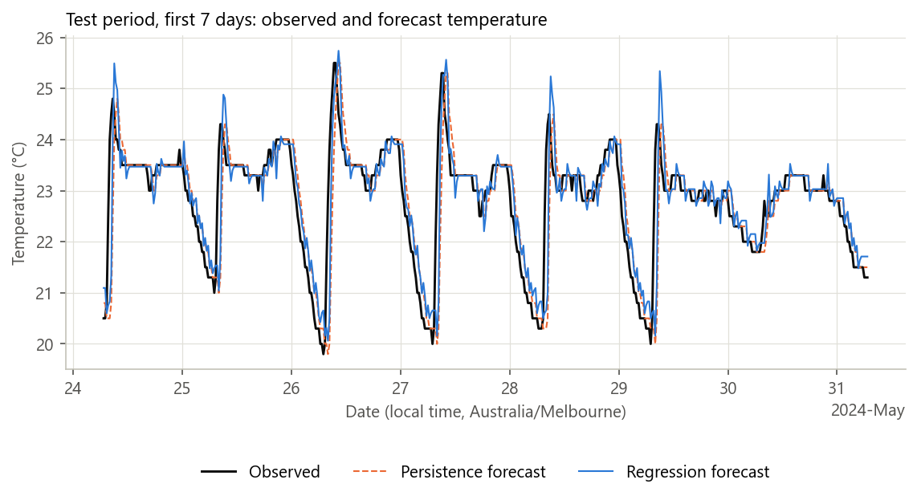
Figure 2. First seven days of the test period, a window fixed in advance so it could not be cherry-picked. Both forecasts lag the sharp morning rise, and the regression tends to overshoot just after it.
Where the error occurs. Figure 3 changes the interpretation of the overall score. The 7–9 am hours hold 40% of persistence’s total error and 37% of the regression’s. At 8 am, MAE is 2.42 °C for persistence and 1.87 °C for regression. Averaged over the other 21 hours, persistence is slightly better (0.258 °C against 0.264 °C), and it wins in every hour from 1 pm to midnight. Figure 4 shows why: when temperature is stable, persistence is often exactly right, while the regression is rarely exact.
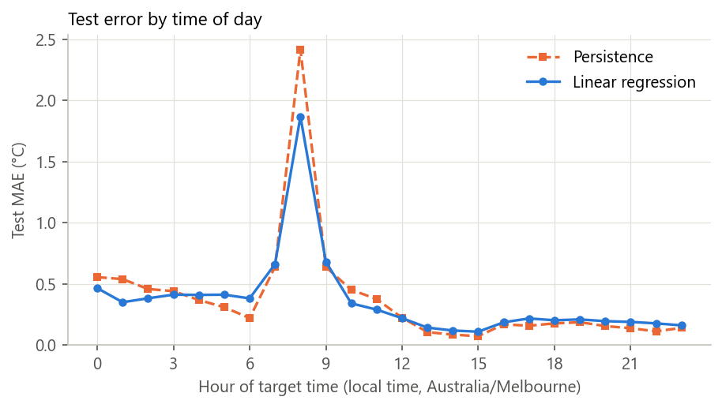
Figure 3. Test MAE by local hour of the forecast’s target time, sensor 869.
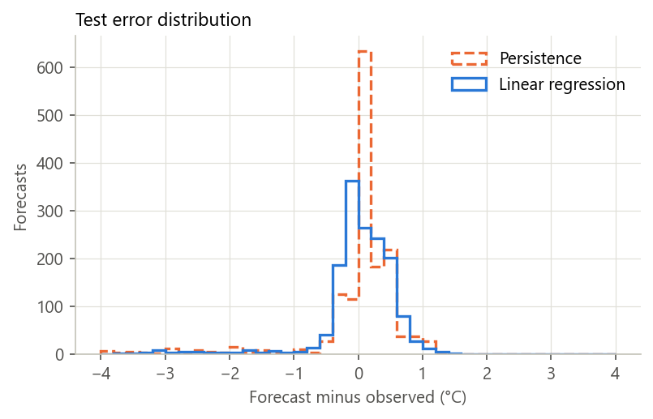 | 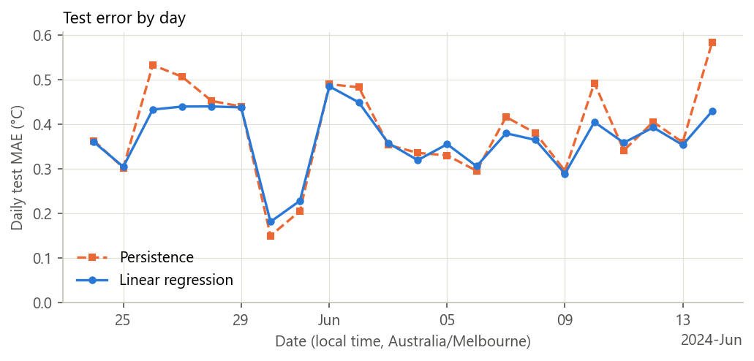
Figure 4. Left: test error distribution; persistence has a tall peak at zero and more large errors. Right: daily test MAE shows no steady drift across the 22 days.
Independent check. The same settings on sensor 326, with its own training and test periods, gave test MAE of 0.444 °C for persistence and 0.348 °C for regression (a gain of 0.096 °C, 95% interval 0.073 to 0.121, over 45 days) and RMSE of 0.605 °C against 0.508 °C. The method therefore carries over to a second, more variable signal, but the sensor’s location is unknown, so this cannot be presented as a second indoor result.
What the validation cannot establish. It does not show performance in other seasons, rooms or operating regimes, or that errors of this size are acceptable for any specific application. Its 22-day test period is also short, and the bootstrap treats days as independent, which is only an approximation.

5. Comparison and optimisation
All settings below were compared on the validation period of sensor 869.
Table 4. Validation sensitivity. Persistence MAE on the rows used for the lag comparison is 0.375 °C. The condition number is for the standardised inputs.
Number of inputs | Inputs’ span | Regression MAE (°C) | Regression RMSE (°C) | Condition number
1 | Current only | 0.398 | 0.605 | 1
3 (selected) | 40 min | 0.349 | 0.526 | 20
6 | 100 min | 0.349 | 0.525 | 31
12 | 220 min | 0.348 | 0.522 | 43

Number of inputs. My first rule, lowest validation MAE, chose 12 inputs. That gain over 3 inputs is only 0.001 °C, far below what the sensor can resolve, while the condition number doubles. I therefore changed the rule to “the fewest inputs within 0.01 °C of the best”, which selects 3. I made this change after seeing validation results but before any test scoring, so it does not affect the integrity of the test. A single input is worse than persistence on MAE (0.398 °C against 0.375 °C) yet better on RMSE (0.605 °C against 0.625 °C): consistent with a model that pulls forecasts towards the mean, which reduces large errors but gives up the frequent exact hits.
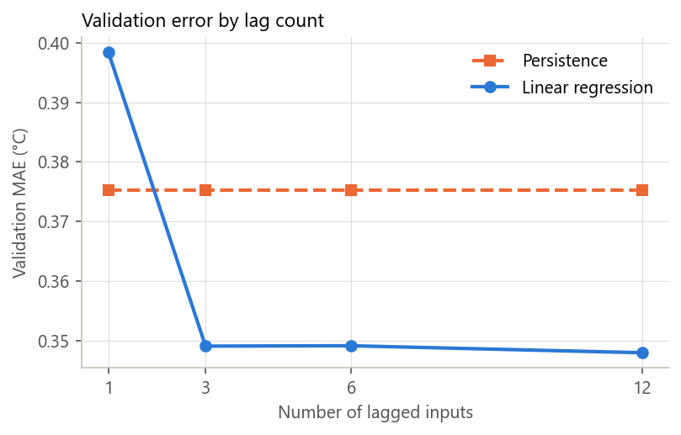 | 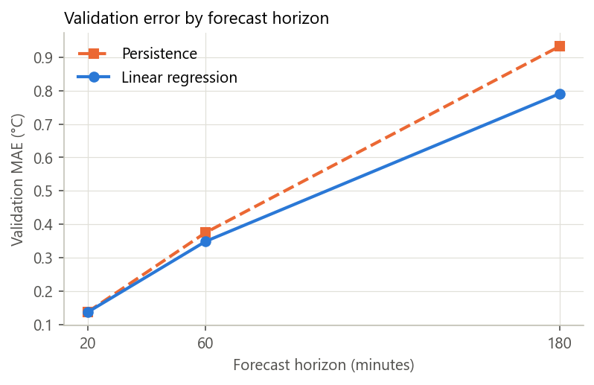
Figure 5. Left: validation MAE by number of inputs. Right: validation MAE by forecast horizon, with 3 inputs.
Table 5. Other validation comparisons with 3 inputs or an equivalent history of about 1 hour. Example counts differ slightly from Table 3 because these rows require fewer inputs.
Setting | Training examples | Persistence MAE (°C) | Regression MAE (°C) | MAE improvement
Horizon 20 min | n/a | 0.138 | 0.137 | 0.4%
Horizon 60 min, step 20 min | 4,553 | 0.375 | 0.349 | 7.0%
Horizon 180 min | n/a | 0.932 | 0.791 | 15.2%
Step 10 min, 6 inputs | 3,585 | 0.397 | 0.381 | 4.0%
Step 30 min, 2 inputs | 3,035 | 0.377 | 0.346 | 8.2%

Horizon had the largest effect of any setting: error grows about sixfold from 20 to 180 minutes, and the regression’s advantage grows with it. At 20 minutes it adds essentially nothing. Time step: 10 minutes leaves fewer complete examples because missed readings break more input windows. A 30-minute step scored slightly better than 20 minutes (0.346 °C against 0.349 °C), but on about a third fewer examples and different rows, so I kept 20 minutes.
Table 6. Computational cost on 4,544 training rows, with 3 inputs. Times are medians of 20 runs on one laptop. FLOPS are textbook estimates, not measurements.
Measure | Persistence | Linear regression
Fit time | None | 1.4 ms
Predict all rows | 0.02 ms | 0.6 ms
Peak Python allocation during fit | None | 0.41 MB
Estimated FLOPS to fit (2np² − ⅔p³) | 0 | about 82,000
Estimated FLOPS per prediction (2p) | 0 | 6

Performance. Cost does not limit either method. Profiling with cProfile shows that half of the 0.96 s selection run goes on saving figures, not modelling, so optimising the model code would achieve little. The slowest stage is the audit, at about 12–13 s to stream the full archive, which avoids extracting a 353 MB CSV to disk.
Final design. Persistence is cheaper, simpler and better during stable hours. The regression is better overall and clearly better during the morning rise. I selected the 3-input regression because it reduces the large errors that persistence makes, at negligible computational cost, and remains simple enough to inspect.

6. Limitations and lessons learned
- Scope. One primary sensor, about 3.5 months of one season, with a 22-day test period. A compactus may be a low-activity space, so busier rooms could behave differently.
- Cause of the morning rise is unknown. It recurs on most days shown in Figure 2, which may reflect building operation, but nothing in this data establishes that.
- Inputs are limited. Only past temperature is used, so a model cannot anticipate a rise that has not started. Time of day, humidity and CO2 were not tested. Time of day is the obvious next experiment, since the largest error occurs at a predictable hour.
- Resolution and timing. Values are recorded in steps of about 0.25 °C. Because a slot holds the latest reading in that slot, the true gap between input and target can differ slightly from a nominal 60 minutes.
- A fixed model. Coefficients are not updated as conditions change.
Lessons. First, auditing the data changed the project: the filename and row count both suggested far more than was there. Second, a good baseline is informative; persistence set a bar that one-input regression failed to clear. Third, an overall score can hide the main behaviour: the gain here comes from about three hours a day, which only the hourly breakdown revealed. Fourth, MAE and RMSE can disagree, and understanding why gave more insight than either number alone. A negligible gain on MAE is a valid result, and reporting it honestly is more useful than presenting 4% as a success.

7. AI use and reflection

Tools and level of contribution
- Claude (Claude Code, model Opus 5.5) wrote the ingestion, audit and modelling code, the tests, the README, the slides and the first draft of this report. [Add your own estimate of the share of code and writing, and describe what you changed.]
- ChatGPT was used to choose the dataset and outline the project. [Confirm this, and add any other tools.]

Decisions
Claude presented evidence and recommendations. I decided on sensor 869, the 20-minute step, the 60-minute horizon, using sensor 326 as a second test, and 3 inputs rather than 12. [Explain why you accepted or changed each one, and any you overruled.]

Errors and limitations found in the AI’s work
- Claude’s first statement that a 10-minute grid leaves no usable validation examples applied only to a 24-input model. With a comparable 1-hour look-back, it left 3,585 training examples and a higher error.
- Claude’s draft README said “most” of the error came from the 8 am rise. Calculating the share showed about a quarter at 8 am and about 40% across 7–9 am, so it was corrected.
- The first validation run crashed on the 10-minute setting because a partition was empty. The code now reports zero examples, and a test was added.
- The planning handover notes [say who or what wrote them] did not mention the brief’s profiling and FLOPS expectations. These were found by reading the brief directly.
[Add anything you noticed yourself. Only include things that actually happened.]

Reflection
- [Why did you use AI for these tasks?]
- [How did you check its output? Say what you personally ran, read and tested.]
- [How did AI affect your understanding and workflow, both helping and hindering? What can you now explain without it?]

References
Efron, B. and Tibshirani, R.J. (1993) An Introduction to the Bootstrap. Chapman & Hall.
Golub, G.H. and Van Loan, C.F. (2013) Matrix Computations, 4th edn. Johns Hopkins University Press.
Harris, C.R. et al. (2020) ‘Array programming with NumPy’, Nature, 585, pp. 357–362.
Hunter, J.D. (2007) ‘Matplotlib: A 2D graphics environment’, Computing in Science & Engineering, 9(3), pp. 90–95.
Hyndman, R.J. and Athanasopoulos, G. (2021) Forecasting: Principles and Practice, 3rd edn. OTexts.
McKinney, W. (2010) ‘Data structures for statistical computing in Python’, Proceedings of the 9th Python in Science Conference, pp. 56–61.
Monash University (2026) MMA3001 Project Brief; MMA3001 Project Datasets, Dataset 2: Monash Smart Infrastructure Occupancy and Environmental Data; Sensor ID and Locations workbook. Unit materials, Moodle.
Granland, K. (2026) MMA3001 Week 5 workshop materials: machine learning regression. Monash University, Moodle.
Pedregosa, F. et al. (2011) ‘Scikit-learn: Machine learning in Python’, Journal of Machine Learning Research, 12, pp. 2825–2830.

