**Assignment 5**

Edmund Leong

206049891

STATS 10

Introduction to Statistical Reasoning

**Part I**

Exercise 1

Part A

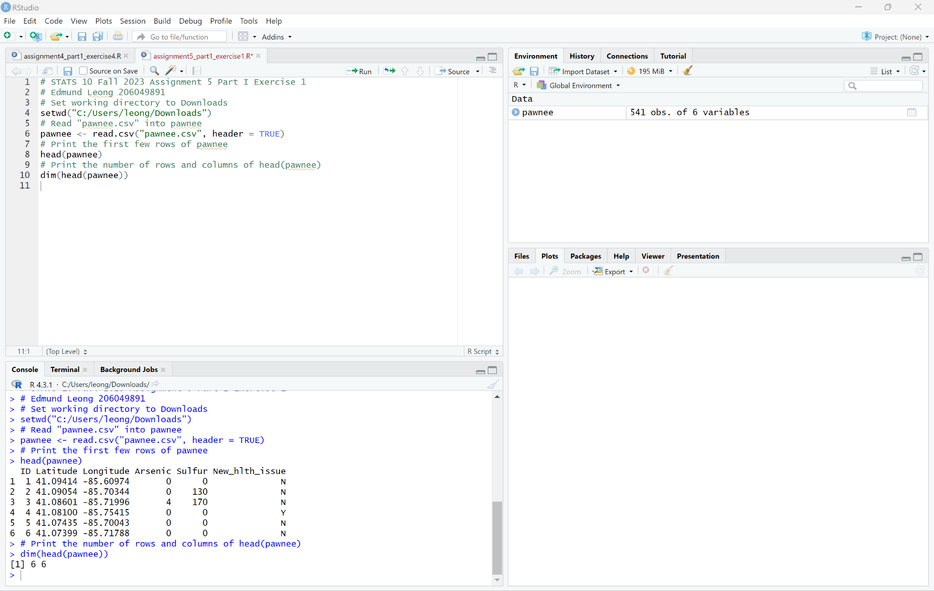

The dataset in question contains 6 rows and 6 columns.

Part B

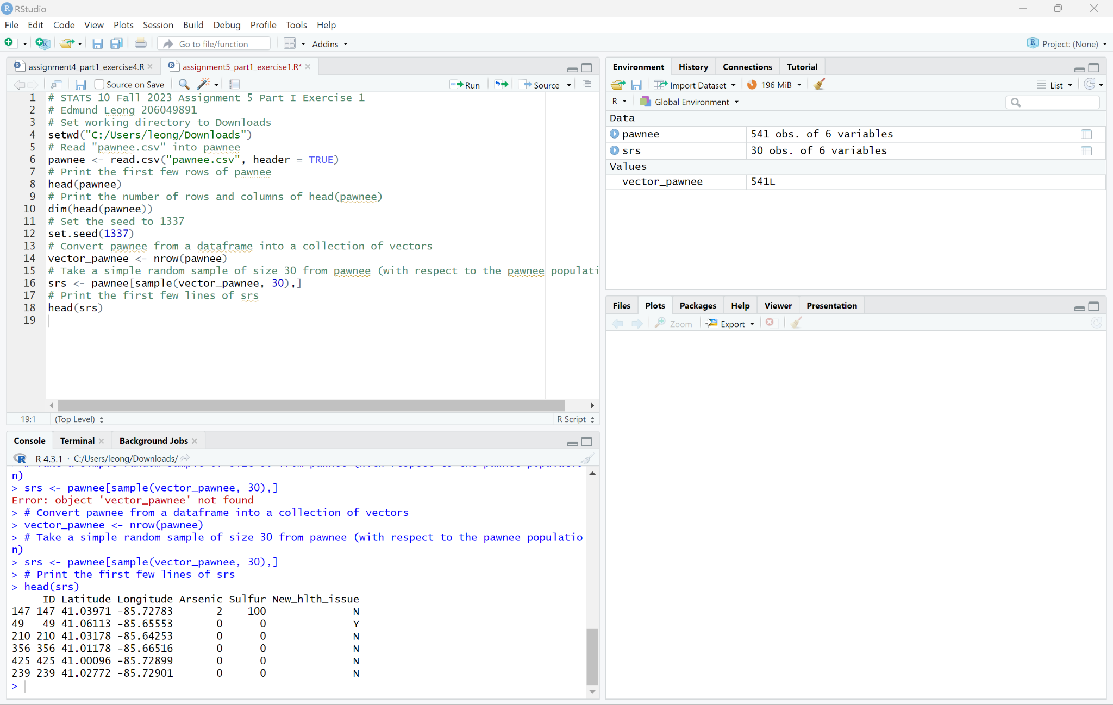

Part C

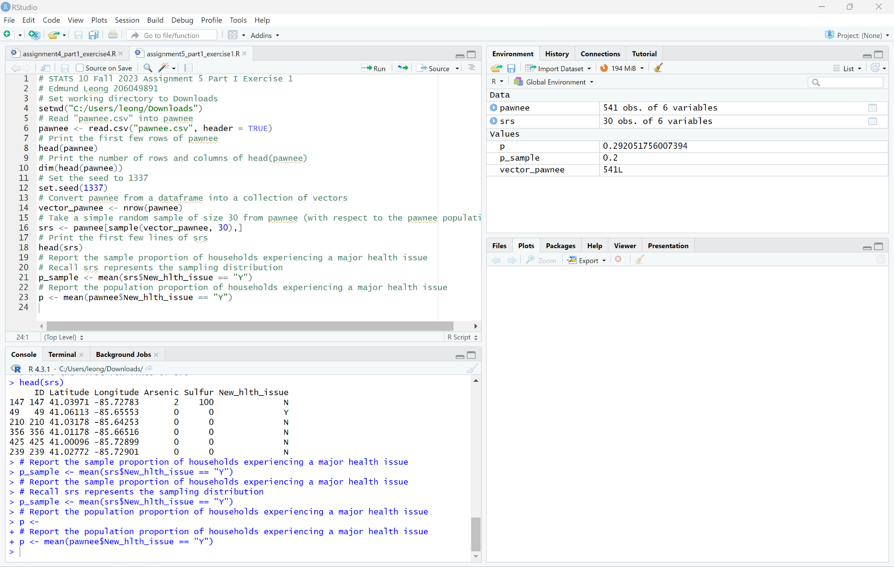

Part D