- Can you please explain regression in the context of data analytics in a simple easy to understand manner, with examples
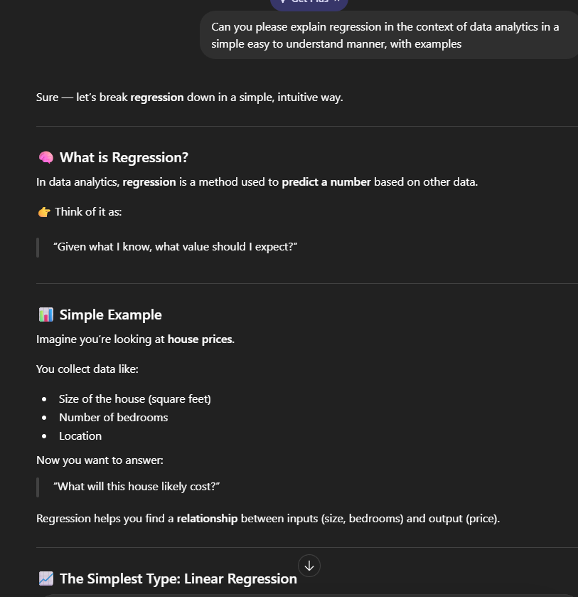
This is a stronger prompt because it gives additional context in terms of what I would like the explanation to pertain to and also asking for an example that I could learn from.

- I'm an aspiring data analyst who is going to start learning SQL. Can you please help me understand SQL with a brief breakdown on what SQL is, and what it is used for?
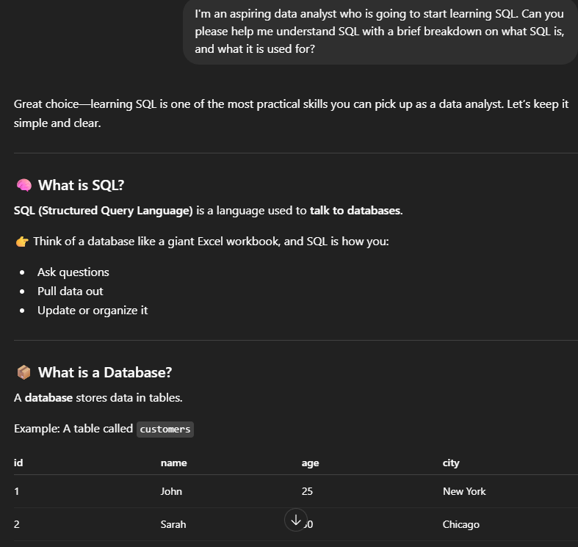
This new prompt is much stronger as it lets the AI know I don’t have prior knowledge, which makes the explanation easier to understand, while also asking for additional information that would help me understand SQL better.
- Can you please create an example dataset displaying 4 different countries and their daily shipments. Format as a table, and include 10 daily shipments for each country
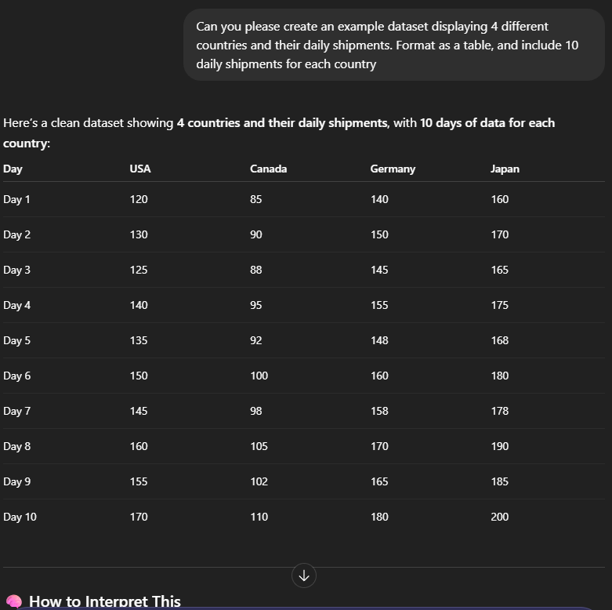
Just saying to create a dataset is extremely vague and doesn’t show how you would want the data displayed. This prompt clearly asks how much data I want, what the data represents, and how to format the table.

