


AWS Academy
Wind turbines locations

´

Eduardo Neves
01.08.2026

Change History
Date | Version | Author | Description
07/08/2025 | 1 | Eduardo Neves | Week 1

Table of Contents

Change History 2
Introduction 4
Summary 4
Problem Statement 4
Project Objectives 4
Business Objectives 4
Technical Objectives 5
Key answers 5
Target Users 5
Technical Objectives 5
Wind Turbines 5
Factors for good wind turbine placement 6
Datasets 6
Model 6
Architecture 8
Needs and Considerations 8
Steps 8
Technical decisions 9
Diagram 9
Implementation 10
AI 10
Infrastructure as Code (IaC) 10
CI/CD 11
Testing and results 11
Conclusion 11
References 11

Introduction

Summary
Renewable-energy developers face significant uncertainty when selecting locations for new wind turbines. Poor site selection can lead to lower energy production, regulatory issues, higher construction costs, and delays in project approval.
The proposed solution is an AI-powered geospatial decision platform built on AWS that combines wind, terrain, population, environmental, and infrastructure data to identify and rank optimal wind turbine locations, forecast energy generation, and provide explainable recommendations to planners and stakeholders.

Problem Statement
Wind-farm developers face tremendous pressure for optimal turbine locations. From the logistics to the great costs, the a wind turbine is a long-term investment with great repercussions for the entities and population. On the upside, they give tremendous upsides from in the clean-energy department and energy production physical and monetary costs.
The uncertainties of these installations require extensive research and development. Without a centralized tool that analysis climacteric conditions, terrain, population, accessibility, protected areas and so on, the task of wind turbine planning becomes too overwhelming, adding to the regulations and legal teams’ efforts.

Project Objectives
The primary objective is to develop an AWS-based platform capable assessing and identifying optimal wind turbines locations. The solution should also predict energy production and explain decisions based on the scores given.

Business Objectives
- Reduce risk of poor location instalments;
- Improve regulatory compliance and strategic planning;
- Build a centralized cloud-native platform for data storage and processing;
- Maintain real-time exploration and energy production predictions.

Technical Objectives
- Build a scalable cloud-native architecture.
- Implement Infrastructure as Code using Terraform.
- Create automated deployment workflows.
- Establish a machine learning training and prediction pipeline.

Key answers
- Site identification
- Energy produced prediction
- Rick assessment
- Financial analysis
- Environmental concern

Target Users
- Renewable Energy Development Managers - Monitor customers with high churn probability and initiate retention actions.
- Site planning teams - Develop personalized campaigns based on churn risk.
- Energy analysts - Identify customers requiring additional engagement.
- Regulatory teams - Monitor model performance and data quality.

Technical Objectives
The cloud-native application should perform the following tasks:
- Upload data to cloud;
- Process the data in inside the cloud and upload it to a GIS Database;
- Make predictions of the best locations and generate text to support and explain decisions;
- Visualize the map with the data layers and predictions.

Wind Turbines
This project is focused on geospatial prediction hence, most of the used datasets revolve around GIS data. These

Factors for good wind turbine placement
Turbine placement, as the main objective of this application, will be influenced on a set of parameters listed below:
There is also a concern on the wind speeds, as there is a minimum and maximum wind speed for the turbine to work. As It reaches the maximum the turbine shuts down to prevent damage. Ideally a turbine site should have consistently high wind speeds within the operational range.
As some papers sources suggest^{[1]} there is also some relation between the factors and variables. For example, the terrain itself can influence the wind patterns. Some sets of features of terrain, such as hills and ridges, might enhance wind speeds.
There is also an impact associated with the terrain and wildlife in the construction of these sites.
Another consideration is the installation of one turbine influences others output. This will ultimately not be addressed thoroughly as there is no access to data or expert input on the matter at this stage.

Datasets
Turbine placement, as the main objective of this application, will be influenced on a set of parameters listed below:
- Wind speeds;
- Terrain morphology;
- Vegetation;
- Decline;
- Protected areas;
- Sea shores;
- Water concentrations;
- Road map.
- Eolic atlas
As some papers sources suggest[] there is also some relation between the factors and variables. For example, the terrain itself can influence the wind patterns. Some sets of features of terrain, such as hills and ridges, might enhance wind speeds.
For the dataset search it was also considered places where there is a physical impossibility of wind turbines placement. These take into account rivers, vegetation, roads, inclination. The roads in itself also serve the purpose of transportation of the infrastructure to the sites. There is also a dataset for protected areas, where turbine installations are not possible.
Further datasets might include power grid information, power grid locations and population by area, but those were impossible to get at this stage.
Each dataset comprises of metadata and .shp and .tiff files from 1MB to 300MB.
The Eolic atlas gives a geoloalized dataset which gives information about eolic potential[] in the whole country. it is for a wind turbine site.
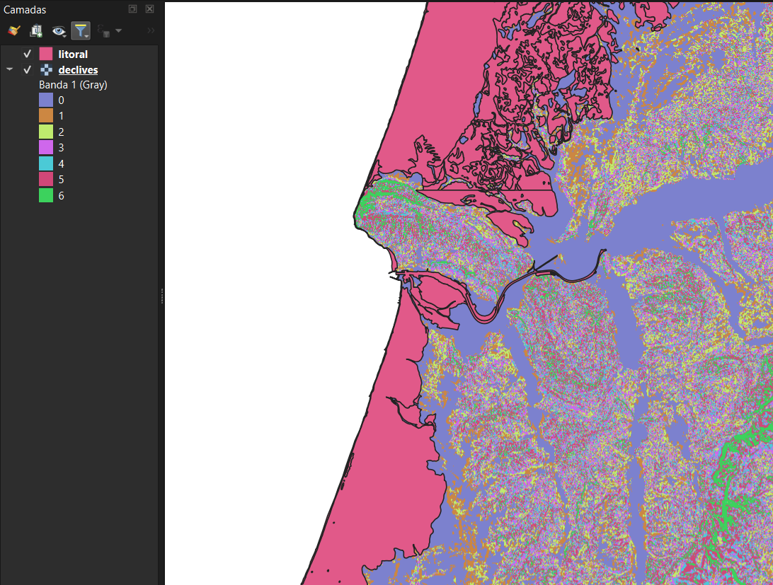

Model

Architecture

Needs and Considerations
The application needs to ingest geospatial information in zip files in a raw manner. On the pool of data it needs to extract the files and select the filetypes needed for the ingestion. This will be mainly .tiff and .shp files at this stage. Furthermore, it needs to ingest them into a PostGis database.
From that database the application needs to make predictions on the data and store those predictions in the same database. From all that dashboard needs to be created to visualize the processed data and the predictions made from the model. A GenAi model also needs to be created to explain and interact based on the predictions and information on the subject.

Steps
The cloud-native application should perform the following tasks:
- Upload raw data to a S3 bucket;
- Process the data with Lambda functions;
- Create an geo database on RDS with PostGis
- Populate the dataset and geo dataset with Glue/Lambda ogr2ogr/ Lambda GDAL layer;
- Perform queries with Athena to retrieve the needed data;
- Implement an ML predictor model with SageMaker geospacial;
- Store predictions in the previous database constructed;
- Implement a GenAI solution for decision making explanation with Bedrock from a knowledge base;
- Provide a mas dashboard tool for data exploration and predictions visualization.
Optional tasks:
- Implement real-time wind data ingestion with Kinesis;
- Predict energy production with the data ingested on time-window of the data;
- Provide geographic data exploration based on the data collected.
For this project and given the data gathered, RDS might be the simpler and best solution as we are dealing with a relatively low weight of data. Furthermore, the support for faster OLTP is not crucial as the ingestion data is daily and the predictions don’t need to be fast.

Technical decisions
For data ingestion in the database one could rely solely on the Lambda, as it might be enough for the amount of data at this stage. This needs to be assess accordingly to adjust for pricing and allow further scalability for adaptation to other regions and countries. This improvement allows for scalability to greater amounts of data.
RDS was the preferred dataset as it provides full support with most of the extensions needed, specially the postgis for the geolocalized data. For this project and given the data gathered, RDS might be the simpler and best solution as we are dealing with a relatively low weight of data. Furthermore, the support for faster OLTP is not crucial as the ingestion data is daily and the predictions don’t need to be fast. It was preferred over the Aurora for example as the further need for the streaming data is reserved for daily or weekly updates, minimizing the need for high-throughput ...
The visualization tool needed to be support map exploration and layers. Some map exploration can be done with SageMaker geospacial, but it does not support for interactive exploraion with the dashboard, needing hard code in notebook knowledge.
On the intelligent systems implemented, a GenAI algorithm will be introduced also. This will be done with Bedrock for users interaction. This will be linked to the knowledge base hosted in an S3 bucket.
The further and advanced streaming implementation will be done with Kinesis but, apart from the
Requirement | Best option
Small dependencies, simple deployment | Lambda Layers
GDAL under the Lambda package limit | Lambda Layers
Large GDAL/native dependencies | Container image
Files larger than 300 MB or long processing | ECS/Fargate or AWS Batch
Shared files across invocations | EFS

Diagram
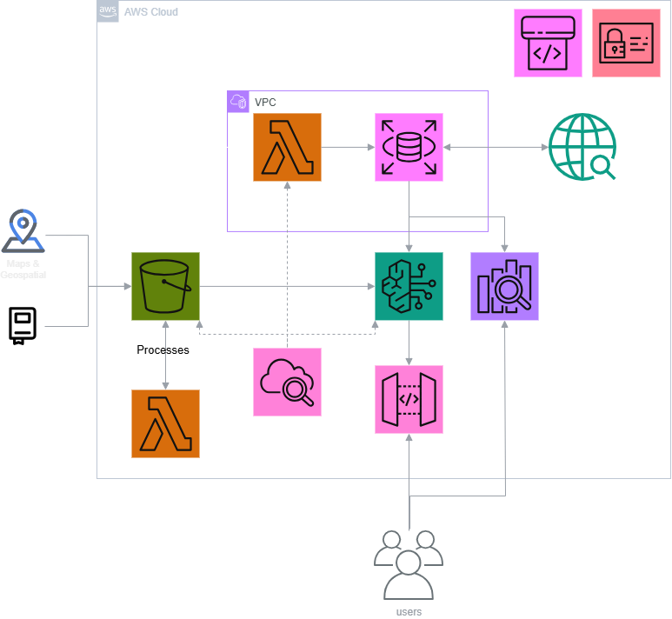

Implementation

AI
For geospacial data two model families will be tested. Tree-based models, with preference for Random Forest Classifiers, and XGBoost. This will be compared geometrically with the dataset “Atlas Eólico” which comes from a privous national laboratory of energy and geology stydy done in Portugal

Infastructure as Code (IaC)
The IaC in this implementation will be developed in Terraform. The whole project will be planned and deployed with this management tool, to make the code modular and reusable.
The structure of the project will follow the following structure:
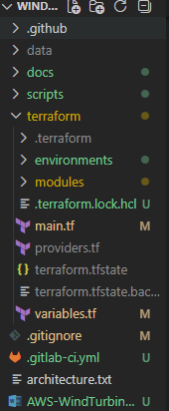

CI/CD

Testing and results

Conclusion

References
How Does Wind Turbine Placement Matter? → Question
What Are the Best Locations for Installing Wind Turbines?
Efficient turbine placement optimization in large-scale offshore wind farms: A space-constrained deep reinforcement learning algorithm - ScienceDirect
geoPortal LNEG

About Capgemini Engineering
World leader in engineering and R&D services, Capgemini Engineering combines its broad industry knowledge and cutting-edge technologies in digital and software to support the convergence of the physical and digital worlds. Coupled with the capabilities of the rest of the Group, it helps clients to accelerate their journey towards Intelligent Industry. Capgemini Engineering has 65,000 engineer and scientist team members in over 30 countries across sectors including Aeronautics, Space, Defense, Naval, Automotive, Rail, Infrastructure & Transportation, Energy, Utilities & Chemicals, Life Sciences, Communications, Semiconductor & Electronics, Industrial & Consumer, Software & Internet.
Capgemini Engineering is an integral part of the Capgemini Group, a global business and technology transformation partner, helping organizations to accelerate their dual transition to a digital and sustainable world, while creating tangible impact for enterprises and society. It is a responsible and diverse group of 340,000 team members in more than 50 countries. With its strong over 55-year heritage, Capgemini is trusted by its clients to unlock the value of technology to address the entire breadth of their business needs. It delivers end-to-end services and solutions leveraging strengths from strategy and design to engineering, all fueled by its market leading capabilities in AI, cloud and data, combined with its deep industry expertise and partner ecosystem. The Group reported 2023 global revenues of €22.5 billion.
Get the future you want | www.capgemini.com


This presentation contains information that may be privileged or
confidential and is the property of the Capgemini Group.
Copyright © 2024 Capgemini. All rights reserved.

