# Arduino ESP32-Nano word clock

A clock that displays time in words in the languages Dutch, English, French and German in a large 4-language clock or as a single language clock.  
The Arduino ESP32 Nano is used to drive the clock.   
Time is synchronized with the Network Time Protocol (NTP) from the internet.   
Settings can be controlled with a webpage, a PC or a Bluetooth Low Energy (BLE) serial terminal app installed on a phone, PC or tablet.

|  |  |
| --- | --- |
|  |  |
| 4-language clock | Dutch language clock |

|  |  |
| --- | --- |
|  |  |

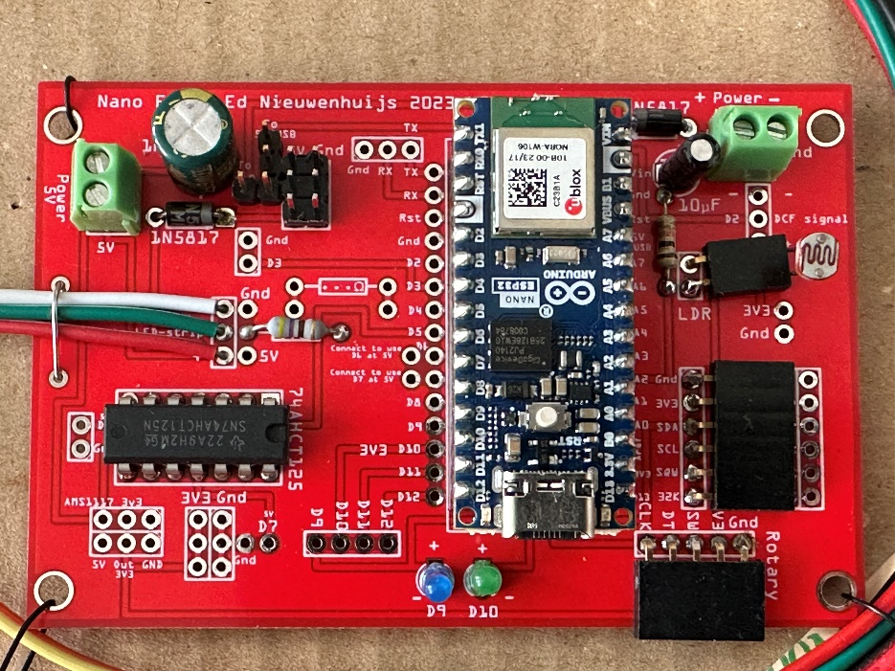  
Arduino ESP32 Nano on the PCB inside the clock.

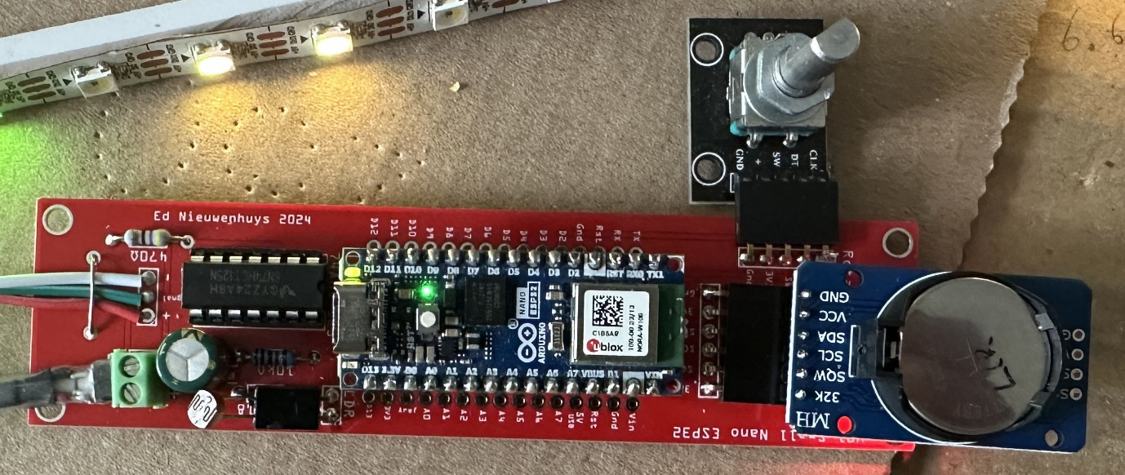

Small PCB design with Rotary and DS3231 RTC attached

**Before starting**  
The clock receives time from the internet when there is a WIFI connection. When a DS3231 time module is attached to the circuit board an internet connection is not obliged. A rotary encoder can be used to set time.

To connect to the internet the name of the WIFI station and its password must be entered in the clock software to be able to connect to a WIFI router.  
The name of the WIFI-station and password has to be entered once. These credentials will be stored in memory of the microprocessor. (See **Installations**)

To make life easy it is preferred to use a phone or tablet and a Bluetooth communication app to enter the WIFI credentials into the clock.

|  |  |  |
| --- | --- | --- |
|  |  |  |
| BLESerial nRF | BLE Serial Pro | Serial Bluetooth Terminal |

- Download a Bluetooth UART serial terminal app on your phone, PC, or tablet.  
For IOS: BLE Serial Pro or BLESerial nRF.  
For Android: Serial Bluetooth Terminal.

**Compilation and uploading**

The settings of the Arduino Nano ESP32 board is as follows.   
Install ESP32 boards. There are two version. One from Arduino with only the Arduino Nano ESP32 in the list core version 2.0.17 or higher or the ESP32 boards from Espressif with many boards with core version 3.0.5 or higher.

Board: Arduino Nano ESP32

Partition Scheme: With FAT

Pin Numbering: By GPIO number (legacy)

(or By Arduino pin (default) in later esp32 board versions)

If the LEDs do not turn on then it is most probably this pin settings that is wrong.

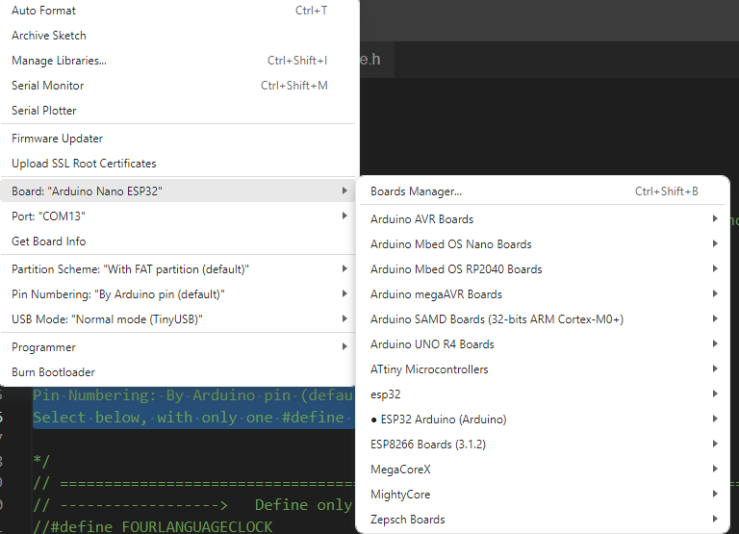 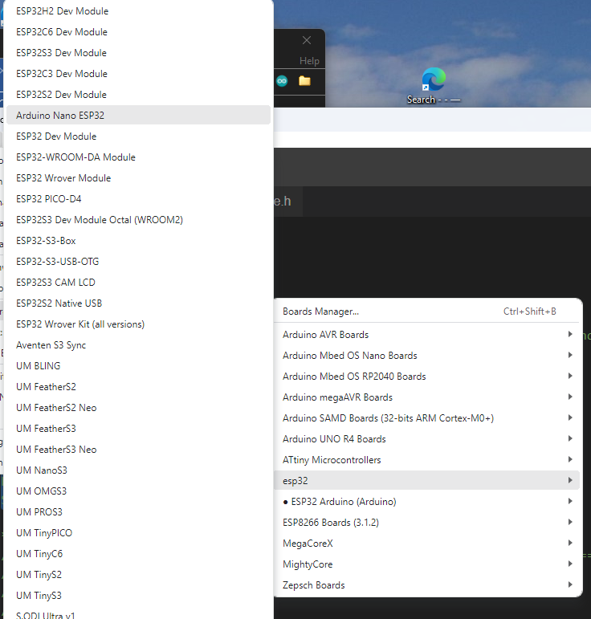

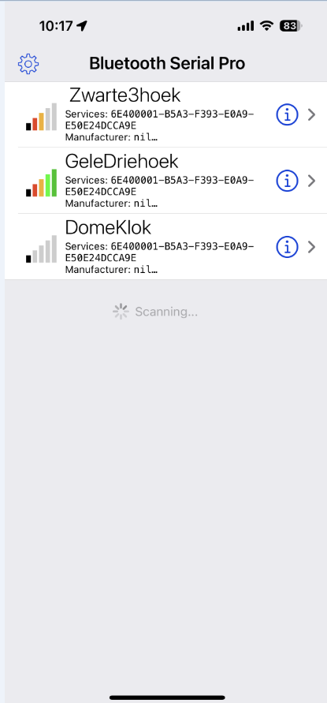**Installations**    
  
To connect to a WIFI network a SSID (WIFI name) and password must be entered.  
There are a few methods:  
Connect the MCU in the clock with a micro USB serial cable to a PC and use a serial terminal.   
Use a BLE serial terminal app on a phone or tablet for connection.

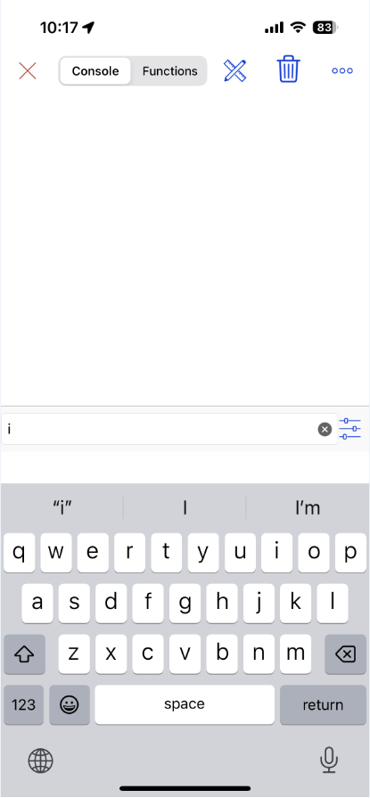For a PC the app [**Termite**](https://www.compuphase.com/software_termite.htm) is fine as serial terminal.  
  
For IOS use: **BLE Serial Pro** or **BLESerial nRF**.   
  
For Android use: **Serial Bluetooth terminal**.   
  
Bluetooth Low Energy (BLE) can use two types of protocol CC25nn or nRF52nn where nn is a specific number. This clock uses nRF52 from the company Nordic.   
  
- Start the app and start a connection with the clock. Some apps automatically start with a connection window but for some a connection symbol must be pressed. You will most probably find one station to select from.   
  
- Select the clock in the list.  
  
- The app will display a window and a line where commands can be entered and send to the clock.  
  
- Sending the letter I or i for information will display the menu followed with the actual settings of several preferences.

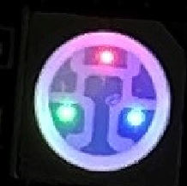In the clock there is a LED that will have a red dot lighted when the program is running.   
A green dot will turn on when there is a WIFI connection.  
When there is a Bluetooth connection a blue dot in the LED will light.

|  |  |
| --- | --- |
| In both cases **send the letter I of Information and the menu shows up**. Enter the first letter of the setting you want to changes followed with a code. Some entries just toggle On and Off. Like the W to set WIFI Off or On.  To change the SSID and password: Send the letter **A** or **a** followed with the WIFI station name.  **Amy-ssid** and send this command. Eg AFRITZ!Box01 or aFRITZ!Box01. Starting with an upper or lower case character is an identical instruction in the command string Then the letter B followed with the password. **Bmypassword** and send the password. **Cbroadcastname**  will change to name displayed in the Bluetooth connection list. Something like: cMyClock  If the length of the SSID and/or password is less then 5 characters the WIFI will be turned off automatically to avoid connection errors. Use a length of minimal 8 characters for SSID and password. Check in the menu (third row from the bottom) if WIFI and NTP are on.  Enter @ to restart the MCU. It will restart and connections will be made.  Sometimes a second or third reset must be given to get the clock connected to WIFI. If connection still fails check the SSID name and the entered password. (send the letter b, an easter egg)) If WIFI is connected the LED on the MCU will turn on a green dot. | ______________________________  A SSID B Password C BLE beacon name  D Date (D15012021) T Time (T132145)  E Timezone (E<-02>2 or E<+01>-1)  F Own colour (Hex FWWRRGGBB)  G Scan WIFI networks  H Toggle use rotary encoder  I To print this Info menu  J Toggle use DS3231 RTC module  K LDR reads/sec toggle On/Off  N Display off between Nhhhh (N2208)  O Display toggle On/Off  P Status LED toggle On/Off  Q Display colour choice  Q0 Yellow Q1 Hourly Q2 White  Q3 All Own Q4 Own Q5 Wheel  Q6 Digital  R Reset settings @ = Reset MCU  U Demo mode (msec) (M200)  --Light intensity settings (1-250)--  S Slope, L Min, M Max (S80 L5 M200)  W WIFI, X NTP&, CCC BLE, + Fast BLE  # Self test, ! See RTC, & Update RTC  Ed Nieuwenhuys November 2024  ___________________________________  Display off between: 23h - 08h  Display choice: Wheel  Slope: 5 Min: 5 Max: 100  SSID: FRITZ!Box  BLE name: RedSmall01  IP-address: 192.168.178.199 (/update)  Timezone:CET-1CEST,M3.5.0,M10.5.0/3  WIFI=On NTP=On BLE=On FastBLE=On  LED strip: SK6812 (Send % to switch)  Software: ESP32Arduino_WordClockV049.ino  ESP32 Arduino core version: 2.0.17  ______________________________________________________________________ |
|  | Menu displayed in serial output. |

Default the clock is set to Amsterdam time. A reset with option R in the menu will restore this time zone to Amsterdam again.  
To set a different time zone send the time zone string between the quotes prefixed with the character E or e.  
At the bottom of this manual many time zones are printed.  
For example; if you live in Australia/Sydney send the string,

eAEST-10AEDT,M10.1.0,M4.1.0/3.

The clock will use the Daylight saving time (DST) when connected to an NTP server but not when using the DS3231 time module

|  |  |
| --- | --- |
|  |  |
| HTML page on iPhone | Termite Terminal from a PC |

**Upgrading software**

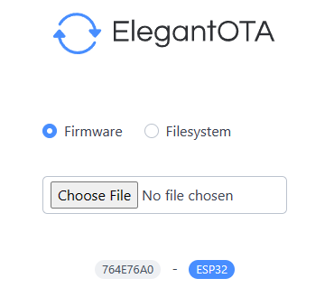**Software can be upgraded over the air (OTA) by opening a web browser and entering the IP-address of the clock followed with /update.   
For example: 192.168.178.78/update.   
Choose firmware and click on Choose File.  
Choose the appropriate bin file.**

**Control and settings of the clock**

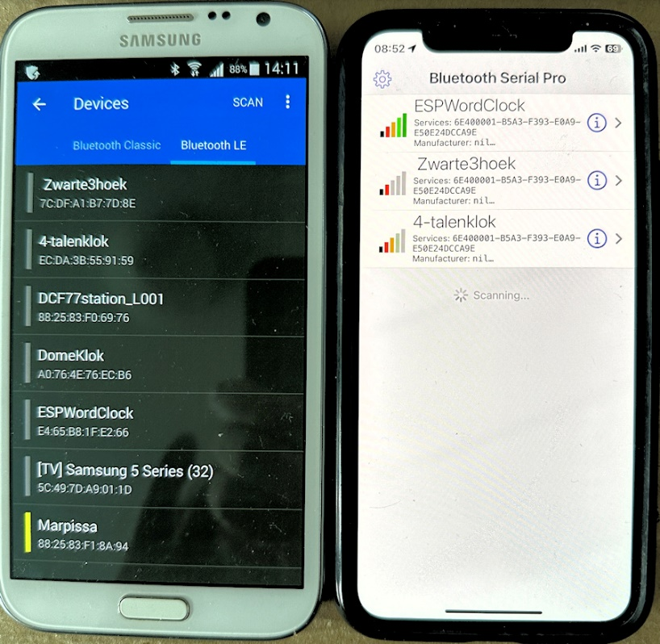The clock can be controlled with the WIFI webpage or BLE UART terminal app.  
When the clock is connected to WIFI it has received an IP-address from the router it is connected to.  
The IP-address is printed in the menu. If you cannot use a terminal app the IP-address of the clock can be found in your WIFI router.   
  
To start the menu in a web page the IP-address numbers and dots (for example: 192.168.178.77) must be entered in the web browser of your mobile or PC where you type your internet addresses (URL).  
  
Or with a Bluetooth connection:  
- Open the BLE terminal app.   
- Look in the app for the clock to connect to and connect.  
  
Every app has its own way of showing the Bluetooth device to connect to.   
  
The iPhone/iPad/iMac BLE serial apps are made by me and work with their default settings.   
With other apps settings for sending and receiving data may have to be changed. Play with the font size and the CR and LF setting until you get   
On a iPhone, iPad or iMac with the BLE serial app it is possible to speed up the transmission speed by selecting option ‘Z Fast BLE’ in the menu

Unfortunately some apps can not read strings longer than 20 characters and you will see the strings truncated or garbled.  
If you see a garbled menu enter and send the character '+' to select the slower transmission mode.  
If transmission is too garbled and it is impossible to send the character Z try the web page of the clock and send the character +.  
  
If all fails you have to connect the MCU inside the clock with a USB-C cable to a PC and use a serial terminal app to send a +.

**Adjusting the light intensity of the display**

In the menu light intensity of the display can be controlled with three parameters:

--Light intensity settings (1-250)--

S=Slope V=Min U=Max (S80 V5 U200)

The default values are shown between the ().

S How fast the brightness reaches maximum brightness.

V How bright the display is in complete darkness.

U the maximum brightness of the display.

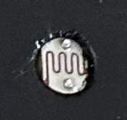

In the bottom half of the menu the stored values are displayed

Slope: 80 Min: 5 Max: 255

The clock reacts on light with its LDR (light dependent resistor).

When it gets dark the display does not turn off completely but will stay dimmed at a minimum value.   
With the parameter V the lowest brightness can be controlled. With a value between 0 and 255 this brightness can be set.  
V5 is the default value.

The maximum brightness of the display is controlled with the parameter U. Also a value between 0 and 255.

With parameter S the slope can be controlled how fast maximum brightness is achieved.

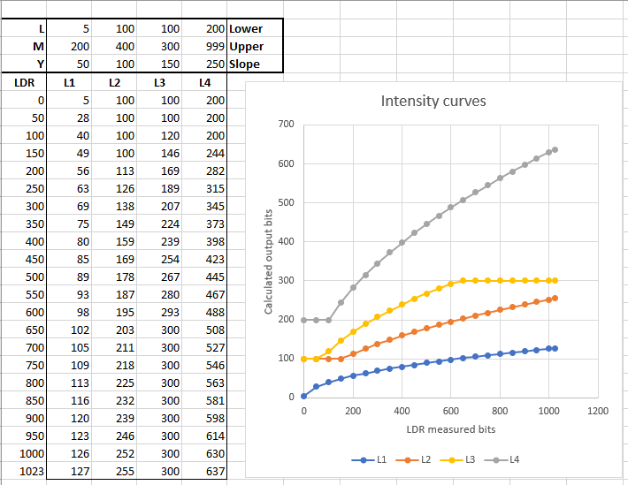

**Settings are set by entering the first character of a command following by parameters if necessary.**  
For example:   
To set the colours of the words in the clock to white enter: Q2  
  
To shown random all four languages every minute send L4. (This will not function in a single language clock)  
  
Turn off WIFI by sending a W.

Restart the clock with the letter @.

Reset to default setting by send R.

|  |  |
| --- | --- |
|  |  |
| HTML page | BLE menu |

**Updating the software**

**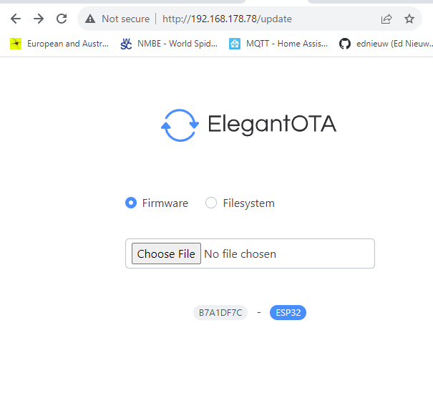  
The software can be updated ‘Over The Air’ when the clock is connected to WIFI.  
You can find the IP-address in the menu or in the digital display mode menu option Q6.  
Enter the IP-address of the clock followed with /update**

Something like this : 192.168.178.78/update

**‘Choose File’ in the menu and select the bin file to update.**

**Something like: ESP32Arduino_WordClockV046.ino.bin**

**where V046 is the version number of the software.  
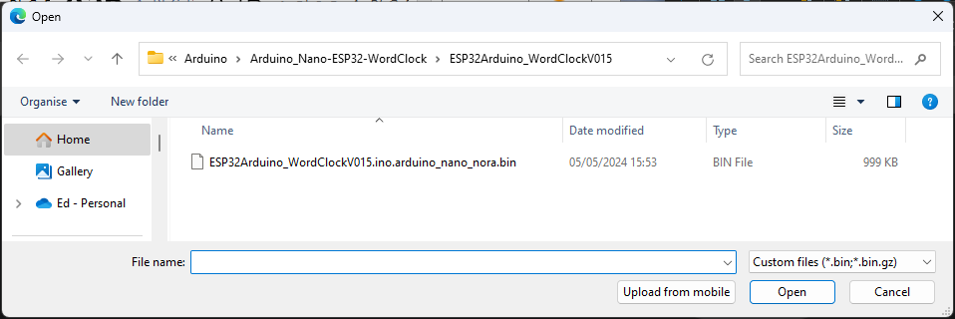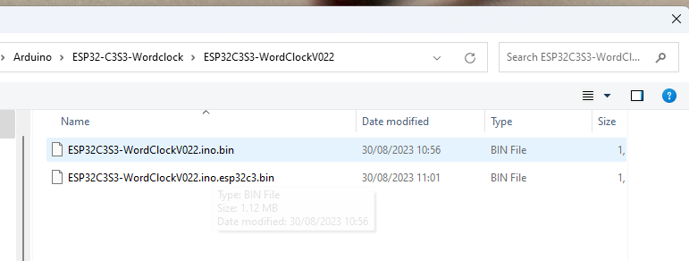**

**Detailed description**  
  
With the menu many preferences can be set. These preferences are stored on a SD-card or in the ESP32-S3 storage space.  
   
Enter the first character in the menu of the item to be changed followed with the parameter.  
There is no difference between upper or lower case. Both are OK.

Serial started

Rotary NOT used

Rotary available

Found I2C address: 0X57

Found I2C address: 0X68

External RTC module IS found

DS3231 RTC software started

Mem.Checksum = 25065

Stored settings loaded

LED strip is SK6812

LED strip started

BLE started

10: networks found

1: FRITZ!BoxEd -47 * -- Will connect to

2: NETGEAR_EXT -69

3: FRITZ!BoxEd -71 * -- Will connect to

4: H369A209CE1 -75 *

5: H3baas -81 *

6: H369A209CE1 -81 *

7: FRITZ!Box -82 *

8: H369A209CE1 -83 *

9: FRITZ!Box 5490 IS -83 *

10: FRITZ!Box 5490 XL -84 *

[WiFi-event] event: 0 : WiFi interface ready

[WiFi-event] event: 2 : WiFi client started

[WiFi-event] event: 4 : Connected to access point

[WiFi-event] event: 7 : Obtained IP address: 192.168.178.199

IP Address: 192.168.178.199

Web page started

WIFI started

01/01/2000 00:06:42

___________________________________

A SSID B Password C BLE beacon name

D Date (D15012021) T Time (T132145)

E Timezone (E<-02>2 or E<+01>-1)

F Own colour (Hex FWWRRGGBB)

G Scan WIFI networks

H Toggle use rotary encoder

I To print this Info menu

J Toggle use DS3231 RTC module

K LDR reads/sec toggle On/Off

N Display off between Nhhhh (N2208)

O Display toggle On/Off

P Status LED toggle On/Off

Q Display colour choice

Q0 Yellow Q1 Hourly Q2 White

Q3 All Own Q4 Own Q5 Wheel

Q6 Digital

R Reset settings @ = Reset MCU

U Demo mode (msec) (M200)

--Light intensity settings (1-250)--

S Slope, L Min, M Max (S80 L5 M200)

W WIFI, X NTP&, CCC BLE, + Fast BLE

# Self test, ! See RTC, & Update RTC

Ed Nieuwenhuys November 2024

___________________________________

Display off between: 23h - 08h

Display choice: Yellow

Slope: 5 Min: 5 Max: 100

SSID: FRITZ!BoxEd

BLE name: RedSmall01

IP-address: 192.168.178.199 (/update)

Timezone:CET-1CEST,M3.5.0,M10.5.0/3

WIFI=On NTP=Off BLE=On FastBLE=On

LED strip: SK6812 (Send % to switch)

Software: ESP32Arduino_WordClockV049.ino

ESP32 Arduino core version: 2.0.17

01/01/2000 00:06:42

___________________________________

Het is vijf over twaalf

Het is vijf over twaalf LDR:140= 3% 220692 l/s 20°C 00:06:43

Het was vijf over twaalf LDR:140= 3% 215629 l/s 20°C 00:07:00  
  
**A SSID B Password C BLE beacon name**  
Change the name of the SSID of the router to be connected to.   
For example: aFRITZ!Box or AFRITZ!Box.  
Then enter the password. For example: BSecret_password.  
Restart the clock by sending @.   
Entering a single 'b' will show the used password. This ‘Easter egg’ can be used to check if a valid password was entered.

**CCC** Entering CCC or ccc will toggle BLE on or off. Be careful turning it off. When BLE is off the clock can only be controlled with WIFI or the serial port to turn it on again   
  
**D Set Date**  and **T Set Time**   
If you are not connected to WIFI you have to set time and date by hand.  
For example enter: D06112022 to set the date to 6 November 2022.

Enter for example T132145 (or 132145 , or t132145)  to set the time to 45 seconds and 21 minute past one o'clock.  
Changing date and time only works when a DS3231 RTC module is attached.

**E Set Timezone E<-02>2 or E<+01>-1**  
At the bottom of this page you can find the time zones used in 2022.   
It is a rather complicated string and it is therefore wise to copy it.  
Let's pick one if you happen to live here: Antarctica/Troll,"<+00>0<+02>-2,M3.5.0/1,M10.5.0/3"  
Copy the string between the " "'s and send it with starting with an 'E' or 'e' in front.  
E<+00>0<+02>-2,M3.5.0/1,M10.5.0/3

**F Own colour (Hex WWRRGGBB)**You can set the colours of the words of your choice and select them with option Q in the menu with Q3 or Q4 .The format to be entered is hexadecimal. 0123456789ABCDEF are the characters that can be used.   
The command is 2 digits for Red followed with  two for Green and ending with two digits for Blue.   
To colour the characters intense Green enter F0000FF00 prefixed with the letter F.

**G Scan for WIFI networks in the neighbourhood**  
Sending ‘G’ will print the available networks in the neighbour hood in the serial terminal. This can be easy to copy the sometimes difficult net workname into option A of the menu.

**H Toggle to use the rotary encoder**  
Sending ‘H’ will toggle the use of an optional rotary encode attached to the PCB.

If turned on and not attaching a rotary encoder will result in unintentional input because the not attached pins will pick up signal randomly.

**I To print this Info menu**  
Print the menu to Bluetooth and the serial monitor connected with an USB-cable.

**J Toggle to use the DS3231 module time**  
Sending ‘J’ will toggle the use of an optional DS3231 time module ON and OFF.   
If the clock does not has an internet connection time will probably drift undesirably quick. Installing a DS3231 time module will reduce the drift to a few seconds per year. Time can be entered with option T and D in the menu.

**K Reads/sec toggle On/Off**  
Entering a K toggles printing of the LDR reading of the measured light intensity.   
It also shows how many times the processor loops through the program and checks its tasks to run the clock.

**N Display off between Nhhhh (N2208)**  
With N2208 the display will be turned off between 22:00 and 8:00.  
  
**O Display toggle On/Off**  
O Toggles the display off and on.

**P Status LEDs toggle On/Off**  
P Toggles the status LEDs on the Arduino Nano off and on.  
  
**Q Display colour choice (Q0-6)  
Q0 Yellow Q1 hourly Q2 White Q3 All Own Q4 Own Q5 Wheel Q6 Digital display**  
  
Q0 will show the time with yellow words

and will change HET )or IT) from green to red via yellow in an hour.

and will change IS or WAS from green to red via yellow in an minute.  
Q1 will show every hour another colour.  
Q2 shows all the texts white.  
Q3 and Q4 uses you own defined colours.  
Q5 will follow rainbow colours every minute.  
Q6 is the digital display

**R Reset settings**   
R will set all preferences to default settings,

It also clears the SSID and password.

Perform a reset when you upload the sketch for the first time in the Arduino Nano.

**S=Slope L=Min M=Max (S80 L5 M200)**  
S How fast the brightness reaches maximum brightness.  
L How bright the display is in complete darkness.  
M the maximum brightness of the display.  
Values between 0 and 250’

**U Demo mode (msec) (M200)**

Enter U followed with the duration of a second in milli seconds.

M200 (200 milli second) will speed up the clock 5 times.

Sending an U will turn off the demo mode.

**W=WIFI, X=NTP&, CCC=BLE**  
Toggle WIFI, NTP on and off.  
Enter the character will toggle it on or off.   
At the bottom of the menu the stated is printed.

Sending a & will start a query from the time server.

**+ Fast BLE**  
The BLE UART protocol sends default packets 20 bytes long. Between every packet there is a delay of 50 msec.  
The IOS BLEserial app, and maybe others too, is able to receive packets of 80 bytes or more before characters are missed. This makes the menu printed faster.   
Option Z toggles between the long and short packages.

**! = Show NTP, RTC and DS3231 time  
!**  will display the NTP, RTC and DS3231 time as they are stored in the clock in the clock. The DS3231 time module must be installed and being used to show a realistic time.  
Same as & option but this option will not update from the internet NTP server but only shows the time.

**# = Selftest**Sending a # will start the clock self test. This is convenient to check if all the words in the clock a functioning.

**% = Switch between SK6812 and WS2812 LED strip**With this option the used LED strip can be changed. The clock is equipped with on of these to types of LED strips.

A Reset of all settings by sending a R in the menu will not change the LED strip selection.  
 **@ = Reset MCU**@ will restart the MCU. This is handy when the SSID, et cetera are changed and the program must be restarted. Settings will not be deleted.

**& = Get and stores NTP time in RTC and DS3231 time  
&**  will get the NTP time immediately from the internet and stores it in the RTC clocks. This option is convenient to force the clock to get the proper NTP time.   
In other cases the program will check the time running in the clock and on the NTP server so now and then and update the RTC clocks.  
The DS3231 time module must be installed and being used to show a realistic time.

**123456 Set time in RTC module**

Enter the time as 152300 hhmmss. Same as T152300  
Changing date and time only works when a DS3231 RTC module is attached.

**Program explanation**

The program uses the following standard libraries.

//--------------------------------------------

// ESP32 Includes defines and initialisations

//--------------------------------------------

#include <Arduino.h>

#include <Preferences.h>

#if ESP_ARDUINO_VERSION >= ESP_ARDUINO_VERSION_VAL(3, 0, 0)

#include "EdSoftLED.h" // for LED strip WS2812 or SK6812

#else

#include <Adafruit_NeoPixel.h> // for LED strip WS2812 or SK6812

#endif

#include <NimBLEDevice.h> // For BLE communication

#include <ESPNtpClient.h> // https://github.com/gmag11/ESPNtpClient

#include <WiFi.h> // Used for web page

#include <AsyncTCP.h> // Used for webpage

#include <ESPAsyncWebServer.h> // Used for webpage ESPAsyncWebServer

#include <ElegantOTA.h>

#include <Wire.h>

#include <RTClib.h> // Used for connected DS3231

#include <Encoder.h>

The TAB in the IDE is the web page to display in the browser.  
The #include "Webpage.h" a few lines further in the code loads the webpage.  
I made the web page in the free 'Microsoft Expression Web 4'. It is not maintained anymore but has more than enough functionalities for our purposes.  
  
To copy the code from the MS-Expression web HTML editor:  
In the bottom line of the window of MS-Expression click 'Split'.  
In the upper half the raw HTML Code is displayed and in the bottom half the Design window.  
Copy in the Code window all the HTML code  
Go to the Arduino IDE and paste it in the webpage.h TAB between:  
R"rawliteral(  ... and ...  )rawliteral";  
  
Or copy the code from the webpage.h into MSexpression Code area and redesign the page as you like.

[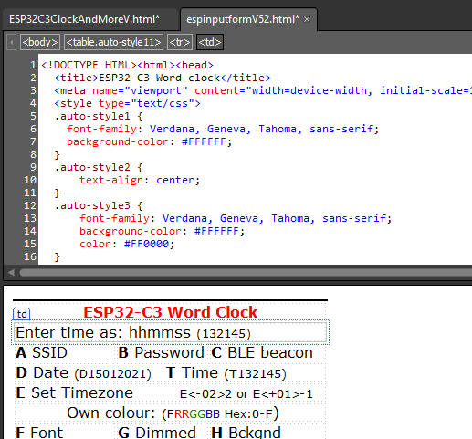](https://github.com/ednieuw/Arduino-ESP32-Nano-Wordclock/blob/main/Pics/MSExpression.jpg)

A long list if definitions and initialisations follows.  
I am not a fan of passing all the variables to and from functions and like to keep them global in one program list.  
If you write a program with other people it is good practice not to use too many global variables but this program is in one large listing, for the same reason to keep it simple.  
I grouped all the variables per application to keep track where they are used.  
With a simple find it is easy in this one great listing to find the back.  
  
To print the time as text and colour with the proper LEDs or characters, the words and its position in a string of LEDs or text are defined.  
The defines executes the function ColorLeds with its proper parameters.  
Further in the program  in the function void Dutch(void), void English(void) et cetera it becomes clear why these defines are so useful and handy.

...

#define PRECIES ColorLeds("precies", 16, 22, LetterColor);

#define MTIEN ColorLeds("tien", 25, 28, LetterColor);

#define KWART ColorLeds("kwart", 32, 36, LetterColor);

#define VOOR ColorLeds("voor", 38, 41, LetterColor);

...

This is the initialisation of the storage area to store the struct EEPROMstorage.  
The Struct with all its settings is saved in one command to permanent memory or SD  
Preferences FLASHSTOR;

struct EEPROMstorage { // Data storage to maintain them after power loss  
byte DisplayChoice = 0;  
...  
char BLEbroadcastName[30]; // Name of the BLE beacon  
char Timezone[50];  
int Checksum = 0;  
} Mem;  
  
The variables are addressed with a short name Mem.  
For example Mem.DisplayChoice = 3;  
  
The Struct EEPROMstorage  
is stored in the function StoreStructInFlashMemory  
and retrieved in the function GetStructFromFlashMemory  
  
The menu displayed in the serial monitor and BLE app is defined here.  
String may not be longer than 40 characters what can be checked with the 'ruler'  
string.

// Menu

//0 1 2 3 4

//1234567890123456789012345678901234567890

char menu[][40] = {

"A SSID B Password C BLE beacon name",

"D Date (D15012021) T Time (T132145)",

...

"W=WIFI, X=NTP, Y=BLE, Z=Fast BLE",

"Jun 2024" };

The Setup happens here:

//--------------------------------------------

// ARDUINO Setup

//--------------------------------------------

void setup()

{

Serial.begin(115200); // Setup the serial port to 115200 baud //

pinMode(secondsPin, OUTPUT); // turn On seconds LED-pin

...

...

msTick = millis();  
}

The loop is kept almost empty and the program starts in EverySeccondCheck.  
Only subroutine in CheckDevices(); must be executed often.

//--------------------------------------------

// ESP32 Loop

//--------------------------------------------

void loop()

{

Loopcounter++; // How often do the MCU loops/sec?

EverySecondCheck();

CheckDevices();

}

The following routines check if something must happen every second, minute, hour and day.  
This flow handling of the program keeps the processor for 99% free for other uses.  
In this program that is almost nothing but for other purposes this can be needed.  
In the Bluetooth and Serial communication functions some short delays are used that are essential here but the program only runs here when there is an actual  communication.  
(An alternative method could have been the use of an interrupt every second and an empty loop).  
  
//--------------------------------------------

// CLOCK Update routine done every second

//--------------------------------------------

void EverySecondCheck(void)

{

static int Toggle = 0;

uint32_t msLeap = millis() - msTick; //

if (msLeap >999) // Every second enter the loop

{

msTick = millis();

GetTijd(false); // Get the time for the seconds

Toggle = 1-Toggle; // Used to turn On or Off Leds

UpdateStatusLEDs(Toggle);

SetSecondColour(); // Set the colour per second of 'IS' and 'WAS'

DimLeds(TestLDR); // Every second an intensity check

if (timeinfo.tm_min != lastminute) EveryMinuteUpdate();

Loopcounter=0;

}}

//--------------------------------------------

// CLOCK Update routine done every minute

//--------------------------------------------

void EveryMinuteUpdate(void)

{

...

if(timeinfo.tm_hour != lasthour) EveryHourUpdate();

}

//--------------------------------------------

// CLOCK Update routine done every hour

//--------------------------------------------

void EveryHourUpdate(void)

{

...

if (timeinfo.tm_mday != lastday) EveryDayUpdate();

}

// //

//------------------------------------------------------------------------------

// CLOCK Update routine done every day

//------------------------------------------------------------------------------

void EveryDayUpdate(void)

{

...

}

Check for serial input from the serial monitor and pass the command to ReworkInputString()

//--------------------------------------------

// Common check for serial input

//--------------------------------------------

void SerialCheck(void)

{

...

ReworkInputString(SerialString+"\n"); // Rework ReworkInputString();

...

}

Restore all the default values.

//------------------------------------------------------------------------

// Common Reset to default settings

//------------------------------------------------------------------------

void Reset(void)

{

Mem.Checksum = 25065;

...

}

Common print routines.  
To keep all the print commands in one places it is easy to change these routines for other boards with a different 'slang'.

//--------------------------------------------

// Common common print routines

//--------------------------------------------

void Tekstprint(char const tekst[])

{ if(Serial) Serial.print(tekst); SendMessageBLE(tekst);sptext[0]=0; }

void Tekstprintln(char const tekst[])

{ sprintf(sptext,"%s\n",tekst); Tekstprint(sptext); }

void TekstSprint(char const tekst[])

{ printf(tekst); sptext[0]=0;} // printing for Debugging purposes

void TekstSprintln(char const tekst[])

{ sprintf(sptext,"%s\n",tekst); TekstSprint(sptext); }

//-------------------------------------------------------------------------

// Common Constrain a string with integers

// The value between the first and last character in a string is returned between the low and up boundaries

//-------------------------------------------------------------------------

int SConstrainInt(String s,byte first,byte last,int low,int up)

{return constrain(s.substring(first, last).toInt(), low, up);}

int SConstrainInt(String s,byte first, int low,int up)

{return constrain(s.substring(first).toInt(), low, up);}

The setup of storage space and control of the validity of the settings.  
In the checksum is invalid a reset() will restore the default settings

//--------------------------------------------

// Common Init and check contents of EEPROM

//--------------------------------------------

void InitStorage(void)

Store and retrieve the settings from SPIFFS or SD or EEPROM  
the several possibilities are store here. EEPROM becomes outdated but still works.

--------------------------------------------

// COMMON Store mem.struct in FlashStorage or SD

//--------------------------------------------

void StoreStructInFlashMemory(void)

{

}

//--------------------------------------------

// COMMON Get data from FlashStorage Preferences.h

//--------------------------------------------

void GetStructFromFlashMemory(void)

{

}

Get the commands from the strings entered in the serial monitor, Bluetooth or the webpage and perform the command in an action.  
The menu letters are almost used but it possible to distinguish between lower and uppercase when more commands are needed.  
(That is why there is no conversion to UpperCase or LowerCase).

//--------------------------------------------

// CLOCK Input from Bluetooth or Serial

//--------------------------------------------

void ReworkInputString(String InputString)

{

....

switch (InputString[0])

{

case 'A':

case 'a':

if (InputString.length() >5 )

...

Read the LDR and divide it with 16 to get the values from 0 - 4096 between 0 and 255.  
Not all boards has a 12 bit AD converter like.

//--------------------------------------------

// LDR reading are between 0 and 255.

// ESP32 analogue read is between 0 - 4096 -- is: 4096 / 8

//--------------------------------------------

int ReadLDR(void) { return analogRead(PhotoCellPin)/16;}

Control the colour and intensity of the LED on the boards in one command

//--------------------------------------------

// CLOCK Control the LEDs on the ESP32

// 0 Low is LED off. Therefore the value is inversed with the ! Not

//--------------------------------------------

void SetStatusLED(bool Red, bool Green, bool Blue)

{

This function reads the analog port and calculates an output intensity to a display or LED-strip. The readings are squared to get a hyperbolic curve that resembles you eye correction for dark and light better than a linear range. It works wonderfully well.

//--------------------------------------------

// LED Dim the leds measured by the LDR and print values

// LDR reading are between 0 and 255. The Brightness send to the LEDs is between 0 and 255

//--------------------------------------------

void DimLeds(bool print) { ... }

Here we print and colour the characters in the display or light up to proper LEDs in a String of RGB(W) LEDs.  
The #define executes this functions with the proper parameters for every language and prints the texts in the serial connections.  
#define QUARTER ColorLeds("quarter", 32, 38, LetterColor);

//-------------------------------------------- /

/ LED Set colour for LED.

//--------------------------------------------

void ColorLeds(char const *Texkst, int FirstLed, int LastLed, uint32_t RGBColor)

{ }

To convert all characters to uppercase in a character array.

//--------------------------------------------

// COMMON String upper

//--------------------------------------------

void to_upper(char* string)

Every display or strip uses other commands to regulate the brightness

Therefore for all LED/Display commands a function

//------------------------------------------------------------------------

// LED Set brightness of backlight

//-------------------------------------------------------------------------

void SetBrightnessLeds(byte Bright)

{

SetBackLight(Bright); // Set brightness of LEDs

}

A place to turn off all LEDs or clear the display

//--------------------------------------------

// LED Clear the character string

//--------------------------------------------

void LedsOff(void)

Here are all the colours are set for the characters are set.  
The function has changed often and it's name describes it's original purpose  
For backward compatibility it's name is unchanged.  
//--------------------------------------------  
// LED Set second color  
//--------------------------------------------  
void SetSecondColour(void)  
{  switch (Mem.DisplayChoice)   {  case DEFAULTCOLOUR: LetterColor = C_YELLOW;  
...  
  
  
SWversion() prints the menu and the settings of several preferences  
The function has changed often and it's name describes it's original purpose  
For backward compatibility it's name is unchanged.  
PrintLine() prints the horizontal lines in the menu.

//--------------------------------------------

// CLOCK Version and preferences info

//--------------------------------------------

void SWversion(void)

{

#define FILENAAM (strrchr(__FILE__, '\\') ? strrchr(__FILE__, '\\') + 1 : __FILE__)

PrintLine(35);

for (uint8_t i = 0; i < sizeof(menu) / sizeof(menu[0]); Tekstprintln(menu[i++]));

...

PrintLine(35);

}

void PrintLine(byte Lengte)

{... }

Displaytime() prints the time to the serial monitor as text and control wiich language is printed.  
It also sends the appropriate sequence of colour and intensities to a RGB(W) LED strip.

//--------------------------------------------  
// CLOCK Say the time and load the LEDs  
// with the proper colour and intensity

//--------------------------------------------

void Displaytime(void)

{  
..

switch(Language) // Print all the character in the backgound color, a sort of ClearScreen

{

case 0: strncpy(Template,"HETVISOWASOVIJFQPRECIESZSTIENKPFKWARTSVOORS

OVERAHALFSMIDDERTVIJFATWEESOEENOXVIERELFQTIENK

TWAALFBHDRIE CNEGENACHTFZESVZEVENOENVUUR",129);  
 ColorLeds(Template,0,127, Mem.DimmedLetter);

Dutch(); Print_tijd(); break;

case 1:  
...

}

A series of functions to get and store time.  
The NTP time server puts the retrieved time in the standard C time structures.

//--------------------------- Time functions --------------------------

void GetTijd(byte printit)

void Print_RTC_tijd(void)

void PrintNTP_tijd(void)

void PrintUTCtijd(void)

void Print_tijd(void)

void SetRTCTime(void)

Convert a HEX string to a unsigned 32-bits integer

//--------------------------------------------

// CLOCK Convert Hex to uint32

//--------------------------------------------

uint32_t HexToDec(String hexString)

Functions to let the clocks speak the time in four languages

There is also a lot of slang in languages.  
'Half nine' sometimes means 8:30 but can also be 9:30. (-:  
  
/--------------------------------------------  
// CLOCK Dutch clock display  
//--------------------------------------------  
void Dutch(void)  
{  
HET; // HET is always on  
switch (timeinfo.tm_min)  
{  
case 0: IS; PRECIES; break;  
case 1: IS; break;  
case 2:  
case 3: WAS; break;  
case 4:  
case 5:  
...  
  
void English(void)  
void German(void)  
void French(void)  
  
  
The Bluetooth Low Energy Nordic nRF.. functions.  
They are different from the Texas instrument CC2540/CC2541 that is used in other chipsets like the HM-10, HM16, JDY-08 et cetera.  
[More here on Instructables](https://www.instructables.com/Communicate-Using-CC254x-or-NRF-BLE-With-Arduino-a/) https://www.instructables.com/Communicate-Using-CC254x-or-NRF-BLE-With-Arduino-a/

/-----------------------------

// BLE SendMessage by BLE Slow in packets of 20 chars

//------------------------------

void SendMessageBLE(std::string Message)

/-----------------------------

// BLE Start BLE Classes

//------------------------------

class MyServerCallbacks: public BLEServerCallbacks

/-----------------------------

// BLE Start BLE Service

//------------------------------

void StartBLEService(void)

/-----------------------------

// BLE CheckBLE

//------------------------------

void CheckBLE(void)

Functions to start a WIFI connection and use the webpage

/--------------------------------------------

// WIFI WEBPAGE

//--------------------------------------------

void StartWIFI_NTP(void)

/--------------------------------------------

// WIFI WEBPAGE

//--------------------------------------------

void WebPage(void)

/--------------------------------------------

// WIFI WEBPAGE Not found message

//--------------------------------------------

void notFound(AsyncWebServerRequest *request)

**Time zones**

Copy the text **between the quotes**and paste them after the character E and send it to the clock

For example EGMT0.

Africa/Abidjan,"GMT0"

Africa/Accra,"GMT0"

Africa/Addis_Ababa,"EAT-3"

Africa/Algiers,"CET-1"

Africa/Asmara,"EAT-3"

Africa/Bamako,"GMT0"

Africa/Bangui,"WAT-1"

Africa/Banjul,"GMT0"

Africa/Bissau,"GMT0"

Africa/Blantyre,"CAT-2"

Africa/Brazzaville,"WAT-1"

Africa/Bujumbura,"CAT-2"

Africa/Cairo,"EET-2"

Africa/Casablanca,"<+01>-1"

Africa/Ceuta,"CET-1CEST,M3.5.0,M10.5.0/3"

Africa/Conakry,"GMT0"

Africa/Dakar,"GMT0"

Africa/Dar_es_Salaam,"EAT-3"

Africa/Djibouti,"EAT-3"

Africa/Douala,"WAT-1"

Africa/El_Aaiun,"<+01>-1"

Africa/Freetown,"GMT0"

Africa/Gaborone,"CAT-2"

Africa/Harare,"CAT-2"

Africa/Johannesburg,"SAST-2"

Africa/Juba,"CAT-2"

Africa/Kampala,"EAT-3"

Africa/Khartoum,"CAT-2"

Africa/Kigali,"CAT-2"

Africa/Kinshasa,"WAT-1"

Africa/Lagos,"WAT-1"

Africa/Libreville,"WAT-1"

Africa/Lome,"GMT0"

Africa/Luanda,"WAT-1"

Africa/Lubumbashi,"CAT-2"

Africa/Lusaka,"CAT-2"

Africa/Malabo,"WAT-1"

Africa/Maputo,"CAT-2"

Africa/Maseru,"SAST-2"

Africa/Mbabane,"SAST-2"

Africa/Mogadishu,"EAT-3"

Africa/Monrovia,"GMT0"

Africa/Nairobi,"EAT-3"

Africa/Ndjamena,"WAT-1"

Africa/Niamey,"WAT-1"

Africa/Nouakchott,"GMT0"

Africa/Ouagadougou,"GMT0"

Africa/Porto-Novo,"WAT-1"

Africa/Sao_Tome,"GMT0"

Africa/Tripoli,"EET-2"

Africa/Tunis,"CET-1"

Africa/Windhoek,"CAT-2"

America/Adak,"HST10HDT,M3.2.0,M11.1.0"

America/Anchorage,"AKST9AKDT,M3.2.0,M11.1.0"

America/Anguilla,"AST4"

America/Antigua,"AST4"

America/Araguaina,"<-03>3"

America/Argentina/Buenos_Aires,"<-03>3"

America/Argentina/Catamarca,"<-03>3"

America/Argentina/Cordoba,"<-03>3"

America/Argentina/Jujuy,"<-03>3"

America/Argentina/La_Rioja,"<-03>3"

America/Argentina/Mendoza,"<-03>3"

America/Argentina/Rio_Gallegos,"<-03>3"

America/Argentina/Salta,"<-03>3"

America/Argentina/San_Juan,"<-03>3"

America/Argentina/San_Luis,"<-03>3"

America/Argentina/Tucuman,"<-03>3"

America/Argentina/Ushuaia,"<-03>3"

America/Aruba,"AST4"

America/Asuncion,"<-04>4<-03>,M10.1.0/0,M3.4.0/0"

America/Atikokan,"EST5"

America/Bahia,"<-03>3"

America/Bahia_Banderas,"CST6CDT,M4.1.0,M10.5.0"

America/Barbados,"AST4"

America/Belem,"<-03>3"

America/Belize,"CST6"

America/Blanc-Sablon,"AST4"

America/Boa_Vista,"<-04>4"

America/Bogota,"<-05>5"

America/Boise,"MST7MDT,M3.2.0,M11.1.0"

America/Cambridge_Bay,"MST7MDT,M3.2.0,M11.1.0"

America/Campo_Grande,"<-04>4"

America/Cancun,"EST5"

America/Caracas,"<-04>4"

America/Cayenne,"<-03>3"

America/Cayman,"EST5"

America/Chicago,"CST6CDT,M3.2.0,M11.1.0"

America/Chihuahua,"MST7MDT,M4.1.0,M10.5.0"

America/Costa_Rica,"CST6"

America/Creston,"MST7"

America/Cuiaba,"<-04>4"

America/Curacao,"AST4"

America/Danmarkshavn,"GMT0"

America/Dawson,"MST7"

America/Dawson_Creek,"MST7"

America/Denver,"MST7MDT,M3.2.0,M11.1.0"

America/Detroit,"EST5EDT,M3.2.0,M11.1.0"

America/Dominica,"AST4"

America/Edmonton,"MST7MDT,M3.2.0,M11.1.0"

America/Eirunepe,"<-05>5"

America/El_Salvador,"CST6"

America/Fortaleza,"<-03>3"

America/Fort_Nelson,"MST7"

America/Glace_Bay,"AST4ADT,M3.2.0,M11.1.0"

America/Godthab,"<-03>3<-02>,M3.5.0/-2,M10.5.0/-1"

America/Goose_Bay,"AST4ADT,M3.2.0,M11.1.0"

America/Grand_Turk,"EST5EDT,M3.2.0,M11.1.0"

America/Grenada,"AST4"

America/Guadeloupe,"AST4"

America/Guatemala,"CST6"

America/Guayaquil,"<-05>5"

America/Guyana,"<-04>4"

America/Halifax,"AST4ADT,M3.2.0,M11.1.0"

America/Havana,"CST5CDT,M3.2.0/0,M11.1.0/1"

America/Hermosillo,"MST7"

America/Indiana/Indianapolis,"EST5EDT,M3.2.0,M11.1.0"

America/Indiana/Knox,"CST6CDT,M3.2.0,M11.1.0"

America/Indiana/Marengo,"EST5EDT,M3.2.0,M11.1.0"

America/Indiana/Petersburg,"EST5EDT,M3.2.0,M11.1.0"

America/Indiana/Tell_City,"CST6CDT,M3.2.0,M11.1.0"

America/Indiana/Vevay,"EST5EDT,M3.2.0,M11.1.0"

America/Indiana/Vincennes,"EST5EDT,M3.2.0,M11.1.0"

America/Indiana/Winamac,"EST5EDT,M3.2.0,M11.1.0"

America/Inuvik,"MST7MDT,M3.2.0,M11.1.0"

America/Iqaluit,"EST5EDT,M3.2.0,M11.1.0"

America/Jamaica,"EST5"

America/Juneau,"AKST9AKDT,M3.2.0,M11.1.0"

America/Kentucky/Louisville,"EST5EDT,M3.2.0,M11.1.0"

America/Kentucky/Monticello,"EST5EDT,M3.2.0,M11.1.0"

America/Kralendijk,"AST4"

America/La_Paz,"<-04>4"

America/Lima,"<-05>5"

America/Los_Angeles,"PST8PDT,M3.2.0,M11.1.0"

America/Lower_Princes,"AST4"

America/Maceio,"<-03>3"

America/Managua,"CST6"

America/Manaus,"<-04>4"

America/Marigot,"AST4"

America/Martinique,"AST4"

America/Matamoros,"CST6CDT,M3.2.0,M11.1.0"

America/Mazatlan,"MST7MDT,M4.1.0,M10.5.0"

America/Menominee,"CST6CDT,M3.2.0,M11.1.0"

America/Merida,"CST6CDT,M4.1.0,M10.5.0"

America/Metlakatla,"AKST9AKDT,M3.2.0,M11.1.0"

America/Mexico_City,"CST6CDT,M4.1.0,M10.5.0"

America/Miquelon,"<-03>3<-02>,M3.2.0,M11.1.0"

America/Moncton,"AST4ADT,M3.2.0,M11.1.0"

America/Monterrey,"CST6CDT,M4.1.0,M10.5.0"

America/Montevideo,"<-03>3"

America/Montreal,"EST5EDT,M3.2.0,M11.1.0"

America/Montserrat,"AST4"

America/Nassau,"EST5EDT,M3.2.0,M11.1.0"

America/New_York,"EST5EDT,M3.2.0,M11.1.0"

America/Nipigon,"EST5EDT,M3.2.0,M11.1.0"

America/Nome,"AKST9AKDT,M3.2.0,M11.1.0"

America/Noronha,"<-02>2"

America/North_Dakota/Beulah,"CST6CDT,M3.2.0,M11.1.0"

America/North_Dakota/Center,"CST6CDT,M3.2.0,M11.1.0"

America/North_Dakota/New_Salem,"CST6CDT,M3.2.0,M11.1.0"

America/Nuuk,"<-03>3<-02>,M3.5.0/-2,M10.5.0/-1"

America/Ojinaga,"MST7MDT,M3.2.0,M11.1.0"

America/Panama,"EST5"

America/Pangnirtung,"EST5EDT,M3.2.0,M11.1.0"

America/Paramaribo,"<-03>3"

America/Phoenix,"MST7"

America/Port-au-Prince,"EST5EDT,M3.2.0,M11.1.0"

America/Port_of_Spain,"AST4"

America/Porto_Velho,"<-04>4"

America/Puerto_Rico,"AST4"

America/Punta_Arenas,"<-03>3"

America/Rainy_River,"CST6CDT,M3.2.0,M11.1.0"

America/Rankin_Inlet,"CST6CDT,M3.2.0,M11.1.0"

America/Recife,"<-03>3"

America/Regina,"CST6"

America/Resolute,"CST6CDT,M3.2.0,M11.1.0"

America/Rio_Branco,"<-05>5"

America/Santarem,"<-03>3"

America/Santiago,"<-04>4<-03>,M9.1.6/24,M4.1.6/24"

America/Santo_Domingo,"AST4"

America/Sao_Paulo,"<-03>3"

America/Scoresbysund,"<-01>1<+00>,M3.5.0/0,M10.5.0/1"

America/Sitka,"AKST9AKDT,M3.2.0,M11.1.0"

America/St_Barthelemy,"AST4"

America/St_Johns,"NST3:30NDT,M3.2.0,M11.1.0"

America/St_Kitts,"AST4"

America/St_Lucia,"AST4"

America/St_Thomas,"AST4"

America/St_Vincent,"AST4"

America/Swift_Current,"CST6"

America/Tegucigalpa,"CST6"

America/Thule,"AST4ADT,M3.2.0,M11.1.0"

America/Thunder_Bay,"EST5EDT,M3.2.0,M11.1.0"

America/Tijuana,"PST8PDT,M3.2.0,M11.1.0"

America/Toronto,"EST5EDT,M3.2.0,M11.1.0"

America/Tortola,"AST4"

America/Vancouver,"PST8PDT,M3.2.0,M11.1.0"

America/Whitehorse,"MST7"

America/Winnipeg,"CST6CDT,M3.2.0,M11.1.0"

America/Yakutat,"AKST9AKDT,M3.2.0,M11.1.0"

America/Yellowknife,"MST7MDT,M3.2.0,M11.1.0"

Antarctica/Casey,"<+11>-11"

Antarctica/Davis,"<+07>-7"

Antarctica/DumontDUrville,"<+10>-10"

Antarctica/Macquarie,"AEST-10AEDT,M10.1.0,M4.1.0/3"

Antarctica/Mawson,"<+05>-5"

Antarctica/McMurdo,"NZST-12NZDT,M9.5.0,M4.1.0/3"

Antarctica/Palmer,"<-03>3"

Antarctica/Rothera,"<-03>3"

Antarctica/Syowa,"<+03>-3"

Antarctica/Troll,"<+00>0<+02>-2,M3.5.0/1,M10.5.0/3"

Antarctica/Vostok,"<+06>-6"

Arctic/Longyearbyen,"CET-1CEST,M3.5.0,M10.5.0/3"

Asia/Aden,"<+03>-3"

Asia/Almaty,"<+06>-6"

Asia/Amman,"EET-2EEST,M2.5.4/24,M10.5.5/1"

Asia/Anadyr,"<+12>-12"

Asia/Aqtau,"<+05>-5"

Asia/Aqtobe,"<+05>-5"

Asia/Ashgabat,"<+05>-5"

Asia/Atyrau,"<+05>-5"

Asia/Baghdad,"<+03>-3"

Asia/Bahrain,"<+03>-3"

Asia/Baku,"<+04>-4"

Asia/Bangkok,"<+07>-7"

Asia/Barnaul,"<+07>-7"

Asia/Beirut,"EET-2EEST,M3.5.0/0,M10.5.0/0"

Asia/Bishkek,"<+06>-6"

Asia/Brunei,"<+08>-8"

Asia/Chita,"<+09>-9"

Asia/Choibalsan,"<+08>-8"

Asia/Colombo,"<+0530>-5:30"

Asia/Damascus,"EET-2EEST,M3.5.5/0,M10.5.5/0"

Asia/Dhaka,"<+06>-6"

Asia/Dili,"<+09>-9"

Asia/Dubai,"<+04>-4"

Asia/Dushanbe,"<+05>-5"

Asia/Famagusta,"EET-2EEST,M3.5.0/3,M10.5.0/4"

Asia/Gaza,"EET-2EEST,M3.4.4/48,M10.5.5/1"

Asia/Hebron,"EET-2EEST,M3.4.4/48,M10.5.5/1"

Asia/Ho_Chi_Minh,"<+07>-7"

Asia/Hong_Kong,"HKT-8"

Asia/Hovd,"<+07>-7"

Asia/Irkutsk,"<+08>-8"

Asia/Jakarta,"WIB-7"

Asia/Jayapura,"WIT-9"

Asia/Jerusalem,"IST-2IDT,M3.4.4/26,M10.5.0"

Asia/Kabul,"<+0430>-4:30"

Asia/Kamchatka,"<+12>-12"

Asia/Karachi,"PKT-5"

Asia/Kathmandu,"<+0545>-5:45"

Asia/Khandyga,"<+09>-9"

Asia/Kolkata,"IST-5:30"

Asia/Krasnoyarsk,"<+07>-7"

Asia/Kuala_Lumpur,"<+08>-8"

Asia/Kuching,"<+08>-8"

Asia/Kuwait,"<+03>-3"

Asia/Macau,"CST-8"

Asia/Magadan,"<+11>-11"

Asia/Makassar,"WITA-8"

Asia/Manila,"PST-8"

Asia/Muscat,"<+04>-4"

Asia/Nicosia,"EET-2EEST,M3.5.0/3,M10.5.0/4"

Asia/Novokuznetsk,"<+07>-7"

Asia/Novosibirsk,"<+07>-7"

Asia/Omsk,"<+06>-6"

Asia/Oral,"<+05>-5"

Asia/Phnom_Penh,"<+07>-7"

Asia/Pontianak,"WIB-7"

Asia/Pyongyang,"KST-9"

Asia/Qatar,"<+03>-3"

Asia/Qyzylorda,"<+05>-5"

Asia/Riyadh,"<+03>-3"

Asia/Sakhalin,"<+11>-11"

Asia/Samarkand,"<+05>-5"

Asia/Seoul,"KST-9"

Asia/Shanghai,"CST-8"

Asia/Singapore,"<+08>-8"

Asia/Srednekolymsk,"<+11>-11"

Asia/Taipei,"CST-8"

Asia/Tashkent,"<+05>-5"

Asia/Tbilisi,"<+04>-4"

Asia/Tehran,"<+0330>-3:30<+0430>,J79/24,J263/24"

Asia/Thimphu,"<+06>-6"

Asia/Tokyo,"JST-9"

Asia/Tomsk,"<+07>-7"

Asia/Ulaanbaatar,"<+08>-8"

Asia/Urumqi,"<+06>-6"

Asia/Ust-Nera,"<+10>-10"

Asia/Vientiane,"<+07>-7"

Asia/Vladivostok,"<+10>-10"

Asia/Yakutsk,"<+09>-9"

Asia/Yangon,"<+0630>-6:30"

Asia/Yekaterinburg,"<+05>-5"

Asia/Yerevan,"<+04>-4"

Atlantic/Azores,"<-01>1<+00>,M3.5.0/0,M10.5.0/1"

Atlantic/Bermuda,"AST4ADT,M3.2.0,M11.1.0"

Atlantic/Canary,"WET0WEST,M3.5.0/1,M10.5.0"

Atlantic/Cape_Verde,"<-01>1"

Atlantic/Faroe,"WET0WEST,M3.5.0/1,M10.5.0"

Atlantic/Madeira,"WET0WEST,M3.5.0/1,M10.5.0"

Atlantic/Reykjavik,"GMT0"

Atlantic/South_Georgia,"<-02>2"

Atlantic/Stanley,"<-03>3"

Atlantic/St_Helena,"GMT0"

Australia/Adelaide,"ACST-9:30ACDT,M10.1.0,M4.1.0/3"

Australia/Brisbane,"AEST-10"

Australia/Broken_Hill,"ACST-9:30ACDT,M10.1.0,M4.1.0/3"

Australia/Currie,"AEST-10AEDT,M10.1.0,M4.1.0/3"

Australia/Darwin,"ACST-9:30"

Australia/Eucla,"<+0845>-8:45"

Australia/Hobart,"AEST-10AEDT,M10.1.0,M4.1.0/3"

Australia/Lindeman,"AEST-10"

Australia/Lord_Howe,"<+1030>-10:30<+11>-11,M10.1.0,M4.1.0"

Australia/Melbourne,"AEST-10AEDT,M10.1.0,M4.1.0/3"

Australia/Perth,"AWST-8"

Australia/Sydney,"AEST-10AEDT,M10.1.0,M4.1.0/3"

Europe/Amsterdam,"CET-1CEST,M3.5.0,M10.5.0/3"

Europe/Andorra,"CET-1CEST,M3.5.0,M10.5.0/3"

Europe/Astrakhan,"<+04>-4"

Europe/Athens,"EET-2EEST,M3.5.0/3,M10.5.0/4"

Europe/Belgrade,"CET-1CEST,M3.5.0,M10.5.0/3"

Europe/Berlin,"CET-1CEST,M3.5.0,M10.5.0/3"

Europe/Bratislava,"CET-1CEST,M3.5.0,M10.5.0/3"

Europe/Brussels,"CET-1CEST,M3.5.0,M10.5.0/3"

Europe/Bucharest,"EET-2EEST,M3.5.0/3,M10.5.0/4"

Europe/Budapest,"CET-1CEST,M3.5.0,M10.5.0/3"

Europe/Busingen,"CET-1CEST,M3.5.0,M10.5.0/3"

Europe/Chisinau,"EET-2EEST,M3.5.0,M10.5.0/3"

Europe/Copenhagen,"CET-1CEST,M3.5.0,M10.5.0/3"

Europe/Dublin,"IST-1GMT0,M10.5.0,M3.5.0/1"

Europe/Gibraltar,"CET-1CEST,M3.5.0,M10.5.0/3"

Europe/Guernsey,"GMT0BST,M3.5.0/1,M10.5.0"

Europe/Helsinki,"EET-2EEST,M3.5.0/3,M10.5.0/4"

Europe/Isle_of_Man,"GMT0BST,M3.5.0/1,M10.5.0"

Europe/Istanbul,"<+03>-3"

Europe/Jersey,"GMT0BST,M3.5.0/1,M10.5.0"

Europe/Kaliningrad,"EET-2"

Europe/Kiev,"EET-2EEST,M3.5.0/3,M10.5.0/4"

Europe/Kirov,"<+03>-3"

Europe/Lisbon,"WET0WEST,M3.5.0/1,M10.5.0"

Europe/Ljubljana,"CET-1CEST,M3.5.0,M10.5.0/3"

Europe/London,"GMT0BST,M3.5.0/1,M10.5.0"

Europe/Luxembourg,"CET-1CEST,M3.5.0,M10.5.0/3"

Europe/Madrid,"CET-1CEST,M3.5.0,M10.5.0/3"

Europe/Malta,"CET-1CEST,M3.5.0,M10.5.0/3"

Europe/Mariehamn,"EET-2EEST,M3.5.0/3,M10.5.0/4"

Europe/Minsk,"<+03>-3"

Europe/Monaco,"CET-1CEST,M3.5.0,M10.5.0/3"

Europe/Moscow,"MSK-3"

Europe/Oslo,"CET-1CEST,M3.5.0,M10.5.0/3"

Europe/Paris,"CET-1CEST,M3.5.0,M10.5.0/3"

Europe/Podgorica,"CET-1CEST,M3.5.0,M10.5.0/3"

Europe/Prague,"CET-1CEST,M3.5.0,M10.5.0/3"

Europe/Riga,"EET-2EEST,M3.5.0/3,M10.5.0/4"

Europe/Rome,"CET-1CEST,M3.5.0,M10.5.0/3"

Europe/Samara,"<+04>-4"

Europe/San_Marino,"CET-1CEST,M3.5.0,M10.5.0/3"

Europe/Sarajevo,"CET-1CEST,M3.5.0,M10.5.0/3"

Europe/Saratov,"<+04>-4"

Europe/Simferopol,"MSK-3"

Europe/Skopje,"CET-1CEST,M3.5.0,M10.5.0/3"

Europe/Sofia,"EET-2EEST,M3.5.0/3,M10.5.0/4"

Europe/Stockholm,"CET-1CEST,M3.5.0,M10.5.0/3"

Europe/Tallinn,"EET-2EEST,M3.5.0/3,M10.5.0/4"

Europe/Tirane,"CET-1CEST,M3.5.0,M10.5.0/3"

Europe/Ulyanovsk,"<+04>-4"

Europe/Uzhgorod,"EET-2EEST,M3.5.0/3,M10.5.0/4"

Europe/Vaduz,"CET-1CEST,M3.5.0,M10.5.0/3"

Europe/Vatican,"CET-1CEST,M3.5.0,M10.5.0/3"

Europe/Vienna,"CET-1CEST,M3.5.0,M10.5.0/3"

Europe/Vilnius,"EET-2EEST,M3.5.0/3,M10.5.0/4"

Europe/Volgograd,"<+03>-3"

Europe/Warsaw,"CET-1CEST,M3.5.0,M10.5.0/3"

Europe/Zagreb,"CET-1CEST,M3.5.0,M10.5.0/3"

Europe/Zaporozhye,"EET-2EEST,M3.5.0/3,M10.5.0/4"

Europe/Zurich,"CET-1CEST,M3.5.0,M10.5.0/3"

Indian/Antananarivo,"EAT-3"

Indian/Chagos,"<+06>-6"

Indian/Christmas,"<+07>-7"

Indian/Cocos,"<+0630>-6:30"

Indian/Comoro,"EAT-3"

Indian/Kerguelen,"<+05>-5"

Indian/Mahe,"<+04>-4"

Indian/Maldives,"<+05>-5"

Indian/Mauritius,"<+04>-4"

Indian/Mayotte,"EAT-3"

Indian/Reunion,"<+04>-4"

Pacific/Apia,"<+13>-13"

Pacific/Auckland,"NZST-12NZDT,M9.5.0,M4.1.0/3"

Pacific/Bougainville,"<+11>-11"

Pacific/Chatham,"<+1245>-12:45<+1345>,M9.5.0/2:45,M4.1.0/3:45"

Pacific/Chuuk,"<+10>-10"

Pacific/Easter,"<-06>6<-05>,M9.1.6/22,M4.1.6/22"

Pacific/Efate,"<+11>-11"

Pacific/Enderbury,"<+13>-13"

Pacific/Fakaofo,"<+13>-13"

Pacific/Fiji,"<+12>-12<+13>,M11.2.0,M1.2.3/99"

Pacific/Funafuti,"<+12>-12"

Pacific/Galapagos,"<-06>6"

Pacific/Gambier,"<-09>9"

Pacific/Guadalcanal,"<+11>-11"

Pacific/Guam,"ChST-10"

Pacific/Honolulu,"HST10"

Pacific/Kiritimati,"<+14>-14"

Pacific/Kosrae,"<+11>-11"

Pacific/Kwajalein,"<+12>-12"

Pacific/Majuro,"<+12>-12"

Pacific/Marquesas,"<-0930>9:30"

Pacific/Midway,"SST11"

Pacific/Nauru,"<+12>-12"

Pacific/Niue,"<-11>11"

Pacific/Norfolk,"<+11>-11<+12>,M10.1.0,M4.1.0/3"

Pacific/Noumea,"<+11>-11"

Pacific/Pago_Pago,"SST11"

Pacific/Palau,"<+09>-9"

Pacific/Pitcairn,"<-08>8"

Pacific/Pohnpei,"<+11>-11"

Pacific/Port_Moresby,"<+10>-10"

Pacific/Rarotonga,"<-10>10"

Pacific/Saipan,"ChST-10"

Pacific/Tahiti,"<-10>10"

Pacific/Tarawa,"<+12>-12"

Pacific/Tongatapu,"<+13>-13"

Pacific/Wake,"<+12>-12"

Pacific/Wallis,"<+12>-12"

Etc/GMT,"GMT0"

Etc/GMT-0,"GMT0"

Etc/GMT-1,"<+01>-1"

Etc/GMT-2,"<+02>-2"

Etc/GMT-3,"<+03>-3"

Etc/GMT-4,"<+04>-4"

Etc/GMT-5,"<+05>-5"

Etc/GMT-6,"<+06>-6"

Etc/GMT-7,"<+07>-7"

Etc/GMT-8,"<+08>-8"

Etc/GMT-9,"<+09>-9"

Etc/GMT-10,"<+10>-10"

Etc/GMT-11,"<+11>-11"

Etc/GMT-12,"<+12>-12"

Etc/GMT-13,"<+13>-13"

Etc/GMT-14,"<+14>-14"

Etc/GMT0,"GMT0"

Etc/GMT+0,"GMT0"

Etc/GMT+1,"<-01>1"

Etc/GMT+2,"<-02>2"

Etc/GMT+3,"<-03>3"

Etc/GMT+4,"<-04>4"

Etc/GMT+5,"<-05>5"

Etc/GMT+6,"<-06>6"

Etc/GMT+7,"<-07>7"

Etc/GMT+8,"<-08>8"

Etc/GMT+9,"<-09>9"

Etc/GMT+10,"<-10>10"

Etc/GMT+11,"<-11>11"

Etc/GMT+12,"<-12>12"

Etc/UCT,"UTC0"

Etc/UTC,"UTC0"

Etc/Greenwich,"GMT0"

Etc/Universal,"UTC0"

Etc/Zulu,"UTC0"