Business Template

mUsEUM DATABASE
Logo / Image

Contents
1 Business Description 3
1.1 Business background 3
1.2 Problems. Current Situation 3
1.3 The benefits of implementing a database. Project Vision 3
2 Model description 3
2.1 Definitions & Acronyms 3
2.2 Logical Scheme 4
2.3 Objects 4-7

Business Description

Business background
This database is designed for a Museum Management System. Its core purpose is to digitally catalog and manage the museum’s extensive collection of artworks and artifacts. The system tracks detailed information about artists, artwork locations (storage facilities vs. exhibition halls), exhibition schedules, employee assignments, and visitor transactions. It ensures a seamless flow of information between the curatorial department, inventory management, and visitor services.

Problems. Current Situation
The current process likely relies on fragmented methods such as manual logbooks and disconnected spreadsheets, leading to inefficient inventory control. This makes it difficult to track the real-time location of artworks (e.g., whether an item is on display or in storage), coordinate exhibition timelines effectively, and manage employee responsibilities. Without a unified system, there is a high risk of data redundancy, scheduling conflicts, and an inability to accurately analyze visitor attendance trends.

the Benefits of implementing a database. Project Vision
The vision is to create a centralized, relational database (designed in 3NF) to act as a single source of truth for all museum operations. This will ensure precise inventory tracking, maintain data integrity across artists and exhibitions, and provide robust security through role-based access control (e.g., read-only access for managers). Ultimately, the system will streamline exhibition planning and enable data-driven decisions regarding visitor engagement and resource allocation.

Model description

Definitions & Acronyms
• PK (Primary Key): Unique identifier for a record.
• FK (Foreign Key): Field linking to another table's PK.
• 3NF (Third Normal Form): Design standard to minimize redundancy.
• M:N (Many-to-Many): Relationship where multiple records link to multiple records.
• 1:M (One-to-Many): Relationship where one record links to multiple records.
• Composite Key: A Primary Key consisting of multiple columns.
• Junction Table: Intermediate table used to resolve M:N relationships.
• Generated Column: Column value computed automatically from others.
• Constraint: Rule ensuring data validity (e.g., CHECK, UNIQUE).
• Schema: Logical container organizing database objects.
• SERIAL: Auto-incrementing integer type in PostgreSQL.

Logical Scheme
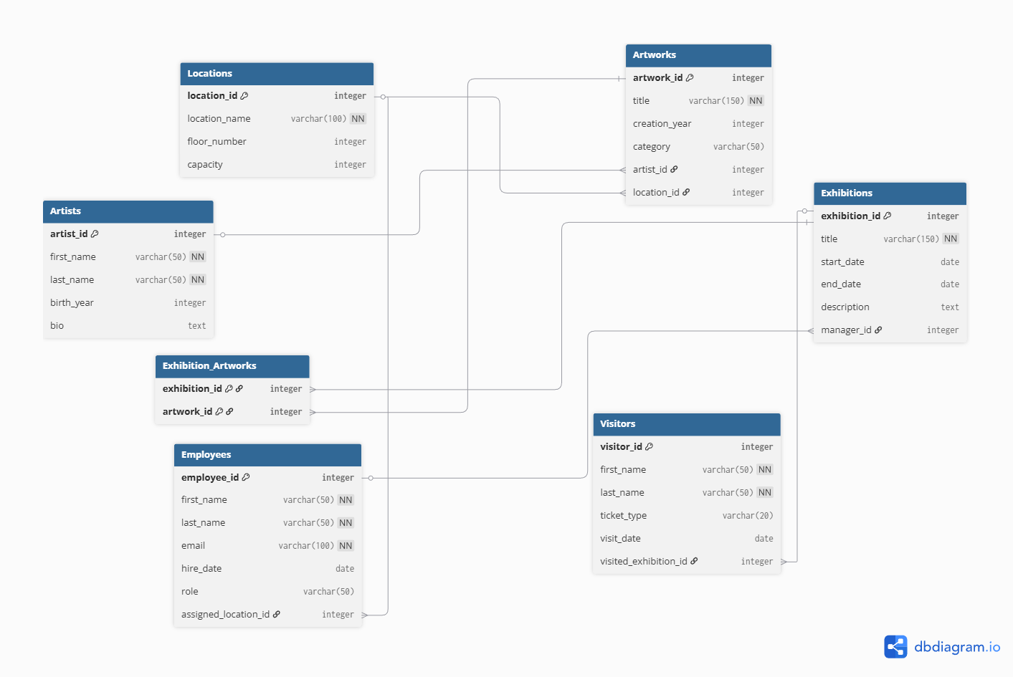

Objects

The model includes 7 tables, grouped by core entities (Artists, Artworks) and operational entities (Employees, Visitors). The design adheres to 3rd Normal Form (3NF); for example, by using a separate Locations table to manage storage and exhibition spaces efficiently, preventing redundant address data in the Artworks and Employees tables.
Table Name | Field name | Field Description | Data Type
Artists | artist_id | Unique ID for the artist. PK, NOT NULL, UNIQUE | Integer (Serial)
Artists | first_name | The artist's first name. NOT NULL | Varchar(50)
Artists | last_name | The artist's last name. NOT NULL | Varchar(50)
Artists | birth_year | The year the artist was born. | Integer
Artists | bio | Biographical information about the artist. | Text

Table Name | Field name | Field Description | Data Type
Locations | location_id | Unique ID for the facility (Storage/Hall). PK, NOT NULL | Integer (Serial)
Locations | location_name | Name of the location (e.g., "Main Hall"). NOT NULL | Varchar(100)
Locations | floor_number | The floor number where the location is situated. | Integer
Locations | capacity | Maximum capacity of the location. (Check Constraint: >= 0) | Integer

Table Name | Field name | Field Description | Data Type
Artworks | artwork_id | Unique identifier for the artwork. PK, NOT NULL | Integer (Serial)
Artworks | title | Title of the artwork. NOT NULL | Varchar(150)
Artworks | creation_year | The year the artwork was created. | Integer
Artworks | category | Category of the art (e.g., Painting, Sculpture). | Varchar(50)
Artworks | artist_id | Foreign Key linking to the Artists table. | Integer
Artworks | location_id | Foreign Key linking to Locations (Inventory tracking). | Integer

Table Name | Field name | Field Description | Data Type
Exhibitions | exhibition_id | Unique ID for the exhibition event. PK, NOT NULL | Integer (Serial)
Exhibitions | title | Title of the exhibition. NOT NULL | Varchar(150)
Exhibitions | start_date | Date when the exhibition opens. | Date
Exhibitions | end_date | Date when the exhibition closes. | Date
Exhibitions | description | Details about the exhibition theme. | Text
Exhibitions | manager_id | Foreign Key linking to Employees (Responsible Manager). | Integer

Table Name | Field name | Field Description | Data Type
Exhibitions_Artworks  (Junction Table) | exhibition_id | Composite PK, FK linking to the Exhibitions table. | Integer
Exhibitions_Artworks  (Junction Table) | artwork_id | Composite PK, FK linking to the Artworks table. | Integer

Table Name | Field name | Field Description | Data Type
Employees | employee_id | Unique ID for the staff member. PK, NOT NULL | Integer (Serial)
Employees | first_name | Employee's first name. NOT NULL | Varchar(50)
Employees | last_name | Employee's last name. NOT NULL | Varchar(50)
Employees | full_name | Generated Column: Combines first and last name automatically. | Varchar(101)
Employees | email | Corporate email address. UNIQUE, NOT NULL | Varchar(100)
Employees | hire_date | Date of employment start. | Date
Employees | role | Job title (e.g., Curator, Security). | Varchar(50)
Employees | assigned_location_id | Foreign Key linking to Locations (Workplace). | Integer

Table Name | Field name | Field Description | Data Type
Visitors | visitor_id | Unique ID for the visitor transaction. PK, NOT NULL | Integer (Serial)
Visitors | first_name | Visitor's first name. NOT NULL | Varchar(50)
Visitors | last_name | Visitor's last name. NOT NULL | Varchar(50)
Visitors | ticket_type | Type of ticket purchased (e.g., Student, Adult). | Varchar(20)
Visitors | visit_date | Date of the visit. (Check Constraint: >= 2024-01-01) | Date
Visitors | visited_exhibition_id | Foreign Key linking to Exhibitions. | Integer

