**STORY MAPPING EXAMPLE**

*Review this user story mapping example for an e-mail system that allows user to organize & manage email, manage calendar and manage contacts. Use this example to grasp the concept of mapping user stories and to use this learning in the below activity.*

**Here are some benefits of user story mapping:**

* *Decide on what to build first*
* *Build product or feature using an iterative approach*
* *Planning releases at a high level*
* *Prioritizing the product backlog*
* *Having an open approach to supporting goals and activities*

**USER STORY MAPPING ACTIVITY INSTRUCTION**

NOTE: U*se this template below or utilize tools of your own (notepad, whiteboard, sticky notes, etc.)*

For this activity,

1. Brainstorm and write down the tasks (3-5) that needs to go under each

of the activity (blue boxes).

1. Once you have those 3-5 tasks on each column, rearrange them with the highest priority activity to the top of the column.
2. Consider a workflow that will provide value to your user (student taking online course in this case)
3. Create a release or increment.

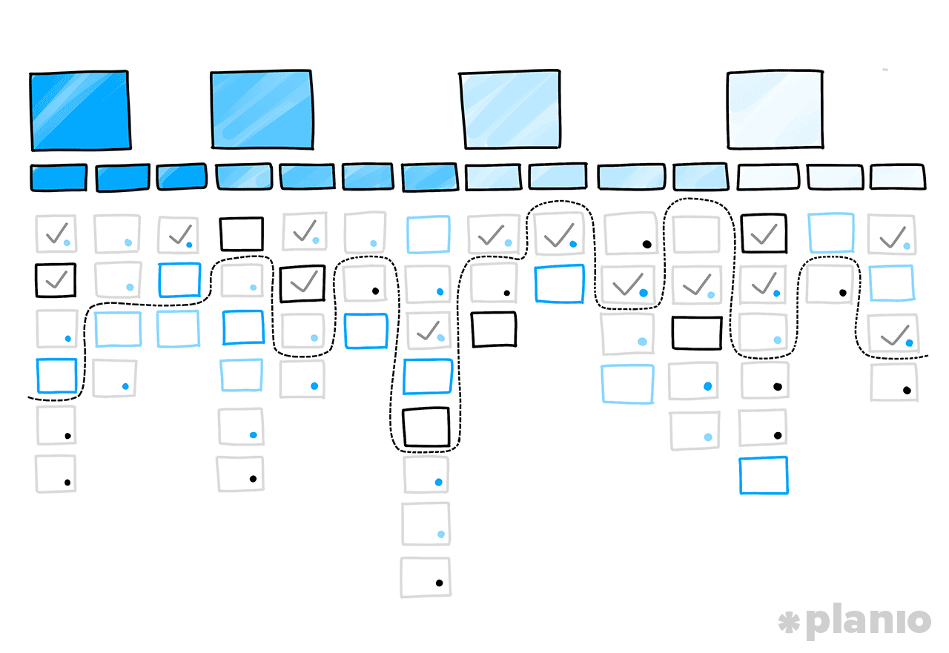

**Source**: <https://plan.io/blog/user-story-mapping/>

**STORY MAPPING ACTIVITY SHEET**

Watch the Course

Course Access Confirmation

Search Course

Shopping Cart

Learn more about Course

**Key takeaways from the story mapping exercise**

**………………………………..………………………………..………………………………..**

**………………………………..……………………………….………………………………..**

**………………………………..………………………………..………………………………..**

**………………………………..………………………………..………………………………..**

**………………………………..………………………………..………………………………..**

**………………………………..………………………………..………………………………..**

**………………………………..………………………………..………………………………..**

**For further understanding, read this blog**:

<https://plan.io/blog/user-story-mapping/>

