Riverside Research Institute

Sonocare system operation:

1. Insert DAQ-1200 card into laptop. Computer can be on or off.

2 .Verify DAQ-1200 operation:
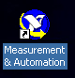
2a.Select MAX icon and double click the Measurement & Automation icon (shown to the right). This will open a new window.

2b If the DAQ-1200 is functioning properly, it will be listed under the Devices and Interfaces menu found beneath Configurations (see figure below, green oval). Note that the image here is for a different piece of hardware.

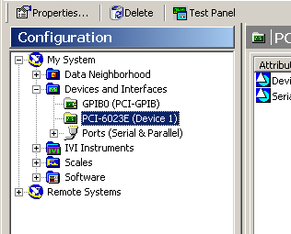
2c. If the DAQ-1200 is not listed, press F5 and see if it appears under Devices and Interfaces. If still not there, try ejecting the DAQ-1200 card and reinserting it while the computer is still on. If still not visible, reboot the computer with card out, and then insert card once computer has booted up.

2d. If DAQ-1200 is listed, select it (green oval). An icon that says Test Panel will then appear (red oval). Click on Test Panel. If the DAQ-1200 is functioning properly, a test panel will open with a live trace. If there is still a problem, a text box will appear explaining the error. Go back to 2c if this should occur.

2e. If all else fails, call RRI.

3. Once the DAQ-1200 is confirmed to be working, open the ColumbiaSonocare application. Instructions on how to use the software will appear when the software opens.

