**ASSIGNMENT 2**

**CE1003 INTRODUCTION TO COMPUTATIONAL THINKING**

**PYTHON HANGMAN GAME**



**EDWIN CANDINEGARA (FE2)**

**U1320135K**

**SEMESTER 1**

**AY 2013/2014**

**SCHOOL OF COMPUTER ENGINEERING**

**NANYANG TECHNOLOGICAL UNIVERSITY**

**Name:** Edwin Candinegara / U1320135K

**Tutorial Group:** FE2

**Note:** Please use command line instead of IDLE to run this program and put all 3 files into the same folder (picture.py and dictionary.py are used as module in Hangman.py)

**Program Starts:**

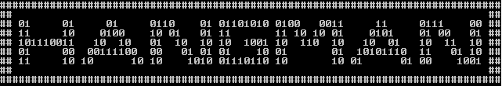

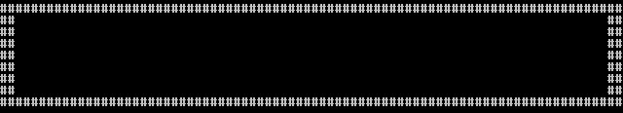





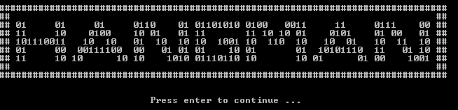

It is some kind of a flip-flop light (turn on then turn off then turn on again and so on). The pictures are taken for each on and off.

**Case 1: You win**

1.

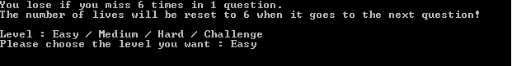

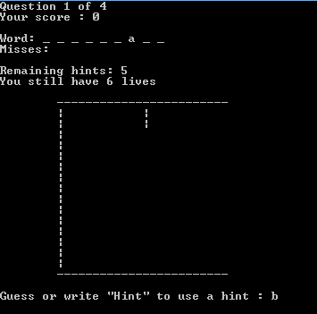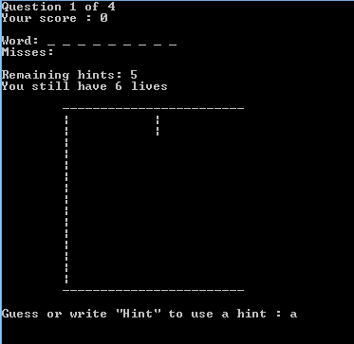

2.

3.

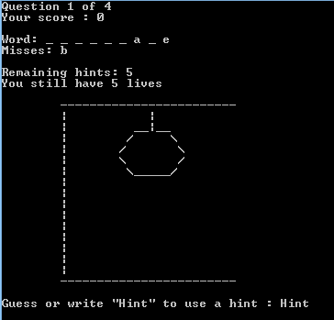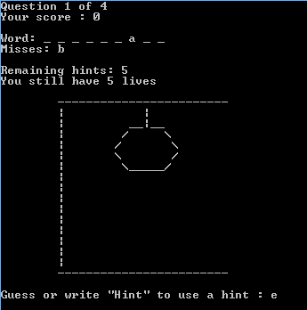

5.

4.

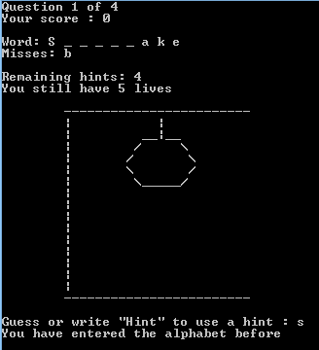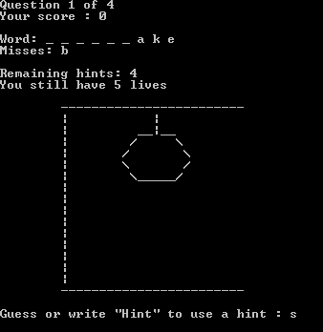

7.

6.

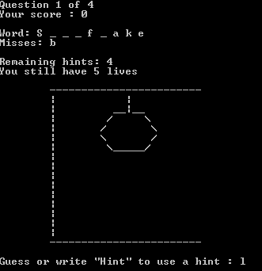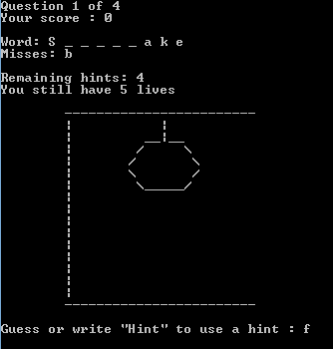

9.

8.

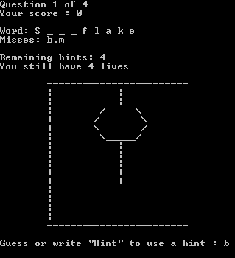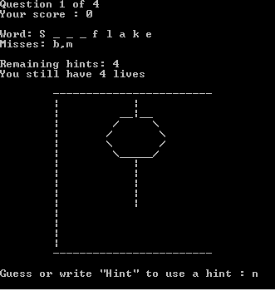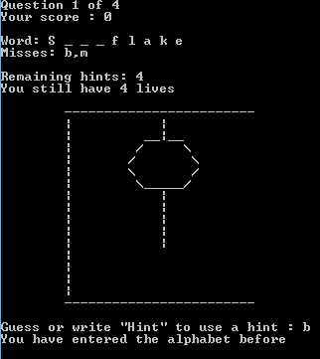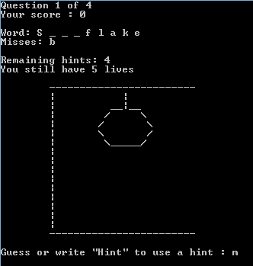

11.

10.

13.

12.

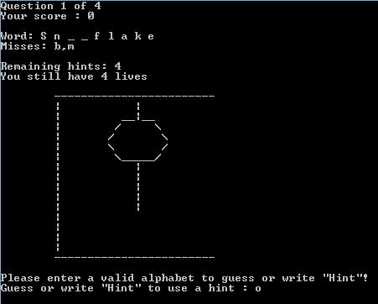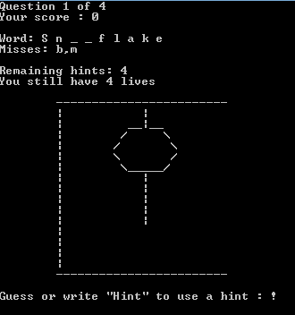

15.

14.

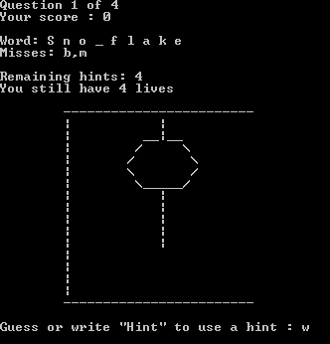

16.

17.



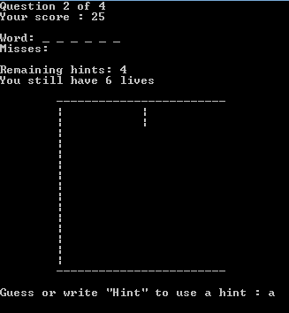

18.

19. This screenshot is taken after the first three questions are correctly answered and the final alphabet of the last question is going to be entered. I skip the question 2, question 3, and the entering of the 6 alphabets in question 4 because the processes are the same with the first question. This is just to show what happens if the player finishes all questions.

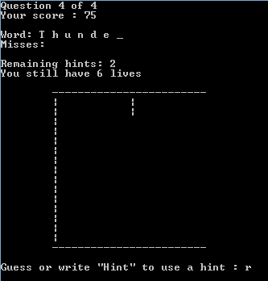

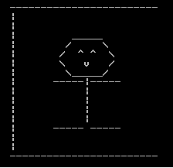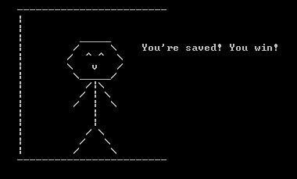

21.

20.



22.



23.

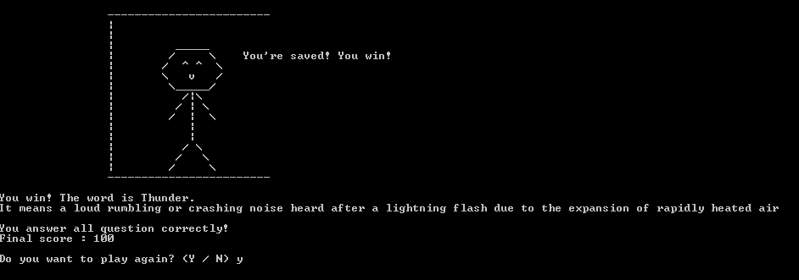

24.

**Case 2: You lose**



1.

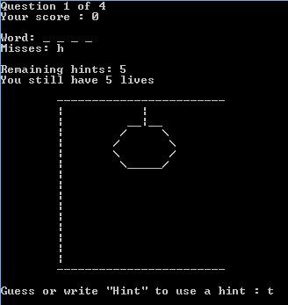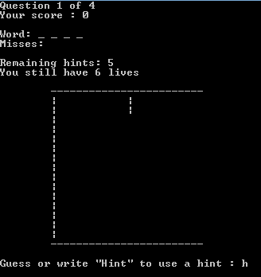

2.

3.

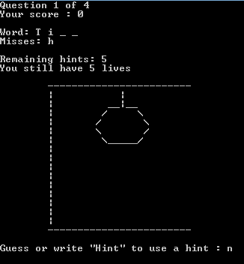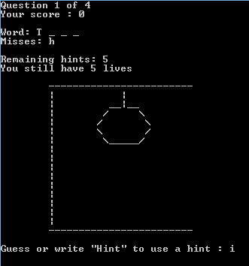

5.

4.

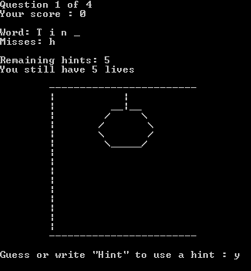

6.

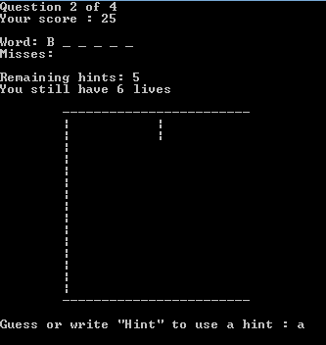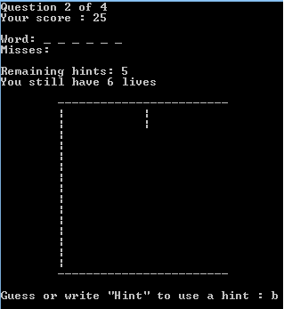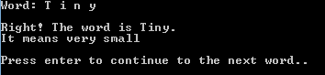

7.

9.

8.

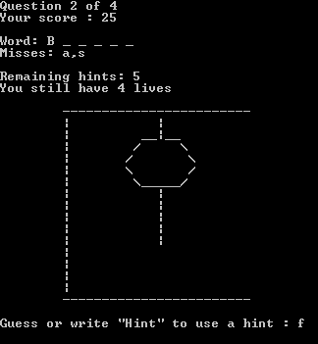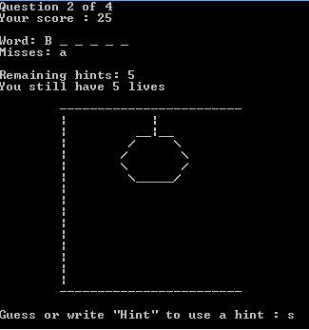

11.

10.

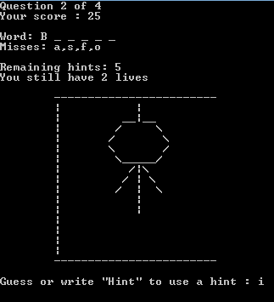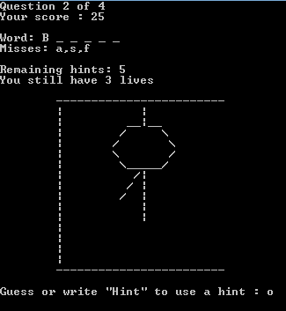

12.

13.

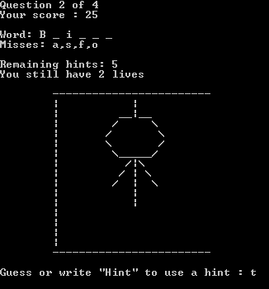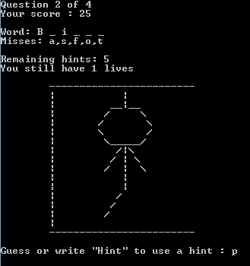

15.

14.

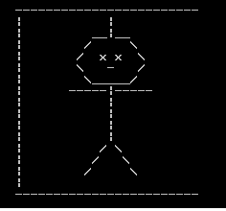

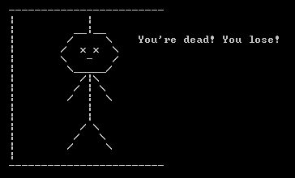

16.

17.



18.

19.

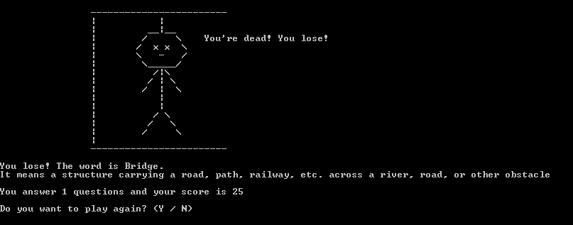

**Play Again:**

In the end of the game, regardless of winning or losing, player will be asked whether he/she wants to play again or not. If player wants to play again, write ‘Y’ or ‘y’ and the program will start over from asking the level. If not, write ‘N’ or ‘n’ and the program will be terminated. If the player does not write ‘Y’ or ‘N’ in either upper or lower case, there will be a warning printed and the player will be prompted again as seen in the pictures below.