**PokeMongo**

**Students: Edoardo Fazzari, Mirco Ramo, Olgerti Xhanej**

**MOCK-UP**

LOG-IN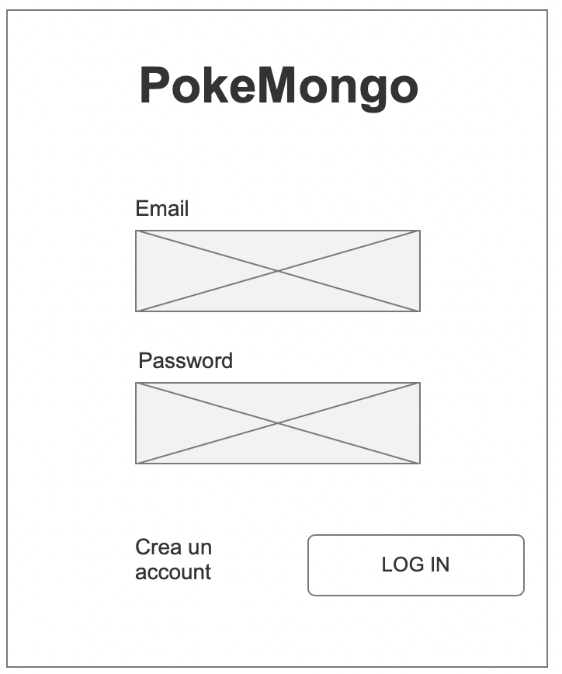

SIGN-UP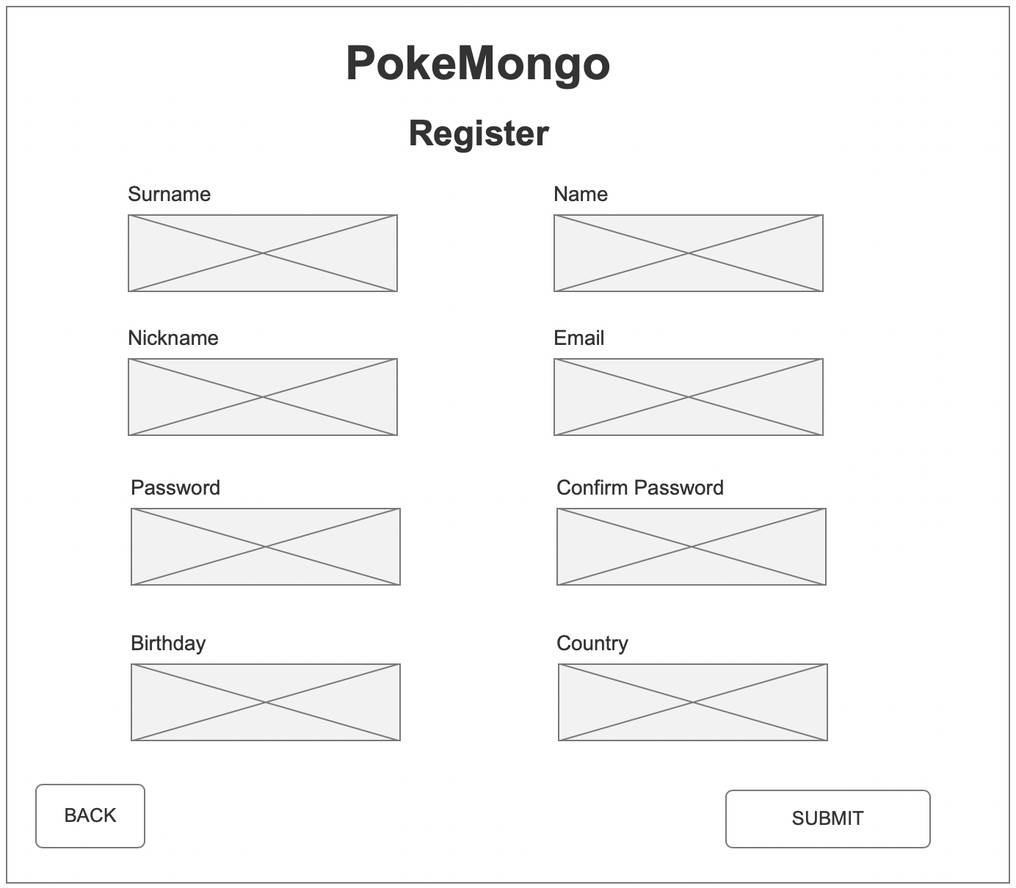

HOMEPAGE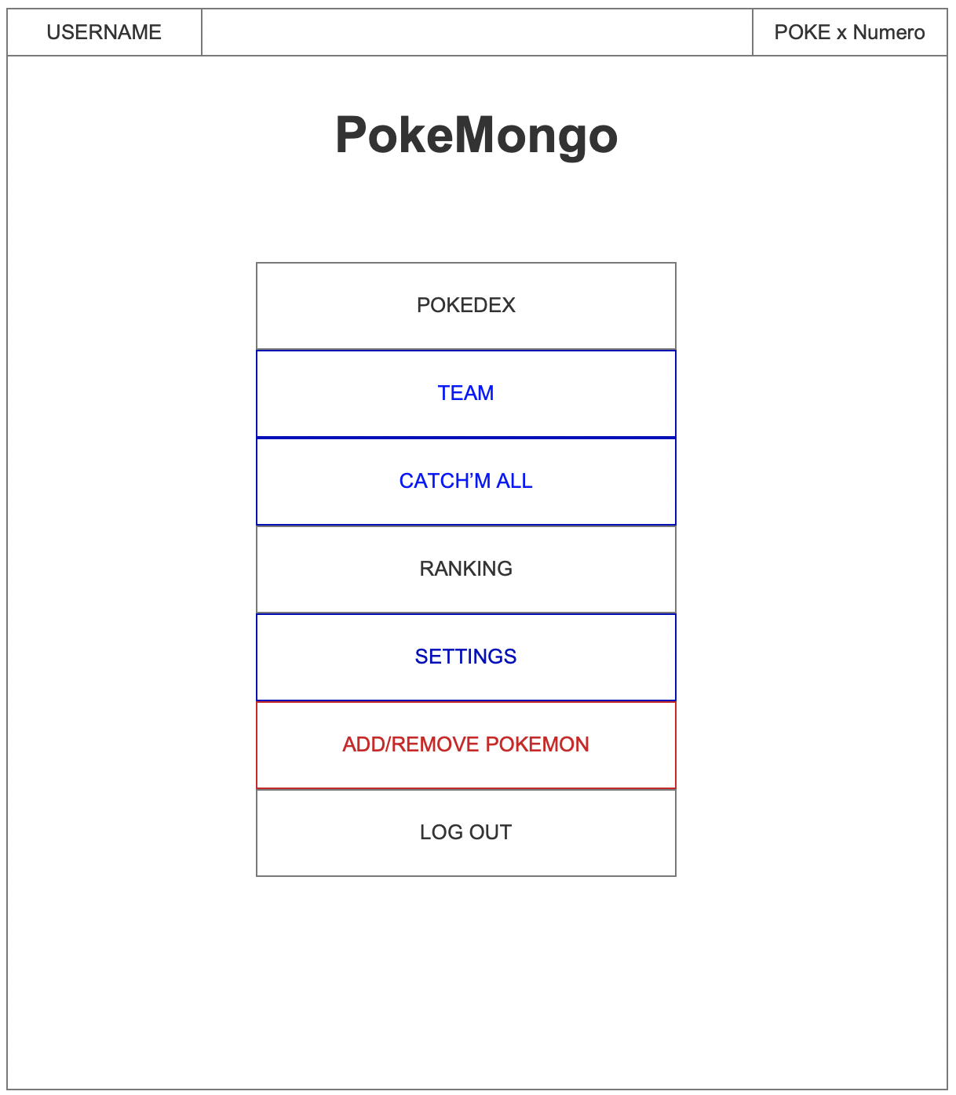

Black: everybody

Blue: just the normal user

Red: just the admin

RANKING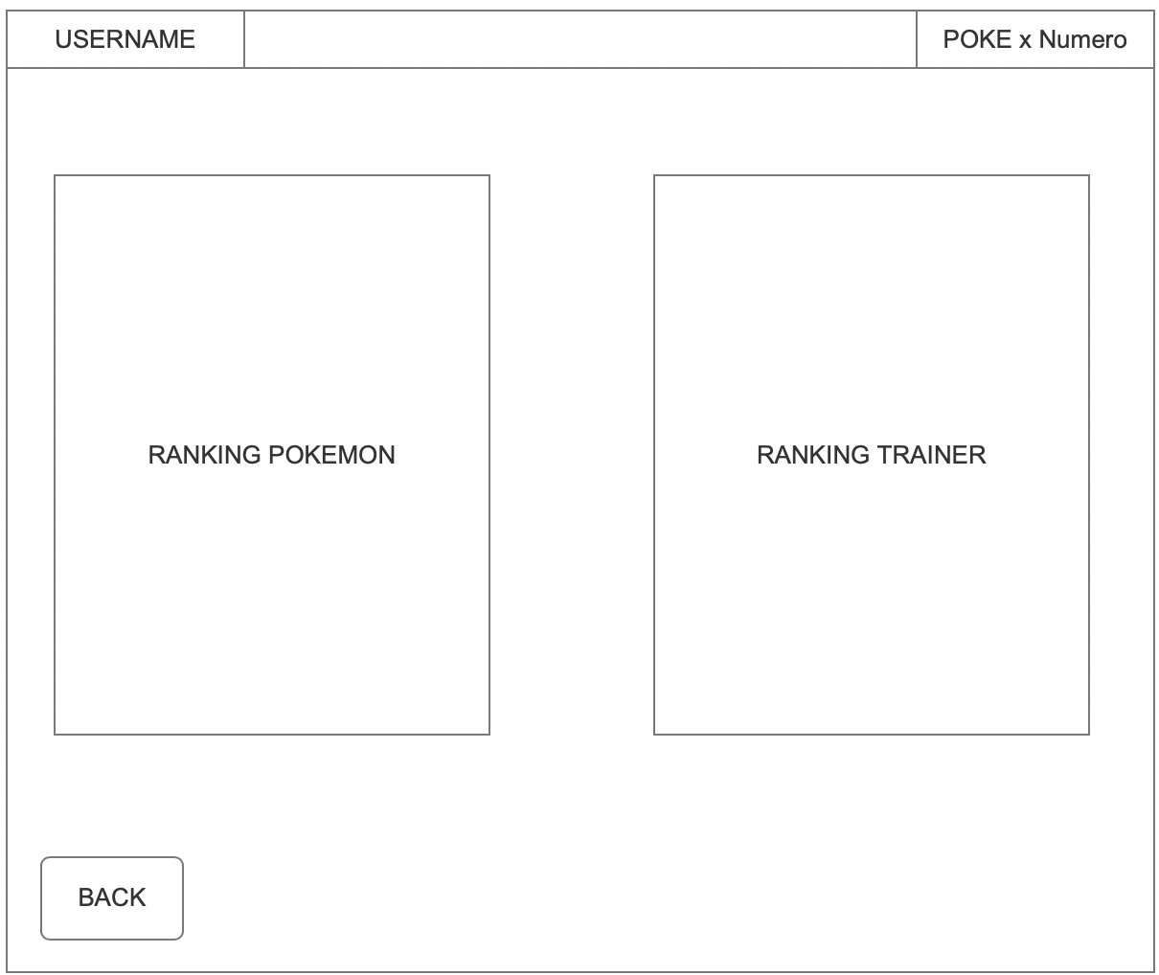

TEAM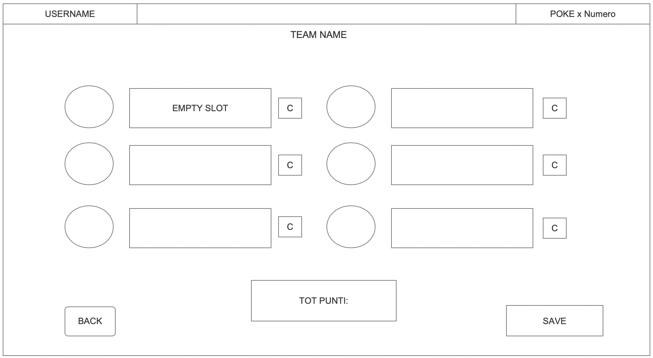

SETTINGS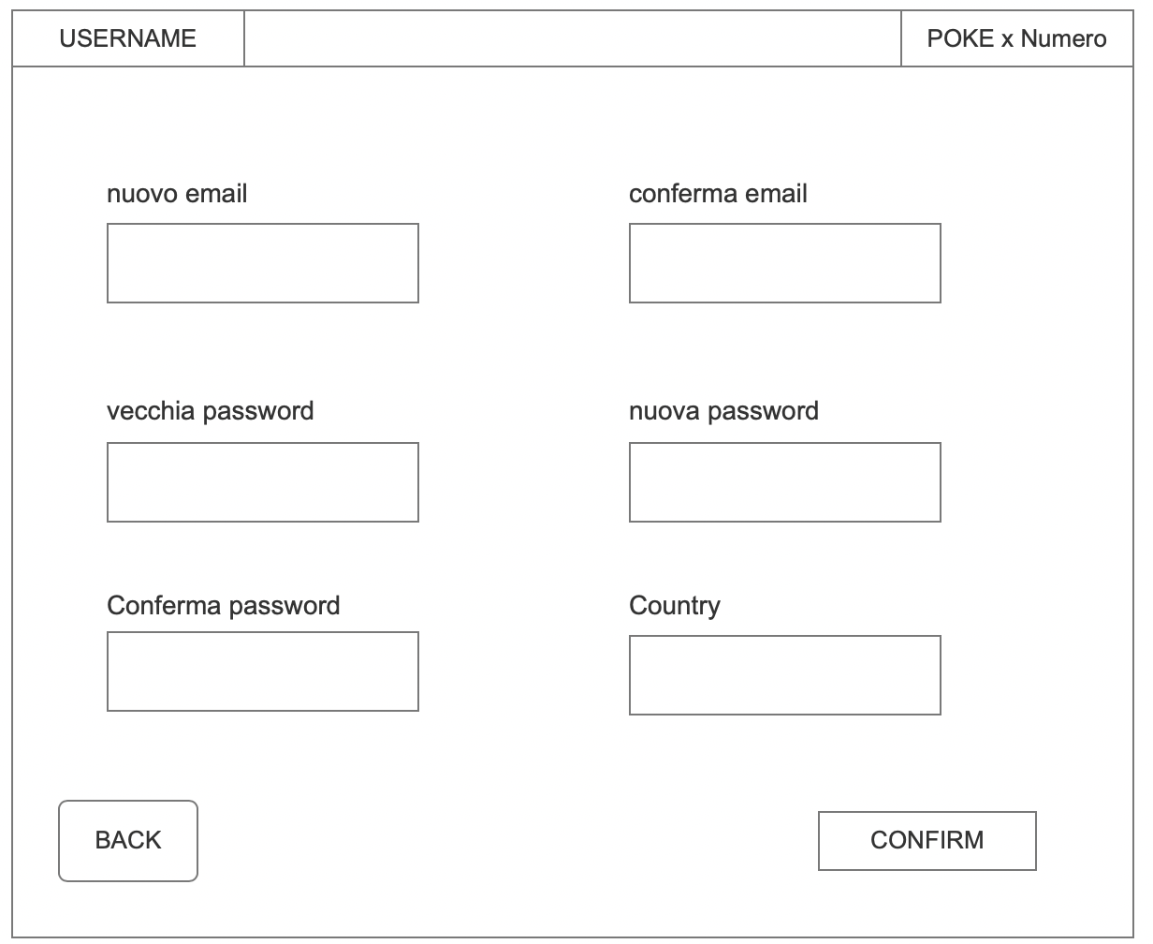

*Note:* the remaining windows (Pokédex, catch’em all, add/remove pokemon) will be done after projecting the database, in order to make the most appropriate solution.

**USE CASES**

* Unregistered user
  + Compile register form
  + Register
* Registered user
  + Sign in
  + Consult Pokédex:
    - Search by name
    - Search by type(s)
    - Search by Pokédex ID
    - Search by generation
    - Search by Pokemon characteristics (i.e, height, weight,..)
  + Consult ranking:
    - Most popular pokemon
    - Best team
  + Team handling:
    - Remove Pokemon from the team
    - View team
    - Save modified team
    - View a kind of value for the team
  + Settings:
    - Change email
    - Change password
    - Change country
  + Logout:
    - Exit from the account
    - Return to the sign in window
* Admin
  + Add pokemon to the Pokédex
  + Remove pokemon from the Pokédex

Advance use case: an user can try to catch his/her pokemon using 10 pokeball per day.

**QUERY:**

* Retrieve user information
* Retrive team information based on user
* Retrieve pokemon with different filters
* Analytics: most popular pokemons (*MongoDB: count()*), best teams
* Create user
* Modify user
* Update team (add/remove pokemons)
* Remove/Add from the database (admin related)