CENSORED

9/14/18

COMP-3220

Part 1 – Short Answer

1. In the code below, “Hello World” is printed with a following blank line.
2. In the code below, the three terms are defined and printed to the console, with a following blank line.

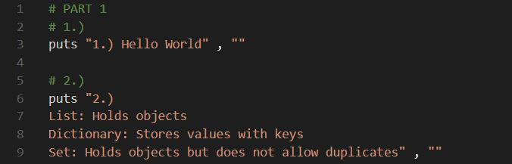

1. In the code below, a list is created with the numbers 0 – 10 and then a for loop is used to iterate throughout the list and print each number, followed by a blank line.
2. In the code below, the values for the first name, last name, tiger email id, banner id, and favorite movies are assigned to keys in a dictionary and then printed on separate lines, followed by a blank line.

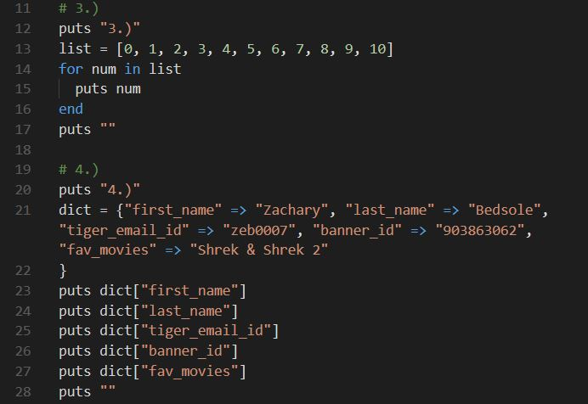

*Below is the Parent class and Child subclass that will be used as examples in 5.) and 6.), along with a new object called “Bob”.

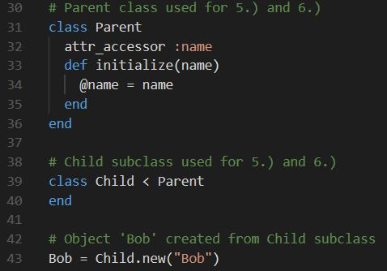

1. Prints the definition of a class and an object to the console, with a blank line following. The example of a class is the Parent class above, and the example of an object is “Bob”.
2. Prints the definitions of Inheritance, Encapsulation, and Abstraction to the console. The first example prints Bob’s current name (Bob), updates it to “Frank”, and then reprints the updated name. The second example shows that we need an appropriate accessor method to get Bob’s name to print to the console, such as attr_accessor (note: we could have used attr_reader for getting the name or attr_writer for setting the name, but attr_accessor accomplishes both). The third example merely states that if we only put the initialize method in the subclass, then we would only be able to create an object from the subclass and not the main class.

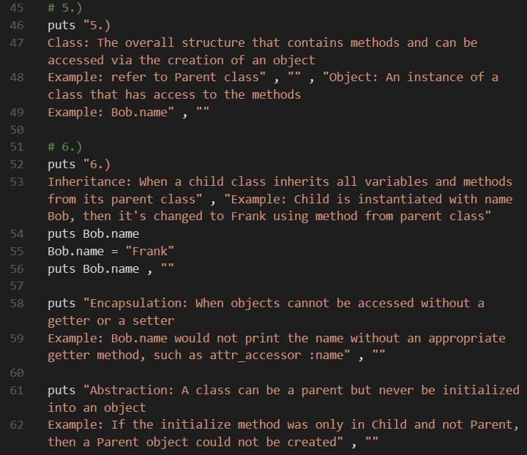

1. The animal class is created with 3 parameters that can be printed or set to different values. A new object ‘cat’ is created and ‘meow’ is the assigned value of animalNoise, so it is called to print to the console. The animalNoise is then reassigned to ‘woof’ and reprinted to the console to show that the accessor method works.
2. The definitions for all the accessor methods are printed to the console for this answer.

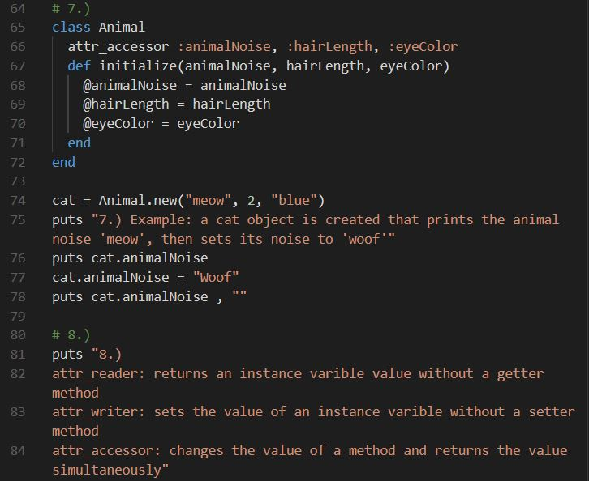

CENSORED

9/14/18

COMP-3220

Part 4 – Thinking Assignment

**Assignment Question:** When given an array with a million entries (some of the entries being duplicates), given that it increases but also decreases at a certain point (called the fluctuation point), what code could be written to find said fluctuation point?

**Goal:** To create a code that will find this fluctuation point without going over O(N^2), causing the program to take a long time to check each entry.

**The Method:** A for each loop and an if statement could be written to solve this issue. It will compare each value to the previous one within the array to check which one is greater.

**Code Example:**

for n in array {

if (array[n] > array[n + 1]) {

puts n + 1

}

}

**Summary:** This will sufficiently ignore duplicate values as the fluctuation point and check each independent value in the array against the next one. Once a value is found to be greater than the next one, the next one will be chosen as the fluctuation point within the array and will be printed to the screen. This will accomplish this task in O(N^2) time complexity, because the if statement is inside of the for loop and depends upon it to run.